Alexandros Kokkalis, Elvar Halldor Hallfredsson, Lise Heggebakken

05/02/2020

## Introduction

This working document present a series of different assessments using the surplus production model in continous time (SPiCT; Pedersen and Berg (2017)) available as an R package (<https://github.com/DTUAqua/spict>).

## Read in the data

library(spict)  
  
## Read in the data  
dat <- readxl::read_xlsx("../data/GSS_indices270120_AK.xlsx")  
#plot(dat$year,dat$catchTOT,type = "l",ylim = c(0,max(na.omit(dat$catchTOT))))  
## Sum up the catches from each area to get the total catch  
dat$catchTOT <- dat$catch1and2 + dat$catch3 + dat$catch4  
#plot(dat$year,dat$catchTOT,type = "l", ylim = c(0,max(na.omit(dat$catchTOT))))  
## run retro or not   
runretro <- FALSE

## Scenario 1

Input data for Scenario 1

|  |  |  |  |
| --- | --- | --- | --- |
| Input data | Name | Range | Notes |
| Catch | Total catch | 1988-2018 |  |
| Biomass indices | Shrimp survey | 1984–2002 2005–2018 | Split in two periods |
|  |  |  | Default priors |

## Choose only the years where the survey was in October   
w <- !is.na(dat$northsea_month) & dat$northsea_month == 10  
## Choose only the years where the survey was in January or February   
v <- !is.na(dat$northsea_month) & dat$northsea_month %in% c(1, 2)  
  
  
## Make the input list  
inp_NS <- list(timeC = dat$year, ## Timing of catch  
 obsC = dat$catchTOT, ## Observed catches  
 timeI = list(dat$year[w] + dat$northsea_month[w] / 12, ## Timing of survey index  
 dat$year[v] + dat$northsea_month[v] / 12),  
 obsI = list(dat$northsea_SA[w], ## Observed indices  
 dat$northsea_SA[v]),  
 optimiser.control = list(iter.max = 1e5, ## Optimiser options   
 eval.max = 1e5), ## sometimes help converge  
 priors = list( ## List of priors (empty, i.e. default priors)  
 ## see possible priors with list.possible.priors()  
 ))  
## Check input time series, remove missing and zero observations  
inp_NS <- check.inp(inp_NS)

## Removing zero, negative, and NAs in C series

## Plot input data  
plotspict.data(inp_NS)

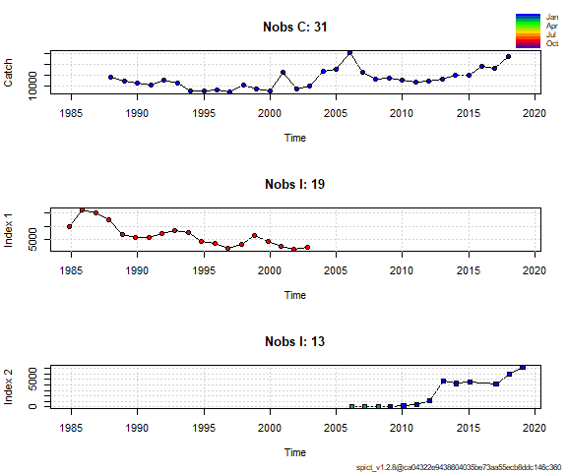

## Fit spict  
fit_NS <- fit.spict(inp_NS)  
  
## Summary of the fit - in the vignette there is a line-by-line description of that summary  
fit_NS

## Convergence: 0 MSG: relative convergence (4)  
## Objective function at optimum: 57.3810526  
## Euler time step (years): 1/16 or 0.0625  
## Nobs C: 31, Nobs I1: 19, Nobs I2: 13  
##   
## Priors  
## logn ~ dnorm[log(2), 2^2]  
## logalpha ~ dnorm[log(1), 2^2]  
## logbeta ~ dnorm[log(1), 2^2]  
##   
## Model parameter estimates w 95% CI   
## estimate cilow ciupp log.est   
## alpha1 2.390221e+00 0.6561160 8.707540e+00 0.8713858   
## alpha2 1.185998e+01 3.5324125 3.981958e+01 2.4731699   
## beta 9.416977e-01 0.3601728 2.462137e+00 -0.0600710   
## r 1.999363e-01 0.0614380 6.506482e-01 -1.6097566   
## rc 6.376559e-01 0.0245182 1.658384e+01 -0.4499565   
## rold 5.361626e-01 0.0090055 3.192149e+01 -0.6233178   
## m 2.551782e+04 1202.3903015 5.415541e+05 10.1471325   
## K 2.797479e+05 4660.6208760 1.679152e+07 12.5416442   
## q1 1.544270e-02 0.0000792 3.010343e+00 -4.1706220   
## q2 4.063500e-03 0.0000136 1.210055e+00 -5.5057111   
## n 6.270977e-01 0.0459170 8.564407e+00 -0.4666529   
## sdb 1.576217e-01 0.0512043 4.852053e-01 -1.8475574   
## sdf 1.625876e-01 0.0768551 3.439552e-01 -1.8165384   
## sdi1 3.767507e-01 0.2468519 5.750051e-01 -0.9761716   
## sdi2 1.869391e+00 1.2648928 2.762781e+00 0.6256125   
## sdc 1.531084e-01 0.0978477 2.395782e-01 -1.8766094   
##   
## Deterministic reference points (Drp)  
## estimate cilow ciupp log.est   
## Bmsyd 8.003635e+04 544.6157898 1.176209e+07 11.290236   
## Fmsyd 3.188279e-01 0.0122591 8.291918e+00 -1.143104   
## MSYd 2.551782e+04 1202.3903015 5.415541e+05 10.147132   
## Stochastic reference points (Srp)  
## estimate cilow ciupp log.est rel.diff.Drp   
## Bmsys 7.831263e+04 552.3440915 1.110335e+07 11.268464 -0.022010800   
## Fmsys 3.210608e-01 0.0122407 8.421108e+00 -1.136125 0.006954625   
## MSYs 2.514696e+04 1185.4484886 5.334435e+05 10.132492 -0.014747787   
##   
## States w 95% CI (inp$msytype: s)  
## estimate cilow ciupp log.est   
## B_2019.08 2.203227e+05 776.4156084 6.252077e+07 12.302849   
## F_2019.08 9.836480e-02 0.0003846 2.515559e+01 -2.319072   
## B_2019.08/Bmsy 2.813374e+00 0.4986872 1.587182e+01 1.034385   
## F_2019.08/Fmsy 3.063744e-01 0.0036177 2.594577e+01 -1.182947   
##   
## Predictions w 95% CI (inp$msytype: s)  
## prediction cilow ciupp log.est   
## B_2019.08 2.203227e+05 7.764156e+02 6.252077e+07 12.302849   
## F_2019.08 9.836480e-02 3.846000e-04 2.515559e+01 -2.319072   
## B_2019.08/Bmsy 2.813374e+00 4.986872e-01 1.587182e+01 1.034385   
## F_2019.08/Fmsy 3.063744e-01 3.617700e-03 2.594577e+01 -1.182947   
## Catch_2019.08 2.110211e+04 1.295520e+04 3.437222e+04 9.957128   
## E(B_inf) 1.727415e+05 NA NA 12.059552

## If the model converged, it reports convergence as 0  
## Continue with plotting and diagnostics only if convergence was reached  
converged <- fit_NS$opt$convergence == 0  
if (converged) {  
 ## Calculate the One Step Ahead (osa) residuals   
 fit_NS <- calc.osa.resid((fit_NS))  
   
 ## Make a plot showing relative F, relative B, Kobe plot catch   
 par(mfrow = c(2,2), ## 2x2 subplots  
 mar = c(4.1, 4.1, 0.5, 0.5)) ## Change default margins for the plots   
 plotspict.catch(fit_NS)  
 plotspict.ffmsy(fit_NS)  
 plotspict.bbmsy(fit_NS)  
 plotspict.fb(fit_NS)  
}

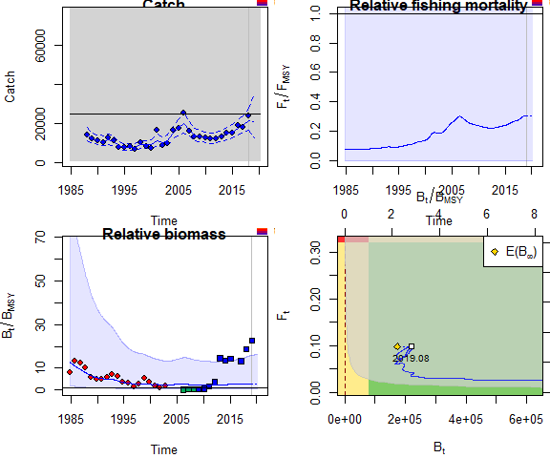

if (converged) {  
 plotspict.diagnostic(fit_NS)  
}

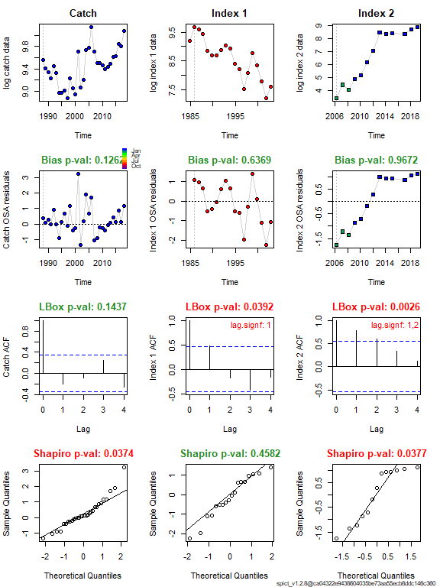

## If runretro is TRUE, run and plot the retrospective analysis  
 if (runretro & converged) {  
 fit_NS <- retro(fit_NS)  
 plotspict.retro(fit_NS)  
 }

## Scenario 2

Input data for Scenario 2

|  |  |  |  |
| --- | --- | --- | --- |
| Input data | Name | Range | Notes |
| Catch | Total catch | 1988-2018 |  |
| Biomass indices | Shrimp survey | 1984–2002 | Only october period |
| Biomass indices | Acoustic survey | 2009–2018 | Matlab |
|  |  |  | Default priors |

## Choose only the years where the survey was in October   
w <- !is.na(dat$northsea_month) & dat$northsea_month == 10  
## Choose only the years where the survey was in January or February   
##v <- !is.na(dat$northsea_month) & dat$northsea_month %in% c(1, 2)  
  
  
## Make the input list  
inp_NS <- list(timeC = dat$year, ## Timing of catch  
 obsC = dat$catchTOT, ## Observed catches  
 timeI = list(dat$year[w] + dat$northsea_month[w] / 12, ## Timing of survey index  
 dat$year+3.5/12),  
 obsI = list(dat$northsea_SA[w], ## Observed indices  
 dat$norwegian_seaAC),  
 optimiser.control = list(iter.max = 1e5, ## Optimiser options   
 eval.max = 1e5), ## sometimes help converge  
 priors = list( ## List of priors (empty, i.e. default priors)  
 logn=c(log(2),.5,1),  
 logbkfrac=c(log(.5),1,1)  
## see possible priors with list.possible.priors()  
 ))  
## Check input time series, remove missing and zero observations  
inp_NS <- check.inp(inp_NS)

## Removing zero, negative, and NAs in C series   
## Removing zero, negative, and NAs in I series 2

## Plot input data  
plotspict.data(inp_NS)

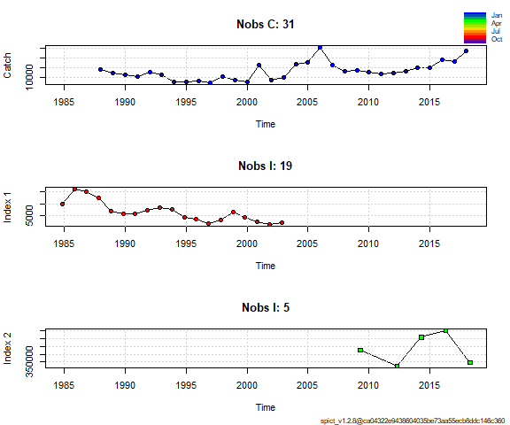

## Fit spict  
fit_NS <- fit.spict(inp_NS)  
  
## Summary of the fit - in the vignette there is a line-by-line description of that summary  
fit_NS

## Convergence: 0 MSG: relative convergence (4)  
## Objective function at optimum: 28.3888908  
## Euler time step (years): 1/16 or 0.0625  
## Nobs C: 31, Nobs I1: 19, Nobs I2: 5  
##   
## Priors  
## logn ~ dnorm[log(2), 0.5^2]  
## logbkfrac ~ dnorm[log(0.5), 1^2]  
## logalpha ~ dnorm[log(1), 2^2]  
## logbeta ~ dnorm[log(1), 2^2]  
##   
## Model parameter estimates w 95% CI   
## estimate cilow ciupp log.est   
## alpha1 3.110579e+00 7.699815e-01 1.256615e+01 1.1348088   
## alpha2 1.551961e+00 3.382870e-01 7.119942e+00 0.4395195   
## beta 1.066262e+00 4.099298e-01 2.773440e+00 0.0641595   
## r 1.878088e-01 4.709680e-02 7.489285e-01 -1.6723309   
## rc 2.588986e-01 4.339450e-02 1.544631e+00 -1.3513188   
## rold 4.165855e-01 1.347390e-02 1.288001e+01 -0.8756636   
## m 1.612555e+04 5.107054e+03 5.091651e+04 9.6881603   
## K 2.843817e+05 3.946527e+04 2.049218e+06 12.5580725   
## q1 1.840820e-02 1.227900e-03 2.759774e-01 -3.9949610   
## q2 2.469988e+00 1.496627e-01 4.076394e+01 0.9042132   
## n 1.450829e+00 5.912595e-01 3.560035e+00 0.3721351   
## sdb 1.309317e-01 3.852300e-02 4.450098e-01 -2.0330797   
## sdf 1.493363e-01 6.796260e-02 3.281410e-01 -1.9015548   
## sdi1 4.072732e-01 2.634923e-01 6.295118e-01 -0.8982710   
## sdi2 2.032009e-01 8.578800e-02 4.813095e-01 -1.5935603   
## sdc 1.592316e-01 1.058182e-01 2.396063e-01 -1.8373952   
##   
## Deterministic reference points (Drp)  
## estimate cilow ciupp log.est   
## Bmsyd 1.245704e+05 1.438294e+04 1.078902e+06 11.732626   
## Fmsyd 1.294493e-01 2.169730e-02 7.723154e-01 -2.044466   
## MSYd 1.612555e+04 5.107054e+03 5.091651e+04 9.688160   
## Stochastic reference points (Srp)  
## estimate cilow ciupp log.est rel.diff.Drp   
## Bmsys 1.200232e+05 1.417972e+04 1.015927e+06 11.695440 -0.03788633   
## Fmsys 1.275264e-01 2.049930e-02 7.933447e-01 -2.059432 -0.01507846   
## MSYs 1.529738e+04 4.830986e+03 4.843934e+04 9.635437 -0.05413822   
##   
## States w 95% CI (inp$msytype: s)  
## estimate cilow ciupp log.est   
## B_2018.27 1.704629e+05 9476.1521410 3.066391e+06 12.0462727   
## F_2018.27 1.197088e-01 0.0067759 2.114883e+00 -2.1226934   
## B_2018.27/Bmsy 1.420250e+00 0.4788558 4.212352e+00 0.3508327   
## F_2018.27/Fmsy 9.386979e-01 0.1126937 7.819019e+00 -0.0632615   
##   
## Predictions w 95% CI (inp$msytype: s)  
## prediction cilow ciupp log.est   
## B_2019.02 1.684139e+05 8.707537e+03 3.257320e+06 12.0341797   
## F_2019.02 1.230908e-01 6.825200e-03 2.219921e+00 -2.0948329   
## B_2019.02/Bmsy 1.403178e+00 4.395614e-01 4.479258e+00 0.3387398   
## F_2019.02/Fmsy 9.652182e-01 1.128026e-01 8.259088e+00 -0.0354011   
## Catch_2019.00 2.037854e+04 1.329067e+04 3.124637e+04 9.9222378   
## E(B_inf) 1.165644e+05 NA NA 11.6661995

## If the model converged, it reports convergence as 0  
## Continue with plotting and diagnostics only if convergence was reached  
converged <- fit_NS$opt$convergence == 0  
if (converged) {  
 ## Calculate the One Step Ahead (osa) residuals   
 fit_NS <- calc.osa.resid((fit_NS))  
   
 ## Make a plot showing relative F, relative B, Kobe plot catch   
 par(mfrow = c(2,2), ## 2x2 subplots  
 mar = c(4.1, 4.1, 0.5, 0.5)) ## Change default margins for the plots   
 plotspict.catch(fit_NS)  
 plotspict.ffmsy(fit_NS)  
 plotspict.bbmsy(fit_NS)  
 plotspict.fb(fit_NS)  
}

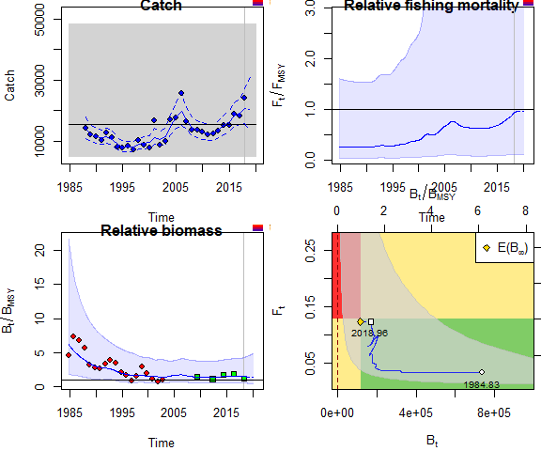

if (converged) {  
 plotspict.diagnostic(fit_NS)  
 plotspict.production(fit_NS)  
}

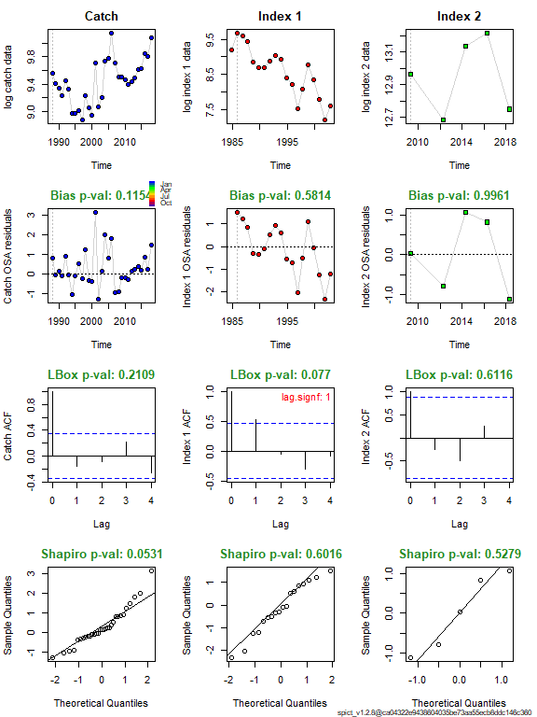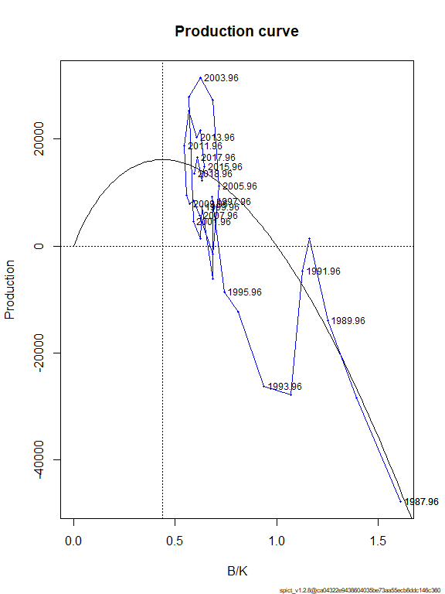

## If runretro is TRUE, run and plot the retrospective analysis  
 if (runretro & converged) {  
 fit_NS <- retro(fit_NS)  
 plotspict.retro(fit_NS)  
 }

## Scenario 3

Input data for Scenario 3

|  |  |  |  |
| --- | --- | --- | --- |
| Input data | Name | Range | Notes |
| Catch | Total catch | 1988-2018 |  |
| Biomass indices | Acoustic survey | 2009–2018 | Matlab |
| Biomass indices | Acoustic survey | 1990-1993 | Monstad |
|  |  |  | Default priors |

## Choose only the years where the survey was in October   
w <- !is.na(dat$northsea_month) & dat$northsea_month == 10  
## Choose only the years where the survey was in January or February   
##v <- !is.na(dat$northsea_month) & dat$northsea_month %in% c(1, 2)  
  
  
## Make the input list  
inp_NS <- list(timeC = dat$year, ## Timing of catch  
 obsC = dat$catchTOT, ## Observed catches  
 timeI = list(dat$year+3.5/12,dat$year+3/12),## Timing of survey index  
 obsI = list(dat$norwegian_seaAC,dat$Norwegian_seaAC_Monstad), ## Observed indices  
 optimiser.control = list(iter.max = 1e3, ## Optimiser options   
 eval.max = 1e3), ## sometimes help converge  
 priors = list( ## List of priors (empty, i.e. default priors)  
 #logn=c(log(2),.5,1),  
 #logbkfrac=c(log(.5),1,1)  
## see possible priors with list.possible.priors()  
 ))  
## Check input time series, remove missing and zero observations  
inp_NS <- check.inp(inp_NS)

## Removing zero, negative, and NAs in C series   
## Removing zero, negative, and NAs in I series 1   
## Removing zero, negative, and NAs in I series 2

## Plot input data  
plotspict.data(inp_NS)

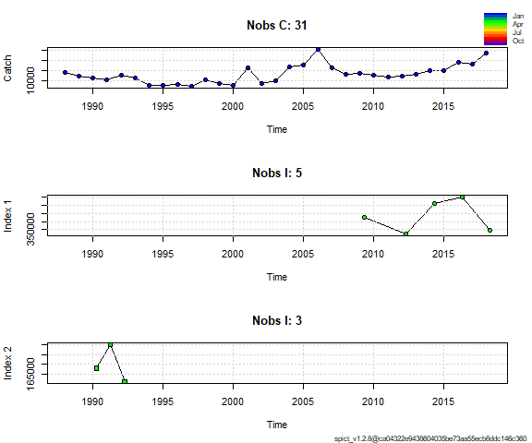

## Fit spict  
fit_NS <- fit.spict(inp_NS)  
  
## Summary of the fit - in the vignette there is a line-by-line description of that summary  
fit_NS

## Convergence: 0 MSG: relative convergence (4)  
## Objective function at optimum: 14.3407429  
## Euler time step (years): 1/16 or 0.0625  
## Nobs C: 31, Nobs I1: 5, Nobs I2: 3  
##   
## Priors  
## logn ~ dnorm[log(2), 2^2]  
## logalpha ~ dnorm[log(1), 2^2]  
## logbeta ~ dnorm[log(1), 2^2]  
##   
## Model parameter estimates w 95% CI   
## estimate cilow ciupp log.est   
## alpha1 5.756276e+00 8.811767e-01 3.760281e+01 1.7502908   
## alpha2 1.431561e+00 1.678045e-01 1.221284e+01 0.3587658   
## beta 9.080295e-01 3.292256e-01 2.504415e+00 -0.0964785   
## r 4.896562e-01 4.112190e-02 5.830555e+00 -0.7140517   
## rc 4.770468e-01 1.828155e-01 1.244827e+00 -0.7401407   
## rold 4.650705e-01 1.956400e-02 1.105556e+01 -0.7655663   
## m 1.595670e+04 1.147293e+04 2.219278e+04 9.6776338   
## K 1.324612e+05 4.637432e+04 3.783552e+05 11.7940448   
## q1 5.779729e+00 1.367156e+00 2.443413e+01 1.7543568   
## q2 5.761715e+00 1.062269e+00 3.125138e+01 1.7512351   
## n 2.052865e+00 1.303502e-01 3.233023e+01 0.7192361   
## sdb 3.434090e-02 5.769200e-03 2.044128e-01 -3.3714171   
## sdf 1.768985e-01 8.492990e-02 3.684577e-01 -1.7321790   
## sdi1 1.976759e-01 1.014676e-01 3.851061e-01 -1.6211263   
## sdi2 4.916120e-02 1.558680e-02 1.550557e-01 -3.0126513   
## sdc 1.606291e-01 1.055958e-01 2.443441e-01 -1.8286574   
##   
## Deterministic reference points (Drp)  
## estimate cilow ciupp log.est   
## Bmsyd 6.689782e+04 2.193877e+04 2.039913e+05 11.110922   
## Fmsyd 2.385234e-01 9.140780e-02 6.224133e-01 -1.433288   
## MSYd 1.595670e+04 1.147293e+04 2.219278e+04 9.677634   
## Stochastic reference points (Srp)  
## estimate cilow ciupp log.est rel.diff.Drp   
## Bmsys 6.679055e+04 2.190420e+04 2.036585e+05 11.109317 -0.001606076   
## Fmsys 2.382187e-01 9.101280e-02 6.235185e-01 -1.434566 -0.001279081   
## MSYs 1.591072e+04 1.148177e+04 2.204808e+04 9.674749 -0.002889347   
##   
## States w 95% CI (inp$msytype: s)  
## estimate cilow ciupp log.est   
## B_2018.25 7.035036e+04 1.489201e+04 3.323375e+05 11.1612432   
## F_2018.25 2.935164e-01 6.110920e-02 1.409802e+00 -1.2258218   
## B_2018.25/Bmsy 1.053298e+00 4.969773e-01 2.232369e+00 0.0519263   
## F_2018.25/Fmsy 1.232130e+00 4.324268e-01 3.510755e+00 0.2087444   
##   
## Predictions w 95% CI (inp$msytype: s)  
## prediction cilow ciupp log.est   
## B_2019.00 6.682726e+04 1.260149e+04 3.543933e+05 11.1098663   
## F_2019.00 3.064146e-01 6.034140e-02 1.555978e+00 -1.1828162   
## B_2019.00/Bmsy 1.000550e+00 4.288084e-01 2.334608e+00 0.0005494   
## F_2019.00/Fmsy 1.286274e+00 4.273219e-01 3.871792e+00 0.2517500   
## Catch_2019.00 1.987688e+04 1.371934e+04 2.879807e+04 9.8973127   
## E(B_inf) 4.723742e+04 NA NA 10.7629416

## If the model converged, it reports convergence as 0  
## Continue with plotting and diagnostics only if convergence was reached  
converged <- fit_NS$opt$convergence == 0  
if (converged) {  
 ## Calculate the One Step Ahead (osa) residuals   
 fit_NS <- calc.osa.resid((fit_NS))  
   
 ## Make a plot showing relative F, relative B, Kobe plot catch   
 par(mfrow = c(2,2), ## 2x2 subplots  
 mar = c(4.1, 4.1, 0.5, 0.5)) ## Change default margins for the plots   
 plotspict.catch(fit_NS)  
 plotspict.ffmsy(fit_NS)  
 plotspict.bbmsy(fit_NS)  
 plotspict.fb(fit_NS)  
}

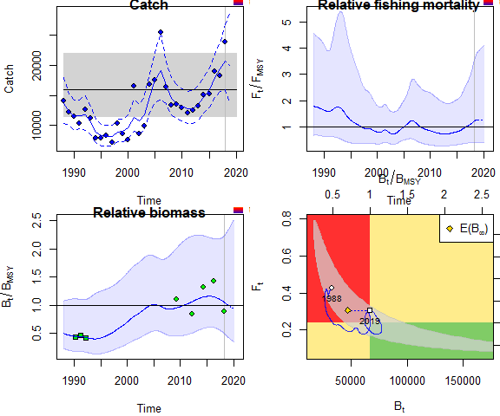

if (converged) {  
 plotspict.diagnostic(fit_NS)  
 plotspict.production(fit_NS)  
}

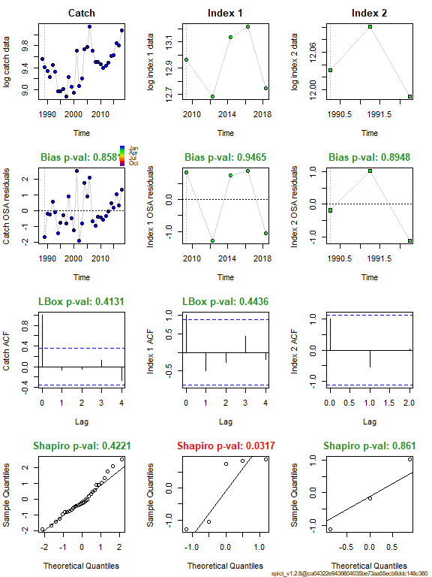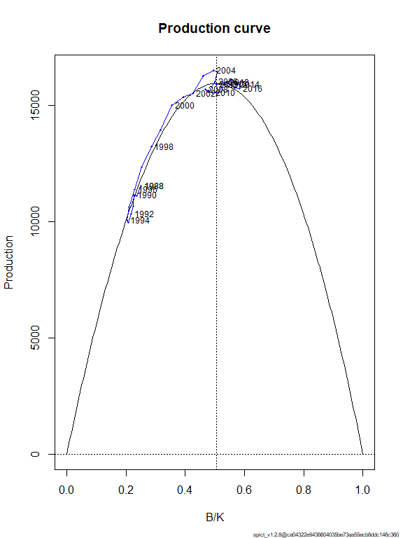

## If runretro is TRUE, run and plot the retrospective analysis  
 #runretro=TRUE  
if (runretro & converged) {  
 fit_NS <- retro(fit_NS)  
 plotspict.retro(fit_NS)  
 }

## Scenario 4

Input data for Scenario 4

|  |  |  |  |
| --- | --- | --- | --- |
| Input data | Name | Range | Notes |
| Catch | Total catch | 1988-2018 |  |
| Biomass indices | Acoustic survey | 2012–2018 | StoX |
| Biomass indices | Acoustic survey | 1990-1993 | Monstad |
|  |  |  | Default priors |

## Choose only the years where the survey was in October   
w <- !is.na(dat$northsea_month) & dat$northsea_month == 10  
w[1:4]<-FALSE  
## Choose only the years where the survey was in January or February   
##v <- !is.na(dat$northsea_month) & dat$northsea_month %in% c(1, 2)  
  
  
## Make the input list  
inp_NS <- list(timeC = dat$year, ## Timing of catch  
 obsC = dat$catchTOT, ## Observed catches  
 timeI = list(dat$year+3.5/12, dat$year+3/12),  
 obsI = list(dat$norwegian_seaAC,dat$Norwegian_seaAC_Monstad),  
 optimiser.control = list(iter.max = 1e3, ## Optimiser options   
 eval.max = 1e3), ## sometimes help converge  
 priors = list( ## List of priors (empty, i.e. default priors)  
 logn=c(log(2),.5,1)  
 #logbkfrac=c(log(.5),1,1)  
## see possible priors with list.possible.priors()  
 ))  
## Check input time series, remove missing and zero observations  
inp_NS <- check.inp(inp_NS)

## Removing zero, negative, and NAs in C series   
## Removing zero, negative, and NAs in I series 1   
## Removing zero, negative, and NAs in I series 2

## Plot input data  
plotspict.data(inp_NS)



## Fit spict  
fit_AC <- fit.spict(inp_NS)  
  
## Summary of the fit - in the vignette there is a line-by-line description of that summary  
fit_AC

## Convergence: 0 MSG: relative convergence (4)  
## Objective function at optimum: 12.9546007  
## Euler time step (years): 1/16 or 0.0625  
## Nobs C: 31, Nobs I1: 5, Nobs I2: 3  
##   
## Priors  
## logn ~ dnorm[log(2), 0.5^2]  
## logalpha ~ dnorm[log(1), 2^2]  
## logbeta ~ dnorm[log(1), 2^2]  
##   
## Model parameter estimates w 95% CI   
## estimate cilow ciupp log.est   
## alpha1 5.735290e+00 9.167939e-01 3.587889e+01 1.7466383   
## alpha2 1.426235e+00 1.733854e-01 1.173193e+01 0.3550379   
## beta 9.053337e-01 3.469476e-01 2.362401e+00 -0.0994517   
## r 4.802329e-01 1.475322e-01 1.563209e+00 -0.7334841   
## rc 4.787391e-01 1.996902e-01 1.147734e+00 -0.7365994   
## rold 4.772546e-01 1.191177e-01 1.912159e+00 -0.7397051   
## m 1.593563e+04 1.194744e+04 2.125514e+04 9.6763129   
## K 1.329867e+05 5.068315e+04 3.489414e+05 11.7980040   
## q1 5.828785e+00 1.983238e+00 1.713094e+01 1.7628085   
## q2 5.828383e+00 1.963658e+00 1.729937e+01 1.7627397   
## n 2.006240e+00 7.762974e-01 5.184869e+00 0.6962625   
## sdb 3.446170e-02 6.040500e-03 1.966066e-01 -3.3679081   
## sdf 1.772791e-01 8.862120e-02 3.546316e-01 -1.7300302   
## sdi1 1.976476e-01 1.013611e-01 3.854000e-01 -1.6212698   
## sdi2 4.915040e-02 1.551090e-02 1.557466e-01 -3.0128701   
## sdc 1.604967e-01 1.065456e-01 2.417668e-01 -1.8294819   
##   
## Deterministic reference points (Drp)  
## estimate cilow ciupp log.est   
## Bmsyd 6.657334e+04 2.523644e+04 1.756194e+05 11.106060   
## Fmsyd 2.393696e-01 9.984510e-02 5.738668e-01 -1.429747   
## MSYd 1.593563e+04 1.194744e+04 2.125514e+04 9.676313   
## Stochastic reference points (Srp)  
## estimate cilow ciupp log.est rel.diff.Drp   
## Bmsys 6.646671e+04 2.519372e+04 1.753541e+05 11.104456 -0.001604306   
## Fmsys 2.390763e-01 9.966970e-02 5.734692e-01 -1.430972 -0.001226657   
## MSYs 1.589059e+04 1.192444e+04 2.117590e+04 9.673482 -0.002834767   
##   
## States w 95% CI (inp$msytype: s)  
## estimate cilow ciupp log.est   
## B_2018.25 6.975339e+04 2.066381e+04 2.354616e+05 11.1527212   
## F_2018.25 2.960679e-01 8.687730e-02 1.008966e+00 -1.2171663   
## B_2018.25/Bmsy 1.049448e+00 5.530032e-01 1.991566e+00 0.0482647   
## F_2018.25/Fmsy 1.238382e+00 5.132862e-01 2.987789e+00 0.2138060   
##   
## Predictions w 95% CI (inp$msytype: s)  
## prediction cilow ciupp log.est   
## B_2019.00 6.621767e+04 1.790426e+04 2.449015e+05 11.1007026   
## F_2019.00 3.091462e-01 8.612220e-02 1.109719e+00 -1.1739409   
## B_2019.00/Bmsy 9.962532e-01 4.908775e-01 2.021931e+00 -0.0037539   
## F_2019.00/Fmsy 1.293086e+00 5.101852e-01 3.277381e+00 0.2570315   
## Catch_2019.00 1.986372e+04 1.381284e+04 2.856524e+04 9.8966500   
## E(B_inf) 4.670922e+04 NA NA 10.7516968

## If the model converged, it reports convergence as 0  
## Continue with plotting and diagnostics only if convergence was reached  
converged <- fit_AC$opt$convergence == 0  
if (converged) {  
 ## Calculate the One Step Ahead (osa) residuals   
 fit_AC <- calc.osa.resid((fit_AC))  
   
 ## Make a plot showing relative F, relative B, Kobe plot catch   
 par(mfrow = c(2,2), ## 2x2 subplots  
 mar = c(4.1, 4.1, 0.5, 0.5)) ## Change default margins for the plots   
 plotspict.catch(fit_AC)  
 plotspict.ffmsy(fit_AC)  
 plotspict.bbmsy(fit_AC)  
 plotspict.fb(fit_AC)  
}

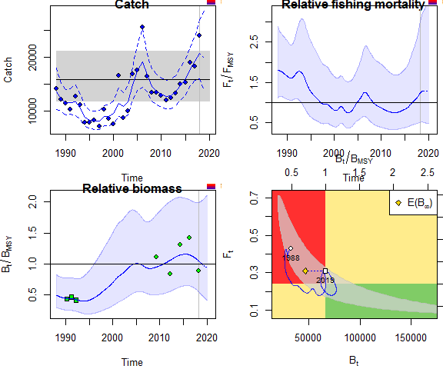

if (converged) {  
 plotspict.diagnostic(fit_AC)  
 plotspict.production(fit_AC)  
}

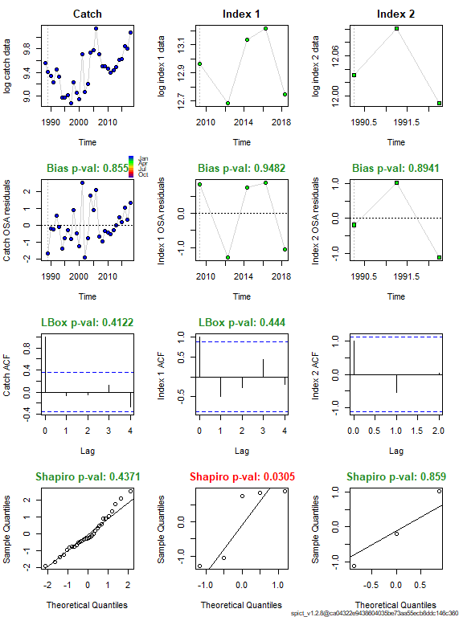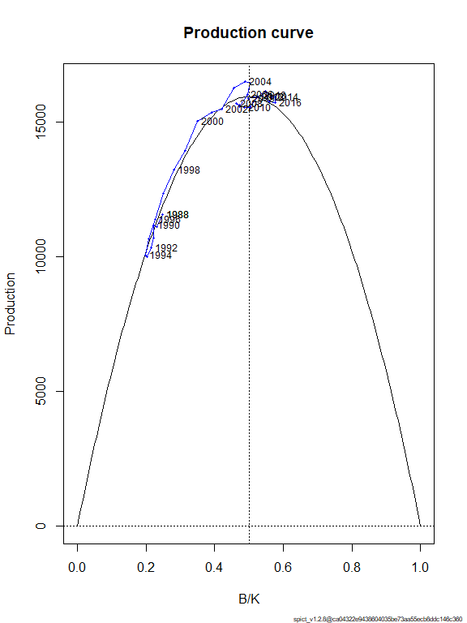

## If runretro is TRUE, run and plot the retrospective analysis  
 ## runretro=TRUE  
if (runretro & converged) {  
 fit_AC <- retro(fit_AC)  
 plotspict.retro(fit_AC)  
 }

##Scenario 5

Input data for Scenario 5

|  |  |  |  |
| --- | --- | --- | --- |
| Input data | Name | Range | Notes |
| Catch | Total catch | 1988-2018 |  |
| Biomass indices | Shrimp survey | 1984–2002 | Only october period |
| Biomass indices | Acoustic survey | 2012–2018 | StoX |
| Biomass indices | Acoustic survey | 1990-1993 | Monstad |
|  |  |  | Default priors |

## Choose only the years where the schrimp survey was in October   
w <- !is.na(dat$northsea_month) & dat$northsea_month == 10  
w[1:4]<-FALSE #remove years before 1988 in schrip survey  
## Choose only the years where the survey was in January or February   
v <- !is.na(dat$northsea_month) & dat$northsea_month %in% c(1)#c(1, 2)  
## Make the input list  
inp_NS <- list(timeC = dat$year, ## Timing of catch  
 obsC = dat$catchTOT, ## Observed catches dat$year[v] + dat$northsea_month[v] / 12  
 timeI = list(dat$year[w] + dat$northsea_month[w] / 12,dat$year+3.5/12, dat$year+3/12),  
 obsI = list(dat$northsea_SA[w],dat$norwegian_seaAC,dat$Norwegian_seaAC_Monstad),  
 optimiser.control = list(iter.max = 1e3, ## Optimiser options   
 eval.max = 1e3), ## sometimes help converge  
   
 priors = list( ## List of priors (empty, i.e. default priors)  
 logn=c(log(2),.5,1)  
 #logbkfrac=c(log(.5),1,1)  
## see possible priors with list.possible.priors()  
 ))  
## Check input time series, remove missing and zero observations  
inp_NS <- check.inp(inp_NS)

## Removing zero, negative, and NAs in C series   
## Removing zero, negative, and NAs in I series 2   
## Removing zero, negative, and NAs in I series 3

## Plot input data  
plotspict.data(inp_NS)

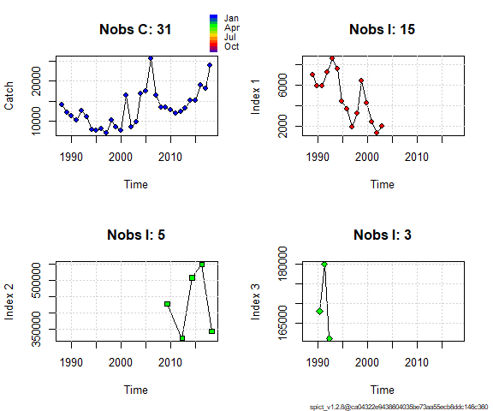

## Fit spict  
fit_NS <- fit.spict(inp_NS)  
  
## Summary of the fit - in the vignette there is a line-by-line description of that summary  
fit_NS

## Convergence: 0 MSG: relative convergence (4)  
## Objective function at optimum: 24.9215913  
## Euler time step (years): 1/16 or 0.0625  
## Nobs C: 31, Nobs I1: 15, Nobs I2: 5, Nobs I3: 3  
##   
## Priors  
## logn ~ dnorm[log(2), 0.5^2]  
## logalpha ~ dnorm[log(1), 2^2]  
## logbeta ~ dnorm[log(1), 2^2]  
##   
## Model parameter estimates w 95% CI   
## estimate cilow ciupp log.est   
## alpha1 4.067293e+00 1.0756626 1.537924e+01 1.4029777   
## alpha2 1.876797e+00 0.4335170 8.125098e+00 0.6295668   
## alpha3 5.116061e-01 0.0455970 5.740303e+00 -0.6702003   
## beta 1.151900e+00 0.4271711 3.106187e+00 0.1414126   
## r 3.336065e-01 0.0378611 2.939515e+00 -1.0977930   
## rc 3.261774e-01 0.0342092 3.110029e+00 -1.1203139   
## rold 3.190719e-01 0.0200195 5.085383e+00 -1.1423388   
## m 2.322892e+04 1204.9062494 4.478215e+05 10.0531535   
## K 2.824064e+05 3754.5033809 2.124205e+07 12.5511023   
## q1 1.509100e-02 0.0001121 2.031132e+00 -4.1936593   
## q2 1.917485e+00 0.0105032 3.500609e+02 0.6510143   
## q3 4.908080e-01 0.0033167 7.262983e+01 -0.7117023   
## n 2.045553e+00 0.6838261 6.118934e+00 0.7156681   
## sdb 1.063387e-01 0.0326205 3.466507e-01 -2.2411261   
## sdf 1.436392e-01 0.0642778 3.209854e-01 -1.9404505   
## sdi1 4.325106e-01 0.2685314 6.966241e-01 -0.8381484   
## sdi2 1.995762e-01 0.0923853 4.311360e-01 -1.6115594   
## sdi3 5.440350e-02 0.0081871 3.615131e-01 -2.9113265   
## sdc 1.654580e-01 0.1120487 2.443256e-01 -1.7990379   
##   
## Deterministic reference points (Drp)  
## estimate cilow ciupp log.est   
## Bmsyd 1.424312e+05 1767.4384920 1.147800e+07 11.866615   
## Fmsyd 1.630887e-01 0.0171046 1.555015e+00 -1.813461   
## MSYd 2.322892e+04 1204.9062494 4.478215e+05 10.053154   
## Stochastic reference points (Srp)  
## estimate cilow ciupp log.est rel.diff.Drp   
## Bmsys 1.394936e+05 1766.4748341 1.101542e+07 11.845774 -0.02105928   
## Fmsys 1.601562e-01 0.0162055 1.582796e+00 -1.831605 -0.01831021   
## MSYs 2.233216e+04 1200.8530329 4.153091e+05 10.013783 -0.04015593   
##   
## States w 95% CI (inp$msytype: s)  
## estimate cilow ciupp log.est   
## B_2018.25 2.209020e+05 1085.1278426 4.496953e+07 12.3054744   
## F_2018.25 9.179850e-02 0.0004545 1.854250e+01 -2.3881594   
## B_2018.25/Bmsy 1.583600e+00 0.5227263 4.797515e+00 0.4597004   
## F_2018.25/Fmsy 5.731809e-01 0.0106305 3.090506e+01 -0.5565539   
##   
## Predictions w 95% CI (inp$msytype: s)  
## prediction cilow ciupp log.est   
## B_2019.00 2.192232e+05 9.924827e+02 4.842283e+07 12.2978458   
## F_2019.00 9.456820e-02 4.576000e-04 1.954490e+01 -2.3584338   
## B_2019.00/Bmsy 1.571565e+00 4.780807e-01 5.166107e+00 0.4520718   
## F_2019.00/Fmsy 5.904748e-01 1.066390e-02 3.269539e+01 -0.5268284   
## Catch_2019.00 2.049855e+04 1.362292e+04 3.084439e+04 9.9281095   
## E(B_inf) 1.901561e+05 NA NA 12.1556007

## If the model converged, it reports convergence as 0  
## Continue with plotting and diagnostics only if convergence was reached  
converged <- fit_NS$opt$convergence == 0  
if (converged) {  
 ## Calculate the One Step Ahead (osa) residuals   
 fit_NS <- calc.osa.resid((fit_NS))  
   
 ## Make a plot showing relative F, relative B, Kobe plot catch   
 par(mfrow = c(2,2), ## 2x2 subplots  
 mar = c(4.1, 4.1, 0.5, 0.5)) ## Change default margins for the plots   
 plotspict.catch(fit_NS)  
 plotspict.ffmsy(fit_NS)  
 plotspict.bbmsy(fit_NS)  
 plotspict.fb(fit_NS)  
}

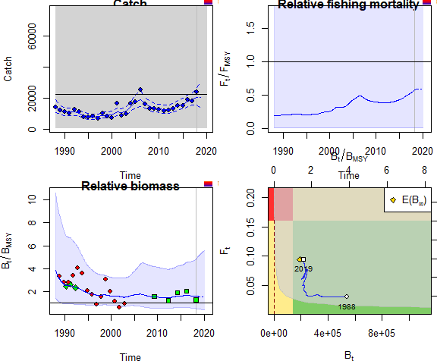

if (converged) {  
 plotspict.diagnostic(fit_NS)  
 plotspict.production(fit_NS)  
}

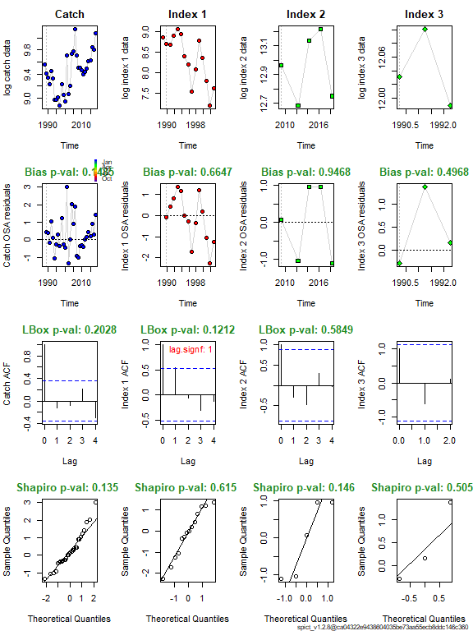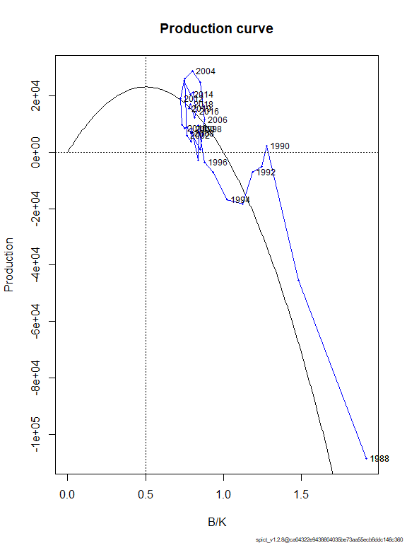

## If runretro is TRUE, run and plot the retrospective analysis  
 #runretro=TRUE  
if (runretro & converged) {  
 fit_NS <- retro(fit_NS)  
 plotspict.retro(fit_NS)  
 }

### Biomass comparsin scenario 4 and 5

bAC <- get.par(parname = "logBBmsy",fit_AC, exp = TRUE)  
time <- as.numeric(rownames(bAC))  
bNS <- get.par(parname = "logBBmsy",fit_NS, exp = TRUE)  
  
  
  
meanAC <- mean(bAC[,2][time > 2005 & time < 2019])  
meanNS <- mean(bNS[,2][time > 2005 & time < 2019])  
ylim <- c(0.6, 1.4)  
par(mfrow =c(1,1))  
plot(time, bNS[,2] / meanNS,type="l", ylim = ylim, xlim=c(2005,2018),ylab = "Bioamass")  
lines(time, bAC[,2] / meanAC,col="red")  
points(dat$year, dat$norwegian_sea_AC_stox / mean(dat$norwegian_sea_AC_stox, na.rm = TRUE, col="blue"),pch =3 )  
points(dat$year, dat$norwegian_seaAC / mean(dat$norwegian_seaAC ,na.rm = TRUE), col="red",pch=16)  
legend("bottomright",c("NS", "AC"), col = 1:2, seg.len = 4, lty = 1)

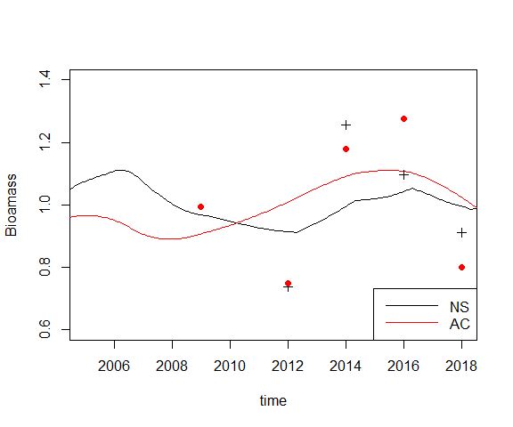

plot(time, bAC[,2] / meanAC,xlim=c(2005,2018),type = "l",ylim =c(0.6,1.4), ylab = "Biomass AC")

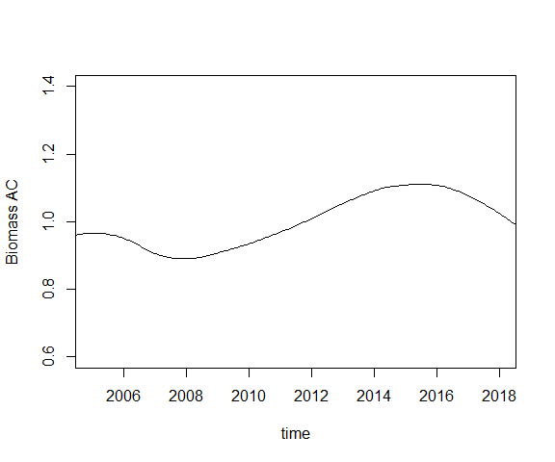

idx2 <- c(which(floor(time) == 2017)[1], which(floor(time) == 2018)[1])  
#time[idx2]  
idx3 <- c(which(floor(time) == 2014)[1], which(floor(time) == 2015)[1], which(floor(time) == 2016)[1])  
#time[idx3]  
ratio2_3AC <- mean(bAC[idx2,2]) / mean(bAC[idx3,2])  
ratio2_3AC

## [1] 0.9528668 (or 0.6471071 Elvar)

## Referneces

Pedersen, Martin W., and Casper W. Berg. 2017. “A stochastic surplus production model in continuous time.” *Fish and Fisheries* 18 (2): 226–43. <https://doi.org/10.1111/faf.12174>.