Alexandros Kokkalis, Elvar H. Hallfredsson and Lise Heggebakken

05/02/2020

## Introduction

This working document present a series of different assessments for greater silver smelt in ICES areas 1,2, 3a and 4, using the surplus production model in continous time (SPiCT; Pedersen and Berg (2017)) available as an R package (<https://github.com/DTUAqua/spict>).

## Data

Input data are total catches since 1988 and biomass indices from tree surveys (depending on scenario); - Acoustic biomass estimates from the Norwegian survey in winter/spring at the eastern slope of the Norwetian Sea. The survey was first concucted in 2009, then 2012, and biennially since then. - Acoustic biomass estimates from surveys at the eastern slope of he Norwegian Sea in 1991-1993 publiched by Monstad and Johannessen (2003) - Swept area biomass estimates from the Norwegian shrimp survey in the North Sea/Skagerrak. The survey was in October 1984-2002, 2004-2005 in May, 2006-2008 in February, and in January sicne then. Time of year apparantly affects the biomass estimates, and the index was thus split in the analysis. Year 2003 and 2016 are missing.

Biomass is in all cases in tonnes.

## Read in the data

library(spict)  
  
## Read in the data  
dat <- readxl::read_xlsx("../data/GSS_indices270120_AK.xlsx")  
#plot(dat$year,dat$catchTOT,type = "l",ylim = c(0,max(na.omit(dat$catchTOT))))  
## Sum up the catches from each area to get the total catch  
dat$catchTOT <- dat$catch1and2 + dat$catch3 + dat$catch4  
#plot(dat$year,dat$catchTOT,type = "l", ylim = c(0,max(na.omit(dat$catchTOT))))  
## run retro or not   
runretro <- FALSE

## Scenario 1

Input data for Scenario 1

|  |  |  |  |
| --- | --- | --- | --- |
| Input data | Name | Range | Notes |
| Catch | Total catch | 1988-2018 |  |
| Biomass indices | Shrimp survey | 1984–2002 2005–2018 | Split in two periods |
|  |  |  | Default priors |

## Choose only the years where the survey was in October   
w <- !is.na(dat$northsea_month) & dat$northsea_month == 10  
## Choose only the years where the survey was in January or February   
v <- !is.na(dat$northsea_month) & dat$northsea_month %in% c(1, 2)  
  
  
## Make the input list  
inp_NS <- list(timeC = dat$year, ## Timing of catch  
 obsC = dat$catchTOT, ## Observed catches  
 timeI = list(dat$year[w] + dat$northsea_month[w] / 12, ## Timing of survey index  
 dat$year[v] + dat$northsea_month[v] / 12),  
 obsI = list(dat$northsea_SA[w], ## Observed indices  
 dat$northsea_SA[v]),  
 optimiser.control = list(iter.max = 1e5, ## Optimiser options   
 eval.max = 1e5), ## sometimes help converge  
 priors = list( ## List of priors (empty, i.e. default priors)  
 ## see possible priors with list.possible.priors()  
 ))  
## Check input time series, remove missing and zero observations  
inp_NS <- check.inp(inp_NS)

## Removing zero, negative, and NAs in C series

## Plot input data  
plotspict.data(inp_NS)

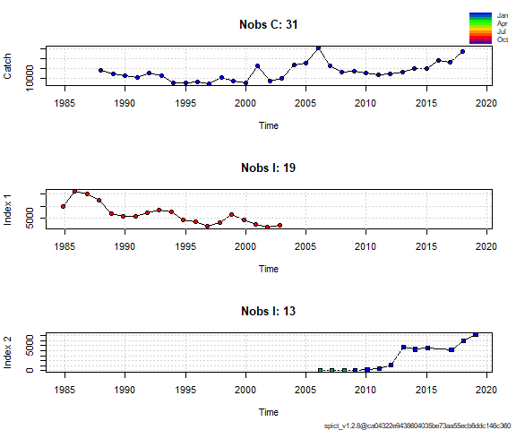

## Fit spict  
fit_NS <- fit.spict(inp_NS)  
  
## Summary of the fit - in the vignette there is a line-by-line description of that summary  
fit_NS

## Convergence: 0 MSG: relative convergence (4)  
## Objective function at optimum: 57.3810526  
## Euler time step (years): 1/16 or 0.0625  
## Nobs C: 31, Nobs I1: 19, Nobs I2: 13  
##   
## Priors  
## logn ~ dnorm[log(2), 2^2]  
## logalpha ~ dnorm[log(1), 2^2]  
## logbeta ~ dnorm[log(1), 2^2]  
##   
## Model parameter estimates w 95% CI   
## estimate cilow ciupp log.est   
## alpha1 2.390221e+00 0.6561160 8.707540e+00 0.8713858   
## alpha2 1.185998e+01 3.5324125 3.981958e+01 2.4731699   
## beta 9.416977e-01 0.3601728 2.462137e+00 -0.0600710   
## r 1.999363e-01 0.0614380 6.506482e-01 -1.6097566   
## rc 6.376559e-01 0.0245182 1.658384e+01 -0.4499565   
## rold 5.361626e-01 0.0090055 3.192149e+01 -0.6233178   
## m 2.551782e+04 1202.3903015 5.415541e+05 10.1471325   
## K 2.797479e+05 4660.6208760 1.679152e+07 12.5416442   
## q1 1.544270e-02 0.0000792 3.010343e+00 -4.1706220   
## q2 4.063500e-03 0.0000136 1.210055e+00 -5.5057111   
## n 6.270977e-01 0.0459170 8.564407e+00 -0.4666529   
## sdb 1.576217e-01 0.0512043 4.852053e-01 -1.8475574   
## sdf 1.625876e-01 0.0768551 3.439552e-01 -1.8165384   
## sdi1 3.767507e-01 0.2468519 5.750051e-01 -0.9761716   
## sdi2 1.869391e+00 1.2648928 2.762781e+00 0.6256125   
## sdc 1.531084e-01 0.0978477 2.395782e-01 -1.8766094   
##   
## Deterministic reference points (Drp)  
## estimate cilow ciupp log.est   
## Bmsyd 8.003635e+04 544.6157898 1.176209e+07 11.290236   
## Fmsyd 3.188279e-01 0.0122591 8.291918e+00 -1.143104   
## MSYd 2.551782e+04 1202.3903015 5.415541e+05 10.147132   
## Stochastic reference points (Srp)  
## estimate cilow ciupp log.est rel.diff.Drp   
## Bmsys 7.831263e+04 552.3440915 1.110335e+07 11.268464 -0.022010800   
## Fmsys 3.210608e-01 0.0122407 8.421108e+00 -1.136125 0.006954625   
## MSYs 2.514696e+04 1185.4484886 5.334435e+05 10.132492 -0.014747787   
##   
## States w 95% CI (inp$msytype: s)  
## estimate cilow ciupp log.est   
## B_2019.08 2.203227e+05 776.4156084 6.252077e+07 12.302849   
## F_2019.08 9.836480e-02 0.0003846 2.515559e+01 -2.319072   
## B_2019.08/Bmsy 2.813374e+00 0.4986872 1.587182e+01 1.034385   
## F_2019.08/Fmsy 3.063744e-01 0.0036177 2.594577e+01 -1.182947   
##   
## Predictions w 95% CI (inp$msytype: s)  
## prediction cilow ciupp log.est   
## B_2019.08 2.203227e+05 7.764156e+02 6.252077e+07 12.302849   
## F_2019.08 9.836480e-02 3.846000e-04 2.515559e+01 -2.319072   
## B_2019.08/Bmsy 2.813374e+00 4.986872e-01 1.587182e+01 1.034385   
## F_2019.08/Fmsy 3.063744e-01 3.617700e-03 2.594577e+01 -1.182947   
## Catch_2019.08 2.110211e+04 1.295520e+04 3.437222e+04 9.957128   
## E(B_inf) 1.727415e+05 NA NA 12.059552

## If the model converged, it reports convergence as 0  
## Continue with plotting and diagnostics only if convergence was reached  
converged <- fit_NS$opt$convergence == 0  
if (converged) {  
 ## Calculate the One Step Ahead (osa) residuals   
 fit_NS <- calc.osa.resid((fit_NS))  
   
 ## Make a plot showing relative F, relative B, Kobe plot catch   
 par(mfrow = c(2,2), ## 2x2 subplots  
 mar = c(4.1, 4.1, 0.5, 0.5)) ## Change default margins for the plots   
 plotspict.catch(fit_NS)  
 plotspict.ffmsy(fit_NS)  
 plotspict.bbmsy(fit_NS)  
 plotspict.fb(fit_NS)  
}

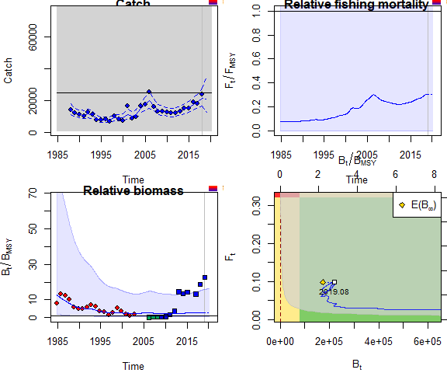

if (converged) {  
 plotspict.diagnostic(fit_NS)  
}

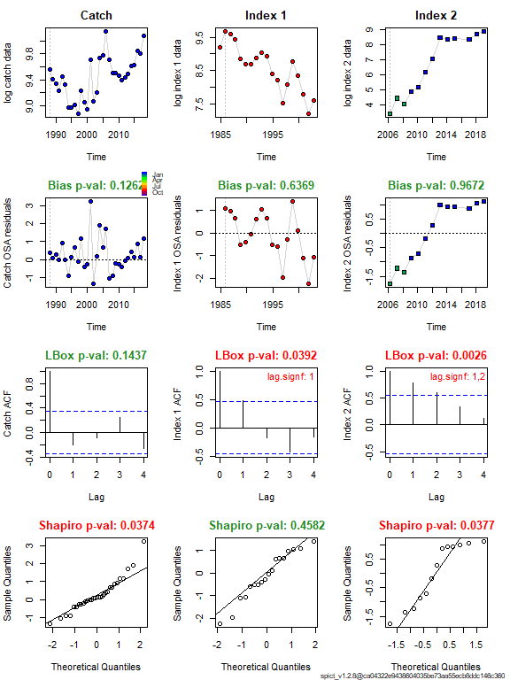

## If runretro is TRUE, run and plot the retrospective analysis  
 if (runretro & converged) {  
 fit_NS <- retro(fit_NS)  
 plotspict.retro(fit_NS)  
 }

## Scenario 2

Input data for Scenario 2

|  |  |  |  |
| --- | --- | --- | --- |
| Input data | Name | Range | Notes |
| Catch | Total catch | 1988-2018 |  |
| Biomass indices | Shrimp survey | 1984–2002 | Only october period |
| Biomass indices | Acoustic survey | 2009–2018 | StoX |
|  |  |  | Priors:logn=c(log(2),.5,1), |
|  |  |  | logbkfrac=c(log(.5),1,1) |

## Choose only the years where the survey was in October   
w <- !is.na(dat$northsea_month) & dat$northsea_month == 10  
## Choose only the years where the survey was in January or February   
##v <- !is.na(dat$northsea_month) & dat$northsea_month %in% c(1, 2)   
  
  
## Make the input list  
inp_NS <- list(timeC = dat$year, ## Timing of catch  
 obsC = dat$catchTOT, ## Observed catches  
 timeI = list(dat$year[w] + dat$northsea_month[w] / 12, ## Timing of survey index  
 dat$year+3.5/12),  
 obsI = list(dat$northsea_SA[w], ## Observed indices  
 dat$norwegian_sea_AC_stox),  
 optimiser.control = list(iter.max = 1e5, ## Optimiser options   
 eval.max = 1e5), ## sometimes help converge  
 priors = list( ## List of priors (empty, i.e. default priors)  
 logn=c(log(2),.5,1),  
 logbkfrac=c(log(.5),1,1)  
## see possible priors with list.possible.priors()  
 ))  
## Check input time series, remove missing and zero observations  
inp_NS <- check.inp(inp_NS)

## Removing zero, negative, and NAs in C series   
## Removing zero, negative, and NAs in I series 2

## Plot input data  
plotspict.data(inp_NS)

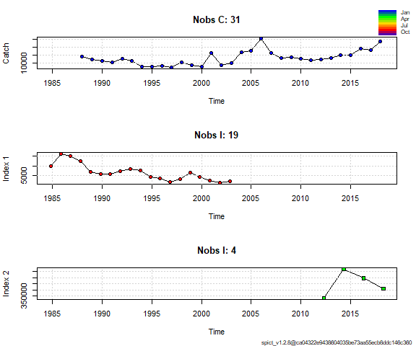

## Fit spict  
fit_NS <- fit.spict(inp_NS)  
  
## Summary of the fit - in the vignette there is a line-by-line description of that summary  
fit_NS

## Convergence: 0 MSG: relative convergence (4)  
## Objective function at optimum: 28.1080245  
## Euler time step (years): 1/16 or 0.0625  
## Nobs C: 31, Nobs I1: 19, Nobs I2: 4  
##   
## Priors  
## logn ~ dnorm[log(2), 0.5^2]  
## logbkfrac ~ dnorm[log(0.5), 1^2]  
## logalpha ~ dnorm[log(1), 2^2]  
## logbeta ~ dnorm[log(1), 2^2]  
##   
## Model parameter estimates w 95% CI   
## estimate cilow ciupp log.est   
## alpha1 2.770922e+00 8.323797e-01 9.224168e+00 1.0191802   
## alpha2 1.278742e+00 2.766823e-01 5.909958e+00 0.2458767   
## beta 1.089340e+00 4.172733e-01 2.843847e+00 0.0855720   
## r 1.985072e-01 4.893050e-02 8.053276e-01 -1.6169298   
## rc 2.671020e-01 4.460290e-02 1.599525e+00 -1.3201245   
## rold 4.081341e-01 1.521120e-02 1.095069e+01 -0.8961595   
## m 1.718695e+04 4.980648e+03 5.930782e+04 9.7519059   
## K 2.907047e+05 3.368074e+04 2.509125e+06 12.5800631   
## q1 1.899280e-02 1.075600e-03 3.353657e-01 -3.9636958   
## q2 2.452999e+00 1.275294e-01 4.718286e+01 0.8973112   
## n 1.486377e+00 6.057030e-01 3.647527e+00 0.3963419   
## sdb 1.456429e-01 5.222060e-02 4.061967e-01 -1.9265977   
## sdf 1.444124e-01 6.575660e-02 3.171538e-01 -1.9350819   
## sdi1 4.035651e-01 2.597342e-01 6.270441e-01 -0.9074175   
## sdi2 1.862396e-01 6.510980e-02 5.327184e-01 -1.6807210   
## sdc 1.573142e-01 1.038452e-01 2.383140e-01 -1.8495099   
##   
## Deterministic reference points (Drp)  
## estimate cilow ciupp log.est   
## Bmsyd 1.286920e+05 1.250275e+04 1.324640e+06 11.765178   
## Fmsyd 1.335510e-01 2.230150e-02 7.997627e-01 -2.013272   
## MSYd 1.718695e+04 4.980648e+03 5.930782e+04 9.751906   
## Stochastic reference points (Srp)  
## estimate cilow ciupp log.est rel.diff.Drp   
## Bmsys 1.230258e+05 1.232297e+04 1.228222e+06 11.720149 -0.04605724   
## Fmsys 1.309850e-01 2.072960e-02 8.276589e-01 -2.032673 -0.01959016   
## MSYs 1.610000e+04 4.684569e+03 5.533269e+04 9.686574 -0.06751300   
##   
## States w 95% CI (inp$msytype: s)  
## estimate cilow ciupp log.est   
## B_2018.27 1.866092e+05 9208.3482185 3.781676e+06 12.1367718   
## F_2018.27 1.106877e-01 0.0055164 2.220957e+00 -2.2010424   
## B_2018.27/Bmsy 1.516829e+00 0.5327076 4.319014e+00 0.4166223   
## F_2018.27/Fmsy 8.450413e-01 0.0977114 7.308206e+00 -0.1683698   
##   
## Predictions w 95% CI (inp$msytype: s)  
## prediction cilow ciupp log.est   
## B_2019.02 1.850808e+05 8.540752e+03 4.010759e+06 12.1285477   
## F_2019.02 1.134601e-01 5.558800e-03 2.315820e+00 -2.1763041   
## B_2019.02/Bmsy 1.504406e+00 4.948592e-01 4.573498e+00 0.4083982   
## F_2019.02/Fmsy 8.662069e-01 9.792560e-02 7.662085e+00 -0.1436315   
## Catch_2019.00 2.064753e+04 1.344021e+04 3.171978e+04 9.9353512   
## E(B_inf) 1.299476e+05 NA NA 11.7748867

## If the model converged, it reports convergence as 0  
## Continue with plotting and diagnostics only if convergence was reached  
converged <- fit_NS$opt$convergence == 0  
if (converged) {  
 ## Calculate the One Step Ahead (osa) residuals   
 fit_NS <- calc.osa.resid((fit_NS))  
   
 ## Make a plot showing relative F, relative B, Kobe plot catch   
 par(mfrow = c(2,2), ## 2x2 subplots  
 mar = c(4.1, 4.1, 0.5, 0.5)) ## Change default margins for the plots   
 plotspict.catch(fit_NS)  
 plotspict.ffmsy(fit_NS)  
 plotspict.bbmsy(fit_NS)  
 plotspict.fb(fit_NS)  
}

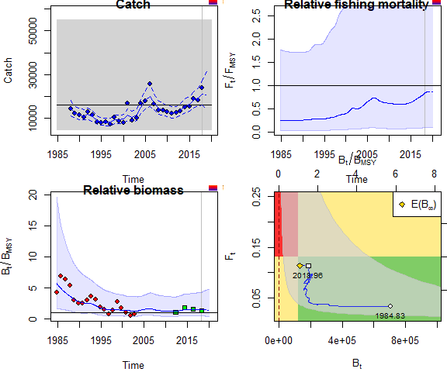

if (converged) {  
 plotspict.diagnostic(fit_NS)  
 plotspict.production(fit_NS)  
}

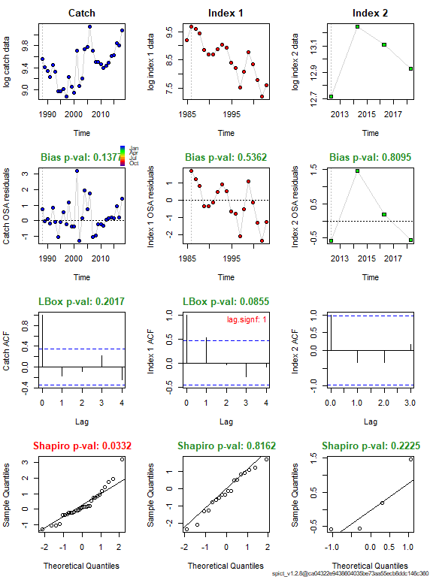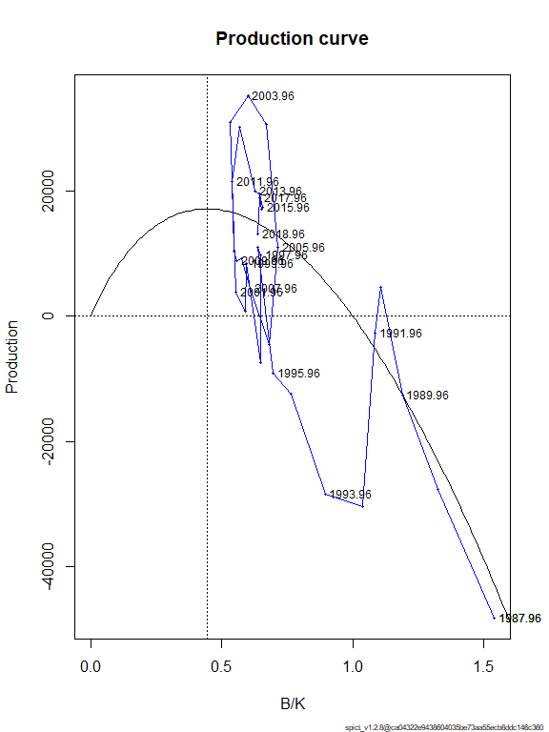

## If runretro is TRUE, run and plot the retrospective analysis  
 if (runretro & converged) {  
 fit_NS <- retro(fit_NS)  
 plotspict.retro(fit_NS)  
 }

## Scenario 3

Input data for Scenario 3

|  |  |  |  |
| --- | --- | --- | --- |
| Input data | Name | Range | Notes |
| Catch | Total catch | 1988-2018 |  |
| Biomass indices | Acoustic survey | 2009–2018 | StoX |
| Biomass indices | Acoustic survey | 1990-1993 | Monstad |
|  |  |  | Default priors |

## Choose only the years where the survey was in October   
w <- !is.na(dat$northsea_month) & dat$northsea_month == 10  
w[1:4]<-FALSE  
## Choose only the years where the survey was in January or February   
##v <- !is.na(dat$northsea_month) & dat$northsea_month %in% c(1, 2)  
  
  
## Make the input list  
inp_NS <- list(timeC = dat$year, ## Timing of catch  
 obsC = dat$catchTOT, ## Observed catches  
 timeI = list(dat$year+3.5/12, dat$year+3/12),  
 obsI = list(dat$norwegian_sea_AC_stox,dat$Norwegian_seaAC_Monstad),  
 optimiser.control = list(iter.max = 1e3, ## Optimiser options   
 eval.max = 1e3), ## sometimes help converge  
 priors = list( ## List of priors (empty, i.e. default priors)  
 logn=c(log(2),.5,1)  
 #logbkfrac=c(log(.5),1,1)  
## see possible priors with list.possible.priors()  
 ))  
## Check input time series, remove missing and zero observations  
inp_NS <- check.inp(inp_NS)

## Removing zero, negative, and NAs in C series   
## Removing zero, negative, and NAs in I series 1   
## Removing zero, negative, and NAs in I series 2

## Plot input data  
plotspict.data(inp_NS)

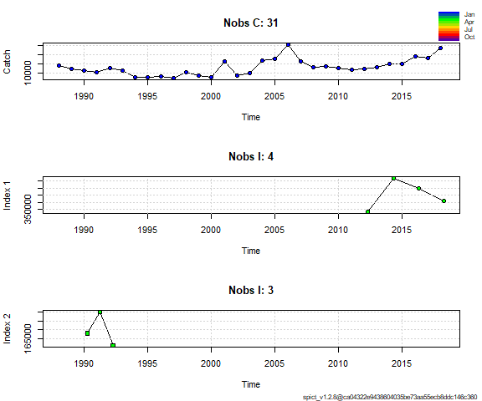

## Fit spict  
fit_AC <- fit.spict(inp_NS)  
  
## Summary of the fit - in the vignette there is a line-by-line description of that summary  
fit_AC

## Convergence: 0 MSG: relative convergence (4)  
## Objective function at optimum: 12.5623155  
## Euler time step (years): 1/16 or 0.0625  
## Nobs C: 31, Nobs I1: 4, Nobs I2: 3  
##   
## Priors  
## logn ~ dnorm[log(2), 0.5^2]  
## logalpha ~ dnorm[log(1), 2^2]  
## logbeta ~ dnorm[log(1), 2^2]  
##   
## Model parameter estimates w 95% CI   
## estimate cilow ciupp log.est   
## alpha1 4.880942e+00 6.704762e-01 3.553235e+01 1.5853383   
## alpha2 1.361347e+00 1.526678e-01 1.213921e+01 0.3084749   
## beta 9.779617e-01 3.893076e-01 2.456692e+00 -0.0222848   
## r 4.295465e-01 1.191276e-01 1.548846e+00 -0.8450252   
## rc 4.557751e-01 1.585245e-01 1.310403e+00 -0.7857557   
## rold 4.854152e-01 9.565420e-02 2.463331e+00 -0.7227508   
## m 1.747139e+04 1.224026e+04 2.493813e+04 9.7683197   
## K 1.569284e+05 4.616570e+04 5.334378e+05 11.9635450   
## q1 5.208347e+00 1.259001e+00 2.154635e+01 1.6502626   
## q2 6.072720e+00 1.662306e+00 2.218481e+01 1.8038066   
## n 1.884905e+00 7.372030e-01 4.819390e+00 0.6338777   
## sdb 3.569060e-02 5.757100e-03 2.212596e-01 -3.3328684   
## sdf 1.653781e-01 8.419010e-02 3.248588e-01 -1.7995211   
## sdi1 1.742037e-01 8.066770e-02 3.761968e-01 -1.7475302   
## sdi2 4.858730e-02 1.526390e-02 1.546610e-01 -3.0243936   
## sdc 1.617334e-01 1.090203e-01 2.399341e-01 -1.8218059   
##   
## Deterministic reference points (Drp)  
## estimate cilow ciupp log.est   
## Bmsyd 7.666669e+04 2.227961e+04 2.638189e+05 11.247223   
## Fmsyd 2.278876e-01 7.926220e-02 6.552016e-01 -1.478903   
## MSYd 1.747139e+04 1.224026e+04 2.493813e+04 9.768320   
## Stochastic reference points (Srp)  
## estimate cilow ciupp log.est rel.diff.Drp   
## Bmsys 7.653202e+04 2.222670e+04 2.635186e+05 11.245464 -0.001759683   
## Fmsys 2.276104e-01 7.914150e-02 6.546063e-01 -1.480120 -0.001217736   
## MSYs 1.741945e+04 1.220335e+04 2.486508e+04 9.765342 -0.002981590   
##   
## States w 95% CI (inp$msytype: s)  
## estimate cilow ciupp log.est   
## B_2018.25 8.473260e+04 1.936805e+04 3.706938e+05 11.3472557   
## F_2018.25 2.434288e-01 5.694970e-02 1.040525e+00 -1.4129307   
## B_2018.25/Bmsy 1.107152e+00 5.706952e-01 2.147883e+00 0.1017913   
## F_2018.25/Fmsy 1.069498e+00 4.407644e-01 2.595094e+00 0.0671891   
##   
## Predictions w 95% CI (inp$msytype: s)  
## prediction cilow ciupp log.est   
## B_2019.00 8.220350e+04 1.764803e+04 3.828992e+05 11.3169532   
## F_2019.00 2.525728e-01 5.729300e-02 1.113453e+00 -1.3760556   
## B_2019.00/Bmsy 1.074106e+00 5.365548e-01 2.150207e+00 0.0714887   
## F_2019.00/Fmsy 1.109672e+00 4.415725e-01 2.788604e+00 0.1040641   
## Catch_2019.00 2.038817e+04 1.421398e+04 2.924426e+04 9.9227099   
## E(B_inf) 6.791407e+04 NA NA 11.1259985

## If the model converged, it reports convergence as 0  
## Continue with plotting and diagnostics only if convergence was reached  
converged <- fit_AC$opt$convergence == 0  
if (converged) {  
 ## Calculate the One Step Ahead (osa) residuals   
 fit_AC <- calc.osa.resid((fit_AC))  
   
 ## Make a plot showing relative F, relative B, Kobe plot catch   
 par(mfrow = c(2,2), ## 2x2 subplots  
 mar = c(4.1, 4.1, 0.5, 0.5)) ## Change default margins for the plots   
 plotspict.catch(fit_AC)  
 plotspict.ffmsy(fit_AC)  
 plotspict.bbmsy(fit_AC)  
 plotspict.fb(fit_AC)  
}

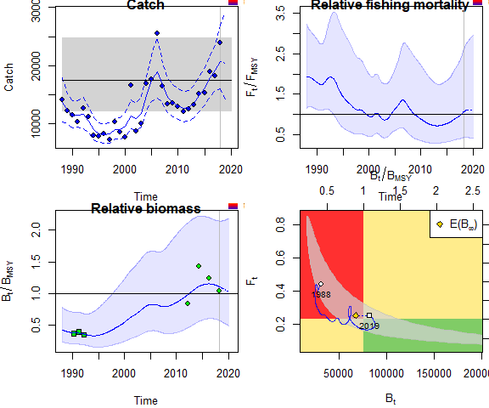

if (converged) {  
 plotspict.diagnostic(fit_AC)  
 plotspict.production(fit_AC)  
}

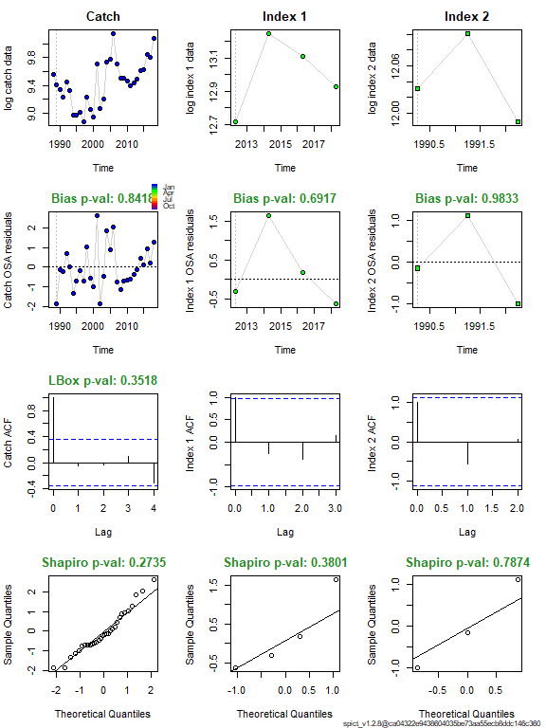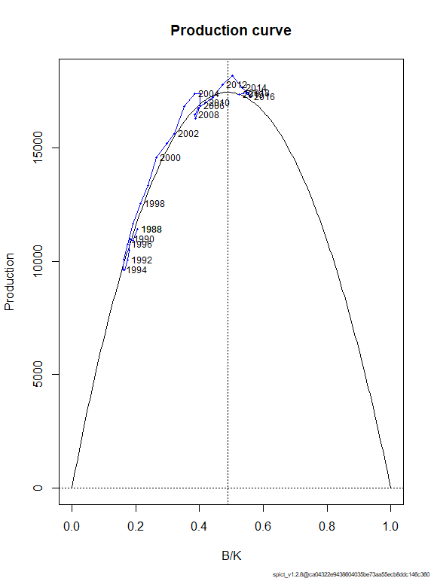

## If runretro is TRUE, run and plot the retrospective analysis  
 ## runretro=TRUE  
if (runretro & converged) {  
 fit_AC <- retro(fit_AC)  
 plotspict.retro(fit_AC)  
 }

##Scenario 4

Input data for Scenario 4

|  |  |  |  |
| --- | --- | --- | --- |
| Input data | Name | Range | Notes |
| Catch | Total catch | 1988-2018 |  |
| Biomass indices | Shrimp survey | 1988–2002 | Only october period |
| Biomass indices | Acoustic survey | 2009–2018 | StoX |
| Biomass indices | Acoustic survey | 1990-1993 | Monstad |
|  |  |  | Default priors |

## Choose only the years where the schrimp survey was in October   
w <- !is.na(dat$northsea_month) & dat$northsea_month == 10  
w[1:4]<-FALSE #remove years before 1988 in schrip survey  
## Choose only the years where the survey was in January or February   
v <- !is.na(dat$northsea_month) & dat$northsea_month %in% c(1)#c(1, 2)  
## Make the input list  
inp_NS <- list(timeC = dat$year, ## Timing of catch  
 obsC = dat$catchTOT, ## Observed catches dat$year[v] + dat$northsea_month[v] / 12  
 timeI = list(dat$year[w] + dat$northsea_month[w] / 12,dat$year+3.5/12, dat$year+3/12),  
 obsI = list(dat$northsea_SA[w],dat$norwegian_sea_AC_stox,dat$Norwegian_seaAC_Monstad),  
 optimiser.control = list(iter.max = 1e3, ## Optimiser options   
 eval.max = 1e3), ## sometimes help converge  
   
 priors = list( ## List of priors (empty, i.e. default priors)  
 logn=c(log(2),.5,1)  
 #logbkfrac=c(log(.5),1,1)  
## see possible priors with list.possible.priors()  
 ))  
## Check input time series, remove missing and zero observations  
inp_NS <- check.inp(inp_NS)

## Removing zero, negative, and NAs in C series   
## Removing zero, negative, and NAs in I series 2   
## Removing zero, negative, and NAs in I series 3

## Plot input data  
plotspict.data(inp_NS)

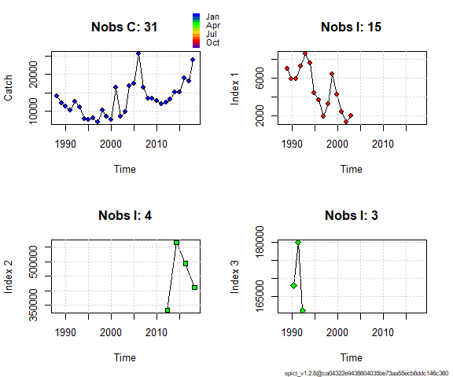

## Fit spict  
fit_NS <- fit.spict(inp_NS)  
  
## Summary of the fit - in the vignette there is a line-by-line description of that summary  
fit_NS

## Convergence: 0 MSG: relative convergence (4)  
## Objective function at optimum: 24.7243902  
## Euler time step (years): 1/16 or 0.0625  
## Nobs C: 31, Nobs I1: 15, Nobs I2: 4, Nobs I3: 3  
##   
## Priors  
## logn ~ dnorm[log(2), 0.5^2]  
## logalpha ~ dnorm[log(1), 2^2]  
## logbeta ~ dnorm[log(1), 2^2]  
##   
## Model parameter estimates w 95% CI   
## estimate cilow ciupp log.est   
## alpha1 3.742685e+00 1.0661283 1.313884e+01 1.3198033   
## alpha2 1.614257e+00 0.3475294 7.498141e+00 0.4788745   
## alpha3 4.688954e-01 0.0442392 4.969868e+00 -0.7573756   
## beta 1.171634e+00 0.4382486 3.132298e+00 0.1583990   
## r 3.233137e-01 0.0388112 2.693336e+00 -1.1291323   
## rc 3.132968e-01 0.0336047 2.920867e+00 -1.1606044   
## rold 3.038819e-01 0.0194018 4.759578e+00 -1.1911161   
## m 2.610602e+04 743.2713545 9.169252e+05 10.1699212   
## K 3.293055e+05 2358.0886384 4.598728e+07 12.7047410   
## q1 1.282910e-02 0.0000504 3.267047e+00 -4.3560400   
## q2 1.658810e+00 0.0049839 5.521055e+02 0.5061006   
## q3 4.114147e-01 0.0015121 1.119417e+02 -0.8881537   
## n 2.063945e+00 0.7012074 6.075049e+00 0.7246193   
## sdb 1.140260e-01 0.0376686 3.451663e-01 -2.1713288   
## sdf 1.403935e-01 0.0630275 3.127261e-01 -1.9633060   
## sdi1 4.267634e-01 0.2673152 6.813195e-01 -0.8515255   
## sdi2 1.840672e-01 0.0740638 4.574532e-01 -1.6924542   
## sdi3 5.346630e-02 0.0075874 3.767633e-01 -2.9287044   
## sdc 1.644898e-01 0.1114263 2.428231e-01 -1.8049070   
##   
## Deterministic reference points (Drp)  
## estimate cilow ciupp log.est   
## Bmsyd 1.666536e+05 1121.1652508 2.477193e+07 12.023673   
## Fmsyd 1.566484e-01 0.0168023 1.460434e+00 -1.853752   
## MSYd 2.610602e+04 743.2713545 9.169252e+05 10.169921   
## Stochastic reference points (Srp)  
## estimate cilow ciupp log.est rel.diff.Drp   
## Bmsys 1.625624e+05 1116.8161967 2.366239e+07 11.998817 -0.02516690   
## Fmsys 1.532150e-01 0.0157316 1.492207e+00 -1.875913 -0.02240894   
## MSYs 2.489296e+04 735.7212644 8.422475e+05 10.122340 -0.04873107   
##   
## States w 95% CI (inp$msytype: s)  
## estimate cilow ciupp log.est   
## B_2018.25 2.739175e+05 766.1777881 9.792871e+07 12.5205823   
## F_2018.25 7.466650e-02 0.0002109 2.643447e+01 -2.5947236   
## B_2018.25/Bmsy 1.684999e+00 0.5864277 4.841554e+00 0.5217649   
## F_2018.25/Fmsy 4.873315e-01 0.0053331 4.453133e+01 -0.7188106   
##   
## Predictions w 95% CI (inp$msytype: s)  
## prediction cilow ciupp log.est   
## B_2019.00 2.722341e+05 7.104022e+02 1.043231e+08 12.5144175   
## F_2019.00 7.673720e-02 2.125000e-04 2.770646e+01 -2.5673689   
## B_2019.00/Bmsy 1.674643e+00 5.451508e-01 5.144320e+00 0.5156002   
## F_2019.00/Fmsy 5.008463e-01 5.357500e-03 4.682168e+01 -0.6914559   
## Catch_2019.00 2.064245e+04 1.373083e+04 3.103315e+04 9.9351051   
## E(B_inf) 2.344834e+05 NA NA 12.3651400

## If the model converged, it reports convergence as 0  
## Continue with plotting and diagnostics only if convergence was reached  
converged <- fit_NS$opt$convergence == 0  
if (converged) {  
 ## Calculate the One Step Ahead (osa) residuals   
 fit_NS <- calc.osa.resid((fit_NS))  
   
 ## Make a plot showing relative F, relative B, Kobe plot catch   
 par(mfrow = c(2,2), ## 2x2 subplots  
 mar = c(4.1, 4.1, 0.5, 0.5)) ## Change default margins for the plots   
 plotspict.catch(fit_NS)  
 plotspict.ffmsy(fit_NS)  
 plotspict.bbmsy(fit_NS)  
 plotspict.fb(fit_NS)  
}

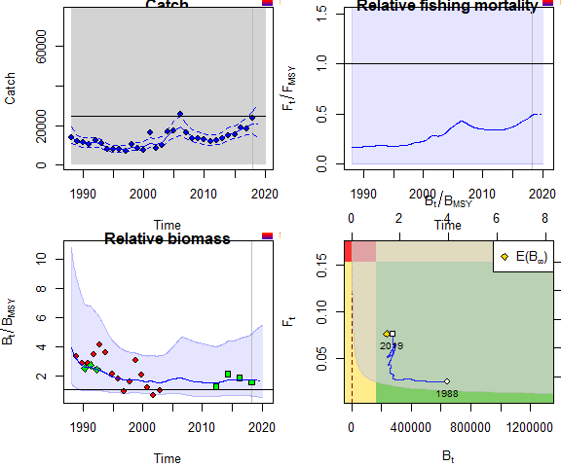

if (converged) {  
 plotspict.diagnostic(fit_NS)  
 plotspict.production(fit_NS)  
}

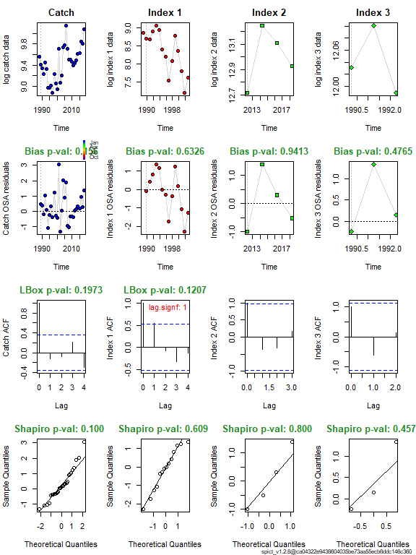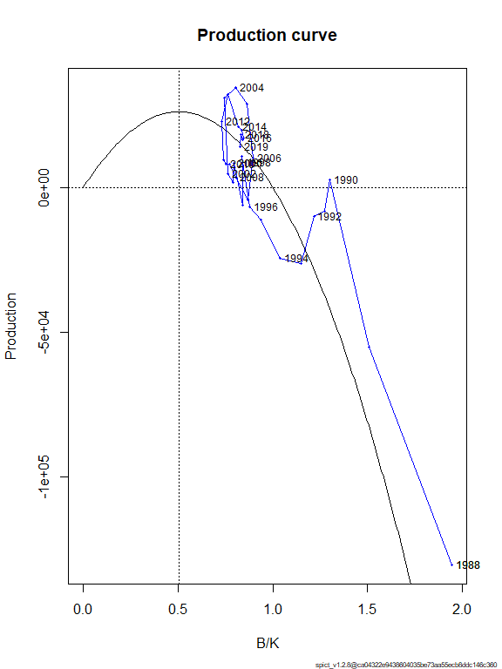

## If runretro is TRUE, run and plot the retrospective analysis  
 #runretro=TRUE  
if (runretro & converged) {  
 fit_NS <- retro(fit_NS)  
 plotspict.retro(fit_NS)  
 }

### Biomass comparison scenario 3 and 4

bAC <- get.par(parname = "logBBmsy",fit_AC, exp = TRUE)  
time <- as.numeric(rownames(bAC))  
bNS <- get.par(parname = "logBBmsy",fit_NS, exp = TRUE)  
BmsyAC<- get.par(parname = "Bmsy",fit_AC)  
  
  
meanAC <- mean(bAC[,2][time > 2005 & time < 2019])  
meanNS <- mean(bNS[,2][time > 2005 & time < 2019])  
AC_StoX<-data.frame(na.omit(cbind(dat$year,dat$norwegian_sea_AC_stox / mean(dat$norwegian_sea_AC_stox ,na.rm = TRUE))))  
ylim <- c(0.6, 1.4)  
par(mfrow =c(1,1))  
plot(time, bNS[,2] / meanNS,type="l", ylim = ylim, xlim=c(2005,2018),ylab = "Bioamass", xlab = "Year")  
lines(time, bAC[,2] / meanAC,col="red")  
#points(dat$year, dat$norwegian_sea_AC_stox / mean(dat$norwegian_sea_AC_stox, na.rm = TRUE, col="blue"),pch =3 )  
lines(AC_StoX, type = "b", col="red",pch=16,lty=2)  
legend("bottomright",c("AC+SA_Oct", "AC","AC-StoX"), col = c(1,2,2), seg.len = 4, lty = c(1,1,2),pch = c(NA,NA,16),box.lty=0)

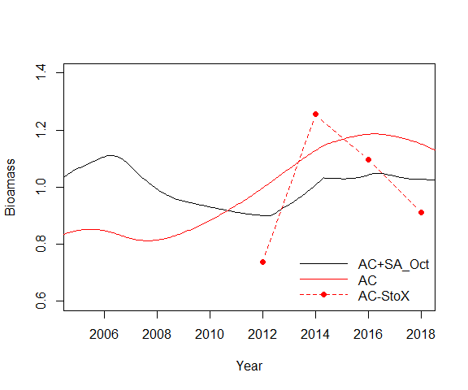

Figure XXXX. SPiCT biomass estimates from scenario 3 and 4. AC = SPiCT run with only acoustic indices, AC+SA_Oct = SPiCT run with acoustic incieces and swept area index from North Sea/Skagerrak survy in years when it was conducted in October, AC-StoX = acoustic biomass indx from the Norwegian Sea slope survey.

#plot(time, bAC[,2] / meanAC,xlim=c(2005,2018),type = "l",ylim =c(0.6,1.4), ylab = "Biomass AC")  
  
idx2 <- c(which(floor(time) == 2017)[1], which(floor(time) == 2018)[1])  
#time[idx2]  
idx3 <- c(which(floor(time) == 2014)[1], which(floor(time) == 2015)[1], which(floor(time) == 2016)[1])  
#time[idx3]  
ratio2_3AC <- mean(bAC[idx2,2]) / mean(bAC[idx3,2])  
ratio2_3AC

## [1] 1.003642

ratio2_3ACexp <- mean(BmsyAC[2]*exp(bAC[idx2,2])) / mean(BmsyAC[2]*exp(bAC[idx3,2]))  
ratio2_3ACexp

## [1] 1.003919

## Discussion

## Referneces

Monstad, T., & Johannessen, A. (2003). Acoustic recordings of greater silver smelt (*Argentina silus*) in Norwegian waters and west of the British Isles, 1989-94. J. Northw. Atl. Fish. Sci., 31, 339-351.

Pedersen, Martin W., and Casper W. Berg. 2017. “A stochastic surplus production model in continuous time.” *Fish and Fisheries* 18 (2): 226–43. <https://doi.org/10.1111/faf.12174>.