**SPiCT scenarios for the Greater silver smelt (*Argentina silus*) in 5b and 6a.**

authors: Martin Pastoors, Lise Helen Ofstad, Frodi Skuvedal

date: 06/02/2020 18:06

**Introduction**

This working document present a series of different assessments using the surplus production model in continous time (SPiCT; Pedersen2016) available as an R package (<https://github.com/DTUAqua/spict>).

**Descriptions of scenarios**

Scenarios with long catch time series

* Scenario 1: long time-series of catch (1988-2018), including the Faroe DW survey (2014-2018), Faroe Summer survey (1996-2018), Scottish DW survey (1998-2018) and CPUE Faroer fleet (1995-2018). Priors: default
* Scenario 2: long time-series of catch (1988-2018), including the Faroe DW survey (2014-2018), and CPUE Faroer fleet (1995-2018). Priors: default

Scenarios with shorter catch time series

* Scenario 3: shorter time-series of catch (1995-2018), including the Faroe DW survey (2014-2018), Faroe Summer survey (1996-2018) and CPUE Faroer fleet (1995-2018). Priors: default
* Scenario 4: shorter time-series of catch (1995-2018), including the Faroe DW survey (2014-2018) and CPUE Faroer fleet (1995-2018). Priors: default

Scenarios similar to the SAM assessment

* Scenario 5: shorter time-series of catch (1995-2018), including the Faroe DW survey (2014-2018), Faroe Summer survey (1996-2018) and CPUE combined fleet (2005-2018). Priors: default
* Scenario 6: shorter time-series of catch (1995-2018), including the Faroe DW survey (2014-2018), Faroe Summer survey, Scottish DW survey and CPUE Faroer fleet (1995-2018). Priors: default. This run uses the same data as the SAM assessment.

**Main results**

Results for each of the scenarios are presented in four pages: input data, estimated model parameters, stock summaries and model diagnostics. Overall results are compared in trends of (log) B over average biomass and F over average fishing mortality.

The Spict fits appear to be very sensitive to the length of the catch time series and to the data series used. Scenarios 1 and 2 (using the long catch time series) have the drawbacks that the initial catches are not accompanied by survey or CPUE observations. That gives rise to very low estimates of biomass at the beginning of the time series.

Scenarios 3 and 4 are based on a shorter catch time series (starting in 1995) and using the Faroer CPUE series in combination with the Faroerse surveys. They generally give a somewhat similar biomass trajectory as the SAM assessment.

Scenarios 5 and 6 are closest to the SAM assessment because using the combined CPUE information (2005 onwards) rather than the longer CPUE series from the Faroes. In these runs only the Faroese summer survey has information that goes back to the beginning of the catch time series. This results in a more smooth pattern in both biomass and fishing mortality.

The comparison between the spict scenarios and the SAM assessment is shown in the final plot. Biomass seems to be somewhat comparable between spict scenarios 3-64 and the SAM assessment. The fishing mortality estimated by SAM is generally much more variable than the Spict runs.

The Spict runs are rather sensitive to the length of the time series and the type of biomass information used. The Spict runs are only used in a qualitative way and do not really contradict the results from the SAM assessment.

##### page break

**Scenario 1**

* Total catch, long time-series (1988-2018)
* Faroe DW survey (2014-2018)
* Faroe Summer survey (1996-2018)
* Scottish DW survey (1998-2018); some missing years
* CPUE Faroer fleet (1995-2018)
* priors: default

## Removing zero, negative, and NAs in I series 1   
## Removing zero, negative, and NAs in I series 2   
## Removing zero, negative, and NAs in I series 3   
## Removing zero, negative, and NAs in I series 4

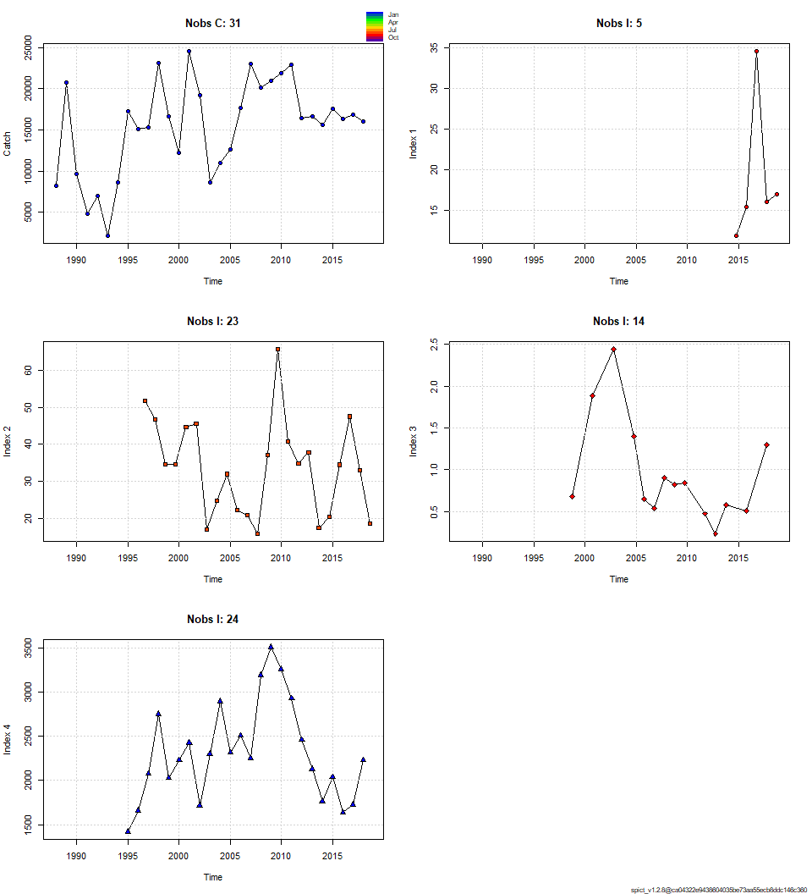

##### page break

## Convergence: 0 MSG: relative convergence (4)  
## Objective function at optimum: 52.6658457  
## Euler time step (years): 1/16 or 0.0625  
## Nobs C: 31, Nobs I1: 5, Nobs I2: 23, Nobs I3: 14, Nobs I4: 24  
##   
## Priors  
## logn ~ dnorm[log(2), 2^2]  
## logalpha ~ dnorm[log(1), 2^2]  
## logbeta ~ dnorm[log(1), 2^2]  
##   
## Model parameter estimates w 95% CI   
## estimate cilow ciupp log.est   
## alpha1 1.629468e+00 2.785253e-01 9.532944e+00 0.4882535   
## alpha2 1.763759e+00 3.325269e-01 9.355171e+00 0.5674473   
## alpha3 2.738216e+00 5.253986e-01 1.427074e+01 1.0073065   
## alpha4 3.552878e-01 3.314290e-02 3.808640e+00 -1.0348271   
## beta 1.960060e+00 7.246711e-01 5.301490e+00 0.6729753   
## r 3.968142e+01 9.778811e+00 1.610232e+02 3.6808831   
## rc 4.322401e+01 1.381399e+01 1.352481e+02 3.7663962   
## rold 4.746115e+01 1.670399e+01 1.348517e+02 3.8599114   
## m 1.795494e+04 1.529950e+04 2.107127e+04 9.7956205   
## K 1.718376e+03 5.165781e+02 5.716108e+03 7.4491350   
## q1 3.121860e-02 8.462300e-03 1.151703e-01 -3.4667412   
## q2 4.672810e-02 1.291740e-02 1.690374e-01 -3.0634089   
## q3 1.149200e-03 3.096000e-04 4.265100e-03 -6.7686830   
## q4 3.431215e+00 9.616465e-01 1.224279e+01 1.2329143   
## n 1.836082e+00 1.147930e+00 2.936763e+00 0.6076341   
## sdb 2.148425e-01 4.302470e-02 1.072810e+00 -1.5378500   
## sdf 1.310528e-01 5.008270e-02 3.429296e-01 -2.0321548   
## sdi1 3.500790e-01 1.765426e-01 6.941968e-01 -1.0495964   
## sdi2 3.789304e-01 2.737039e-01 5.246117e-01 -0.9704027   
## sdi3 5.882851e-01 4.018655e-01 8.611822e-01 -0.5305435   
## sdi4 7.633090e-02 1.364830e-02 4.268965e-01 -2.5726770   
## sdc 2.568714e-01 1.923313e-01 3.430693e-01 -1.3591795   
##   
## Deterministic reference points (Drp)  
## estimate cilow ciupp log.est   
## Bmsyd 830.78534 272.504587 2532.81709 6.722371   
## Fmsyd 21.61201 6.906994 67.62404 3.073249   
## MSYd 17954.93834 15299.495917 21071.27008 9.795621   
## Stochastic reference points (Srp)  
## estimate cilow ciupp log.est rel.diff.Drp   
## Bmsys 830.78890 272.498532 2532.89507 6.722376 4.282703e-06   
## Fmsys 21.61407 6.909242 67.61497 3.073345 9.567944e-05   
## MSYs 17956.73336 15301.984835 21072.05544 9.795720 9.996364e-05   
##   
## States w 95% CI (inp$msytype: s)  
## estimate cilow ciupp log.est   
## B_2018.75 562.0562299 151.0183748 2091.846148 6.3316019   
## F_2018.75 28.7793724 8.4038317 98.556505 3.3596589   
## B_2018.75/Bmsy 0.6765332 0.3808315 1.201836 -0.3907738   
## F_2018.75/Fmsy 1.3315107 0.9698086 1.828114 0.2863142   
##   
## Predictions w 95% CI (inp$msytype: s)  
## prediction cilow ciupp log.est   
## B_2019.00 5.625766e+02 1.470708e+02 2151.972463 6.3325273   
## F_2019.00 2.877888e+01 8.345938e+00 99.236801 3.3596419   
## B_2019.00/Bmsy 6.771595e-01 3.624101e-01 1.265265 -0.3898485   
## F_2019.00/Fmsy 1.331488e+00 9.456750e-01 1.874704 0.2862972   
## Catch_2019.00 1.619038e+04 1.246776e+04 21024.503236 9.6921725   
## E(B_inf) 5.619819e+02 NA NA 6.3314697

##### page break

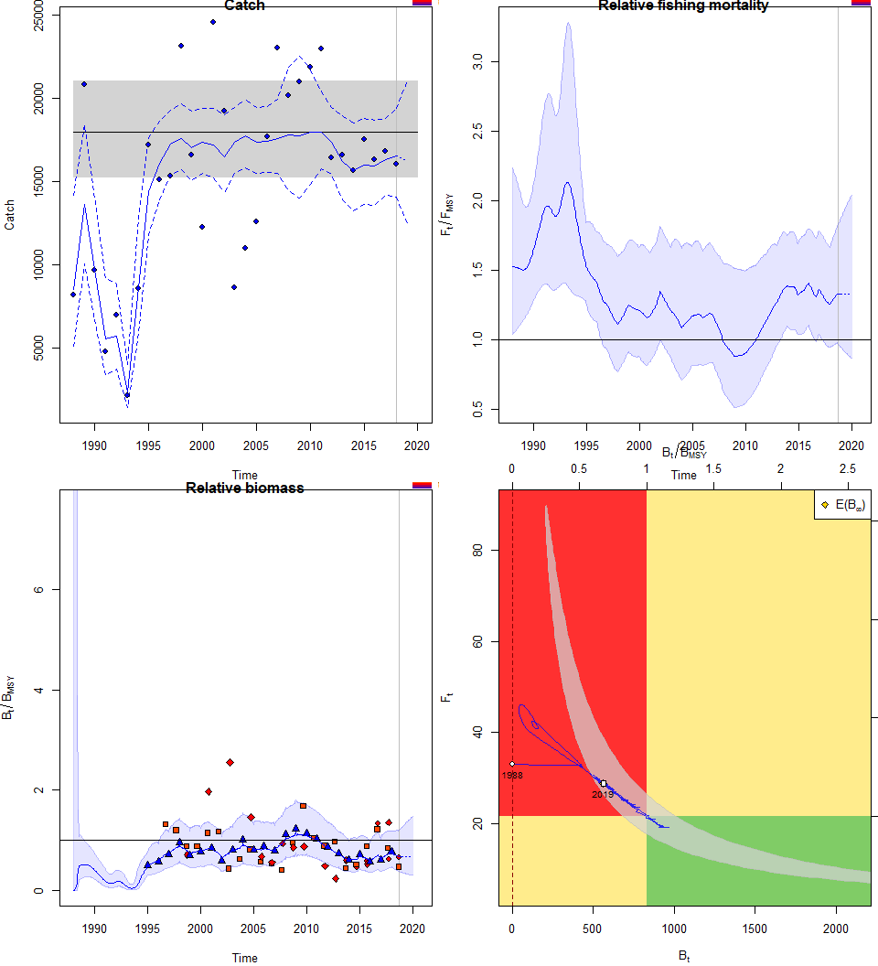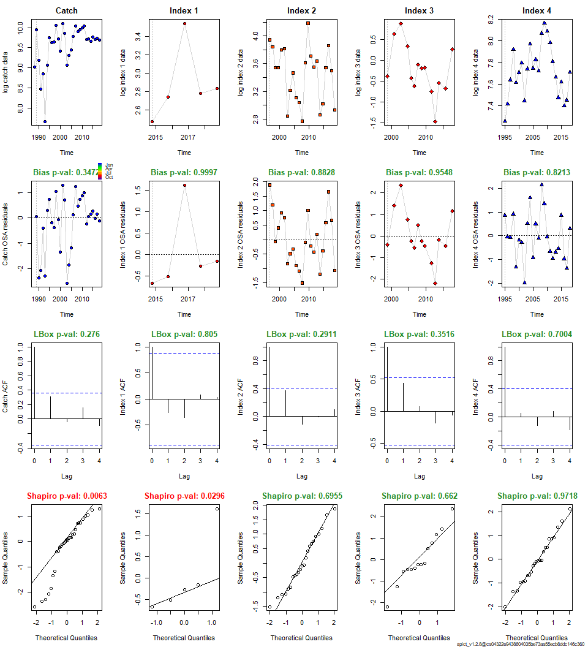

##### page break

**Scenario 2**

* Total catch, long time-series (1988-2018)
* Faroe DW survey (2014-2018)
* CPUE Faroer fleet (1995-2018)
* priors: default

## Removing zero, negative, and NAs in I series 1   
## Removing zero, negative, and NAs in I series 2

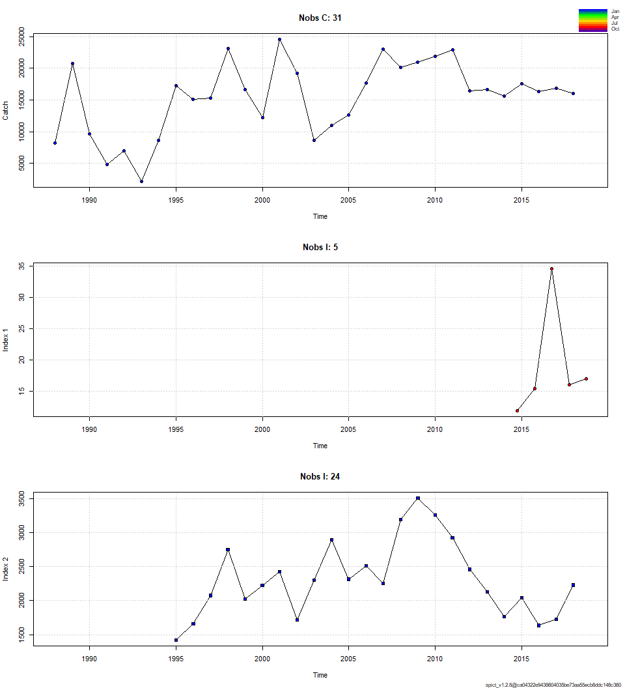

##### page break

## Convergence: 0 MSG: relative convergence (4)  
## Objective function at optimum: 24.6665593  
## Euler time step (years): 1/16 or 0.0625  
## Nobs C: 31, Nobs I1: 5, Nobs I2: 24  
##   
## Priors  
## logn ~ dnorm[log(2), 2^2]  
## logalpha ~ dnorm[log(1), 2^2]  
## logbeta ~ dnorm[log(1), 2^2]  
##   
## Model parameter estimates w 95% CI   
## estimate cilow ciupp log.est   
## alpha1 3.136091e+00 1.758481e-01 5.592933e+01 1.1429772   
## alpha2 5.036632e-01 2.224050e-02 1.140607e+01 -0.6858475   
## beta 1.828169e+00 5.890663e-01 5.673729e+00 0.6033149   
## r 3.810967e+01 8.323340e+00 1.744909e+02 3.6404680   
## rc 4.327283e+01 1.289582e+01 1.452050e+02 3.7675250   
## rold 5.005427e+01 1.704869e+01 1.469574e+02 3.9131079   
## m 1.799013e+04 1.548439e+04 2.090136e+04 9.7975785   
## K 1.748859e+03 4.781004e+02 6.397209e+03 7.4667189   
## q1 3.165830e-02 8.152400e-03 1.229393e-01 -3.4527536   
## q2 3.445013e+00 9.213124e-01 1.288175e+01 1.2369278   
## n 1.761367e+00 1.051177e+00 2.951370e+00 0.5660901   
## sdb 1.203171e-01 7.404100e-03 1.955163e+00 -2.1176243   
## sdf 1.415032e-01 4.717550e-02 4.244398e-01 -1.9554328   
## sdi1 3.773255e-01 1.931740e-01 7.370273e-01 -0.9746471   
## sdi2 6.059930e-02 2.097600e-03 1.750742e+00 -2.8034718   
## sdc 2.586918e-01 1.939182e-01 3.451015e-01 -1.3521179   
##   
## Deterministic reference points (Drp)  
## estimate cilow ciupp log.est   
## Bmsyd 831.47457 253.351378 2728.8186 6.723201   
## Fmsyd 21.63642 6.447911 72.6025 3.074378   
## MSYd 17990.12953 15484.386513 20901.3615 9.797579   
## Stochastic reference points (Srp)  
## estimate cilow ciupp log.est rel.diff.Drp   
## Bmsys 831.47685 253.34905 2728.85867 6.723204 2.744333e-06   
## Fmsys 21.63701 6.44839 72.60108 3.074405 2.726332e-05   
## MSYs 17990.66937 15485.11043 20901.63876 9.797609 3.000642e-05   
##   
## States w 95% CI (inp$msytype: s)  
## estimate cilow ciupp log.est   
## B_2018.75 605.6787914 148.0253202 2478.270595 6.4063498   
## F_2018.75 27.7051791 7.3462162 104.486029 3.3216194   
## B_2018.75/Bmsy 0.7284373 0.4189423 1.266573 -0.3168537   
## F_2018.75/Fmsy 1.2804535 0.9100006 1.801714 0.2472143   
##   
## Predictions w 95% CI (inp$msytype: s)  
## prediction cilow ciupp log.est   
## B_2019.00 6.062850e+02 1.456792e+02 2523.226388 6.4073502   
## F_2019.00 2.770359e+01 7.289531e+00 105.286492 3.3215622   
## B_2019.00/Bmsy 7.291665e-01 4.002143e-01 1.328498 -0.3158532   
## F_2019.00/Fmsy 1.280380e+00 8.853464e-01 1.851675 0.2471571   
## Catch_2019.00 1.679613e+04 1.342857e+04 21008.202980 9.7289040   
## E(B_inf) 6.061101e+02 NA NA 6.4070617

##### page break

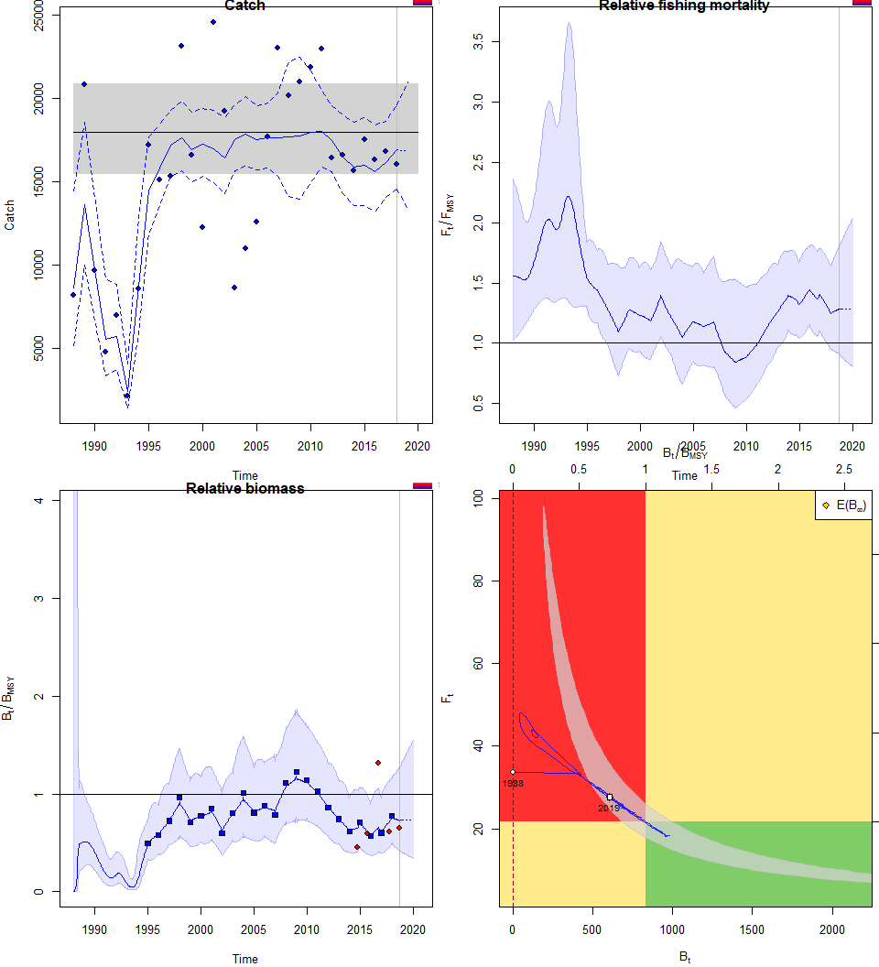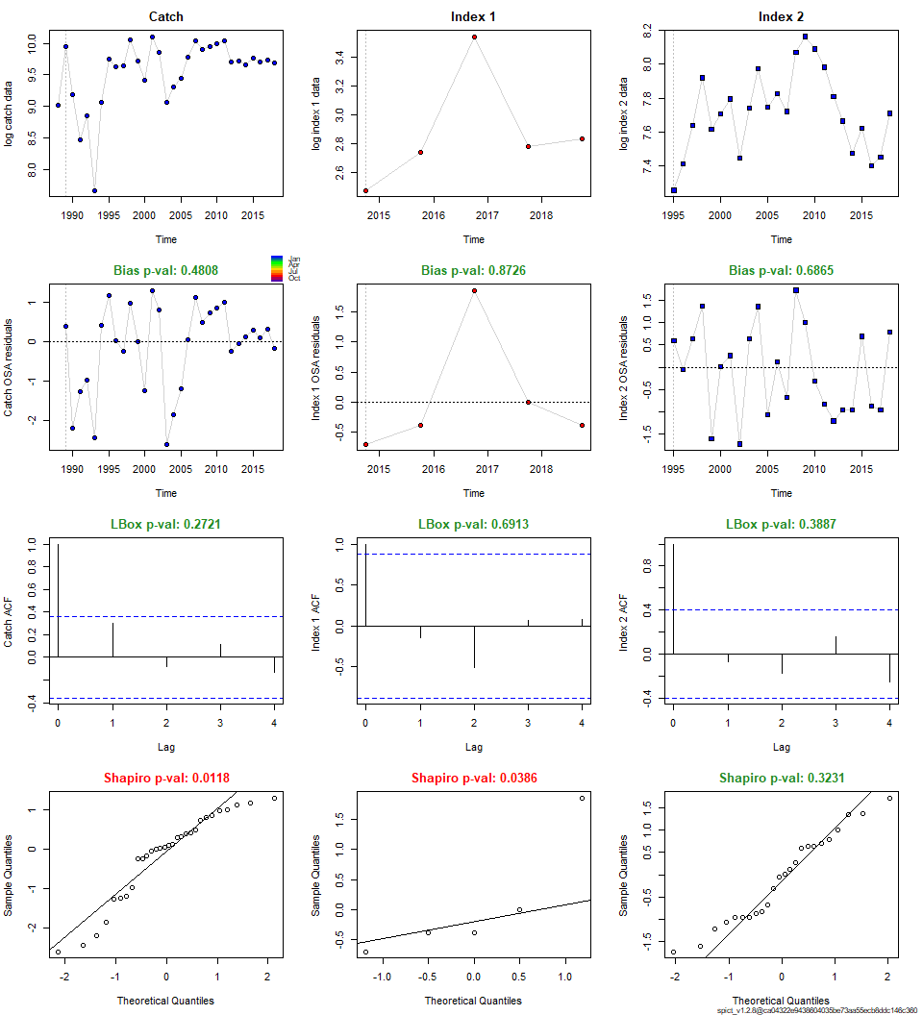

##### page break

**Scenario 3**

* Total catch, shorter time-series (1995-2018)
* Faroe DW survey (2014-2018)
* Faroe Summer survey (1996-2018)
* CPUE Faroer fleet (1995-2018)
* priors: default

## Removing zero, negative, and NAs in I series 1   
## Removing zero, negative, and NAs in I series 2

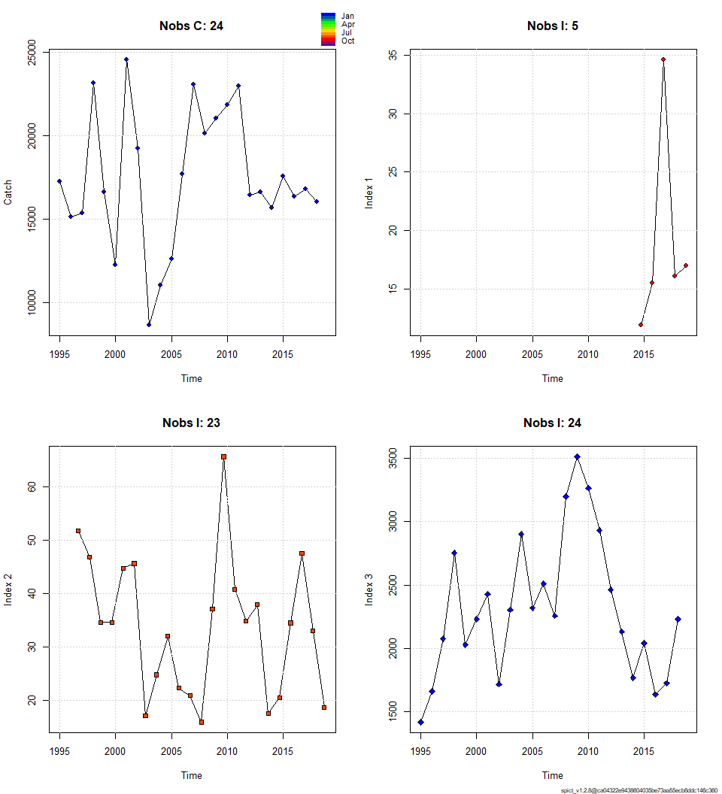

##### page break

## Convergence: 0 MSG: relative convergence (4)  
## Objective function at optimum: 27.2052913  
## Euler time step (years): 1/16 or 0.0625  
## Nobs C: 24, Nobs I1: 5, Nobs I2: 23, Nobs I3: 24  
##   
## Priors  
## logn ~ dnorm[log(2), 2^2]  
## logalpha ~ dnorm[log(1), 2^2]  
## logbeta ~ dnorm[log(1), 2^2]  
##   
## Model parameter estimates w 95% CI   
## estimate cilow ciupp log.est   
## alpha1 2.584176e+00 9.625893e-01 6.937506e+00 0.9494069   
## alpha2 2.877510e+00 1.226169e+00 6.752794e+00 1.0569254   
## alpha3 9.250290e-01 3.375593e-01 2.534899e+00 -0.0779302   
## beta 2.320833e+00 6.227148e-01 8.649653e+00 0.8419262   
## r 4.248426e-01 3.148660e-02 5.732320e+00 -0.8560365   
## rc 1.521300e+00 3.799989e-01 6.090422e+00 0.4195652   
## rold 9.623271e-01 3.603800e-03 2.569725e+02 -0.0384008   
## m 1.749688e+04 1.488849e+04 2.056224e+04 9.7697778   
## K 8.605135e+04 1.471882e+04 5.030861e+05 11.3626995   
## q1 8.401000e-04 1.725000e-04 4.091100e-03 -7.0819314   
## q2 1.265300e-03 2.731000e-04 5.861200e-03 -6.6724539   
## q3 9.241870e-02 2.010460e-02 4.248381e-01 -2.3814265   
## n 5.585258e-01 4.457710e-02 6.998016e+00 -0.5824545   
## sdb 1.349748e-01 6.323320e-02 2.881111e-01 -2.0026671   
## sdf 9.480270e-02 2.836330e-02 3.168727e-01 -2.3559577   
## sdi1 3.487987e-01 1.857140e-01 6.550964e-01 -1.0532602   
## sdi2 3.883914e-01 2.847293e-01 5.297939e-01 -0.9457417   
## sdi3 1.248556e-01 7.430640e-02 2.097926e-01 -2.0805973   
## sdc 2.200212e-01 1.554110e-01 3.114924e-01 -1.5140314   
##   
## Deterministic reference points (Drp)  
## estimate cilow ciupp log.est   
## Bmsyd 23002.53588 5.917208e+03 89419.987942 10.043360   
## Fmsyd 0.76065 1.899995e-01 3.045211 -0.273582   
## MSYd 17496.87863 1.488849e+04 20562.240102 9.769778   
## Stochastic reference points (Srp)  
## estimate cilow ciupp log.est rel.diff.Drp   
## Bmsys 2.284049e+04 5.913763e+03 88215.944675 10.0362903 -0.007094495   
## Fmsys 7.619033e-01 1.911406e-01 3.037014 -0.2719356 0.001644976   
## MSYs 1.740245e+04 1.484114e+04 20405.799162 9.7643663 -0.005426127   
##   
## States w 95% CI (inp$msytype: s)  
## estimate cilow ciupp log.est   
## B_2018.75 2.137316e+04 4357.5969872 1.048312e+05 9.9698914   
## F_2018.75 7.895716e-01 0.1680962 3.708730e+00 -0.2362648   
## B_2018.75/Bmsy 9.357575e-01 0.1502881 5.826422e+00 -0.0663989   
## F_2018.75/Fmsy 1.036315e+00 0.1597862 6.721159e+00 0.0356709   
##   
## Predictions w 95% CI (inp$msytype: s)  
## prediction cilow ciupp log.est   
## B_2019.00 2.145688e+04 4.323464e+03 1.064882e+05 9.9738007   
## F_2019.00 7.893627e-01 1.675548e-01 3.718743e+00 -0.2365294   
## B_2019.00/Bmsy 9.394229e-01 1.486802e-01 5.935660e+00 -0.0624896   
## F_2019.00/Fmsy 1.036040e+00 1.593108e-01 6.737646e+00 0.0354062   
## Catch_2019.00 1.703921e+04 1.317226e+04 2.204137e+04 9.7432723   
## E(B_inf) 2.204868e+04 NA NA 10.0010081

##### page break

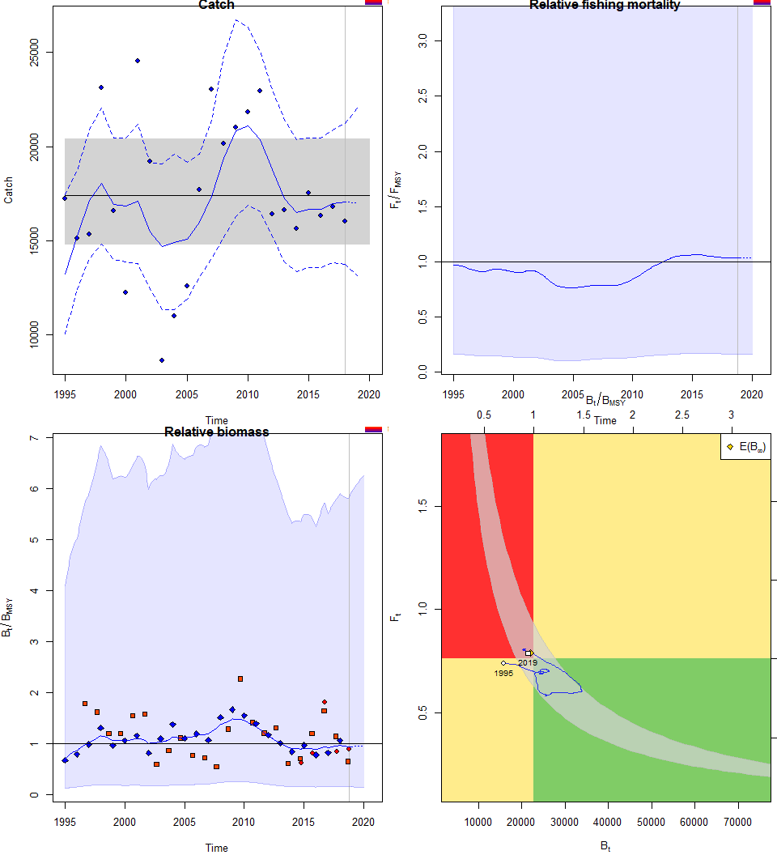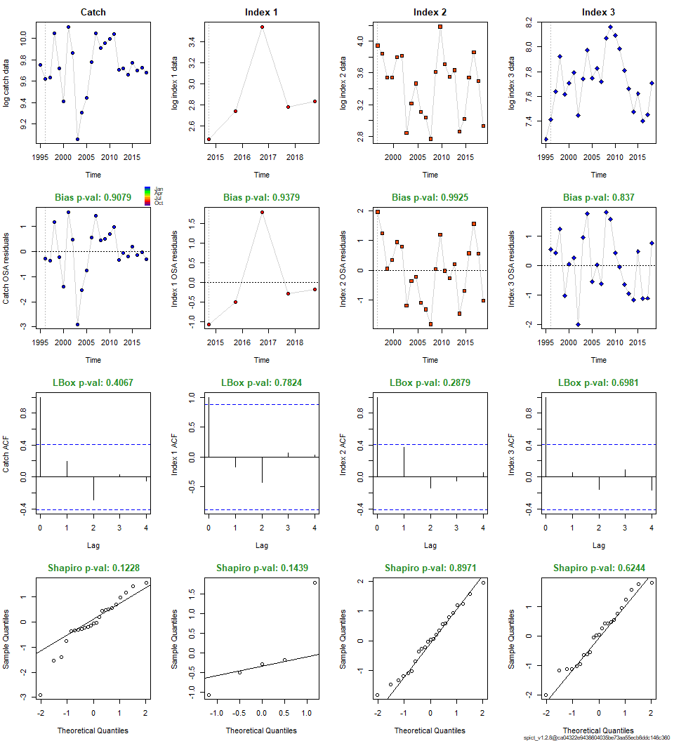

##### page break

**Scenario 4**

* Total catch, shorter time-series (1995-2018)
* Faroe DW survey (2014-2018)
* CPUE Faroer fleet (1995-2018)
* priors: default

## Removing zero, negative, and NAs in I series 1

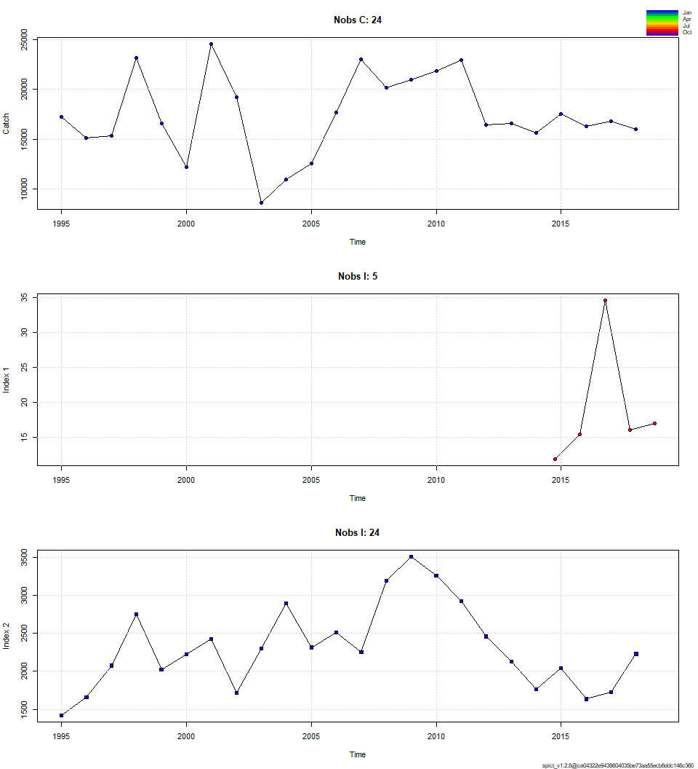

##### page break

## Convergence: 0 MSG: both X-convergence and relative convergence (5)  
## Objective function at optimum: 13.5172765  
## Euler time step (years): 1/16 or 0.0625  
## Nobs C: 24, Nobs I1: 5, Nobs I2: 24  
##   
## Priors  
## logn ~ dnorm[log(2), 2^2]  
## logalpha ~ dnorm[log(1), 2^2]  
## logbeta ~ dnorm[log(1), 2^2]  
##   
## Model parameter estimates w 95% CI   
## estimate cilow ciupp log.est   
## alpha1 3.182915e+00 1.069106e+00 9.476096e+00 1.1577974   
## alpha2 1.125620e+00 3.410545e-01 3.715006e+00 0.1183336   
## beta 1.863290e+00 5.693829e-01 6.097563e+00 0.6223435   
## r 3.727581e-01 2.714940e-02 5.117926e+00 -0.9868257   
## rc 1.409889e+00 3.640306e-01 5.460494e+00 0.3435110   
## rold 7.910430e-01 4.235400e-03 1.477443e+02 -0.2344030   
## m 1.751704e+04 1.531239e+04 2.003912e+04 9.7709296   
## K 9.606382e+04 1.573433e+04 5.865046e+05 11.4727680   
## q1 8.018000e-04 2.062000e-04 3.117900e-03 -7.1286021   
## q2 8.751830e-02 2.398040e-02 3.194052e-01 -2.4359074   
## n 5.287765e-01 4.353870e-02 6.421980e+00 -0.6371895   
## sdb 1.131125e-01 4.457730e-02 2.870171e-01 -2.1793720   
## sdf 1.149949e-01 4.083880e-02 3.238051e-01 -2.1628675   
## sdi1 3.600276e-01 1.932855e-01 6.706134e-01 -1.0215746   
## sdi2 1.273217e-01 7.836320e-02 2.068678e-01 -2.0610384   
## sdc 2.142688e-01 1.487506e-01 3.086449e-01 -1.5405240   
##   
## Deterministic reference points (Drp)  
## estimate cilow ciupp log.est   
## Bmsyd 2.484883e+04 6.503441e+03 94944.239759 10.1205659   
## Fmsyd 7.049445e-01 1.820153e-01 2.730247 -0.3496362   
## MSYd 1.751704e+04 1.531239e+04 20039.120945 9.7709296   
## Stochastic reference points (Srp)  
## estimate cilow ciupp log.est rel.diff.Drp   
## Bmsys 2.471937e+04 6.492407e+03 94117.198681 10.1153424 -0.005237157   
## Fmsys 7.060052e-01 1.827668e-01 2.727209 -0.3481327 0.001502407   
## MSYs 1.745214e+04 1.528850e+04 19921.971208 9.7672175 -0.003719054   
##   
## States w 95% CI (inp$msytype: s)  
## estimate cilow ciupp log.est   
## B_2018.75 2.309332e+04 5987.8715029 89063.569377 10.0472985   
## F_2018.75 7.365748e-01 0.1943410 2.791703 -0.3057445   
## B_2018.75/Bmsy 9.342195e-01 0.1893668 4.608864 -0.0680439   
## F_2018.75/Fmsy 1.043299e+00 0.2072877 5.251028 0.0423882   
##   
## Predictions w 95% CI (inp$msytype: s)  
## prediction cilow ciupp log.est   
## B_2019.00 2.316462e+04 5.949525e+03 90191.998876 10.0503813   
## F_2019.00 7.362793e-01 1.932943e-01 2.804569 -0.3061457   
## B_2019.00/Bmsy 9.371040e-01 1.881315e-01 4.667819 -0.0649610   
## F_2019.00/Fmsy 1.042881e+00 2.062701e-01 5.272702 0.0419871   
## Catch_2019.00 1.713790e+04 1.334662e+04 22006.127568 9.7490475   
## E(B_inf) 2.370413e+04 NA NA 10.0734047

##### page break

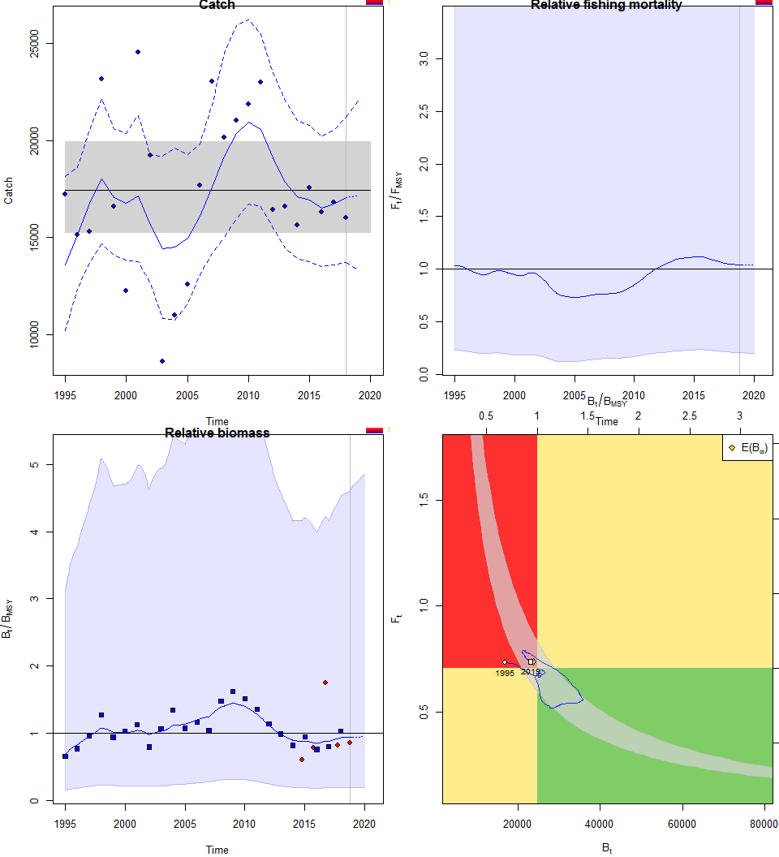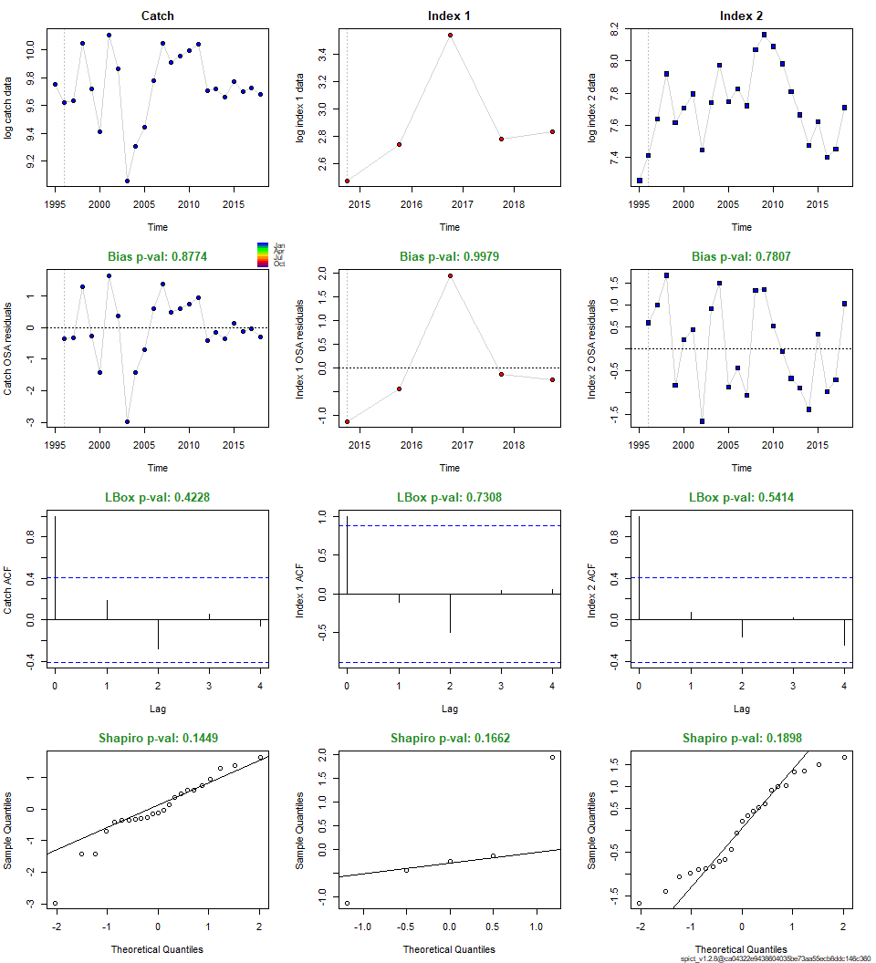

##### page break

**Scenario 5**

* Total catch, shorter time-series (1995-2018)
* Faroe DW survey (2014-2018)
* Faroe summer survey (1995-2018)
* CPUE combined fleet (2005-2018)
* priors: default

## Removing zero, negative, and NAs in I series 1   
## Removing zero, negative, and NAs in I series 2   
## Removing zero, negative, and NAs in I series 3

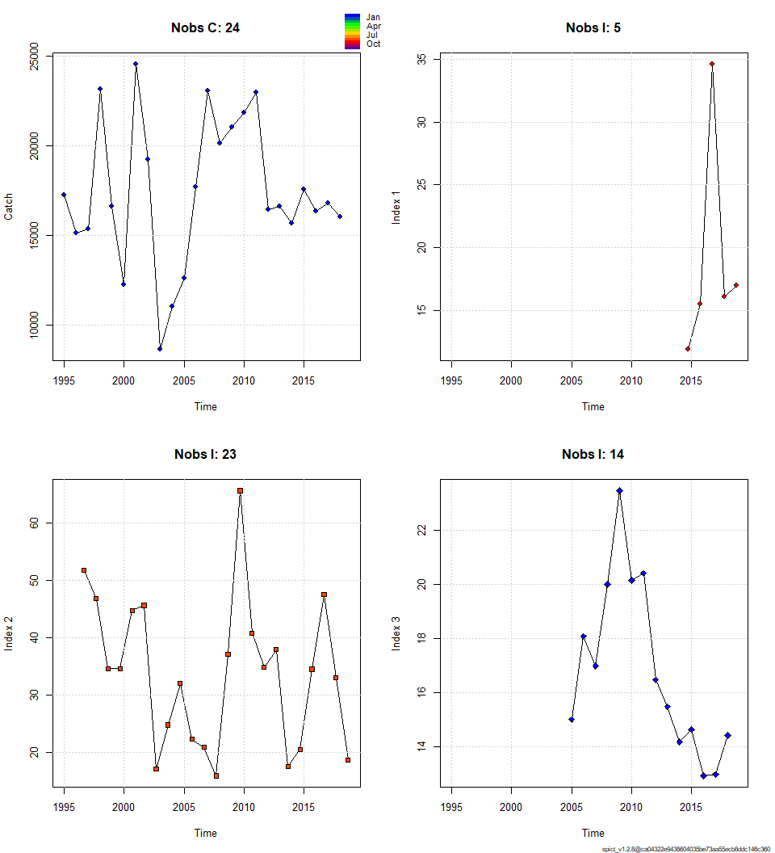

##### page break

## Convergence: 0 MSG: relative convergence (4)  
## Objective function at optimum: 20.2237387  
## Euler time step (years): 1/16 or 0.0625  
## Nobs C: 24, Nobs I1: 5, Nobs I2: 23, Nobs I3: 14  
##   
## Priors  
## logn ~ dnorm[log(2), 2^2]  
## logalpha ~ dnorm[log(1), 2^2]  
## logbeta ~ dnorm[log(1), 2^2]  
##   
## Model parameter estimates w 95% CI   
## estimate cilow ciupp log.est   
## alpha1 2.796171e+00 1.204190e+00 6.492807e+00 1.0282509   
## alpha2 2.739588e+00 1.406010e+00 5.338043e+00 1.0078076   
## alpha3 2.919469e-01 4.058570e-02 2.100076e+00 -1.2311833   
## beta 2.701258e+00 8.583597e-01 8.500856e+00 0.9937174   
## r 5.870607e-01 3.807010e-02 9.052785e+00 -0.5326271   
## rc 8.426176e-01 1.975655e-01 3.593767e+00 -0.1712421   
## rold 1.492193e+00 2.411000e-04 9.234524e+03 0.4002470   
## m 1.706053e+04 1.352505e+04 2.152020e+04 9.7445230   
## K 9.410690e+04 2.215492e+04 3.997355e+05 11.4521866   
## q1 4.717000e-04 7.880000e-05 2.823900e-03 -7.6591150   
## q2 6.785000e-04 1.154000e-04 3.990200e-03 -7.2955863   
## q3 3.689000e-04 6.380000e-05 2.132700e-03 -7.9051088   
## n 1.393421e+00 6.135680e-02 3.164482e+01 0.3317621   
## sdb 1.301369e-01 7.272530e-02 2.328709e-01 -2.0391686   
## sdf 7.184980e-02 2.463550e-02 2.095509e-01 -2.6331780   
## sdi1 3.638849e-01 1.964897e-01 6.738886e-01 -1.0109178   
## sdi2 3.565214e-01 2.624479e-01 4.843152e-01 -1.0313610   
## sdi3 3.799310e-02 6.889700e-03 2.095118e-01 -3.2703519   
## sdc 1.940847e-01 1.360537e-01 2.768677e-01 -1.6394606   
##   
## Deterministic reference points (Drp)  
## estimate cilow ciupp log.est   
## Bmsyd 4.049413e+04 9.278335e+03 1.767315e+05 10.6089123   
## Fmsyd 4.213088e-01 9.878270e-02 1.796884e+00 -0.8643893   
## MSYd 1.706053e+04 1.352505e+04 2.152020e+04 9.7445230   
## Stochastic reference points (Srp)  
## estimate cilow ciupp log.est rel.diff.Drp   
## Bmsys 3.992446e+04 9261.665980 1.721032e+05 10.5947444 -0.014268739   
## Fmsys 4.197617e-01 0.096044 1.834575e+00 -0.8680681 -0.003685622   
## MSYs 1.675788e+04 13295.434686 2.112202e+04 9.7266237 -0.018060467   
##   
## States w 95% CI (inp$msytype: s)  
## estimate cilow ciupp log.est   
## B_2018.75 3.749806e+04 6240.6479580 2.253139e+05 10.5320446   
## F_2018.75 4.362377e-01 0.0745796 2.551680e+00 -0.8295680   
## B_2018.75/Bmsy 9.392254e-01 0.3653791 2.414327e+00 -0.0626998   
## F_2018.75/Fmsy 1.039251e+00 0.3659180 2.951596e+00 0.0385001   
##   
## Predictions w 95% CI (inp$msytype: s)  
## prediction cilow ciupp log.est   
## B_2019.00 3.756339e+04 6.193321e+03 2.278274e+05 10.5337852   
## F_2019.00 4.361938e-01 7.446560e-02 2.555074e+00 -0.8296687   
## B_2019.00/Bmsy 9.408617e-01 3.592230e-01 2.464265e+00 -0.0609591   
## F_2019.00/Fmsy 1.039146e+00 3.649833e-01 2.958560e+00 0.0383994   
## Catch_2019.00 1.643860e+04 1.235731e+04 2.186783e+04 9.7073873   
## E(B_inf) 3.781634e+04 NA NA 10.5404967

##### page break

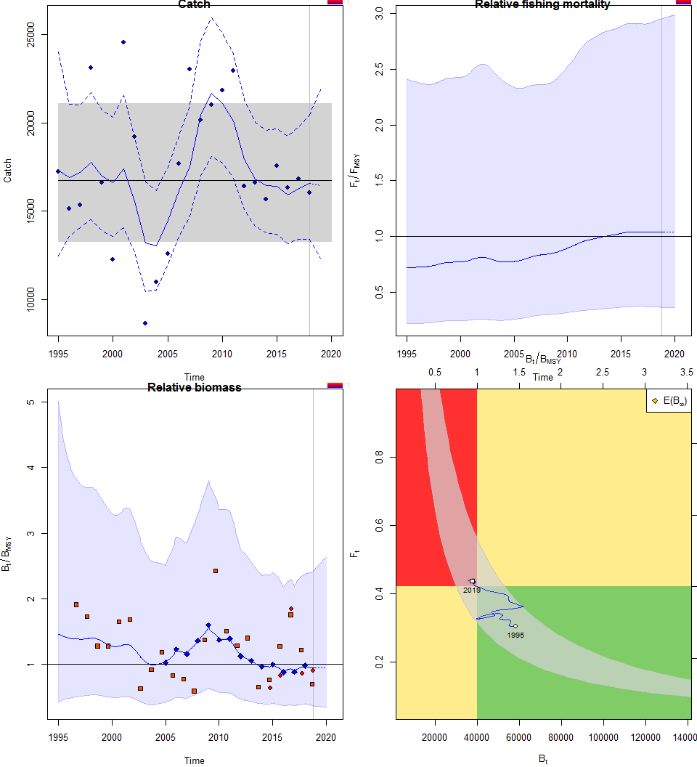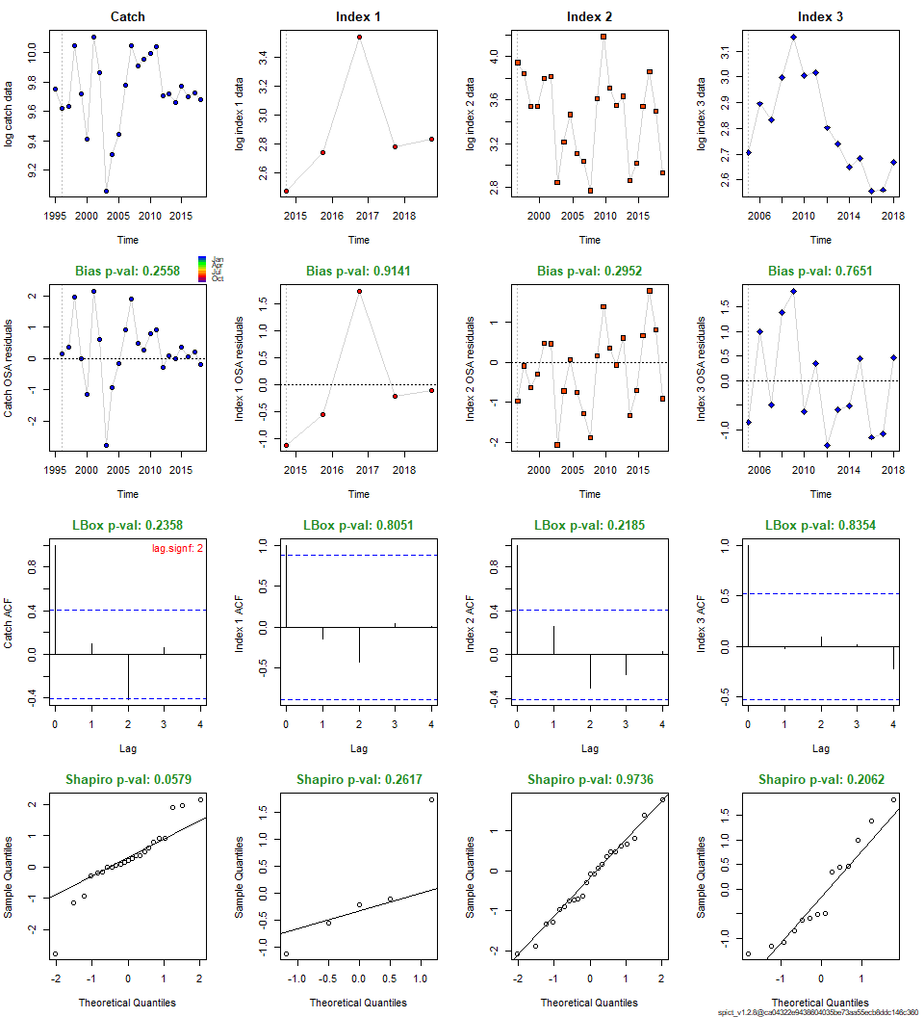

##### page break

**Scenario 6**

* Total catch, shorter time-series (1995-2018)
* Faroe DW survey (2014-2018)
* Faroe summer survey (1995-2018)
* Scottish DW survey (1998-2018)
* CPUE combined fleet (2005-2018)
* priors: default

## Removing zero, negative, and NAs in I series 1   
## Removing zero, negative, and NAs in I series 2   
## Removing zero, negative, and NAs in I series 3   
## Removing zero, negative, and NAs in I series 4

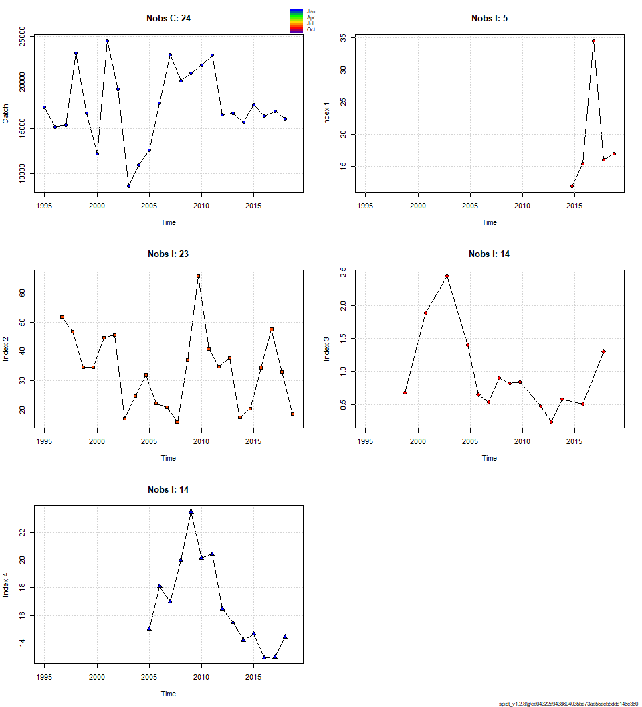

##### page break

## Convergence: 0 MSG: both X-convergence and relative convergence (5)  
## Objective function at optimum: 34.7063892  
## Euler time step (years): 1/16 or 0.0625  
## Nobs C: 24, Nobs I1: 5, Nobs I2: 23, Nobs I3: 14, Nobs I4: 14  
##   
## Priors  
## logn ~ dnorm[log(2), 2^2]  
## logalpha ~ dnorm[log(1), 2^2]  
## logbeta ~ dnorm[log(1), 2^2]  
##   
## Model parameter estimates w 95% CI   
## estimate cilow ciupp log.est   
## alpha1 2.729983e+00 1.182825e+00 6.300853e+00 1.0042954   
## alpha2 2.672731e+00 1.393221e+00 5.127322e+00 0.9831010   
## alpha3 4.334444e+00 2.194177e+00 8.562395e+00 1.4665934   
## alpha4 2.824018e-01 3.882160e-02 2.054287e+00 -1.2644244   
## beta 2.661702e+00 9.062055e-01 7.817937e+00 0.9789657   
## r 6.182238e-01 4.274800e-02 8.940786e+00 -0.4809048   
## rc 8.625462e-01 1.871824e-01 3.974657e+00 -0.1478666   
## rold 1.426169e+00 3.902000e-04 5.212878e+03 0.3549919   
## m 1.719917e+04 1.346411e+04 2.197038e+04 9.7526167   
## K 9.152425e+04 2.199393e+04 3.808637e+05 11.4243592   
## q1 4.735000e-04 8.060000e-05 2.782900e-03 -7.6554341   
## q2 6.726000e-04 1.166000e-04 3.879400e-03 -7.3043092   
## q3 1.700000e-05 2.900000e-06 9.970000e-05 -10.9798777   
## q4 3.712000e-04 6.530000e-05 2.109700e-03 -7.8989038   
## n 1.433486e+00 6.097670e-02 3.369945e+01 0.3601090   
## sdb 1.333535e-01 7.536340e-02 2.359656e-01 -2.0147517   
## sdf 7.312860e-02 2.695440e-02 1.984020e-01 -2.6155353   
## sdi1 3.640528e-01 1.963802e-01 6.748873e-01 -1.0104563   
## sdi2 3.564181e-01 2.628366e-01 4.833189e-01 -1.0316507   
## sdi3 5.780134e-01 3.971408e-01 8.412619e-01 -0.5481583   
## sdi4 3.765930e-02 6.652300e-03 2.131930e-01 -3.2791762   
## sdc 1.946466e-01 1.361900e-01 2.781944e-01 -1.6365695   
##   
## Deterministic reference points (Drp)  
## estimate cilow ciupp log.est   
## Bmsyd 3.988001e+04 8.451176e+03 1.881886e+05 10.5936304   
## Fmsyd 4.312731e-01 9.359120e-02 1.987329e+00 -0.8410138   
## MSYd 1.719917e+04 1.346411e+04 2.197038e+04 9.7526167   
## Stochastic reference points (Srp)  
## estimate cilow ciupp log.est rel.diff.Drp   
## Bmsys 3.929342e+04 8.444630e+03 1.828349e+05 10.5788124 -0.014928356   
## Fmsys 4.294916e-01 9.054720e-02 2.037202e+00 -0.8451532 -0.004147909   
## MSYs 1.687515e+04 1.316539e+04 2.163024e+04 9.7335973 -0.019201384   
##   
## States w 95% CI (inp$msytype: s)  
## estimate cilow ciupp log.est   
## B_2018.75 3.738905e+04 6338.3031969 2.205544e+05 10.5291330   
## F_2018.75 4.388570e-01 0.0760504 2.532472e+00 -0.8235817   
## B_2018.75/Bmsy 9.515345e-01 0.3847693 2.353145e+00 -0.0496794   
## F_2018.75/Fmsy 1.021806e+00 0.3665676 2.848280e+00 0.0215715   
##   
## Predictions w 95% CI (inp$msytype: s)  
## prediction cilow ciupp log.est   
## B_2019.00 3.747463e+04 6.300352e+03 2.229000e+05 10.5314196   
## F_2019.00 4.388074e-01 7.592830e-02 2.535972e+00 -0.8236946   
## B_2019.00/Bmsy 9.537127e-01 3.784317e-01 2.403519e+00 -0.0473928   
## F_2019.00/Fmsy 1.021690e+00 3.655787e-01 2.855339e+00 0.0214585   
## Catch_2019.00 1.651305e+04 1.236764e+04 2.204791e+04 9.7119060   
## E(B_inf) 3.785130e+04 NA NA 10.5414206

##### page break

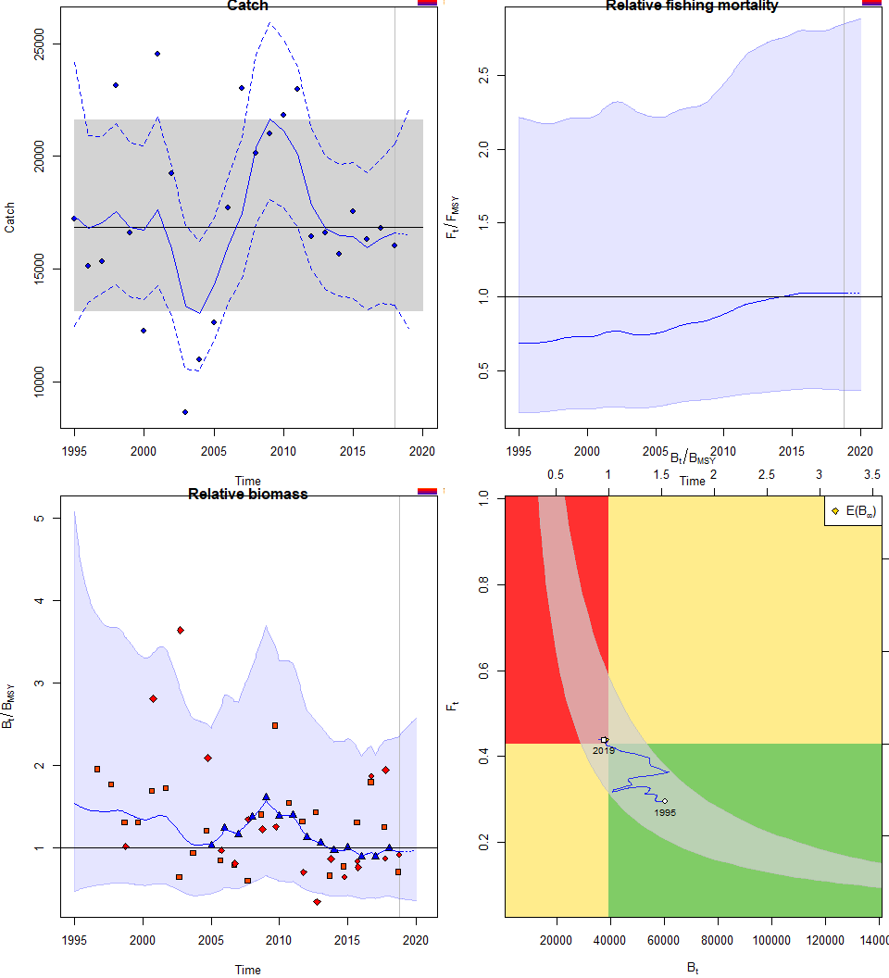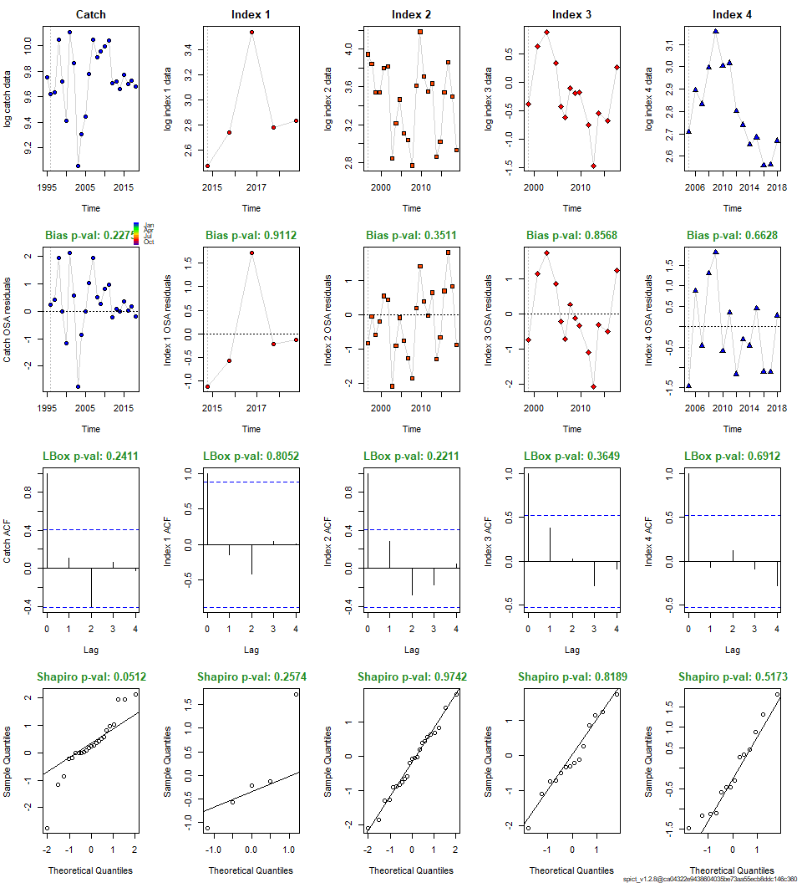

##### page break

**Comparison of scenarios**

