Contents

9 Sandeel in Division 3.a and Subarea 4 597

9.1 Sandeel in SA 6 597

9.1.1 Catch data 597

# Sandeel in Division 3.a and Subarea 4

Larval drift models and studies on recruitment and growth differences have indicated that the assumption of a single stock unit in the area is invalid.

## Sandeel in SA 6

### Catch data

Total catch weight by year for SA 6 is given in tables 9.1.2–9.1.4.

Table 9.1.2 Sandeel. Total catch (tonnes) by area as estimated by ICES.

|  | Area 1r | Area 2r | Area 3r | Area 4 | Area 5r | Area 6 | Area 7r | All |
| --- | --- | --- | --- | --- | --- | --- | --- | --- |
| 1983 | 382629 | 156208 | 24828 | 2782 | 0 | 364 | 0 | 566810 |
| 1984 | 498671 | 133398 | 49111 | 2563 | 5821 | 791 | 744 | 691098 |
| 1985 | 460057 | 111889 | 20859 | 38122 | 3004 | 1927 | 0 | 635858 |
| 1986 | 382844 | 225581 | 282334 | 12718 | 628 | 13219 | 10650 | 927973 |
| 1987 | 373021 | 49067 | 395298 | 8154 | 1713 | 1163 | 0 | 828417 |
| 1988 | 422805 | 151543 | 336919 | 1338 | 0 | 2726 | 0 | 915330 |
| 1989 | 446129 | 227292 | 374252 | 4384 | 2903 | 909 | 450 | 1056318 |
| 1990 | 306302 | 133796 | 163224 | 3314 | 374 | 499 | 0 | 607508 |
| 1991 | 332204 | 215565 | 274839 | 41372 | 1168 | 17 | 2529 | 867694 |
| 1992 | 558602 | 184241 | 87022 | 68905 | 1099 | 4277 | 3455 | 907600 |
| 1993 | 144389 | 147964 | 200123 | 133136 | 586 | 4490 | 80 | 630768 |
| 1994 | 193241 | 244944 | 267281 | 158690 | 2757 | 3748 | 4 | 870666 |
| 1995 | 400759 | 122155 | 213168 | 52591 | 152274 | 1830 | 0 | 942776 |
| 1996 | 291709 | 186460 | 159304 | 158490 | 27570 | 1263 | 1 | 824796 |
| 1997 | 426414 | 242680 | 474093 | 58446 | 10772 | 2372 | 3061 | 1217839 |
| 1998 | 372604 | 99305 | 474843 | 58911 | 3010 | 941 | 5228 | 1014841 |
| 1999 | 425478 | 70085 | 193621 | 53338 | 145 | 0 | 4415 | 747083 |
| 2000 | 374724 | 101952 | 196525 | 37792 | 303 | 0 | 4371 | 715667 |
| 2001 | 540248 | 97210 | 196209 | 47918 | 1678 | 26 | 971 | 884260 |
| 2002 | 610161 | 120520 | 115207 | 12762 | 8 | 493 | 453 | 859604 |
| 2003 | 178642 | 56248 | 35365 | 64049 | 44 | 111 | 260 | 334718 |
| 2004 | 215352 | 116837 | 33658 | 6882 | 0 | 573 | 0 | 373302 |
| 2005 | 126261 | 34569 | 13994 | 1557 | 0 | 259 | 0 | 176640 |
| 2006 | 247510 | 37952 | 7094 | 86 | 0 | 161 | 0 | 292802 |
| 2007 | 110395 | 44069 | 75376 | 11 | 4 | 0 | 0 | 229855 |
| 2008 | 236069 | 35655 | 74943 | 1168 | 0 | 0 | 0 | 347836 |
| 2009 | 309712 | 37049 | 6161 | 0 | 0 | 0 | 0 | 352922 |
| 2010 | 300896 | 52470 | 60542 | 275 | 0 | 0 | 0 | 414183 |
| 2011 | 320241 | 24310 | 92450 | 270 | 0 | 489 | 0 | 437761 |
| 2012 | 45954 | 12672 | 40141 | 2618 | 0 | 214 | 0 | 101599 |
| 2013 | 214787 | 48172 | 9838 | 5119 | 0 | 72 | 0 | 277989 |
| 2014 | 99059 | 64707 | 95426 | 4505 | 0 | 65 | 0 | 263762 |
| 2015 | 162861 | 39492 | 104607 | 4736 | 0 | 198 | 0 | 311894 |
| 2016 | 15407 | 9569 | 44074 | 6232 | 0 | 123 | 0 | 75405 |
| 2017 | 242069 | 141314 | 115642 | 18474 | 0 | 0 | 0 | 517499 |
| 2018 | 132828 | 20569 | 74933 | 42528 | 0 | 0 | 0 | 270858 |
| arith. mean | 302806 | 105486 | 149536 | 30951 | 5996 | 1203 | 1019 | 596998 |

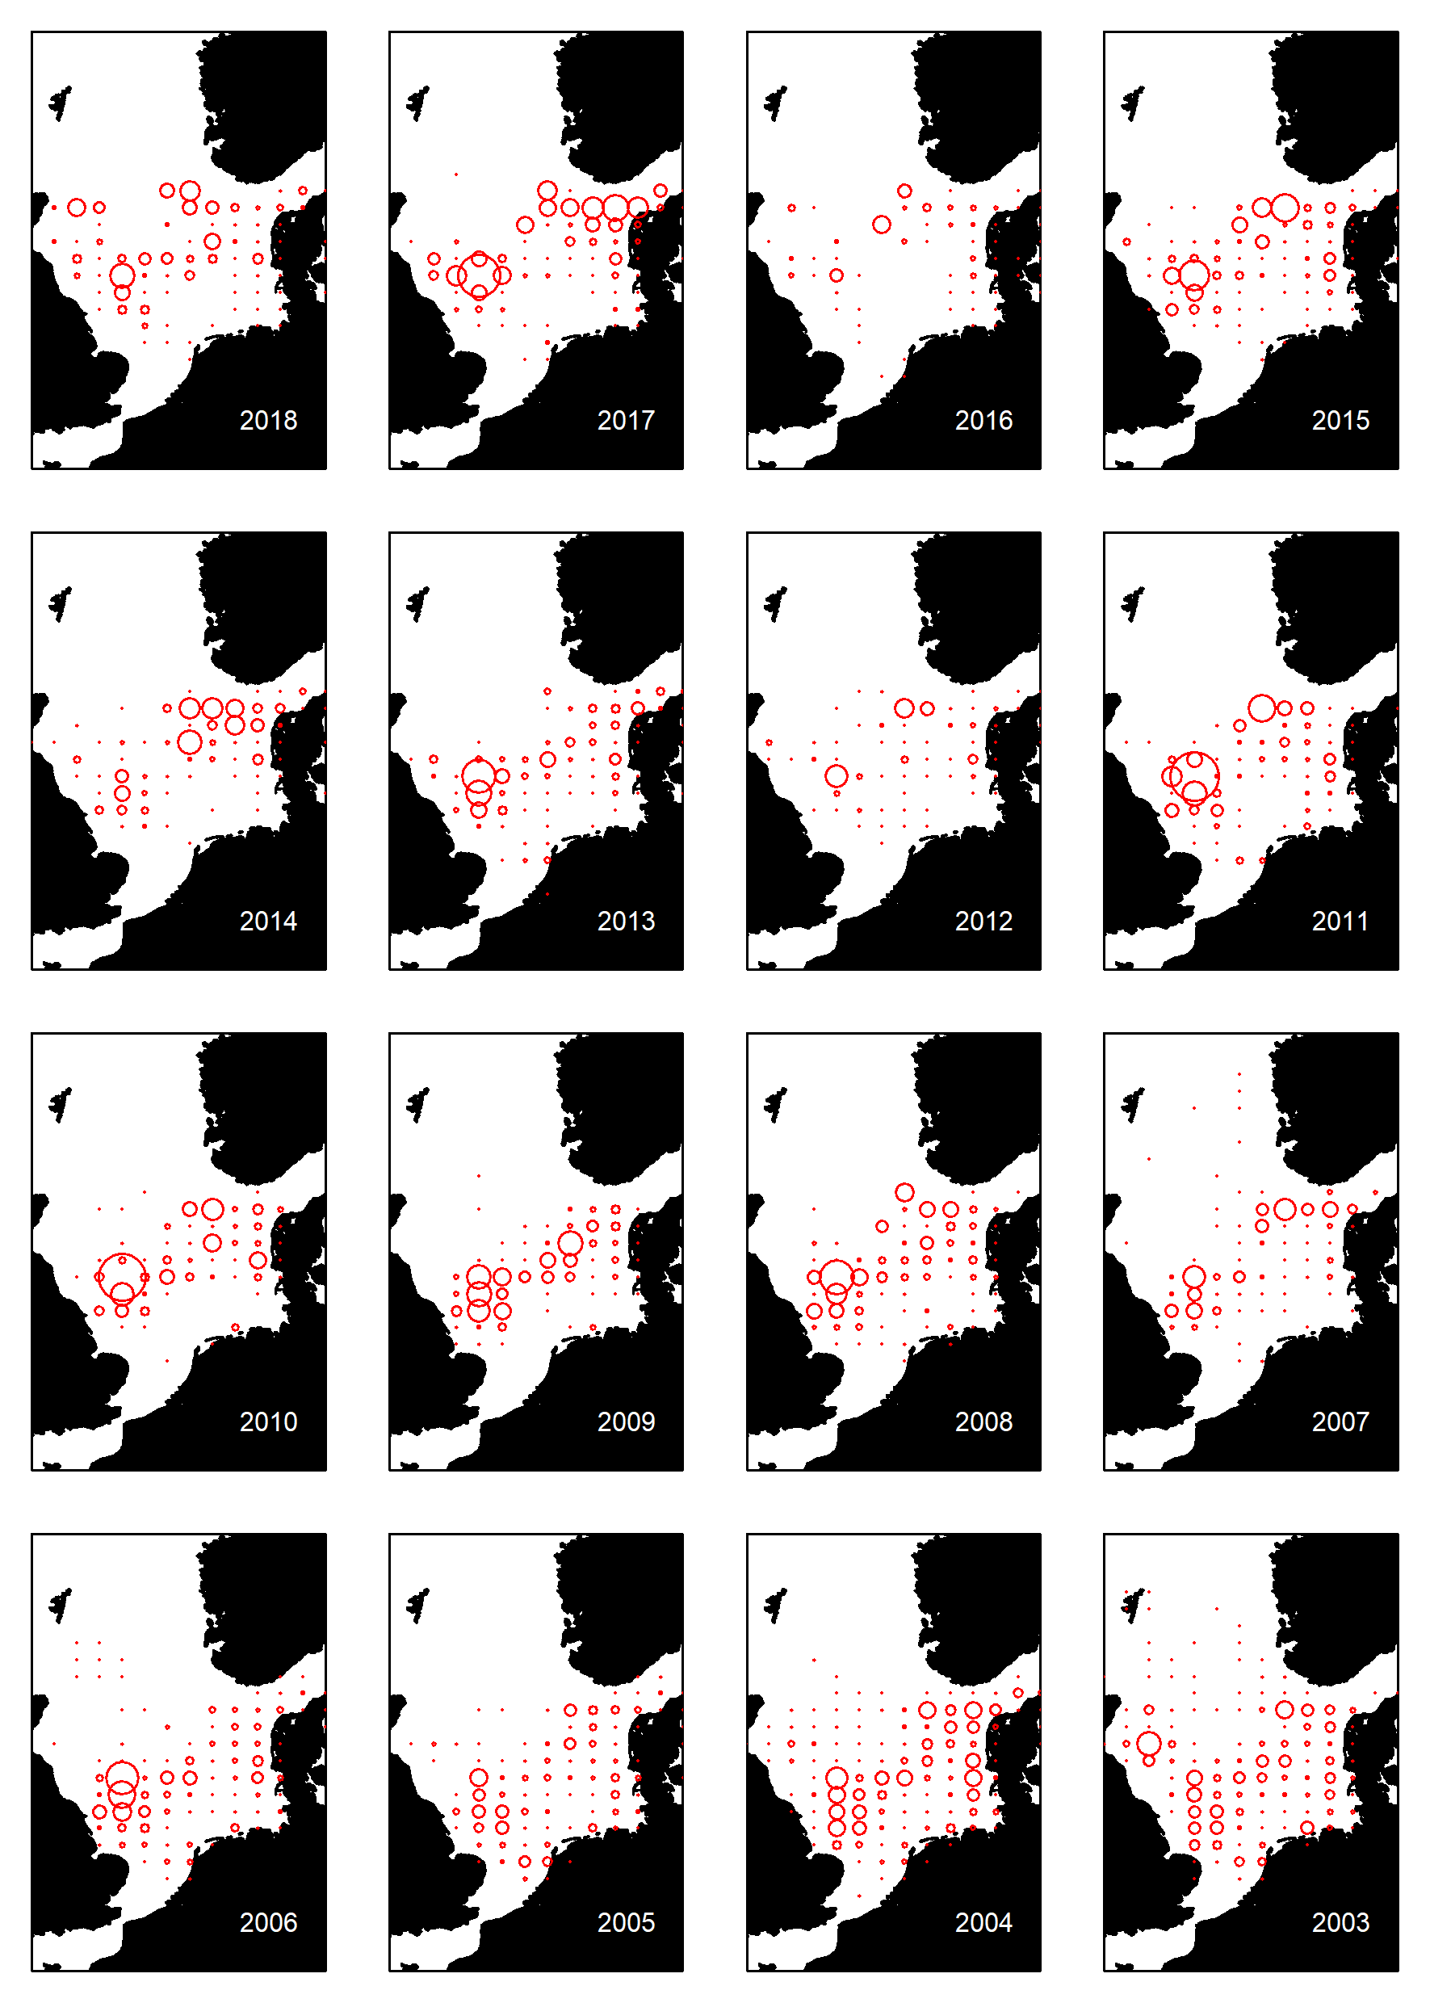

Figure 11.1.2 Sandeel in ICES Division 4 and 3.a. Catch by ICES rectangles 2003–2018. Area of the circles is proportional to catch by rectangle.