Weight-at-age for Bay of Biscay anchovy

- Results from WP3
A recent study by Taboada et al. (2023) confirmed a decline in the average anchovy size based on data three decades of survey data (1990-2021). Allometric adjustment indicated slightly more pronounced declines in weight than in total length. To disentangle the potential drivers of the observed decrease, the association between natural logarithm of size at age and three covariates was studied by linear regression. These covariates were: environmental temperature, resource availability and spawning stock size (SSB). Reduced juvenile size was strongly related to higher anchovy abundance while temperature became the best predictor of declines in adult size.
All the data and code of the paper are available here: https://zenodo.org/records/10090204
For updates see also the following gitlab repository: https://gitlab.com/fgtaboada/sizanc

Table 1. Source of data for the potential drivers considered.
Variable | Source
Temperature | Annual averages based on the AVHRR-only version of the National Oceanic and Atmospheric Administration (NOAA)  Optimum interpolation 0.25° daily sea surface temperature analysis  (oiSST version 2.1)
Food | Annual time series between 1998 and 2021  based on the monthly, “cloud free” 4 km data product, generated by satellite based estimates of chlorophyll a concentration produced  by ACRI-ST for Copernicus Global Ocean Satellite Observations  (OCEANCOLOUR_GLO_BGC_L4_MY_009_104)
Spawning stock size | Spawning stock biomass (ICES, 2021)

Nb. Temperature and chlorophyll data were averaged over the Bay of Biscay continental shelf, defined here by the bottom depths below 500 m based on GEBCO Compilation Group (2022) bathymetry data, within the quadrangle defined by the coordinates 6° W 43° N and 0° 47° N.
Nb. Covariate data were averaged for each age class in time using a moving average filter rolling over the years between the year each age class was born and the time of the survey.

Table 2. Summary of the models fitted for the weight-at-age in (Taboada et al., 2023). Taken from Table S3 in the supplementary material.
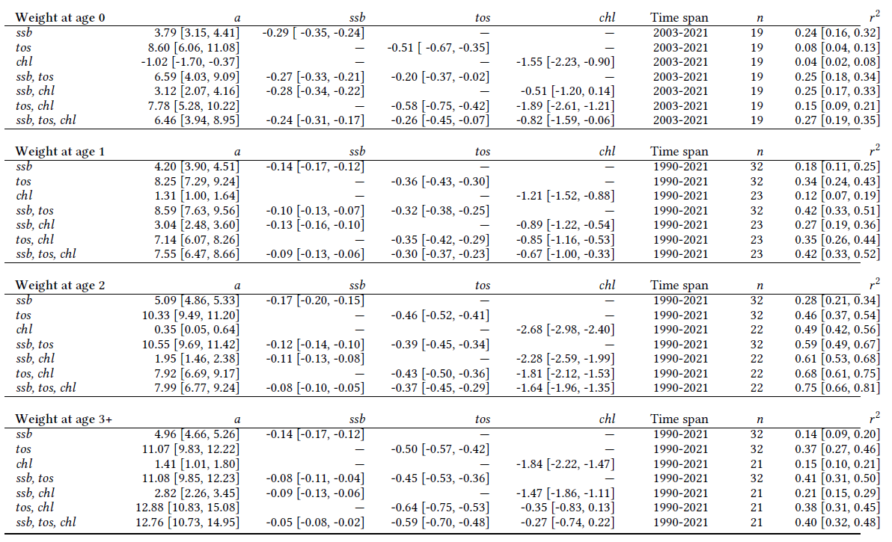

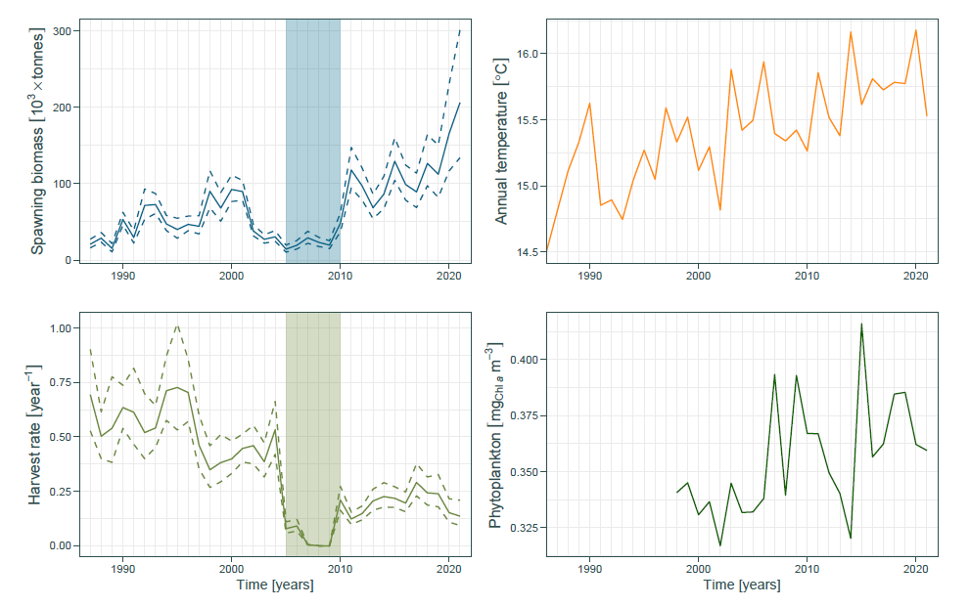
Figure 1: Time series of potential drivers of observed changes in anchovy body size in the Bay of Biscay. Taken from Figure S1 from the supplementary material in (Taboada et al., 2023).
- Results from WP3
These models cannot be taken as they are because:
- The weights-at-age used are trend-modelled based on data from JUVENA and BIOMAN
- Data sources for the environmental variables are different to those used in SEAwise
- Data source for SSB is different (SSB from 2021 assessment in paper and SSB from FLBiol for the FLR work)
- Weight-at-age 0 from JUVENA are not included in the FLStock object
- Log transformation for SSB and Chloropyll
- Covariates are rolled-up
Summary of proxy models in the markdown:

Proposal:
- For age 0: Use linear regression model between log(w0) ~ log(SSB)
- For ages 1-3+: use linear regression model between log(w) ~ SST or log(w) ~ SST + log(SSB), where SST is taken from NOAA (oisst)

- References

Taboada, F. G., Chust, G., Santos Mocoroa, M., Aldanondo, N., Fontán, A., Cotano, U., Álvarez, P., et al. 2023. Shrinking body size of European anchovy in the Bay of Biscay. Global Change Biology, 30.

