Derivation of equations used in the PlotMSY software

Population Dynamics

Definitions for all symbols used are provided in Appendix 3.

Stock-recruit function:
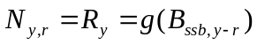 (1)

Population numbers-at-age:
(2)
(3)

Catch numbers-at-age:
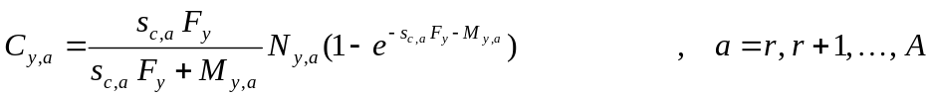 (4)

Spawning stock biomass:
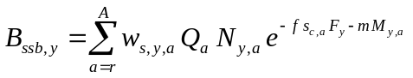 (5)

Stock-recruit functions g:

Ricker:
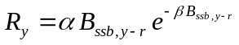 (6)

Beverton-Holt:
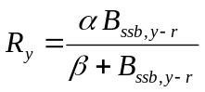 (7)

Smooth Hockey-stick:
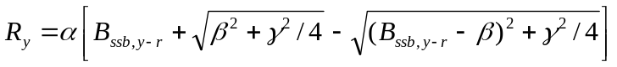 (8)
where 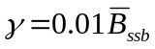

This formulation reduces to the following when γ=0:
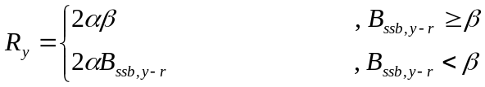 (8a)

Yield-per-recruit and SSB-per-recruit

Derivations of yield- and SSB-per-recruit are given in Appendix 1, and are as follows (given that these follow from equilibrium considerations, the year subscript is dropped):
(9)
and
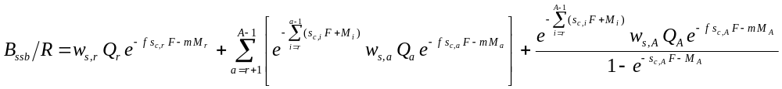 (10)
A specification of whether total, landings or discard yield-per-recruit (ypr) is being considered is needed in order to complete the formulation of equation (9), where Y/R, w_{a} and s_{a} are formulated generically; for example, these need to be replaced by Y_{C}/R, w_{c,a} and s_{c,a} for total ypr, and by Y_{L}/R, w_{l,a} and s_{l,a} for landings ypr (a=r, r+1, …, A; Appendix 1).

Calculation of F_{0.1}, F_{max} and F_{x%SPR}

F_{0.1} and F_{max} are estimated calculating the derivative with respect to F of ypr equation (9), as shown in Appendix 2. F_{x%SPR} (typically x=35 or 40) is derived by solving equation (10) for the F that gives x% of B_{ssb}/R_{F=0} (the B_{ssb}/R value for F=0 in equation (10)).

Calculation of MSY quantities

MSY quantities are also derived from ypr equation (9), but they need to incorporate the stock-recruit relationship. In order to do this, the stock-recruit functions, g, need to be re-formulated as R = g(B_{ssb}/R):

Ricker:
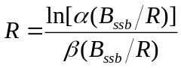 (11)

Beverton-Holt:
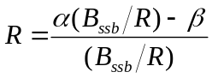 (12)

Smooth Hockey-stick:
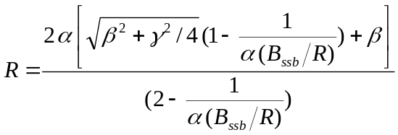 (13)

Doing this makes it straight-forward to multiply equation (9) with the stock-recruit function and then to substitute equation (10) into the resultant equation in order to have an expression of yield in terms of F.

Yield is calculated by substituting the relevant equations (9)-(13) into the following, so that it is expressed in terms of F (and not R or B_{ssb}):
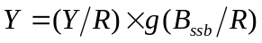 (14)

[Note, however, that this procedure (of expressing g in terms of B_{ssb}/R) is not, strictly speaking, needed for the hockey-stick model, as only the horizontal part of the curve would be used in calculations of MSY quantities, which amounts to multiplying equation (9) by a constant (2αβ in equation (8a)).]

F_{MSY} is then the value of F for which 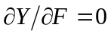. Other MSY quantities follow by making relevant substitutions in equations (9)-(13).

Including uncertainty in biological and fishery-related variables

Assuming that estimates of precision (CVs) are available for the variables 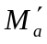, 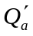, 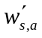, 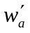 and 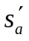 (given here as point estimates, with the latter two being treated generically, but could be specific to one of several catch components), say 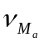, 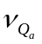, 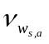, 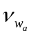 and 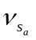 (note these are all CVs) then given a random variable ε drawn from a N(0;1) distribution (one for each biological or fishery-related variable at age), uncertainty in these variables are included as follows:

Natural mortality:
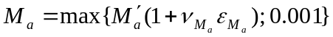

Proportion mature:
For 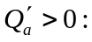
Set 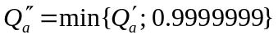
and transform 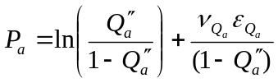
so that 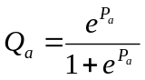

For 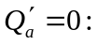 Set 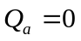

Mean weights (for stock w=w_{s,a}, and for the relevant catch component, e.g. landings, w=w_{l,a}):
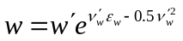
where 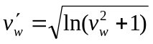

Selectivity of the relevant catch component (e.g. for landings s_{a}=s_{l,a}):
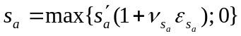

Appendix 1
Equilibrium Calculations

Assuming N_{y,r} = R and F_{y} = F for all y, we have:
Age | Population numbers | Total Yield | SSB
r |  | 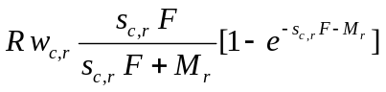 | 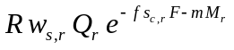
r+1 | 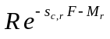 | 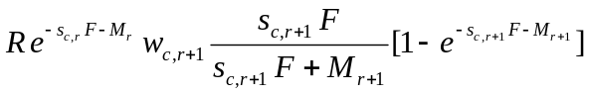 | 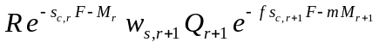
… | … | … | …
a | 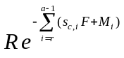 | 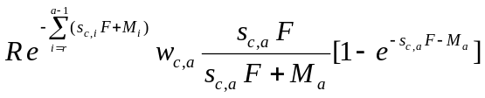 | 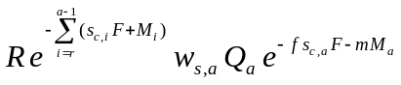
… | … | … | …
A | 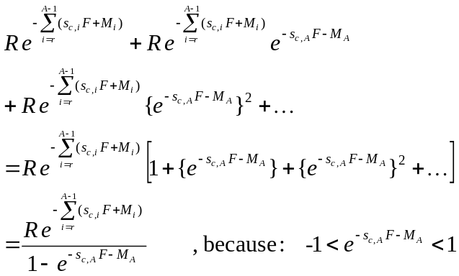 | 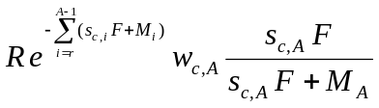 | 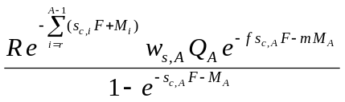

Summing across all ages, Total Yield and SSB can therefore be calculated as follows:
Total Yield:
A1.1

SSB:
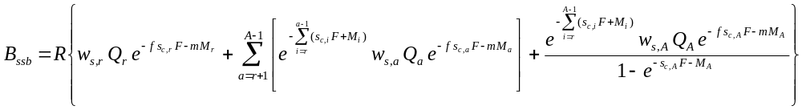 A1.2

Total Yield-per-recruit and SSB-per-recruit follow by simply dividing equations A1.1 and A1.2 by R.

Where the catch is made up of different components (e.g. landings and discards), then the weight-at-age of the catch is calculated as follows:
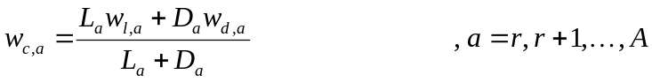 A1.3
Substituting equation A1.3 into A1.1 means that Y_{C} can be expressed as Y_{C} = Y_{L} + Y_{D}, where for example Landings Yield Y_{L} is as follows:
A1.4
where
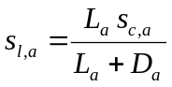 A1.5
Similar expressions can be obtained for Y_{D} and s_{d,a}.

Appendix 2
Derivation of F_{0.1} and F_{max}

Differentiating equation (9) with respect to F, we have:
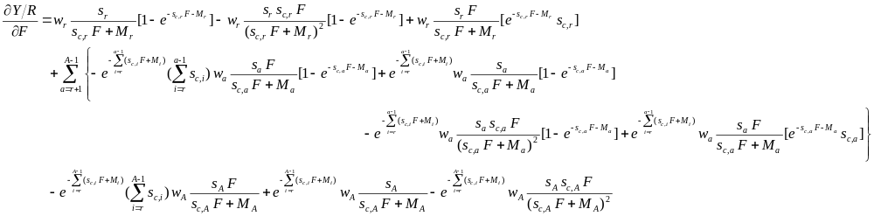and therefore:
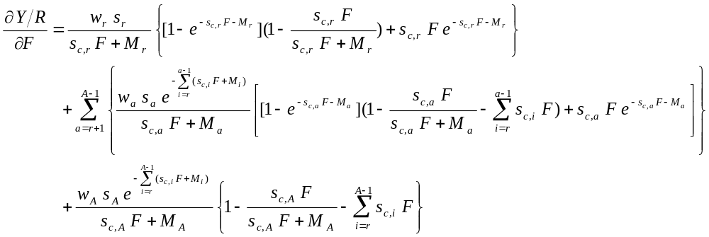 A2.1

F_{0.1} is calculated by finding the value of F which results in:
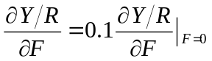 A2.2
where the right-hand-side is derived by setting F=0 in equation A2.1:
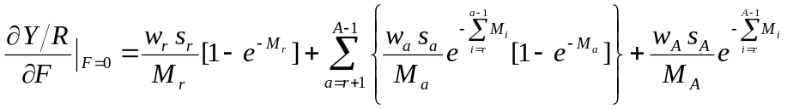 A2.3

F_{max} is calculated by finding the value of F which results in:
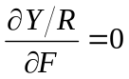 A2.4

Appendix 3
Definitions

y | year
a | age
r; A | age at recruitment (r) and of the plus-group (A)
N_{y,a} | Number of fish in year y and age a
R_{y} | Recruitment in year y
B_{ssb,y} | Spawning stock biomass in year y. For the purposes of fitting the smooth hockey stick given in equation (8), the average over the whole time series, 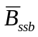, is used.
g | The stock-recruit function
α, β, γ | Parameters of the stock-recruit functions (note, γ is fixed to 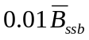)
M_{y,a} | Natural mortality in year y and age a
F_{y} | Fishing mortality in year y
s_{a}; s_{c,a}; s_{l,a}; s_{d,a} | Fishery selection at age a, given in generic form (s_{a}) for the purposes of equation (9), and relevant to the total catch (c), landings (l)and discards (d), respectively
C_{y,a} | Total catch numbers in year y and age a
Q_{a} | Proportion mature at age a
f, m | Proportion of fishing (f) and natural mortality (m) prior to spawning
w_{s,y,a} | Mean weights in the stock in year y and age a. For equilibrium equations, the year subscript is dropped to give w_{s,a}.
w_{a}; w_{c,a}; w_{l,a}; w_{d,a} | Mean weights at age a, given in generic form (w_{a}) for the purposes of equation (9), and relevant to the total catch (c), landings (l)and discards (d), respectively
Y/R; Y_{C}/R; Y_{L}/R; Y_{D}/R | Yield per recruit, given in generic form (Y/R) for the purposes of equation (9), and relevant to the total catch (C), landings (L)and discards (D), respectively
B_{ssb}/R | Spawning stock biomass per recruit
F_{0.1}; F_{max}; F_{x%SPR} | Fishing mortality reference points based on yield per recruit. Typically, x=35 or 40 in F_{x%SPR}.
F_{MSY} | Fishing mortality at maximum sustainable yield

