WORKSHOP1

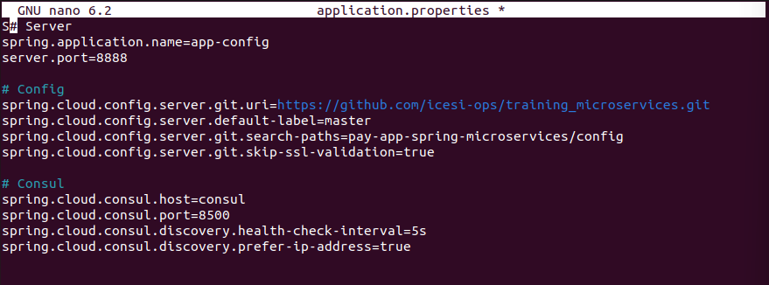

Create network with name ‘distribuidos’

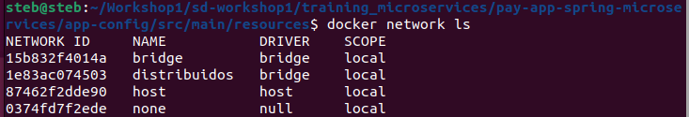

Up the consul

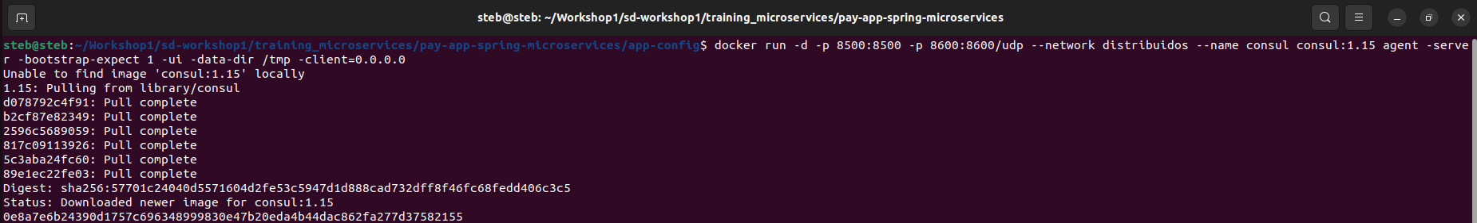

Build config server image and create its container:

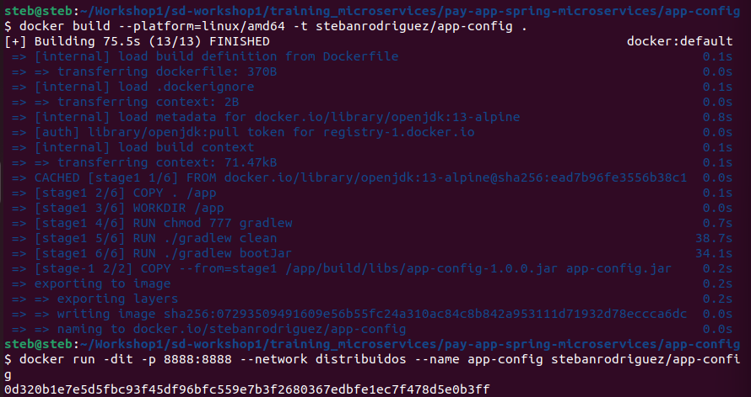

Now the service is up

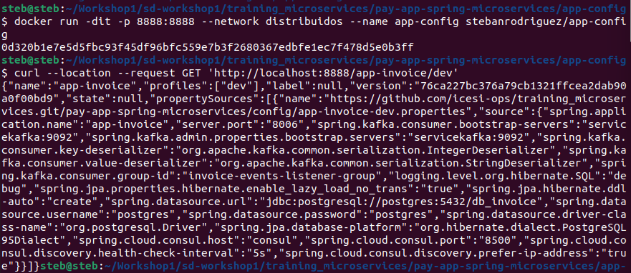

Now we create the image of the invoice microservice, for this we modify the port to expose and put in its place the 8006: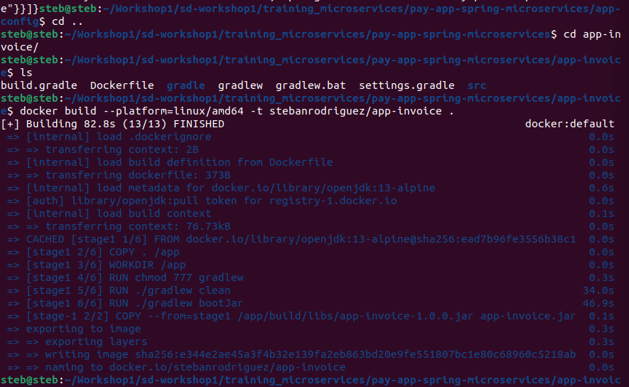

Check if the consuls are as variables and create the invoice image.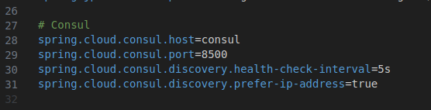

Now we create the postgres image and turn it on: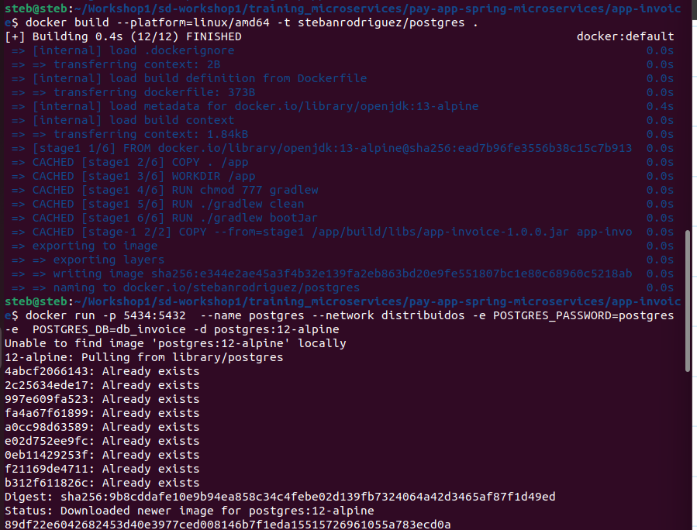

Now we run the Kafka service and run the invoice service: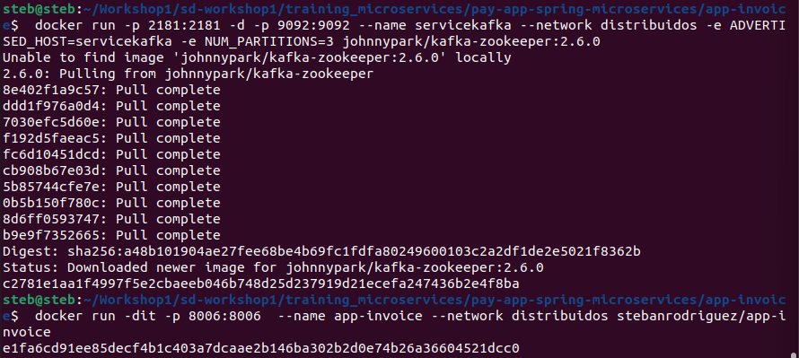

Finally, we have all the services above: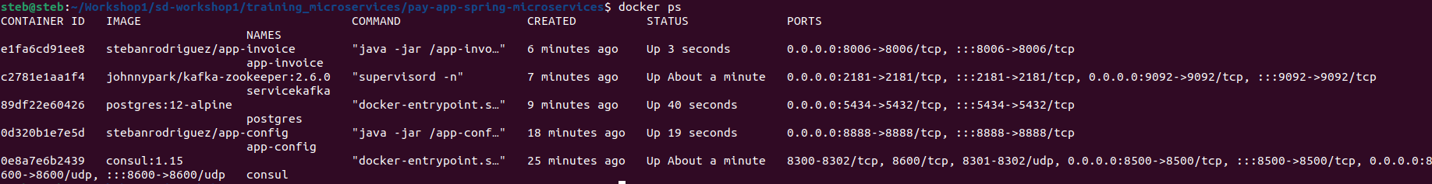

In this way we can already check that the microservices are working correctly.