Sebastian Navia Ramirez
Consul:
To run the Consul use the following command (VERSION 1.15):
- docker run -d -p 8500:8500 -p 8600:8600/udp --network distribuidos2 --name consul consul:1.15 agent -server -bootstrap-expect 1 -ui -data-dir /tmp -client=0.0.0.0

To ensure that all our services are displayed on the page generated by the consul, you must enter the following 2 lines in all services, in their respective "build.gradle", located in each of your folders.

-implementation 'org.springframework.boot:spring-boot-starter-actuator'
-implementation 'org.springframework.cloud:spring-cloud-starter-consul-discovery'

Now, in each service go to src/main/resources/ and enter application.propiertis and paste this code.
Example with app-pay service:
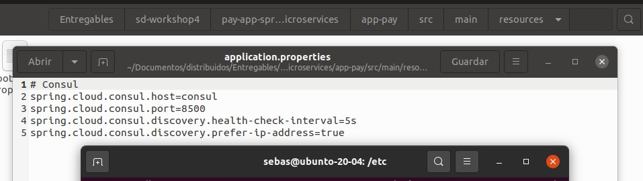

-# Consul
-spring.cloud.consul.host=consul
-spring.cloud.consul.port=8500
-spring.cloud.consul.discovery.health-check-interval=5s
-spring.cloud.consul.discovery.prefer-ip-address=true
We save the image of each service and run the image.

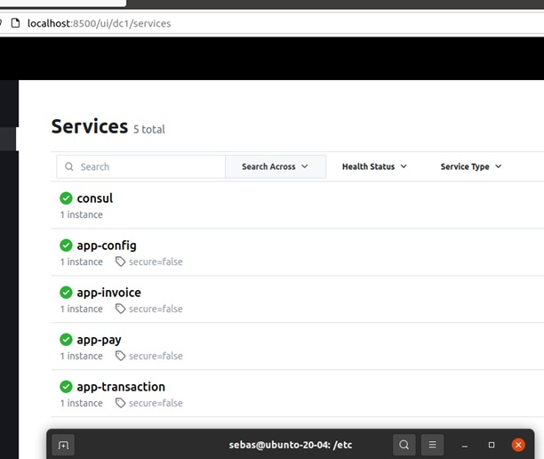

Install dnsmasq Service:

Begin by installing the dnsmasq service, which provides DNS functionality.
- sudo apt-get install dnsmasq

Create Configuration File:

Create a new file, let's name it '10-consul', in the etc/dnsmasq.d directory.
-sudo nano /etc/dnsmasq.d/10-consul

Add the following line to the file, specifying the Consul server with the loopback address and port:
-Server=/consul/127.0.0.1#8600

Restart dnsmasq Service:

Restart the dnsmasq service to apply the changes.

Modify resolv.conf:

Edit the resolv.conf file to enable DNS resolution for services:
-sudo nano /etc/resolv.conf

Add the following line to the file
-nameserver 127.0.0.1

Verify DNS Resolution:

Confirm that the DNS service is resolving the IP addresses of each microservice.
dig <service name>.service.consul
Example:

