AI Integration Architecture for Advana FM
Audit Acceleration Blueprint, Process Map, Milestones, KPIs, Resources, and Operating Model
Prepared for DoD Financial Management, DCFO, Advana FM, audit remediation, and enterprise data/AI stakeholders

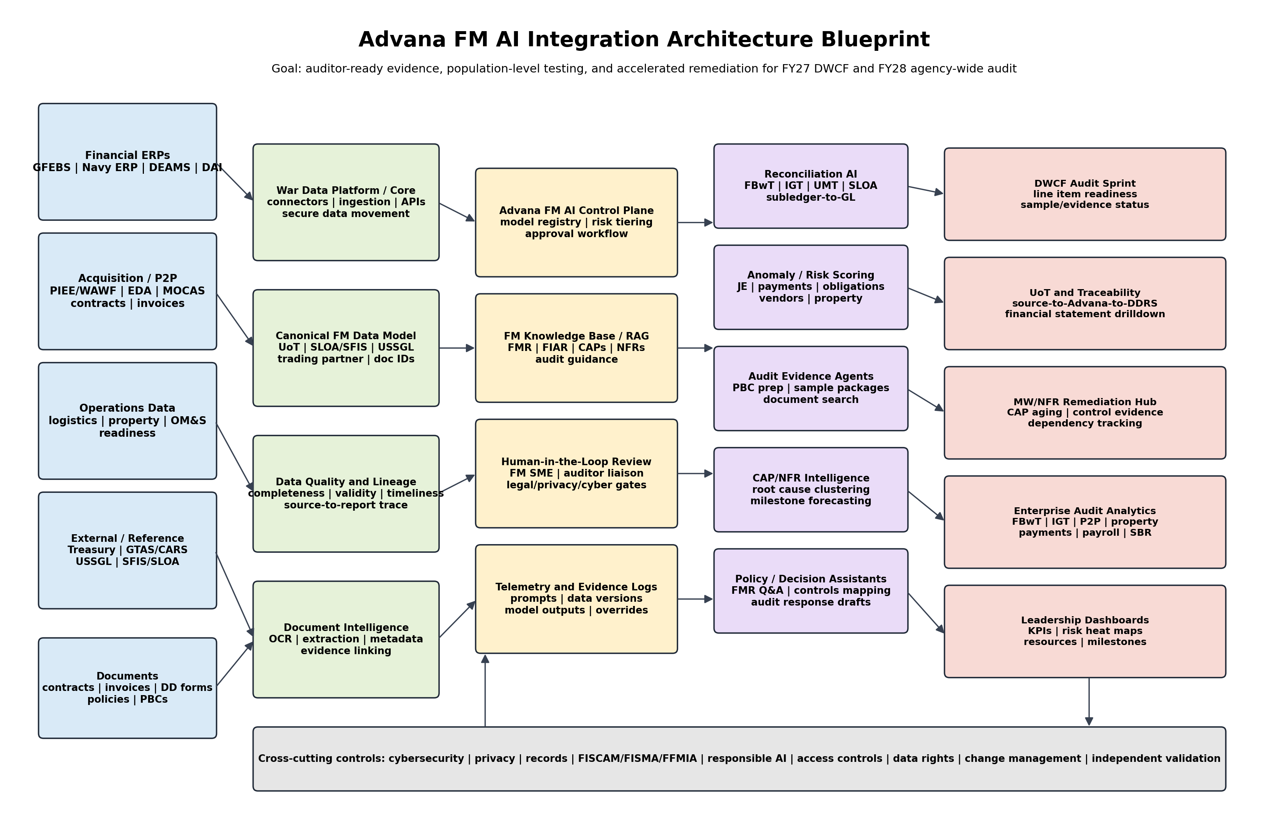
Version: July 2026 | Objective: Support FY 2027 Defense Working Capital Fund audit and FY 2028 agency-wide clean audit goal

Executive Summary
The Department needs an AI integration architecture for Advana FM that is outcome-driven, audit-centered, and operationally realistic. The purpose is not to create a long list of generic AI experiments. The purpose is to turn Advana FM into the financial management evidence, reconciliation, analytics, and remediation operating layer that helps the Department meet two time-bound audit outcomes: support a clean FY 2027 Defense Working Capital Fund audit and support a clean FY 2028 agency-wide audit.
The January 2026 Advana transformation direction creates the institutional opening for this architecture. Advana is being reorganized around a War Data Platform, Advana for Financial Management, and War Data Platform Application Services. The Advana for Financial Management mission should be treated as an audit acceleration mission under Comptroller/DCFO leadership, supported by CDAO engineering resources and a dedicated control plane. The architecture proposed in this paper translates that direction into a practical solution blueprint.
The core recommendation is to establish Advana FM as an AI-enabled audit operating environment. The solution should ingest authoritative financial, acquisition, logistics, readiness, property, travel, payroll, and external reference data; standardize it through a canonical FM data model; apply data quality and lineage controls; run AI-enabled reconciliation, anomaly detection, document extraction, and evidence package workflows; and provide human-reviewed outputs to auditors, FM operators, component leaders, and the FIAR governance structure.
AI should be used where it compresses time, increases population coverage, improves evidence quality, or accelerates remediation. AI should not be used as a substitute for accountable process ownership, source-system correction, internal controls, or auditable documentation. Every use case should trace to a financial statement line item, audit assertion, material weakness, notice of finding and recommendation, corrective action plan, data quality gap, or leadership decision requirement.
Bottom line: The winning architecture is not a chatbot on top of messy data. It is a governed Advana FM data-and-AI control plane that connects source transactions, documents, reconciliations, evidence packages, human review, auditor response, and remediation feedback into one repeatable audit acceleration cycle.

1. Strategic Context and Architecture Assumptions
The Department is under significant time pressure to achieve audit outcomes. Public reporting states that the Department has not yet achieved a department-wide clean opinion, that longstanding financial management and business systems issues persist, and that the Department is targeting an unmodified opinion by 2028. Recent leadership messaging has elevated audit to a top priority and identified AI and automation as necessary tools to accelerate evidence production and population testing.
Advana is already positioned as the common enterprise data repository for DoD. DoD FMR Volume 1, Chapter 10 describes Advana as a centralized data and analytics platform that provides common business data, decision support analytics, and data tools, and states that performance measures or data products relying on DoD data should originate from authoritative transaction-level detail.
The Advana FM architecture must respect the current business environment. DoD FM is not a single-system problem. It is a federated ecosystem of ERPs, feeder systems, acquisition systems, disbursement systems, logistics/property systems, personnel/payroll systems, Treasury interfaces, document repositories, and management reporting layers. AI value will come from connecting these pieces, not pretending they have already been standardized.
The architecture therefore assumes a dual operating model: CDAO/War Data Platform teams manage enterprise data integration, engineering, infrastructure, and AI-enabling services; the DCFO/Comptroller team owns Advana FM priorities, audit business requirements, use-case acceptance criteria, component coordination, and evidence standards.
Architecture assumption | Implication for Advana FM design
Audit is the controlling mission. | Prioritize line items, assertions, material weaknesses, NFRs, and CAPs before general analytics requests.
Advana FM is separated from non-audit Advana apps. | Create an FM control plane, FM backlog, FM data priorities, and dedicated release train.
DCFO must control audit priorities. | Product owners should come from Comptroller/DCFO, with CDAO supporting engineering and platform services.
AI depends on trusted data. | No production AI without lineage, data contracts, completeness checks, access controls, and exception ownership.
Auditors need evidence, not just dashboards. | Every AI output must link to source records, documents, model version, human review, and management certification.
Time is the constraint. | Use AI first for high-volume evidence packaging, reconciliation, UMT clearing, and population testing where cycle-time compression matters.

2. Target Operating Concept
Advana FM should function as the Department’s AI-enabled financial evidence and audit acceleration layer. It should not replace component systems of record or auditor judgment. It should sit between authoritative source systems and audit/management workflows, applying standardization, reconciliation, document intelligence, analytics, AI, and governance to make financial activity traceable, testable, and explainable.
The target state is a repeatable operating model in which the Department can identify an audit objective, define the required data and evidence, ingest and validate the population, score and reconcile transactions, package evidence, route exceptions to accountable owners, support auditor testing, and feed results back into corrective actions and controls.
Current business reality | AI-enabled Advana FM target state
Audit evidence is gathered manually after auditor sample requests. | Evidence packages are pre-built and continuously refreshed for high-risk populations.
Data lineage often requires manual research across source systems. | Source-to-report lineage is stored, visualized, and traceable at transaction/document level.
Substantive testing is sample-heavy and labor-intensive. | Population-level analytics identify risk, exceptions, and completeness gaps before samples arrive.
Corrective action plans are managed as project artifacts. | CAP/NFR intelligence links findings, root causes, milestones, owners, data evidence, and closure criteria.
Components solve similar problems separately. | Common Advana FM patterns are built once and reused across components with local configuration.
AI pilots can be disconnected from audit impact. | AI use cases must pass an audit-value gate and show measurable impact on cycle time, coverage, quality, and remediation.

3. Architecture Blueprint
The architecture has six layers. The layers are designed to preserve system-of-record accountability while creating an Advana FM operating layer that can support AI, automation, reconciliation, evidence packaging, and audit governance.

Figure 1. Advana FM AI Integration Architecture Blueprint


Layer | Core components | Primary purpose
1. Source systems and documents | Financial ERPs, acquisition/P2P, disbursement, Treasury, logistics/property, travel, payroll, contracts, invoices, policies, and auditor PBCs. | Provide authoritative transaction and document evidence.
2. War Data Platform/core integration | Secure ingestion, APIs, data contracts, mapping, canonical data model, UoT, SLOA/SFIS, USSGL, document identifiers, lineage. | Create consistent, traceable, reusable data foundation.
3. Data quality and lineage | Completeness, validity, timeliness, duplicate detection, reconciliation status, source-to-report traceability. | Make the population reliable enough for audit and AI.
4. Advana FM AI control plane | Model registry, FM RAG knowledge base, prompt library, risk tiering, approvals, access controls, evidence logs, telemetry. | Govern AI as an auditable business capability.
5. AI/automation services | Reconciliation AI, anomaly scoring, document extraction, audit evidence agents, CAP/NFR intelligence, policy assistant. | Compress time and expand population coverage.
6. FM and audit applications | DWCF command center, UoT traceability, remediation hub, analytics apps, auditor portal, leadership dashboards. | Deliver operational outcomes to managers, auditors, and leaders.

4. AI-Enabled Audit Process Map
The process map below shows the required operating rhythm. It begins with an audit objective and ends with remediation feedback, not simply an AI output.

Figure 2. AI-Enabled Audit Process Map
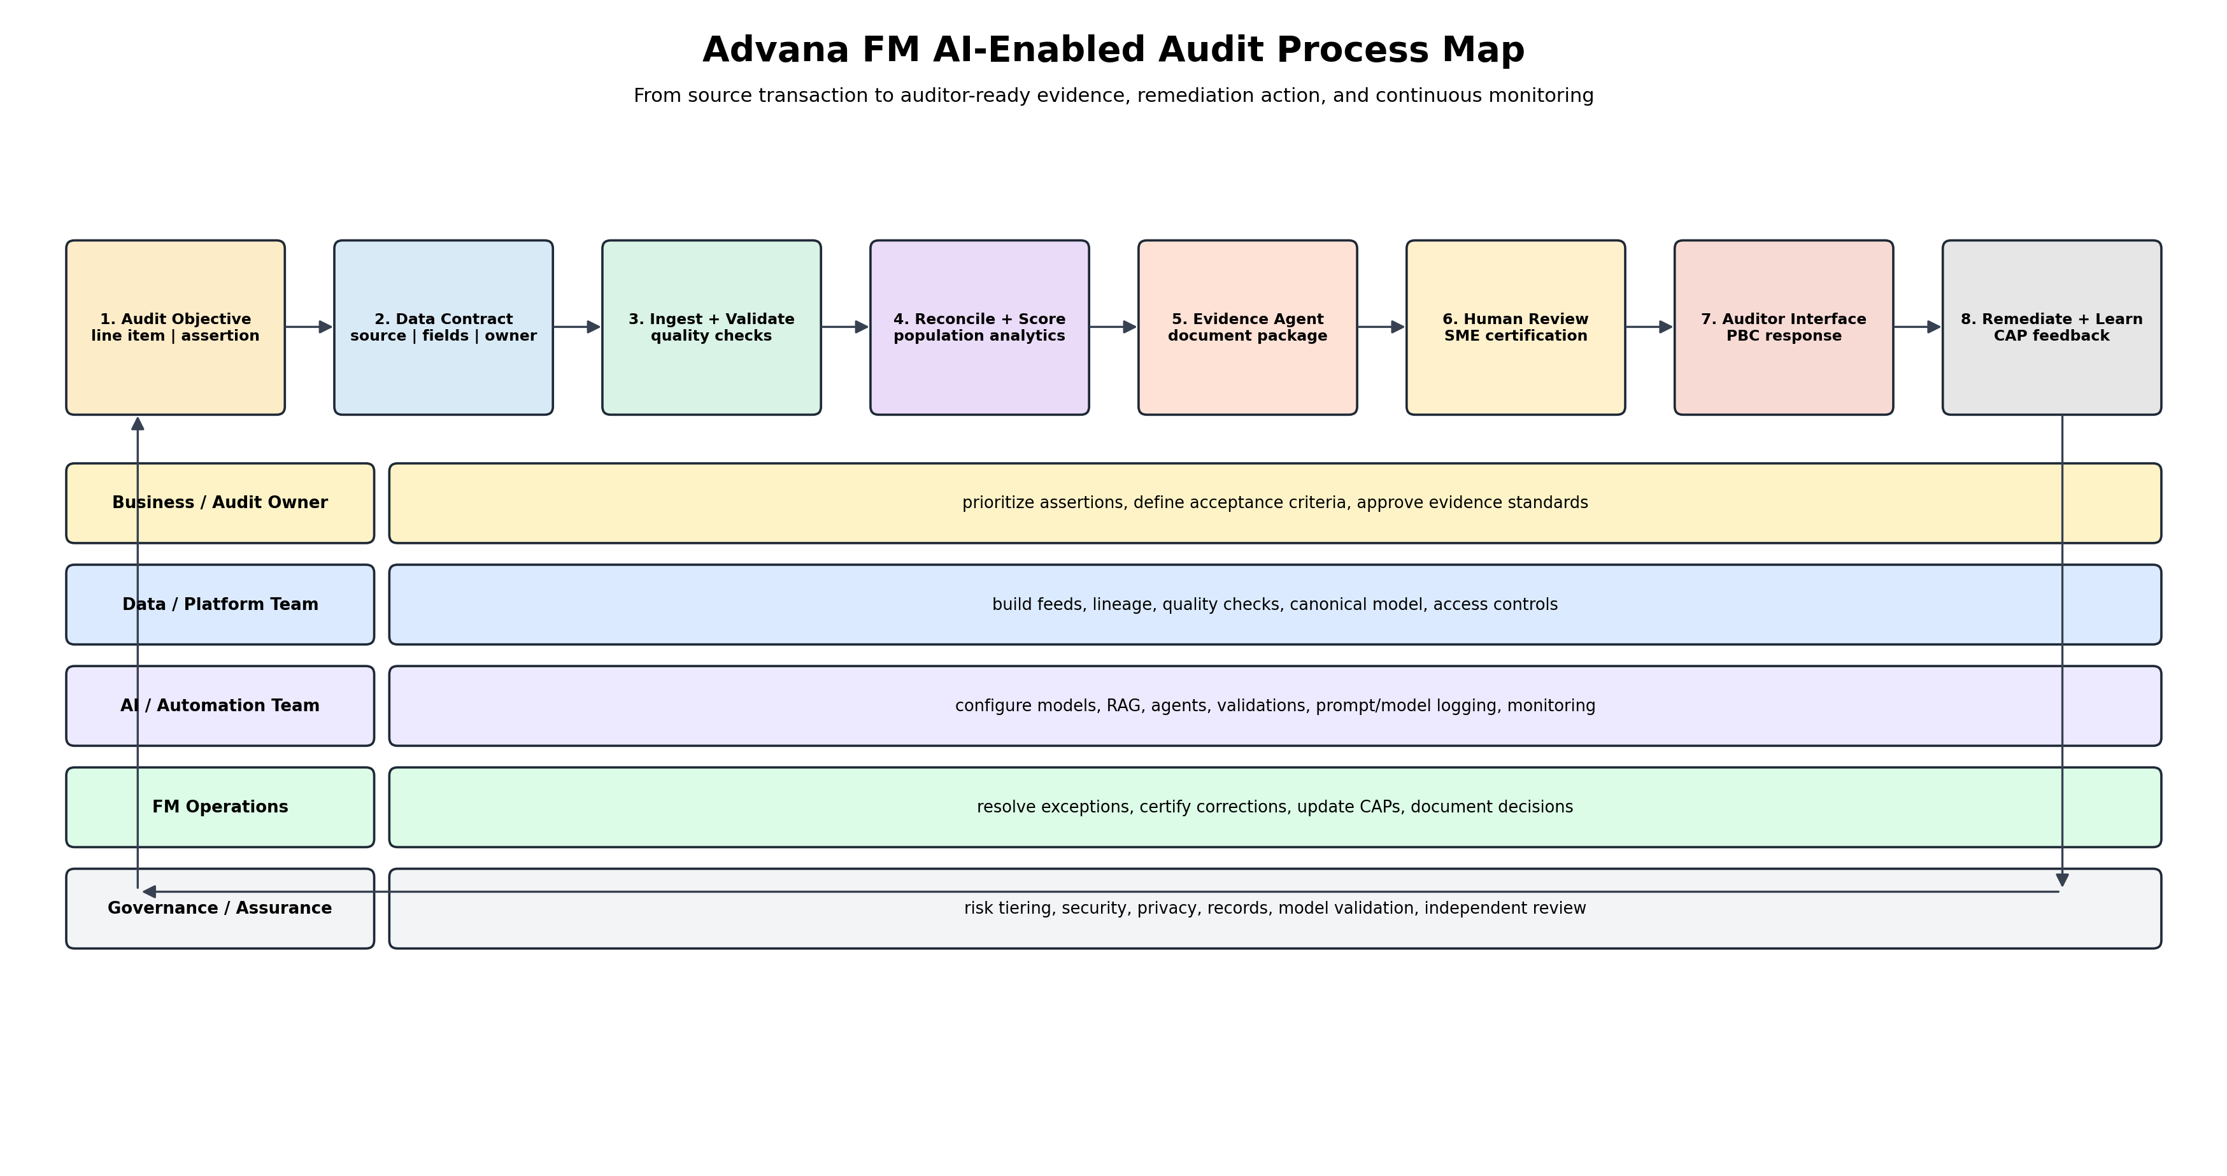

Step | Process | Key output
1 | Define audit objective | Select line item, assertion, component, NFR, material weakness, CAP, or DWCF priority; define acceptance criteria.
2 | Create data contract | Identify source owner, required fields, refresh, authoritative source, control owner, lineage, and quality rules.
3 | Ingest and validate | Load source data into Advana FM; run completeness, validity, timeliness, duplicate, and referential-integrity checks.
4 | Reconcile and risk-score | Perform population matching, anomaly detection, trading-partner analysis, SLOA/USSGL validation, and exception ranking.
5 | Generate evidence package | Use document intelligence and agents to collect, extract, label, and organize supporting records.
6 | Human review and certification | FM SME validates AI findings, approves package, explains exceptions, and signs management certification.
7 | Auditor interface | Provide PBC response, audit trail, model/version metadata, source links, and transaction-to-document traceability.
8 | Remediate and learn | Update CAPs, fix source-system or process issues, retrain models, revise controls, and monitor recurrence.

5. Priority AI Capability Portfolio
The portfolio should be smaller than a broad AI idea catalog and tied directly to audit outcomes. The following recommended capabilities should be treated as the initial Advana FM release train.
Capability | What it does | Audit/business value | Priority
DWCF Audit Sprint Command Center | Working Capital Fund line items, sample readiness, auditor requests, evidence aging, leadership risk heat map. | Sep 2027 DWCF clean audit support. | High
Universe of Transactions 2.0 | Full population ingestion, lineage, source-system mapping, transaction-to-document links, data quality scoring. | Population completeness and auditability. | Critical
FBwT Reconciliation AI | Treasury-to-GL matching, reconciling item classification, stale item prioritization, evidence package generation. | Sustain closed/downgraded FBwT weaknesses. | High
Intergovernmental Transaction Analyzer | Trading partner inference, buyer/seller matching, elimination support, abnormal aging, unsupported differences. | Reduce IGT and elimination risk. | High
Unmatched Transaction/HUnT Expansion | ML prediction of corrective action, RPA execution support, exception ownership, recurrence analysis. | Reduce UMT aging and manual labor. | High
Procure-to-Pay Evidence Agent | Contract, obligation, receipt, invoice, acceptance, disbursement, and modification package automation. | Accelerate P2P sample support. | Critical
Journal Entry and Adjustment Risk Scoring | Unusual timing, manual entry, preparer/approver patterns, crosswalk errors, reversals, abnormal text. | Fraud/error risk and audit focus. | Medium-high
Property/OM&S Assertion Analytics | Asset existence, completeness, valuation support, accountable property system comparison, data gaps. | Material asset line item readiness. | High
DDRS/Tie-Out and Disclosure Assistant | Trial balance to DDRS to statements/notes tie-out, variance explanation, missing support flags. | Financial reporting quality. | Medium-high
CAP/NFR Intelligence Hub | Root-cause clustering, milestone forecasting, dependency tracking, evidence of closure, recurrence detection. | Accelerate remediation governance. | Critical
FM Policy and Audit Guidance Assistant | FMR/FIAR/NFR/CAP knowledge retrieval, control mapping, PBC response drafting with citations. | Workforce productivity and consistency. | Medium
IT Controls and FISCAM Risk Monitor | System access, SoD, interfaces, change management, logging, security deficiency analytics. | Address IT control/material weakness risks. | High

6. Alignment with Current FM Business Processes
The architecture should align to existing FM business functions instead of creating a parallel AI organization. Each capability should have an accountable business process owner and an audit objective.
Current business area | AI/Advana FM alignment | Audit relevance
Budget formulation / PPBE | Historical execution trends, obligation burn rates, unfunded requirements, budget narrative support. | Decision support; not the first audit-critical wave.
Budget execution and funds control | SLOA validation, obligation anomaly detection, expired funds, Antideficiency risk indicators. | Supports Statement of Budgetary Resources and funds control.
Accounting and GL | USSGL/SLOA mapping, journal entry risk scoring, suspense/clearing account analysis, subledger-to-GL reconciliation. | Supports source-to-report integrity.
Procure-to-pay | Contract-to-invoice-to-receipt-to-disbursement matching; evidence package generation. | High-volume audit sample support and improper payment prevention.
Travel/DTS | Travel authorization/voucher matching, policy checks, split-disbursement review, sample package automation. | Supports compliance and expense testing.
Payroll/personnel | Personnel-to-pay comparison, entitlement anomaly detection, access/SoD monitoring. | Supports payroll assertions and IT control testing.
Property/OM&S | Asset existence/completeness/valuation analytics, APSR-to-GL matching, document support. | Supports largest balance sheet risk areas.
Reporting/DDRS | Trial balance tie-out, DDRS upload controls, note/disclosure consistency, variance explanations. | Supports financial-statement reporting quality.
Audit remediation/FIAR | NFR/CAP clustering, dependency tracking, closure evidence, milestone health. | Supports management accountability and audit readiness.
Systems modernization | Legacy system retirement analytics, FFMIA/FISCAM compliance dashboards, interface risk. | Aligns system investment to audit impact.

7. Milestones and Phased Implementation Plan
The roadmap is intentionally compressed because the audit deadline is fixed. The implementation must use agile releases while maintaining strict control over data, model risk, and audit evidence.

Figure 3. Milestone Roadmap: July 2026 - December 2028
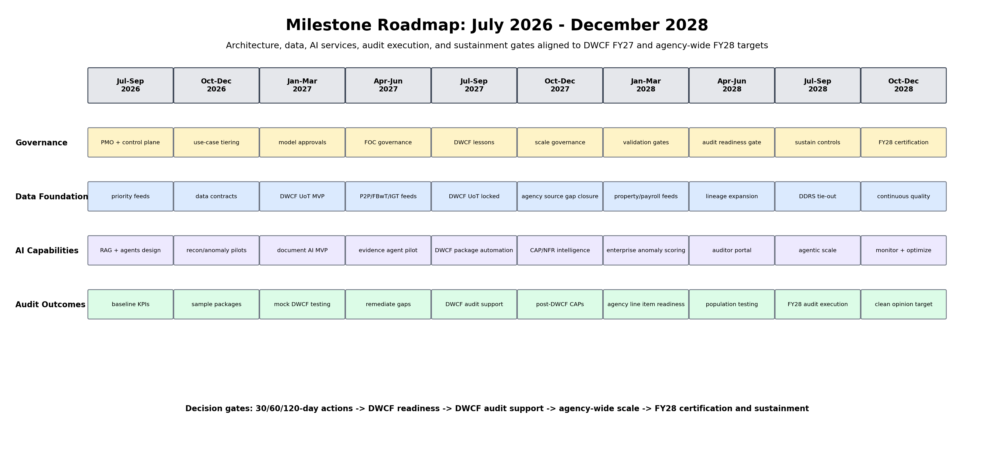

Phase | Timing | Major actions | Gate/outcome
Phase 0: Mobilize | Jul-Sep 2026 | Confirm DCFO product authority; stand up Advana FM PMO; establish use-case gate; define DWCF sprint backlog; create data priority list; start 30/60/120-day actions. | Approved charter, backlog, governance model, source-system inventory, KPI baseline.
Phase 1: Data/control foundation | Oct-Dec 2026 | Implement core data contracts; build UoT MVP for DWCF; establish AI control plane, model registry, RAG knowledge base, evidence logging, access model. | DWCF data foundation MVP, AI governance controls, source-to-report data lineage for priority populations.
Phase 2: DWCF MVP build | Jan-Jun 2027 | Deploy FBwT, IGT, UMT, P2P evidence agents, anomaly scoring, sample package automation, CAP/NFR intelligence for DWCF. | DWCF mock audit packages, population testing outputs, exception queues, remediation velocity metrics.
Phase 3: DWCF audit execution | Jul-Sep 2027 | Freeze DWCF evidence standards; operate audit command center; respond to PBCs; monitor first-pass acceptance; correct critical gaps. | DWCF audit support, evidence acceptance metrics, lessons learned for FY28 scale.
Phase 4: Enterprise scale | Oct-Dec 2027 | Extend architecture to agency-wide material line items and high-risk components; standardize reusable patterns; close source-system gaps. | Enterprise scale plan, reused capability patterns, improved NFR and CAP closure rates.
Phase 5: FY28 agency-wide readiness | Jan-Jun 2028 | Expand UoT, source-to-report traceability, document intelligence, property and SBR analytics, and auditor portal to agency-wide audit scope. | Agency-wide readiness scorecards, population testing coverage, high-risk exception remediation.
Phase 6: FY28 execution and sustainment | Jul-Dec 2028 | Operate evidence command center, support FY28 audit, preserve complete logs, evaluate AI performance, sustain controls after audit. | FY28 audit support, management certification, sustainment plan, post-audit CAP refinement.

8. Key Performance Indicators
KPIs must measure audit outcomes, business process health, data readiness, AI quality, and adoption. The recommended KPI model is below.
KPI category | Example KPIs | Frequency | Owner
Audit outcome | DWCF opinion readiness; agency-wide line-item readiness; material weaknesses closed/downgraded; NFR closure rate; PBC first-pass acceptance. | Monthly; weekly during audit sprint. | DCFO/FIAR Governance Board
Data foundation | UoT population coverage; data contract completion; source-to-report lineage coverage; data quality pass rate; feed latency; missing-field rate. | Weekly. | Advana FM data product owner
Reconciliation | FBwT/IGT/UMT unmatched item count; aging; auto-match rate; exception resolution time; recurrence rate. | Daily/weekly. | Process owner / DFAS / Component
Evidence packaging | Average package cycle time; completeness score; document extraction accuracy; human review rework rate; auditor rejection rate. | Weekly during audit. | Audit evidence product owner
AI performance | Precision/recall for exception classification; false positive/negative rate; human override rate; model drift; prompt/model incident count. | Per release and monthly. | AI/MLOps lead
Governance/security | Models in inventory; risk assessments completed; logs retained; access reviews completed; privacy/security issues; unresolved high-risk AI findings. | Monthly. | AI governance board / CISO / privacy
Workforce/adoption | Active users; trained users; time saved; manual hours eliminated; component adoption; number of reusable patterns deployed. | Monthly/quarterly. | Change management lead
Business value | Interest penalties avoided; improper payments prevented/recovered; audit support hours saved; reduction in aged corrections; avoided duplicated development. | Quarterly. | DCFO / Component CFOs

9. Resource Model
The limiting factor is not only technology. It is the combined availability of FM SMEs, source-system owners, data engineers, AI engineers, cyber/privacy staff, product managers, and audit liaisons. The resource model should be organized by product teams, not by isolated pilots.
Resource group | Roles | Responsibilities
Executive sponsors | DCFO/Comptroller, CDAO, FIAR Governance Board, Component CFOs | Resolve priorities, remove blockers, allocate resources, enforce accountability.
Advana FM PMO | Program manager, portfolio lead, release train lead, risk/control lead, communications lead | Run backlog, milestones, sprint reviews, risk register, component coordination.
Product owners | DWCF, UoT, FBwT, IGT, P2P, property, DDRS, CAP/NFR owners | Translate audit outcomes into product requirements and acceptance criteria.
FM and audit SMEs | Accountants, budget analysts, FIAR leads, DFAS SMEs, component auditors, internal controls specialists | Define business rules, review evidence, certify outputs.
Data team | Data engineers, data architects, data quality analysts, stewards, source-system/interface SMEs | Build feeds, data contracts, lineage, canonical models, quality controls.
AI/automation team | ML engineers, data scientists, prompt/RAG engineers, automation developers, MLOps engineers | Build models, agents, extraction, scoring, automation, validation, monitoring.
Cyber/privacy/records/legal | CISO representatives, privacy officer, records officer, counsel, authorizing officials | Approve environment, access, retention, records, legal and responsible AI controls.
Change and training | Training designers, community managers, user support, metrics analysts | Drive adoption, workforce readiness, feedback, and sustainment.
Auditor liaison | IPA liaison, DoD OIG coordination, PBC manager | Ensure evidence packages meet audit standards and reduce back-and-forth.

10. Governance and Control Model
The Advana FM AI architecture must be auditable by design. This means every AI capability must have a named business owner, data owner, model owner, validation owner, control owner, and production support owner. High-risk outputs should not move directly from model to auditor or system-of-record correction without human review.
The minimum control model should include AI use-case risk tiering, model inventory, data lineage, model validation, prompt/output logging, user access control, segregation of duties, change management, human approval workflow, records retention, incident response, and periodic independent review. Agentic AI should be limited to bounded workflows with explicit tools, permissions, stopping rules, and approval gates.
Control | Minimum requirement | Why it matters
Use-case intake gate | No use case accepted without audit objective, value case, data source, owner, and risk tier. | Prevents generic AI sprawl.
Data readiness gate | No production model without defined lineage, data contract, data quality checks, and exception owner. | Avoids AI on untrusted data.
Model validation gate | Test accuracy, bias/fairness where relevant, robustness, drift, explainability, and false-negative risk. | Ensures reliable AI outputs.
Human approval gate | FM SMEs approve audit evidence, corrective actions, and any output used for management certification. | Preserves accountability.
Audit evidence log | Record inputs, data snapshot, model version, prompts, outputs, human overrides, certification, and timestamps. | Makes AI outputs auditable.
Operational monitoring | Monitor performance, drift, exceptions, incidents, user adoption, and business impact. | Supports sustainment and continuous improvement.
Independent review | Internal audit/OIG-compatible review of AI governance and control design. | Builds confidence and prevents unmanaged model risk.

11. Step-by-Step Implementation Playbook
Step 1 - Confirm mission and governance. Issue an Advana FM AI charter tied to FY27 DWCF and FY28 agency-wide audit outcomes.
Step 2 - Build the prioritized audit backlog. Rank use cases by materiality, audit assertion, cycle-time impact, data readiness, and control risk.
Step 3 - Create source-system data contracts. For each prioritized population, define authoritative fields, refresh cycles, owners, lineage, and quality rules.
Step 4 - Establish the Advana FM AI control plane. Implement model registry, RAG knowledge base, prompt library, approval workflow, telemetry, and evidence logging.
Step 5 - Build reusable AI patterns. Start with reconciliation, anomaly scoring, document extraction, evidence package generation, and CAP/NFR intelligence.
Step 6 - Pilot on DWCF. Use DWCF as the first sprint environment because the deadline arrives before the agency-wide audit target.
Step 7 - Run mock audit cycles. Test evidence packages and exception queues with internal reviewers and auditor liaisons before formal audit periods.
Step 8 - Scale by pattern, not by custom project. Once a pattern works for one component or process, convert it into reusable products and configuration templates.
Step 9 - Measure, report, and correct. Track KPIs weekly, report blockers every 45 days or at the governance cadence, and feed results into CAPs and product releases.
Step 10 - Sustain the capability. After FY28, keep the same controls, dashboards, data quality rules, and AI monitoring active so audit readiness is continuous.

12. Key Risks and Mitigation Actions
Risk | Failure mode | Mitigation
AI use-case sprawl | Every ongoing effort is relabeled as AI. | Audit-value gate; portfolio board; rank by materiality, time compression, data readiness, and control impact.
Poor data quality | AI produces confident but wrong conclusions from incomplete or inconsistent data. | Data contracts; quality scoring; lineage; exception ownership; no production AI without data readiness gate.
Overreliance on AI | Staff accept AI output without review. | Human-in-the-loop certification, training, audit logs, segregation of duties.
Auditor non-acceptance | Evidence packages do not meet audit standards. | Early auditor liaison, mock audit cycles, package acceptance criteria, source traceability.
Component resistance | Components see Advana FM as external oversight rather than shared value. | Component product owners, shared dashboards, reusable products, feedback loops, value metrics.
Technical talent shortage | Insufficient engineers and AI specialists delay delivery. | Surge talent, contractor support, Navy/component detail assignments, reusable templates, focused backlog.
Security/privacy/records gaps | AI tools expose sensitive data or fail retention requirements. | Controlled environment, access rules, privacy/legal review, records retention, prompt/output logging.
Model drift or hidden failure | Models degrade as source data/processes change. | Monitoring, periodic validation, drift detection, retraining/reapproval workflow.

13. Recommended Leadership Actions
1. Name Advana FM as the audit acceleration operating environment and require every priority use case to map to a line item, assertion, NFR, material weakness, CAP, or SecDef audit priority.
2. Establish a DCFO-led Advana FM product board with CDAO engineering representation and Component CFO participation.
3. Implement a 45-day executive reporting cycle that tracks data ingestion, AI capability delivery, DWCF readiness, agency-wide line-item readiness, NFR/CAP closure, and blockers requiring leadership intervention.
4. Fund a dedicated product team for DWCF audit sprint capabilities through September 2027, then convert the team into enterprise agency-wide audit acceleration products for FY28.
5. Build the UoT and source-to-report lineage as the foundation. Do not let AI pilots outrun the data foundation.
6. Prioritize high-volume and high-friction work: P2P evidence packaging, FBwT/IGT reconciliation, UMT clearing, journal-entry risk scoring, property/OM&S assertions, CAP/NFR intelligence, and DDRS tie-out.
7. Require every AI output used in audit support to carry an evidence trail: source data, documents, model version, prompt/tool logs, human reviewer, and final approval.
8. Train the FM workforce on practical AI use, limits, evidence review, prompt discipline, model risk, and responsible use in audit settings.

14. Conclusion
The Department does not need a generic AI strategy for Advana FM. It needs an audit acceleration architecture that makes financial activity more traceable, evidence-ready, and correctable. The Department’s audit goals are time-bound and public. The FY 2027 DWCF target and FY 2028 agency-wide target require a compressed operating model that uses AI to expand population testing, accelerate evidence packaging, and shorten remediation cycles without weakening internal control accountability.
Advana FM can become the central operating layer for this mission if it is designed around data contracts, canonical FM data, source-to-report lineage, governed AI services, human-reviewed evidence, and continuous remediation feedback. The architecture should preserve system-of-record accountability while giving leaders and auditors a single, trusted environment to see what happened, where the evidence is, what remains unsupported, who owns the exception, and whether the corrective action is working.
The most important design choice is discipline. Not every process should become an AI project. Every AI project should become either better audit evidence, faster reconciliation, stronger controls, clearer accountability, improved decision support, or measurable workforce relief. If Advana FM follows that discipline, AI can help the Department move from after-the-fact audit support to continuous audit readiness.

Appendix A: Minimum Viable Product Definition
MVP element | Requirement
Data ingestion | DWCF priority populations loaded with source-system owner, data contract, lineage, completeness checks, and refresh schedule.
Reconciliation | FBwT, IGT, UMT, and selected P2P populations reconciled with exception owners and aging metrics.
Evidence package | Automated package for selected PBC/sample types, including source records, extracted attributes, and human certification.
Dashboards | Leadership view of readiness, evidence status, exception aging, data quality, and blocker escalation.
AI governance | Model inventory, risk tier, validation record, prompt/model logs, access control, and human review workflow.
Mock audit | Dry-run with auditor liaison or internal audit to test completeness, traceability, and package usability.

Appendix B: Source-Informed Reference Notes
Ref. | Source note
R1 | Deputy Secretary of Defense memorandum, Transforming Advana to Accelerate Artificial Intelligence and Enhance Auditability, Jan. 12, 2026. Public PDF describes Advana transformation, dedicated Advana for Financial Management, 45-day status updates, data pipeline prioritization, and FY27 DWCF/FY28 agency-wide audit acceleration. URL: https://media.defense.gov/2026/Jan/12/2003855667/-1/-1/0/TRANSFORMING-ADVANA-TO-ACCELERATE-ARTIFICIAL-INTELLIGENCE-AND-ENHANCE-AUDITABILITY.PDF
R2 | DoD 7000.14-R Financial Management Regulation, Volume 1, Chapter 10, Advana - Common Enterprise Data Repository for the Department of Defense. URL: https://comptroller.war.gov/Portals/45/documents/fmr/current/01/01_10.pdf
R3 | Department of Defense Financial Management Strategy FY2022-FY2026. URL: https://comptroller.defense.gov/Portals/45/Documents/DoDFMStrategy/DoD_FM_Strategy.pdf
R4 | GAO-26-109115, DOD Financial Management: Questions Associated with New Financial Audit Approach, May 13, 2026. URL: https://www.gao.gov/products/gao-26-109115
R5 | DoD Financial Improvement and Audit Remediation Report, July 2025. URL: https://comptroller.war.gov/Portals/45/documents/fiar/FIAR_Report_July_2025.pdf
R6 | DoD FY 2024 Agency Financial Report, Management Discussion and Analysis, audit overview and systems strategy sections. URL: https://comptroller.defense.gov/Portals/45/Documents/afr/fy2024/3-Managements_Discussion_and_Analysis_MDA.pdf
R7 | DefenseScoop, Pentagon to lean on AI to achieve audit goals, May 5, 2026. URL: https://defensescoop.com/2026/05/05/pentagon-plans-to-use-ai-for-audits/
R8 | DIU, DIU and JAIC Successfully Implement Machine Learning Solutions to Resolve Accounting Discrepancies in the DoD Financial Management Enterprise, May 12, 2022. URL: https://www.diu.mil/latest/IBA
R9 | MeriTalk, Pentagon to Split Advana Data Platform, Jan. 16, 2026. URL: https://www.meritalk.com/articles/pentagon-to-split-advana-data-platform/
R10 | Reuters, Pentagon says it fails eighth audit, targets 2028 to pass, Dec. 19, 2025. URL: https://www.reuters.com/world/us/pentagon-fails-eighth-audit-targets-2028-pass-pentagon-says-2025-12-19/

