

**Statement and Confirmation of Own Work**

**Programme/Qualification name:**

Each NCC Education assessed assignment submitted by you must have this statement attached to the assignment as the cover page or it will not be accepted for marking. Please ensure that this statement is either firmly attached to the cover of the assignment or electronically inserted into the front of the assignment.

**Student Declaration**

I have read and understood NCC Education’s Policy on Academic Dishonesty and Plagiarism.

I can confirm the following details:

**Student ID/Registration number: 00151170**

**Name: S.M. Abdul Wassae**

**Centre Name: Daffodil International Academy**

**Module Name: Computing project**

**Module Leader: Mohammad Azizur Rahman**

**Number of words: 3969**

I confirm that this is my own work and that I have not plagiarized any part of it. I have also noted the assessment criteria and pass mark for assignments.

**Due Date: November 1, 2016**

**Student Signature: S.M. Abdul Wassae**

**Submitted Date: November 1, 2016**

Contents

Acknowledgement: 3

Abstract: 4

Introduction: 5

Chapter-1: Details of the project 6

Introduction: 6

Project initiation: 6

Background study: 6

Project Description: 7

Aims: 7

Objectives: 7

Methodology: 7

Choosing methodology: 8

Reason of choosing waterfall: 8

Development details: 8

Key activities with time frame: 8

Key milestone: 8

Feasibility analysis: 9

Economic benefit: 9

Technological benefit: 9

Socio-cultural benefit: 9

Chapter-2: Requirement specification 10

Introduction: 10

Functional requirement: 10

Non-Functional requirement: 10

Final requirement 10

Designing tools: 11

Chapter-3: Design specification 12

Introduction: 12

Class diagram: 12

Use case diagram: 13

ERD: 14

Sequential diagram: 16

Add center: 16

Add route: 16

Add vehicle: 17

Edit permission: 18

Accept transport: 18

Chapter-4: Implementation and testing 19

Introduction: 19

Language selection: 19

Development process: 19

Work breakdown structure: 19

Code architecture add center: 20

Code architecture add route: 20

Code architecture add vehicle: 21

Code architecture edit permission: 21

Code architecture accept transport: 22

Testing: 23

Black-box testing: 23

Integration testing: 24

Unit testing: 26

Cross browser: 28

Chapter-5: Critical evaluation 29

Introduction: 29

Strength: 29

Weakness: 29

Performances: 29

Further development: 29

Conclusion: 31

Appendix: 32

Project proposal 32

Introduction: 32

Background study: 32

Description: 32

Justification: 33

Project scope: 33

Aims: 34

Objectives: 34

Key activities with time frame: 34

Key milestone: 34

Work breakdown structure: 35

Bibliography 36

# Acknowledgement:

It is the first time I am doing a real life project. I have learnt a lot about JSP and other updated technologies. This project also makes me experienced with client requirement gathering and analysis. I have been helped a lot from my module teacher Mohammad Azizur Rahman.

# Abstract:

This project is developed in limited time based on for local market demand. Its main purpose is finding out transportation cost between two center and store relative data so that any company can make their business decisions by knowing expenses.

# Introduction:

Bangladesh is a developing county and has involved with IT very recently. Some of its sectors are depend on IT but still most of the sectors are out of touch with IT. One of them is transportation management system. They use page and paper for every step of recording data and the process is too much lengthy and sometime they lost data for the loosing of paper and make a chance to be corrupted. So involving IT can be the better solution to overcome the challenges.

# Chapter-1: Details of the project

## Introduction:

In this chapter details of project proposal will be described. It contains background study, project description, aims and objectives, choosing methodology, development details and feasibility study.

## Project initiation:

Day by day life is getting too complex as the demands of services are increasing and felt in need of manipulating bigger information and better analysis. But many companies do not have computerized system especially countries like Bangladesh and they can’t get exact report when in need. PTCMS in detail Product Transport Cost Management System which provides user level access in system to add cost related information and view status of transportation between two centers.

## Background study:

As the era of communication the world is getting smaller through transportation of goods. But for the developing countries such as Bangladesh are still using analog system in this sector. Different types of companies have different kind of policies and way of service for their product delivery. Sometimes it is quite difficult for the companies especially for the large one to maintain their vehicles during product distribution. Besides many of small company have no delivery vehicles and they depends on courier companies for their product distributions. But in Bangladesh the courier companies are using analog data entry using page and paper. They use mobile communication to know the delivery status but cannot record data for analysis. As they using page and paper calculating fuel, other cost per trip and maintenance cost over month and year. Many of time data is lost over damage on paper and quite impossible to keep and display report about daily, monthly and yearly delivery status.

On this circumstance, a survey has already been done among 3 courier and product distribution companies. They have a lot of requirements and some of them are totally different from each other according to their business policies. I have compared and wish to provide a common software solution for transportation management systems like ‘xcelerator’, ‘Sameday Courier Software’ etc. for those product transportation companies. Besides being many software solutions in this sector I wish to provide a completely separated transportation management system including the features given below:

* Can be fitted to any type of transportation services`
* No need to involve with production
* Route wise estimation of cost for each vehicle maintenance or trip
* Providing overall report about delivery status to sender and receiver.
* Analyzing fuel and staff cost
* Managing level of access as user category
* Take employ records who ordered a transportation
* Recipient-end delivery verification, keep data record and generate report if needed.

For the limited time I do not provide extra additional features that would be developed later.

## Project Description:

To provide the solution, the system needs at least a sender and a receiver of product that can be considered as two centers or branches. The vehicles are categorized as their load capacity and their fuel costing are depends on their category. There will be basic cost estimation for each vehicle provided by admin. There are three kind of user in this system. They are-

* Admin
* Supervisor and
* Manager

Admin can add user, center, vehicle, staff, issue bills and their relevant information and view all kind reports. Supervisor can see all reports but cannot add anything if not permitted. Manager can see only report related to his center. The system will report about the status of vehicle as three situations ‘Busy on delivery’, ‘Free in garage’ and ‘Sent for repair’. Before a complete transportation routes between two centers must be added by permitted user. Multiple vehicle and staff can go with a single transport and after completing delivery the vehicles can be used for another transport again. In this project only owned vehicles are calculated.

## Aims:

The main goal of project is just cost calculation in a single ordered transportation. But without center, vehicle, route, staff information it cannot be done. To complete that goal some aim some aim are defined which are given below:

* Giving an overall costing idea on transportation of product to the company.
* Company will choose vehicle easily.
* Company can compare estimated cost with the actual cost to reduce corruption.
* Company can get confirmation of receiving product from center or user.
* Company can keep track for further more business issues and analysis.

## Objectives:

To achieve the goals objectives are set to make a clear idea about the project. The objectives of the project are:

* Company will get suggestion about car for delivery easily.
* Show cost on transportation.
* Managing user access level to see report.
* Save time, money and labor to calculate costing.

## Methodology:

In general methodology means the system of methods and principles used in a particular discipline. (methodology, n.d.) In software solution development, it means a framework that is used to structure, plan, and control the process of developing. (software_methodology, n.d.) The most popular software development methodologies are:

* Waterfall: Waterfall methodology is a development method which is actually linear and sequential. It has distinct goals for each phase of development. (waterfall, n.d.)
* Agile: Agile methodology is actually an approach of developing with unpredictable situation through incremental and iterative work. (Agile, n.d.)

### Choosing methodology:

In this project waterfall methodology is used for developing and implementation purposes.

### Reason of choosing waterfall:

Waterfall is referred to maintain a linear-sequential life cycle model. Besides it is very simple and easy to understand. It defines its each phase must be completed fully before starting the next phase. The project is small and there are no no uncertain requirements to be changed. So waterfall methodology is time saving and easy approach to provide the solution.

## Development details:

I have set key milestones by using key activities time frame for the project. The development details structures are given below:

### Key activities with time frame:

|  |  |  |  |
| --- | --- | --- | --- |
| **No.** | **Activity name** | **Start time** | **End time** |
| 1. | Understanding business scenario and objectives | Aug 14, 2016 | Aug 19, 2016 |
| 2. | Analysis scenario and system architecture | Aug 20, 2016 | Aug 25, 2016 |
| 3. | Design database | Aug 26, 2016 | Aug 31, 2016 |
| 4. | UI design | Aug 26, 2016 | Aug 31, 2016 |
| 5. | Implementation | Sept 01, 2016 | Oct 01, 2016 |
| 6. | Testing and Bug fixing | Oct 02, 2016 | Oct 15, 2016 |
| 7. | Documentation | Aug 14, 2016 | Oct 19, 2016 |

### Key milestone:

1. **Understanding business scenario and objectives:**
   * Collect data from companies via survey.
   * Interview with some people working on centers.
   * Understanding information about vehicle and its route
2. **Analysis scenario and system architecture:**
   * Drawing rich picture.
   * Drawing Data Flow Diagram.
   * Drawing Use Case Diagram.
   * Drawing Activity Diagram.
   * Drawing Sequence Diagram.
3. **Design database:**
   * Applying normalization.
   * Drawing ERD.
   * Create database and its tables.
4. **UI design:**
   * Drawing Wire Frame model
   * Analysis and finalizing UI components.
5. **Implementation:**
   * Drawing Class Diagram
   * Coding with javafx following the entire diagram used.
6. **Testing and Bug fixing:**
   * Create a test plan.
   * Test and find bug.
   * Fixing bug.
   * If bug fixing is not possible keeping it for further development.
7. **Documentation:**
   * Documenting about collected data.
   * Documentation about diagrams.
   * Documenting database and UI design.
   * Commenting on code.
   * Documentation on testing and its result.
   * Keep unsolved issues documented for further development.

## Feasibility analysis:

Feasibility of the project is given below

### Economic benefit:

The system is calculating the overall cost spent by staff per trip and compares it with the estimation given by admin. It will also generate report daily, weekly, monthly and yearly. So user can easily see and analysis for economic development of the organization. It also reduces employee cost and time to calculate transportation cost.

### Technological benefit:

To implement the solution I like to use JSP. It is well secured and has less threat from external attacks. It also can integrate with JavaScript and HTML5 in the same application. For all kind of user I have used CSS with bootstrap 4 framework.

### Socio-cultural benefit:

This application solution is makes comfort to the employees to order a transport, keep its record and calculate cost. So delivery and release process would be faster for them. It will help them to get a better customer satisfaction.

# Chapter-2: Requirement specification

## Introduction:

In this chapter requirements will be described. It contains background functional requirements, non-functional requirements, final requirements list and a shortcut brief of designing tools. I have collect requirements via survey and understand business logics by using different tools and techniques like MoSCow. The details are given below:

## Functional requirement:

A functional requirement defines the functionality of a system that depends on the type of software, expected users and the type of system where the software is used. (fr, n.d.)List of functional requirement for the project is given below:

* Route wise estimation of cost for each vehicle maintenance or trip.
* Providing overall report about delivery status to sender and receiver.
* Analyzing fuel and transport cost.
* Managing level of access as user category.
* Take employ records per transport.
* Tracking individual vehicles about their repair or transport status.
* Recipient-end delivery verification, keep data record and generate report as user need.

## Non-Functional requirement:

Non-functional requirement defines the attributes such as performance, security, usability, compatibility. List of functional requirement for the project is given below:

* The solution should be used for large data
* User can access from anywhere
* User specified access should be done properly
* Program should run fast

## Final requirement

According to the MoSCow analysis the final requirement is given below:

* Route wise estimation of cost for each vehicle maintenance or trip.
* Providing overall report about delivery status to sender and receiver.
* Analyzing fuel and transport cost.
* Managing level of access as user category.
* Take employ records per transport.
* Recipient-end delivery verification, keep data record and generate report as user need.
* User can access from anywhere
* User specified access should be done properly
* Program should run fast

## Designing tools:

The designing tools used for developing solution are:

* Class diagram are based on the OMG's UML 2.0 specification
* Use case diagram with use case notation
* ERD done by 3rd NF normalization with crow s foot notation
* Sequential diagram with interaction notation

# Chapter-3: Design specification

## Introduction:

In this chapter design specification will be defined. It contains the design tools such as detailed class diagram, use case diagram, ERD with 3rd NF normalization and sequential diagram.

## Class diagram:

I have used JSP with object-oriented approach. So the detailed class diagram is given below:

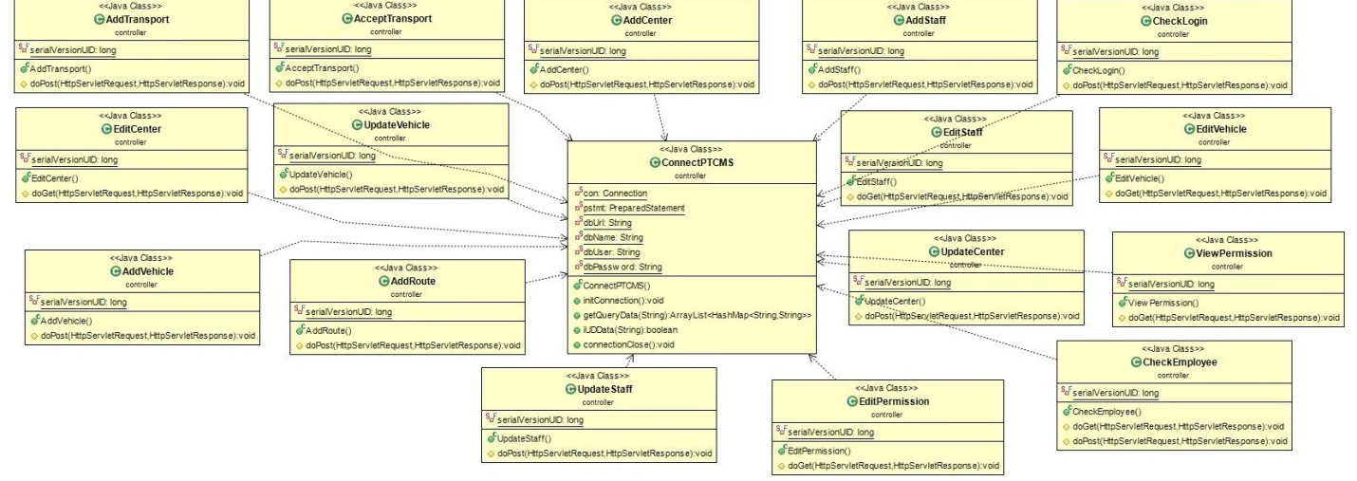

Figure Class diagram

Here the ConnectPTCMS class is the database connector and other query operation methods holder. Other classes is using its object to add or retrieve data.

## Use case diagram:

I have different type of actors in this project. The use case diagram based on actors is given below:

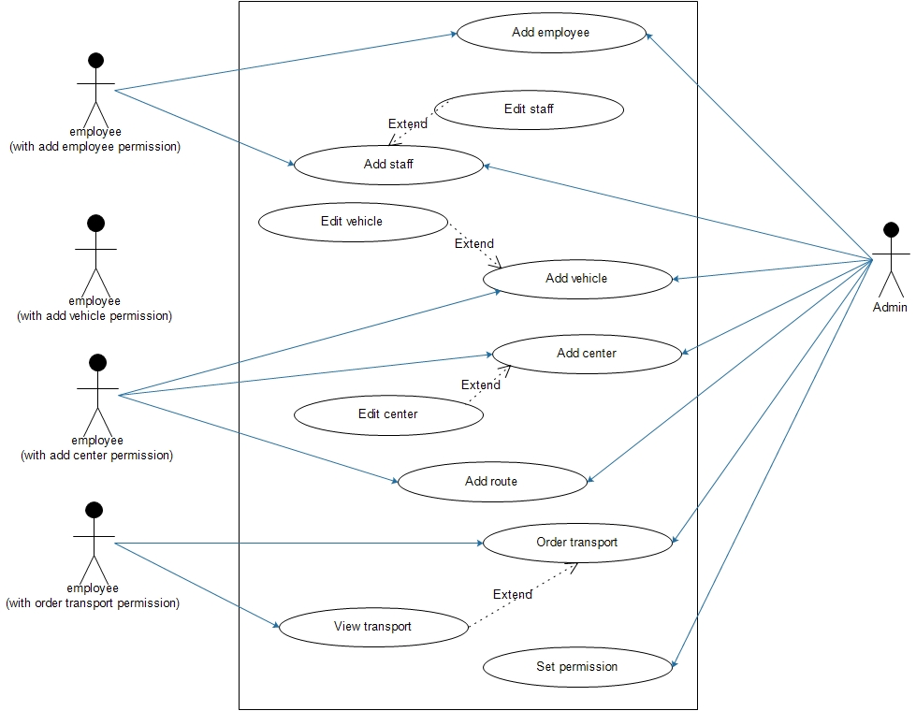

Figure 3 Use case diagram

Here the admin is allowed to access everything and other users are allowed to access according the permission is set by admin. User with add functionality can edit too.

## ERD:

Before providing the ERD 3rd NF normalization is given below:

|  |  |  |  |  |
| --- | --- | --- | --- | --- |
| UNF | level | 1st NF | 2nd NF | 3rd NF |
| eid  ename  etype  uname  password  address  email  phno  authorisedby  addvehicle  addemployee  ordertransportation  supervisor  sid  sname  stype  phno  address  staffstatus  vslno  vtype  costperkilo  status  vname  cid  cname  address  routeid  sendercenter  receivercenter  routename  routedesc  distances  **tid**  tdate  ttime  status  totalcost | 1  1  1  1  1  1  1  1  1  1  1  1  1  2  2  2  2  2  2  2  2  2  2  2  2  2  2  1  1  1  1  1  1  1  1  1  1  1 | **tid**  eid  ename  etype  uname  password  address  email  phno  authorisedby  addvehicle  addemployee  ordertransportation  supervisor  routeid  sendercenter  receivercenter  routename  routedesc  distances  tdate  ttime  status  totalcost  **tid**  sid  sname  stype  phno  address  staffstatus  vslno  vtype  costperkilo  status  vname  cid  cname  address | **tid**  eid  ename  etype  uname  password  address  email  phno  authorisedby  addvehicle  addemployee  ordertransportation  supervisor  routeid  sendercenter  receivercenter  routename  routedesc  distances  tdate  ttime  status  totalcost  **tid**  **sid**  sid  sname  stype  phno  address  staffstatus  **tid**  **vslno**  vslno  vtype  costperkilo  status  vname  cid  cname  address | center |
| **cid**  cname  address |
|  |
| vehicle |
| **vslno**  vtype  costperkilo  status  vname |
|  |
| staff |
| **sid**  sname  stype  phno  address  staffstatus |
|  |
| employee |
| **Eid**  ename  etype  uname  password  address  email  phno  authorisedby  addvehicle  addemployee  ordertransportation  supervisor |
|  |
| route |
| **routeid**  sendercenter*  receivercenter*  routename  routedesc  distances |
|  |
| transportation |
| **tid**  tdate  ttime  status  totalcost  eid*  routeid* |
|  |
| vehicletransport |
| **tid\***  **vslno\*** |
|  |
| stafftransport |
| **tid\***  **sid\*** |

Now the ERD is given below:

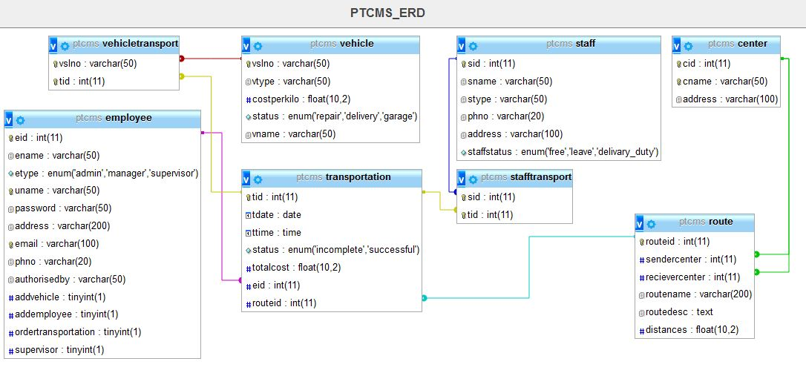

Figure ERD

## Sequential diagram:

The sequential diagram is separately provided for add center, add route, add vehicle, edit permissions and accept transport. The diagrams are given below:

### Add center:

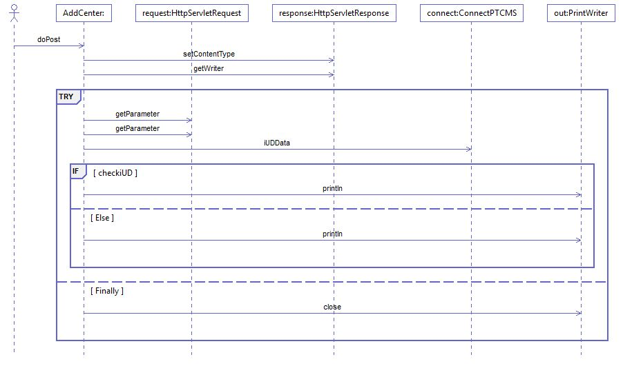

Figure Sequential diagram add center

### Add route:

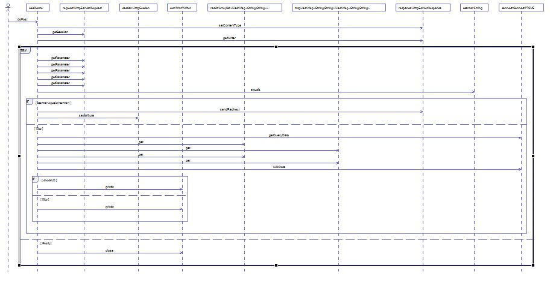

Figure Sequential diagram add route

### Add vehicle:

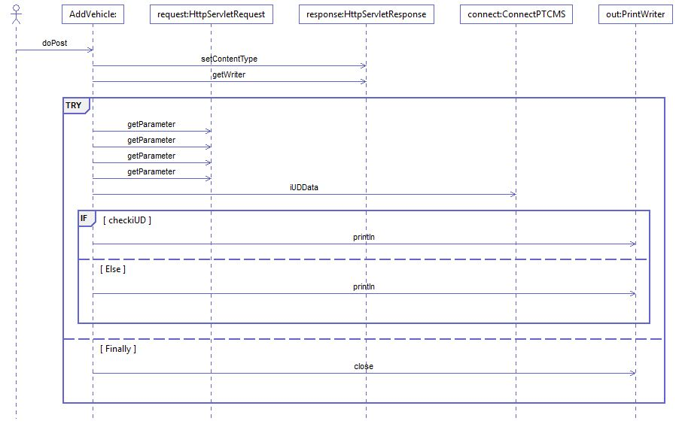

Figure Sequential diagram add vehicle

### Edit permission:

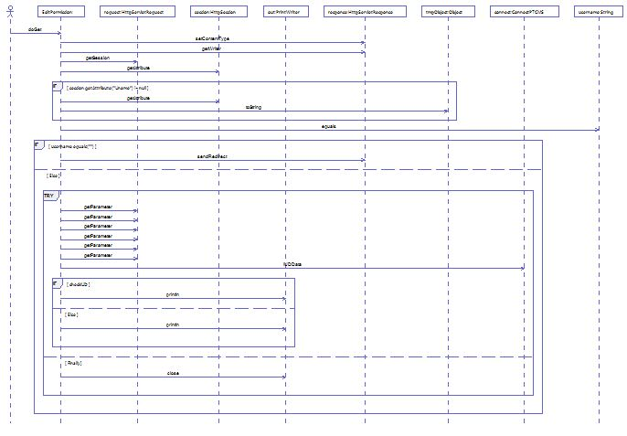

Figure Sequential diagram edit permission

### Accept transport:

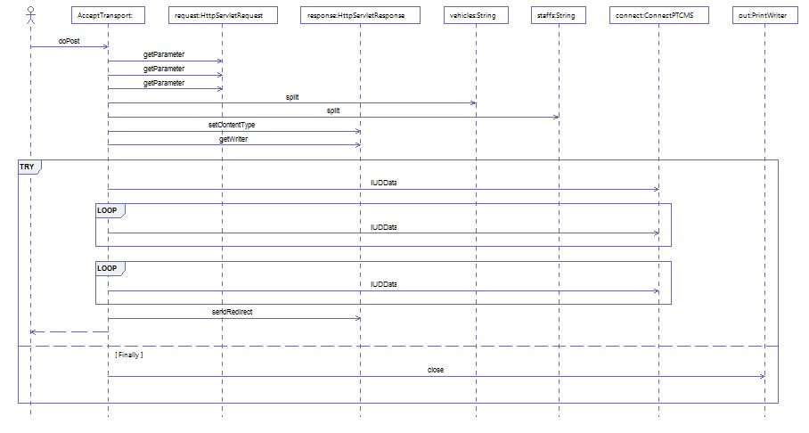

Figure Sequential diagram accept transport

Here the diagrams show that how the application server get the request and process the data sequentially from the web view part.

# Chapter-4: Implementation and testing

## Introduction:

In this chapter implementation and testing will be described. In implementation part language selection with its reason and development process are briefly described. On the other hand in testing part testing such as black-box testing, integration testing, unit testing and cross-browser testing have been shown.

## Language selection:

I have selected different languages for various purposes. They are:

* JSP: As web view with object-oriented concept
* HTML5: To get the latest feature of html
* CSS3: To get the latest feature of CSS
* Bootstrap 4 framework: To make the latest version of device comparative layout
* Mysql: To store and retrieve data from database.

## Development process:

I have followed MVC pattern to implement the project in code. The project is developed in apache-tomcat-8.5.4. I have used eclipse IDE for coding. I established connection with mysql by using JDBC driver. I have successfully tried to achieve my key milestones. The gantt chart is given below:

### Work breakdown structure:

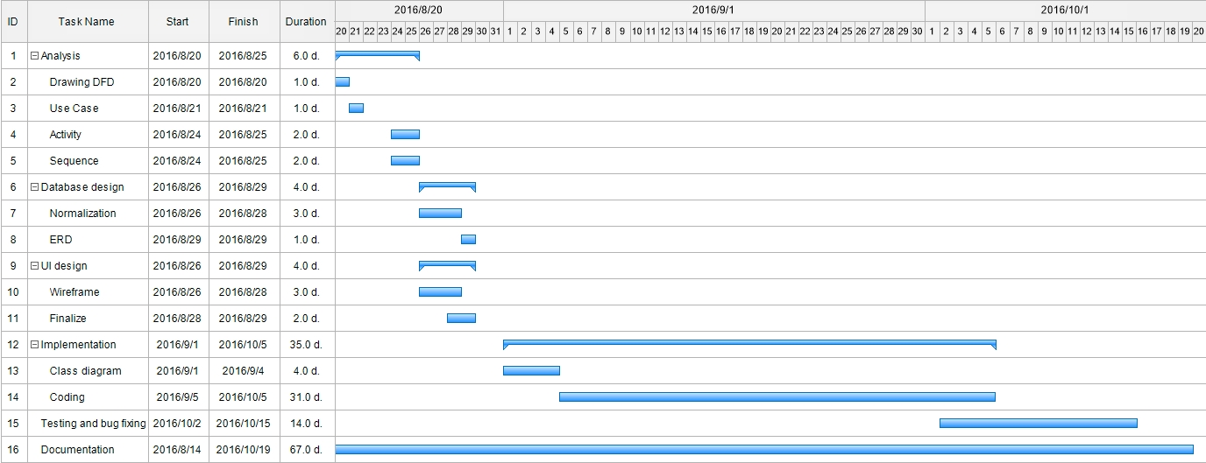

Figure 0 Gantt chart

The gantt chart shows the development procedure done by me. Finally I am providing .war file as implement on field. The code architecture of the major functionalities are given below:

### Code architecture add center:

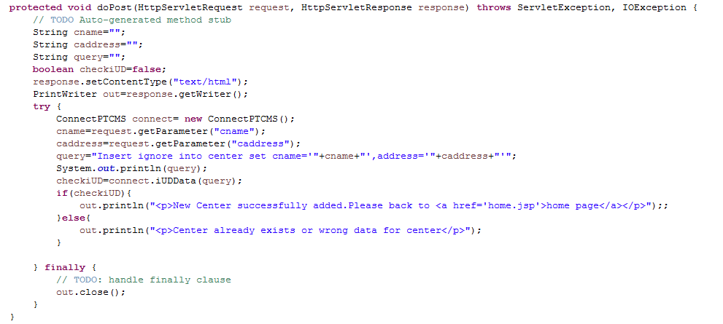

### Code architecture add route:

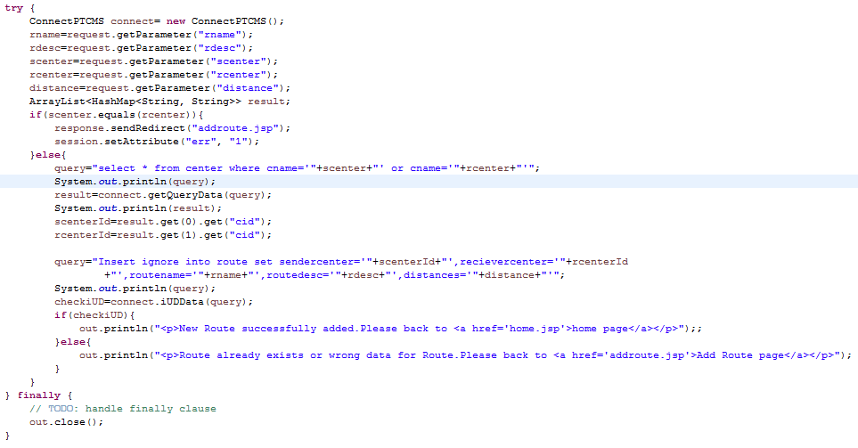

### Code architecture add vehicle:

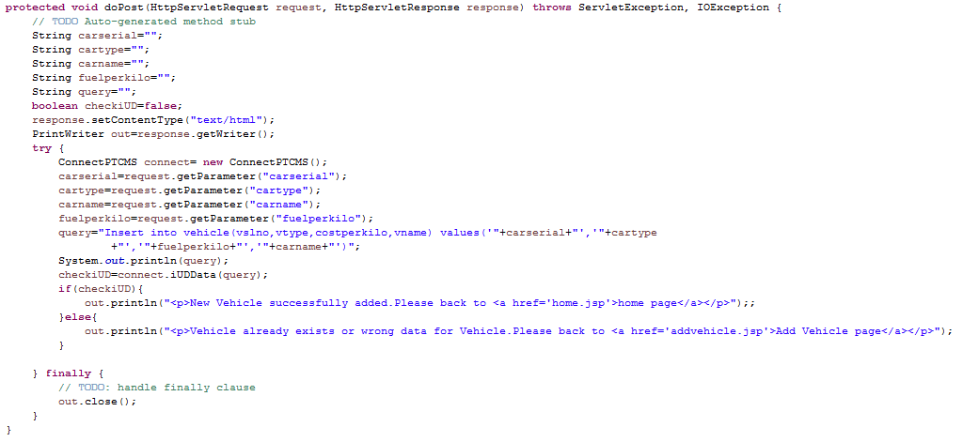

### Code architecture edit permission:

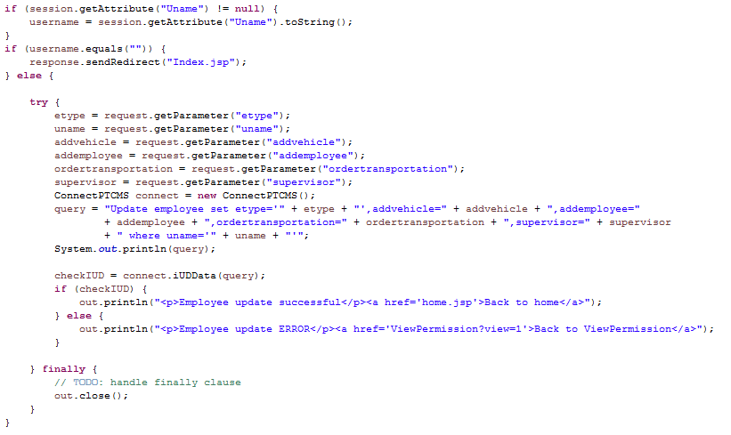

### Code architecture accept transport:

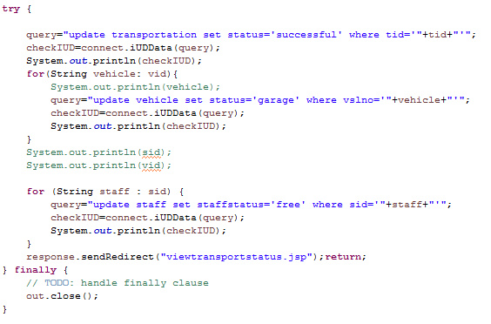

## Testing:

Testing is an important part of implementation. I have done black box, integration, cross broser and unit testing. They are given below:

### Black-box testing:

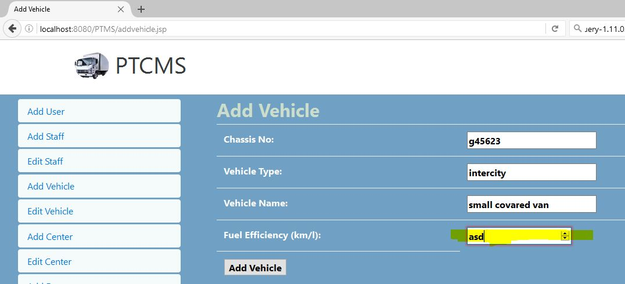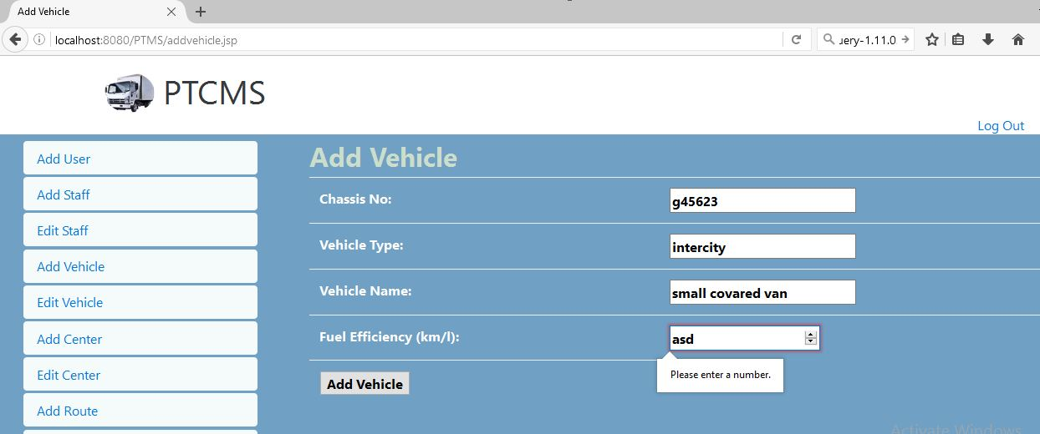

### Integration testing:

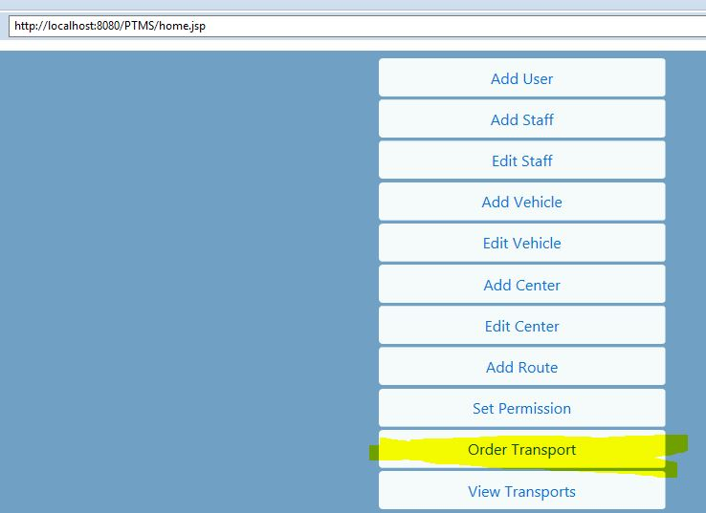

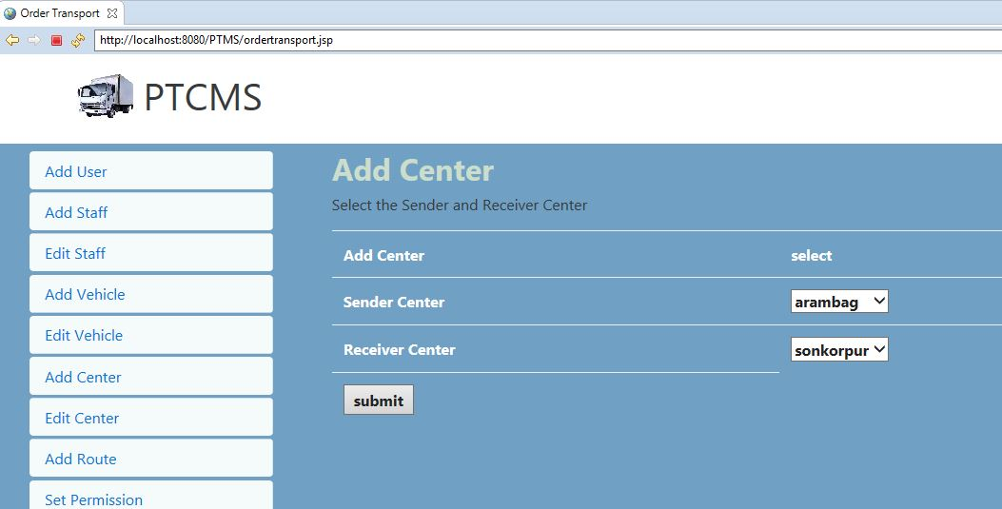

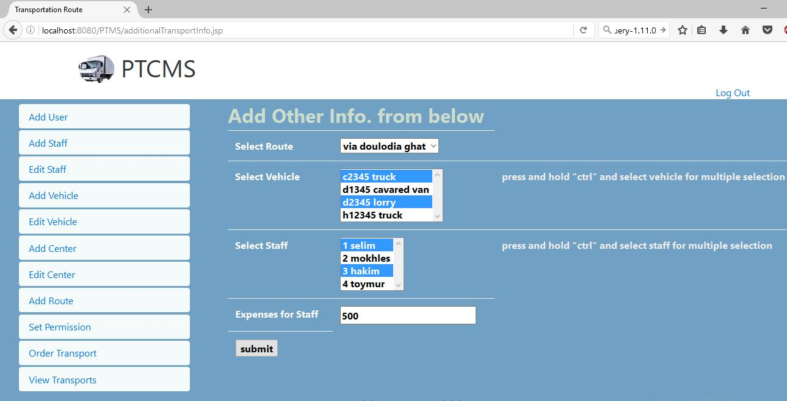

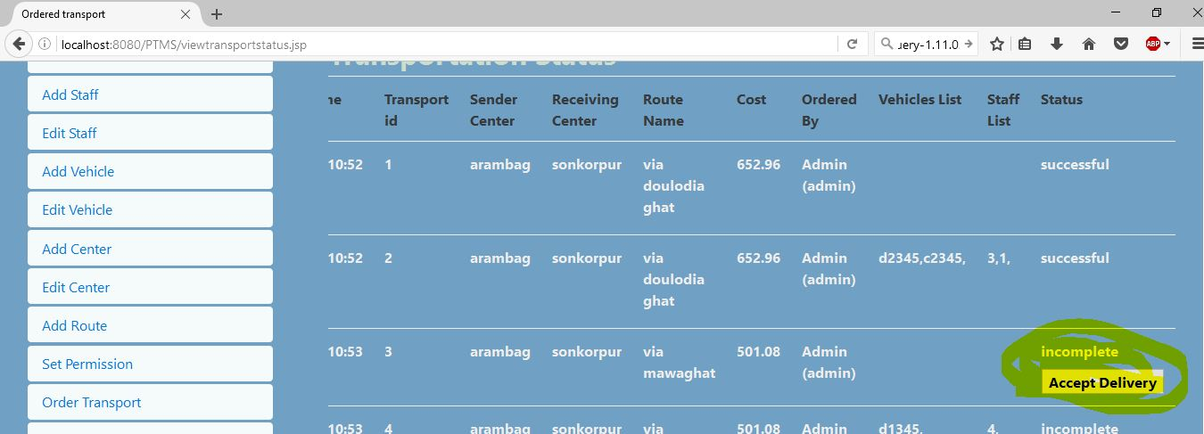

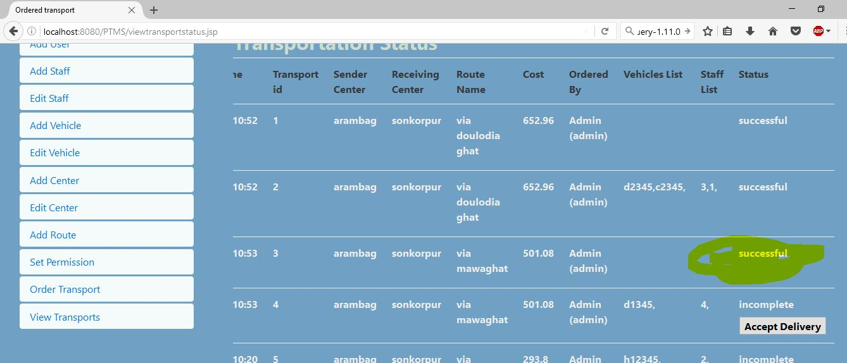

### Unit testing:

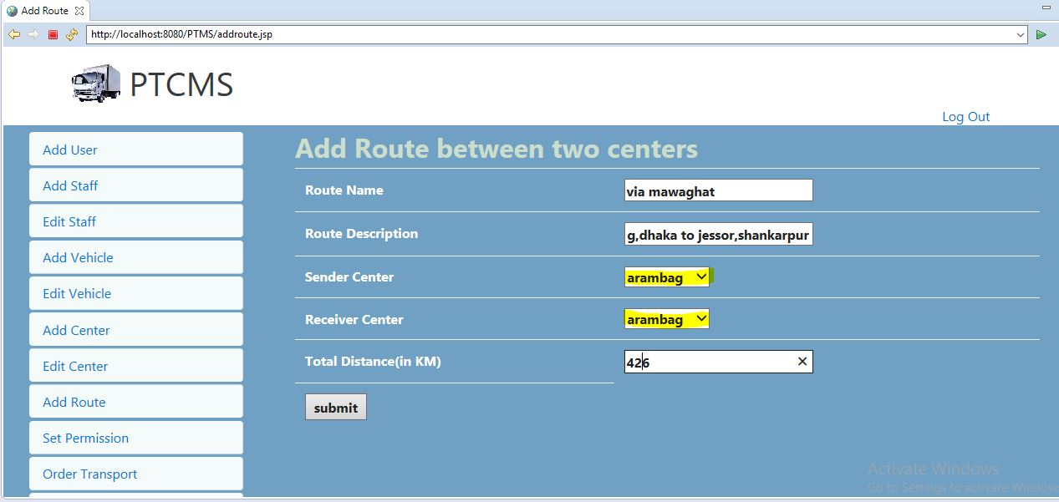

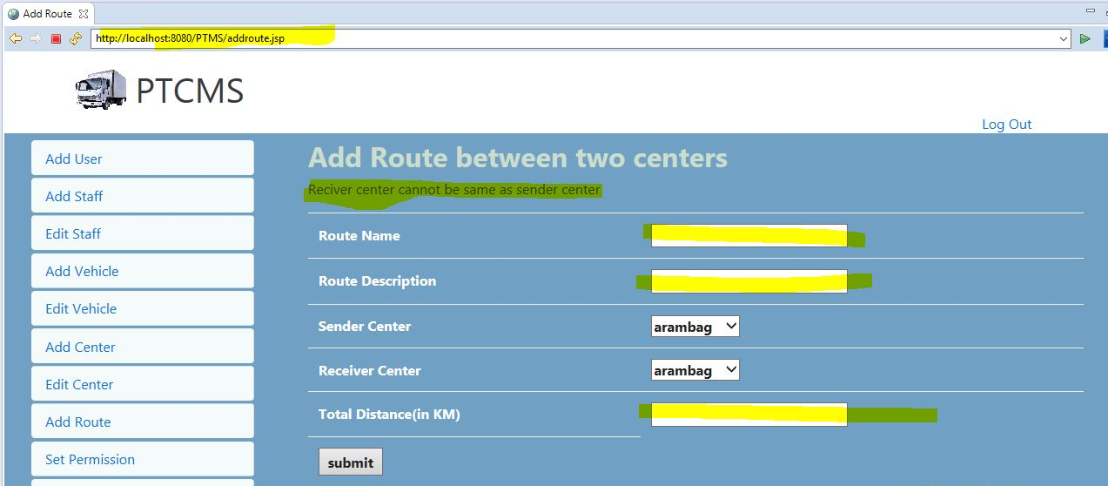

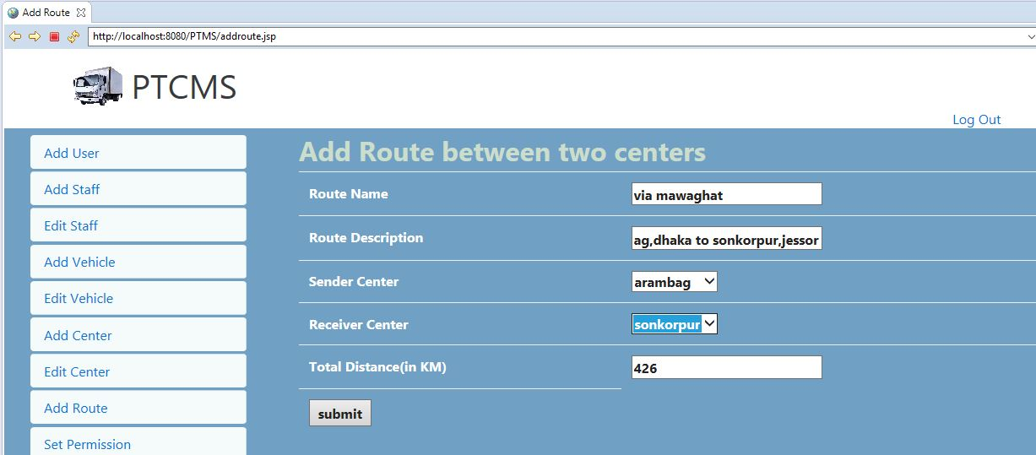

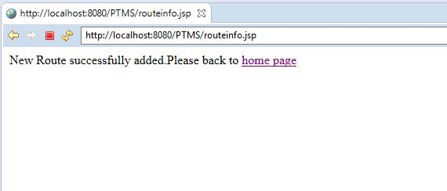

### Cross browser:

#### Mozilla:

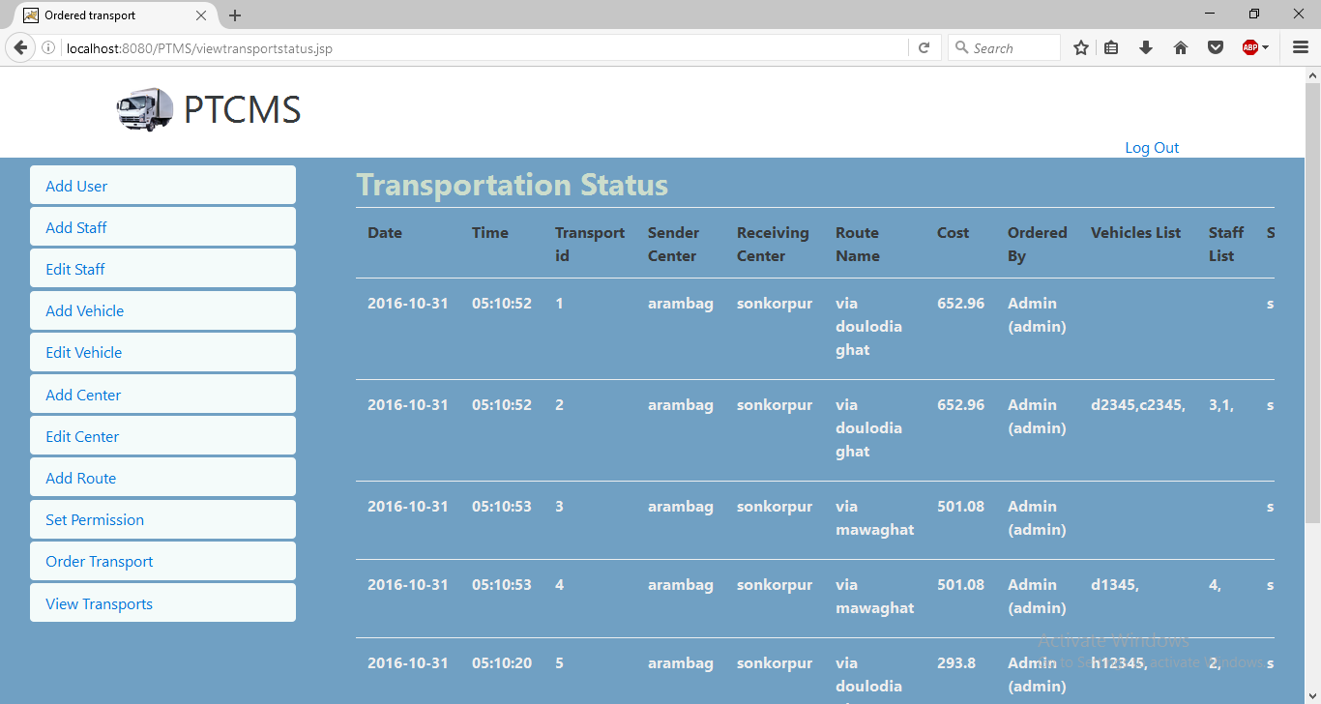

#### Chrome:

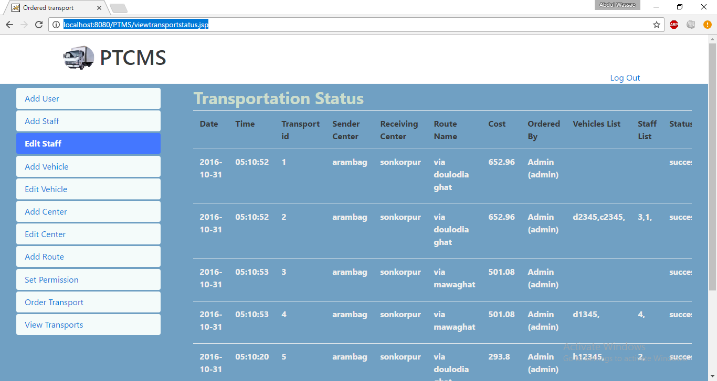

# Chapter-5: Critical evaluation

## Introduction:

In this chapter the project will be critically evaluated with strength and weakness checking. Here is also identified further development in future so that options can be added to improve its scope with better feature.

## Strength:

The strengths of the project are given below:

* Mobility of access as a web solution
* Fit for any kind of transportation
* No need to involve with production
* Well secured by maintaining level of access
* JSP is used as secured technology
* Extendable as Object-Oriented solution used
* Can be used for small or large organization

## Weakness:

The weaknesses of the project are given below:

* Not suitable for global market
* Need more features for large organization
* Any employee from same permission of different center can access features.
* Should not edit vehicle status if on delivery

## Performances:

There are different issues in performance. They are given below:

* Different browser shows some difference in UI.
* It is loading much faster as no customized javascript added.
* Server side validations perform page loading in any wrong input.

## Further development:

The following features can be added with this project

* Separated individual costs
* Actual cost, differences with estimated cost and its reason
* Repair and car maintenance cost should be added
* Transport time estimation as average speed of vehicle on specific route
* Cost for hired vehicle
* Display weekly, monthly, yearly cost report
* Identifying vehicle is in trouble on the way of transport

# Conclusion:

This project is only for local market. There are some bugs in the project which should be fixed. But it is a great work for any kind of transportation related companies. In future with additional extra features it can be a big business platform independent project and can take place in global market too.

# Appendix:

## Project proposal

### Introduction:

Bangladesh is a developing county and has involved with IT very recently. Some of its sectors are depend on IT but still most of the sectors are out of touch with IT. One of them is transportation management system. They use page and paper for every step of recording data and the process is too much lengthy and sometime they lost data for the loosing of paper and make a chance to be corrupted. So involving IT can be the better solution to overcome the challenges.

### Background study:

As the era of communication the world is getting smaller through transportation of goods. But for the developing countries such as Bangladesh are still using analog system in this sector. Different types of companies have different kind of policies and way of service for their product delivery. Sometimes it is quite difficult for the companies especially for the large one to maintain their vehicles during product distribution. Besides many of small company have no delivery vehicles and they depends on courier companies for their product distributions. But in Bangladesh the courier companies are using analog data entry using page and paper. They use mobile communication to know the delivery status but cannot record data for analysis. As they using page and paper calculating fuel, other cost per trip and maintenance cost over month and year. Many of time data is lost over damage on paper and quite impossible to keep and display report about daily, monthly and yearly delivery status.

On this circumstance I wish to provide a software solution for transportation management systems like ‘xcelerator’, ‘Sameday Courier Software’ etc. for those product transportation companies. Besides being many software solutions in this sector I wish to provide a completely separated transportation management system including the features given below:

* Can be fitted to any type of transportation services`
* No need to involve with production
* Route wise estimation of cost for each vehicle maintenance or trip
* Providing overall report about delivery status to sender and receiver.
* Analyzing fuel and maintenance cost
* Managing level of access as user category
* Take employ records per trip
* Tracking car activity and location
* Recipient-end delivery verification, keep data record and generate report if needed.

### Description:

To provide the solution, the system needs at least a sender and a receiver of product that can be considered as two centers or branches. The vehicles are categorized as their load capacity and their fuel costing are depends on their category. There will be basic cost estimation for each vehicle provided by admin. There are three kind of user in this system. They are-

* Admin
* Supervisor and
* Area Manager

Admin can add user, center, vehicle, staff, issue bills and their relevant information and view all kind reports. Supervisor can see all reports but cannot add anything. Area manager can see only report related to his center. The system will report about the status of vehicle as three situations ‘Busy on delivery’, ‘Free in garage’ and ‘Sent for repair’.

### Justification:

Project justification for the solution is given below:

**Economic benefit:**

The system is calculating the overall cost spent by staff per trip and compares it with the estimation given by admin. It will also generate report daily, weekly, monthly and yearly. So user can easily see and analysis for economic development of the organization. It also reduces employee cost and time to calculate transportation cost.

**Technological benefit:**

To implement the solution I like to use JSP. It is well secured and has less threat from external attacks. It also can integrate with JavaScript and HTML5 in the same application. For all kind of user I have used CSS with bootstrap 4 framework.

**Methodological benefit:**

In hard approach it works for the development a technological aspect priority. On the other hand soft approach follows human activities. To develop the system both is needed. So, Multiview methodology as combined hard and soft approach is preferable for this system.

### Project scope:

Project scope is the boundary that will be done within fixed time. As it is open to suit for all kind of transportation system all of its feature cannot be developed on short time. So the features provided as boundary are given below:

* Route wise estimation of cost for each vehicle maintenance or trip.
* Providing overall report about delivery status to sender and receiver.
* Analyzing fuel and maintenance cost.
* Managing level of access as user category.
* Take employ records per transport.
* Tracking individual vehicles about their repair or transport status.
* Recipient-end delivery verification, keep data record and generate report as user need.

### Aims:

The aims of the project are given below:

* Giving an overall costing idea on transportation of product to the company.
* Company will choose vehicle easily.
* Company can compare estimated cost with the actual cost to reduce corruption.
* Company can get confirmation of receiving product from center or user.
* Company can keep track for further more business issues and analysis.

### Objectives:

The objectives of the project are:

* Company will get suggestion about car for delivery easily.
* Show cost on transportation daily, weekly, monthly and yearly.
* Notification and confirmation from centers.
* Managing user access level to see report.
* Save time, money and labor to calculate costing.

### Key activities with time frame:

|  |  |  |  |
| --- | --- | --- | --- |
| **No.** | **Activity name** | **Start time** | **End time** |
| 1. | Understanding business scenario and objectives | Aug 14, 2016 | Aug 19, 2016 |
| 2. | Analysis scenario and system architecture | Aug 20, 2016 | Aug 25, 2016 |
| 3. | Design database | Aug 26, 2016 | Aug 31, 2016 |
| 4. | UI design | Aug 26, 2016 | Aug 31, 2016 |
| 5. | Implementation | Sept 01, 2016 | Oct 01, 2016 |
| 6. | Testing and Bug fixing | Oct 02, 2016 | Oct 15, 2016 |
| 7. | Documentation | Aug 14, 2016 | Oct 19, 2016 |

### Key milestone:

1. **Understanding business scenario and objectives:**
   * Collect data from companies via survey.
   * Interview with some people working on centers.
   * Understanding information about vehicle and its route
2. **Analysis scenario and system architecture:**
   * Drawing rich picture.
   * Drawing Data Flow Diagram.
   * Drawing Use Case Diagram.
   * Drawing Activity Diagram.
   * Drawing Sequence Diagram.
3. **Design database:**
   * Applying normalization.
   * Drawing ERD.
   * Create database and its tables.
4. **UI design:**
   * Drawing Wire Frame model
   * Analysis and finalizing UI components.
5. **Implementation:**
   * Drawing Class Diagram
   * Coding with javafx following the entire diagram used.
6. **Testing and Bug fixing:**
   * Create a test plan.
   * Test and find bug.
   * Fixing bug.
   * If bug fixing is not possible keeping it for further development.
7. **Documentation:**
   * Documenting about collected data.
   * Documentation about diagrams.
   * Documenting database and UI design.
   * Commenting on code.
   * Documentation on testing and its result.
   * Keep unsolved issues documented for further development.

### Work breakdown structure:



## Bibliography

*Agile*, [Online], Available: <http://agilemethodology.org/>.

*fr*, [Online], Available: <https://www.tutorialspoint.com/software_testing_dictionary/functional_requirements.htm>.

*methodology*, [Online], Available: <http://www.dictionary.com/browse/methodologies>.

*software_methodology*, [Online], Available: <http://www.itinfo.am/eng/software-development-methodologies/>.

*waterfall*, [Online], Available: <http://searchsoftwarequality.techtarget.com/definition/waterfall-model>.