Contents

Use Case 2

ERD 2

Class Diagram 2

# Use Case

# ERD

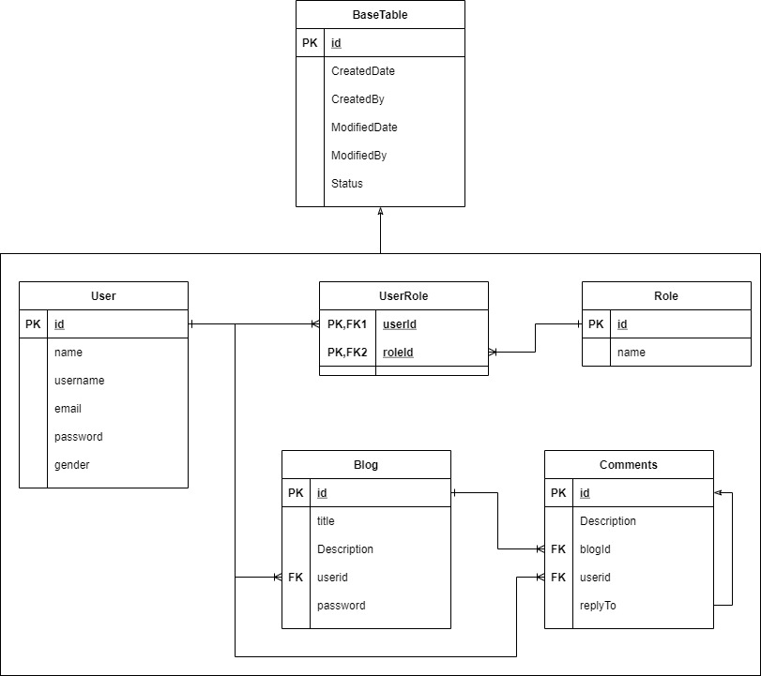

Figure : Conceptual ERD

# Class Diagram