Lloyd D’Silva 64858

Matei-Alexandru Lupașcu 64471

Yubing Chen 52915
Github link: https://github.com/iceyubing/ipai25.git

Abstract

Introduction
PM2.5 refers to fine particulate matter with a diameter less than or equal to 2.5 micrometers. In environmental science, it is considered one of the main indicators of air pollution, as it represents the excessive dispersion and suspension of particles in the air caused by human activities. In recent years, air pollution has become increasingly associated with public health, making PM2.5 a highly discussed and relevant topic.
For this topic, our project focuses on research analyzing which factors influence the PM2.5 index. Based on this core question, we have established several hypotheses, including: the number of vehicles per capita in a country, the population size, the percentage of forest coverage, and local weather parameters. We will analyze data to examine whether these factors have an impact on PM2.5 levels. Additionally, we will compare the national average PM2.5 index with the PM2.5 index of capital cities to investigate whether the index tends to be higher in capitals.
This first phase of the project aims to find one (or several) data sources that can further be passed through an entity matching process.
In this project, we will use five datasets: Global Weather Repository, Traffic List for Country, App Air Quality Database 2018, Forest Coverage List and Global PM2.5 (1998–2022). (Annex 1)
Global Weather Repository provides daily weather information for worldwide locations and for an exact period, such as temperature, precipitation, air quality, among others. with data sourced from Kaggle.
The Traffic List for Country provides data on the number of vehicles per capita for each city, sourced from Wikipedia.
The App Air Quality Database 2018 provides PM2.5 index data for various cities in each country, sourced from WHO Database.
The Forest Coverage List contains information about forest coverage and population for each country, with data sourced from Kaggle.
The Global PM2.5 (1998–2022) dataset provides the average PM2.5 levels for each country, sourced from Atmospheric Composition Analysis Group, Washington University in St. Louis, USA.
In this report, we will present and analyze the attributes and value of each dataset by Jupyter and Excel or some other tools. Identify and correct any existing errors (if any), and finally, we will attempt to analyze the research question “What factors influence PM2.5?” based on the data results.

Integration and Analytic Data Processing
First, we broke down each attribute from all previously collected datasets into more detailed, smaller tables, and clearly annotated the meaning of each attribute (see Annex 3 for details). Then, we re-integrated the data based on similar attributes and restructured the schema accordingly (the result is shown in Annex 5).
In this step, we organized and integrated similar data from different sources into unified dimension tables. For example, the Location table consolidates geographical information from the Global Weather, Forest Cover Rate, and Global Air Quality - Country datasets. Similarly, the Population_Coverage dimension combines population-related data from both the Forest Cover Rate and Global Air Quality - Country sources. (see the annex 4)
Furthermore, we integrate attributes from different data sources when they convey the same underlying meaning. In certain instances, different authors may adopt varying but equivalent terminology to describe the same attribute for distinct analytical purposes (see Annex 1).

Identity Resolution
Blocking strategy:
To efficiently compare and link records across multiple datasets (forest, air_city, air_country, weather, and traffic), we implemented a prefix-based blocking strategy. For both city and country attributes, we extracted the first three characters from normalized versions of these fields, creating standardized prefixes (e.g., "Portugal" → "por"). This approach reduces the comparison space by grouping records with identical prefixes before applying more computationally expensive similarity measures. We then computed intersections of these prefix sets across datasets to identify potential matches. This method ensures scalability while maintaining recall, as it focuses on subsets of data with high initial overlap. For country fields, the same logic was applied, enabling systematic cross-dataset linkage while minimizing false positives.
In the identity resolution phase of our project, we implemented a rule-based approach to match and link entities across different datasets. This approach leverages three distinct similarity metrics to ensure accurate and robust matching of country and city names. Each metric was chosen based on its strengths in handling specific types of variations in textual data.

1. Jaro-Winkler Similarity (Character-Based)
Description:
Jaro-Winkler measures similarity between two strings by comparing characters and their order, with a bonus for matching prefixes. It is highly effective for detecting minor spelling variations, abbreviations, or transpositions (e.g. "Algeria" vs. "Algerie").

Application:
We applied Jaro-Winkler to match country names across datasets where minor spelling differences or abbreviations were present. A threshold of 0.90 was set to ensure high confidence in matches.
Why did we use it:
This metric excels in cases where strings are similar but not identical, making it ideal for datasets with inconsistent formatting or truncations.
2. Levenshtein Distance (Edit Distance-Based)
Description:
Measures the minimum number of single-character edits (insertions, deletions, substitutions) needed to transform one string into another.
Application:
We set a max edit distance of 1 to catch typos or close variants. We initially established a threshold of 2, but we inspected the matched data and observed that many country names only differ by a small number of characters. Therefore, the initial threshold did not only include slightly misspelled names, but totally different countries as well.
Why did we use it:
Perfect for rigid, small-scale discrepancies where even a single character difference should be flagged.
3. Cosine Similarity with TF-IDF (Token-Based)
Description:
A token-based metric that treats strings as vectors of word tokens (using TF-IDF weighting) and computes the cosine of the angle between them. This captures semantic similarity beyond character-level differences.
Application:
Used for multi-word names (e.g., "Sao Tome and Principe") where word order or minor term variations exist. A threshold of 0.90 ensured high confidence matches.
Why did we use it:
Best for compound names or phrases where meaning matters more than exact spelling (e.g., "United Kingdom" vs. "UK" after normalization).
Implementation Workflow
Normalization: Lowercasing, removing accents/special characters.
Threshold Tuning: Balanced precision/recall (e.g., Jaro-Winkler’s 0.90 threshold avoids false matches like "Iran" vs. "Iraq").
Cross-Validation: Matches confirmed by multiple metrics, based on inspecting the matched data between the different sources.
This hybrid approach ensured robust matching across datasets with diverse naming conventions.

Data Cleaning
Due to the large volume of data, we also need to further filter the datasets to determine which parts are relevant to our report and should be retained, and which are irrelevant or redundant and should be removed (Result is shown in Annex 2).
Data was also normalized, in order to pass it through the matching process, in order to obtain more accurate metrics. Therefore, the normalization consisted of converting the country and city names to lower case, eliminating eventual special characters.

Data profiling and solution
Inside the notebook we applied Pandas Profiling for each dataset, after cleaning the columns beforehand. It was observed that the traffic, air_city, weather and air_country datasets do not contain any missing values. However, missing values were identified in the forest dataset. The following data frame highlights the missing values in the forest dataset and details the methods applied to address them, which were implemented in the dp.py file.

Therefore, we inspected the missing values and decided to eliminate some rows where data was missing from all of the columns corresponding to the forest percentage in each year. For one of the missing values, we decided to substitute the null value with the average of the other ones within the same row.

Data Fusion
Actual Scenarios
1. Inconsistent Country Names
Strategy Used: Trust your friends
To address inconsistencies in country names (e.g., "USA" vs "United States"), we applied the Trust your friends strategy by adopting a standardized naming convention based on a trusted authority, such as the ISO or World Bank. When conflicting variants were found, we retained the version used by the most reliable source. A mapping table was constructed (country_mapping.csv) to ensure consistency across all datasets.
2. Missing Country Data
Strategy Used: Pass it on
In the 52915 personal challenge dataset, certain anomalies were identified – for example, countries like the United States and other Western nations did not report GDP data for specific years, resulting in values of zero. To ensure factual accuracy and data integrity, we chose to remove such records. This approach aligns with the Pass it on strategy, which escalates unresolved conflicts by ignoring unreliable or insufficient data.
3. Missing Population Data
Strategy Used: Take the information
Two population-related datasets were used in this report. However, due to differences in source and data collection periods, the forest-cover-v1.csv dataset only included population data for the year 2020, while the GlobalPM25-1998-2022.csv dataset lacked this information entirely.
Given the structural requirements of the data mart, we applied the available 2020 population data to fill in the missing values for other years. This follows the Take the information strategy, classified as Instance-based, Avoiding, where non-null values are preferred over missing data.
Hypothetical Scenarios [There are examples code in notebook]
4. Population Data Conflict
Strategy Used: Keep up to date
Suppose two data sources provide conflicting population values for the same country and year:
- Source A (official, published 2020): 139 million
- Source B (third-party, published 2020): 138 million
In such cases, we would apply the Keep up to date strategy, classified as Metadata-based, Deciding, by selecting the most recently published or updated value, assuming it reflects the most accurate information.
5. Forest Coverage Conflict
Strategy Used: Meet in the middle
Consider three different sources reporting varying forest coverage values for the same country and year:
- Source A: 65.2% [2020]
- Source B: 64.8% [2020]
We would use the Meet in the middle strategy, classified as Instance-based, Mediating, to compute the average value (≈ 65%). This approach ensures a fair and neutral resolution of numerical conflicts.
6. Air Quality Data Conflict
Strategy Used: Trust your friends
When PM2.5 concentration data varies across sources with different levels of credibility:
- Source A (satellite-based estimation): 32.5 µg/m³
- Source B (ground-based monitoring station): 28.1 µg/m³
- Source C (academic model): 30.2 µg/m³
We apply a weighted average based on source reliability—assigning higher weight to ground-based data (e.g., 0.5), followed by satellite (0.3), and academic model (0.2). This reflects the Trust your friends strategy, classified as Metadata-based, Deciding, where data from more credible sources is prioritized in the fusion process.

Data Marts and Analysis
Building the Data Mart – SQLite

Our data mart is built upon an SQLite3-based data warehouse.
During the data preparation phase, we restructured the existing datasets to fit the warehouse architecture. Specifically, we separated the year attribute from other data fields, organizing it as an independent attribute to support a more normalized schema.
Subsequently, we constructed the data architecture (as illustrated in Annex 6) based on a fact table (PM2.5Regist) and multiple related dimension tables, following the star schema model. The data was integrated and loaded using SQLite3 Studio. (Due to size limitations, the PM2.5-city and GlobalWeatherRepository datasets were not imported into the database. Instead, they were processed separately as CSV files using Pandas.)

The data mart supports environmental, demographic, and socio-economic analysis across countries and years, enabling multi-dimensional insights into sustainability, public health, and development patterns for further research.
We compiled a list of example questions that can be answered using the data in the warehouse (Annex 7).
Data Analysis

The initial step involved loading several data tables from an SQLite database, ipai25.db, which serves as the project's data mart. A custom Python function, load_table_from_db, was developed to facilitate this process.
The following tables were successfully loaded:
- Country_information: Contains static information about countries, including Country, Country Code, Capital, Continent, and Area.
- PM2.5-Country: Provides PM2.5 concentration data per country and year.
- Forest_coverage: Contains data on forest area coverage by country and year.
- Trafficlist: Includes information on vehicle traffic rates and numbers per country and year.
- Population_coverage: Details population statistics, including total population, density, and coverage percentages.
A critical check was implemented post-loading to ensure that all essential dataframes were populated, preventing further analysis if any critical data was missing.
3. Data Preprocessing and Merging
3.1. Column Renaming and Standardization
Prior to merging, column names across all dataframes were standardized to ensure consistency and facilitate accurate joins. This involved stripping whitespace and newline characters and replacing multiple spaces with single spaces. [Specified in the Jupyter Notebook]
3.2. In-depth Cleaning of Merge Keys
A dedicated function was applied to the 'Country' and 'Year' columns across all relevant dataframes. This function performed stripping leading/trailing whitespace, replacing non-breaking spaces with standard spaces, normalizing Unicode characters to their closest ASCII representation to resolve encoding inconsistencies, and converting 'Year' columns to string type to ensure consistent merging behavior.
3.3. Merging Dataframes
The cleaned dataframes were merged sequentially into a single analytical dataframe, df_analysis, primarily using 'Country' and 'Year' as common keys. An inner join was used for df_pm25_country and df_country_info to retain only matching records, while left joins were used for other dataframes (df_population_coverage, df_forest_coverage, df_traffic_list) to preserve all PM2.5 records and append relevant information where available.
4. Debugging for Trafficlist Data
During the merging process, it was observed that the Rate_per_1000 and Vehicles columns from the Trafficlist table contained a high number of NaN values in the merged df_analysis. A targeted debugging effort was undertaken to investigate this data sparsity.
Targeted Debugging Example (India, 2015)
To confirm the root cause, a specific example (India, 2015) was examined. Both df_pm25_country and df_traffic_list contained data for this specific country-year combination, and their 'Country' and 'Year' columns were confirmed to be of object (string) dtype with consistent raw values. This confirmed that the cleaning and type conversion steps were effective for these specific instances and that the NaN values were indeed due to a lack of corresponding data in the Trafficlist for many country-year combinations present in the PM2.5-Country data.
5. Analysis and Visualizations
5.1. Analysis 1 - The Influence of the Number of Vehicles on PM2.5
Despite an initial hypothesis of a positive correlation, the data revealed a moderate and statistically significant inverse relationship between the vehicle rate per 1000 people and PM2.5 concentrations (Pearson correlation: -0.41, p-value: 0.000). This suggests that as the vehicle rate increases, PM2.5 tends to decrease. However, it's important to note that the vehicle rate only explains about 17.2% of the variation in PM2.5 levels, indicating that many other factors are at play. This counter-intuitive finding could be attributed to data limitations, effective pollution mitigation strategies in countries with higher vehicle rates, or the more dominant influence of other environmental and industrial factors.
5.2. Analysis 2 - Influence of Population on PM2.5
For this analysis, the visualizations indicate a nuanced relationship between population and PM2.5. While the box plot suggests that higher population density generally correlates with increased PM2.5 levels, the scatter plots show that total population alone is not a straightforward predictor. The relationship is complex, with significant regional variations (e.g., Asia showing higher PM2.5 in large populations, similarly Oceania has lowest PM2.5 independently of the country’s population) and other factors likely influencing air quality.
5.3. Analysis 3 - Influence of Forest coverage on PM2.5
For the third analysis, the visualizations suggest a moderately weak negative correlation between forest area percentage and PM2.5 concentration (Pearson correlation: -0.28, p-value: 0.000). The scatter plot shows a general tendency for PM2.5 to be slightly lower in countries with higher forest coverage, but the relationship is not very strong, and there is considerable scatter. While plotting the forest coverage area on top of the PM2.5 average values of the first five countries in our data mart, we have noticed that constant forest coverage areas could lead to both increases and decreases in the PM2.5 index, as other attributes contribute as well. However, in countries such as Albania or Algeria, where there is clear evidence of a forestation tendency in the last years, the values of PM2.5 have been moderately decreasing.
5.4. Analysis of the difference between the capital of a country and the other cities, in terms of average PM2.5 values
The analysis indicates that PM2.5 concentrations are generally elevated in capital cities, aligning with the hypothesis that densely populated areas experience higher pollution. However, a notable number of countries deviate from this pattern, displaying higher PM2.5 levels in non-capital cities. Our interactive visualization further highlights this, revealing Beijing, China, with the most significant positive difference (capital > other cities) and Thimphu, Bhutan, with the most substantial negative difference (capital < other cities).
5.5. Time Series analysis between PM2.5 and Temperature
The time series suggests a tendency for PM2.5 to be higher in colder months (autumn/winter) and lower in warmer periods (late summer/early autumn, early spring), indicating a potential inverse relationship with temperature. Temperature follows a typical seasonal pattern, decreasing into winter and increasing towards spring. While PM2.5 shows considerable short-term fluctuation, its overall levels appear to rise as temperatures fall and decline as temperatures rise. However, this observation doesn't confirm causation, and other factors likely influence PM2.5.

Conclusions

Annex
Annex 1
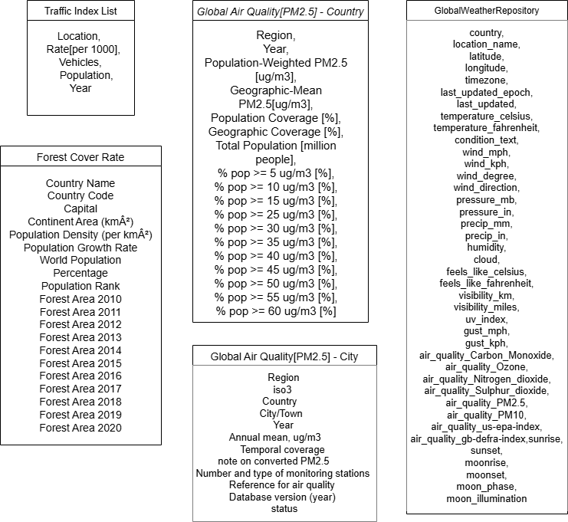

Annex 2

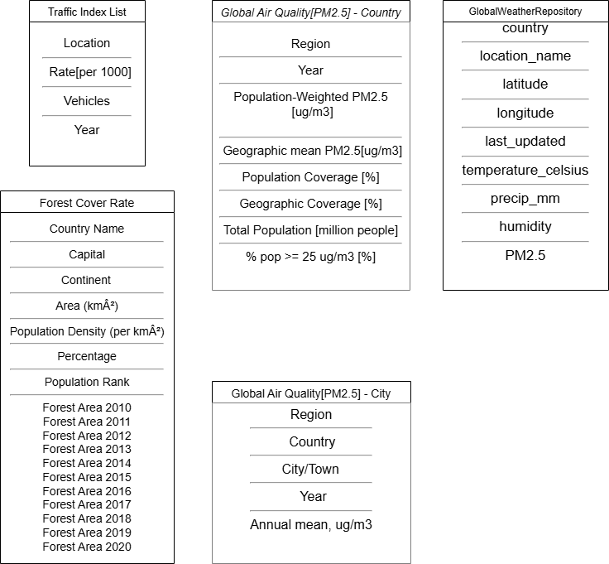

Annex 3
Description of Data Structures
1. Traffic index Table
The Traffic index Table refers to the total count of motor vehicles that have been officially registered with the appropriate government or transportation authorities within a country, region, or city. This includes passenger cars, motorcycles, buses, trucks, and other motorized vehicles that are legally permitted to operate on public roads.

field | Description | Type of date | exemple
Location | Name of the country | Text | Lisbon
Rate[per 1000] | Vehicles per 1,000 people | Numeric | 1059
Vehicles | Total number of motor vehicles in a country | Numeric | 158658
Year | Reporting year | Numeric | 2018

2. Forest Cover Rate
Location Table
Field | Description | Data Type | Example
country_name | Name of the country | Text | Brazil
capital | Capital of the country | Text | Brasília
continent | Continent of the country | Text | South America
area_km2 | Area of the country in square kilometers | Numeric | 8515767
The Location Table contains information about the location of the corresponding forest cover rate data. It has attributes such as country, capital, continent, longitude and area. This data will be important for easily identifying a location.Population Table
The Population Table contains information about the population of the corresponding country in the dataset. It has attributes such as density, world population percentage and global rank.
Field | Description | Data Type | Example
population_density | Population density per km² | Numeric | 25.2841
population_percentage | World Population Percentage | Numeric | 2.7
population_rank | Population rank | Numeric | 7

Forest Coverage Table
The Forest Coverage Table holds information regarding the percentage of forest areas in each corresponding country during ten consecutive years. It has attributes such as the percentage of forest area and the year when the percentage was registered.
Field | Description | Data Type | Example
forest_area | Percentage of forest area | Numeric | 61.20748157
year | The year when the data was collected | Numeric | 2010

3. Global Air Quality[PM2.5] - Country

The Global Air Quality [PM2.5] Table contains information about PM2.5 pollution levels and population exposure in the corresponding countries. It includes attributes such as population-weighted PM2.5, geographic mean PM2.5, population coverage and total population.

3.1. Location Table: The Location table provides details about the country and the year for which the data is recorded, including the name of the region (country) and the specific year of the data.

Field | Description | Type of date | Example
Region | Name of the country | Text | Portugal
Year | Year of the data | Numeric | 1998

3.2. Air Quality Information - country Table: The Air Quality Information table includes data on PM2.5 pollution levels, such as the population-weighted concentration of fine particulate matter (PM2.5), the geographic-mean concentration of PM2.5 and the percentage of the population exposed to high concentrations of PM2.5.

Field | Description | Type of date | Example
Population-Weighted PM2.5 [ug/m3] | Avg conc. of fine particulate matter (PM2.5) that the population is exposed to weighted by population density | Numeric | 13.6
PM2.5[ug/m3] | Denotes the mean annual concentration of PM2.5 in the region, without considering population distribution | Numeric | 11
% pop >= 25 ug/m3[%] | Specifies the percentage of the population exposed to PM2.5 concentrations exceeding 25 micrograms per cubic meter | Numeric | 19.4

3.3. Population and Coverage Information Table: The Population and Coverage Information table contains data on the total population of the country, as well as the percentage of the population included in the exposure assessment and the geographic area covered by the PM2.5 monitoring.

Field | Description | Type of date | Example
Population Coverage[%] | Indicates the percentage of the region's population included in the PM2.5 exposure assessment. | Numeric | 100
Geographic Coverage [%] | Reflects the proportion of the region's total land area covered by the PM2.5 monitoring or estimation. | Numeric | 100
Total Population [million people] | Total population of the country | Numeric | 10.124

4. Global Air Quality[PM2.5] - City
Location Table
The Location Table contains information about the location of the registered annual mean values of the PM2.5 concentration in the atmosphere within the Global Air Quality[PM2.5] - City table. It has attributes such as region, country and city name where the data was collected.

Field | Description | Data Type | Example
region | World region of the country | Text | Europe (LMIC)
country | Country of the city | Text | Romania
city_town | Name of the city or town | Text | Cluj-Napoca

Air Quality Information - city Table

The Air Quality Information - city Table contains information about each annual mean value of the PM2.5 concentration in the atmosphere along the year when the data was updated. It has attributes such as the year and the annual mean value of PM2.5 concentration measured in µg/m³.

Field | Description | Data Type | Example
year | Year of the data | Numeric | 2015
annual_mean_pm25 | Annual mean PM2.5 concentration (µg/m³) | Numeric | 17

5. Global Weather Repository

The Global Weather Repository Table contains information about the weather conditions in the capital city of each country. It includes attributes such as temperature, precipitation, humidity, and the last update timestamp.

5.1. Location Table: The Location table provides details about the country and its capital city, including the name, geographical coordinates (latitude and longitude) and the capital's location name.

Field | Description | Type of date | Example
country | Name of the country | Text | Portugal
location_name | Name of the city | Text | Lisbon
latitude | Latitude of the capital | Float | 38.72
longitude | Longitude of the capital | Float | -9.13

5.2. Weather Conditions: The Weather Conditions table includes data about the current weather in the capital city, such as the temperature (in Celsius), the amount of precipitation (measured in millimeters), and the humidity level in the capital. The Data Update Information contains the timestamp of when the weather data was last updated, providing context on the freshness of the information.

Field | Description | Type of date | Example
temperature_celsius | Temperature of the capital | Number | 21
precip_mm | Refers to the amount of precipitation (rain, snow, or other forms of moisture) measured in millimeters (mm) in the capital. | Float | 0.8
humidity | Humidity in the capital | Numeric | 69
last_updated | Date & time when the data was last updated | Date and time | 29-08-2023 10:30

Annex 4

Origin Dataset | From | Target | Type Corresp. | Description
Global air quality [PM2.5]-Country | Air_quality_contry_Region | Location_Country | 1:1 | Name of the country
Forest Cover Rate | Forest_Country Name | Location_Country | 1:1 | Name of the country
Global weatherRepository | Weather_location_name | Location_City | 1:1 | Name of the city
Air_quality_city | Air_quality_city_City/Town | Location_City | 1:1 | Name of the city
Forest_coverge | Forest_coverge.capital | Location.capital | 1:1 | Name of the capital
Forest_coverge | Forest_coverge.polulation_density | Population_coverage.polulation_density | 1:1 | The population density of the country
Forest_coverge | Forest_coverge.population_rank | Population_coverage.rank | 1:1 | The rank of the population
Global weatherRepository | Global weatherRepository.polulation_converge | Population_coverage. polulation_converge | 1:1 | the percentage of the region's population included in the PM2.5 exposure assessment.
Global weatherRepository | Global weatherRepository.Total_population_million | Population_coverage. Total_population_million | 1:1 | Total population of the country
Forest_coverge | Forest_coverge. area_km2 | Location. area_km2 | 1:1 | Area of the country
Forest_coverge | continent | Location. continent | 1:1 | Name of the continent
Global weatherRepository | Global weatherRepository.latitude | Location.latitude | 1:1 | Latitude
Global weatherRepository | Global weatherRepository.longitude | Location.longitude | 1:1 | Longitude
Global air quality [PM2.5]-Country | Global air quality [PM2.5]-Country.region | Location.Region | 1:1

ANNEX 5

