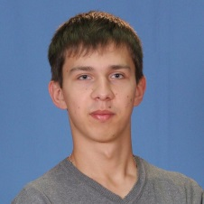

**Ivan Chaban**

Tel: +38 066 933 60 21

E-mail: zanusilker@gmail.com

Skype: zanusilker

Date of birth: 17/02/1997

City: Kharkov, Poltava

**Github: https://github.com/zanusilker**

**Objective**

Junior WEB developer position Telecommuting

**Technical Skills**

Programming languages: JavaScript, Python

# Additional technologies: HTML, CSS, Bower, SASS, SCSS, PostCSS, ES6, jQuery, Bootstrap, Ajax, ReactJS, Responsive Web Design

Development Environments and Tools: PHPStorm, Atom, Sublime text 3, Photoshop

Source Control: GIT

Databases: MySQL

Build Systems: Gulp

Methodologies: BEM

**Foreign languages**

English-Pre-Intermediate

**Education**

**Poltava National Technical University named after Yuri Kondratyuk, Poltava, Ukraine** 2016 - present time

Oil-gas and nature management

Additional education

|  |  |
| --- | --- |
| A-Level "Development Basics" Kharkov, Ukraine | 06.2016 – 08.2016 |
| A-Level "Front-end" Kharkov, Ukraine | 06.2016 – 09.2016 |