Download python 2.7.12 from <https://www.python.org/downloads/>

1. Install to C:\

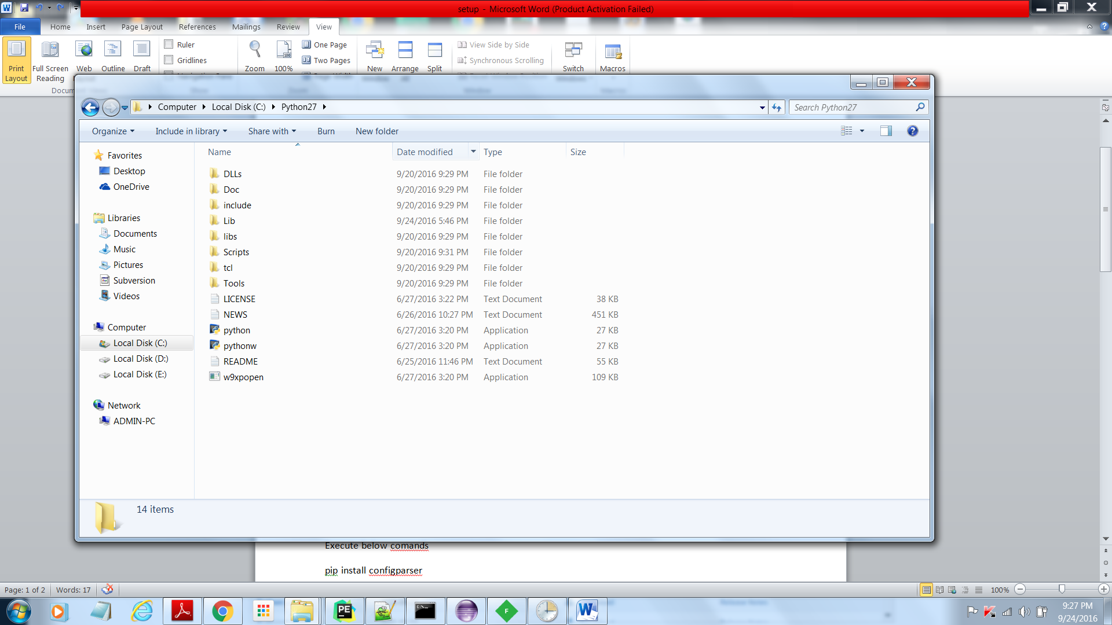

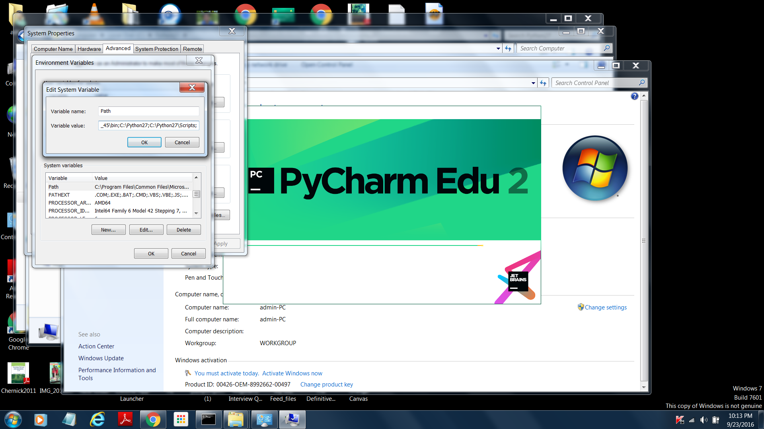

1. Add python.exe & pip.exe to path variable .See above screenshot

Check python is working or not by executing

**python –V**

in command prompt

1. Execute below commands for below 2package installations

pip install configparser

pip install requests

pip install re

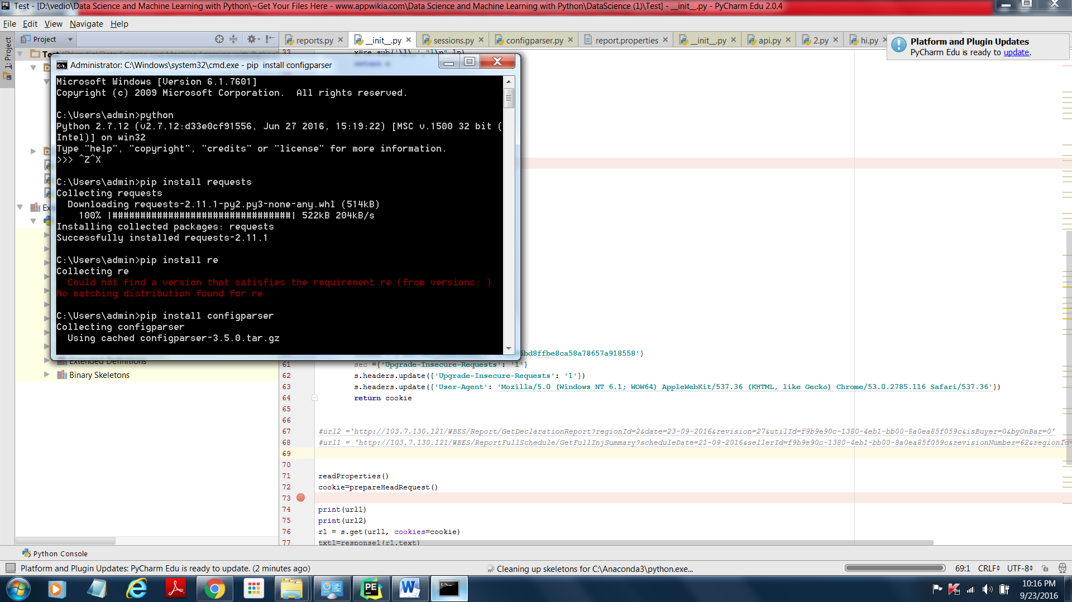

1. Download from github and copy to D:\ReportsInPython-master

<https://github.com/ichaitu4u/ReportsInPython>

