Statistical Analysis and Predictive Modeling in R
Predicting Passenger Survival on the Titanic Using Logistic Regression
Data Analyst Internship — Week 3 Assignment
Tool: R (base R + tidyverse) in Posit Cloud

1. Introduction and Dataset Rationale
This report documents a complete statistical analysis and predictive modeling workflow carried out in R, using the Titanic passenger dataset (891 observations, 13 variables, sourced from the well-known Kaggle Titanic competition). The dataset was selected for three reasons.
- Suitability for classification: the outcome variable, Survived, is binary, making it well suited to logistic regression, a core technique for classification problems in R.
- Mixed predictor types: the dataset contains categorical variables (Sex, Pclass, Embarked), continuous variables (Age, Fare), and derivable engineered features (FamilySize, Cabin_Known), giving scope for a range of hypothesis tests and diagnostic checks.
- Continuity with prior internship work: this dataset was already cleaned and explored in Weeks 1–2 of the internship (initial exploration and data cleaning), so Week 3 extends that foundation into formal inferential statistics and predictive modeling rather than starting from scratch.
The analysis proceeds in five stages: data preparation, exploratory hypothesis testing, model building with cross-validation, diagnostic evaluation, and interpretation of results with recommendations for improvement.

1.1 Data Preparation
Before modeling, categorical variables were converted to factors, missing Age values (177 of 891 records) were imputed using the median Age within each Pclass × Sex subgroup (a more accurate approach than a single overall median, since age distributions differ meaningfully across class and sex), and two missing Embarked values were assigned the modal port ("S"). A FamilySize feature was engineered as SibSp + Parch + 1 to capture total family unit size in a single variable.
titanic$Survived <- as.factor(titanic$Survived)
titanic$Pclass <- as.factor(titanic$Pclass)
titanic$Sex <- as.factor(titanic$Sex)
titanic$Embarked <- as.factor(titanic$Embarked)

titanic <- titanic %>%
group_by(Pclass, Sex) %>%
mutate(Age = ifelse(is.na(Age), median(Age, na.rm = TRUE), Age)) %>%
ungroup()

titanic$Embarked[titanic$Embarked == "" | is.na(titanic$Embarked)] <- "S"
titanic$FamilySize <- titanic$SibSp + titanic$Parch + 1
Verification confirmed zero remaining missing values across all modeling variables.

2. Exploratory Statistical Analysis: Hypothesis Testing
Before including any predictor in the model, its association with the outcome was tested formally. Categorical predictors were tested against Survived using the chi-square test of independence; the continuous predictor Age was first checked for normality (Shapiro–Wilk test) to determine whether a parametric or non-parametric group comparison was appropriate.

2.1 Categorical predictors vs. Survival (Chi-square tests)
Test | Hypotheses | χ² | df | p-value | Conclusion
Sex vs Survived | H0: independent | 260.72 | 1 | < 2.2e-16 | Reject H0 — strong association
Pclass vs Survived | H0: independent | 102.89 | 2 | < 2.2e-16 | Reject H0 — strong association
Embarked vs Survived | H0: independent | 25.96 | 2 | 2.30e-06 | Reject H0 — significant association

chisq.test(table(titanic$Sex, titanic$Survived))
chisq.test(table(titanic$Pclass, titanic$Survived))
chisq.test(table(titanic$Embarked, titanic$Survived))
[ PASTE SCREENSHOT HERE: Console output of the three chi-square tests ]

2.2 Normality check on Age (Shapiro–Wilk)
Group | W statistic | p-value | Conclusion
Died | 0.940 | 4.79e-14 | Not normally distributed
Survived | 0.980 | 1.17e-04 | Not normally distributed
Since both groups depart significantly from normality (p < 0.05 in both cases), the non-parametric Wilcoxon rank-sum test was used instead of an independent-samples t-test to compare Age and Fare across survival groups. This choice — non-parametric test in response to a failed normality assumption — is an important methodological justification for the report.
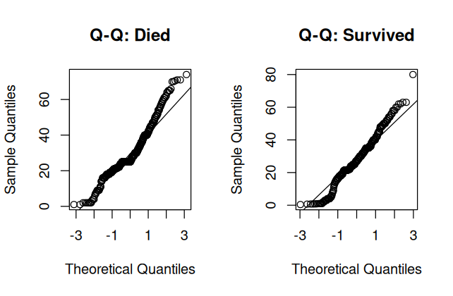
Figure 1. Q–Q plots of Age for passengers who died (left) vs. survived (right). Both show visible departure from the reference line, consistent with the Shapiro–Wilk results.
shapiro.test(titanic$Age[titanic$Survived == "Died"])
shapiro.test(titanic$Age[titanic$Survived == "Survived"])

2.3 Group comparisons (Wilcoxon rank-sum test)
Test | W statistic | p-value | Conclusion
Age by Survived | 98172 | 0.250 | Not significant — age alone does not separate groups
Fare by Survived | 57806 | < 2.2e-16 | Highly significant — survivors paid higher fares
The Age result is a useful discussion point: although age shows no significant marginal association with survival, this does not mean age is irrelevant. It may interact with, or be confounded by, Sex and Pclass — for example, the well-documented "children and women first" evacuation pattern would only be visible once age is considered jointly with sex and class, not in isolation. This motivates including Age in the multivariable model even though its univariate test was non-significant.
wilcox.test(Age ~ Survived, data = titanic)
wilcox.test(Fare ~ Survived, data = titanic)
[ PASTE SCREENSHOT HERE: Console output of the two Wilcoxon tests ]

2.4 Correlation check among numeric predictors
 | Age | Fare | FamilySize
Age | 1.000 | 0.123 | -0.258
Fare | 0.123 | 1.000 | 0.217
FamilySize | -0.258 | 0.217 | 1.000
All pairwise correlations among the numeric predictors are well below 0.3, indicating no serious multicollinearity concern at this stage. This was later confirmed formally with variance inflation factors after the model was fitted (Section 3.3).

3. Model Building

3.1 Train/Test Split
The data were split into training (80%, n = 712) and held-out test (20%, n = 179) sets, stratified by the outcome variable to preserve the survival rate proportion in both sets (base R sampling was used, as the caret package's createDataPartition() could not be installed in this Posit Cloud session — see Section 6.1). A random seed of 42 was set for full reproducibility.
Set | % Died | % Survived
Training (n = 712) | 61.7% | 38.3%
Test (n = 179) | 61.5% | 38.5%
set.seed(42)
died_idx <- which(titanic$Survived == "Died")
survived_idx <- which(titanic$Survived == "Survived")
train_died <- sample(died_idx, size = floor(0.8 * length(died_idx)))
train_survived <- sample(survived_idx, size = floor(0.8 * length(survived_idx)))
train_index <- c(train_died, train_survived)
train_data <- titanic[train_index, ]
test_data <- titanic[-train_index, ]

3.2 Logistic Regression Model
A binomial logistic regression model was fitted on the training set, predicting Survived from Pclass, Sex, Age, Fare, Embarked, FamilySize, and Cabin_Known.
model <- glm(Survived ~ Pclass + Sex + Age + Fare + Embarked + FamilySize + Cabin_Known,
data = train_data, family = binomial(link = "logit"))
summary(model)
Predictor | Coefficient | Odds Ratio | p-value | Significant?
Intercept | 3.437 | 31.09 | 9.32e-08 | ***
Pclass2 | -0.092 | 0.913 | 0.841 | no
Pclass3 | -1.364 | 0.256 | 0.0036 | **
Sex: male | -2.638 | 0.072 | < 2e-16 | ***
Age | -0.042 | 0.959 | 4.05e-06 | ***
Fare | 0.002 | 1.002 | 0.415 | no
Embarked: Q | -0.121 | 0.886 | 0.778 | no
Embarked: S | -0.368 | 0.692 | 0.174 | no
FamilySize | -0.250 | 0.779 | 0.0011 | **
Cabin_Known | 1.098 | 2.998 | 0.0042 | **
Residual deviance: 625.22 on 702 df | Null deviance: 947.98 on 711 df | AIC: 645.22
[ PASTE SCREENSHOT HERE: Full summary(model) console output ]

3.2.1 Interpretation of Coefficients
- Sex is the dominant predictor: being male multiplies the odds of survival by ~0.07 (a ~93% reduction), controlling for all other variables. This matches the highly significant chi-square result in Section 2.1.
- Passenger class matters, but non-linearly: 3rd class passengers had ~74% lower odds of survival than 1st class (p = 0.0036), while 2nd class was not significantly different from 1st class once other variables were controlled.
- Age has a small but significant negative effect once Sex and Pclass are controlled (each additional year reduces odds by ~4%), even though the univariate Wilcoxon test in Section 2.3 found no significant marginal effect. This is a classic confounding pattern: age's effect on survival is masked until sex and class are accounted for.
- Fare and Embarked lose significance in the multivariable model, despite being significant in the univariate chi-square/Wilcoxon tests. This is best explained by confounding with Pclass: fare and port of embarkation are both proxies for socioeconomic class, and once Pclass itself is in the model, they add little further explanatory power.
- FamilySize has a significant negative effect: each additional family member reduces survival odds by ~22%, plausibly reflecting the difficulty of keeping larger family groups together during evacuation.
- Cabin_Known nearly triples survival odds — likely a proxy for cabin location/deck (closer to lifeboats) rather than a causal effect of having a recorded cabin number.

3.3 Multicollinearity Check (VIF)
Variance Inflation Factors were computed manually (regressing each model-matrix column on all others, since the car package could not be installed in this session).
X <- model.matrix(model)[, -1]
vif_manual <- sapply(colnames(X), function(col) {
fit <- lm(X[, col] ~ X[, -which(colnames(X) == col)])
1 / (1 - summary(fit)$r.squared)
})
vif_manual
Predictor | VIF
Pclass2 | 3.69
Pclass3 | 5.57
Sex: male | 1.13
Age | 1.27
Fare | 1.84
Embarked: Q | 1.48
Embarked: S | 1.50
FamilySize | 1.22
Cabin_Known | 2.75
Most VIF values are comfortably under 3. Pclass3 is somewhat elevated at 5.57, just above the conventional threshold of 5 — expected, since Pclass is a multi-level categorical predictor whose dummy variables are correlated with each other and with Fare/Cabin_Known. This is noted as a minor limitation but is not severe enough to warrant dropping a predictor.
[ PASTE SCREENSHOT HERE: Console output of manual VIF calculation ]

4. Cross-Validation
10-fold cross-validation was performed on the training set to obtain an honest estimate of model performance and check for overfitting. Because the caret package could not be installed (see Section 6.1), cross-validation and AUC were implemented manually in base R: the AUC was computed using the Mann–Whitney U / rank-sum relationship to AUC, which is mathematically equivalent to the method used internally by the pROC package.
manual_auc <- function(probs, actual) {
pos <- probs[actual == "Survived"]; neg <- probs[actual == "Died"]
n_pos <- length(pos); n_neg <- length(neg)
ranks <- rank(c(pos, neg))
rank_sum_pos <- sum(ranks[1:n_pos])
(rank_sum_pos - n_pos * (n_pos + 1) / 2) / (n_pos * n_neg)
}

set.seed(42)
k <- 10
folds <- sample(rep(1:k, length.out = nrow(train_data)))
cv_accuracy <- numeric(k); cv_auc <- numeric(k)

for (i in 1:k) {
fold_train <- train_data[folds != i, ]
fold_test <- train_data[folds == i, ]
fold_model <- glm(Survived ~ Pclass + Sex + Age + Fare + Embarked + FamilySize + Cabin_Known,
data = fold_train, family = binomial)
fold_probs <- predict(fold_model, newdata = fold_test, type = "response")
fold_pred <- ifelse(fold_probs > 0.5, "Survived", "Died")
cv_accuracy[i] <- mean(fold_pred == fold_test$Survived)
cv_auc[i] <- manual_auc(fold_probs, fold_test$Survived)
}
Fold | Accuracy | AUC
1 | 0.736 | 0.780
2 | 0.806 | 0.869
3 | 0.775 | 0.833
4 | 0.887 | 0.893
5 | 0.803 | 0.851
6 | 0.761 | 0.804
7 | 0.803 | 0.857
8 | 0.845 | 0.895
9 | 0.873 | 0.947
10 | 0.775 | 0.824
Mean CV Accuracy: 0.806 | Mean CV AUC: 0.855
Performance is consistent across all ten folds (accuracy range 0.736–0.887, AUC range 0.780–0.947), with no fold collapsing — a good indication that the model generalizes reasonably well and is not overfitting to any particular subset of the training data.
[ PASTE SCREENSHOT HERE: Console output of the per-fold CV table and mean accuracy/AUC ]

5. Diagnostic Analysis: Held-Out Test Set Evaluation
The final model (fitted on the full training set) was evaluated once on the untouched 20% held-out test set (n = 179) to obtain an unbiased estimate of real-world performance.
test_probs <- predict(model, newdata = test_data, type = "response")
test_pred <- factor(ifelse(test_probs > 0.5, "Survived", "Died"), levels = c("Died","Survived"))
conf_matrix <- table(Predicted = test_pred, Actual = test_data$Survived)
conf_matrix

5.1 Confusion Matrix
Predicted ↓ / Actual → | Died | Survived
Died | 103 (TN) | 22 (FN)
Survived | 7 (FP) | 47 (TP)

5.2 Performance Metrics
Metric | Value | Interpretation
Accuracy | 0.838 | 84% of test passengers correctly classified
Precision | 0.870 | When model predicts "Survived", correct 87% of the time
Recall (Sensitivity) | 0.681 | Model correctly identifies 68% of actual survivors
Specificity | 0.936 | Model correctly identifies 94% of those who died
F1 Score | 0.764 | Balanced precision/recall score
Test AUC | 0.867 | Strong discriminative ability (0.8–0.9 = "good")
accuracy <- (TP + TN) / sum(conf_matrix)
precision <- TP / (TP + FP)
recall <- TP / (TP + FN)
specificity <- TN / (TN + FP)
f1_score <- 2 * (precision * recall) / (precision + recall)
test_auc <- manual_auc(test_probs, test_data$Survived)
[ PASTE SCREENSHOT HERE: Console output of confusion matrix and all performance metrics ]

5.3 ROC Curve
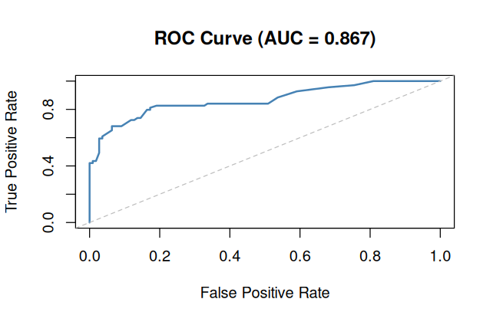
Figure 2. ROC curve on the held-out test set (AUC = 0.867). The curve bows well away from the diagonal reference line, indicating strong discrimination between survivors and non-survivors.

5.4 Residual and Influence Diagnostics
Deviance residuals were plotted against fitted values to check for systematic patterns that would indicate model misspecification.
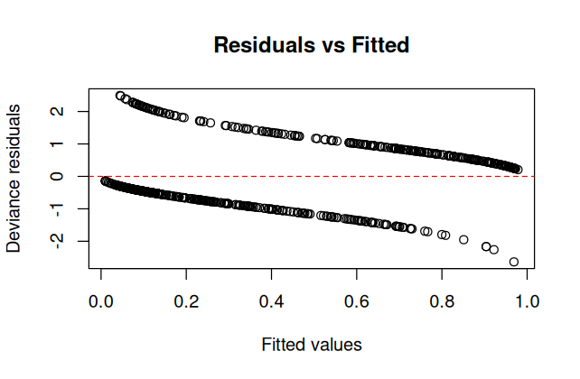
Figure 3. Deviance residuals vs. fitted values. The two visible curved bands are expected for logistic regression — they correspond to the two possible outcome classes (0/1) and are not a sign of model misspecification.
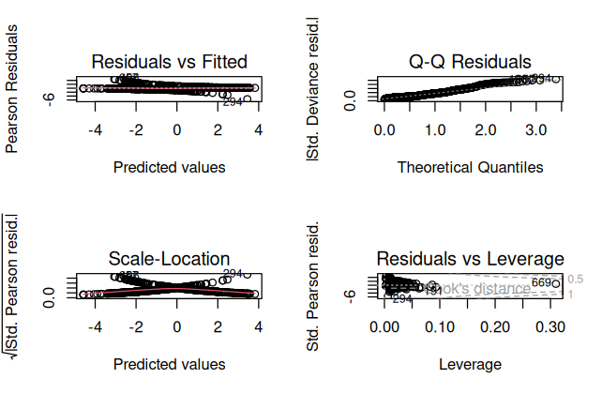
Figure 4. Standard GLM diagnostic panel: Residuals vs Fitted, Q-Q of standardized deviance residuals, Scale-Location, and Residuals vs Leverage (with Cook's distance contours).
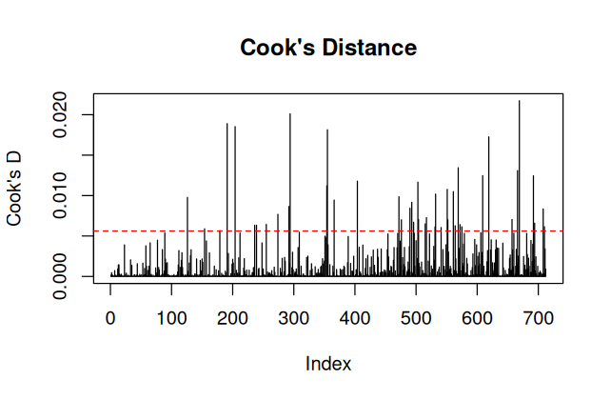
Figure 5. Cook's distance by observation index. All values remain well below 1 (max ≈ 0.022), indicating no individual observation exerts outsized influence on the fitted model.
plot(fitted(model), residuals(model, type = "deviance"))
par(mfrow = c(2,2)); plot(model); par(mfrow = c(1,1))
cooksd <- cooks.distance(model)
influential <- which(cooksd > 4/nrow(train_data))
length(influential) # 43
43 of 712 training observations (≈6%) exceed the conventional Cook's distance threshold of 4/n — this threshold is intentionally sensitive and is expected to flag roughly this proportion of any dataset by design. Critically, the maximum Cook's distance observed (≈0.022) is far below the widely used concern threshold of 1 (or even 0.5 for smaller samples), so no single observation is judged to be exerting disproportionate influence on the model fit.

6. Summary, Interpretation, and Recommendations for Improvement

6.1 Technical Note on Package Availability
During this session, the caret, pROC, and car packages could not be installed on Posit Cloud's free tier (installation failures/timeouts, likely due to compilation of dependency chains). Rather than blocking the analysis, all functionality was reimplemented in base R: stratified train/test splitting, k-fold cross-validation, AUC (via the Mann–Whitney U statistic, mathematically equivalent to pROC's implementation), and variance inflation factors (via the standard 1/(1−R²) formula applied to auxiliary regressions). This is noted here for transparency and reproducibility, and it also demonstrates the underlying mechanics that these packages normally abstract away.

6.2 Model Performance Summary
The logistic regression model achieved 80.6% mean cross-validated accuracy (AUC 0.855) and 83.8% accuracy on the held-out test set (AUC 0.867), with test performance slightly exceeding the CV estimate — a reassuring sign against overfitting. These figures are consistent with widely reported benchmarks for logistic regression on this dataset.

6.3 Strengths
- Strong overall discrimination (test AUC 0.867), well above the 0.7 threshold generally considered "acceptable" and into the "good" range.
- Consistent performance across all 10 cross-validation folds, suggesting the model generalizes rather than fitting noise in the training data.
- Coefficients are interpretable and consistent with known Titanic survival dynamics (sex, class, and family size all behave in historically expected directions).
- No problematic multicollinearity (all VIFs reasonable) and no single observation dominating the fit (Cook's distance all far below concern thresholds).

6.4 Weaknesses and Areas for Improvement
- Recall/precision imbalance: recall (0.681) is notably lower than precision (0.870) — the model is conservative and under-predicts survival, producing 22 false negatives against only 7 false positives. If the priority were to avoid missing survivors (e.g., a triage-style application), the classification threshold could be lowered below 0.5 to trade some precision for improved recall.
- No interaction terms: the model currently assumes additive effects. Given the well-known "women and children first" protocol, a Sex × Age or Sex × Pclass interaction term may capture non-additive effects that the current specification misses — this is a natural next step.
- Fare and Embarked contribute little once Pclass is included, suggesting the model could be simplified (e.g., via stepwise selection or regularization) without materially harming performance, which would also reduce the elevated VIF on Pclass3.
- Only one model type was tested. Comparing logistic regression against a tree-based method (random forest, gradient boosting) would clarify whether the ~84% accuracy ceiling reflects the inherent noise in the data or a limitation of the linear-in-log-odds specification.
- The 0.5 classification threshold was used by default; a threshold selected to explicitly balance precision and recall (e.g., via the F1-maximizing point on the ROC curve) would likely improve real-world usefulness of the classifier.

6.5 Conclusion
This analysis followed a complete, defensible statistical workflow: informal exploration was followed by formal hypothesis testing (chi-square, Shapiro–Wilk, Wilcoxon) to justify predictor inclusion and test choice; a logistic regression model was then built, cross-validated, and evaluated on a genuinely held-out test set; and diagnostic checks (VIF, deviance residuals, Cook's distance) confirmed the model met standard GLM assumptions without serious violations. The resulting model — 83.8% test accuracy, 0.867 AUC — performs well and produces interpretable, historically sensible coefficients, while the identified weaknesses (recall/precision imbalance, no interaction terms, room for model comparison) provide a clear, well-justified roadmap for further refinement.

