Virtual R Data Analyst Internship
Week 2: Data Visualization and Insight Communication using R
Dataset: Titanic Passenger Survival Data (continued from Week 1)
Prepared using R (ggplot2, dplyr)

1. Data Overview
This week's visualizations build on the Titanic passenger dataset cleaned and prepared in Week 1. Rather than selecting a new dataset, the Week-1-cleaned version was reused, since it already has missing values resolved, outliers handled, and several useful derived columns available.
As a quick refresher, the dataset covers 891 Titanic passengers, with the following variables central to this week's charts:
Variable | What it represents
Survived | Whether the passenger survived (target variable)
Pclass / Pclass_Factor | Ticket class (1st, 2nd, 3rd) - a proxy for wealth/status
Age | Passenger age in years (missing values filled in Week 1)
Fare / Fare_Capped | Ticket price (extreme values capped in Week 1)
Sex | Passenger sex
SibSp / Parch | Number of siblings/spouses and parents/children aboard

For reference, two charts from last week's analysis are included below, since they informed the direction of this week's visualizations - particularly the correlation matrix, which pointed to Sex, Pclass, and Fare as the variables most worth visualizing further.
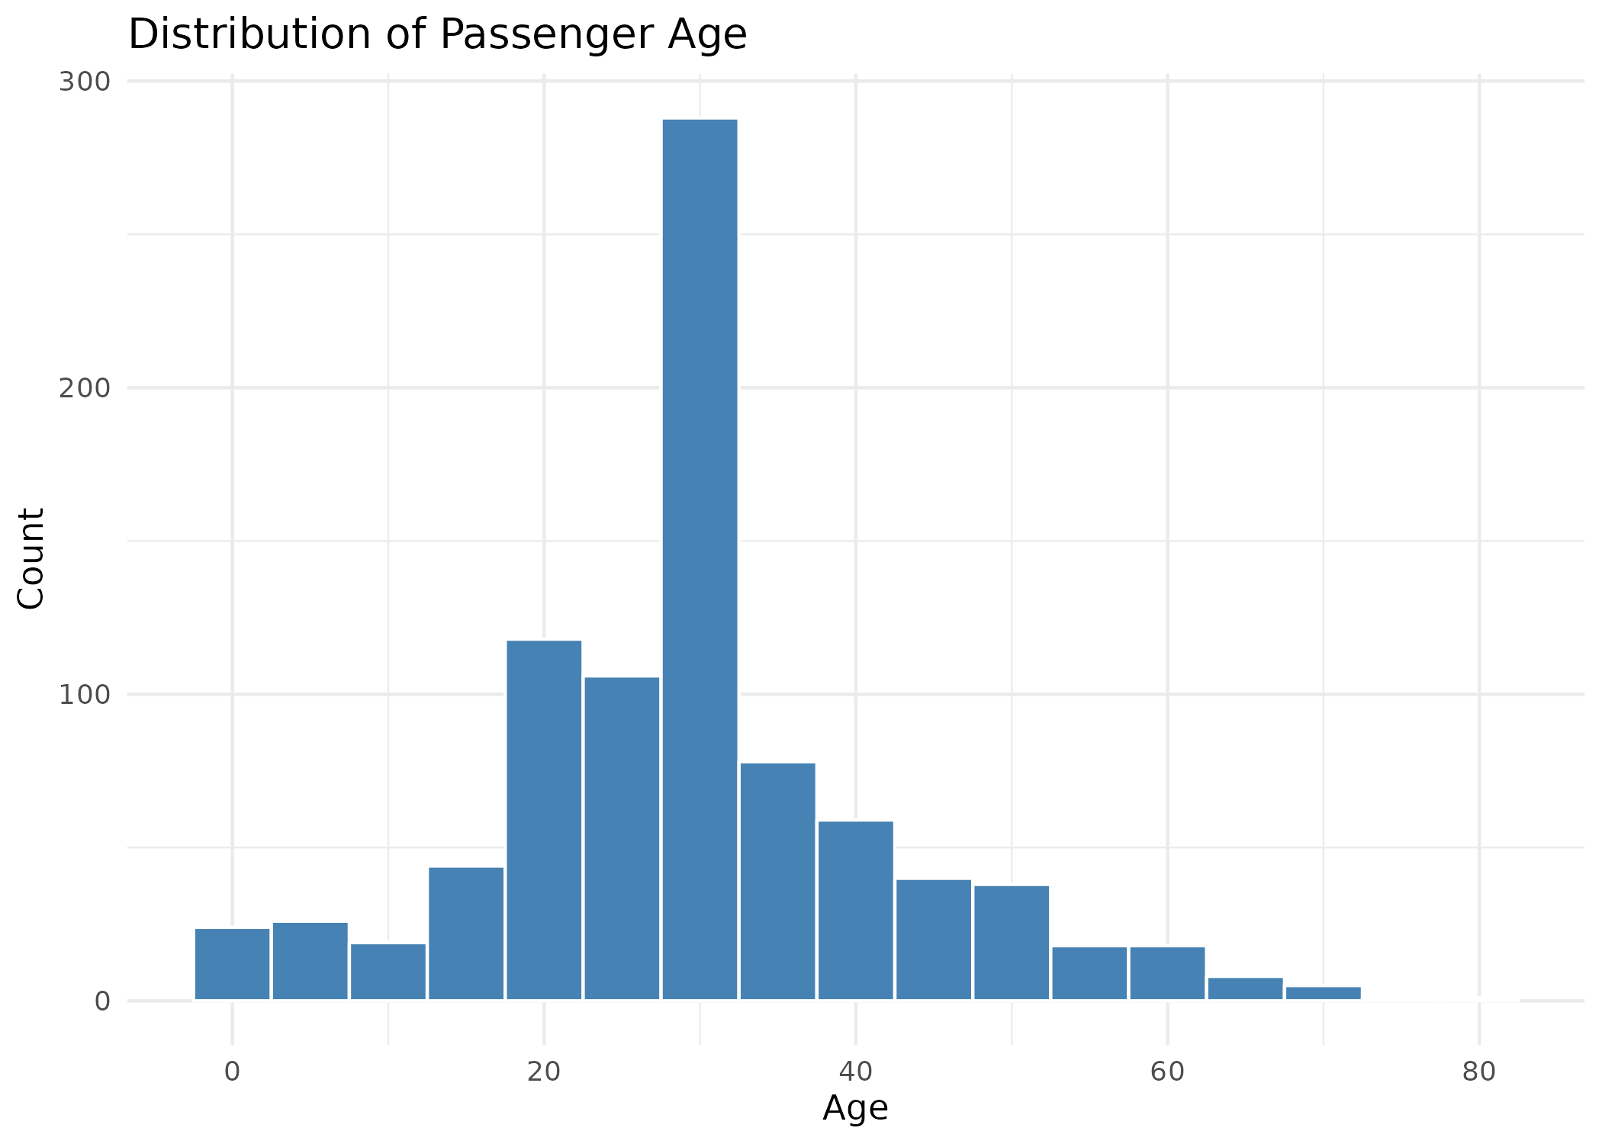
Reference - Figure from Week 1: Age distribution.
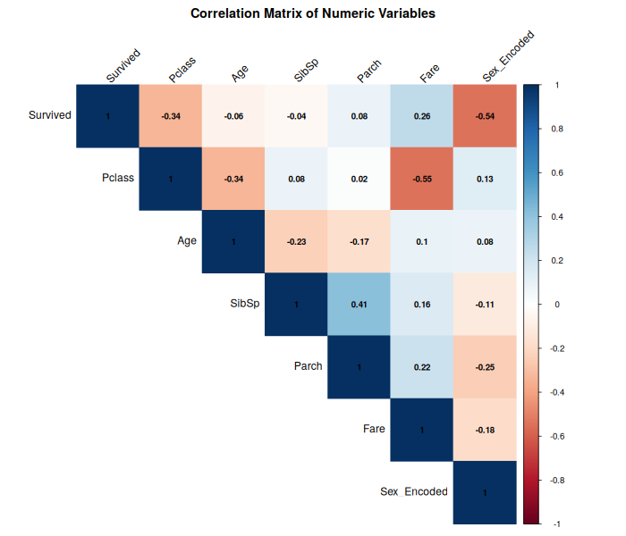
Reference - Figure from Week 1: Correlation matrix, showing Sex, Pclass, and Fare as the strongest correlates of survival.
This week's goal shifts from statistical exploration to communication: the charts below are designed to explain the same underlying patterns in a way that is clear to someone with no background in statistics or R.

2. Visualizations and Insights

2.1 Survival Rate by Passenger Class (Bar Chart)
Why this chart: a bar chart is the most intuitive way to compare a single number across a small number of categories. Here, instead of showing raw counts (which can be misleading when group sizes differ), the bars show a directly comparable percentage - the survival rate within each class.
survival_by_class <- titanic_clean %>%
group_by(Pclass_Factor) %>%
summarise(Survival_Rate = mean(Survived) * 100)
ggplot(survival_by_class, aes(x = Pclass_Factor, y = Survival_Rate,
fill = Pclass_Factor)) +
geom_col() +
geom_text(aes(label = round(Survival_Rate, 1)), vjust = -0.5) +
labs(title = "Survival Rate by Passenger Class",
x = "Passenger Class", y = "Survival Rate (%)") +
theme_minimal() + theme(legend.position = "none")
Pclass_Factor Survival_Rate
1st 63.0
2nd 47.3
3rd 24.2
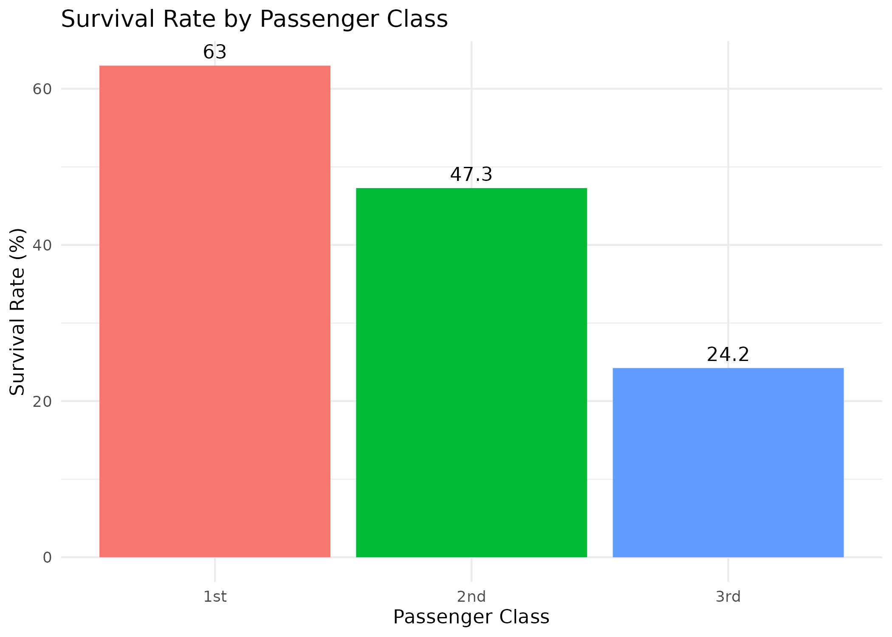
Figure 1: Survival rate by passenger class.
Insight: survival rate falls sharply and steadily from 1st class (63%) to 3rd class (24%) - a 39-point gap. This is one of the clearest, most communicable findings in the dataset: where you were seated on the ship mattered enormously to whether you lived.

2.2 Age vs Fare, Colored by Survival (Scatter Plot)
Why this chart: a scatter plot is the standard choice when examining the relationship between two numeric variables at once (Age and Fare), while a third variable (survival) is layered in using color. This lets a viewer visually scan for clustering or separation between groups.
ggplot(titanic_clean, aes(x = Age, y = Fare_Capped,
color = Survived_Factor)) +
geom_point(alpha = 0.5) +
labs(title = "Age vs Fare, Colored by Survival",
x = "Age", y = "Fare (capped)", color = "Survived") +
theme_minimal()
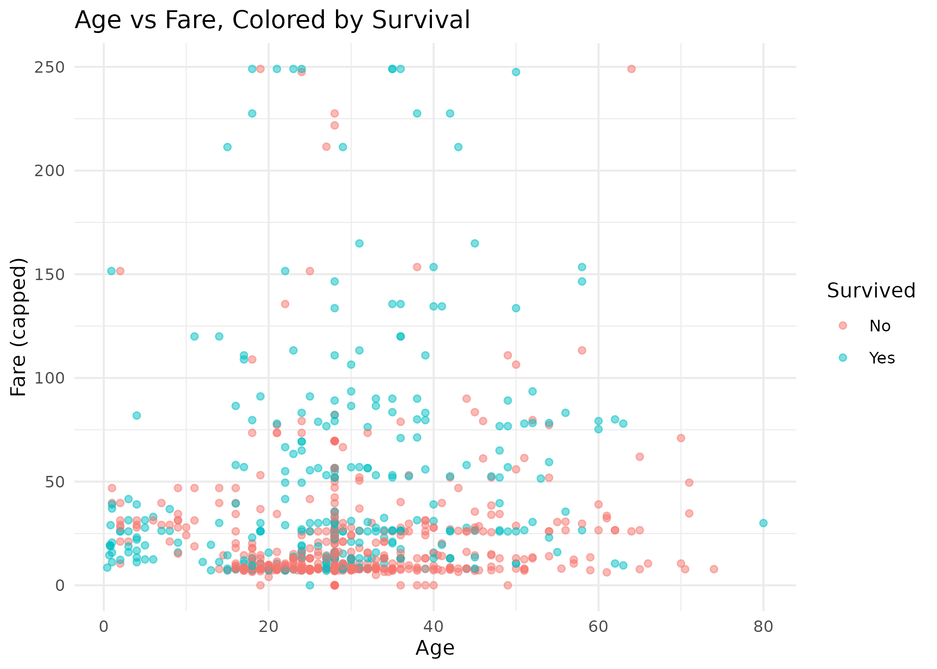
Figure 2: Age vs Fare scatter plot, colored by survival outcome.
Insight: surviving passengers (teal dots) are visibly more concentrated in the higher-fare range of the chart, while non-survivors (red dots) are denser toward the bottom. There is no clear pattern along the Age axis - dots of both colors are spread fairly evenly across all ages. This visually confirms what the class-based bar chart already suggested: fare/class was a much stronger factor in survival than age alone.

2.3 Fare Distribution (Histogram, Log Scale)
Why this chart: a histogram is the standard way to show how a numeric variable is distributed. A first attempt at plotting Fare on its normal scale produced a chart dominated by one tall bar near zero, with almost nothing else visible - because a small number of very expensive tickets stretch the scale so far that most passengers' fares get compressed into a single bucket. Applying a log scale to the x-axis fixes this by giving equal visual space to equal proportional differences (e.g. 10 to 100 gets the same width as 100 to 1000), revealing the actual shape of the distribution.
# Fixed version (log scale)
ggplot(titanic_clean, aes(x = Fare)) +
geom_histogram(bins = 30, fill = "coral", color = "white") +
scale_x_log10() +
labs(title = "Fare Distribution (Log Scale)",
x = "Fare (log scale)", y = "Count") +
theme_minimal()
Warning: Removed 15 rows containing non-finite values (stat_bin()).
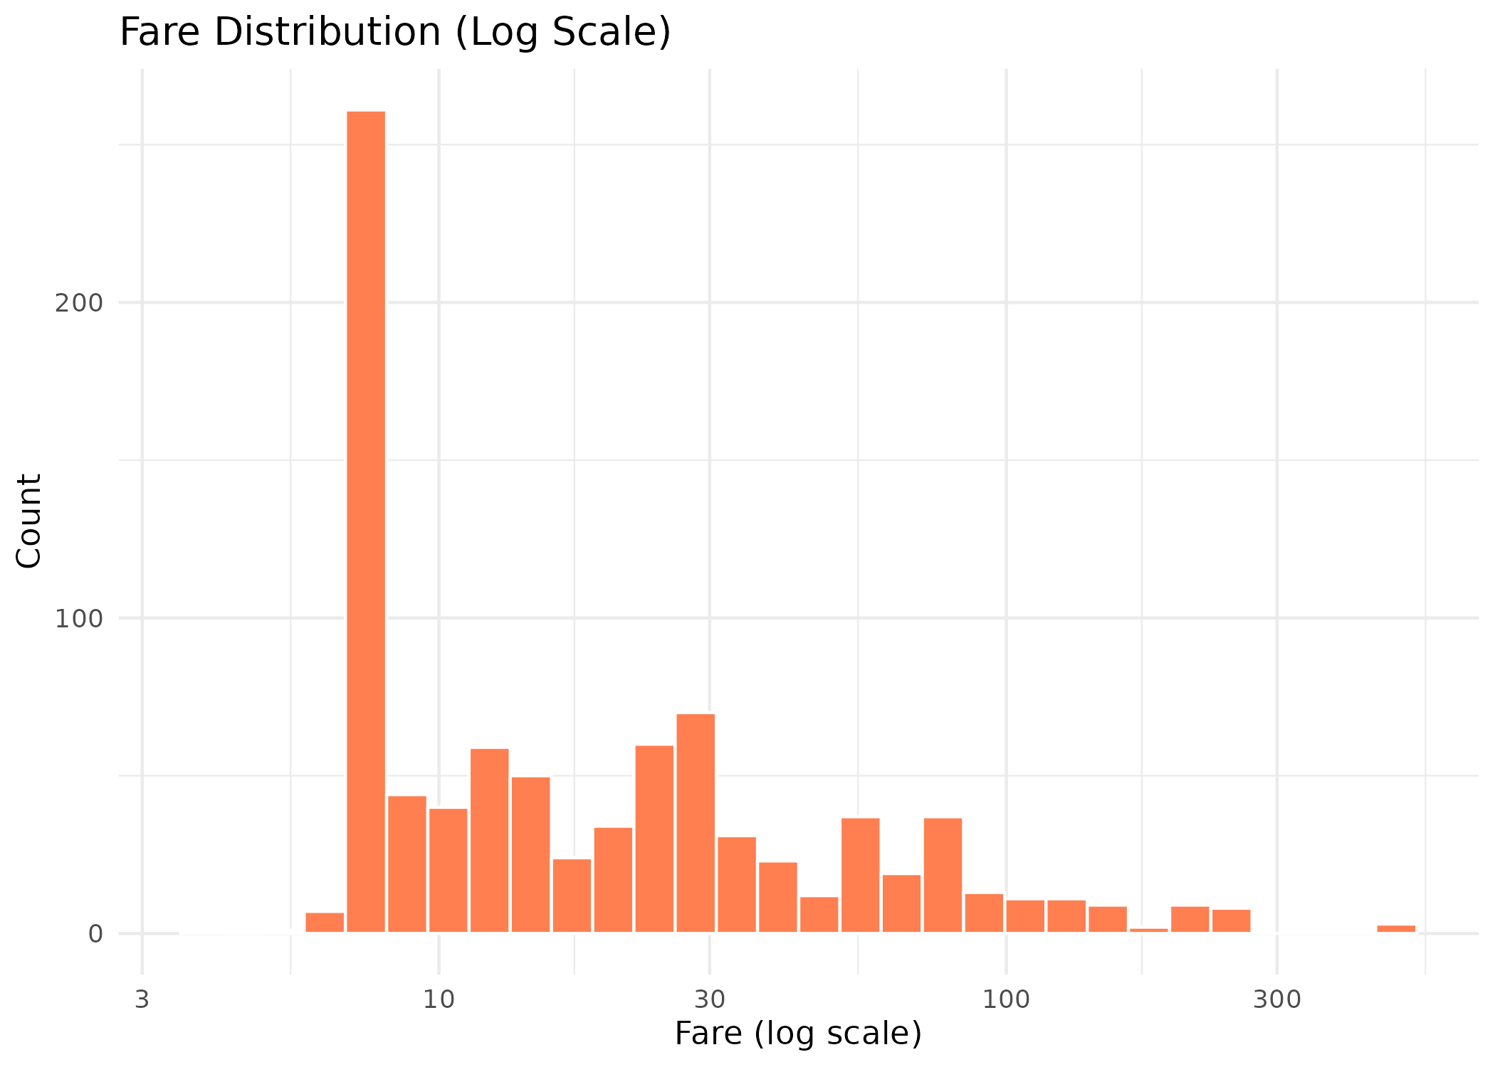
Figure 3: Fare distribution shown on a log-scaled x-axis.
Note: 15 passengers with a Fare of exactly 0 (likely crew members or passengers with complimentary passage) were automatically excluded from this specific chart, since a log scale cannot represent zero. They remain in the dataset and in every other chart in this report.
Insight: once shown on a log scale, Fare turns out to have several distinct clusters rather than one smooth curve - consistent with fares being grouped around a handful of common ticket price tiers rather than varying continuously. The large spike around the 7-8 range corresponds to the cheapest, most common 3rd class tickets.

2.4 Survival Rate Across Age Groups (Line Chart)
Why this chart: a line chart is the natural choice for showing how a value changes across an ordered sequence of categories - here, ascending age brackets. Age was grouped into 10-year bands (0-10, 11-20, and so on) so the trend is easier to read than a raw age-by-age comparison would be.
titanic_clean$Age_Group <- cut(titanic_clean$Age,
breaks = c(0,10,20,30,40,50,60,80),
labels = c("0-10","11-20","21-30","31-40","41-50","51-60","61-80"))
survival_by_age <- titanic_clean %>%
group_by(Age_Group) %>%
summarise(Survival_Rate = mean(Survived) * 100)
ggplot(survival_by_age, aes(x = Age_Group, y = Survival_Rate, group = 1)) +
geom_line(color = "steelblue", linewidth = 1) +
geom_point(color = "steelblue", size = 3) +
labs(title = "Survival Rate Across Age Groups",
x = "Age Group", y = "Survival Rate (%)") +
theme_minimal()
Age_Group Survival_Rate
0-10 59.4
11-20 38.3
21-30 33.4
31-40 44.5
41-50 38.4
51-60 40.5
61-80 22.7
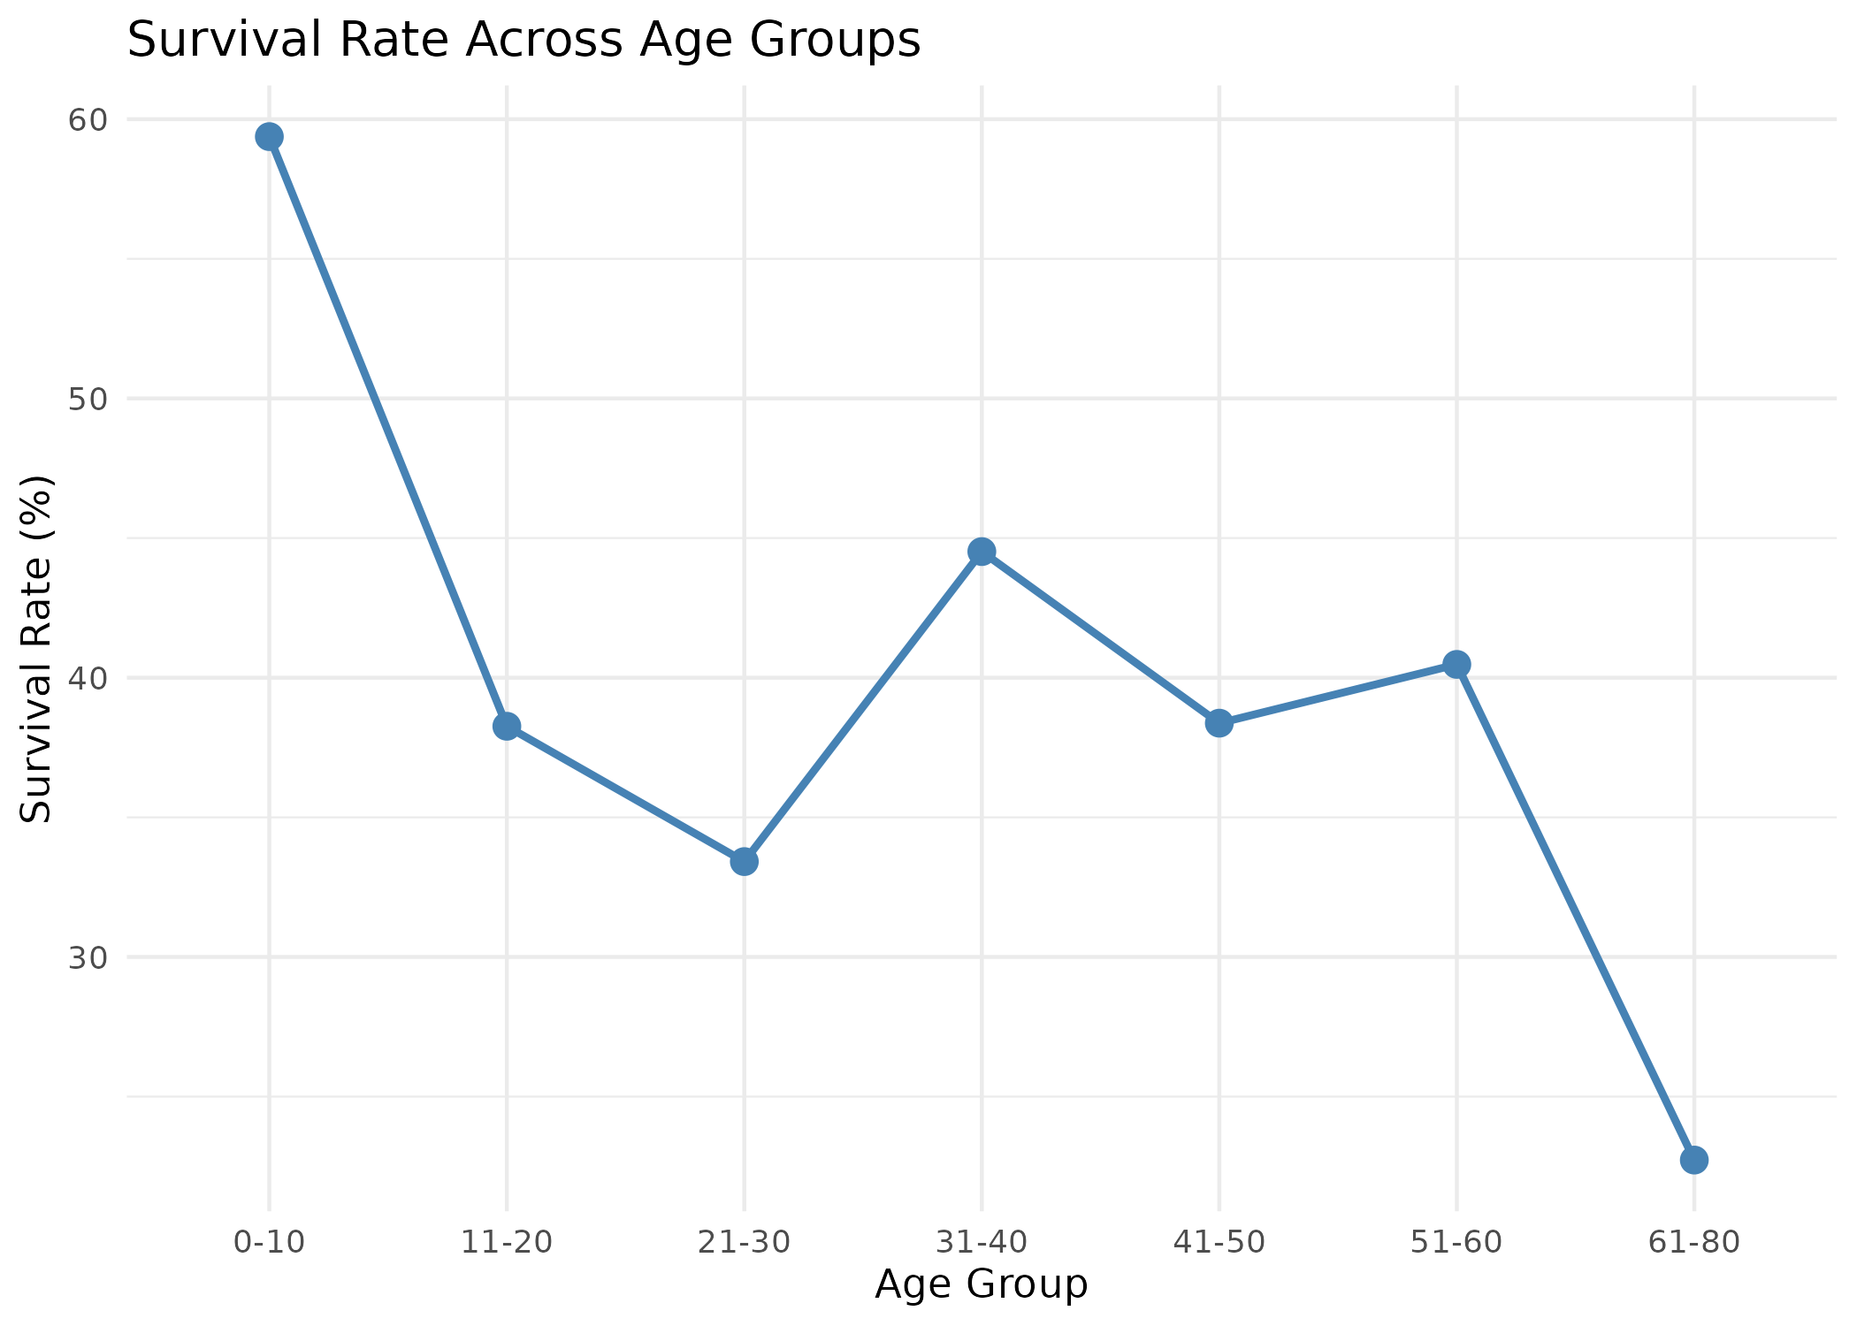
Figure 4: Survival rate across age groups.
Insight: children aged 0-10 had by far the highest survival rate (59%), and survival rate was lowest for the oldest passengers (61-80, at 23%). This lines up with the historical 'women and children first' evacuation policy. The middle age groups fluctuate without a strong trend, suggesting age mattered mainly at the extremes (very young vs. elderly) rather than as a smooth, continuous effect.

2.5 Survival Proportion by Family Size (Stacked Bar Chart)
Why this chart: this combines two related variables - number of siblings/spouses and number of parents/children aboard - into a single 'family size' measure, then groups passengers into Alone, Small family (2-4), and Large family (5+). A stacked, proportion-based bar chart (rather than a simple count-based one) is used here because the three groups have very different numbers of passengers, so comparing raw counts would be misleading; showing each bar rescaled to 100% makes the groups directly comparable.
titanic_clean$Family_Size <- titanic_clean$SibSp + titanic_clean$Parch + 1
titanic_clean$Family_Group <- cut(titanic_clean$Family_Size,
breaks = c(0,1,4,11), labels = c("Alone","Small (2-4)","Large (5+)"))
ggplot(titanic_clean, aes(x = Family_Group, fill = Survived_Factor)) +
geom_bar(position = "fill") +
labs(title = "Survival Proportion by Family Size",
x = "Family Size", y = "Proportion", fill = "Survived") +
theme_minimal()
Family_Group Survival_Rate N
Alone 30.4 537
Small (2-4) 57.9 292
Large (5+) 16.1 62
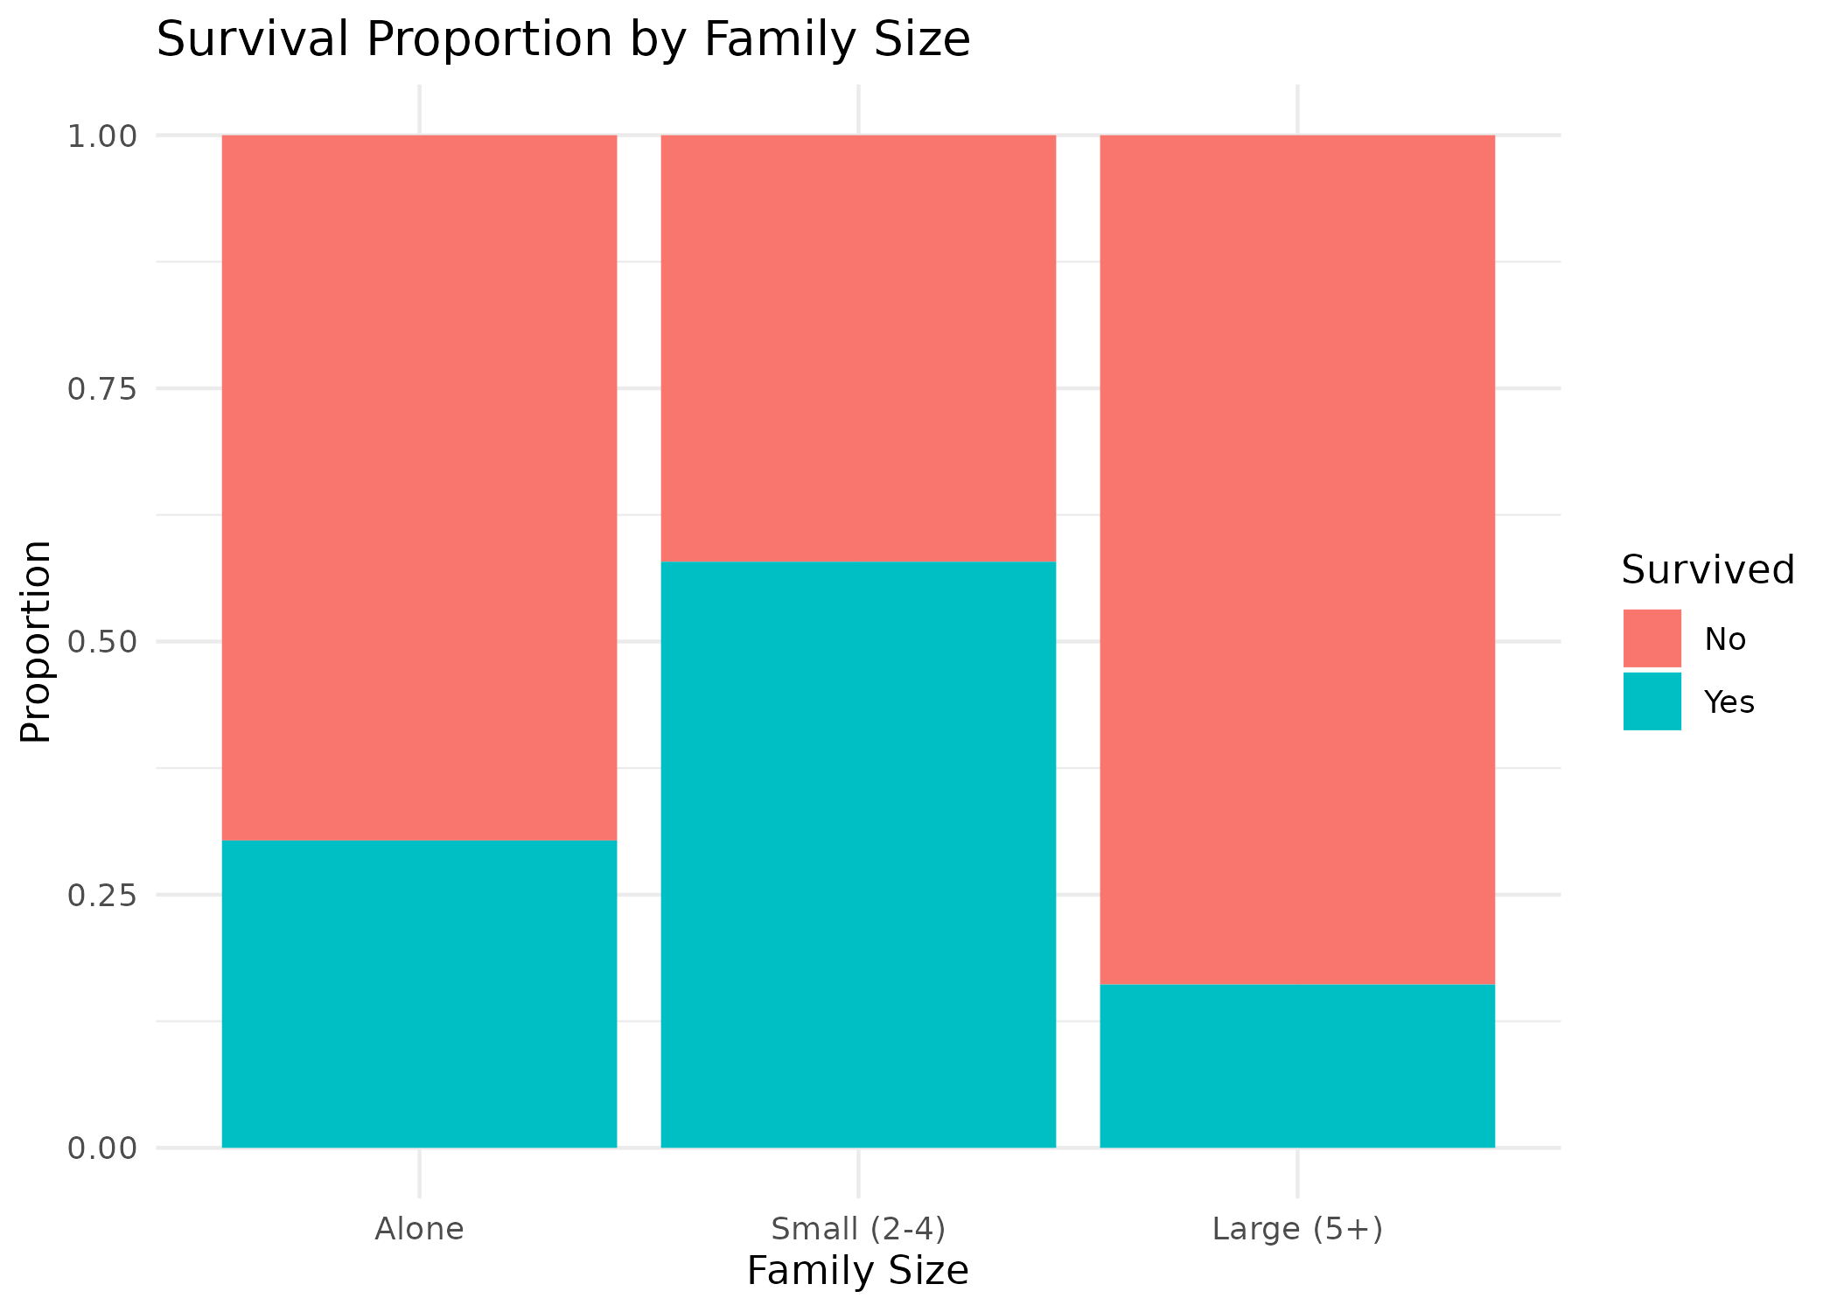
Figure 5: Survival proportion by family size group.
Insight: passengers traveling in a small family (2-4 people) had the highest survival rate (58%) - notably higher than those traveling completely alone (30%) or in a large family (16%). A plausible explanation: solo travelers had no one to help them find or reach a lifeboat, while large families often struggled to stay together and evacuate as a full group, sometimes waiting for members who couldn't be found in time. Small families were large enough to help each other, but small enough to move and coordinate quickly.

3. Summary of Key Insights
- Passenger class remains the single clearest driver of survival: 1st class passengers were more than twice as likely to survive as 3rd class passengers (63% vs 24%).
- Fare and survival visually track together in the scatter plot, reinforcing the class-based finding, while age alone shows no comparable pattern outside of the extremes.
- Age's effect on survival is concentrated at the extremes: children survived at far higher rates than any other age group, and the elderly at the lowest.
- Family size has a non-linear relationship with survival: small families outperformed both solo travelers and large families, suggesting a 'safety in small numbers' effect specific to group evacuation.
- Across all five visualizations, three variables - class/fare, age, and family size - each tell a distinct part of the survival story, and no single variable fully explains the outcome on its own.

4. Files Produced
- analysis_week2.R - full R script for all five visualizations
- titanic_week2_final.csv - dataset with this week's derived columns (Age_Group, Family_Size, Family_Group) added
- plots/ - all figures referenced in this report, saved as PNG

