Virtual R Data Analyst Internship
Week 1: Data Cleaning and Preliminary Analysis with R
Dataset: Titanic Passenger Survival Data
Prepared using R (base, dplyr, tidyr, ggplot2, corrplot)

1. Dataset Overview
The dataset selected for this task is the Titanic passenger dataset, a widely used public dataset documenting passengers aboard the RMS Titanic, including whether each passenger survived. It was retrieved from a public GitHub data repository (Data Science Dojo's open dataset collection) as a CSV file.
This dataset was chosen because it satisfies the complexity requirements of the task: it contains a mix of numerical variables (Age, Fare, SibSp, Parch), categorical variables (Sex, Embarked, Pclass), genuine missing values (in Age, Cabin, and Embarked), and potential outliers (in Fare).

1.1 Dataset Structure
The raw dataset contains 891 observations of 12 variables:
Variable | Type | Description
PassengerId | Integer | Unique passenger identifier
Survived | Integer (0/1) | Survival outcome (target variable)
Pclass | Integer (1-3) | Ticket class (proxy for socio-economic status)
Name | Character | Passenger name
Sex | Character | Passenger sex
Age | Numeric | Age in years (contains missing values)
SibSp | Integer | Number of siblings/spouses aboard
Parch | Integer | Number of parents/children aboard
Ticket | Character | Ticket number
Fare | Numeric | Passenger fare
Cabin | Character | Cabin number (mostly missing)
Embarked | Character | Port of embarkation (C/Q/S)

R code used to load the dataset and inspect its structure:
titanic <- read.csv("titanic.csv", stringsAsFactors = FALSE,
na.strings = c("", "NA"))
str(titanic)
dim(titanic)
Output of str(titanic):
'data.frame': 891 obs. of 12 variables:
$ PassengerId: int 1 2 3 4 5 6 7 8 9 10 ...
$ Survived : int 0 1 1 1 0 0 0 0 1 1 ...
$ Pclass : int 3 1 3 1 3 3 1 3 3 2 ...
$ Name : chr "Braund, Mr. Owen Harris" ...
$ Sex : chr "male" "female" "female" "female" ...
$ Age : num 22 38 26 35 35 NA 54 2 27 14 ...
$ SibSp : int 1 1 0 1 0 0 0 3 0 1 ...
$ Parch : int 0 0 0 0 0 0 0 1 2 0 ...
$ Ticket : chr "A/5 21171" "PC 17599" ...
$ Fare : num 7.25 71.28 7.92 53.1 8.05 ...
$ Cabin : chr NA "C85" NA "C123" ...
$ Embarked : chr "S" "C" "S" "S" ...

2. Data Cleaning Process

2.1 Identifying Missing Values
Missing values were quantified for every column using colSums(is.na(...)). Three columns contained missing data: Cabin (heavily missing), Age (moderately missing), and Embarked (negligibly missing, 2 rows).
missing_counts <- colSums(is.na(titanic))
missing_pct <- round(100 * missing_counts / nrow(titanic), 2)
Column | Missing Count | Missing %
Cabin | 687 | 77.10%
Age | 177 | 19.87%
Embarked | 2 | 0.22%
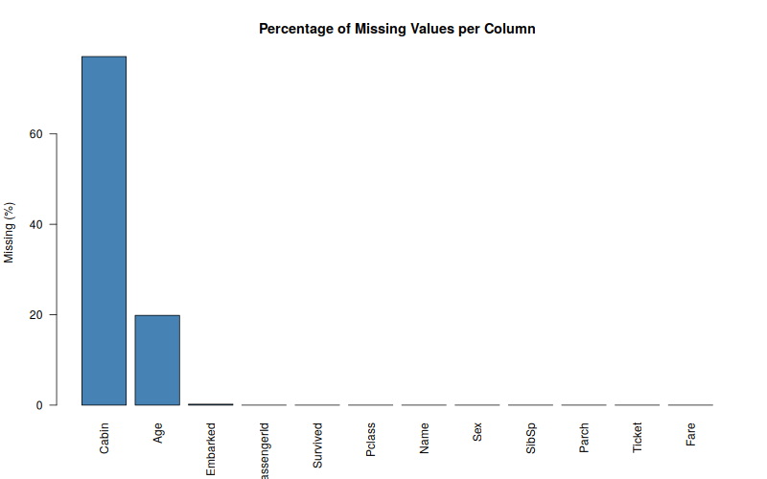
Figure 1: Percentage of missing values per column.

2.2 Handling Missing Values
Different strategies were applied depending on the nature and proportion of missingness in each column:
- Cabin (77% missing): Imputing this column would be unreliable given the scale of missingness. Instead of dropping the information entirely, a binary indicator Cabin_Known was created (1 = cabin recorded, 0 = missing), which preserves the signal that cabin data availability itself correlates with passenger class, before the raw Cabin column was dropped.
- Age (20% missing): Imputed using the median age, which is robust to the right-skew and outliers present in the Age distribution (unlike the mean).
- Embarked (0.2% missing): Imputed using the mode (most frequent port), an appropriate strategy for a categorical variable with very few missing rows.
- Name, Ticket, PassengerId: Dropped, as they are unique identifiers or free text with no direct analytical value for this exploratory task.
titanic$Cabin_Known <- ifelse(is.na(titanic$Cabin), 0, 1)
titanic_clean <- titanic %>% select(-Cabin, -Ticket, -Name, -PassengerId)
age_median <- median(titanic_clean$Age, na.rm = TRUE)
titanic_clean$Age[is.na(titanic_clean$Age)] <- age_median
get_mode <- function(v) {
v <- v[!is.na(v)]
uniqv <- unique(v)
uniqv[which.max(tabulate(match(v, uniqv)))]
}
embarked_mode <- get_mode(titanic_clean$Embarked)
titanic_clean$Embarked[is.na(titanic_clean$Embarked)] <- embarked_mode
Output confirming successful imputation:
Age missing values imputed with median: 28
Embarked missing values imputed with mode: S
=== MISSING VALUES AFTER CLEANING ===
Pclass Sex Age SibSp Parch Fare Embarked Cabin_Known
0 0 0 0 0 0 0 0

2.3 Outlier Detection
Outliers in the two continuous numeric variables (Age and Fare) were detected using the interquartile range (IQR) method: any value below Q1 - 1.5*IQR or above Q3 + 1.5*IQR is flagged as an outlier.
detect_outliers <- function(x) {
q1 <- quantile(x, 0.25, na.rm = TRUE)
q3 <- quantile(x, 0.75, na.rm = TRUE)
iqr <- q3 - q1
sum(x < (q1 - 1.5*iqr) | x > (q3 + 1.5*iqr))
}
Fare outliers: 116
Age outliers: 66
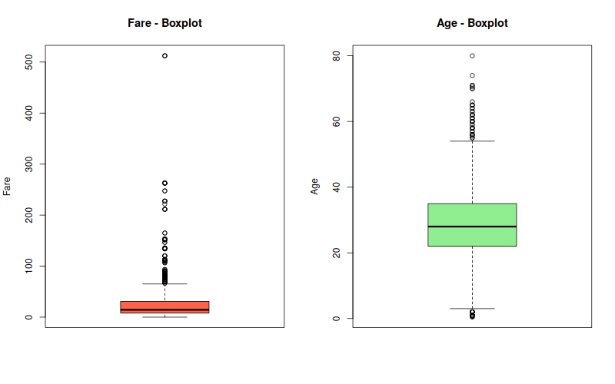
Figure 2: Boxplots of Fare and Age showing outlier spread.
Fare had a higher outlier count (116 rows) than Age (66 rows). The Age outliers split into 24 very young passengers (infants/toddlers below the lower fence of 2.5 years) and 42 older passengers (above the upper fence of 54.5 years) — both genuine, meaningful ages rather than data errors. The Fare outliers are driven by a small number of very expensive first-class tickets. Rather than deleting these rows — which would discard real information about passengers' survival outcomes — Fare was winsorized: values above the 99th percentile were capped at that percentile. This reduces the influence of extreme values on later analysis while retaining every observation. Age outliers were left uncapped, since age extremes are less likely to distort later statistics the way a handful of very large fares can.
fare_cap <- quantile(titanic_clean$Fare, 0.99, na.rm = TRUE)
titanic_clean$Fare_Capped <- ifelse(titanic_clean$Fare > fare_cap,
fare_cap, titanic_clean$Fare)
Fare 99th percentile cap applied at: 249.01

2.4 Normalization
Age and the capped Fare were rescaled to a common [0, 1] range using min-max normalization. Normalization was applied only for downstream comparability across variables of different scales, and the original columns were retained alongside the scaled versions for interpretability.
min_max_scale <- function(x) (x - min(x)) / (max(x) - min(x))
titanic_clean$Age_Scaled <- min_max_scale(titanic_clean$Age)
titanic_clean$Fare_Scaled <- min_max_scale(titanic_clean$Fare_Capped)
Age_Scaled Fare_Scaled
Min. :0.0000 Min. :0.0000
1st Qu.:0.2718 1st Qu.:0.0318
Median :0.3467 Median :0.0580
Mean :0.3644 Mean :0.1105
3rd Qu.:0.4342 3rd Qu.:0.1246
Max. :1.0000 Max. :1.0000

2.5 Encoding Categorical Variables
Categorical variables were converted into numeric form so they can be used in later statistical or modeling steps:
- Sex: Label-encoded as a binary indicator Sex_Encoded (male = 1, female = 0).
- Embarked: One-hot encoded into three binary columns (EmbarkedC, EmbarkedQ, EmbarkedS) using model.matrix(), since it is a nominal variable with no inherent order.
- Pclass and Survived: Converted into labeled factors (Pclass_Factor, Survived_Factor) to make tables and plots more readable, while the original numeric codes were kept for correlation analysis.
titanic_clean$Sex_Encoded <- ifelse(titanic_clean$Sex == "male", 1, 0)
embarked_dummies <- model.matrix(~ Embarked - 1, data = titanic_clean)
titanic_clean <- cbind(titanic_clean, embarked_dummies)
titanic_clean$Pclass_Factor <- factor(titanic_clean$Pclass,
labels = c("1st","2nd","3rd"))
titanic_clean$Survived_Factor <- factor(titanic_clean$Survived,
labels = c("No","Yes"))

3. Exploratory Data Analysis

3.1 Descriptive Statistics
summary() was used to generate descriptive statistics for the key numeric variables:
summary(titanic_clean[, c("Age","Fare","SibSp","Parch")])
Age Fare SibSp Parch
Min. : 0.42 Min. : 0.00 Min. :0.000 Min. :0.0000
1st Qu.:22.00 1st Qu.: 7.91 1st Qu.:0.000 1st Qu.:0.0000
Median :28.00 Median : 14.45 Median :0.000 Median :0.0000
Mean :29.36 Mean : 32.20 Mean :0.523 Mean :0.3816
3rd Qu.:35.00 3rd Qu.: 31.00 3rd Qu.:1.000 3rd Qu.:0.0000
Max. :80.00 Max. :512.33 Max. :8.000 Max. :6.0000
The median age (28) is close to the mean (29.4), indicating a moderately symmetric age distribution after imputation. Fare, by contrast, has a mean (32.2) well above its median (14.45), confirming the strong right-skew driven by the high-fare outliers identified in Section 2.3.
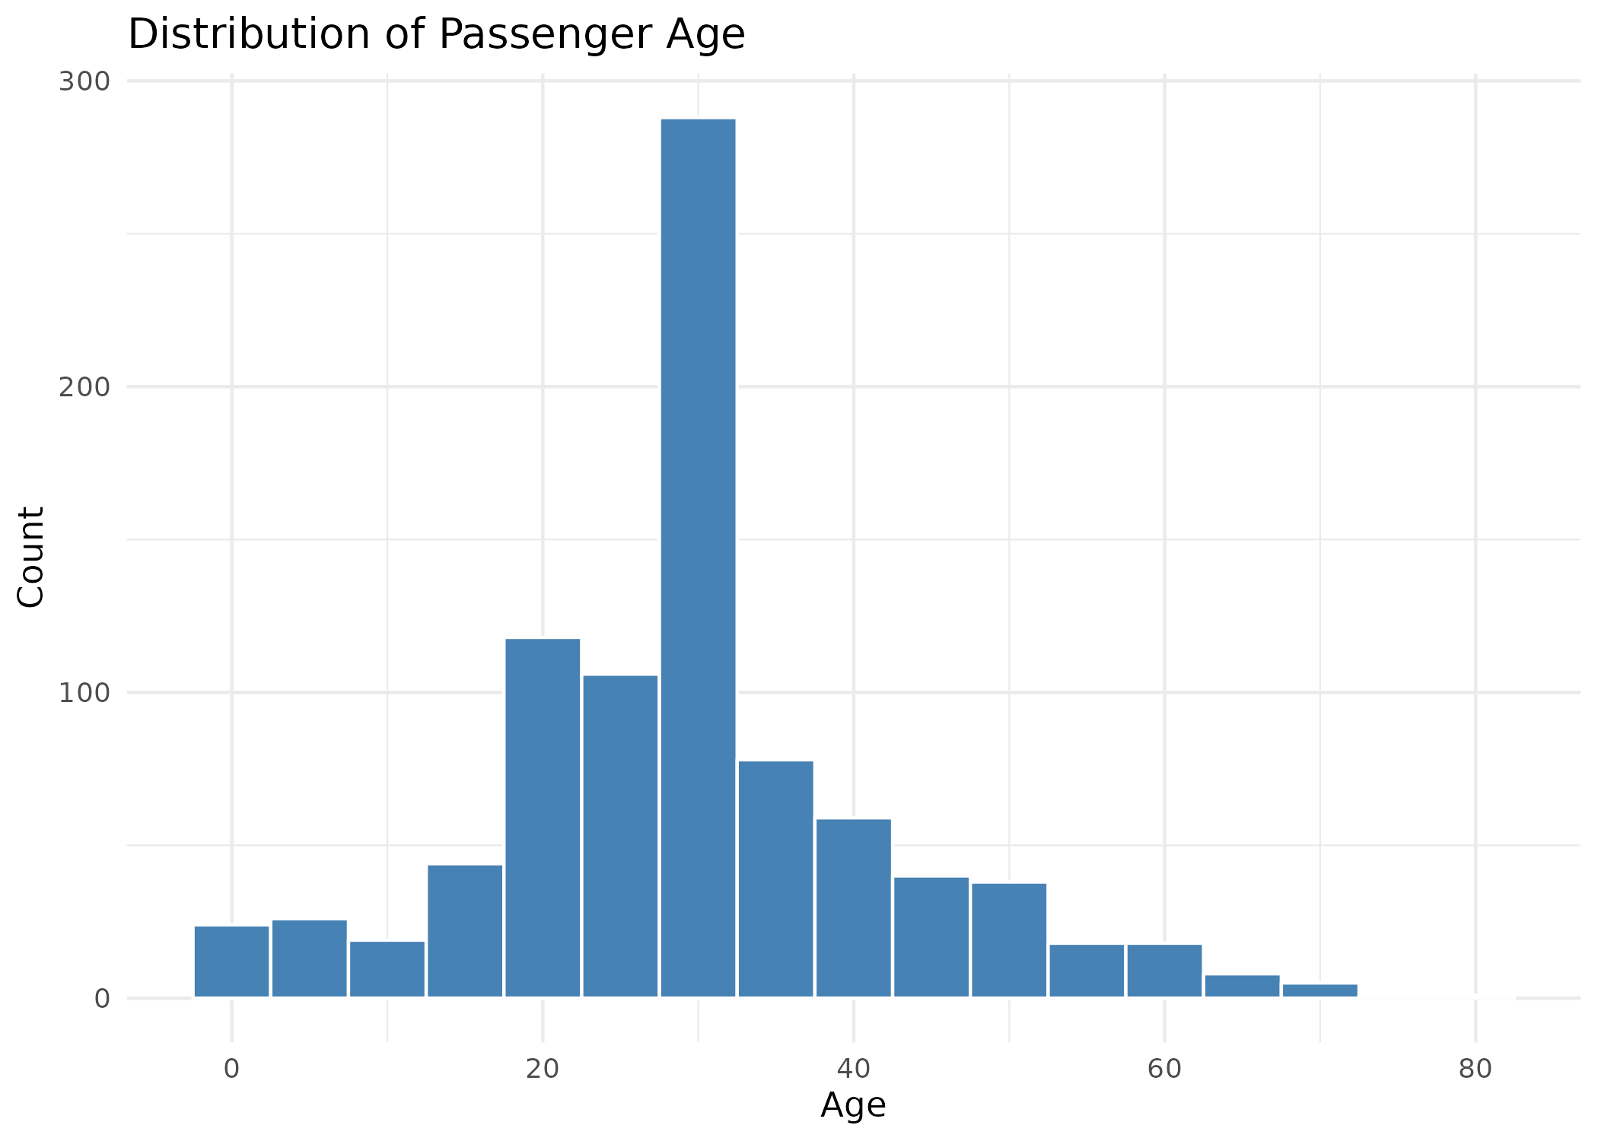
Figure 3: Distribution of passenger age.

3.2 Survival Breakdown
Overall, 38.4% of passengers in the dataset survived. Survival was strongly associated with both sex and passenger class:
Group | Survived: No | Survived: Yes
Female | 25.8% | 74.2%
Male | 81.1% | 18.9%
1st Class | 37.0% | 63.0%
2nd Class | 52.7% | 47.3%
3rd Class | 75.8% | 24.2%

Female passengers survived at roughly four times the rate of male passengers, and survival rate decreased steadily from 1st to 3rd class — consistent with the historical account that lifeboat access prioritized women and first-class passengers.
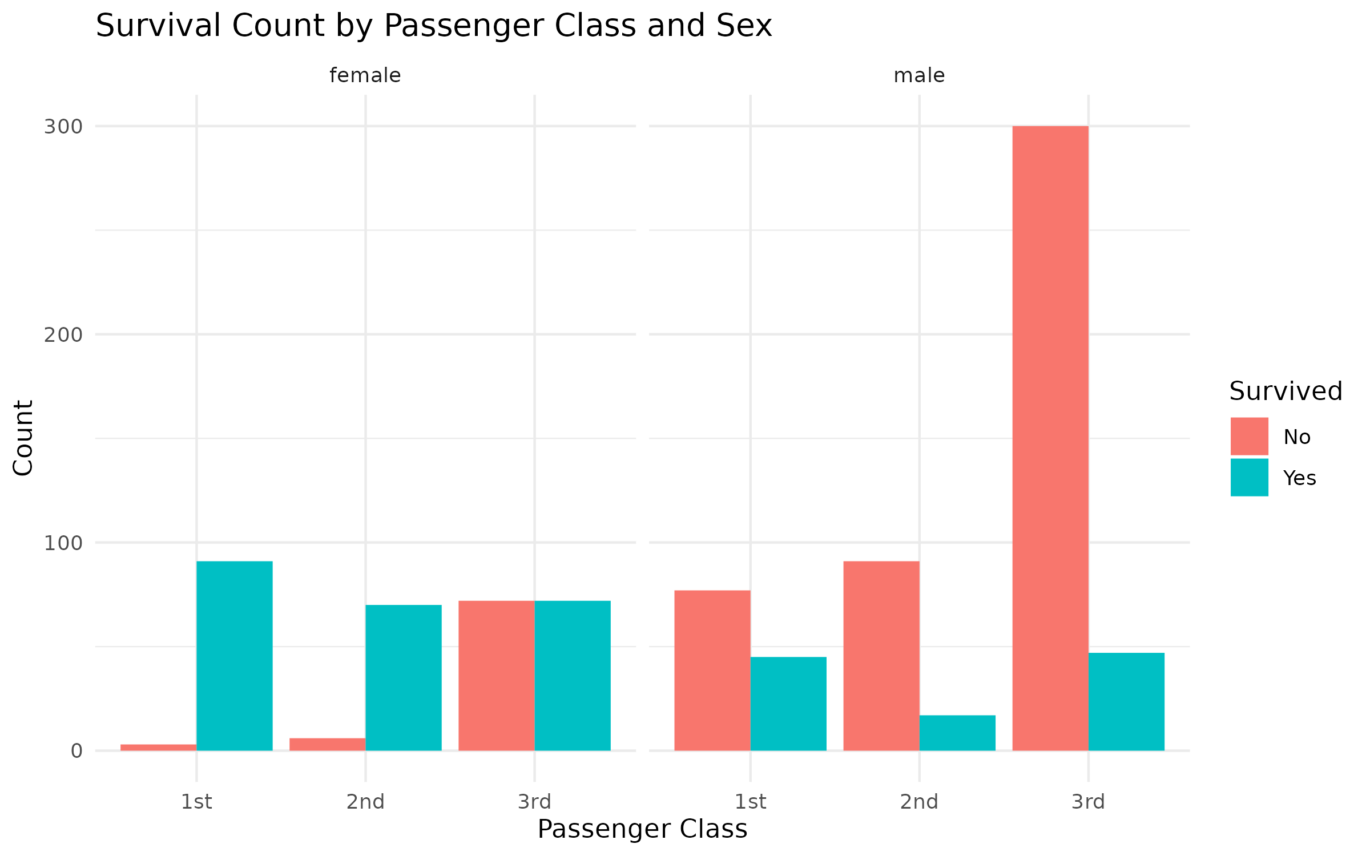
Figure 4: Survival counts by passenger class, split by sex.
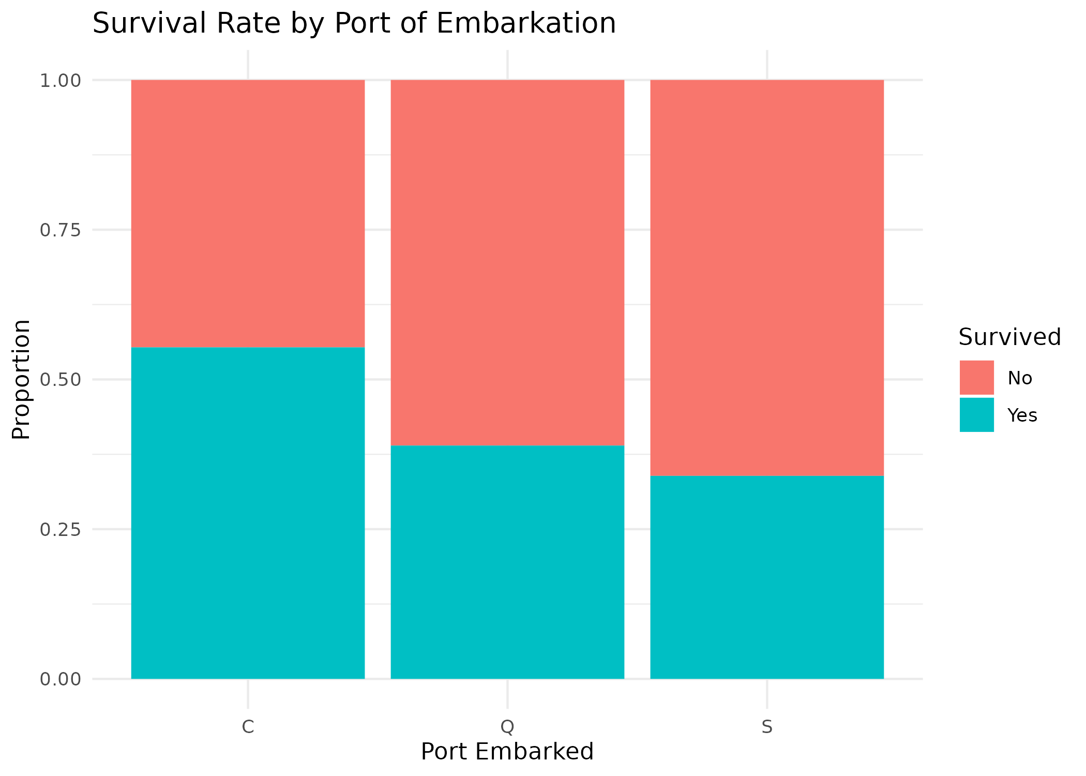
Figure 5: Survival rate by port of embarkation.

3.3 Fare by Class
As expected, Fare (outlier-capped) increases markedly with passenger class, validating Pclass as a reasonable proxy for socio-economic status and explaining its correlation with survival.
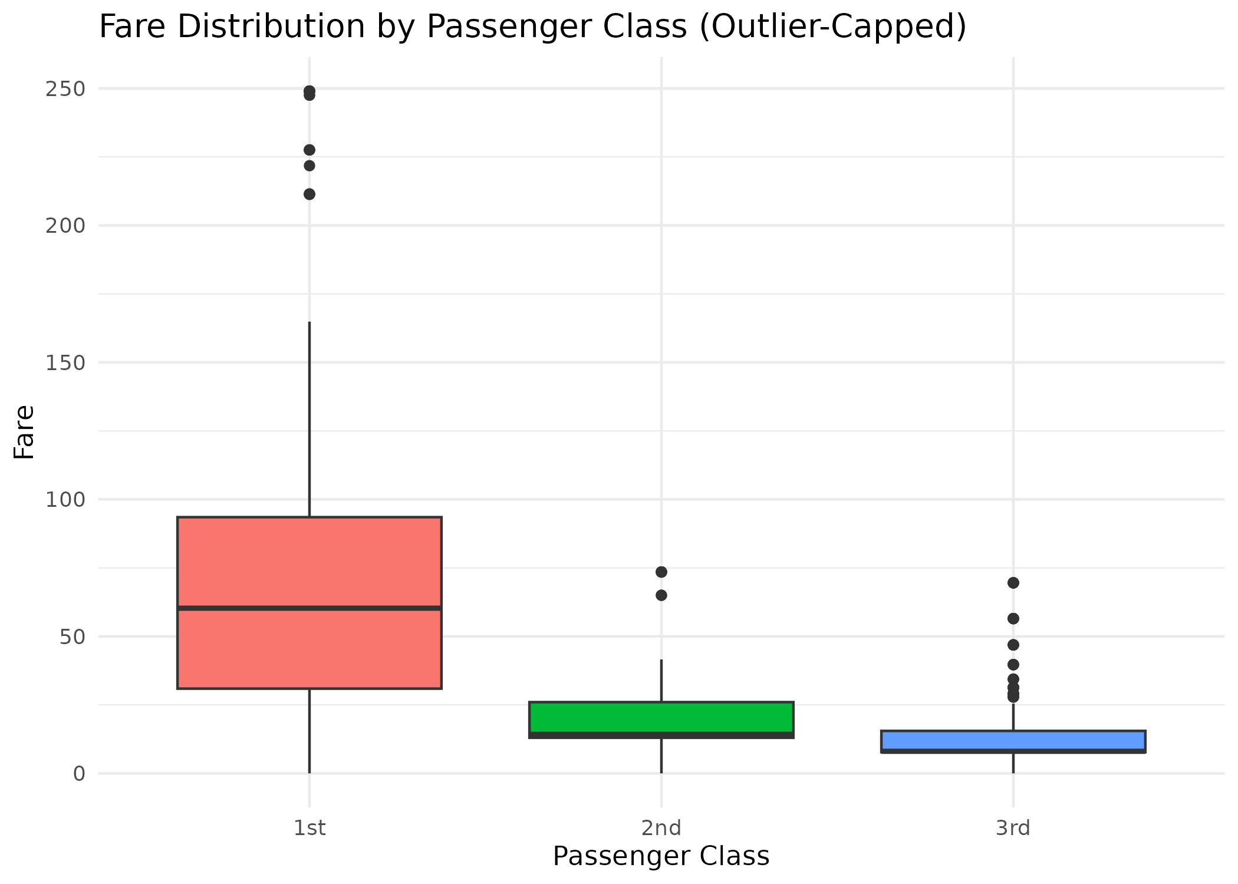
Figure 6: Fare distribution by passenger class.

3.4 Correlation Analysis
A correlation matrix was computed across the numeric and encoded variables to identify relationships relevant to survival:
num_vars <- titanic_clean %>%
select(Survived, Pclass, Age, SibSp, Parch, Fare, Sex_Encoded)
corr_matrix <- cor(num_vars, use = "complete.obs")
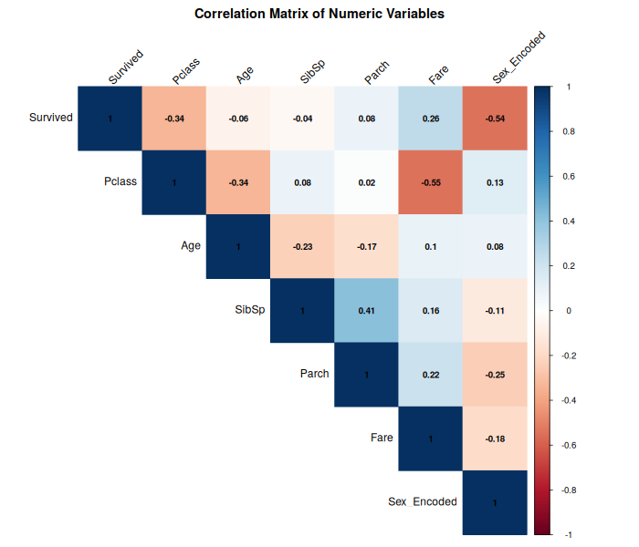
Figure 7: Correlation matrix of numeric variables.
Key relationships observed:
- Sex_Encoded and Survived: -0.54 — the strongest correlation in the matrix, confirming sex was the single most important factor in survival (being male sharply reduced survival odds).
- Pclass and Survived: -0.34 — higher class number (i.e., lower status class) is associated with lower survival, consistent with the class-wise survival table above.
- Pclass and Fare: -0.55 — as expected, lower class number (better class) corresponds to higher fare paid.
- Age showed only a weak correlation with survival (-0.06), suggesting age alone was a much less decisive factor than sex or class.

4. Summary of Key Insights
- Sex was the strongest single predictor of survival in this dataset, followed by passenger class — both consistent with the Titanic's 'women and children first' evacuation policy and unequal lifeboat access across classes.
- Missingness was concentrated in Cabin (77%) and Age (20%); both were handled with strategies that preserved information (a 'known/unknown' flag and median imputation, respectively) rather than discarding rows, which would have shrunk the usable sample by nearly 20%.
- Fare was heavily right-skewed with a meaningful number of high-value outliers corresponding to first-class fares; capping rather than removing them retained the full sample of 891 passengers.
- After cleaning, encoding, and scaling, the dataset was fully numeric-ready (no missing values, categorical variables encoded) and suitable for further statistical modeling in later weeks.

5. Files Produced
- titanic.csv — original raw dataset
- titanic_cleaned.csv — cleaned, encoded, and scaled dataset
- analysis.R — full R script covering all cleaning and analysis steps
- plots/ — all 7 figures referenced in this report, saved as PNG

