**Docker Developer Tools**

Dockertools - A Curated List of Developers Tools

[View on GitHub](https://github.com/collabnix/dockertools) [Join Slack](https://launchpass.com/collabnix) [Docker Cheatsheet](https://collabnix.com/docker-cheatsheet/) [Docker Compose Cheatsheet](https://collabnix.com/docker-compose-cheatsheet/) [Follow us on Twitter](https://twitter.com/collabnix)

Developers love Docker. Docker is a suite of software development tools for creating, sharing and running containers. Developers use Docker to accelerate how they build, share, and run modern applications. This repository was built with a purpose. It is being used by Collabnix community internally to target the most popular developer tools and technique and coming up with the best practices around these tools.

Follow [the Collabnix Twitter account](https://twitter.com/collabnix) to keep track of the latest developer tools.

Have Questions? Join us over [Slack](https://launchpass.com/collabnix) and get chance to be a part of 6700+ DevOps enthusiasts.

Types of Docker Developer Tools

* [Docker Integrated Developer Tools](https://github.com/collabnix/dockertools#docker-integrated-developer-tools)
* [Open Source Developer Tools](https://github.com/collabnix/dockertools#open-source-developer-tools)

Docker Integrated Developer Tools

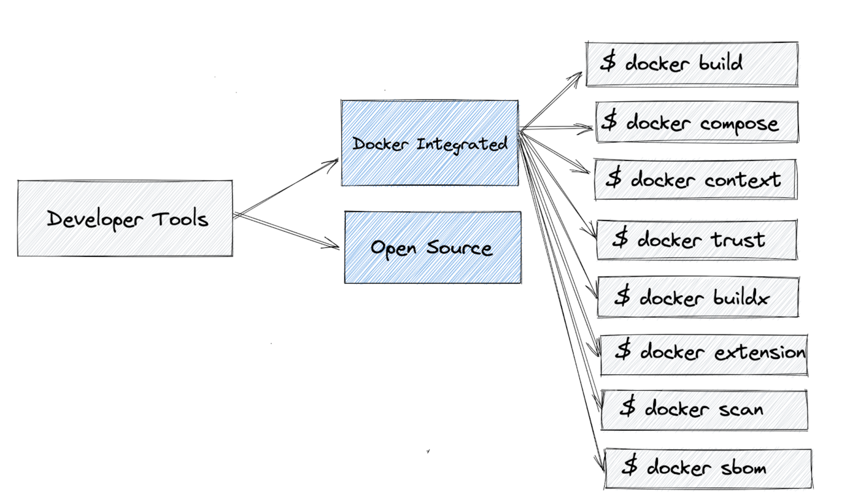

* docker build - [Easily create and share portable Docker container images using open standards](https://docs.docker.com/engine/reference/commandline/build/)
* docker buildx - [Extended build capabilities with Buildkit](https://docs.docker.com/engine/reference/commandline/buildx/)
* docker compose - [Build and Manage multiple services in Docker containers](https://docs.docker.com/engine/reference/commandline/compose/)
* docker scan - [Quickly detect and learn how to remediate CVEs in your Docker image](https://docs.docker.com/engine/scan/)
* docker context - [Manages multiple Swarm clusters, Kubernetes clusters and Docker nodes](https://docs.docker.com/engine/context/working-with-contexts/)
* docker sbom - [Generate the Software Bill of Materials (SBOM) of a container image](https://docs.docker.com/engine/sbom/)
* docker extensions - [Use 3rd party tools within Docker Desktop to extend its functionality](https://docs.docker.com/desktop/extensions/)
* docker trust - [Manage trust on Docker Images](https://docs.docker.com/engine/reference/commandline/trust/)
* docker dev - [Run Dev Envs via command line](https://docs.docker.com/desktop/release-notes/#new)
* docker scout - [A Software Supply Chain Security for Developers](https://docs.docker.com/scout/)

Open Source Developer Tools

Image Slim

* DockerSlim - [Minify and Secure Docker containers](https://github.com/docker-slim/docker-slim)
* Minicon - [Minimization of the filesystem for containers](https://github.com/grycap/minicon)
* Watchtower - [A process for automating Docker container base image updates](https://github.com/containrrr/watchtower)
* Syft - [CLI tool and library for generating a Software Bill of Materials from container images and filesystems](https://github.com/anchore/syft)
* gitlab-ci-image-scanner (gcis) - [executes security scan over all Docker images used in all CI files](https://github.com/jkosik/gitlab-ci-image-scanner)
* Watchtower - [A process for automating Docker container base image updates](https://github.com/containrrr/watchtower)
* Syft - [CLI tool and library for generating a Software Bill of Materials from container images and filesystems](https://github.com/anchore/syft)
* dockcross - [Cross compiling toolchains in Docker images.](https://linktr.ee/dockcross)

Image Build Toolkit

* BuildKit - [Toolkit for converting source code to build artifacts in an efficient, expressive and repeatable manner](https://github.com/moby/buildkit)
* Dive - [Tool for exploring each layer in a docker image](https://github.com/wagoodman/dive)
* Docker-Squash - [Squashing helps with organizing images in logical layers.](https://github.com/goldmann/docker-squash)
* Docker-Diun - [Docker image update notifier](https://github.com/crazy-max/diun)
* Trivy - [Trivy is a container image scanner which uncovers known vulnerabilities.](https://www.cloudsavvyit.com/12027/how-to-use-trivy-to-find-vulnerabilities-in-docker-containers)
* vbaksa/promoter - [Docker Image promotion tool](https://github.com/vbaksa/promoter)
* Argo Watcher - [A small tool that will wait for the specific docker image to be rolled out](https://github.com/shini4i/argo-watcher)
* Terrier - [Terrier is a Image and Container analysis tool that can be used to scan Images and Containers to identify and verify the presence of specific files according to their hashes](https://github.com/heroku/terrier)
* PHPQA - [Docker image that provides static analysis tools for PHP](https://github.com/jakzal/phpqa)
* Docker Registry Pruner - [Tool to apply retention logic to docker images in a Docker Registry](https://github.com/tumblr/docker-registry-pruner)
* tini - [A tiny but valid init for containers](https://github.com/krallin/tini)
* Modus - [Modus is a language for building Docker/OCI container images.](https://github.com/modus-continens/modus)

Image Utilties

* Bing Daily Images - [A docker container that downloads bing daily images for you](https://github.com/ms-jpq/bing-daily-images)

Dockerfile Tools & Metrics

* Haskell Dockerfile Linter - [Dockerfile linter, validate inline bash, written in Haskell](https://github.com/hadolint/hadolint)
* ctop - [Top-like interface for container metrics](https://github.com/bcicen/ctop)
* Dfimage - [Reverse-engineers a Dockerfile from a Docker image.](https://github.com/LanikSJ/dfimage)
* bctx - [packing and uploading docker build contex](https://github.com/orisano/bctx)
* Dfimage - [Reverse-engineers a Dockerfile from a Docker image.](https://github.com/LanikSJ/dfimage)
* Buildg - [buildg is a tool to interactively debug Dockerfile based on BuildKit.](https://github.com/ktock/buildg)   
  master

Debugger

* Gebug - [A tool that makes debugging of Dockerized Go applications super easy by enabling Debugger and Hot-Reload features, seamlessly](https://github.com/moshebe/gebug)
* Sidekick - [Sidekick is a live application debugger that lets you troubleshoot your applications while they keep on running.](https://github.com/runsidekick/sidekick)

Image Security

* TerraScan -[Detect compliance and security violations across Infrastructure as Code to mitigate risk before provisioning cloud native infrastructure](https://github.com/accurics/terrascan)
* Clair - [Vulnerability Static Analysis for Containers](https://github.com/quay/clair)
* Trivy - [Vulnerability Scanner for Containers and other Artifacts, Suitable for CI - Aqua Security](https://github.com/aquasecurity/trivy)
* DeepSource - [Static Analysis for DockerFiles](https://deepsource.io/)
* DockerScan - [A Docker analysis & hacking tools](https://github.com/cr0hn/dockerscan)
* Container-diff - [container-diff is a tool for analyzing and comparing container images. container-diff can examine images along several different criteria.](https://github.com/GoogleContainerTools/container-diff)
* SecretScanner - [🔓 🔓 Find secrets and passwords in container images and file systems 🔓 🔓](https://github.com/deepfence/SecretScanner)
* TerraScan -[Detect compliance and security violations across Infrastructure as Code to mitigate risk before provisioning cloud native infrastructure](https://github.com/accurics/terrascan)
* Clair - [Vulnerability Static Analysis for Containers](https://github.com/quay/clair)
* Trivy - [Vulnerability Scanner for Containers and other Artifacts, Suitable for CI - Aqua Security](https://github.com/aquasecurity/trivy)
* DeepSource - [Static Analysis for DockerFiles](https://deepsource.io/)
* DockerScan - [A Docker analysis & hacking tools](https://github.com/cr0hn/dockerscan)
* Container-diff - [container-diff is a tool for analyzing and comparing container images. container-diff can examine images along several different criteria.](https://github.com/GoogleContainerTools/container-diff)

Docker CLI

* Docker Buildx - [a CLI plugin that extends the docker command with the full support of the features provided by Moby BuildKit builder toolkit.](https://docs.docker.com/buildx/working-with-buildx/)
* Regi - [regi is a CLI tool for managing your accessibility to multiple Docker registries.](https://github.com/iamharvey/regi)
* Lazy Docker - [A simple terminal UI for both docker and docker-compose, written in Go with the gocui library.](https://github.com/jesseduffield/lazydocker)
* Kitt - [Kitt is a container based portable shell environment.](https://github.com/senges/kitt)
* Docker Buildx - [a CLI plugin that extends the docker command with the full support of the features provided by Moby BuildKit builder toolkit.](https://docs.docker.com/buildx/working-with-buildx/)
* Dredge - [A Docker Registry Client CLI](https://github.com/mthalman/dredge)

DockerHub

* DockerHub Scraper - [Scraping DockerHub](https://github.com/itamarhaber/dockerhub-scraper)

Deployment Tool

* Fleetform - [A tool to apply docker container infrastructure as code in a very simple human readable way](https://github.com/majo418/fleetform)
* Swarmsible -[Simple Ansible based Tooling for setting up and managing a production grade Docker Swarm on Ubuntu 18.04/20.04.](https://github.com/neuroforgede/swarmsible)

Docker Volume

* Flocker - [Data Volume Manager for your Dockerized applications.](https://github.com/ClusterHQ/flocker)  
  offen/docker-volume-backup - [Backup Docker volumes locally or to any S3 or WebDAV compatible storage](https://github.com/offen/docker-volume-backup)

Cloud-Job

* Launcha - [Launcha is a docker-based cloud job launcher.](https://github.com/vwxyzjn/launcha)

Runtime Security

* Tracee - [Linux Runtime Security and Forensics using eBPF](https://github.com/aquasecurity/tracee)
* CetusGuard - [Tool that allows to protect the Docker daemon socket by filtering the calls to its API endpoints](https://github.com/hectorm/cetusguard)
* Tetragon - [eBPF-based Security Observability and Runtime Enforcement](https://github.com/cilium/tetragon)
* Falco - [Runtime security and threat detection project](https://falco.org/)

Container Orchestration

* Miniboss - [Manages container locally](https://github.com/afroisalreadyinu/miniboss)
* Portainer - [Making Docker management easy. https://www.portainer.io](https://github.com/portainer/portainer)
* Drone - [continuous delivery system built on container technology](https://github.com/harness/drone)
* Kubernetes - [most popular container orchestration engine](https://github.com/kubernetes/kubernetes)
* Amazon ECS - [highly scalable management service which allows developers to run containerized applications on EC2 instances.](https://aws.amazon.com/ecs/)
* Ryuk - [Remove containers/networks/volumes/images by given filter after specified delay.](https://hub.docker.com/r/testcontainers/ryuk)
* Traefik - [Traefik is an HTTP reverse proxy that’s easy to integrate with container workloads.](https://github.com/traefik/traefik)
* Docker Context - [Makes it easy to switch between multiple Docker and Kubernetes environments.](https://docs.docker.com/engine/context/working-with-contexts/)
* luet - [Container-based Package manager](https://github.com/mudler/luet)

Browser

* kde-in-docker - [Run KDE inside a browser](https://github.com/ms-jpq/kde-in-docker)
* Portus - [3D Docker containers viewer built with Electron, React and Three Fiber](https://github.com/trindadematheus/portus)
* snek - [Snek simplifies the process of porting software to multiple platforms. Uses @docker 20.10.12+](https://t.co/GPblsl9hRc)

Cluster Management

* Nebula - [designed to manage massive clusters at scale.](http://nebula.readthedocs.io/en/latest/)

Machine Learning

* Paddle Serving - [A flexible, high-performance carrier for machine learning models](https://github.com/PaddlePaddle/Serving)

Android app

* Android-Docker - [A Docker image for building and testing Android apps.](https://github.com/randr0id/android-docker)

Development Tool

* envd - [Development environment for AI/ML based on buildkit](https://github.com/tensorchord/envd)
* Konveyor Move2Kube - [Automatically create Dockerfiles, Kubernetes Yamls, Helm charts and other Infrastructure as Code Artifacts for your application.](https://move2kube.konveyor.io/)
* Docksal - [tool for defining and managing web development environments.](https://github.com/docksal/docksal)
* Chartbrew - [Chartbrew is an open-source web application that can connect directly to databases and APIs and use the data to create beautiful charts.](https://github.com/chartbrew/chartbrew)
* Conan Docker - [accelerating the development and Continuous Integration of C and C++ projects.](https://github.com/conan-io/conan-docker-tools)
* PHPQA - [Docker image that provides static analysis tools for PHP](https://github.com/jakzal/phpqa)
* Jump - [Jump is yet another self-hosted startpage for your server designed to be simple, stylish, fast and secure.](https://github.com/daledavies/jump)

Workflow

* Open Policy Registry - [A Docker-inspired workflow for OPA policies](https://www.openpolicyregistry.io/)

Networking

* Libnetwork - [Docker libnetwork plugin for Calico http://www.projectcalico.org](https://github.com/projectcalico/libnetwork-plugin)
* Libnetwork - [networking for containers](https://github.com/moby/libnetwork)
* Caddy Gen - [Automated Caddy reverse proxy for docker containers](https://github.com/wemake-services/caddy-gen)

Swarm

* Orbiter - [Autoscaler for Docker Swarm](https://github.com/gianarb/orbiter)

Maintainer

* [Apurva Bhandari](https://www.linkedin.com/in/apurvabhandari-linux/)
* [Ajeet S Raina](https://www.linkedin.com/in/ajeetsraina)

Contributor

* [Mansi Mishra](https://github.com/0904-mansi)

Practice Docker Tutorial

[Docker Labs](https://dockerlabs.collabnix.com/)

[**dockertools**](https://github.com/collabnix/dockertools)**is maintained by [collabnix](https://github.com/collabnix).**This page was generated by [GitHub Pages](https://pages.github.com/).