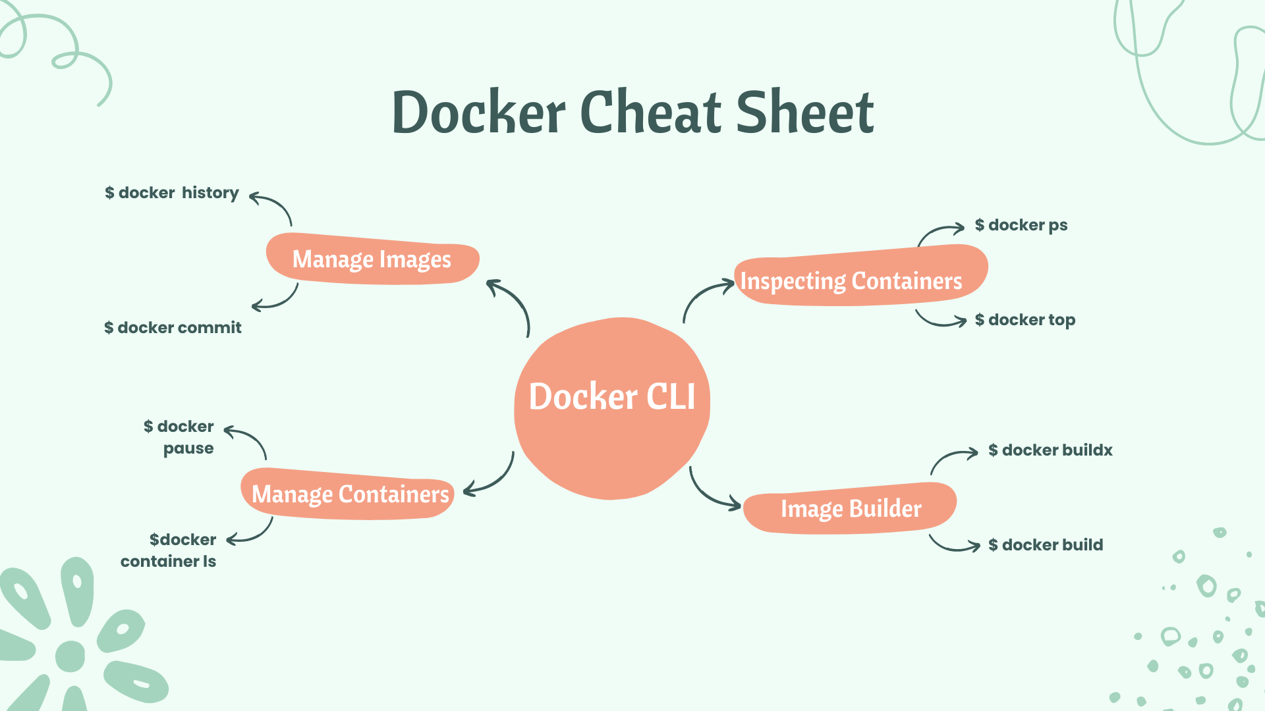

A cheat sheet is a concise summary of important information that is meant to be used as a quick reference. Cheatsheets are often used in the form of a list or a table, and they typically cover a specific topic or subject area. In the context of Docker, a Docker cheatsheet is a summary of commonly used Docker commands and their options and other useful information related to Docker.

Cheatsheets can be particularly helpful when learning a new tool or technology, as they provide a convenient way to quickly look up and remind oneself of key concepts and commands. They can also be useful for experienced users who need to recall a specific command or option but may not remember all the details.

[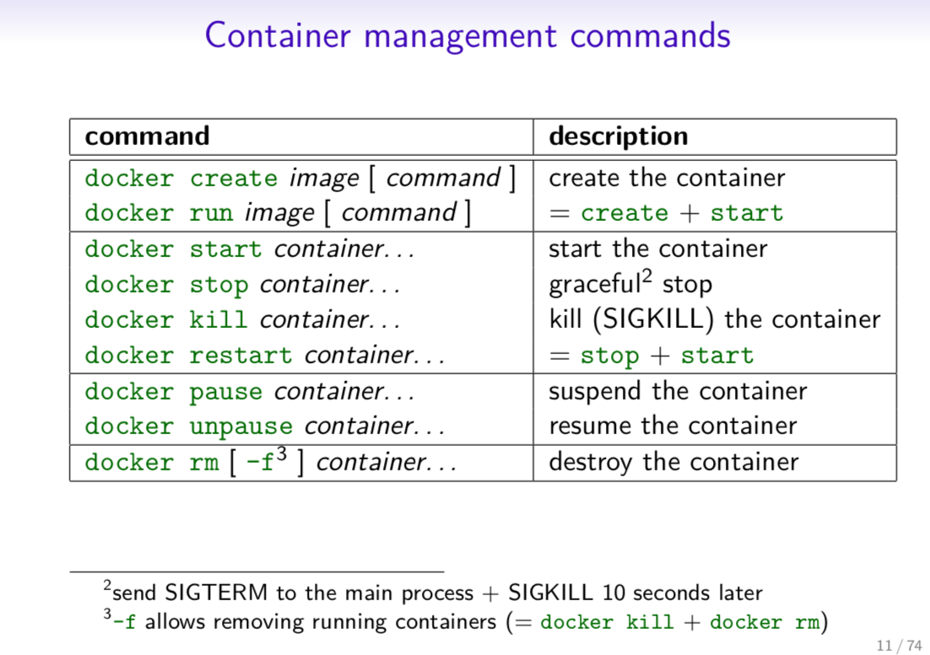](https://raw.githubusercontent.com/sangam14/dockercheatsheets/master/dockercheatsheet1.png)

[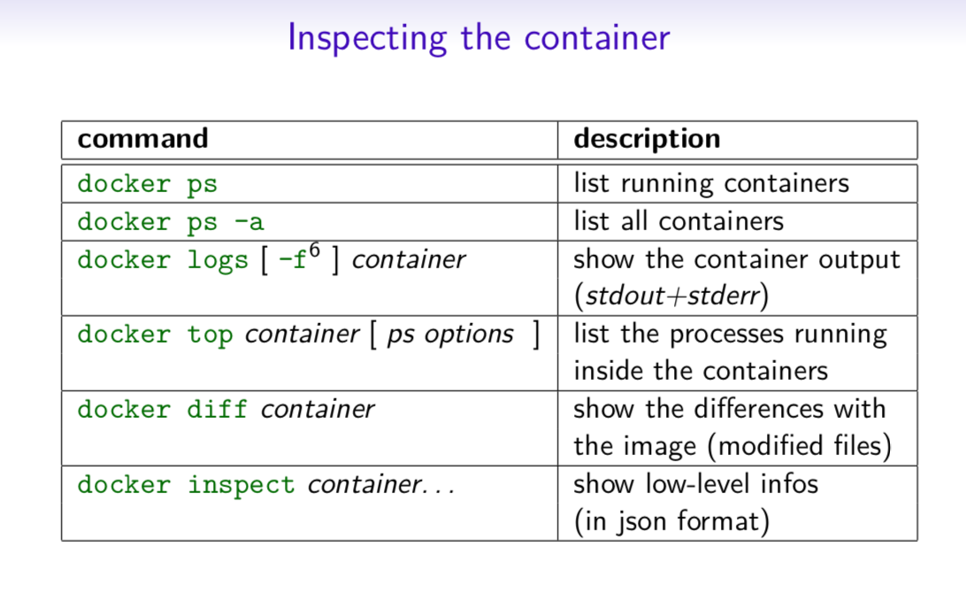](https://raw.githubusercontent.com/sangam14/dockercheatsheets/master/dockercheatsheet3.png)

[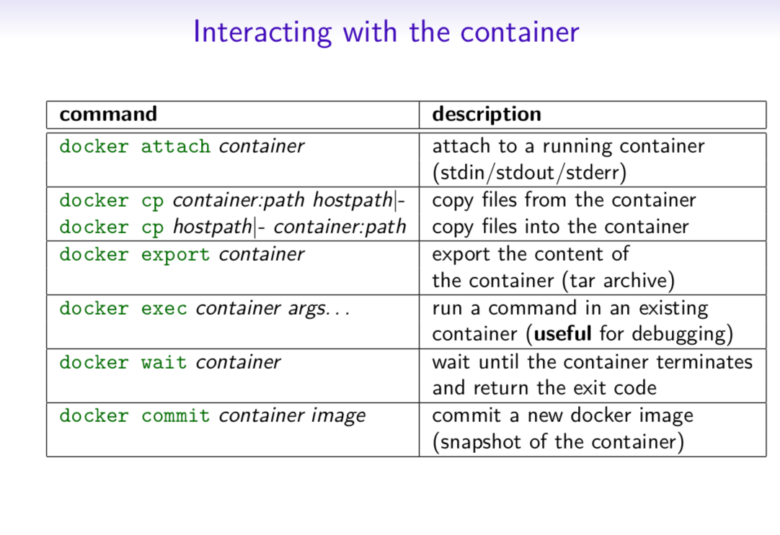](https://raw.githubusercontent.com/sangam14/dockercheatsheets/master/dockercheatsheet4.png)

[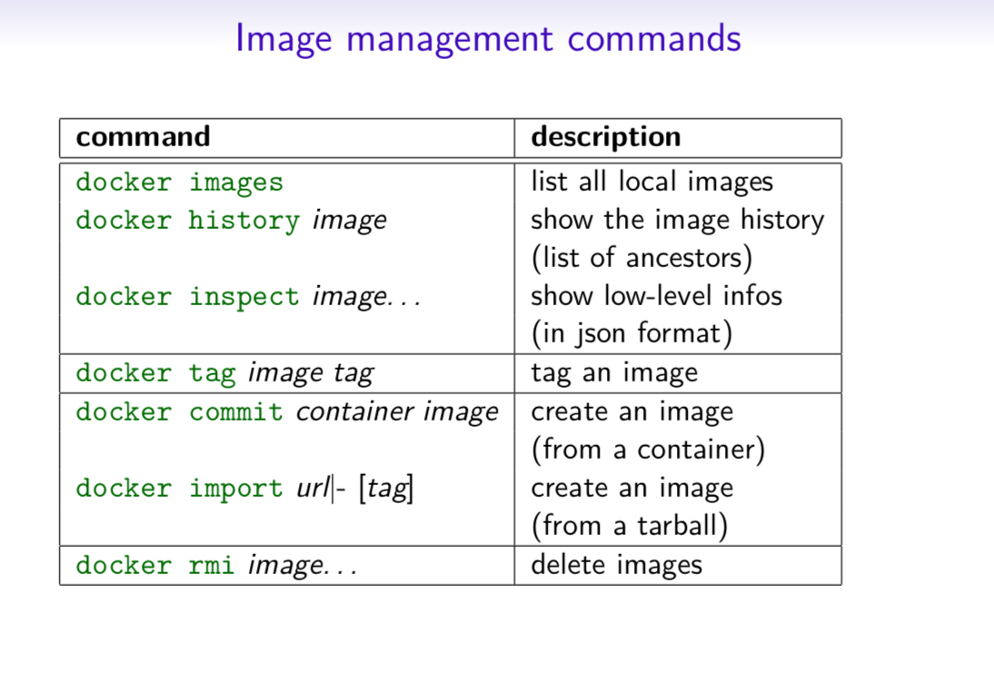](https://raw.githubusercontent.com/sangam14/dockercheatsheets/master/dockercheatsheet5.png)

[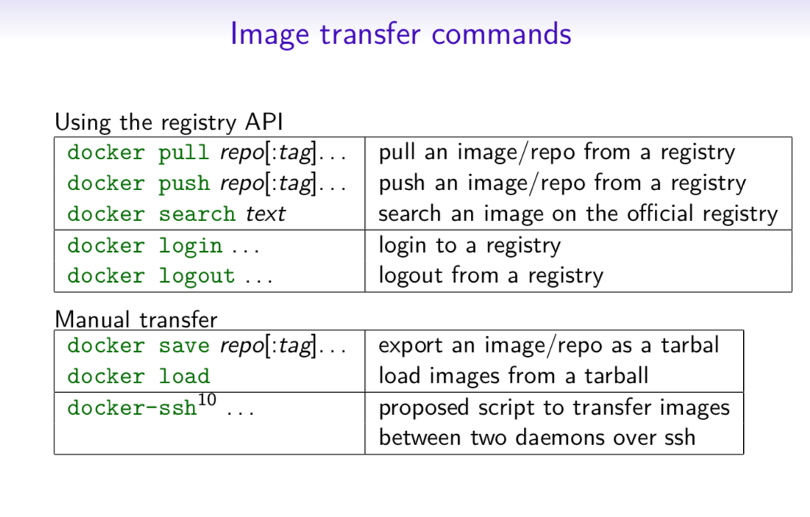](https://raw.githubusercontent.com/sangam14/dockercheatsheets/master/dockercheatsheet6.png)

[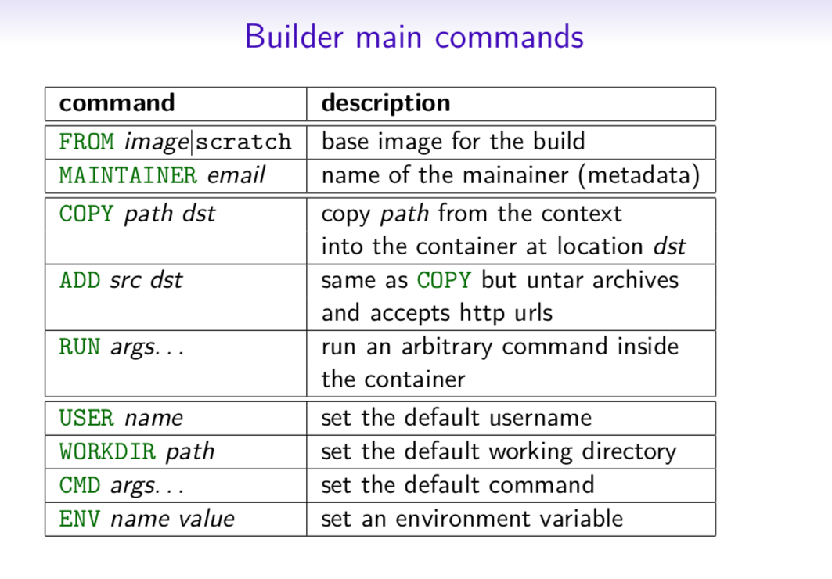](https://raw.githubusercontent.com/sangam14/dockercheatsheets/master/dockercheatsheet7.png)

**The Docker CLI**

**1. Manage Docker Images**

Build a Docker Image:

Command: docker build

|  |
| --- |
| **docker build [options]. -t "app/container_name" # name** |

Description: Create an image from a Dockerfile.

**2. Run a Docker Container:**

Run a command in an image.

Command: docker run

|  |
| --- |
| docker run [options] IMAGE  # see `docker create` for options |

Description: Run a command in an image.

**3. Manage containers**

**docker create**

docker create [options] IMAGE

-a, --attach # attach stdout/err

-i, --interactive # attach stdin (interactive)

-t, --tty # pseudo-tty

--name NAME # name your image

-p, --publish 5000:5000 # port map

--expose 5432 # expose a port to linked containers

-P, --publish-all # publish all ports

--link container:alias # linking

-v, --volume `pwd`:/app # mount (absolute paths needed)

-e, --env NAME=hello # env vars

**Example**

$ docker create --name app_redis_1 \

--expose 6379 \

redis:3.0.2

Create a container from an image.

**4. Executing command in a container**

**docker exec**

docker exec [options] CONTAINER COMMAND

-d, --detach # run in background

-i, --interactive # stdin

-t, --tty # interactive

**Example**

$ docker exec app_web_1 tail logs/development.log

$ docker exec -t -i app_web_1 rails c

Run commands in a container.

**5.  Start a Container**

**docker start**

docker start [options] CONTAINER

-a, --attach # attach stdout/err

-i, --interactive # attach stdin

docker stop [options] CONTAINER

Start/stop a container.

**6. Managing Container**

**docker ps**

$ docker ps

$ docker ps -a

$ docker kill $ID

Manage containers using ps/kill.

**7. Managing Images**

**docker images**

$ docker images

REPOSITORY TAG ID

ubuntu 12.10 b750fe78269d

me/myapp latest 7b2431a8d968

$ docker images -a # also show intermediate

Manages images.

**8. Delete Image**

**docker rmi**

docker rmi b750fe78269d

Deletes images.

**Also see**

* [Getting Started](http://www.docker.io/gettingstarted/) *(docker.io)*

**9. Dockerfile**

**Inheritance**

FROM ruby:2.2.2

**Variables**

ENV APP_HOME /myapp

RUN mkdir $APP_HOME

**Initialization**

RUN bundle install

WORKDIR /myapp

VOLUME ["/data"]

# Specification for mount point

ADD file.xyz /file.xyz

COPY --chown=user:group host_file.xyz /path/container_file.xyz

**Onbuild**

ONBUILD RUN bundle install

# when used with another file

**Commands**

EXPOSE 5900

CMD ["bundle", "exec", "rails", "server"]

**Entrypoint**

ENTRYPOINT ["executable", "param1", "param2"]

ENTRYPOINT command param1 param2

Configures a container that will run as an executable.

ENTRYPOINT exec top -b

This will use shell processing to substitute shell variables, and will ignore any CMD or docker run command line arguments.

**Metadata**

LABEL version="1.0"

LABEL "com.example.vendor"="ACME Incorporated"

LABEL com.example.label-with-value="foo"

LABEL description="This text illustrates \

that label-values can span multiple lines."

**See also**

* <https://docs.docker.com/engine/reference/builder/>

docker-compose

Basic example

# docker-compose.yml

version: '2'

services:

web:

build: .

# build from Dockerfile

context: ./Path

dockerfile: Dockerfile

ports:

- "5000:5000"

volumes:

- .:/code

redis:

image: redis

**Commands**

docker-compose start

docker-compose stop

docker-compose pause

docker-compose unpause

docker-compose ps

docker-compose up

docker-compose down

**Reference**

{: .-three-column}

**Building**

web:

# build from Dockerfile

build: .

# build from custom Dockerfile

build:

context: ./dir

dockerfile: Dockerfile.dev

# build from image

image: ubuntu

image: ubuntu:14.04

image: tutum/influxdb

image: example-registry:4000/postgresql

image: a4bc65fd

**Ports**

ports:

- "3000"

- "8000:80" # guest:host

# expose ports to linked services (not to host)

expose: ["3000"]

**Commands**

# command to execute

command: bundle exec thin -p 3000

command: [bundle, exec, thin, -p, 3000]

# override the entrypoint

entrypoint: /app/start.sh

entrypoint: [php, -d, vendor/bin/phpunit]

**Environment variables**

# environment vars

environment:

RACK_ENV: development

environment:

- RACK_ENV=development

# environment vars from file

env_file: .env

env_file: [.env, .development.env]

**Dependencies**

# makes the `db` service available as the hostname `database`

# (implies depends_on)

links:

- db:database

- redis

# make sure `db` is alive before starting

depends_on:

- db

**Other options**

# make this service extend another

extends:

file: common.yml # optional

service: webapp

volumes:

- /var/lib/mysql

- ./_data:/var/lib/mysql

**Advanced features**

**Labels**

services:

web:

labels:

com.example.description: "Accounting web app"

**DNS servers**

services:

web:

dns: 8.8.8.8

dns:

- 8.8.8.8

- 8.8.4.4

**Devices**

services:

web:

devices:

- "/dev/ttyUSB0:/dev/ttyUSB0"

**External links**

services:

web:

external_links:

- redis_1

- project_db_1:mysql

**Hosts**

services:

web:

extra_hosts:

- "somehost:192.168.1.100"

**sevices**

To view list of all the services runnning in swarm

docker service ls

To see all running services

docker stack services stack_name

to see all services logs

docker service logs stack_name service_name

To scale services quickly across qualified node

docker service scale stack_name_service_name=replicas

**Cleaning up**

To clean or prune unused (dangling) images

docker image prune

To remove all images which are not in use containers , add – a

docker image prune -a

To Prune your entire system

docker system prune

To leave swarm

docker swarm leave

To remove swarm ( deletes all volume data and database info)

docker stack rm stack_name

To kill all running containers

docker kill $(docker ps -q )

**Support and Community**

If you do get enough interest to contribute to this Cheat Sheet, the community at Collabnix is available to support you. Feel free to raise PR and get your favourite Cheat Sheet added to the list via [PR](https://github.com/collabnix/dockerlabs/pulls), or you can connect to us either on Slack or Discord server.