Στο logfile υπάρχουν 4 τύποι μηνυμάτων (3 control και 1 data).
Οι αριθμοί των χαρακτήρων που περιγράφω παρακάτω, ισχύουν μετρώντας και τους χαρακτήρες των αυξοντων αριθμών.
Η τοπολογία του δικτύου φαίνεται στο σχήμα
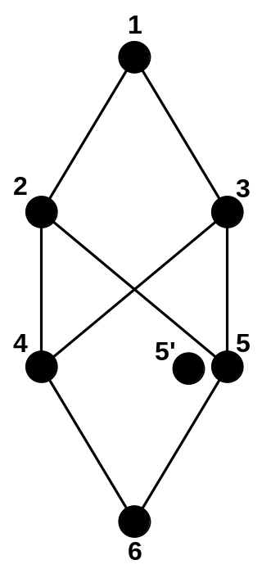

Scenario: Communication between 6->0 is established via the right path (node 5).
After a while, node 5 becomes a black hole attacker (5’) and node 6 selects path via node 4.
Remark: the links between the nodes cannot be parsed from the logfile, so create links between the nodes, as shown in the figure.

Parsing instructions

DIO type (line 32)
Broadcast (color red) chars: 35-38 (you should read: ffff)
Message type: chars: 129-130 (you should read: 01)
Timestamp: chars: 4-20
Source node id: chars: 39-42 (you should read: 0200)

Data packet (line 18)
Unicast (red brick)
Message type: chars: 59-60 (you should read: 11)
Timestamp: chars: 4-20
Source node id: chars: 91-94 (you should read: 0003)
Destin. Node id: chars: 123-126 (you should read: 0001)

We can also show information regarding two other control messages, but it might confuse the reviewers.
I propose to prepare only DIO and Data packet for the moment.
I just put the parsing info here, if we think that it is necessary to include them.

DIS type (line 31)
Broadcast (color blue) chars: 35-38 (you should read: ffff)
Message type: chars: 129-130 (you should read: 00)
Timestamp: chars: 4-20
Source node id: chars: 39-42 (you should read: 0400)

DAO type (line 74)
Unicast (green brick) chars: 35-38 (you should read: ffff)
Message type: chars: 138-139 (you should read: 02)
Timestamp: chars: 4-20
Source node id: chars: 40-43 (you should read: 0200)

