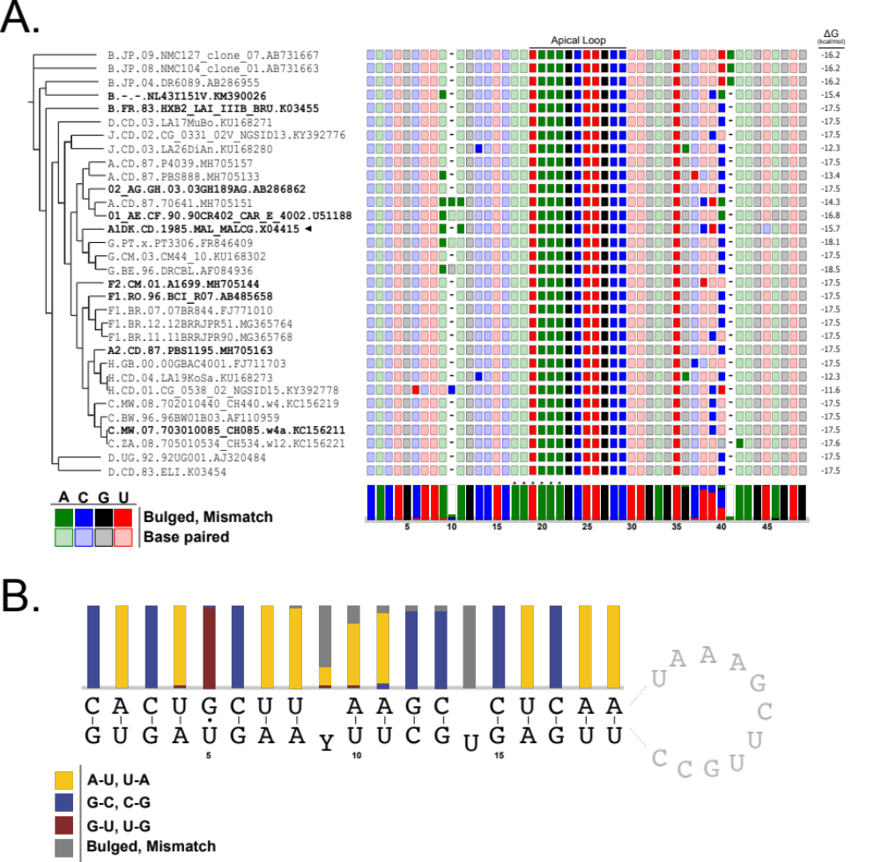

Figure XX. Phylogenetic Analysis of polyA Hairpin (A) An inferred phylogeny of representative HIV-1 strains of Group M subtypes (see methods for selection criteria). The phylogeny was built with bootstrapping (n=1000, branch width indicates branch support) a multiple sequence alignment of the viral polymerase protein sequences. The tree is annotated with a multiple sequence alignment of the polyA-HP as colored blocks where solid blocks indicate residues that are un-base paired and transparent blocks indicate residues that are base paired in the predicted secondary structure. Positional nucleotide frequencies are represented as a bar graph where white space in the bars represents the gaps in the alignment. Positions marked by an asterisk are the hexameric AAUAAA polyadenylation signal. Bold-faced strain names indicate they were part of our experimental analysis, with the majority of the focus on the MAL strain (denoted by◂).(B) The consensus secondary structure of the polyA-HP calculated by locARNA (1-3). The structure is annotated with the position specific frequency of the types of base pairs present at each position in the helical portion of the polyA-HP. Positional frequencies were determined after the predicted helical structures for each strain were aligned with the consensus structure using a modified Needleman-Wunch (4) algorithm (See methods).

Results
We conducted phylogenetic analysis of the 5′ polyA-HP across HIV-1 Group M subtypes to determine the conservation of the hairpin stability (Figure XX. A). Analysis of the structural conservation of the polyA-HP posed the non-trivial challenge of identifying the polyA-HP in each strain since sequence data from the LANL HIV compendium (5) do not have annotations for UTR structural elements. Using a traditional sequence alignment (i.e. BLAST (6)) with previously defined polyA-HP sequences, such as in the MAL (7) and NL4-3 (REF) strains, to identify the polyA-HP in each strain was an option; however, this approach could introduce a bias in the discovery of conserved structural elements. The resulting set of hairpin sequences would be expected to have high sequence similarity which would implicitly result in near complete conservation of the structural elements. We instead used a novel discovery pipeline that rooted the search at the hexameric AAUAAA signal to programmatically extract the most probable polyA-HP in each strain without explicitly requiring sequence similarity (Supplemental Figure XX, Methods). Of the ~4000 strains inputted into the pipeline, we were able to identify polyA-HP sequences for 280. Representative strains from each subtype and strains we analyzed experimentally were assembled (n=32) onto a phylogenetic tree (see Methods for representative strain selection process) (Figure XX. A).
Analysis of these representative strains showed complete sequence conservation of the 5′ and 3′ termini and the apical loop of the hairpin with majority of the sequence variation existing between positions 35 and 42 of the alignment. The predicted secondary structures, as calculated by RNAfold (8), had an average free energy of -16.55 ± 1.9 kcal/mol. The polyA-HP from each of the 32 strains was used to calculate a consensus structure calculated using the locARNA software tool (1-3) (Figure XX. B). The helical base pairs at the basal and apical regions of the helix are completely conserved. The stem had the greatest frequency of bulged residues between positions 9 and 11 on the helix, and completely conserved bulged uracil at position 14 (Figure XX. B).

Discussion
Many discrete structural domains have been functionally characterized in the 5’ UTR of the HIV-1 genome; however, any defined functional role of the 5′ polyA-HP has remained elusive. Recent findings have shown that the viral RNA exists in an equilibrium between a monomeric and dimeric species that is afforded by differential transcription start site usage. The monomeric RNA begins with a capped residue followed by two or three guanosines, ^{Cap}2G and ^{Cap}3G, respectively, and serves as mRNA that codes for viral proteins. The dimeric RNA begins with a capped residue followed by a single guanosine, Cap1G, and serves as genomic (gRNA) material for daughter virions (7, 9). Additionally, the dimeric gRNA exhibits a multi-helical structure where the 5′ poly-HP forms a stable hairpin that sequesters the cap and prevents interactions with cap-binding proteins. The 5′ polyA is unstructured and flexible in the monomeric mRNA which leaves the cap exposed (7, 9). A NMR supported mechanism proposes the addition of a guanosine at the 5′ end of the RNA by differential transcription start site will disrupt the C:G base pair at the base of the polyA-HP stem, and this disruption will allow for downstream remodeling (7). This mechanism suggests the hairpin is at a sensitive thermodynamic tipping point where the disruption of a single base pair affords global remodeling.
Previous studies have implicated the thermodynamic semi-stability of the 5′ polyA-HP in successful viral replication. Das et al. showed in cellulo that stabilization of the 5′ polyA-HP abrogates viral replication (10) and later showed that revertant viral particles evolved to have mutations that resulted in a hairpin with wild type stability (11). While there has been some evidence to suggest functional roles for the 5′ polyA-HP (12), there is little mechanistic understanding of how the thermodynamic stability of this hairpin directly affords successful viral replication. We propose that he stability of the hairpin is critical for modulation of the monomer-dimer equilibrium by way of transcription start site heterogeneity.
[Discussion about structural, biochemical, and in cellulo studies]
We have shown that the bulges in the 5′ polyA-HP are necessary to afford modulation of the monomer-dimer equilibrium via differential transcription start site usage in the MAL strain. Our phylogenetic analysis and consensus secondary structure of the polyA-HP supports this as a conserved mechanism across Group M HIV-1 subtypes. The bulged uracil at position 14 of the helix is conserved in all strains, and all strains have at least one additional bulged residue. Additionally, the C:G base pair at the position 1 of the helix is also completely conserved. Following our proposed NMR supported mechanism, the conservation of the C:G base pair in conjunction with bulges infers conservation of a differential transcription start site as a way to modulate global structure of the 5′-L (Figure XX. B)

Methods
All sequence data was pulled from the LANL HIV compendium (5), and any strains without complete sequence data, as annotated on the GenBank record, were ignored. Identifying the polyA-HP using sequence alignments could potentially introduce a bias in the analysis of the structural conservation of the polyA-HP because a sequence alignment would impose some degree of sequence similarity, and this would confound any variation in the structural features. We instead extracted the polyA-HP sequence by programmatically identifying the most stable hairpin in the 5′-L that contained the hexameric polyadenylation signal, AAUAAA (Supplemental Figure XX). For each strain of interest, the pipeline identifies the AAUAAA signal at position $N_{i}$ and extracts an initial segment, $F_{i}$, the length of which is set by an extension parameter, $X=75$, such that $F_{i}={[N}_{i-X}, N_{i+X}]$. The assumption is that the true polyA-HP, $F'$, is some subsequence of the initial fragment,$F'∈F_{i}$. The set of all possible subsequences, $\{F\}$, is considered and restrained based on minimum and maximum length (35-50nt) and the position of the AAUAAA in the hairpin where the signal must be near the center of the fragment within some threshold, $H=0.25$. The secondary structures for all subsequences that make it through the initial filtering are predicted using RNAfold from the ViennaRNA package (8). Fragments with more than 45% un-base paired residues are filtered out. Then, the subsequence with the lowest predicted free energy is predicted to be the true polyA-HP. If there is more than one instance of the AAUAAA signal, they are all considered, and the lowest energy structure is selected from the pool of all predicted structures from all AAUAAA sites.
Of the 4000+ strains we screened, ~800 were identified to have complete records based on keywords found in the Genebank record, and we were able to predict the polyA-HP sequence for 280 strains. To determine the most representative strains, the strains were grouped by subtype for each subtype in Group M, and for each group, the strains with the highest average percent similarity in the $F_{i}$ to the other strains in that subtype were determined to be representative. The percent similarity, $S$, between the $F_{i}$ of two strains was calculated as the proportion of matches, $m$, to the total number of matches and mismatches, $M$, $S=\frac{m}{M}$. This metric was calculated in a pairwise manner for all strains in a given subtype, and strains with the highest average percent similarity in each subtype were selected to be presented on the phylogeny.
The phylogeny was generated using an alignment of the polymerase gene (13, 14) made using CLUSTALW (15) and de-gapped using Gblocks (16). The pruned alignment was used to construct a Maximum Likelihood tree and infer bootstrap support (n=1000) using PhyML (17). A structure informed alignment of the polyA-HP sequences from the representative strains was conducted using locARNA (1-3) and the predicted secondary structures and free energies were determined by the RNAfold program in the ViennaRNA software suite (8).
The consensus secondary structure was inferred using the locARNA software tool (1-3). The positional frequencies of different types of base pairs in the helix were determined by aligning the consensus structure individually with each of the predicted structures for the polyA-HP of each of the strains presented on the phylogeny. The alignment algorithm for the helices was a modified Needleman-Wunch (4) (Supplemental Figure YY) with a scoring system that took into account the nucleotides present in the base pair and the side of the helix the nucleotides were on. Consider two base-pairs: $(A_{1},B_{1})$and $\left(A_{2},B_{2}\right)$. The scoring system was as follows:
$A_{1}=A_{2} ∩ B_{1}=B_{2}→+1$
$A_{1}∈\left(A_{2},B_{2}\right)∩B_{1}∈\left(A_{2},B_{2}\right)→+0.75$
$A_{1}=A_{2} ∪ B_{1}=B_{2}→+0.5$
$A_{1}∈\left(A_{2},B_{2}\right)∪B∈\left(A_{2},B_{2}\right)→+0.25$
$Gaps→-1$
Following the alignment of each strains’ polyA-HP predicted structure to the consensus structure, the frequency of the types of base pairs that occurred at each position in the consensus structure were noted. The data were graphed on the secondary structure.
Sequence data handling was aided by the Biopython software package (18). The phylogenetic tree was drawn and annotated using the ETE3 (19) and svgwrite (20) libraries for Python3. See code and data availability.

Supplementary
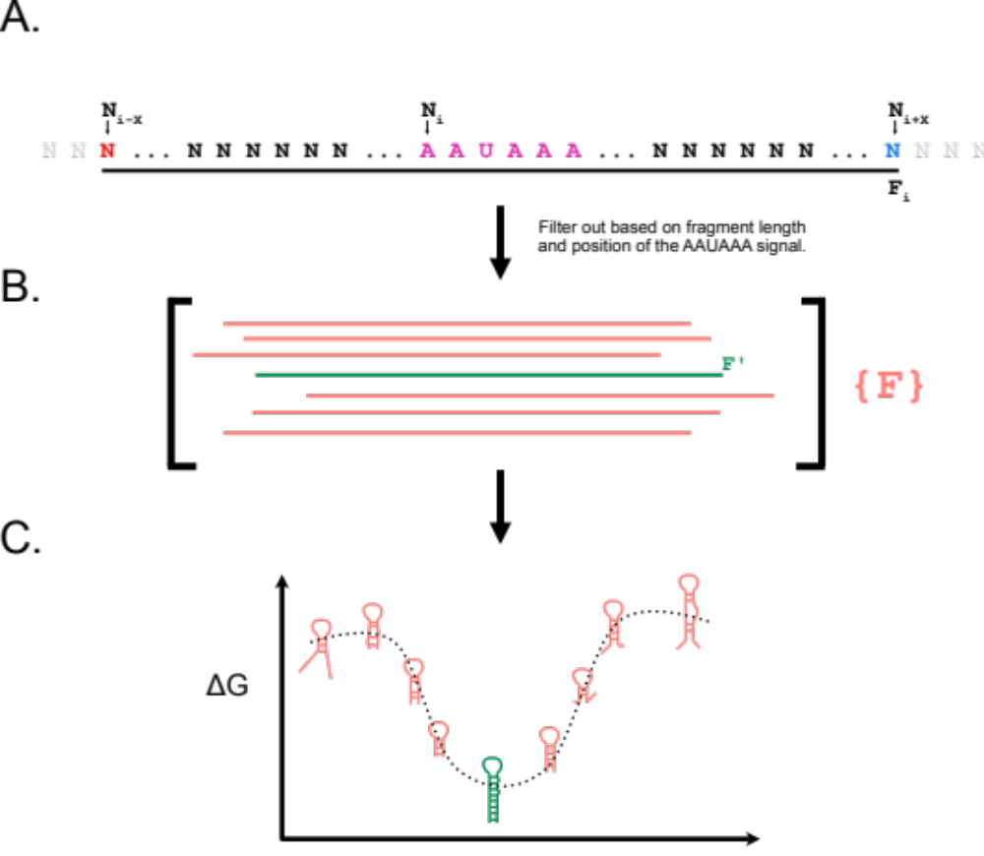
Supplemental Figure XX. polyA-HP Discovery Pipeline An overview of how we programmatically parsed the polyA-HP sequence for each strain. (A) We select an initial fragment, $F_{i}$, that is rooted at the AAUAAA polyadenylation signal and extends $X=75$ positions upstream and downstream. (B) Each sub-sequence, $F$, of $F_{i}$ is considered. Any fragments that is not within the minimum and maximum lengths (35-50nt) or has the AAUAAA too far off center ($H=0.25$) is ignored. (C) The secondary structure is predicted for all remaining fragments. Fragments with more than 45% of the residues being un-base paired are ignored. From here, the fragment that is predicted to form the lowest free energy structure is selected.
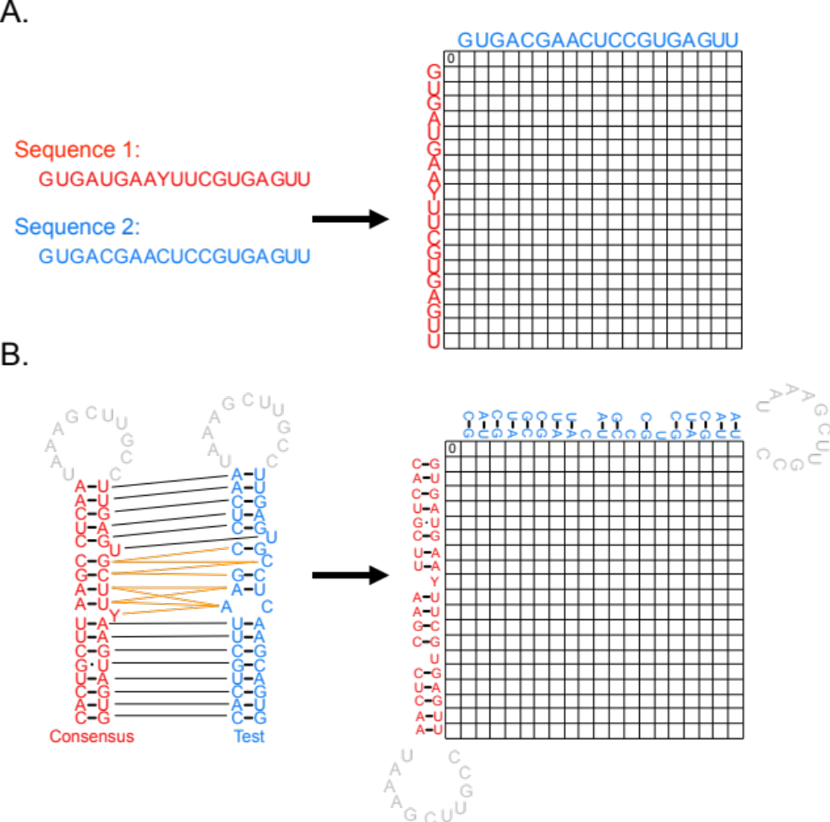
Supplemental Figure YY. Adapted Needleman-Wunch (A) A schematic showing the dynamic programming setup for a traditional Needleman-Wunch algorithm for aligning sequences. (B) The analogous setup of the Needleman-Wunch algorithm that has been adapted to align helical position instead of sequence positions.

References
1. S. Will, I. L. Joshi T Fau - Hofacker, P. F. Hofacker Il Fau - Stadler, R. Stadler Pf Fau - Backofen, R. Backofen, LocARNA-P: accurate boundary prediction and improved detection of structural RNAs.
2. S. Will, I. L. Reiche K Fau - Hofacker, P. F. Hofacker Il Fau - Stadler, R. Stadler Pf Fau - Backofen, R. Backofen, Inferring noncoding RNA families and classes by means of genome-scale structure-based clustering.
3. M. Raden et al., Freiburg RNA tools: a central online resource for RNA-focused research and teaching. Nucleic Acids Research 46, W25-W29 (2018).
4. C. D. Needleman Sb Fau - Wunsch, C. D. Wunsch, A general method applicable to the search for similarities in the amino acid sequence of two proteins.
5. Anonymous (2016) Los Alamos HIV sequence compendium 2016.
6. S. F. Altschul et al., Gapped BLAST and PSI-BLAST: a new generation of protein database search programs. Nucl. Acids Res. 25, 3389-3402 (1997).
7. J. D. Brown, Kharytonchyk, S., Chaudry, I., Iyer, A. S., Carter, H., Becker, G., Desai, Y., Glang, L., Choi, S. H., Singh, K., Lopresti, M. W., Orellana, M., Rodriguez, T., Oboh, U., Hijji, J., Ghinger, F. G., Stewart, K., Frances, D., Edwards, B., Chen, P., Case, D. A., Telesnitsky, A., Summers, M. F., Structural basis for transcriptional start site control of HIV-1 RNA fate. Science 368, 413-417 (2020).
8. R. Lorenz et al., ViennaRNA Package 2.0. Algorithms for Molecular Biology 6, 26 (2011).
9. J. B. B. Patricia S. Boyd, Joshua D. Brown, Jonathan Catazaro, Issac Chaudry, Pengfei Ding, Xinmei Dong, Jan Marchant, Colin T. O’Hern, Karndeep Singh, Canessa Swanson, Michael F. Summers, Saif Yasin, NMR Studies of Retroviral Genome Packaging. Viruses 12, 1-51 (2020).
10. A. T. Das, B. Klaver, B. I. Klasens, J. L. van Wamel, B. Berkhout, A conserved hairpin motif in the R-U5 region of the human immunodeficiency virus type 1 RNA genome is essential for replication. J Virol 71, 2346-2356 (1997).
11. B. Berkhout, A. T. Klaver B Fau - Das, A. T. Das, Forced evolution of a regulatory RNA helix in the HIV-1 genome.
12. R. P. Smyth et al., In cell mutational interference mapping experiment (in cell MIME) identifies the 5' polyadenylation signal as a dual regulator of HIV-1 genomic RNA production and packaging. Nucleic Acids Res 46, e57 (2018).
13. L. Perrin, S. Kaiser L Fau - Yerly, S. Yerly, Travel and the spread of HIV-1 genetic variants.
14. C. Pasquier et al., HIV-1 subtyping using phylogenetic analysis of pol gene sequences.
15. J. D. Thompson, D. G. Higgins, T. J. Gibson, CLUSTAL W: improving the sensitivity of progressive multiple sequence alignment through sequence weighting, position-specific gap penalties and weight matrix choice. Nucleic Acids Res 22, 4673-4680 (1994).
16. G. Talavera, J. Castresana, Improvement of phylogenies after removing divergent and ambiguously aligned blocks from protein sequence alignments.
17. S. Guindon et al., New algorithms and methods to estimate maximum-likelihood phylogenies: assessing the performance of PhyML 3.0. Systematic biology 59, 307-321 (2010).
18. P. J. Cock et al., Biopython: freely available Python tools for computational molecular biology and bioinformatics.
19. J. Huerta-Cepas, F. Serra, P. Bork, ETE 3: Reconstruction, Analysis, and Visualization of Phylogenomic Data.
20. Anonymous (svgwrite.

