Task Outline: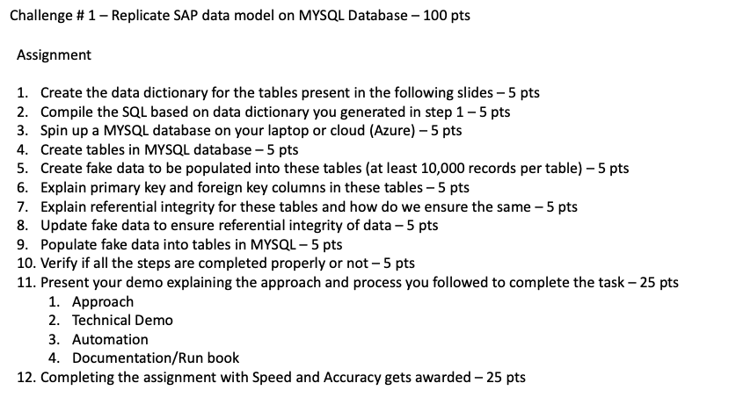

Section 1:

Creating a Data Dictionary.

What is a Data Dictionary?

A data dictionary, also called a metadata repository, is a well-organized list that explains everything about the parts of a database. It includes clear explanations and details about things like tables, columns, how parts of the database are connected, the kind of data each part holds, and the rules for those data parts in the database system.

Using the given diagram the following data dictionary was generated by assuming a few parameters such as size and type of the data:

[Data Dictionary Excel](https://docs.google.com/spreadsheets/d/1o8pXPuRfK1-33TRoUCcmFdj3PGytsJJ3T-M-dlF9CkY/edit#gid=2135765279)

Section 2:

Creating SQL commands based on the Data Dictionary.

With the data dictionary at hand, the following SQL Script was created.

Section3:

Spinning up a MySQL Database

Section 4:

Creating the tables

Section 5:

Create Fake Data

Section 6:

Primary Key and Foreign keys

Section 7:

Referential Integrity

Section 8:

Update the fake data

Section 9:

Populate data into tables

Section 10:

Verification