Michelle Imanuela Winata

2602061441

Dokumentasi Project HCI Lab

1. Home Page



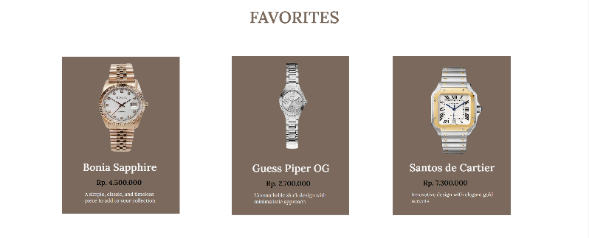

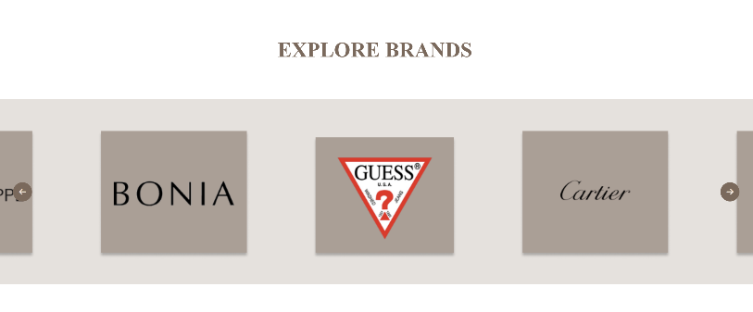

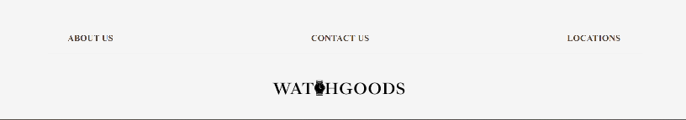

Page Explanation:

The components present on this page are as follow: navigation bar, hero banner, watch favorites catalogue section, explore brands carousel, and footer bar. The navigation bar contains the way to link from the home page to the rest of the other pages. The hero banner would be the first thing that the user will see when they open the website, and the writing “quality, service, authenticity” is presented in a typography effect made using Javascript. This writing helps build the elegant image and credibility of the website. The next component is the favorites catalogue section, which just displays three watches that are the favorites of other customers. This is a dummy display, where the catalogue shows the image, name, price, and description of the watch. In addition to that, there is an “explore brands” carousel, where all of the brands present in WatchGoods are displayed. The user can click on the left or right button to see more of the brands. Lastly, there is a footer bar that allows the user to change pages to the about us page, locations page, and contact us page. The connections that users can make from the home page are to the products page, about us page, locations page, and contact us page.

2. Products Page

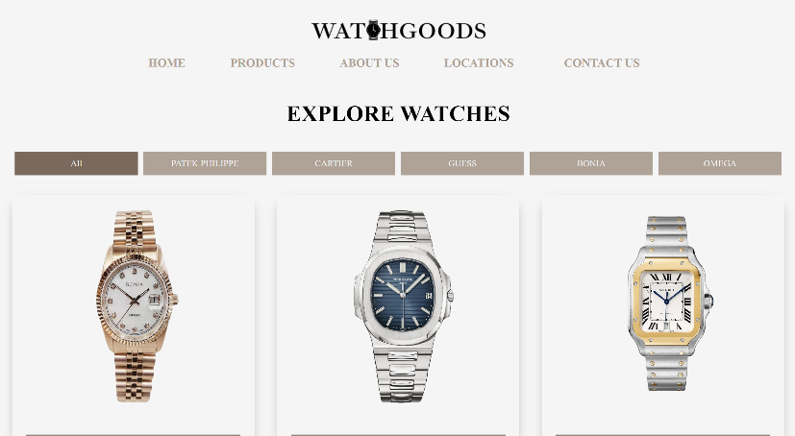

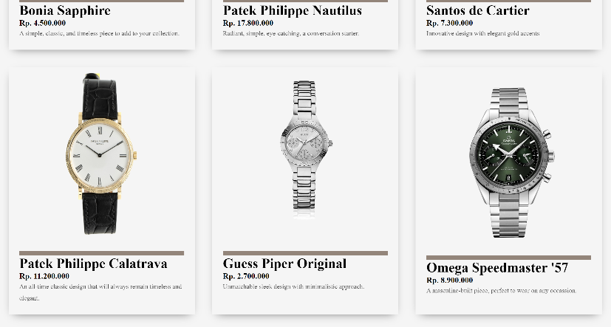

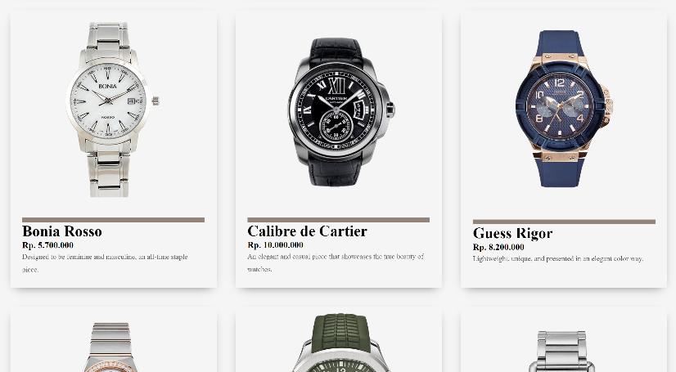

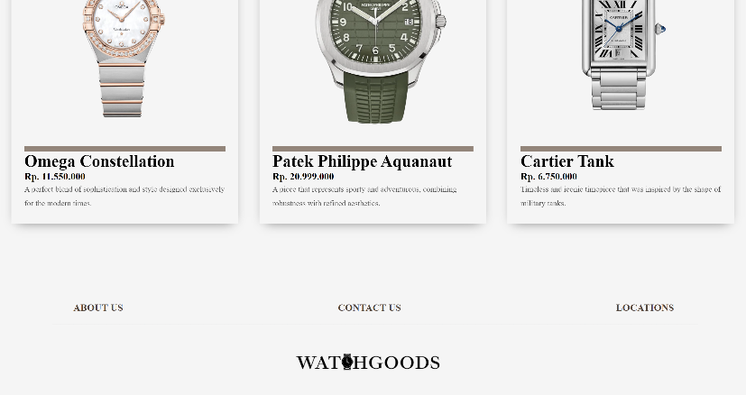

Page Explanation:

The components present in this page are as follow: navigation bar, filter buttons, watch catalogues, and footer bar. The navigation bar contains the way to link from the products page to the rest of the other pages. The filter buttons allows user to change the watches being displayed, which are filtered by brand. The five brands include Patek Philippe, Cartier, Guess, Omega, and Bonia. Next up are the watch catalogues, where all the watches sold at WatchGoods are displayed. The catalogues display the watch image, name, price, and description, which helps customers to know the detailed information about each watch. Lastly is the footer bar, which connects to the about us, contact us, and locations page. The connections that user can make from this page are to the home page, about us page, contact us page, and locations page.

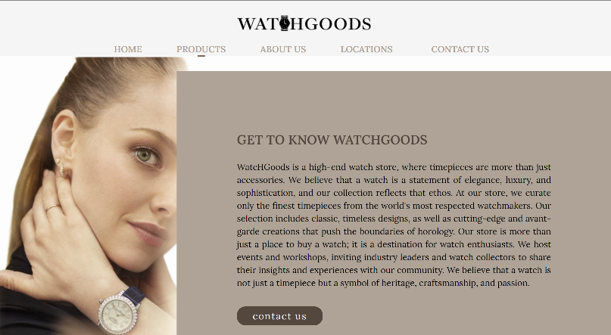3. About Us Page

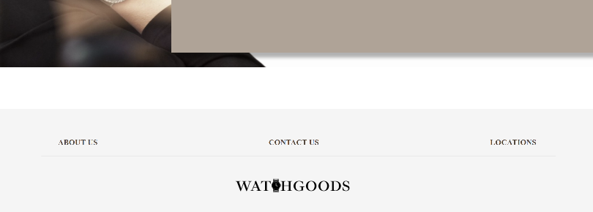

Page Explanation:

The components present in this page are as follow: navigation bar, about us description, contact us button, and footer bar. The navigation button allows user to switch pages from the about us page to the home page, products page, contact us page, and locations page. The about us description contains a brief but detailed explanation about what kind of company WatchGoods is, along with the kind of services WatchGoods try to provide. In addition to the about us descriptions, there is a contact us button at the end of the description, so that when the user is interested with WatchGoods, they can contact the company by sending them a message. The connections that users can make from this page are to the home page, products page, contacts page, and locations page.

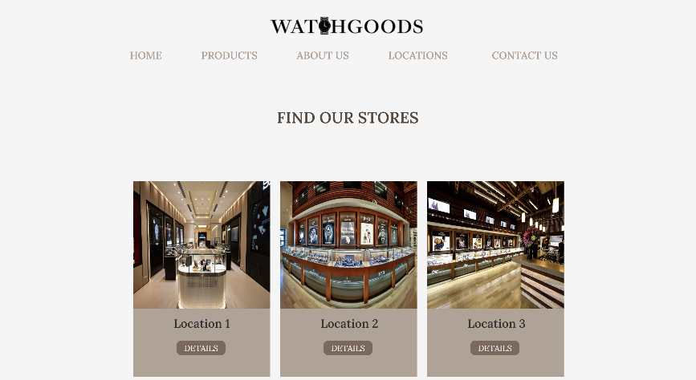4. Locations Page

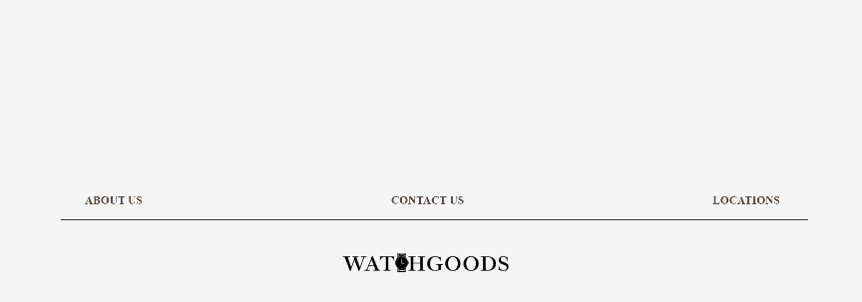

Page Explanation:

The components present in this page are as follow: navigation bar, store location catalogue, and footer bar. The navigation bar allows user to switch pages from the locations page to the home page, products page, about us page and contact us page. The locations catalogue showcase the 3 locations of WatchGoods store around the world. The user can click on the “details” button and an image of the location, address, and picture on google map will appear. This can be done for all 3 catalogues. Lastly, the footer bar allows the user to navigate to the about us, contact us, and locations page. The connections that users can make from this page are to the home page, products page, contact us page, and about us page.

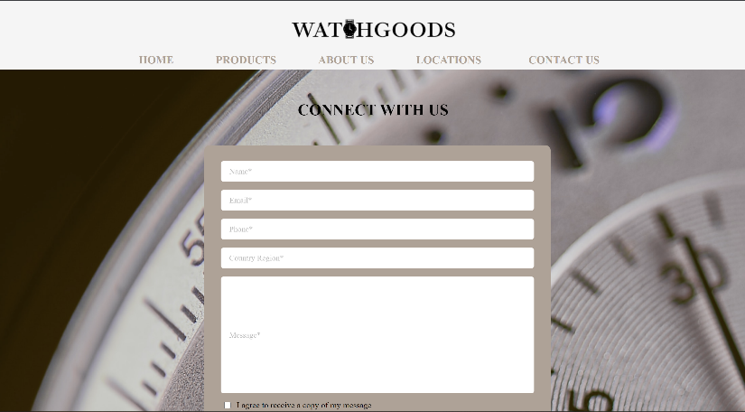5. Contact Us Page

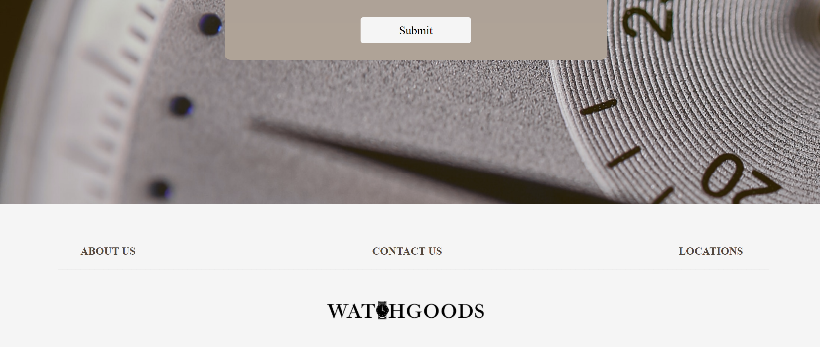

Page Explanation:

The components present in this page are as follow: navigation bar, contact us form, and footer bar. The navigation bar allows user to switch pages from the locations page to the home page, products page, about us page and locations page. The contact form consists of five fields to fill in, with that being the name, email, phone number, country region, and message field. This contact form was made with validation technique using Javascript, so that the user are required to fill in every field if they decide to send a message. An error message will appear if the input is not according to the requirements. Lastly, the footer bar allows the user to navigate to the about us, contact us, and locations page. The connections that users can make from this page are to the home page, products page, locations page, and about us page.