Lab - Explore DevNet Resources

Part 1: Explore More Resources

Step 1: Explore the Start Now page
I went to Learn > Start Now and looked for Networking 101 like the lab says. The live Start Now page does not show that card cleanly anymore, so I checked the Networking 101 track metadata on developer.cisco.com. It lists 3 labs, not the 200+ number some classmates saw from the whole library.
How many labs are linked on this page?
3 labs.
What is the total length of the labs?
About 1 hour 20 minutes total for those 3 labs. The site metadata also shows 30 minutes, which looks like a placeholder.

Step 2: Explore the Video course page
I opened the Videos area on developer.cisco.com. The Network Programmability Basics course is the video course this lab points to. Inside Network Device APIs, each lesson video counts, including ones at the start and end of a module.
How many modules are available as video-based?
6 modules in Network Programmability Basics (Introduction, Programming Fundamentals, Network Device APIs, Network Controllers, Application Hosting and the Network, NetDevOps).
How many videos are available in the Network Device APIs module?
5 videos: YANG, NETCONF, RESTCONF, NX-API Part 1, and NX-API Part 2.

Step 3: Explore the Sandbox page
I opened Sandboxes from Learn. The page is buggy right now and does not show a Learn More button, so I used the Sandbox overview docs (developer.cisco.com/docs/sandbox/) for the first two questions. For ACI I went through Data Center sandboxes to ACI Simulator Always-On in the Self-Service catalog.
Which type of Sandbox provides private access to packaged labs?
Reservation Sandboxes.
Where can you go for help if you have difficulty or wish to ask a question about the Sandboxes?
The DevNet Sandbox Community Forum.
What is the url to connect to the ACI server to start the lab?
https://sandboxapicdc.cisco.com/
The direct URL would not load on my side. Per our professor I attached a screenshot from the DevNet Self-Service catalog showing ACI Simulator Always-On (the Always-On lab for this step).
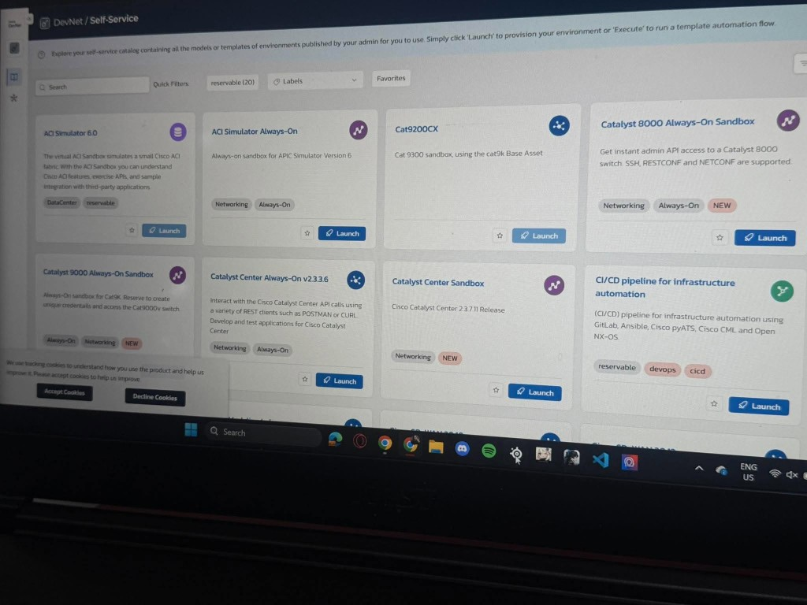
Why is it important not to upload very large resources to the lab?
Always-On labs are shared. Big uploads eat space and capacity other people need.

Step 4: Explore the Code Exchange page
I opened Code Exchange, went to Webex repos, and picked webexteamsbot.
What is the name of the project?
webexteamsbot (hpreston/webexteamsbot)
What category(-ies) does the project fall under?
Collaboration. Product tag is Webex.
What support options does this project provide?
Code Exchange Community. The page also says Cisco gives no formal support of any kind for Code Exchange listings.

Step 5: Explore Cisco Developer platforms
I opened the Networking platform area and picked one platform page.
Which category did you choose?
Networking
What platform did you explore?
Cisco Catalyst Center

