MiroFish Fund Governance Edition
Nontechnical Reviewer Pack - Synthetic Demo
This pack is for a fund manager, senior advisor, or LP-facing reviewer who does not need GitHub access. It uses synthetic data only and is not legal, tax, accounting, investment, or performance advice.
What You Are Looking At
MiroFish Fund Governance Edition is a simulation layer for rehearsing fund operations: capital calls, fund terms, waterfall, IC / LPAC decisions, LP communication, evidence trails, and meeting-pack preparation.
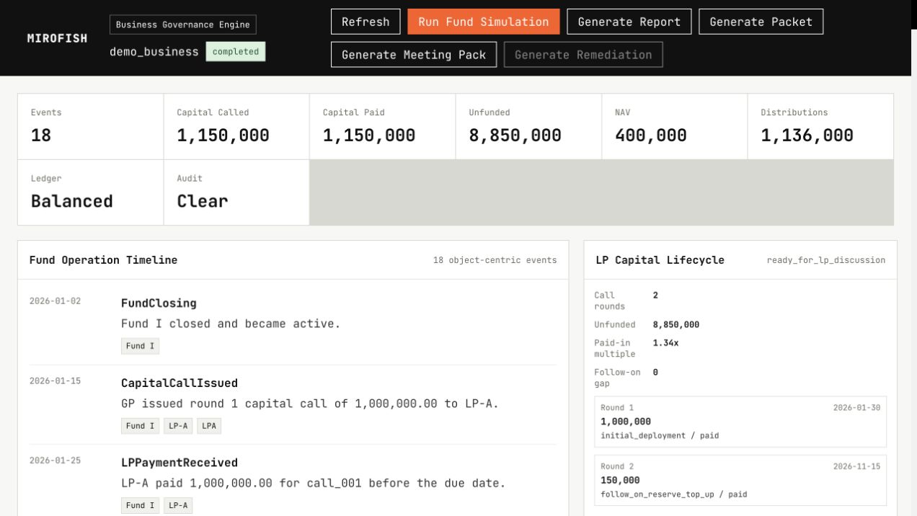
Demo screen after a synthetic fund-governance simulation run.
Sample Completed Report
The completed synthetic run produces an operating report that lets a reviewer inspect what happened, which fund terms or governance issues were triggered, and what should be discussed before LP or IC / LPAC review.
Metric | Synthetic Result | Reviewer Meaning
Events | 18 | Traceable fund-operation timeline
Capital called | 1,150,000 | Capital call activity is visible
Capital paid | 1,150,000 | Synthetic LP paid on time
Unfunded commitment | 8,850,000 | Remaining commitment is visible
NAV | 400,000 | Portfolio value shown separately
Distributions | 1,136,000 | Distribution logic can be inspected

Governance Questions Raised
- Should the follow-on reserve decision require IC approval, LPAC consent, or manager discretion?
- Which document excerpts should be bound as evidence before approval?
- Does the distribution summary show enough waterfall logic for an LP-facing conversation?
- Which assumptions should be editable before the next simulation run?
Three Questions For The Reviewer
- If you were a fund manager or LP-facing advisor, which part of this output would be most useful in a real conversation?
- Which part is unclear, too technical, or not yet credible?
- What would need to be added before you would introduce this to another fund manager, LP, IC member, or LPAC reviewer?
Boundary
This is a synthetic product demonstration. It does not include real LP data, real fund documents, investor identifiers, bank information, tax records, legal advice, accounting records, or investment advice.

