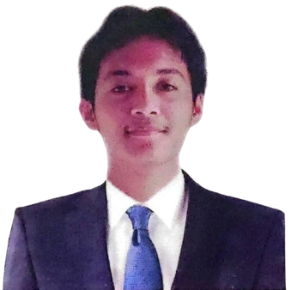**JOHN MARK S. ESTAREJA**

Maagay 1 Upper Brgy.Inarawan, Antipolo City

Contact # 09673191766

Jmestareja06@gmail.com

**OBJECTIVES**

To apply and develop my skills in IT related and Web Development in a dynamic and professional environment. I aim to grow professionally, reach my full potential, and consistently deliver high-quality results that exceed expectations.

**PERSONAL PROFILE**

Nickname : JM

Date of Birth : May 09, 2004

Place of Birth : Antipolo, Rizal

Gender : Male

Age : 21 years old

Height : 5’6 ft.

Weight : 85kg

Civil Status : Single

Citizenship : Filipino

Religion : Iglesia Ni Cristo

Father’s Name : Norberto Y. Estareja

Occupation : Signage Maker

Mother’s Name : Jennelyn S. Estareja

Occupation : House Wife

Their Address : Maagay 1 Upper Brgy.Inarawan, Antipolo City

Languages or Dialects speak or write: Tagalog and English

Person to be contacted in case of Emergency : Jennelyn S. Estareja

Address : Maagay 1 Upper Brgy.Inarawan, Antipolo City

Contact No : 09657813815

**EDUCATIONAL BACKGROUND**

**Tertiary Education**

School : ICCT Colleges Inc.

Address : J. Sumulong Street, Antipolo City

Attended : S. Y. 2022 - Present

**Higher Education (Senior High School)**

School : San Roque National High School

Address : Marigman St., Antipolo City

Attended : S. Y. 2021 - 2022

**Secondary:**

School : San Roque National High School

Address : Marigman St., Antipolo City

Attended : S.Y. 2019 – 2020

**Elementary**

School : Nazarene Ville Elementary School.

Address : Antipolo, Rizal

Attended : S.Y. 2015-2016

**SKILLS**

* Strong Problem Solving and Debugging
* Computer and Laptop Repair
* Knowledgeable in Communicating
* Computer Literate
* Hardware Troubleshooting and Upgrades
* Ability to Work Under Pressure
* Time Management Skills
* Adaptability and Quick Learner
* Patience
* Positive Attitude

**JOB EXPERIENCE(S)**

**YEAR**  **COMPANY POSITION**

March 19, 2024 - November 25, 2024 Sneaky Events Team Web Developer

**CHARACTER REFERENCES**

**NAME INSTITUTION RELATIONSHIP CONTACT INFORMATION**

Mike Jullanes Arcilla Sneaky Events Team Client 09555948151

Omar P. Amro Senior Accounts Payable - Kenvue Inc Mentor 09054624252

Lana Leyne Capistrano San Roque National Highschool Professor 09179932900

**“I hereby certify that the above information is true and correct to the best of my knowledge and belief.”**

**MR. JOHN MARK S. ESTAREJA**

Applicant’s Signature