Test Case 1:

|  |  |
| --- | --- |
| Title: User can find products by inserting their names using the search bar. | |
| Steps to execute | Expected Behavior |
| Users clicks on the search bar. | The user is allowed to type words. |
| User inserts the name of the product. | The letters are registered correctly. |
| User presses the button with a magnifying glass. | A page with the products that the user is looking for appear on the screen. |

Bug report 1:

Title: The user can’t find products after writing the name of existing products using the search bar.

Environment: Using Google Chrome

Steps to reproduce:

1. User clicks on the search bar.
2. User inserts the name of the product.
3. User pressed the button with a magnifying glass.

Expected Result:

The products having the searched name appear on the screen

Actual Result:

The result page contains no products no matter what name the user inserts.

Severity: High

Priority: High

Visual Proof:

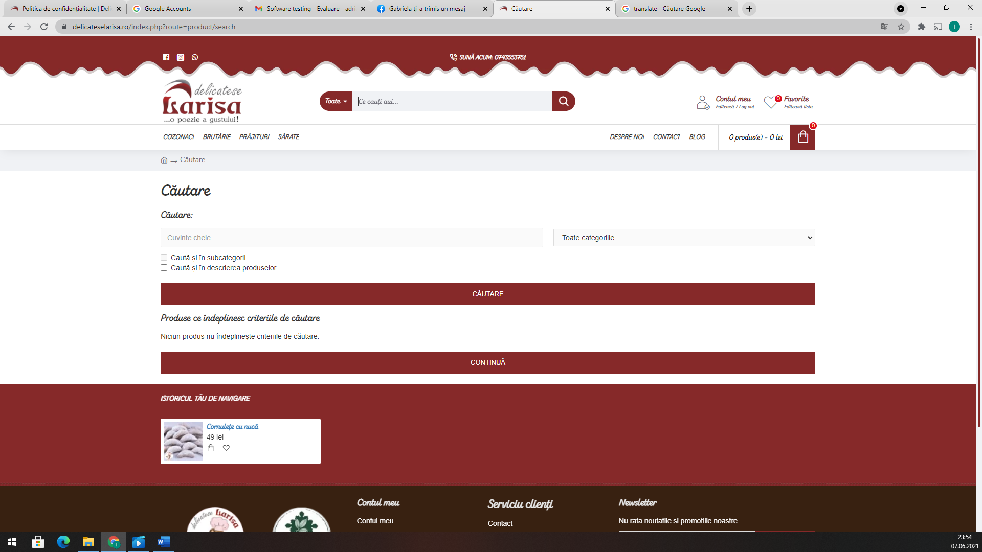

Test Case 2:

|  |  |
| --- | --- |
| Title: The text on the “Politică de confidențialitate” page contains diacritics. | |
| Steps to execute | Expected Behavior |
| User moves the mouse pointer over the “Politică de confidențialitate” button. | The mouse pointer icon changes to a hand. |
| User clicks on the “Politică de confidențialitate” button. | The page is refreshed and the text appears on the screen. |
| The user scrolls down the page. | The entire text is displayed correctly and the words are written using diacritics. |

Bug report 2:

Title: The text displayed on the “Politică de confidențialitate” contains words without diacritics

Environment: Using Google Chrome

Steps to reproduce:

1. User moves the mouse pointer over the “Politică de confidențialitate” button.
2. User clicks on the “Politică de confidențialitate” button.
3. The user scrolls down the page.

Expected Result:

The text on the “Politică de confidențialitate” page contains diacritics.

Actual Result:

The words aren’t written using diacritics.

Severity: High

Priority: High

Visual proof:

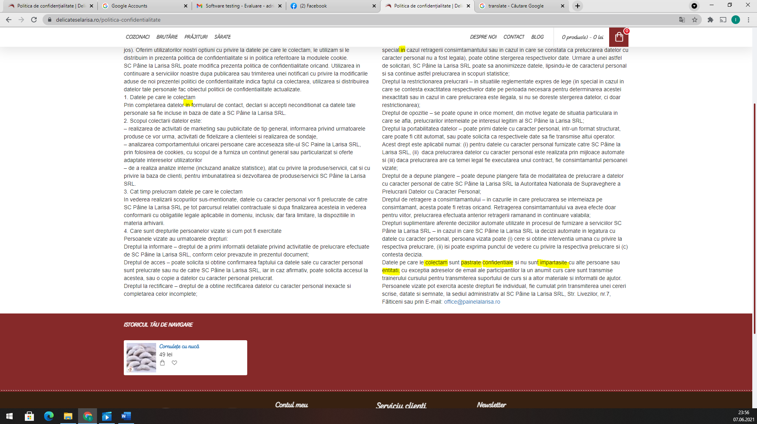

Test Case 3

|  |  |
| --- | --- |
| Title: The page “Newsletter” exist. | |
| Steps to execute | Expected Behavior |
| User moves the mouse pointer over the “Newsletter” text positioned in the footer. | The mouse pointer icon changes to a hand. |
| User clicks on the “Newsletter” text. | The page is refreshed and go to “Newsletter” section. |
| The user scrolls down the page. | The entire page is displayed correct and contains news about products. |

Bug report 3:

**Title:**The page “Newsletter” doesn’t exist

Environment: Using Google Chrome

Steps to reproduce:

1. User moves the mouse pointer over the “Newsletter” text.
2. User clicks on the “Newsletter” text.
3. The user scrolls down the page.

Expected Result:

A page that contains information and news about sweet products.

Actual Result:

The page doesn’t exist.

Severity: Medium

Priority: Medium

Visual proof:

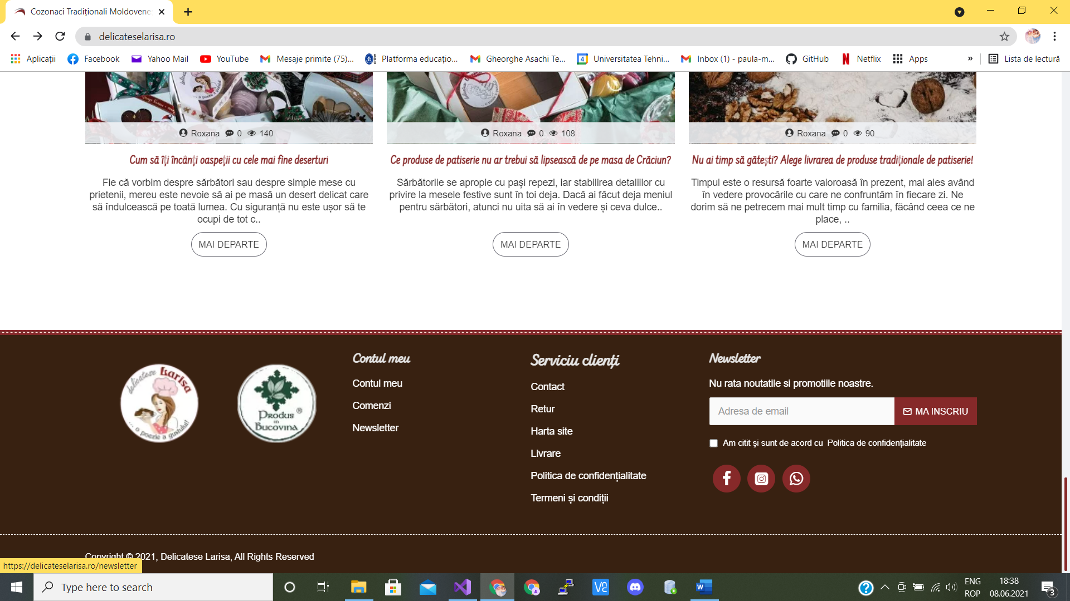

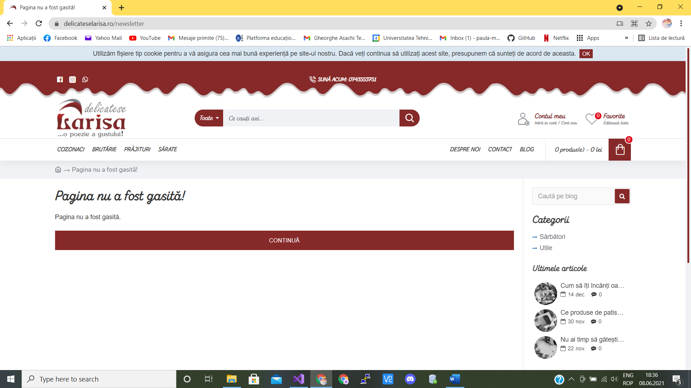

Test Case 4:

|  |  |
| --- | --- |
| Title: Users can buy as many pieces of products as they want. | |
| Steps to execute | Expected Behavior |
| User moves the mouse to “Adaugă coș” next to a product to buy it. | The product is added to the shopping cart. |
| User clicks on the “Vezi coșul”. | The page is refreshed and the shopping cart is displayed. |
| The user modify the box from column “Cantitate” by entering a number. | The quantities is successfully changed and available to be purchased. |

Bug report 4:

Title: The maximum of quantity that can be bought is 100 pieces for each product.

Environment: Using Google Chrome

Steps to reproduce:

1. User moves the mouse to “Adaugă coș” next to a product to buy it.
2. User clicks on the “Vezi coșul”.
3. The user modify the box from column “Cantitate” by entering a number.

Expected Result:

The user can buy as many products as he wants.

Actual Result:

The user can buy at most 100 products.

Severity: Medium

Priority: Medium

Visual proof:

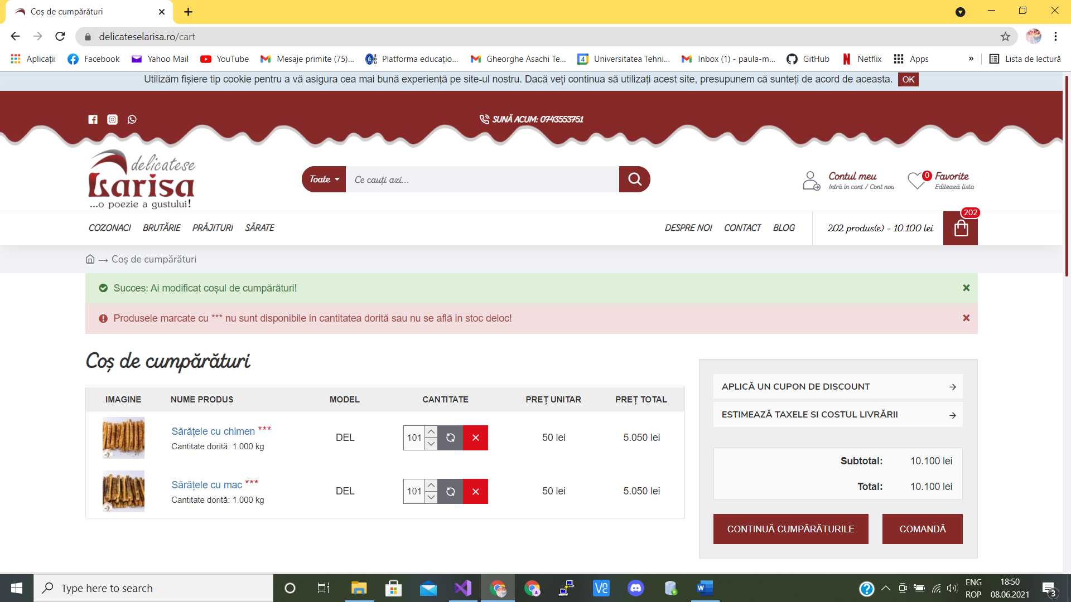

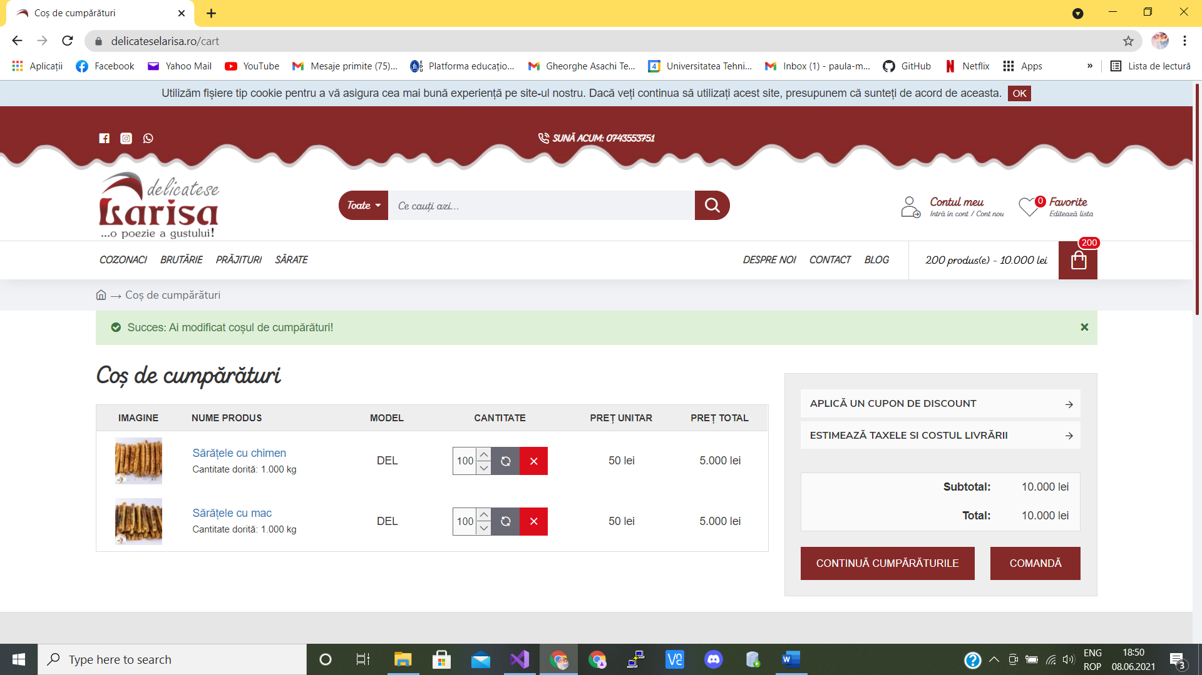

Test Case 5:

|  |  |
| --- | --- |
| Title: The text on the “Returnări” page is in Romanian language. | |
| Steps to execute | Expected Behavior |
| User moves the mouse pointer over the “Contul meu” button. | The mouse pointer icon changes to a hand. |
| User clicks on the “Contul meu” button. | The page is redirected to the “Autentificare” page. |
| User moves the mouse pointer over the “Retururi” button. | The mouse pointer icon changes to a hand. |
| User clicks on the “Retururi” button. | The page is redirected to “Returnări” page |
| User scrolls down the page. | The entire text of the page is displayed in the Romanian language. |

Bug report 5:

Title: The text from “Informaţii despre produs și motivul de returnare“ formular at “Motivul returnării” field is in Engish.

Environment: Using Google Chrome

Steps to reproduce:

1. User moves the mouse pointer over the “Contul meu” button.
2. User clicks on the “Contul meu” button.
3. User moves the mouse pointer over the “Retururi” button.
4. User clicks on the “Retururi” button.
5. User scrolls down the page.

Expected Result:

The text is displayed in Romanian language.

Actual Result:

The text from the “Motivul returnării” fields is in English.

Severity: Low

Priority: Low

Visual proof:

