Test Case 1:

|  |  |
| --- | --- |
| Title: User can find products by inserting their names using the search bar. | |
| Steps to execute | Expected Behavior |
| Users clicks on the search bar. | The user is allowed to type words. |
| User inserts the name of the product. | The letters are registered correctly. |
| User presses the button with a magnifying glass. | A page with the products that the user is looking for appear on the screen. |

Bug report 1:

Title: The user can’t find products after writing the name of existing products using the search bar.

Environment: Using Google Chrome

Steps to reproduce:

1. User clicks on the search bar.
2. User inserts the name of the product.
3. User pressed the button with a magnifying glass.

Expected Result:

The products having the searched name appear on the screen

Actual Result:

The result page contains no products no matter what name the user inserts.

Severity: High

Priority: High

Visual Proof:

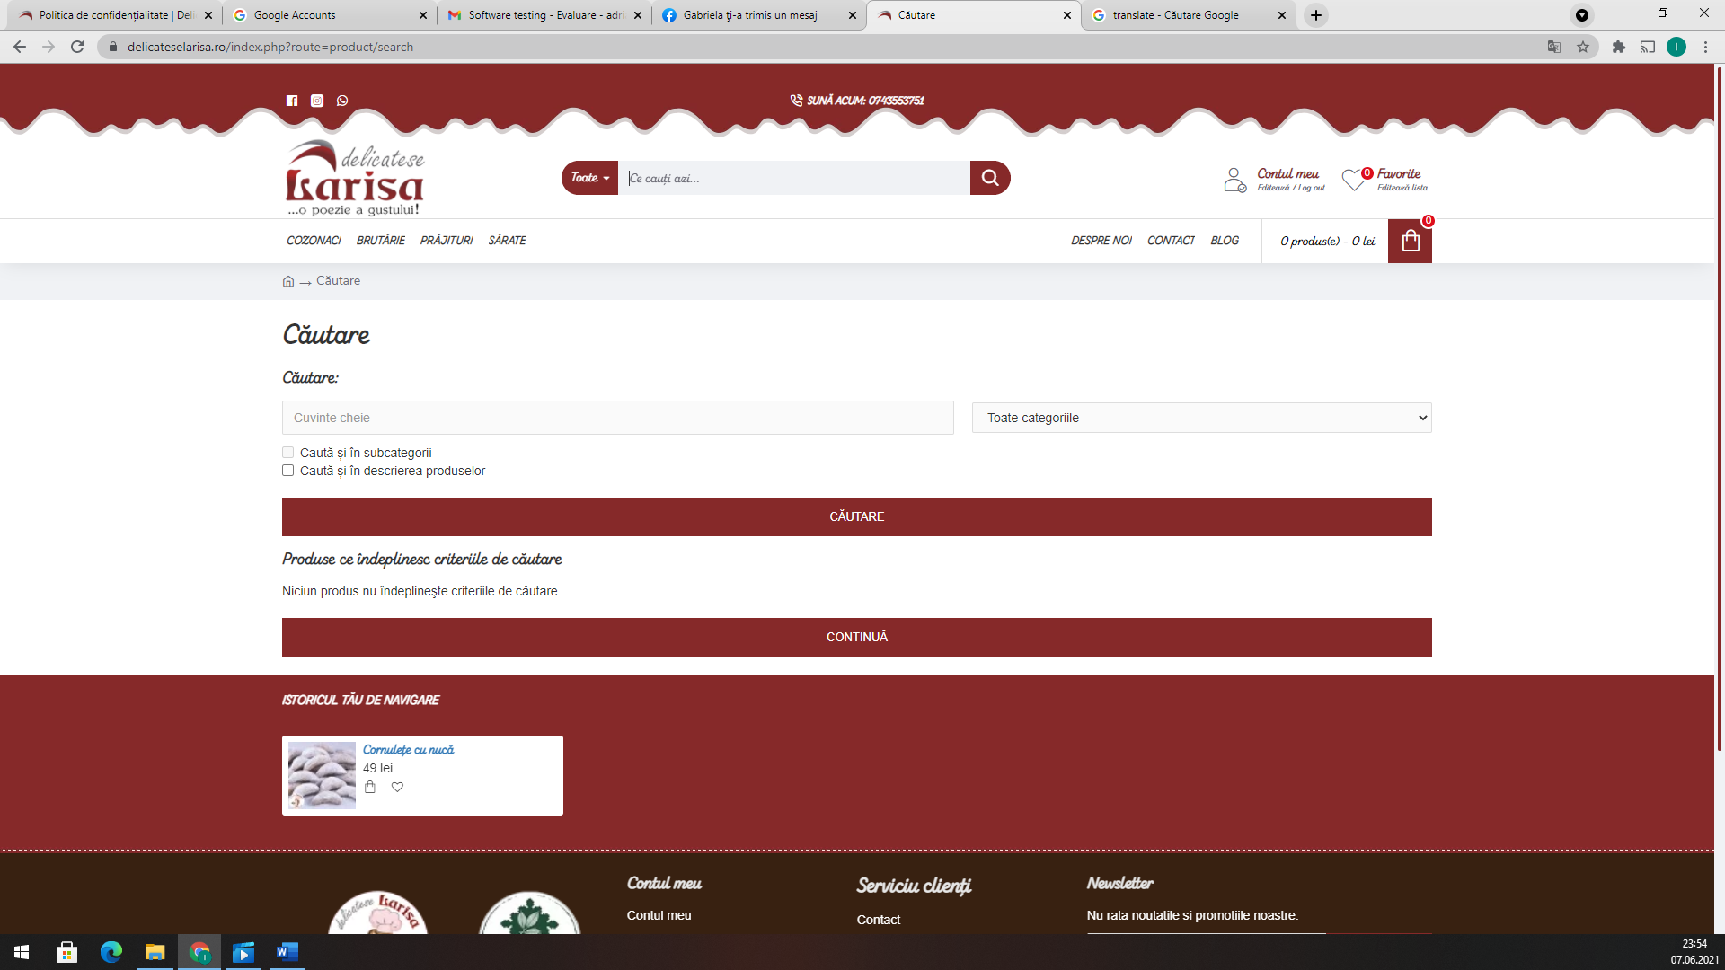

Test Case 2:

|  |  |
| --- | --- |
| Title: The text on the “Politică de confidențialitate” page contains diacritics. | |
| Steps to execute | Expected Behavior |
| User moves the mouse pointer over the “Politică de confidențialitate” button. | The mouse pointer icon changes to a hand. |
| User clicks on the “Politică de confidențialitate” button. | The page is refreshed and the text appears on the screen. |
| The user scrolls down the page. | The entire text is displayed correctly and the words are written using diacritics. |

Bug report 2:

Title: The text displayed on the “Politică de confidențialitate” contains words without diacritics

Environment: Using Google Chrome

Steps to reproduce:

1. User moves the mouse pointer over the “Politică de confidențialitate” button.
2. User clicks on the “Politică de confidențialitate” button.
3. The user scrolls down the page.

Expected Result:

The text on the “Politică de confidențialitate” page contains diacritics.

Actual Result:

The words aren’t written using diacritics.

Severity: High

Priority: High

Visual proof:

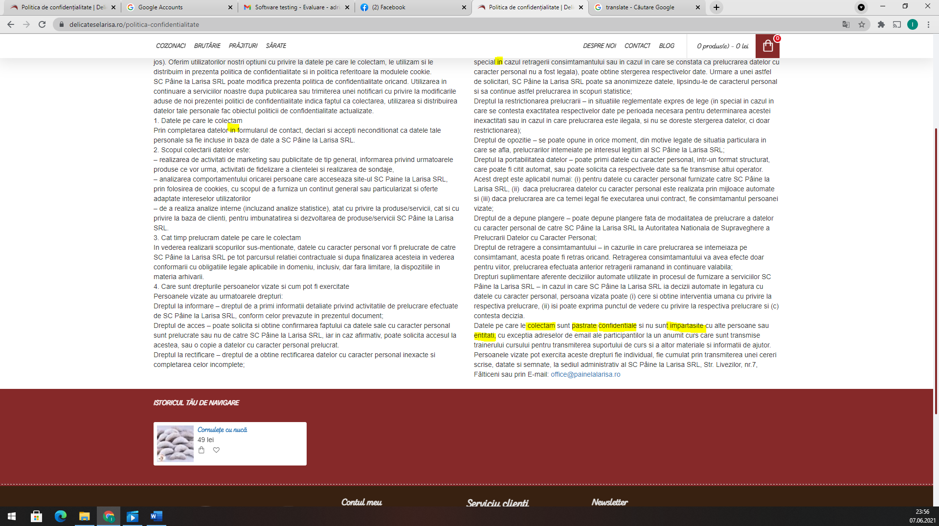

Test Case 3

|  |  |
| --- | --- |
| Title: The page “Newsletter” doesn’t exist. | |
| Steps to execute | Expected Behavior |
| User moves the mouse pointer over the “Newsletter” text positioned in the footer. | The mouse pointer icon changes to a hand. |
| User clicks on the “Newsletter” text. | The page is refreshed and go to “Newsletter” section. |
| The user scrolls down the page. | The entire page is displayed correct and contains news about products. |

Bug report 3:

**Title:**The page “Newsletter” doesn’t exist

Environment: Using Google Chrome

Steps to reproduce:

1. User moves the mouse pointer over the “Newsletter” text.
2. User clicks on the “Newsletter” text.
3. The user scrolls down the page.

Expected Result:

A page that contains information and news about sweet products.

Actual Result:

The page doesn’t exist.

Severity: Medium

Priority: Medium

Visual proof:

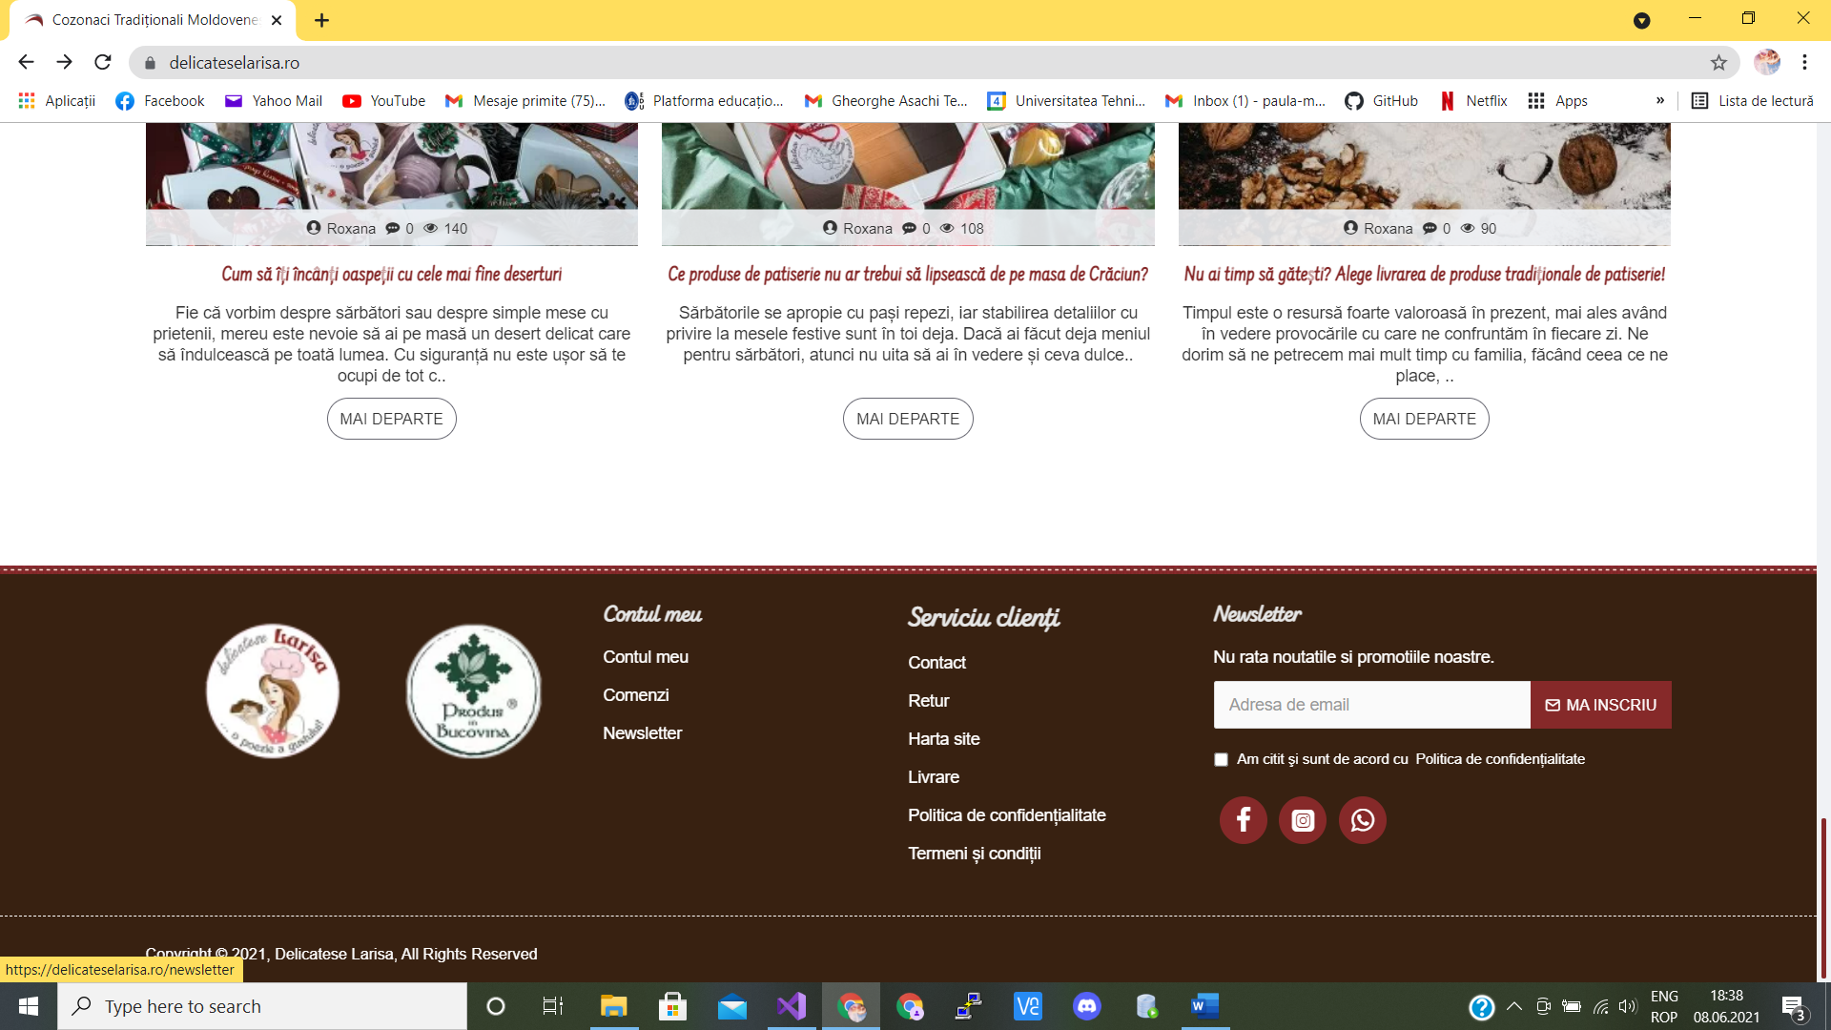

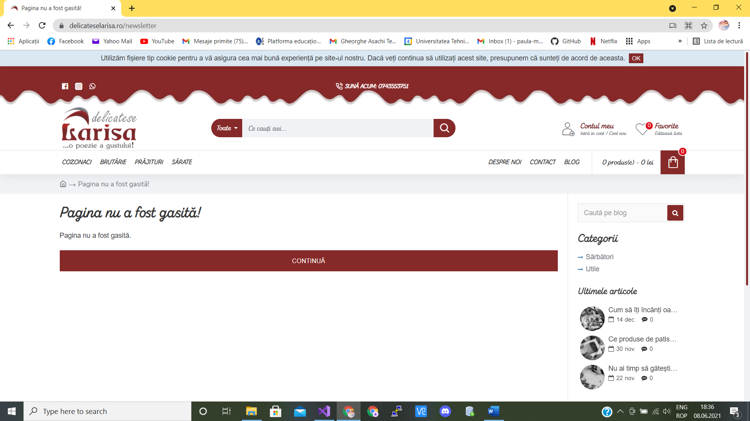

Test Case 4:

|  |  |
| --- | --- |
| Title: The maximum of quantity that can be bought is 100 pieces for each product. | |
| Steps to execute | Expected Behavior |
| User moves the mouse to “Adaugă coș” next to a product to buy it. | The product is added to the shopping cart. |
| User clicks on the “Vezi coșul”. | The page is refreshed and the shopping cart is displayed. |
| The user modify the box from column “Cantitate” by entering a number. | The quantities is successfully changed and available to be purchased. |

Bug report 4:

Title: The maximum of quantity that can be bought is 100 pieces for each product.

Environment: Using Google Chrome

Steps to reproduce:

1. User moves the mouse to “Adaugă coș” next to a product to buy it.
2. User clicks on the “Vezi coșul”.
3. The user modify the box from column “Cantitate” by entering a number.

Expected Result:

The user can buy as many products as he wants.

Actual Result:

The user can buy at most 100 products.

Severity: Medium

Priority: Medium

Visual proof:

