**All fonts used:   
 + Lobster  
 + Merriweather  
 + Lato  
Main color scheme:  
 + Light Blue: #358199  
 + Darker Blue: #04526f  
 + Grey: #ebe8eb  
 + Pink: #** **fbad90  
 + Yellow: #fee202  
 + White and Black**

1. Landing page:  
     
     
     
   - Header:  
     
     
   + Banner picture and logo will be available in the material folder  
   + Login button:   
     
   + Search bar  
     
   - Body:   
     
     
     
   * Merriweather font for “Recent Posts” and “Bloggit’s activities”  
   * Lato Bold and Regular for the posts and activities

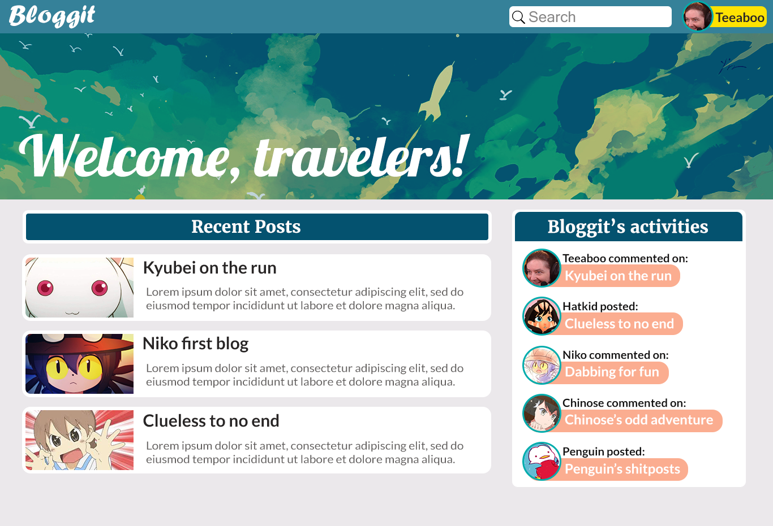

#358199



#fee202



#ebe8eb

#00acac

#04526f

#fbad90

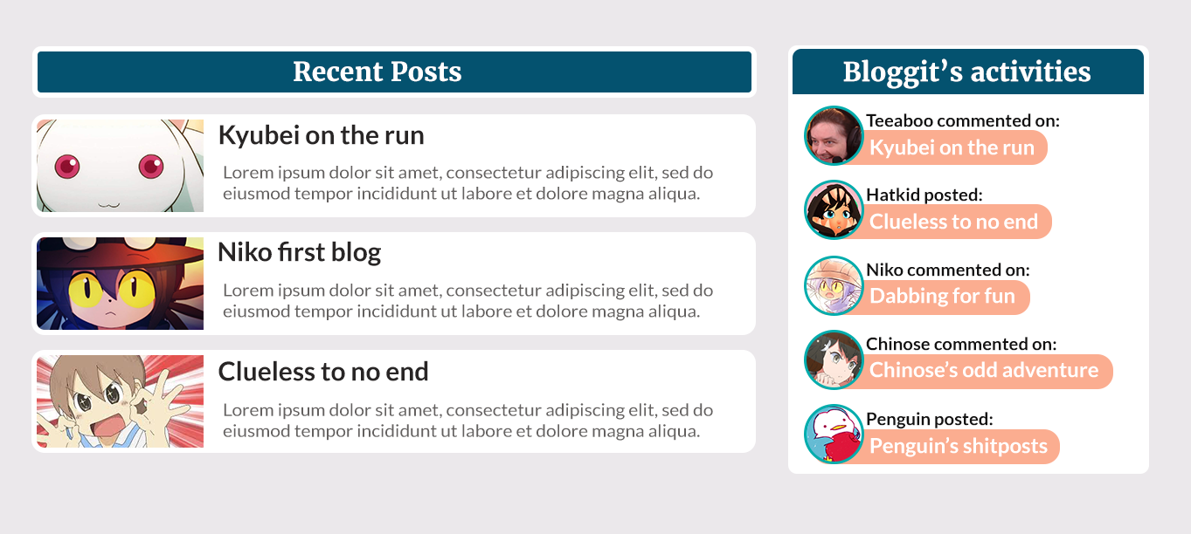

1. Profile  
     
     
   **\* Color scheme are the same as before**  
     
   - Header: *The same as before*  
   - Avatar:   
     
   * Merriweather for Username  
   * Lato Regular for the Description  
     
   > Off option:  
     
     
     
     
     
   > On option:  
     
     
   - Posts section: *same as before*

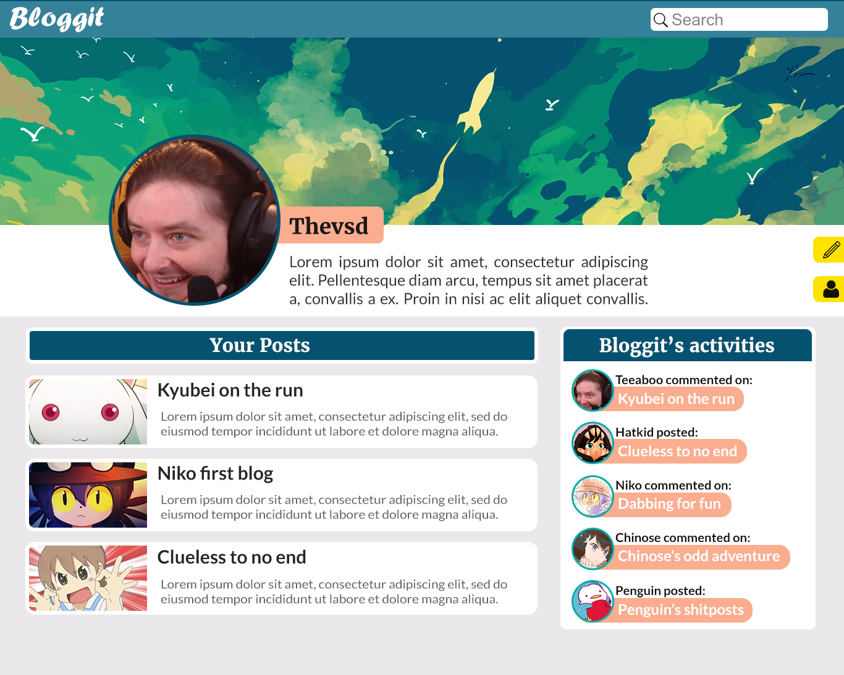

1. Blog example  
     
     
     
   - Header: now has the Title card, the rests are the same  
   * Lato Bold for the Title  
     
   - Body: * Lato Regular for the blog  
   - Comments:   
   * Merriweather for “Comments”  
   * Lato Bold for username  
   * Lato Regular for the comments

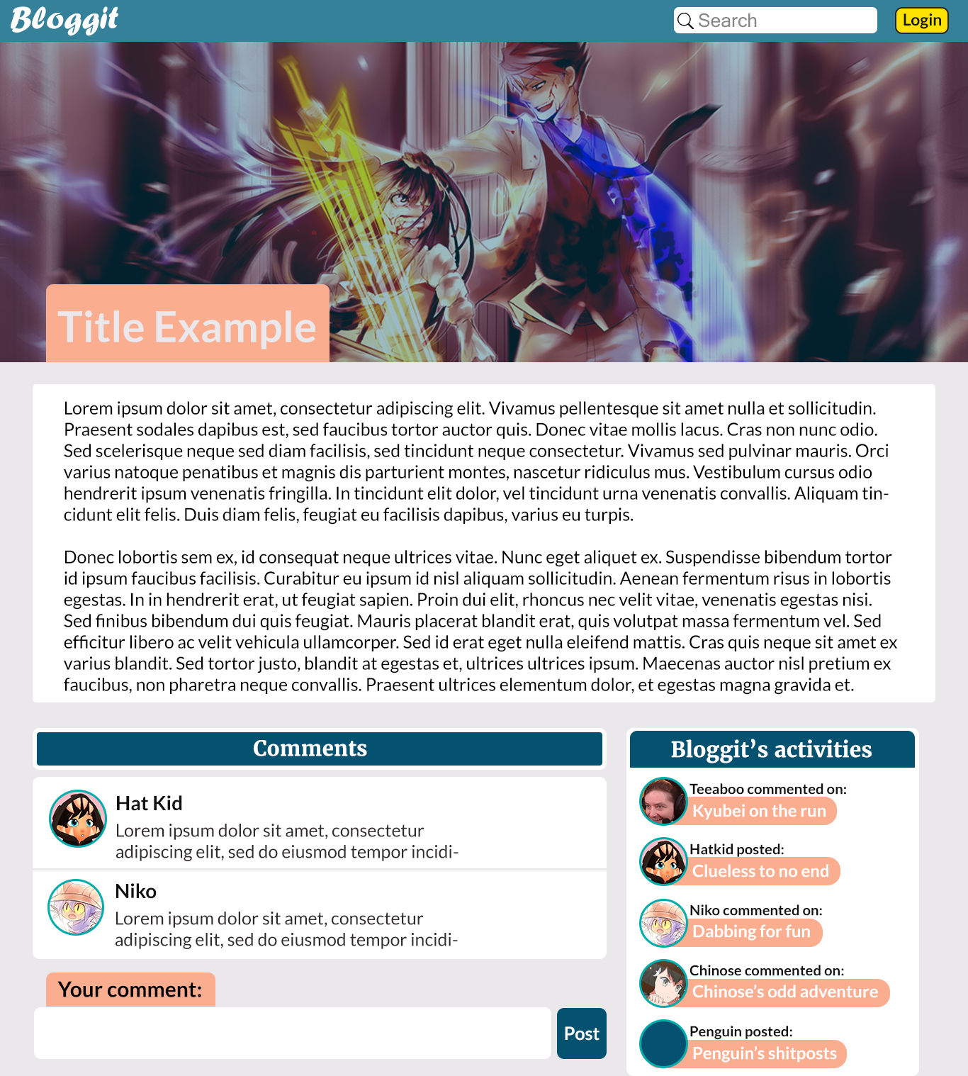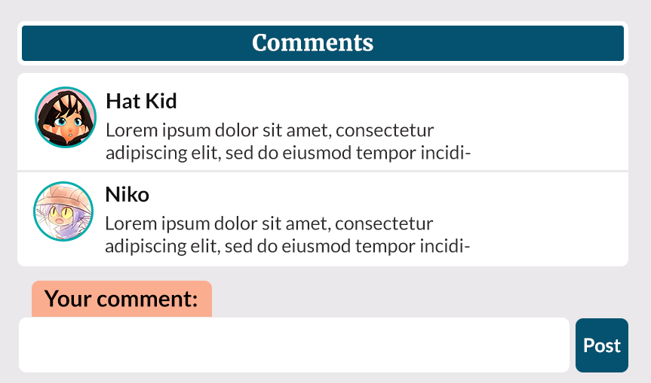

If the users haven’t logged in, they will comment as Anonymous

1. Editor:  
     
     
   * Merriweather for “Post’s settings”  
   * Lato Bold and Regular for the editor

