

Requirement & Design Specification

**Resident Management System(RMS)**

**Version: 1.0**

**Group 1**

**HE200901 – Nguyen Quang Tung**

**HE150438 – Do Nhat Minh**

**HE173361 – Le Ba Tung Lam**

**HE186882 – Do Thanh Hai**

# Table of content

**Table of content** **2**

**Record of Changes** **7**

**I. Overview** **10**

1. User Requirements 10

1.1 Actors 10

1.2 Use Cases 10

a. Diagram(s) 10

b. Descriptions 13

2. Overall Functionalities 15

2.1 Screens Flow 15

2.2 Screen Descriptions 20

2.3 Screen Authorization24

3. System High Level Design 24

3.1 Database Design 24

a. Database Schema 25

b. Table Descriptions

**III. Design Specifications** **52**

**IV. Appendix** **92**

1. Assumptions & Dependencies 92

2. Limitations & Exclusions 92

3. Business Rules 92

# I. Overview

The Residence Registration Management Application is a WPF-based desktop application designed to facilitate the registration and management of permanent , temporary , and temporary stay residence records. Developed using C# and WPF, the system leverages a structured approach to handle user registrations, approvals, and data management efficiently.

The project aims to streamline the residence registration process by enabling online registration, document submission, and approval workflows involving citizens, area leaders, and local police authorities. Additionally, the system supports household transfers, separation of residence records, notifications, and statistical reporting to improve administrative efficiency and transparency.

## 1. User Requirements

### 1.1 Actors

| **#** | **Actor** | **Description** |
| --- | --- | --- |
| 1 | Police | Have full system management, including all CRUD functionality for user accounts, registration records. |
| 2 | AreaLeader | Only permissions to manage registration records. |
| 3 | Citizen | Only permissions to manage own account information, submit new registration records. |

### 1.2 Use Cases

#### a. Diagram(s)

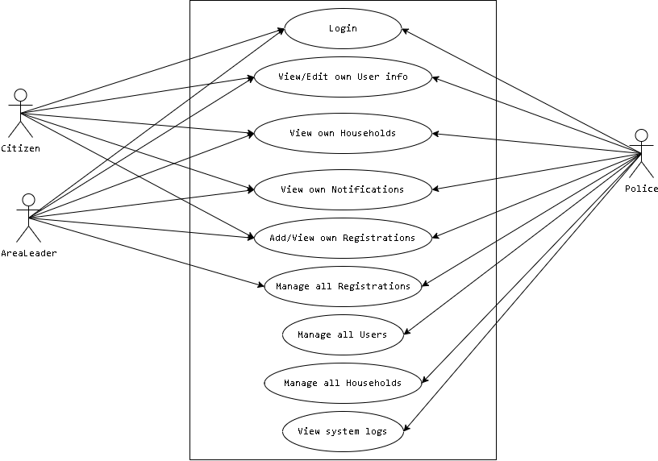

#### 

#### b. Descriptions

| ID | Feature | Use Case | Use Case Description |
| --- | --- | --- | --- |
| 1 | Login | User Authentication | Users can log in using their credentials. |
| 2 | View/Edit User Info | Manage Account | Users can view and edit their own profile information. |
| 3 | View Households | View Own Households | Users can see household information related to them. |
| 4 | View Notifications | Notification System | Users can receive and view system notifications. |
| 5 | Manage Registrations | Registration Approval | Area leaders approve/reject registrations. |
| 6 | Manage All Registrations | Registration Management | Police can review and process registration records. |
| 7 | Manage Users | User Management | Police can create, edit, and delete user accounts. |
| 8 | Manage Households | Household Management | Police can manage household records. |
| 9 | View System Logs | Audit Logs | Police can view activity logs for accountability. |

## 2. Overall Functionalities

### 2.1 Screens Flow

### 

### 

### 2.2 Screen Descriptions

| **#** | **Feature** | **Screen** | **Description** |
| --- | --- | --- | --- |
| 1 | User Login | Log in | This page allows users (citizen, area leader, police) to enter their username and password to log in. |
| 2 | User Dashboard | Home | The home screen interface displays an overview of user-specific actions and notifications. |
| 3 | View/Edit Own User Info | User Profile | Users can view and update their own personal information. |
| 4 | View Own Households | Households | Users can view information about their registered households. |
| 5 | View Own Notifications | Notifications | Users can view system-generated notifications related to their registrations and approvals. |
| 6 | Submit Registration Request | Registration Form | Citizens and area leaders can submit new residency registration requests. |
| 7 | Approve/Reject Registrations | Registration Management | Area leaders can approve or reject citizen registration requests. |
| 8 | Manage Registrations | Registration Management | Police can review and process approved registration requests. |
| 9 | Manage Users | User Management | Police can add, edit, or deactivate user accounts. |
| 10 | Manage Households | Household Management | Police can update household and household member data based on approved registrations. |
| 11 | View System Logs | System Logs | Police can view system activity logs for administrative oversight. |

### 

### 2.3 Screen Authorization

| **#** | **Screen** | **Citizen** | **Area Leader** | **Police** |
| --- | --- | --- | --- | --- |
| 1 | Log in | X | X | X |
| 2 | Home | X | X | X |
| 3 | View/Edit Own User Info | X | X | X |
| 4 | View Own Households | X | X | X |
| 5 | View Own Notifications | X | X | X |
| 6 | Add/View Own Registrations | X | X |  |
| 7 | Approve/Reject Registrations |  | X |  |
| 8 | Manage All Registrations |  |  | X |
| 9 | Manage All Users |  |  | X |
| 10 | Manage All Households |  |  | X |
| 11 | View System Logs |  |  | X |

### System High Level Design

### 3.1 Database Design

#### Database Schema

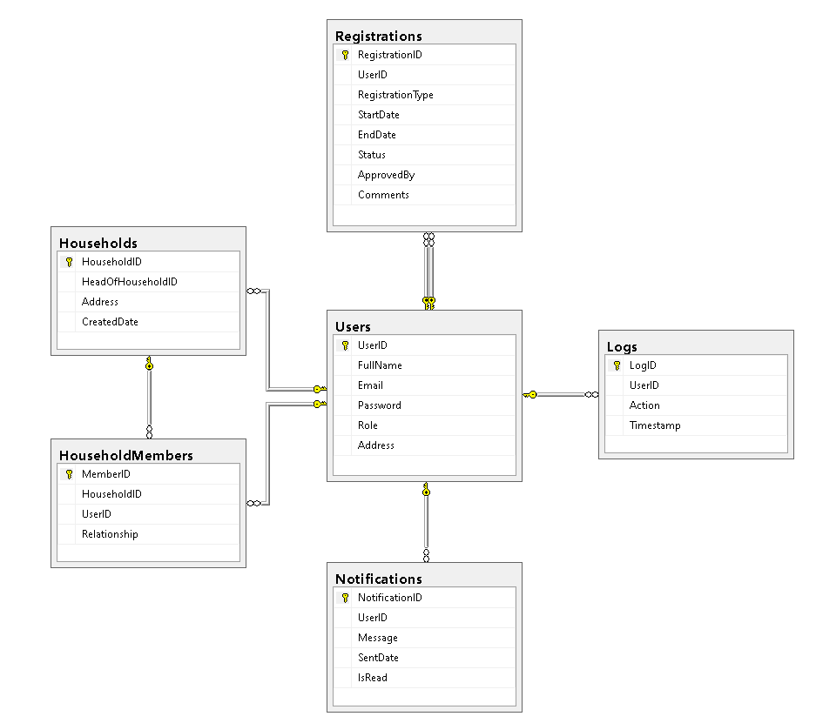

#### 

#### b. Table Descriptions

| **No** | **Table** | **Description** |
| --- | --- | --- |
| 01 | Users | - Stores user information (Citizen, Area Leader, Police).  - Fields: UserID, FullName, Email, Password, Role, Address.  - Primary Key: UserID. |
| 02 | Households | - Represents household entities.  - Fields: HouseholdID, HeadOfHouseholdID, Address, CreatedDate.  - Primary Key: HouseholdID.  - Foreign Key: HeadOfHouseholdID → Users.UserID. |
| 03 | HouseholdMembers | - Tracks relationships between users and households.  - Fields: MemberID, HouseholdID, UserID, Relationship.  - Primary Key: MemberID.  - Foreign Keys: HouseholdID → Households.HouseholdID, UserID → Users.UserID. |
| 04 | Registrations | - Stores residence registration requests.  - Fields: RegistrationID, UserID, RegistrationType, StartDate, EndDate, Status, ApprovedBy, Comments.  - Primary Key: RegistrationID.  - Foreign Key: UserID → Users.UserID, ApprovedBy → Users.UserID. |
| 05 | Notifications | - Stores system notifications sent to users.  - Fields: NotificationID, UserID, Message, SentDate, IsRead.  - Primary Key: NotificationID.  - Foreign Key: UserID → Users.UserID. |
| 06 | Logs | - Tracks system activities performed by users.  - Fields: LogID, UserID, Action, Timestamp.  - Primary Key: LogID.  - Foreign Key: UserID → Users.UserID. |

4. Class diagram

*4.1.*

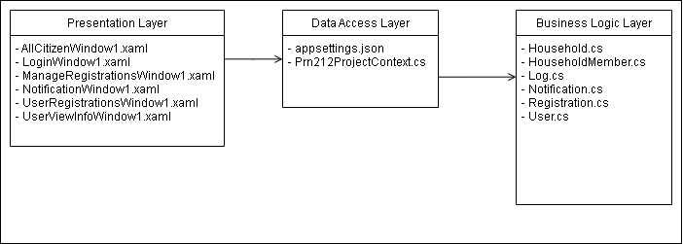

*4.2. Class diagram*

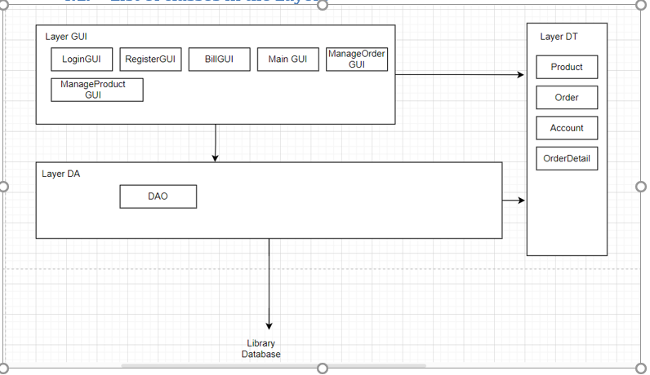

# III. Design Specifications

### 1. Users can log in to the system

* Users (Citizen, Area Leader, Police) log in using their email and password.
* The system verifies credentials and loads the appropriate dashboard based on the user's role.

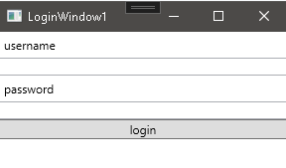

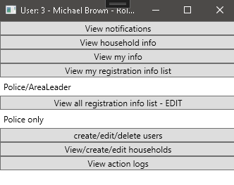

### 

### 2. Citizens can register and update residency information

* Citizens can submit a new permanent, temporary, or transient residence registration.

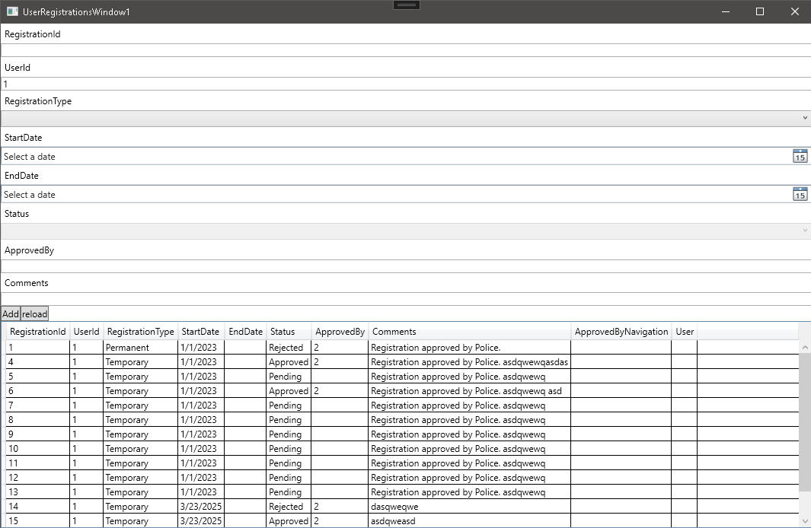

### 

### 3. Area Leaders and Police can review and approve registrations

* Area Leaders review registrations within their jurisdiction and provide comments.
* Police verify and approve or reject registrations.
* System logs all approvals for auditing.

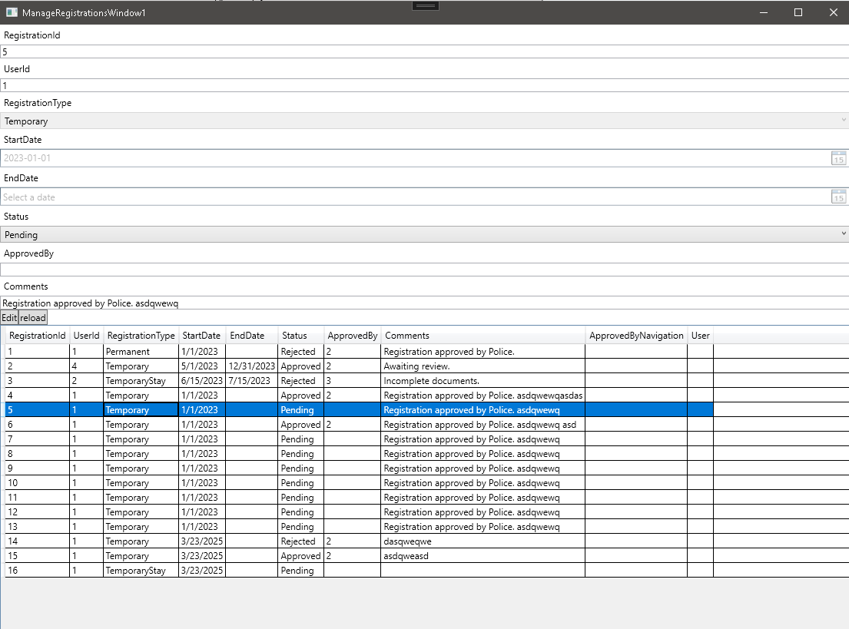

### 

### 4. Users can view household information

* Citizens can see details of their registered household.
* Area Leaders and Police can access and manage household records in their area.

UI Mockup:  
 <insert UI image>

### 5. Users receive notifications

* The system sends notifications about application status (e.g., "Approved," "Pending").
* Users can view and mark notifications as read.

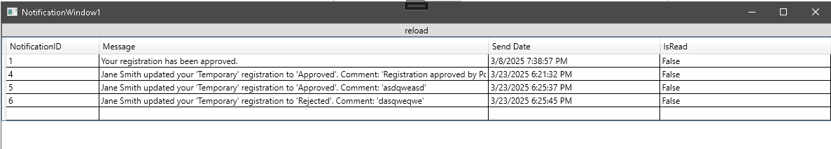

### 6. Police can manage users and households

* Police officers can add, edit, or delete user accounts.
* They can update household records and assign new household heads.

UI Mockup:  
 <insert UI image>

### 

### 7. System logs activities for auditing

* Every approval, update, or deletion is recorded in system logs.
* Police can review logs to track changes and user actions.

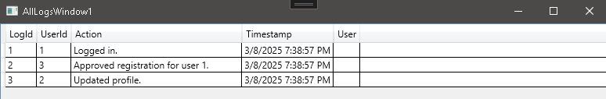

# IV. Appendix

## 1. Assumptions & Dependencies

DE-1: Users have basic knowledge of using Windows applications.

## 2. Limitations & Exclusions

L-E : The system will not support mobile platforms in the current version..

## 3. Business Rules