MP #2: Morphological Operators

# Problem

In this MP, we were tasked with creating several different morphological operators: erosion, dilation, opening, closing, and boundary. These would take in an image, and a structuring element (SE) and would return the image after the operator is preformed using the structuring element. We were also tasked with combining different SEs to attempt to process the two sample images we were provided.

# Implementation

The implementation of the morphological operators was straightforward. The two most involved were erosion and dilation. For these, you simple scanned through the entire image once to apply the SE. For erosion, you checked to make sure all pixels surrounding the one you were on matched the SE structure and then set the output to 255. For dilation, you checked if the pixel you were on was set to 255 and set all outputs to the SE. Various edge cases did have to be accounted for and can be noted in the code. Specifically, it was assumed that the entire border beyond the images was black for the dilation image. It was also assumed that the SE was a square with odd lengthen sides. However, an arbitrary number of pixels inside this square could be 0.

The other three morphological operators were implemented as a combination of erosion and dilation as outlined in the class lecture notes. Care had to be given when using boundary, and a dilation was preformed before boundary was used to give a usable boundary image.

# Results

The results can be seen in the figures below and are what was expected of the result. The final output after trial and error using different SEs and combinations can be seen as well. While all the noise from the gun.bmp was removed, the palm.bmp suffered from several holes that were unable to be completely denoised.

1. Dilated Palm

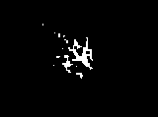

2. Eroded Gun

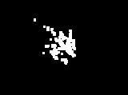

3. Opened Gun

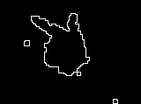

4. Closed Palm

5. Boundary Dilated Gun

6. Arb. Gun Processed