Machine Learning Models for Predicting Pipeline Failures: Implications for Operational Reliability
Victor Anisi¹, Serveh Kamrava^{1*}, Yilin Fan¹, Soutir Bandyopadhyay², Jennifer Miskimins¹
- Department of Petroleum Engineering, Colorado School of Mines, Golden, CO 80401, USA.
- Department of Applied Mathematics and Statistics, Colorado School of Mines, Golden, CO 80401, USA
*Corresponding author email: kamrava@mines.edu
Abstract
Oil and gas pipeline failures pose significant risks to human safety, operational reliability, and economic sustainability, highlighting the critical need for accurate pipeline failure risk prediction. Traditional assessment methods, such as semi-empirical models and expert judgment, struggle with scalability and complexity. Machine learning offers a powerful alternative, allowing large-scale data processing, pattern recognition, and improved failure risk prediction. By overcoming traditional limitations, ML supports proactive pipeline management, especially amid aging infrastructure and rising hazards as a consequence. This study develops an ML-based framework for classifying pipeline failure risks into low, medium, and high-risk classes. Models including support vector machine, random forest, artificial neural network, logistic regression, and stacking ensemble were trained on proprietary industry data. Advanced preprocessing, feature engineering, and hyperparameter tuning improved the overall model performances. Testing on Pipeline and Hazardous Materials Safety Administration data covering 56,402 miles showed the ANN and SVM models performed best with an equal 90% overall accuracy. Through classification metrics, confusion matrix analyses, and feature sensitivity studies, this study highlights key failure factors, including flowline age, operating pressure, and material properties. These findings provide a data-driven approach to risk assessment, helping operators prioritize high-risk pipelines, optimize resource allocation, and improve pipeline safety and sustainability.
Keywords: Machine Learning, pipeline failure, risk assessment, failure prediction, feature sensitivity.

Introduction
Pipeline integrity is critical to oil and gas operations, ensuring public safety, operational reliability, and economic stability. Flowlines, essential for transporting hydrocarbons, face failure risks that can cause severe contamination, disruptions, and financial losses (Al-Sabaeei et al., 2023). Aging infrastructure, particularly in mature fields, increases failure risks, with corrosion being a leading cause of failure (Ahammed, 1998; Caleyo et al., 2002). Corrosion occurs in various forms, such as pitting and stress corrosion cracking, influenced by fluid chemistry, environmental conditions, and protective coatings (Amaya-Gómez et al., 2019). While preventive measures exist, advanced predictive tools are needed to identify high-risk segments before failures occur. Traditional pipeline risk assessments, such as ASME B31G and DNV RP-F101, rely on deterministic models that assess integrity based on defect size, material properties, and operational conditions (B31G - Manual for Determining Remaining Strength of Corroded Pipelines - ASME, 2023.; DNV-RP-F101: Corroded Pipelines, 2010). However, these methods fail to account for the randomness of failures and the complex interactions of operational and environmental factors (Mazumder et al., 2021; Mikolajková-Alifov et al., 2019).
Machine learning (ML) improves predictive maintenance by processing large datasets, uncovering hidden patterns, and enhancing failure risk assessments (Al-Sabaeei et al., 2023; Phan & Dhar, 2021). Supervised models, including Random Forests, Gradient Boosting Machines, and Support Vector Machines have been applied successfully in pipeline integrity management, offering improved prediction accuracy (Breiman, 2001; Ke et al., 2017; Robles-Velasco et al., 2020). (Amaya-Gómez et al., 2019) reviewed ML techniques like decision trees and random forests for assessing corroded pipelines, demonstrating how ML integrates operational, environmental, and material factors for more precise risk evaluation. Mangalathu & Jeon (2019) used Shapley Additive Explanations (SHAP) to enhance model interpretability, a critical factor for industrial adoption. Teixeira et al. (2008) and (Xiao et al., 2024) combined probabilistic methods with Support Vector Machines to classify failure risks effectively. (Chen & Guestrin, 2016) demonstrated how gradient-boosting models like XGBoost handle complex interactions and imbalanced datasets, key challenges in pipeline failure prediction.
Zhang et al. (2018) applied artificial neural networks (ANNs) to post-earthquake structural safety prediction, showcasing their ability to model nonlinear relationships and detect failure patterns. This has inspired their use in pipeline failure prediction, where ANNs handle multiple failure factors, including corrosion and material degradation (Su et al., 2021). Seghier et al. (2022) further demonstrated that ensemble learning improves internal corrosion rate prediction by reducing biases and increasing accuracy. A recent study has successfully integrated geographic information systems with machine learning to enhance spatial risk assessment capabilities, demonstrating the effectiveness of ensemble classifiers when combined with Principal Component Analysis for dimensionality reduction (Chittumuri et al., 2025). However, despite their advantages, ML models struggle with class imbalance leading to biased predictions (Lunardon et al., 2014). Techniques such as Synthetic Minority Oversampling (SMOTE) and focal loss functions improve sensitivity to critical failure cases (He and Garcia, 2009; Tang et al., 2019).
This study develops an ML-based framework for predicting multiclass pipeline failure risk, enabling targeted inspections and proactive maintenance. While previous research has applied machine learning to pipeline failure analysis, our approach uniquely integrates rigorous feature engineering, advanced hyperparameter optimization, and ensemble modeling to enhance predictive performance. Specifically, our study systematically compares Logistic Regression (LR), Support Vector Machines (SVM), Random Forests (RF), Artificial Neural Networks (ANN), and stacking ensemble (SE) models to effectively capture complex nonlinear relationships, manage high-dimensional and imbalanced datasets, and provide interpretable insights into critical feature interactions. Additionally, the validation of these models using extensive real-world data from the Pipeline and Hazardous Materials Safety Administration (PHMSA) database highlights our approach's practicality and generalizability, contributing substantially toward operational reliability and resource optimization in pipeline risk management.
The remaining section of this paper is structured as follows: The methodology section details the algorithms used, including mathematical formulations and evaluation metrics. The results and discussion section presents an in-depth analysis of model performance, supported by visualizations and sensitivity analyses. Finally, the conclusion and recommendations section summarizes key findings, offers actionable insights, and discusses future directions for advancing predictive modeling in pipeline failure risk management.

Methodology
An ML framework was developed to predict flowline failure risk using a multiclass classification approach, categorizing pipelines into "Low," "Medium," and "High" risk levels. The methodology integrates each ML algorithm with rigorous data preprocessing techniques to address key challenges in pipeline failure prediction, such as class imbalance and high-dimensional feature spaces. Exploratory data analysis was performed to assess feature distributions, detect potential outliers, and identify correlations between variables, ensuring that the dataset aligns with ML model requirements. In this study, several ML algorithms, including SVM, RF, LR, ANN, and SE were experimented. Each ML model was tuned to obtain optimal hyperparameters using GridSearchCV with a 5-fold cross-validation to improve predictive accuracy. Finally, an analysis of feature importance was conducted to identify key predictors of failure risk. Furthermore, to evaluate the generalizability and robustness of the ML models, out-of-sample testing (with new unseen data) was conducted with data from the Pipeline and Hazardous Material Safety Administration (PHMSA) covering 56,402 miles of U.S. pipelines in the United States.
The subsequent sections outline the data preparation and analysis, mathematical principles of the ML algorithms, the performance evaluation metrics, and the experimental design used to validate the proposed framework. This structured methodology ensures reproducibility and establishes a rigorous scientific basis for quantitative pipeline failure risk assessment.
  - Data Preparation and Analysis
This study considered a proprietary dataset comprising 808 records of pipeline characteristics and failure incidents, including a broad range of operational, environmental, and material features. Data preprocessing steps included standardization of numerical features, encoding of categorical variables, and imputation of missing values to maintain data integrity. SMOTE was applied to address the class imbalance, such that each ML model can correctly predict any underrepresented class in the dataset. The dataset included three numerical features which are flowline age, maximum allowable operating pressure(MAOP), and pipe diameter, along with seven categorical features such as root cause, weather conditions (e.g., harsh, normal), basin, flowline type (e.g., wellhead line, production line), pipe material (e.g., fiberglass, carbon steel), fluid type (e.g., oil, gas, multiphase), and spill type. The violin plots in Fig. 1 reveal distinctive distribution patterns across pipeline features, where flowline age (a) demonstrates a pronounced right skew with density concentrated below 20 years, indicating most flowlines in our dataset are relatively new, MAOP (b) shows a strong positive skew with values predominantly clustered below 500 psi and a narrow extension reaching approximately 1000-1200 psi, suggesting operational configurations favor lower pressures with occasional high-pressure exceptions. The diameter distribution (c) exhibits a unimodal pattern with a central tendency around 3-4 inches and a wide, relatively symmetric spread from approximately 1 to 16 inches, suggesting a single predominant diameter specification with considerable variation that likely reflects diverse pipeline applications. For categorical features, pipe material (d) and flowline type (f) display multimodal distributions indicating clear groupings, while the basin distribution (e) shows multiple tiers of frequency suggesting geographical clustering of installations, and weather conditions (g) reveals most data points concentrated at lower values with a small secondary peak, likely representing normal versus extreme weather events. The root cause (h) and fluid type (i) distributions both exhibit bimodal patterns with a clear separation between categories, indicating distinct failure mechanisms and transported substances respectively, with upper modes representing the most common causes and fluid types in the dataset.
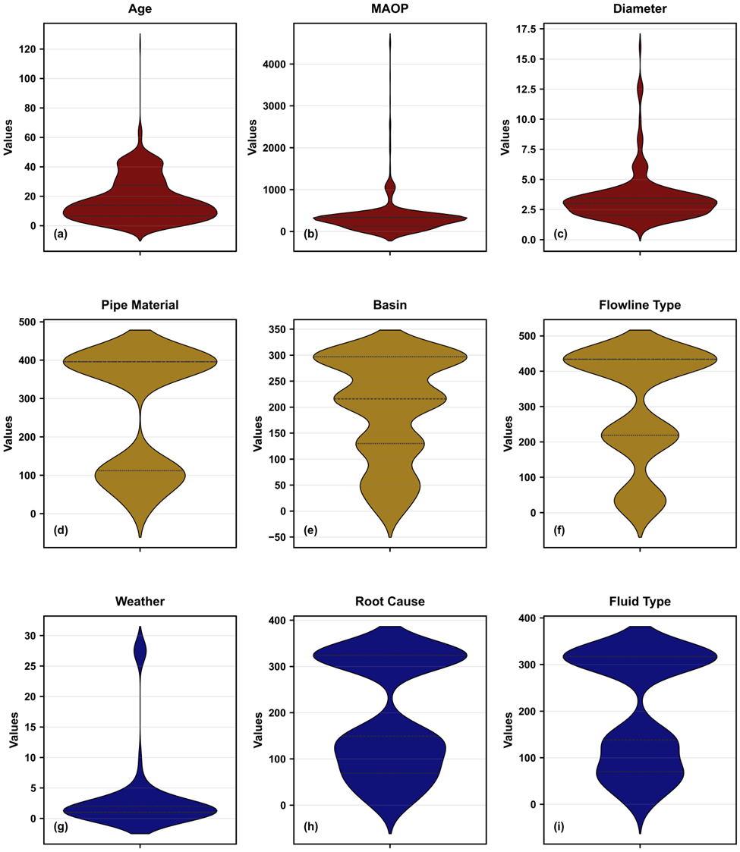
Fig. 1. Violin plot of (a) flowline age, (b) maximum allowable operating pressure (c) diameter, (d). pipe material, (e) basin, (f) flowline type, (g) weather, (h) root cause, and (i) fluid type
The pair plot in Fig. 2 illustrates inter-relationships between features using scatter plots combined with kernel density estimates. The scatter plot of flowline age vs MAOP highlights several notable interactions. Generally, older flowlines have lower MAOP, whereas newer ones tend to have higher MAOP. There is also an inverse relationship between pipe diameter and MAOP, as pipelines with larger diameters typically have lower allowable pressures due to increased hoop stress. Furthermore, older pipelines generally have smaller diameters, while newer pipelines cover a broader diameter range. The numerical values assigned to categorical variables are encoded labels for analytical convenience: "Weather" denotes environmental severity (1: Normal, 2: Harsh); "Root Cause" represents failure mechanisms (e.g., Corrosion, Equipment Failure, Incorrect Operation); "Spill Type" differentiates spill incident timing (e.g. 112: Recent, 95: Historical); "Fluid Type" categorizes transported fluids (e.g., Multiphase, Condensate, Natural Gas, Produced Water, Crude Oil); "Pipe Material" includes pipeline materials (e.g., Carbon Steel, HDPE, Fiberglass, Fiberspar); "Basin" corresponds to geographical operating regions (e.g., Denver-Julesburg, Piceance, Paradox); and "Flowline Type" classifies pipeline function (e.g., Wellhead Line, Production Line, Peripheral Piping, Process Piping, Dump Line). These numerical encodings are further clarified in the supplementary figures detailing each categorical distribution. Also, it should be noted that there exist non-linearities between some features and this influenced the selection of certain ML algorithms in this study. Furthermore, a correlation matrix was used to quantify and display the linear relationship between features as seen in Fig. 3. For constructing the matrix, Pearson’s correlation coefficient is used (Eq. 1), where –1 represents a perfect negative correlation, 0 indicates no correlation, and +1 signifies a perfect positive correlation. Flowline age exhibits a strong positive correlation (0.41) with flowline type, indicating that older flowlines tend to belong to certain types. Diameter demonstrates a substantial negative correlation with flowline type (-0.36), showcasing that smaller diameters predominate in certain flowline categories. The MAOP shows a modest negative correlation with age (-0.21) and a positive correlation with pipe material (0.21), reflecting material-specific pressure tolerances and reduced pressure ratings in aging flowlines. Fluid type shows a significant positive correlation with flowline age (0.23) and flowline type (0.47), suggesting certain fluids are preferentially transported through specific pipeline configurations. Basin characteristics correlate with fluid type (0.24), indicating regional preferences for specific fluid transportation. These moderate correlations highlight interdependencies between operational, physical, and environmental parameters while remaining sufficiently independent to provide complementary information for predictive modeling without excessive multicollinearity, reducing the risk of overfitting in the predictive models.
$$\begin{aligned}R=\frac{\sum_{i=1}^{n}{\left(x_{i}-\overline{x}\right)\left(y_{i}-\overline{y}\right)}}{\sqrt{\sum_{i=1}^{n}{{\left(x_{i}-\overline{x}\right)}^{2}\sum_{i=1}^{n}{{\left(y_{i}-\overline{y}\right)}^{2}}}}}.\#\end{aligned}$$ | (1)
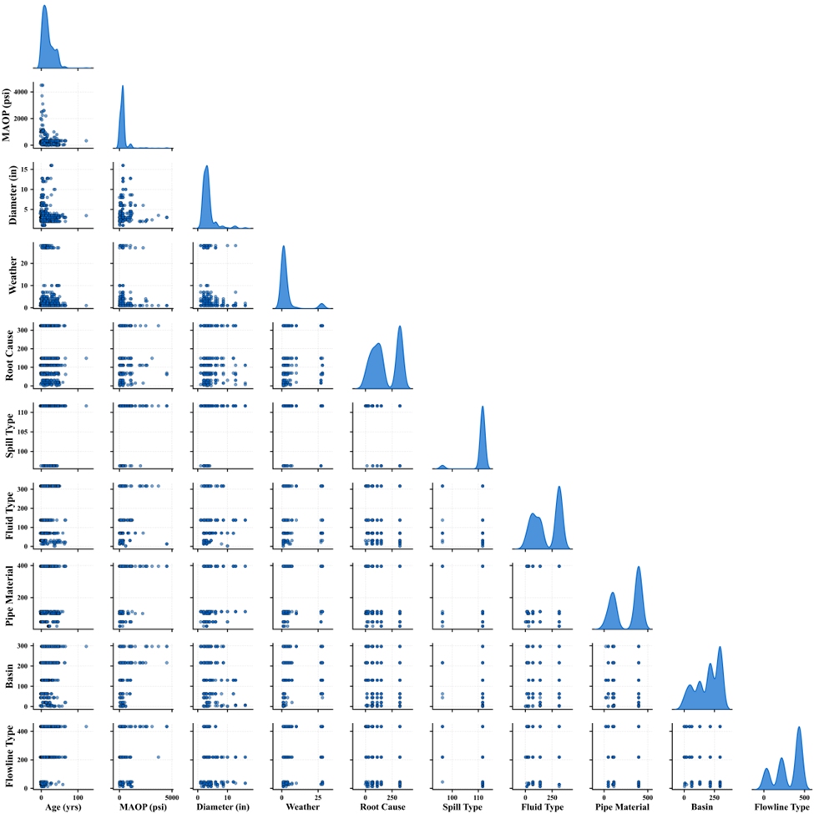
Fig. 2. Pair plot of input features
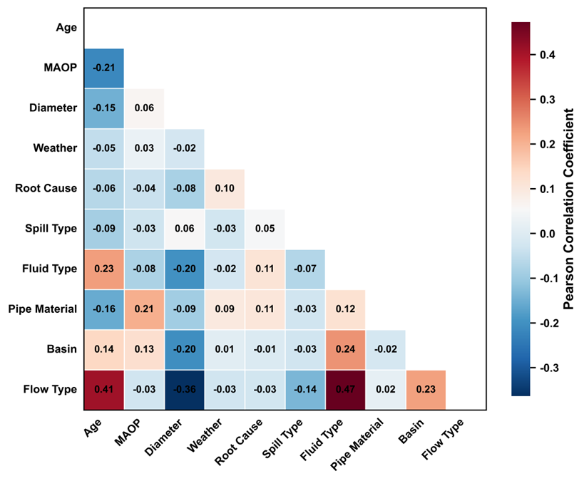
Fig. 3. Pearson correlation matrix of input features
The insights derived from the data analysis informed several critical aspects of the subsequent predictive modeling process. Specifically, the observed distribution patterns and correlations guided feature engineering, ensuring the inclusion of significant parameters such as flowline age, MAOP, diameter, pipe material, and root cause, which exhibited distinct distributions or meaningful correlations indicative of underlying physical or operational relationships. The identification of pronounced skewness in numerical features like age and MAOP informed decisions regarding normalization techniques, and the distinct clustering in categorical features validated the encoding strategies implemented. Additionally, the observed inverse relationship between pipe diameter and MAOP, as well as age-related trends in pressure and diameter, highlighted essential nonlinear interactions, prompting the selection of machine learning algorithms capable of capturing complex nonlinear relationships, such as SE, SVM, and ANN.
  - Pipeline Failure Probability
Using various pipeline features such as flowline age, fluid type, pipe material, etc. we aim to classify pipelines into three categories. This classification will help identify those pipelines that are more susceptible to leakage, posing potential risks to both environmental and human safety. The pipeline failure probability for each flowline in the dataset was estimated based on a probabilistic approach, using operational and material parameters provided within the dataset. This method compares the true failure pressure ($P_{f}$) with the corresponding MAOP ($P_{omax}$​), utilizing a burst limit state function. This approach has been successfully applied in prior studies (Mazumder et al., 2021) to derive burst failure data. The burst limit state function is mathematically expressed as:
$$\begin{aligned}g\left(X\right)=P_{f}-P_{omax},\#\left(2\right)\end{aligned}$$
where$g\left(X\right)≤ 0$ denotes failure conditions, $P_{f}$ represents the true failure pressure, and $P_{omax}$ is the maximum allowable operating pressure provided directly in the dataset. To account for variability in material strength and operational conditions, a Monte Carlo simulation was employed. The true failure pressure ($P_{f}$) for each pipeline segment was modeled as a random variable following a normal distribution:
$$\begin{aligned}P_{f}∼N\left(μ_{P_{f}},σ_{P_{f}}\right).\#\left(3\right)\end{aligned}$$
Here, $μ_{P_{f}}$ corresponds to the testing pressure (which is the pressure at which the pipe will fail) provided in the dataset, and $σ_{P_{f}}$, the standard deviation, was assumed to be 10% of the true failure pressure ($0.1×μ_{P_{f}})$, (Al-Sabaeei et al., 2023) reflecting typical uncertainties in pipeline material properties.
Monte Carlo simulation was run with 10,000 iterations per pipeline segment, generating random samples of $P_{f}$ and evaluating the burst limit state function for each sample. The probability of pipeline failure ($P_{\text{fail}}$) was calculated as:
$$\begin{aligned}P_{\text{fail}}=\frac{\text{Number of samples where }g\left(X\right)≤0}{\text{Total number of samples}}.\#\left(4\right)\end{aligned}$$
Using this calculated probability of failure, pipelines were automatically classified into one of three failure risk classes based on defined thresholds, ensuring a systematic and objective classification approach. Pipelines with $P_{\text{fail}} < 0.30$ were classified as low risk, $0.30 ≤ P_{\text{fail}} < 0.70$ as medium risk, and $P_{\text{fail}} >0.70$ as high risk (Phan & Dhar, 2021). The thresholds applied in this study are based on the available data and literature review. However, in practice, threshold values should be tailored to each operator, reflecting their specific risk tolerance, cost considerations, and inspection capacity. Fig. 4 presents the distribution of failure probabilities across the low, medium, and high-risk classes, highlighting the robustness of this method in capturing the diverse risk profiles within the dataset. The integration of operational parameters directly from the dataset eliminates the need for manual calculations, further enhancing the transparency and reproducibility of the risk classification process.
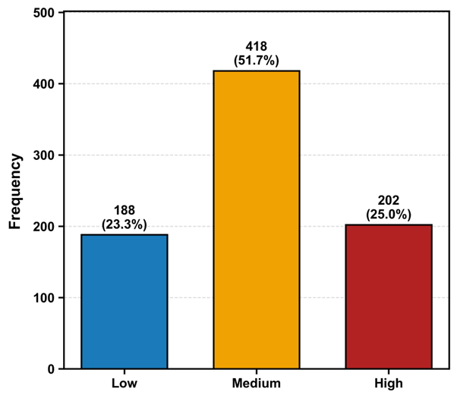
Fig. 4- Failure class distribution
  - Predictive Modelling Using Machine Learning Algorithms
The use of ML algorithms in this study aims to effectively classify pipeline segments into distinct failure risk classes based on their operational, environmental, and material features with respect to computational efficiency. For this purpose, we have trained different models, namely LR, RF, SE, SVM, and ANN with 808 training data having 10 features and tested the trained models with 600 unseen data. ML offers a robust and scalable approach to addressing the inherent complexities of pipeline failure prediction, particularly within extensive and heterogeneous datasets characteristic of oil and gas infrastructure. Five ML algorithms were developed to classify pipeline failure risk into three distinct classes: Low, Medium, and High. Each algorithm was selected for its unique strengths and suitability for the problem domain, including its capacity to handle class imbalance, capture complex feature interactions, and provide reliable predictions. The following subsections (2.3.1-2.3.5) provide a detailed discussion of each ML algorithm used in this work.
    - Logistic Regression (LR)
LR was used as the baseline algorithm in this study due to its simplicity, interpretability, and effectiveness in binary and multiclass classification problems. Logistic regression models the relationship between a set of input features and the probability of an outcome belonging to a particular class. While it assumes linear separability in the feature space, its probabilistic output makes it a valuable benchmark for evaluating more complex ML models. (Hosmer et al., 2013) highlighted that this algorithm operates on the principle of applying the logistic (or sigmoid) function to a linear combination of input features to produce a probabilistic output. For a given pipeline segment with the feature vector $x = \left[x_{1}, x_{2},…..,x_{n}\right]$, the linear model computes a weighted sum of the features:
$$\begin{aligned}z=β_{0}+\sum_{i=1}^{n}{β_{i}x_{i} ,}\#\left(5\right)\end{aligned}$$
where​ $β_{0}$ is the intercept term, and ​ $β_{i}$ are the coefficients (or weights) corresponding to the features $x_{i}$ and n is the total number of features. The logistic function is then applied to transform the output into a probability value between 0 and 1:
$$\begin{aligned}P\left(y=1 ∣ x\right)=σ\left(z\right)=\frac{1}{1+e^{-z}},\#\left(6\right)\end{aligned}$$
Here, $σ\left(z\right)$ represents the sigmoid function, ensuring that the predicted probability $P\left(y=1 ∣ x\right)$ is bound between 0 and 1 (Cox, 1958). For multiclass classification, such as the Low, Medium, and High failure risk classes in this work, the softmax function was used. Bishop (2006) identified that the softmax function generalizes the sigmoid function to multiple classes, producing a probability distribution over $K$classes:
$$\begin{aligned}P\left(y=j ∣ x\right)=\frac{e^{z_{j}}}{\sum_{k=1}^{K}{e^{z_{k}}}},\#\left(7\right)\end{aligned}$$
where $z_{j}=β_{0j}+\sum_{i=1}^{n}{β_{ij}x_{i}}$ is the linear output for class $j$, and $K$ is the total number of classes. The model parameters ($β_{0}$,​ $β_{i}$) were estimated by maximizing the log-likelihood function, which quantifies how well the model fits the training data. For a dataset with $m$ samples and $K$ classes, the log-likelihood function is expressed as:
$$\begin{aligned}L\left(β\right)=\sum_{i=1}^{m}{\sum_{j=1}^{K}{y_{ij}}\log{P}\left(y=j ∣ x_{i}\right). }\#\left(8\right)\end{aligned}$$
Ng (2004) demonstrated that regularization techniques are applied to prevent overfitting and improve generalization. In this work, the logistic regression model incorporates L2 regularization (also known as ridge regression), which penalizes large coefficients and is given by:
$$\begin{aligned}L_{reg}\left(β\right)=L\left(β\right)-\frac{λ}{2}\sum_{i=1}^{n}{β_{i}^{2}, }\#\left(9\right)\end{aligned}$$
where $λ$ is the regularization strength. Larger values of $λ$ enforce stronger regularization, discouraging complex models and encouraging sparsity.
    - Random Forest (RF)
The RF algorithm is a decision-making approach based on the concept of bagging decision trees, where the final output is determined by the vote that has been agreed upon by all the trees. This is especially useful in dealing with high-dimensional data and has been used in classification problems including multiclass problems (Breiman, 2001; Liaw and Wiener, 2002). In this study, RF attempts to improve prediction accuracy by using the average of the decisions of multiple decision trees, where each tree has been trained on different data and features. However, it can be used for classification beyond binary problems by using the “one-vs-rest” strategy, where as many as n classes are pitted against one class at a time by learning different trees for each class (Cutler et al., 2012). The algorithm also uses bootstrap sampling to select data subsets with replacement and select a randomly chosen feature subset for each tree to create variability, reduce overfitting, and improve generalization (Breiman, 2001). The RF model uses decision trees to split the dataset based on the features that best distinguish the classes and at each node. The splitting criterion is typically based on Gini impurity, defined mathematically as:
$$\begin{aligned}G=1-\sum_{i=1}^{C}{p_{i}^{2}},\#\left(10\right)\end{aligned}$$
where $p_{i}$ is the proportion of samples belonging to class $i$ at a given node, and $C$ is the total number of classes. A lower Gini impurity indicates better class homogeneity at a node (Breiman, 1996). For multiclass classification, the output class for a given sample is determined by majority voting across all trees. Let ${\hat{y}}_{i}^{\left(t\right)}​$ be the predicted class by the$t^{th}$ tree for the $i^{th}$. The aggregated prediction is given by:
$$\begin{aligned}\hat{y_{i}}=\arg{\max_{k}{\sum_{t=1}^{T}{I\left(\hat{y_{i}^{\left(t\right)}}=k\right)}}},\#\left(11\right)\end{aligned}$$
where $I(⋅)$ is the indicator function, $k$represents the class labels, and $T$is the total number of trees in the forest. To optimize RF model, a grid search with cross-validation was conducted to systematically evaluate various hyperparameter configurations. The number of estimators ($n_{trees}$), representing the total number of trees in the forest, was tested with values of 100 and 150. The maximum tree depth ($d_{max}$), which determines the depth of each decision tree, was evaluated for values of 10 and 20 to balance model complexity and prevent overfitting. Additionally, the minimum samples required to split a node ($s_{min}$​) and form a leaf ($l_{min}$) were tuned to values of 2, allowing sufficient partitioning without over-fragmenting the dataset. Louppe et al. (2013) showed that a major comparative advantage of RF is its ability to estimate feature importance. The importance of a feature is determined by the total decrease in impurity, achieved across all trees defined as:
$$\begin{aligned}\text{Importance}\left(x_{i}\right)=\sum_{t∈\text{trees}}{ΔG\left(x_{i},t\right)},\#\left(12\right)\end{aligned}$$
where $ΔG\left(x_{i},t\right)$ is the decrease in impurity for feature $x_{i}$ in tree $t$.
Subsequently, this was used to rank the input features in this work which established a practical basis for feature sensitivity analysis.
    - Stacking Ensemble (SE)
The SE method combines multiple base learners to yield an improved predictive model. In this study, the base learners used are gradient boosting, eXtreme gradient boosting, and light gradient boosting machine, while the meta-learner used is LR. This model leverages the strengths of each base learner in improving the classifier performance (Wolpert, 1992). Gradient boosting aims to minimize a loss function by adding the weak learners into the ensemble, step by step. Each weak learner is formed from a trained decision tree using the residual error of the prior learner in each step, increasing the accuracy in every iteration for the model to make a perfect prediction leading to a final model combining all the learner predictions using weighted averages. Unlike decision trees, gradient boosting optimizes a differentiable loss by incorporating decision trees one at a time, reducing the leftover error from earlier steps (Friedman, 2001). For multiclass classification, gradient boosting optimizes a softmax loss function $L$, defined as:
$$\begin{aligned}L=-\frac{1}{N}\sum_{i=1}^{N}{\sum_{k=1}^{K}{y_{ik}}\log\left(p_{ik}\right), }\#\left(13\right)\end{aligned}$$
where $N$is the total number of samples, $K$ is the number of classes, $y_{ik}$ is a binary indicator for the true class, and $p_{ik}$​ is the predicted probability of class $k$ for sample $i$. The eXtreme gradient boosting algorithm extends this concept by incorporating regularization terms to control model complexity and enhance generalization (Chen & Guestrin, 2016). It minimizes a regularized loss function expressed as:
$$\begin{aligned}L=\sum_{i=1}^{N}{l\left(y_{i},\hat{y_{i}}\right)}+\sum_{t=1}^{T}{Ω\left(f_{t}\right),}\#\left(14\right)\end{aligned}$$
where $l\left(y_{i},\hat{y_{i}}\right)$ is a differentiable loss function, $f_{t}$ is the $t-th$ tree, and $Ω\left(f_{t}\right)$ represents the regularization term for controlling model complexity. The regularization term is defined as:
$$\begin{aligned}Ω\left(f_{t}\right)=γT+\frac{1}{2}λ\sum_{j=1}^{T}{w_{j}^{2}},\#\left(15\right)\end{aligned}$$
where $γ$ penalizes the number of leaves T, and $λ$ controls the magnitude of the leaf weights $w_{j}$. Similarly, LightGBM is designed for faster training and better scalability. It uses histogram-based feature binning to reduce computational costs and applies Gradient-based One-Side Sampling (GOSS) to focus on informative samples. The objective function for multiclass classification is like Gradient Boosting, with specific optimization for speed and memory usage. Consequently, the meta-learner integrated the predictions from these base learners. This final step ensures that the combined strengths of the base models are utilized to improve overall prediction accuracy and reduce biases.
    - Support Vector Machine (SVM)
The SVM algorithm is a robust supervised machine learning method that is commonly used for classification due to its ability to handle complex datasets and separate classes using a hyperplane in a multi-dimensional setting. SVM has been extensively applied in pipeline risk classification as well as in other engineering applications due to its ability to handle non-linear relationships and high-dimensional data (Cortes and Vapnik, 1995; Thurnhofer-Hemsi et al., 2020). In this work, we applied an SVM with a radial basis function (RBF) kernel for the multiclass classification of pipeline failure risk. The algorithm maximizes the separation of classes by optimizing the margin around the decision boundary, making it highly suitable for imbalanced datasets where the ability to distinguish between classes with little overlap is critical. The SVM algorithm aims to find the optimal hyperplane $w^{⊺} x + b =0$ that separates the data points belonging to different classes with maximum margin. For a given dataset ${\left\{\left(x_{i},y_{i}\right)\right\}}_{i=1}^{n}$, where $x_{i} ∈ R^{d}$ is the feature vector and $y_{i} ∈ \left\{-1, 1\right\}$ is the class label, the objective is to solve the following optimization problem defined as:
$$\begin{aligned}\min_{w,b}{\frac{1}{2}}|w|^{2}+C\sum_{i=1}^{n}{ξ_{i}},\#\left(16\right)\end{aligned}$$
Subject to:
$y_{i}\left(w^{⊤x_{i}}+b\right)≥1-ξ_{i}, ξ_{i}≥0, i=1,…,n$
where $w$ is the weight vector, b is the bias term, $ξ_{i}$ are slack variables that allow for some misclassification, and $C$ is the regularization parameter that balances margin maximization and misclassification penalty (Don and Iacob, 2018). To handle non-linearly separable data, the SVM employs the kernel trick, which maps the input data into a higher-dimensional feature space where a linear hyperplane can separate the classes. Among kernel functions, the RBF kernel is widely used due to its flexibility and generalization ability in capturing complex relationships (Don, 2018; Madzarov and Gjorgjevikj, 2009). The RBF kernel is defined as:
$$\begin{aligned}K\left(x_{i},x_{j}\right)=\exp\left(-γ|x_{i}-x_{j}|^{2}\right), \#\left(17\right)\end{aligned}$$
where $γ$ is the kernel parameter that controls the influence of a single training sample (Don, 2018.). Like the RF algorithm, for multiclass classification, the SVM used the one-vs-rest (OvR) technique. In this method, the algorithm trains a separate binary SVM for each class against all other classes. For a given test sample, the class with the highest confidence score (decision function value) is assigned. This approach ensures scalability and robustness in multiclass problems. The hyperparameters of the SVM model, including the regularization parameter $C$, the kernel parameter $γ$, and the kernel type, were optimized using grid search with 5-fold cross-validation. This ensures the best model performance while avoiding overfitting. The parameters tested included $C ∈ \left\{0.1, 1,10\right\}$and $γ ∈ \left\{0.1, 1, 10\right\}$. The SVM outputs class probabilities $P\left(y=k ∣ x\right)$ where k$∈ \left\{low, medium, high\right\}$, therefore, the class with the maximum probability is assigned to each sample.
    - Artificial Neural Network (ANN)
The ANN developed in this study uses a multilayer architecture to model the complex relationships between operational pipeline parameters and failure risk classifications. ANNs are well-suited to handle high-dimensional data and detect non-linear relationships, which are characteristic of the dataset used in this study (Ferreira et al., 2021; Mohamed et al., 2015; Zakikhani et al., 2020). The model architecture and training process are designed to optimize predictive performance while mitigating overfitting through the application of regularization techniques. The ANN has a fully connected architecture with three hidden layers and a softmax output layer, specifically designed for the multiclass classification problem of predicting failure risk ("low," "medium," and "high"). Each of the hidden layers uses the rectified linear unit (ReLU) activation function, defined as:
$$\begin{aligned}f\left(x\right)=max\left(0,x\right).\#\left(18\right)\end{aligned}$$

The ReLU activation function increases sparsity and counteracts the vanishing gradient problem, enabling efficient gradient-based optimization in deeper layers. In addition, to avoid overfitting, dropout regularization is applied to each of the hidden layers with a probability of 0.30, which randomly sets a fraction of the input units to zero during training, as originally demonstrated in the work by Srivastava et al. (2014). This dropout method efficiently prevents overfitting by simulating ensemble learning within the network. The output layer uses the softmax activation function to map logits to probabilities associated with the three failure risk classes. The softmax function is expressed as:
$$\begin{aligned}σ{\left(z\right)}_{j}=\frac{e^{z_{j}}}{\sum_{k=1}^{K}{e^{z_{k}}}}, j=1,…,K\#\left(19\right)\end{aligned}$$
where $z_{j}$ is the input to the $j-th$ node, and $K$ represents the total number of classes (in this case, $K=3$). The categorical cross-entropy loss function which is presented in Eq.13 is utilized for training the model, which measures the divergence between the predicted probability distribution and the true distribution. However, here $y_{ik}$ is the one-hot encoded ground truth for the $i-th$ sample and the $k-th$class, and ​$p_{ik}$ is the predicted probability for the same sample and class. Furthermore, the Adam optimizer is also used for training the ANN which provides an adaptive learning rate for efficient convergence. (Kingma & Ba, 2017) presented the Adam update rules given by Eq. 20-24 below:
$$\begin{aligned}m_{t}=β_{1}m_{t-1}+\left(1-β_{1}\right)g_{t},\#\left(20\right)\end{aligned}$$

$$\begin{aligned}v_{t}=β_{2}v_{t-1}+\left(1-β_{2}\right)g_{t}^{2},\#\left(21\right)\end{aligned}$$

$$\begin{aligned}\hat{m_{t}}=\frac{m_{t}}{1-β_{1}^{t}},\#\left(22\right)\end{aligned}$$

$$\begin{aligned}\hat{v_{t}}=\frac{v_{t}}{1-β_{2}^{t}},\#\left(23\right)\end{aligned}$$

$$\begin{aligned}θ_{t}=θ_{t-1}-α\frac{\hat{m_{t}}}{\sqrt{\hat{v_{t}}}+ϵ},\#\left(24\right)\end{aligned}$$
where ​$g_{t}$ represents the gradient of the loss with respect to the weights, $m_{t}$ and $v_{t}$ are the first and second moments of the gradient, $α$ is the learning rate, and $ϵ$ is a small constant for numerical stability. To further ensure model stability, early stopping was implemented which monitors the validation loss and halts training if no improvement is observed over 10 consecutive epochs.
    - Model Performance Evaluation Metrics
Model performance is evaluated using accuracy, precision, recall, and F1-score. Receiver Operating Characteristic (ROC) curves and Area Under the Curve (AUC) values are computed to assess classification performance. The AUC is mathematically expressed as:
$$\begin{aligned}AUC=\int_{0}^{1}{\text{TPR}\left(\text{FPR}\right)} d\left(\text{FPR}\right).\#\left(20\right)\end{aligned}$$
In the case of discretization, AUC is computed as:
$$\begin{aligned}AUC≈\sum_{i=1}^{n}{\frac{\left({\text{FPR}}_{i}-{\text{FPR}}_{i-1}\right)×\left({\text{TPR}}_{i}+{\text{TPR}}_{i-1}\right)}{2},}\#\left(21\right)\end{aligned}$$
where TPR represents the number of true positive rates and FPR represents the number of false positive rates. Similarly, precision, recall, and F1-score are defined in Eq. 22-24:
$$Precision=\frac{TP}{TP+FP}$$ | $$\begin{aligned}\#\left(22\right)\end{aligned}$$
$$Recall=\frac{TP}{TP+FN}$$ | $$\left(23\right)$$
$$F1=2⋅\frac{\text{Precision}⋅\text{Recall}}{\text{Precision}+\text{Recall}}$$ | $$\begin{aligned}\#\left(24\right)\end{aligned}$$
where TP represents the number of true positives, FP represents the number of false positives, and FN represents the number of false negatives.

Results and Discussion
To ensure model generalizability and robustness, the dataset was split into training and testing subsets, with 70% allocated for model development and 30% for performance evaluation. Hyperparameter tuning was done for the ANN, SVM, RF, and SE models to ascertain the best hyperparameter combination of each model that yields optimum prediction capability and Table 1 summarizes the obtained parameters.
Table 1. Summary of hyperparameters applied in ML models
ML model | Tuned hyperparameter | Optimal hyperparameter
RF | Number of estimators  Maximum depth of estimators | 150  20
SE | Minimum samples to split  Number of estimators  Maximum depth of estimators | 2  100  3
SVM | Classifier C  Classifier gamma  Classifier kernel | 10  0.1  RBF
ANN | Learning rate  Number of hidden layers  Activation function (hidden)  Activation function (output)  Number of nodes in each layer | 0.001  3  ReLU  Softmax  128, 64, and 32 respectively
Consequently, after obtaining the optimal hyperparameters, the algorithms were trained using the previously highlighted splitting ratio to obtain the predictive models. Table 2 depicts the predictive performance of the different ML models for the training and testing process using the proprietary dataset. The ANN is the best-performing model across all evaluation metrics.
Table 2- Prediction performance of ML models
Model | Class | Precision | Recall | F1-score | AUC | Accuracy
LR | High | 0.95 | 0.91 | 0.93 | 0.99 | 0.89
LR | Low | 0.84 | 0.99 | 0.91 | 0.99 | 0.89
LR | Medium | 0.89 | 0.76 | 0.82 | 0.91 | 0.89
RF | High | 0.66 | 0.65 | 0.65 | 0.84 | 0.73
RF | Low | 0.85 | 0.85 | 0.85 | 0.97 | 0.73
RF | Medium | 0.69 | 0.70 | 0.69 | 0.85 | 0.73
SE | High | 0.97 | 0.90 | 0.94 | 0.99 | 0.92
SE | Low | 0.93 | 0.90 | 0.91 | 0.99 | 0.92
SE | Medium | 0.86 | 0.94 | 0.90 | 0.98 | 0.92
SVM | High | 0.95 | 0.95 | 0.95 | 0.99 | 0.92
SVM | Low | 0.82 | 0.75 | 0.78 | 0.99 | 0.92
SVM | Medium | 0.89 | 0.91 | 0.90 | 0.94 | 0.92
ANN | High | 0.95 | 0.96 | 0.95 | 0.97 | 0.96
ANN | Low | 0.98 | 0.98 | 0.98 | 0.99 | 0.96
ANN | Medium | 0.96 | 0.98 | 0.97 | 0.99 | 0.96
Fig. 5-6 presents the confusion matrix and ROC curves of ML models; the confusion matrix tells us how well each model can predict each failure class while the ROC curve provides a visual performance of the models across all thresholds. All models in this study show satisfactory prediction performance on the proprietary data. However, the RF model has the least multiclass prediction performance compared to the baseline LR model while the ANN model performed best in prediction across all classes. Also, the SVM and ensemble models show equal prediction performance across all classes. The optimal model in this case is the model that yields a balanced prediction across all classes of failure risk, and this is validated by the performance metrics in Table 2.
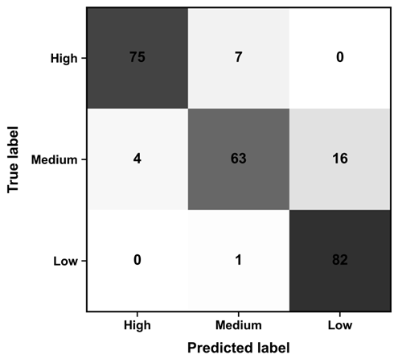 | 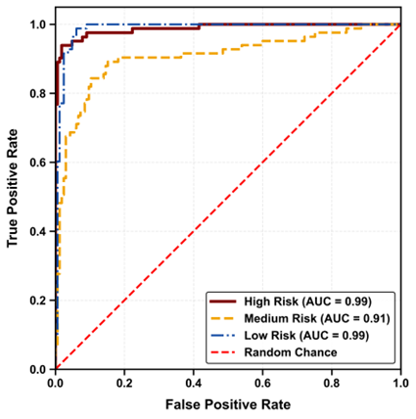
(a) | (b)
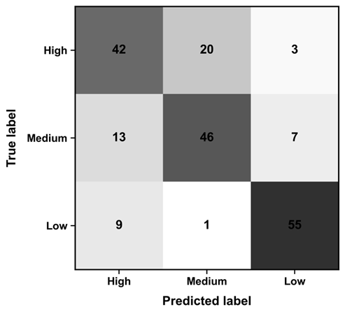 | 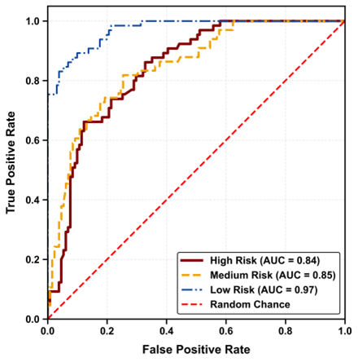
(c) | (d)
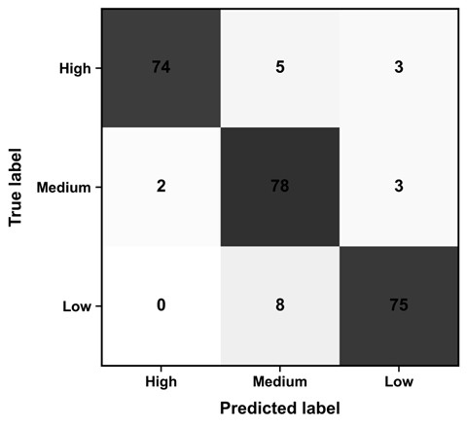 | 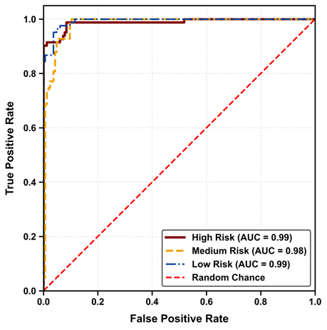
(e) | (f)
Fig. 5. Performance evaluation: (a), (c), (e) confusion matrix; (b), (d), (f) ROC Curve for LR, RF and SE models respectively

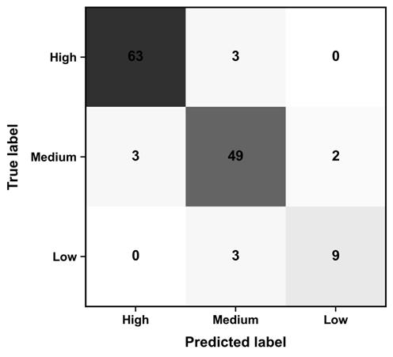 | 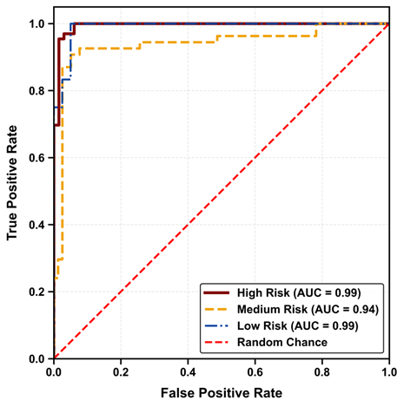
(a) | (b)
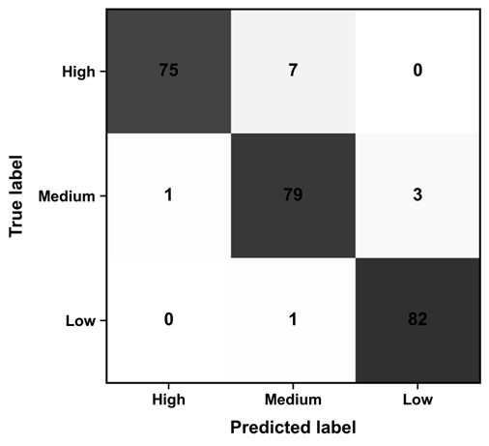 | 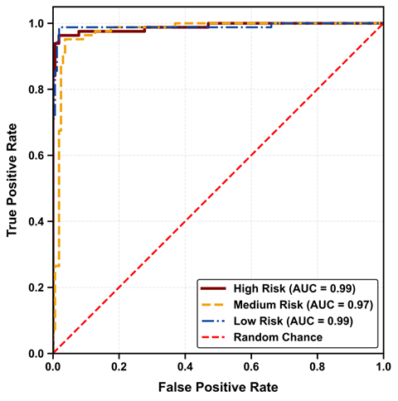
(c) | (d)
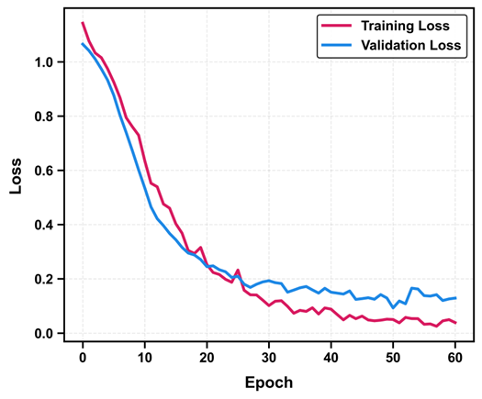
(e)
Fig. 6. Performance evaluation: (a), (c) confusion matrix; (b), (d) ROC Curve for SVM, ANN and models respectively; (e) Training and validation loss of ANN model
After the training and testing process with the proprietary data, the models were coupled with their preprocessors and saved for the purpose of testing them with new unseen data to validate the robustness, generalizability, and deploying these models for practical use in the industry. The new unseen data was obtained from the PHMSA database, consisting of 56,402 miles of pipeline network across the United States of America. Table 3 shows the prediction performance of the models on this unseen data.
Table 3- Prediction performance of ML models on unseen dataset
Model | Class | Precision | Recall | F1-score | AUC | Accuracy
LR | High | 0.97 | 0.97 | 0.97 | 0.97 | 0.88
LR | Low | 0.74 | 1.00 | 0.85 | 0.99 | 0.88
LR | Medium | 0.92 | 0.63 | 0.75 | 0.89 | 0.88
RF | High | 0.65 | 0.56 | 0.60 | 0.73 | 0.64
RF | Low | 0.66 | 0.39 | 0.49 | 0.90 | 0.64
RF | Medium | 0.63 | 0.77 | 0.69 | 0.76 | 0.64
SE | High | 0.94 | 0.84 | 0.89 | 0.97 | 0.88
SE | Low | 0.85 | 0.97 | 0.90 | 0.99 | 0.88
SE | Medium | 0.78 | 0.79 | 0.78 | 0.97 | 0.88
SVM | High | 0.95 | 0.88 | 0.91 | 0.99 | 0.90
SVM | Low | 0.96 | 0.98 | 0.97 | 0.99 | 0.90
SVM | Medium | 0.71 | 0.82 | 0.76 | 0.96 | 0.90
ANN | High | 0.99 | 0.61 | 0.76 | 0.91 | 0.90
ANN | Low | 0.96 | 1.00 | 0.98 | 0.99 | 0.90
ANN | Medium | 0.75 | 1.00 | 0.86 | 0.99 | 0.90
From Table 3, it can be deduced that the LR, stacking ensemble, SVM and ANN models all performed very well on the new unseen dataset. Conversely, the RF model showed poor performance indicating the model’s inability to generalize well in this study. However, although the ANN model performed well, the poor recall score in the high failure risk class prediction raises some concerns. Nonetheless, the ANN model outperforms other models in predicting low and medium risk classes while the SVM model shows superior prediction of the high risk class on the new data. This validates the probabilistic nature of multiclass pipeline failure risk prediction. The confusion matrix for this out-of-sample validation of the ML models is presented in Fig. 7.
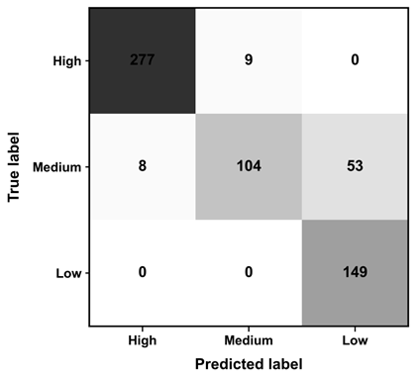 | 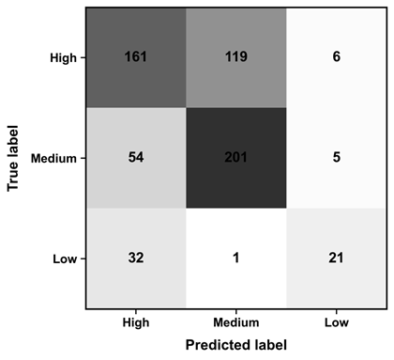
(a) | (b)
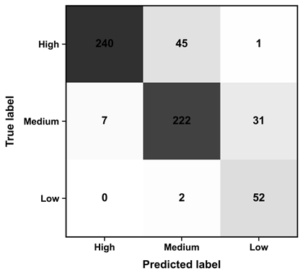 | 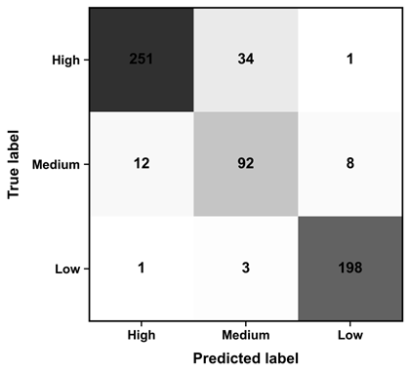
(c) | (d)
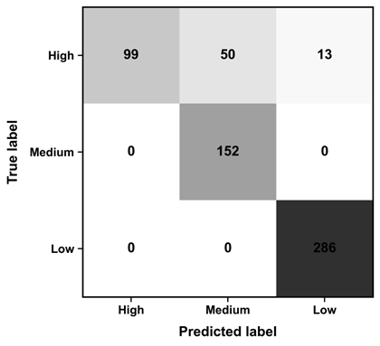
(e)
Fig. 7. Confusion matrices of (a) LR, (b) RF, (c) SE, (d) SVM, and (e) ANN models on the new dataset
The feature ranking of predictors presented in Fig. 8 was calculated using two complementary approaches: intrinsic feature importance from the RF model and permutation importance using the SE classifier. Specifically, the RF intrinsic importance measures were derived from the mean decrease in impurity (Gini importance), indicating how effectively each feature splits the data into distinct risk classes. Additionally, permutation importance was computed by randomly shuffling each feature's values in the test set and measuring the resulting decrease in model accuracy. Features causing the largest decrease in accuracy upon permutation were identified as most critical. From the plots, it becomes clear that flowline age, MAOP, pipeline outer diameter, and root cause (such as corrosion) have the most influence on the model predictions. Age and MAOP consistently emerged as the two dominant predictors across both methodologies, with importance values 50-75% higher than subsequent features. Basin demonstrated high importance (0.100) in the RF model but showed reduced significance (0.095) in permutation analysis. Diameter maintained consistent rankings between the two approaches, with importance values of 0.105 and 0.080, respectively. Weather conditions exhibited higher permutation importance (0.075) compared to its Random Forest ranking, suggesting potential interaction effects captured by the permutation methodology. The lowest-ranked features (Spill Type, Fluid Type, Pipe Material, and Flowline Type) showed minimal influence in both analyses, with particularly diminished importance values (<0.025) in the permutation assessment. This consistency across different features of importance metrics validates the interplay between operational, environmental, and material factors in pipeline failure risk as demonstrated in the data analysis section of this study. It should be noted that low importance of some features in this study should not be generalized. Therefore, for diffrent applications or scenarios their impact should be studied further.
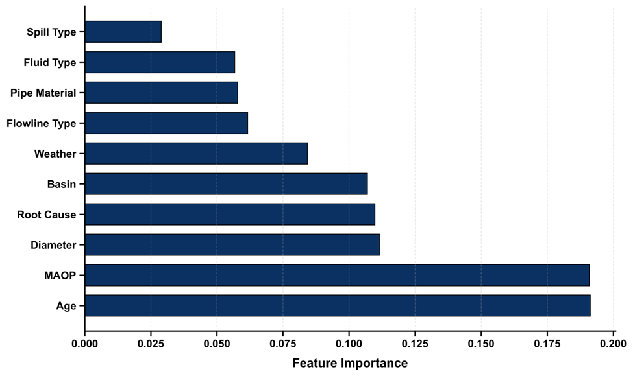
(a)
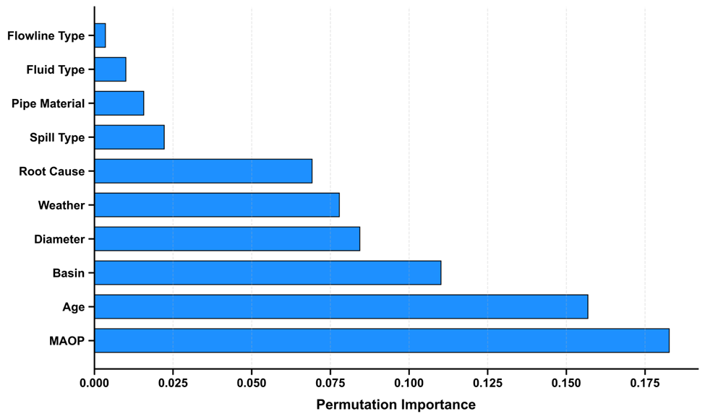
(b)
Fig. 8. Feature ranking of predictors: (a), feature importance (b) permutation importance
Following the feature importance analysis, we went further to analyze the interaction between the critical features and failure incidences. Fig. 9 shows that empirical evidence from our data confirms that operating pressure approaching or exceeding MAOP significantly increases pipeline failure risk. Analysis of pressure-to-MAOP ratios reveals that 87% of all documented failures occurred when operating pressure exceeded 90% of MAOP, with the vast majority happening when pressure surpassed MAOP entirely. This validates the burst limit state function approach and underscores the importance of maintaining adequate pressure safety margins. Fig. 10 shows that diameter demonstrates a strong inverse relationship between pipe size and failure incidence, with 1-2 inch diameter pipes accounting for approximately 76% of all failures (413 failures at 2-inch diameter and 289 at 1-inch diameter). The dominant failure incidence rate in smaller-diameter pipelines likely stems from reduced structural capacity relative to internal pressure loads. Fig. 11 depicts that flowline age failure patterns exhibited a bimodal distribution; both newer pipelines (0-15 years) and older pipelines (30-50 years) showed elevated failure rates, with the latter group demonstrating the highest failure frequency (151 incidents). This suggests two distinct failure mechanisms: material degradation (mainly due to corrosion) affecting older infrastructure and potential incorrect operation in newer pipeline systems. It should be noted that the model outputs can be embedded into a decision-support workflow, for example, by ranking inspection lists according to the low/medium/high risk classifications. This would directly support maintenance planning by enabling operators to prioritize higher-risk segments and allocate resources more effectively. Therefore, to make this more operational, we recommend developing a ranked inspection and intervention list linked to in-line inspection or direct assessment scheduling. Additionally, a what-if analysis can show how the predicted risk can change with the proposed mitigation methods.
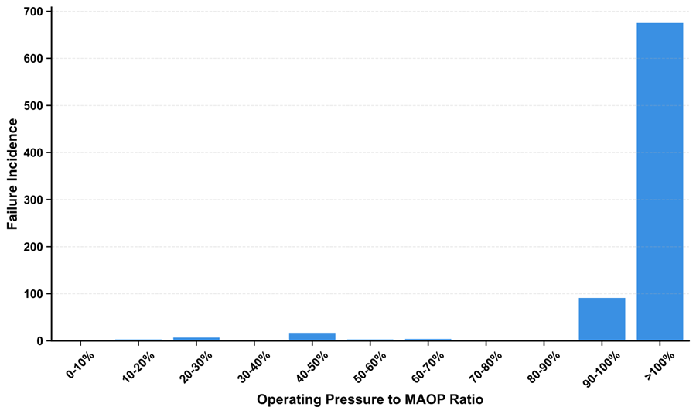
Fig. 9. Failure incidence as a function of operating pressure and MAOP ratio
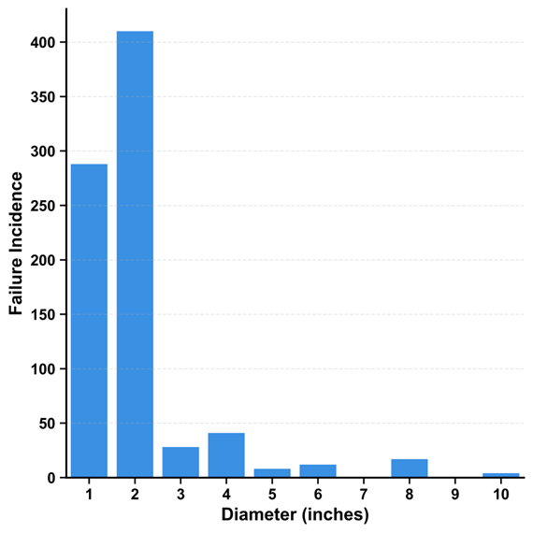
Fig. 10. Failure incidence as a function of pipe diameter
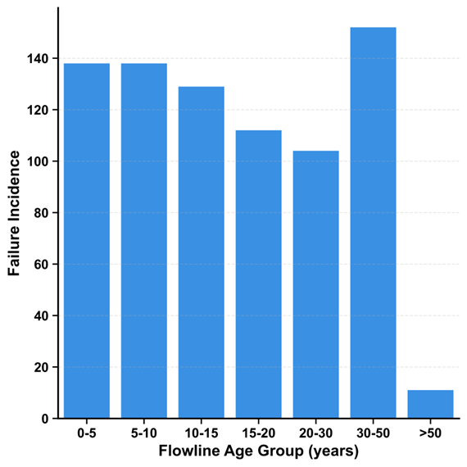
Fig. 11. Failure incidence as a function of flowline age

Conclusion
In this study, we have extensively investigated variables influencing pipeline failure risks using several machine learning algorithms. Feature importance analyses identified flowline age, MAOP, pipeline diameter, and root causes such as corrosion and operational errors as significant predictors of pipeline failure. Furthermore, as the operating pressure approaches the MAOP, the probability of failure increases, showing the effect of fluctuation in pressure on pipeline integrity. It is also observed that failure incidence was more dominant in older pipelines, likely due to material degradation over time. However, failure incidence plots also show that newer pipelines were also susceptible to failure, likely due to incorrect operation and other external factors. Additionally, a decrease in pipeline diameter was associated with increased failure risk, potentially resulting from higher internal pressure and greater structural instability in small diameter pipelines. The results presented here offer a quantitative basis for improving pipeline failure prediction, facilitating improved maintenance scheduling and resource allocation within pipeline integrity management systems. We applied the developed ML models for predicting failure in unseen datasets. The ANN model had a 90% overall accuracy with notably high performance in predicting the low- and medium-risk pipelines while the SVM model had the same overall accuracy as the ANN model, although SVM had a higher recall for the high-risk class on the unseen PHMSA dataset. This difference shows that multiclass failure risk prediction is probabilistic as no single model can optimally capture all classes of risk. Most notably, poor generalization of the RF model on unseen data further justifies the necessity for model selection, balancing predictive accuracy over all classes for operational reliability. These models, once applied to a risk assessment framework, will allow pipeline operators to adopt focused maintenance strategies, give priority to medium to high risk cases, and be resource efficient in the lower categories of risk. However, the poor recall of the ANN model in the high-risk class calls for more tuning, especially toward enhancing sensitivity to critical failure scenarios. Alternatively, a hybrid approach comprising ANN and SVM may offer a more balanced predictive framework that leverages the pattern recognition capabilities of ANN with the robust decision boundaries of SVM. This study shows that ML models can be trained and applied in real-life optimization of oil and gas pipeline failure risk assessments.
Declaration of Competing Interest
The authors declare that they have no known competing financial interests or personal relationships that could have appeared to influence the work reported in this paper.
Acknowledgements
We are grateful to the Martinez and Irwin Memorial Fund and Colorado Energy and Carbon Management Commission (ECMC) for supporting this study. The authors thank Mark Schlagenhauf and Steven Wheeler from ECMC for their valuable recommendations. We gratefully acknowledge the valuable comments from the anonymous reviewers, which greatly improved this paper. Any opinions, findings, conclusions, or recommendations expressed in this work are those of the authors and do not necessarily reflect the views of individuals or organizations providing technical input or financial support.
Funding
This work is supported by the Colorado Energy and Carbon Management Commission Mark Martinez & Joey Irwin Memorial Public Projects Fund.

References
Ahammed, M. (1998). Probabilistic estimation of remaining life of a pipeline in the presence of active corrosion defects. International Journal of Pressure Vessels and Piping, 75(4), 321–329. https://doi.org/10.1016/S0308-0161(98)00006-4
Al-Sabaeei, A. M., Alhussian, H., Abdulkadir, S. J., & Jagadeesh, A. (2023). Prediction of oil and gas pipeline failures through machine learning approaches: A systematic review. Energy Reports, 10, 1313–1338. https://doi.org/10.1016/j.egyr.2023.08.009
Amaya-Gómez, R., Sánchez-Silva, M., Bastidas-Arteaga, E., Schoefs, F., & Muñoz, F. (2019). Reliability assessments of corroded pipelines based on internal pressure – A review. Engineering Failure Analysis, 98, 190–214. https://doi.org/10.1016/j.engfailanal.2019.01.064
B31G - Manual for Determining Remaining Strength of Corroded Pipelines—ASME. (n.d.). Retrieved May 23, 2025, from https://www.asme.org/codes-standards/find-codes-standards/b31g-manual-determining-remaining-strength-corroded-pipelines
Ben Seghier, M. E. A., Höche, D., & Zheludkevich, M. (2022). Prediction of the internal corrosion rate for oil and gas pipeline: Implementation of ensemble learning techniques. Journal of Natural Gas Science and Engineering, 99, 104425. https://doi.org/10.1016/j.jngse.2022.104425
Bishop, C. M. (2006). Pattern Recognition and Machine Learning (Information Science and Statistics). Springer-Verlag.
Breiman, L. (1996). Bagging predictors. Machine Learning, 24(2), 123–140. https://doi.org/10.1007/BF00058655
Breiman, L. (2001). Random Forests. Machine Learning, 45(1), 5–32. https://doi.org/10.1023/A:1010933404324
Caleyo, F., González, J. L., & Hallen, J. M. (2002). A study on the reliability assessment methodology for pipelines with active corrosion defects. International Journal of Pressure Vessels and Piping, 79(1), 77–86. https://doi.org/10.1016/S0308-0161(01)00124-7
Chen, T., & Guestrin, C. (2016). XGBoost: A Scalable Tree Boosting System. Proceedings of the 22nd ACM SIGKDD International Conference on Knowledge Discovery and Data Mining, 785–794. https://doi.org/10.1145/2939672.2939785
Chittumuri, I., Alshehab, N., Voss, R. J., Douglass, L. L., Kamrava, S., Fan, Y., Miskimins, J., Fleckenstein, W., & Bandyopadhyay, S. (2025). Risk Analysis of Flowlines in the Oil and Gas Sector: A GIS and Machine Learning Approach (No. arXiv:2501.11213). arXiv. https://doi.org/10.48550/arXiv.2501.11213
Cortes, C., & Vapnik, V. (1995). Support-vector networks. Machine Learning, 20(3), 273–297. https://doi.org/10.1007/BF00994018
Cox, D. R. (1958). The Regression Analysis of Binary Sequences. Journal of the Royal Statistical Society: Series B (Methodological), 20(2), 215–232. https://doi.org/10.1111/j.2517-6161.1958.tb00292.x
Cutler, A., Cutler, D. R., & Stevens, J. R. (2012). Random Forests. In C. Zhang & Y. Ma (Eds.), Ensemble Machine Learning: Methods and Applications (pp. 157–175). Springer. https://doi.org/10.1007/978-1-4419-9326-7_5
DNV-RP-F101: Corroded Pipelines. (2010).
Don, D. R. (n.d.). Multiclass Classification Using Support Vector Machines.
Don, D. R., & Iacob, I. E. (2018). DCSVM: Fast Multi-class Classification using Support Vector Machines (No. arXiv:1810.09828). arXiv. https://doi.org/10.48550/arXiv.1810.09828
Ferreira, A. D. M., Afonso, S. M. B., Willmersdorf, R. B., & Lyra, P. R. M. (2021). Multiresolution analysis and deep learning for corroded pipeline failure assessment. Advances in Engineering Software, 162–163, 103066. https://doi.org/10.1016/j.advengsoft.2021.103066
Friedman, J. H. (2001). Greedy function approximation: A gradient boosting machine. The Annals of Statistics, 29(5), 1189–1232. https://doi.org/10.1214/aos/1013203451
He, H., & Garcia, E. A. (2009). Learning from Imbalanced Data. IEEE Transactions on Knowledge and Data Engineering, 21(9), 1263–1284. IEEE Transactions on Knowledge and Data Engineering. https://doi.org/10.1109/TKDE.2008.239
Hosmer, D. W., Lemeshow, S., & Sturdivant, R. X. (2013). Applied Logistic Regression: Third Edition. wiley. https://doi.org/10.1002/9781118548387
Ke, G., Meng, Q., Finley, T., Wang, T., Chen, W., Ma, W., Ye, Q., & Liu, T.-Y. (2017). LightGBM: A Highly Efficient Gradient Boosting Decision Tree. Advances in Neural Information Processing Systems, 30. https://proceedings.neurips.cc/paper_files/paper/2017/hash/6449f44a102fde848669bdd9eb6b76fa-Abstract.html
Kingma, D. P., & Ba, J. (2017). Adam: A Method for Stochastic Optimization (No. arXiv:1412.6980). arXiv. https://doi.org/10.48550/arXiv.1412.6980
Liaw, A., & Wiener, M. (n.d.). Classiﬁcation and Regression by randomForest.
Louppe, G., Wehenkel, L., Sutera, A., & Geurts, P. (2013). Understanding variable importances in forests of randomized trees. Advances in Neural Information Processing Systems, 26. https://papers.nips.cc/paper_files/paper/2013/hash/e3796ae838835da0b6f6ea37bcf8bcb7-Abstract.html
Lunardon, N., Menardi, G., & Torelli, N. (2014). ROSE: A Package for Binary Imbalanced Learning. The R Journal, 6(1), 79. https://doi.org/10.32614/RJ-2014-008
Madzarov, G., & Gjorgjevikj, D. (2009). Multi-class classification using support vector machines in decision tree architecture. IEEE EUROCON 2009, 288–295. https://doi.org/10.1109/EURCON.2009.5167645
Mangalathu, S., & Jeon, J.-S. (2019). Machine Learning–Based Failure Mode Recognition of Circular Reinforced Concrete Bridge Columns: Comparative Study. Journal of Structural Engineering, 145(10), 04019104. https://doi.org/10.1061/(ASCE)ST.1943-541X.0002402
Mazumder, R. K., Salman, A. M., & Li, Y. (2021). Failure risk analysis of pipelines using data-driven machine learning algorithms. Structural Safety, 89, 102047. https://doi.org/10.1016/j.strusafe.2020.102047
Mikolajková-Alifov, M., Pettersson, F., Björklund-Sänkiaho, M., & Saxén, H. (2019). A Model of Optimal Gas Supply to a Set of Distributed Consumers. Energies, 12(3), Article 3. https://doi.org/10.3390/en12030351
Mohamed, A., Hamdi, M. S., & Tahar, S. (2015). A Machine Learning Approach for Big Data in Oil and Gas Pipelines. 2015 3rd International Conference on Future Internet of Things and Cloud, 585–590. https://doi.org/10.1109/FiCloud.2015.54
Ng, A. Y. (2004). Feature selection, L₁ vs. L₂ regularization, and rotational invariance. Twenty-First International Conference on Machine Learning - ICML ’04, 78. https://doi.org/10.1145/1015330.1015435
Phan, H. C., & Dhar, A. S. (2021). Predicting pipeline burst pressures with machine learning models. International Journal of Pressure Vessels and Piping, 191, 104384. https://doi.org/10.1016/j.ijpvp.2021.104384
Robles-Velasco, A., Cortés, P., Muñuzuri, J., & Onieva, L. (2020). Prediction of pipe failures in water supply networks using logistic regression and support vector classification. Reliability Engineering & System Safety, 196, 106754. https://doi.org/10.1016/j.ress.2019.106754
Srivastava, N., Hinton, G., Krizhevsky, A., Sutskever, I., & Salakhutdinov, R. (2014). Dropout: A simple way to prevent neural networks from overfitting. J. Mach. Learn. Res., 15(1), 1929–1958.
Su, Y., Li, J., Yu, B., Zhao, Y., & Yao, J. (2021). Fast and accurate prediction of failure pressure of oil and gas defective pipelines using the deep learning model. Reliability Engineering & System Safety, 216, 108016. https://doi.org/10.1016/j.ress.2021.108016
Tang, K., Parsons, D. J., & Jude, S. (2019). Comparison of automatic and guided learning for Bayesian networks to analyse pipe failures in the water distribution system. Reliability Engineering & System Safety, 186, 24–36. https://doi.org/10.1016/j.ress.2019.02.001
Thurnhofer-Hemsi, K., López-Rubio, E., Molina-Cabello, M. A., & Najarian, K. (2020). Radial basis function kernel optimization for Support Vector Machine classifiers (No. arXiv:2007.08233). arXiv. https://doi.org/10.48550/arXiv.2007.08233
Wolpert, D. H. (1992). Stacked generalization. Neural Networks, 5(2), 241–259. https://doi.org/10.1016/S0893-6080(05)80023-1
Xiao, R., Zayed, T., Meguid, M. A., & Sushama, L. (2024). Predicting failure pressure of corroded gas pipelines: A data-driven approach using machine learning. Process Safety and Environmental Protection, 184, 1424–1441. https://doi.org/10.1016/j.psep.2024.02.051
Zakikhani, K., Zayed, T., Abdrabou, B., & Senouci, A. (2020). Modeling Failure of Oil Pipelines. Journal of Performance of Constructed Facilities, 34(1), 04019088. https://doi.org/10.1061/(ASCE)CF.1943-5509.0001368
Zhang, Y., Burton, H. V., Sun, H., & Shokrabadi, M. (2018). A machine learning framework for assessing post-earthquake structural safety. Structural Safety, 72, 1–16. https://doi.org/10.1016/j.strusafe.2017.12.001

