B363: Bioinformatics algorithms
HW2 (Due Monday, July 23, 2018)
http://datamining-iip.fudan.edu.cn/bioAlgoIntro.html
(You do not need to write computer programs for the following questions.)

- 10 pts) Given the following k-mer (k=3) composition: S={ATG, GGG, GGT, GTA, GTG, TAT, TGG}, show the de Bruijn Graph of S, and reconstruct all possible sequences s whose k-mer compositions are equal to S.

- (10 pts) Consider the graph below. Does it have a Eulerian circle? If yes, find the path. If not, why?
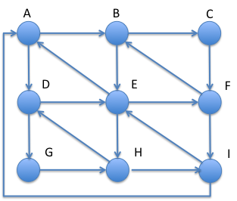
- (10 pts) Reconstruct the DNA sequence spelled by the following Eulerian path of (2, 1)-mers: (AG|AG) → (GC|GC) → (CA|CT) → (AG|TG) → (GC|GC) → (CT|CT) → (TG|TG) → (GC|GC) → (CT|CA). Note: (2, 1)-mer is a pair 2-mer with fixed distance of 1.

- (10 pts) To find a Eulerian cycle in a balanced, strongly connected graph, Dr. Smart suggested to start from a vertex with high indegree (and high outdegree). What is his rationale? Assuming you start from the vertex with the highest indegree in the graph, is it always true that the first cycle you get is a Eulerian cycle? Justify your answer.

- (10 pts) Show the complete theoretical mass spectrum generated from the cyclopeptide NLYV.

- (15 pts) In a noisy mass spectrum of a cyclopeptide, the maximum value in the spectrum may not be the parent mass of the cyclopeptide. Devise an algorithm to compute the parent mass of a cyclopeptide from a given noisy mass spectrum.

- (20 pts) Construct the alignment graph of ACGTTAA and AGTTTA (using the score = 3 for matches, and = -2 for mismatches and gaps). Show the optimal alignment, and its corresponding path in the alignment graph.

- (15 pts) Modify the dynamic programming algorithm for the global alignment of two DNA sequences to solve the Overlap Alignment Problem: given two strings u and v, and a scoring matrix Score, find a highest-scoring overlap alignment, i.e. a global alignment of a suffix of u and a prefix of v.

