Evaluating Deep Tabular Models and Local Explanation Agreement for Credit Card Fraud Detection
Adhiyaman S Sarvesh B

Abstract—I think detecting credit card fraud requires finding fraudulent actions while keeping false alarms low. Explainability brings another problem: when many methods agree it does not guarantee that the explanations are accurate.
I evaluated credit card fraud models TabNet, MLP and FT-Transformer on 112,534 transactions using splits and thresholds that depend on validation F1. In the 16,881 test transactions that contain 36 cases TabNet achieved a PR-AUC of 0.7961, a precision of 0.9310 and an F1 score of 0.8308 and it produced only two false positives. MLP reached a ROC-AUC of 0.9722. FT-Transformer found the frauds detecting 29 out of 36.
I also tested SHAP and LIME on a valid transaction for credit card fraud and proposed a metric for directional alignment. The signs of the three characteristics match at glance giving some early evidence of consistency but this is not enough, for broad validation.
Index Terms—Credit card fraud detection, class imbalance, TabNet, multilayer perceptron, FT-Transformer, SHAP, LIME, explainable machine learning.

- Introduction
Fraud detection is a skewed classification challenge because fraudulent activities make up only 0.21 percent of all transac-tions. A model that classifies every transaction as legitimate would reach 99.79 percent accuracy. It would not detect any fraud. Therefore we evaluate ranking using ROC-AUC and PR-AUC. Also consider precision and recall at specific thresholds [8], [9]. TabNet uses attention [1]. MLP learns through layers. FT-Transformer uses self-attention on feature tokens [2]. The dataset, training method and assessment metric shape the performance of each model. For explainability SHAP uses Shapley values to identify feature contributions [3]. LIME offers an approximation of model behavior [4]. An agreement, among these methods indicates consistency, not correctness, causation or generalisation.
- Related Work
He and Garcia examine approaches, for classification [8]. Dal Pozzolo et al. Emphasize the importance of fraud detection assessment [5]. In imbalanced datasets precision–recall curves provide a more accurate representation of minority-class performance compared to ROC curves [9]. SHAP gives a share to each feature for a prediction [3]. LIME looks at how the model behaves near an example [4]. The magnitudes of SHAP and LIME attributions cannot be compared directly. The directions of shared features can be. This research measures
agreement without presuming that SHAP explanation or LIME explanation is accurate.

- Data and Experimental Setup
The data comes from the ULB credit card fraud database [6], [7] which has 284,807 transactions recorded over a two-day time period in September 2013. We look at 112,534 transactions: 112,298 are real and 236 are fake (477 to 1 imbalance). Each entry has 28 features (V₁–V₂₈) the amount of the transaction and the time that passed. These features do not have business meanings.
Stratified sampling (seed 42) gives 78,773 training 16,880 validation and 16,881 test samples. The test set has 36 cases of fraud. Random splitting keeps the class ratios but does not show future transactions properly.
Models. TabNet uses sparse attention masks [1]; the four-layer MLP has dropout, with batch normalization; FT-Transformer uses -head attention on feature tokens and has 800,897 parameters [2]. All models use class-weighted binary cross-entropy giving a weight of w₊ = 476.41 to fraud.
Threshold selection. The cutoff for each model m is the value that maximizes F1 on validation data,
∗ = arg max F₁(y_{val}, I[p_{m,val} ≥ τ ]) , (1)
τ
m
τ ∈T
where T is the candidate set; τ ∗ is then held fixed on the test set. The resulting thresholds (Table I) maximize F1.
m

- Model Comparison
No single model is the best across all metrics (Table I). TabNet is very strong in PR-AUC, precision and F1: around 93 percent of TabNets alerts are deceptive and TabNet has two wrong alerts out of 16,845 genuine transactions. The MLP evaluates transactions best using ROC-AUC and FT-Transformer counts the number of fraud cases. FT-Transformer caught 29 out of 36 fraud cases. Has four more false alarms compared to TabNet (see Fig. 1). Which model is being used? Which model is best depends on the cost of ignoring deception and sending too many alerts. The test set has 36 fraud cases, including one instance. The prediction changes recall by 2.78 percentage points. Therefore a change in one or two cases does not prove a difference, between models.

TABLE I
Held-out Test Results at the Validation-Selected Thresholds

Model | ROC-AUC | PR-AUC | Precision | Recall | F1 | Threshold | TP | FP | FN
TabNet | 0.9338 | 0.7961 | 0.9310 | 0.7500 | 0.8308 | 0.997419 | 27 | 2 | 9
MLP | 0.9722 | 0.6395 | 0.7778 | 0.7778 | 0.7778 | 0.983198 | 28 | 8 | 8
FT-Transformer | 0.9544 | 0.7652 | 0.8286 | 0.8056 | 0.8169 | 0.991292 | 29 | 6 | 7
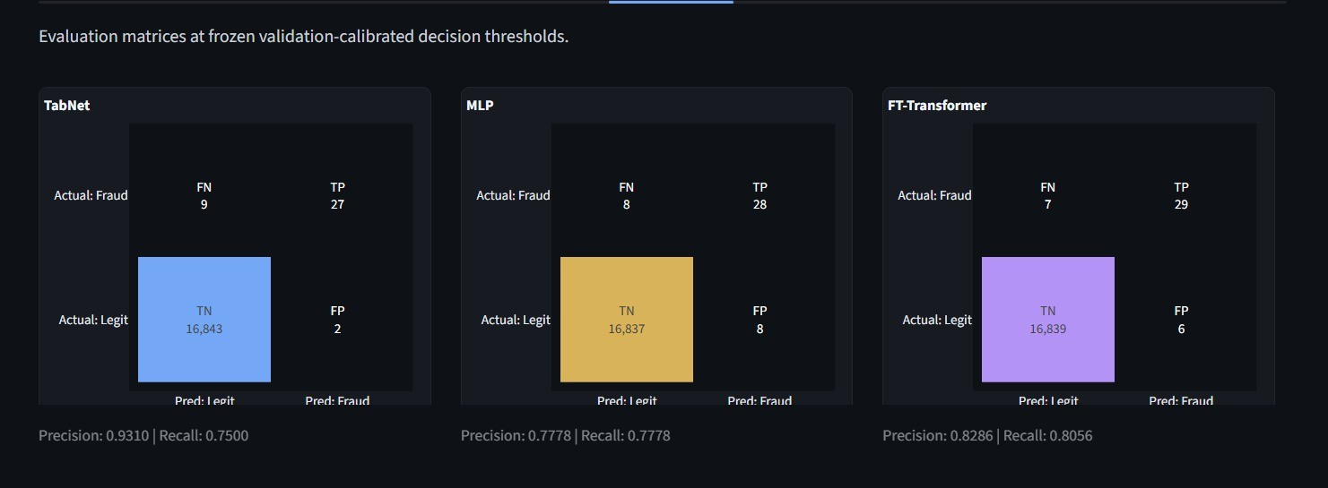

Fig. 1. Confusion matrices for the three models at their fixed, validation-selected thresholds. TabNet produces the fewest false positives, while FT-Transformer detects the most fraud cases.
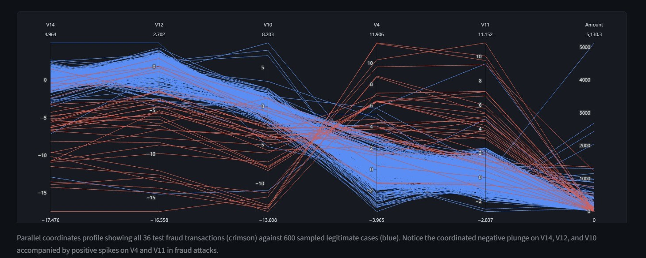
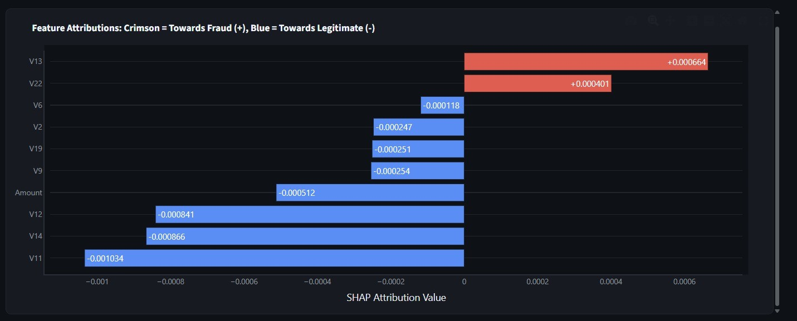

Fig. 2. Parallel-coordinate profiles of the 36 test frauds (red) against 600 sampled legitimate transactions (blue). The patterns describe this sample and are not universal fraud rules.

- Transaction-level Explanation
Row 12507 shows a purchase of $293.86 that happened 69,480 seconds after the first transaction. All three models looked at row 12507 found row 12507 below their cut-off points. Decided that row 12507 is valid. This example shows how we investigate an accurate identification.
SHAP. For TabNet SHAP values are calculated with Ker-nelExplainer using 500 training samples as the background. In the dashboard style a positive number increases the fraud score while a negative number decreases the fraud score.
In row 12507 (Fig. 3) feature V₁₃. Feature V₂₂ push row 12507 toward deceptive behaviour. At the time features V₁₁, V₁₄, V₁₂ and the Amount column pull row 12507 toward a normal outcome. Row 12507’s final label depends more on
Fig. 3. Local SHAP attributions for transaction row 12507 (TabNet).
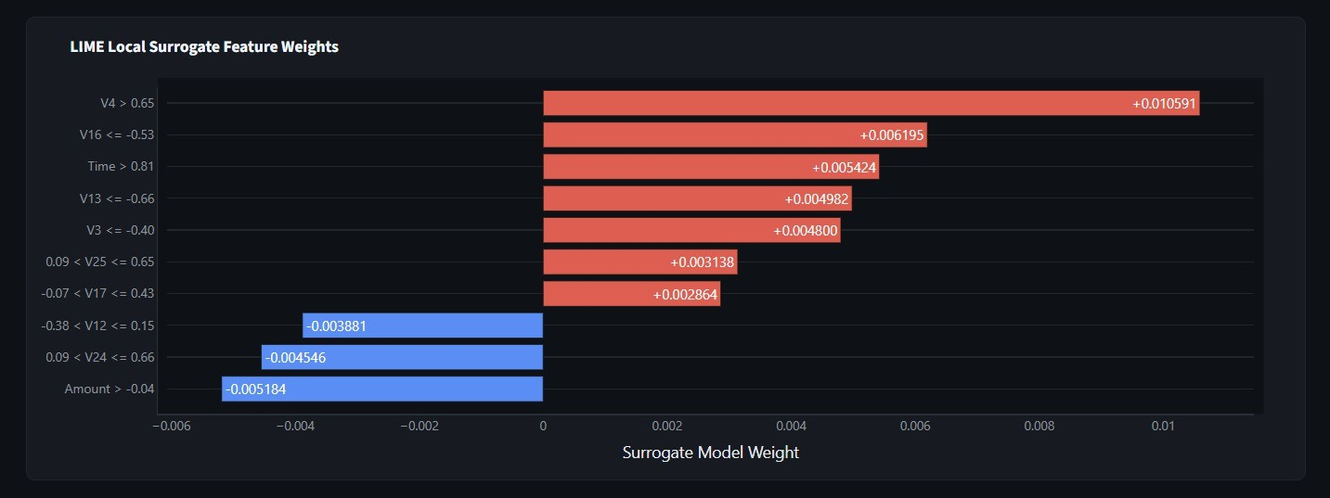

Fig. 4. LIME surrogate weights for transaction row 12507.

LIME. LIME fits a local ridge-regression surrogate and discretizes continuous inputs into rules [4]. The strongest rules for row 12507 (Fig. 4) are V₄ > 0.65, V₁₆ ≤ −0.53, and Time
> 0.81, all on standardized features. These rules describe the
model near this transaction only.
x

this pattern than, on any one feature alone.
Directional agreement. Let C′
be the features reported by

TABLE II
SHAP–LIME Directional Agreement for Row 12507

Feature | SHAP | LIME | Agree
Amount | −0.000512 | −0.0052 | Yes
V13 | +0.000664 | +0.0050 | Yes
V12 | −0.000841 | −0.0039 | Yes
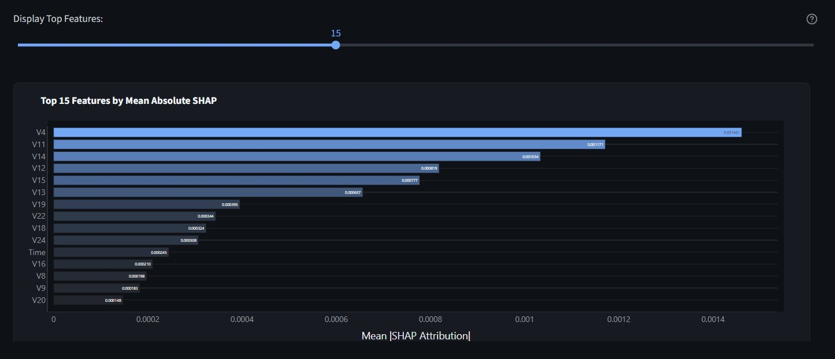

Fig. 5. Top 15 features by mean absolute SHAP value over 20 sampled test transactions. The ranking reflects magnitude, not direction.

both SHAP and LIME for transaction x, excluding zero or undefined values. We define
VII. Conclusion
TabNet, MLP and FT-Transformer on a credit card fraud dataset that was highly skewed. TabNet achieved the PR-AUC, precision and F1 score. MLP performed best in ROC-AUC. FT-Transformer performed best in recall. SHAP and LIME agreed on the importance of three attributes: Amount, V12 and V13 for a transaction. This agreement produced a consensus score that will help in future large-scale evaluations. I believe that evaluating performance, explanation consistency and causal validity should be done separately.
References
- S. O. Arik and T. Pfister, “TabNet: Attentive Interpretable Tabular Learning,” arXiv preprint arXiv:1908.07442, 2019.
- Y. Gorishniy, I. Rubachev, V. Khrulkov, and A. Babenko, “Revisiting Deep Learning Models for Tabular Data,” in Advances in Neural Information Processing Systems, vol. 34, 2021.
- S. M. Lundberg and S.-I. Lee, “A Unified Approach to Interpreting Model Predictions,” in Advances in Neural Information Processing Systems, vol. 30, 2017.
- M. T. Ribeiro, S. Singh, and C. Guestrin, “Why Should I Trust You?: Explaining the Predictions of Any Classifier,” in Proceedings of the 22nd ACM SIGKDD International Conference on Knowledge Discovery and Data Mining, 2016, pp. 1135–1144.
- A. Dal Pozzolo, G. Boracchi, O. Caelen, C. Alippi, and B. Bontempi, “Credit Card Fraud Detection: A Realistic Modeling and a Novel Learning Strategy,” IEEE Transactions on Neural Networks and Learning Systems,

1
A(x) =
|C′ |
x
∑︂ I[sgn(ϕ_{j}(x)) = sgn(λ_{j}(x))] , (2)
j∈C′
x
vol. 29, no. 8, pp. 3784–3797, 2018.
- A. Dal Pozzolo, O. Caelen, R. A. Johnson, and G. Bontempi, “Calibrating Probability with Undersampling for Unbalanced Classification,” in Proceedings of the IEEE Symposium Series on Computational Intelligence

where ϕ_{j} and λ_{j} are the SHAP and LIME attributions of feature
j. For a nonempty set, A(x) ∈ [0, 1], and A(x) = 1 means every shared feature has matching signs; with no overlap the
score is undefined. It measures direction only, not magnitude, causality, or correctness.
In row 12507, Amount is reported by both SHAP and LIME, V₁₃. and V₁₂, assigning each the same sign (Table II), thus A(x₁₂₅₀₇) = 1. This does not mention characteristics that pertain exclusively to a single method. reports, or regarding other transactions. Worldwide ranking. Average absolute SHAP values across 20 held-out transactions involve V₄, V₁₁, V₁₄, and V₁₂ positioned at the top (Fig. 5). Since this measure ignores the sign, a feature can be ranked. greatly, even if its impact shifts direction between transactions, and a sample of 20 transactions is insufficient to create consistency throughout the populace.
- Discussion and Limitations
TabNet works best when reducing alarms is very important. FT-Transformer works better when a strong fraud detection system is needed. Neither TabNet nor FT-Transformer is the winner until the costs are examined.
The study has limits because there were 36 test fraud cases the data were split at random and the SHAP and LIME explanations might not be reliable. Future studies should try random seeds split the data by time use cost-sensitive thresholds and check if the explanations stay stable when different samples are used. The agreement was tested on one transaction and three features, which shows that more validation is needed.
(SSCI), 2015, pp. 159–166.
- Machine Learning Group, Universite´ Libre de Bruxelles, “Credit Card Fraud Detection,” Kaggle dataset. [Online]. Available: https://www.kaggle. com/datasets/mlg-ulb/creditcardfraud
- H. He and E. A. Garcia, “Learning from Imbalanced Data,” IEEE Transactions on Knowledge and Data Engineering, vol. 21, no. 9, pp. 1263–1284, 2009.
- T. Saito and M. Rehmsmeier, “The Precision-Recall Plot Is More Informative than the ROC Plot When Evaluating Binary Classifiers on Imbalanced Datasets,” PLOS ONE, vol. 10, no. 3, Art. no. e0118432, 2015.

