Checkpoint-Mongo

- Version Mongo :

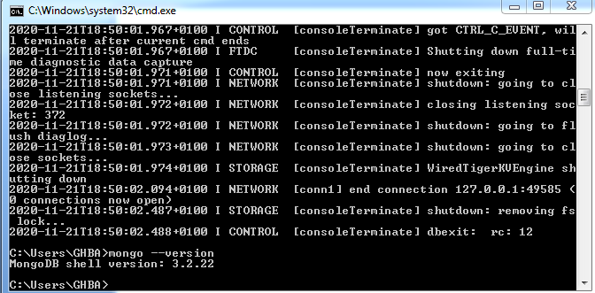
- Create a database called "contact" :
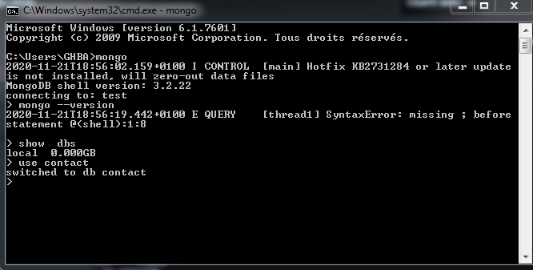

- Create a collection called : « contactlist » :

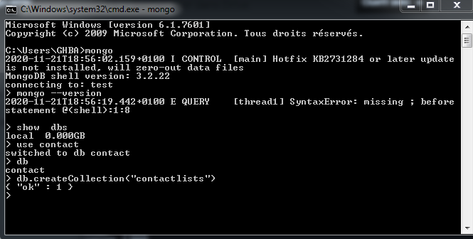

- Insert documents in « contactlist » :

- One :
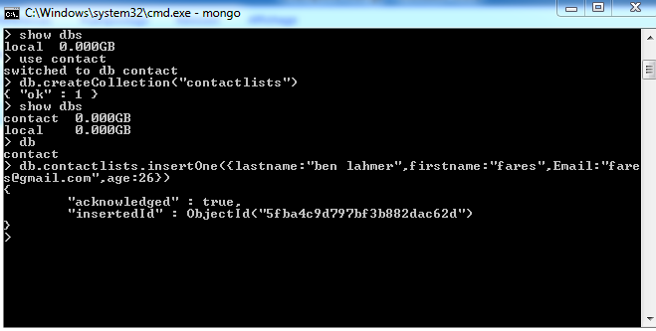
- Many :

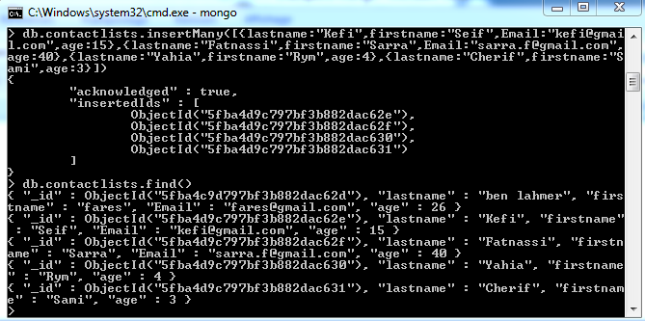

- Display all the contact list :
- Without pretty() :

- With pretty() :

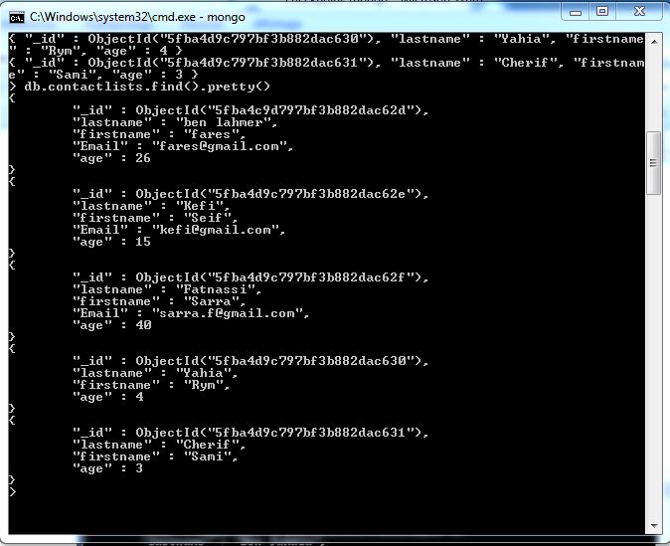

- Display all the information about only one person using his id:

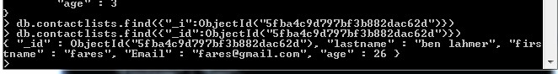
- Display all the contact list having age>18:
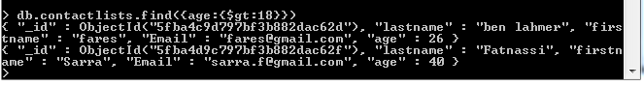
- Display all the contact list having age>18 and name containing “ah “:

- Change the contact first name of 3kefi Seif” by “kefi Anis “:

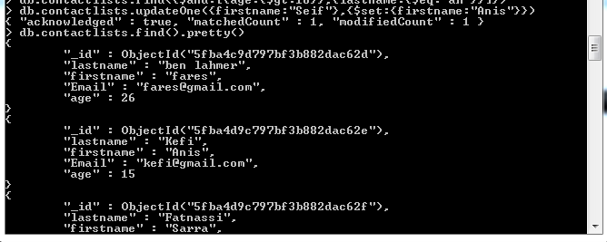
- Delete the contact list having age<5 :

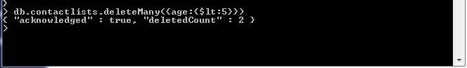

- Display all the contact list :

