Briarwood Avenue Drainage Upgrade
Storm Event Record and Field Photo Log
Document BA-DGN-FLD-009 | Revision B | Issued 20 May 2026
This record summarises field observations after the 14 May 2026 flooding complaint. It is intended to support hydrology and hydraulic reconciliation only. Design calculations must use the authority hierarchy issued with the project package.

1. Event summary
Item | Record
Event date | 14 May 2026
Reported flooding window | 17:35 to 18:15 local time
Reported location | Briarwood Avenue sag between Sta. 0+185 and Sta. 0+235
Primary concern | Outside lane ponding and surcharge at MH-4 during high-intensity rainfall
Governing design event to rebuild | 25-year, 15-minute storm per authority hierarchy and public PFDS lookup instruction
Provisional tailwater mark | 83.05 m BWD 2026 at C-01 outlet staff mark; requires survey confirmation before final design

2. Field photo log and interpretation
Photo ID | Location | Design relevance
P-01 | Sta. 0+210, north gutter | Ponding width measured from curb face was approximately 2.2 m at peak observation. Use workbook calculation for final gutter-spread result.
P-03 | East apron curb line | 2025 curb works divert east apron runoff to Cedar Lane. C-06 should not be included in Briarwood contributing area.
P-07 | Contractor yard surface | Surface is compacted gravel; use runoff coefficient 0.70 unless later paving evidence is supplied.
P-09 | C-01 outlet | Outlet was partly submerged and the barrel could not be confirmed visually. Use Rev D as-built box culvert geometry and keep CCTV confirmation open.
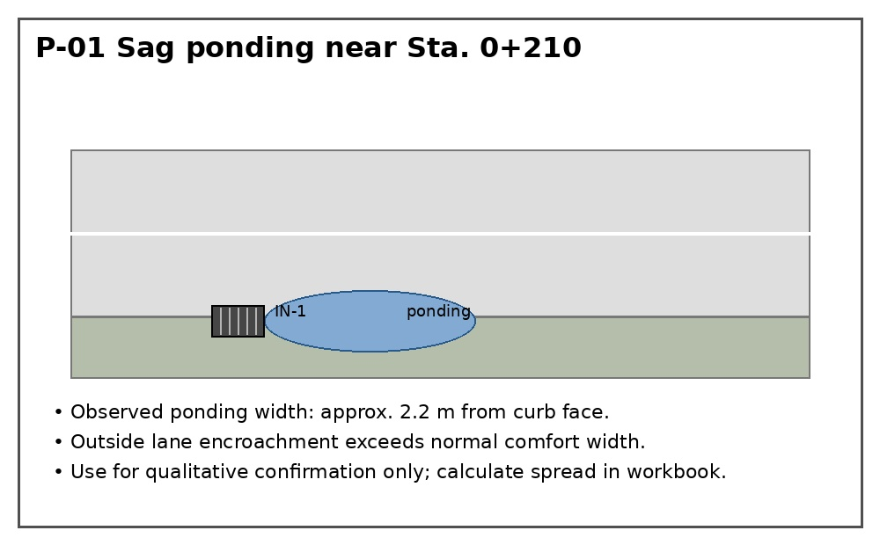
Figure P-01. Sag ponding observation near Sta. 0+210.
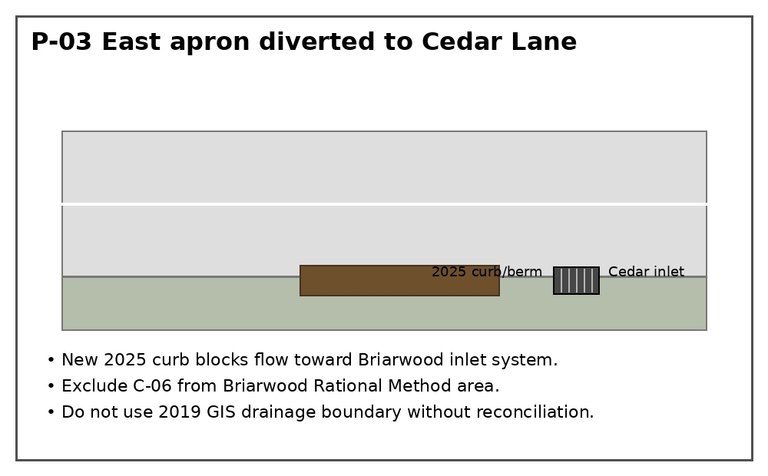
Figure P-03. East apron diverted away from Briarwood system.
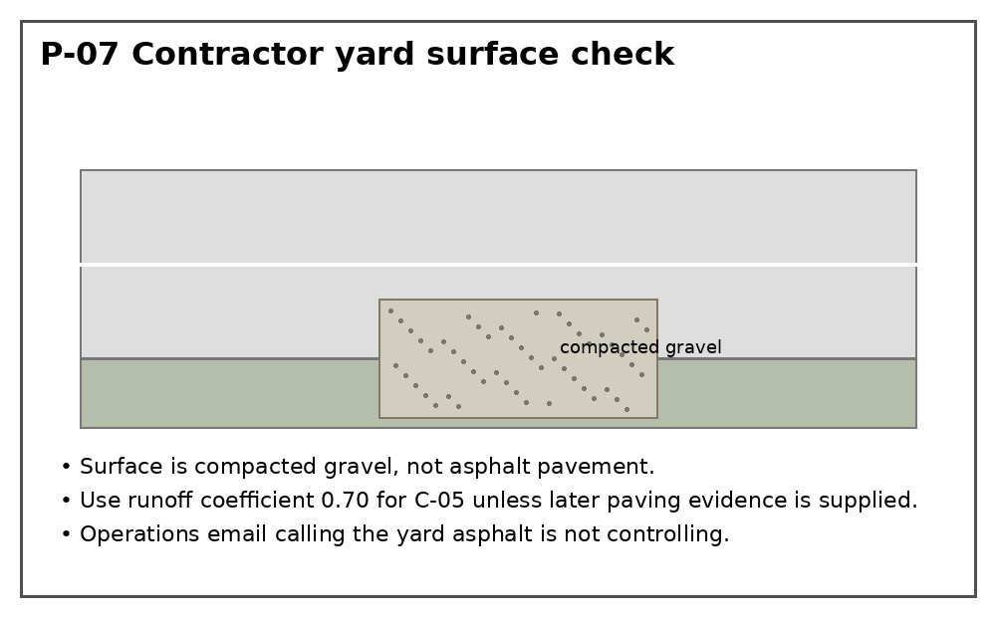
Figure P-07. Contractor yard surface classification.
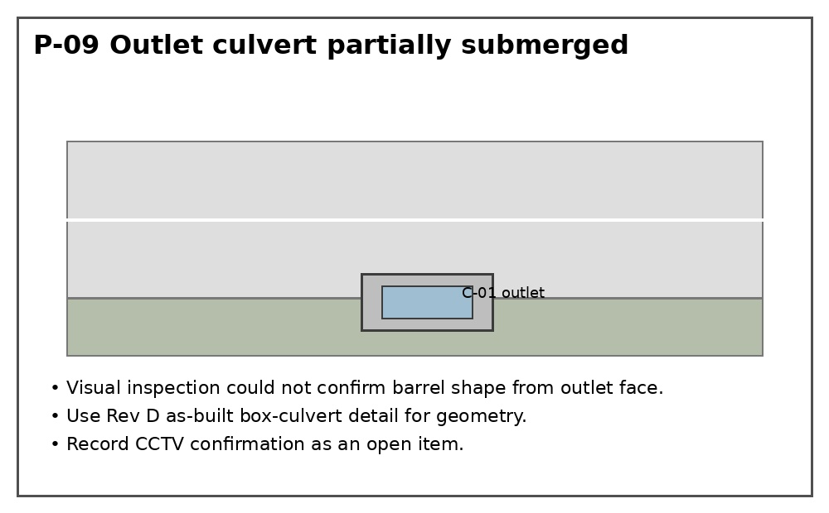
Figure P-09. Outlet culvert visibility limitation.

3. Conflicting field information to reconcile
ID | Topic | Conflict or gap | Required deduction
FLD-01 | Ponding width | Complaint email says water crossed both lanes; field mark shows approx. 2.2 m from north curb. | Use photo mark as qualitative check, but calculate HEC-22 gutter spread from the corrected flow and street geometry.
FLD-02 | Drainage boundary | 2019 GIS map includes east apron C-06 in Briarwood catchment; P-03 shows curb diversion to Cedar Lane. | Exclude C-06 from Briarwood Rational Method area and record the 2019 GIS map as superseded for this boundary.
FLD-03 | P-07 runoff coefficient | Operations email calls P-07 asphalt; photo P-07 shows compacted gravel. | Use compacted gravel runoff coefficient 0.70 for C-05. Do not use asphalt coefficient 0.90 unless paving records are supplied.
FLD-04 | C-01 culvert shape | Field note says outlet appears circular from partial view; Rev D as-built detail shows 900 x 600 box culvert. | Use Rev D as-built geometry. Keep barrel CCTV confirmation open because the visible outlet was partly submerged.
FLD-05 | Tailwater | Observed mark is 83.05 m, but receiving-channel normal-depth survey is not complete. | Use 83.05 m as provisional tailwater in the 60% reconciliation and list the missing survey check as an open item.

4. Open items from field inspection
Open item | Required evidence
OI-FLD-01 | CCTV inspection of C-01 barrel because visual outlet check was obstructed by tailwater.
OI-FLD-02 | Survey confirmation of receiving-channel tailwater and normal-depth condition.
OI-FLD-03 | Sediment measurement at MH-4 after cleaning.
OI-FLD-04 | Utility potholing near MH-3 to MH-4 replacement corridor.

