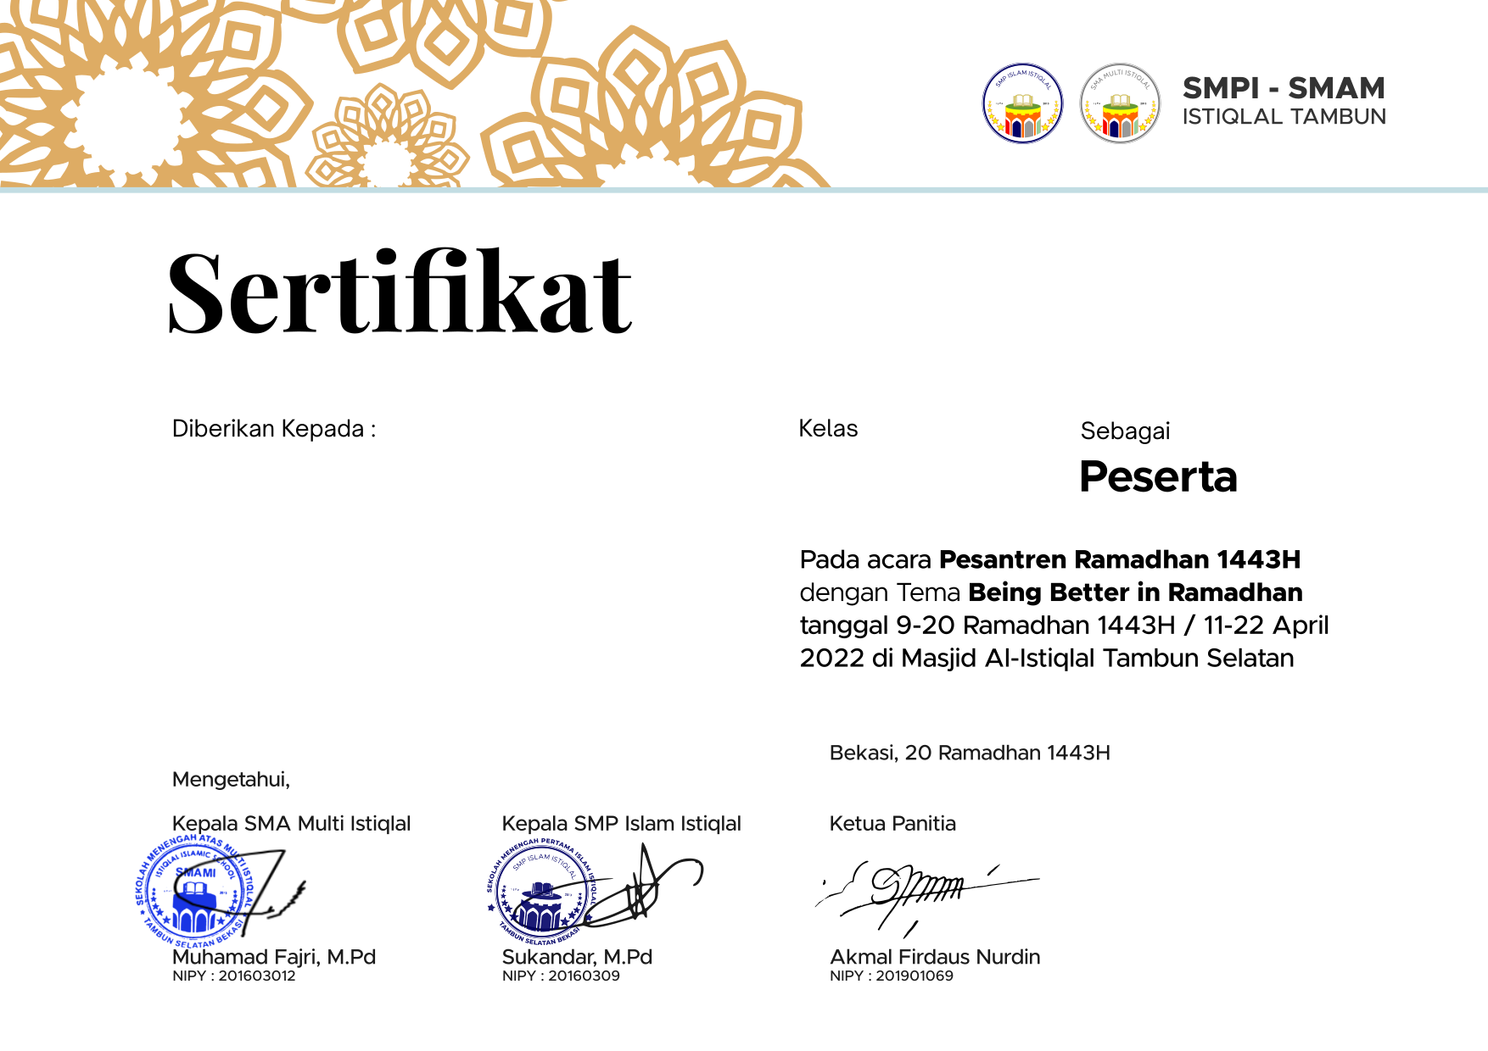

**XII**

**NOVIANTORO RAMADHANI**