Document Management System (DMS)
Backend — Technical Test Evidence

Mandatory Test Scenarios Evidence (REPLACE • Notifications • DELETE)

Author: Ichsan Saputra
Date: 17 Feb 2026 (UTC)

Repository: dms-backend-cybermax-v6

Contents
- 1. REPLACE workflow (USER request → ADMIN approve → verification)
- 2. Notification verification (USER)
- 3. DELETE workflow (ADMIN approve → verification)
- Appendix: RBAC / Security checks (Forbidden for USER)

1. REPLACE Workflow Evidence
Scenario: a USER requests a document replacement. The system creates a permission request, locks the document (PENDING_REPLACE), and waits for an ADMIN to approve. After approval, the document is updated transactionally (fileUrl + version increment) and the user receives a notification.

1.1 Initial Upload (baseline document state)

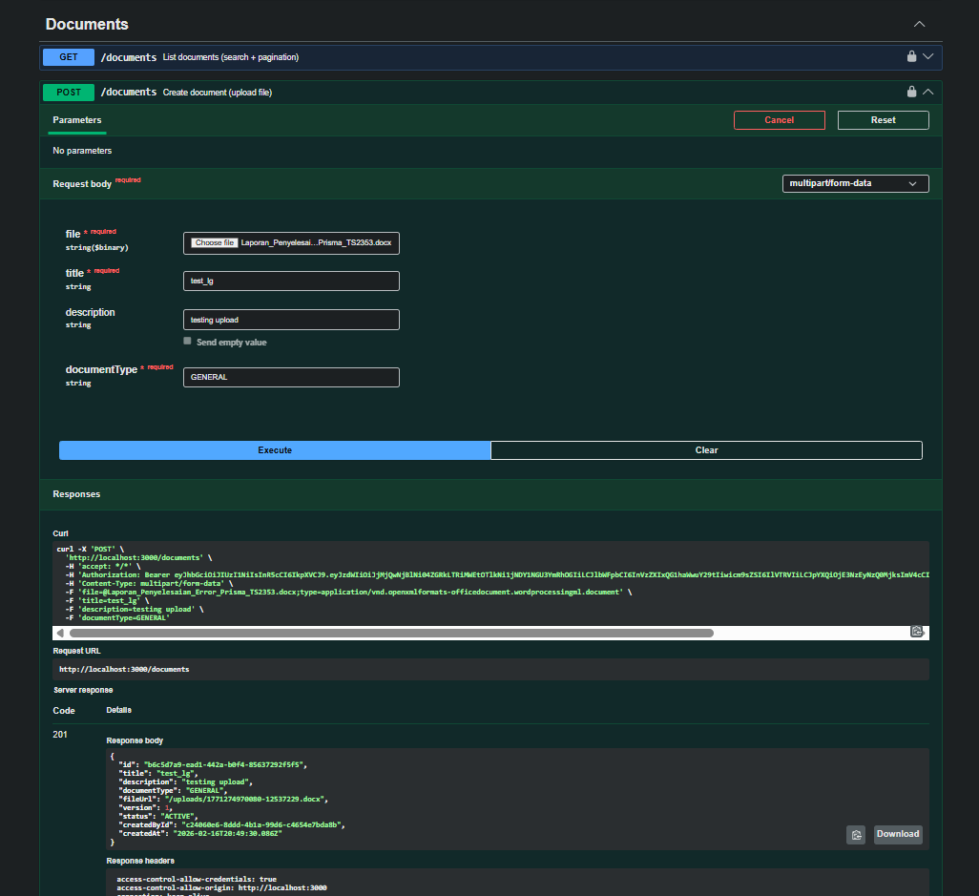
Figure 1 — Create document (upload) succeeded (HTTP 201).

1.2 USER creates REPLACE request

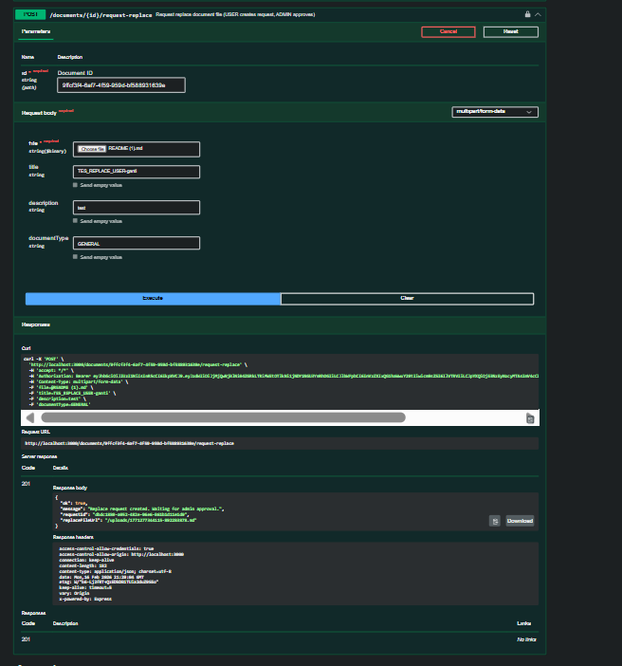
Figure 2 — USER calls /documents/{id}/request-replace (HTTP 201), request created and waiting for admin approval.

1.3 ADMIN sees pending request

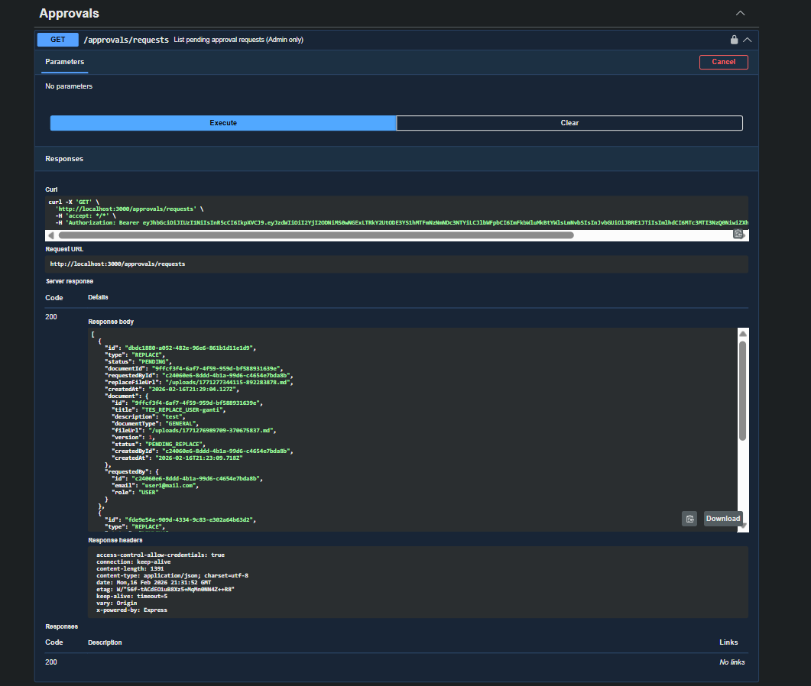
Figure 3 — ADMIN calls /approvals/requests and sees the REPLACE request with status PENDING.

1.4 ADMIN approves REPLACE request

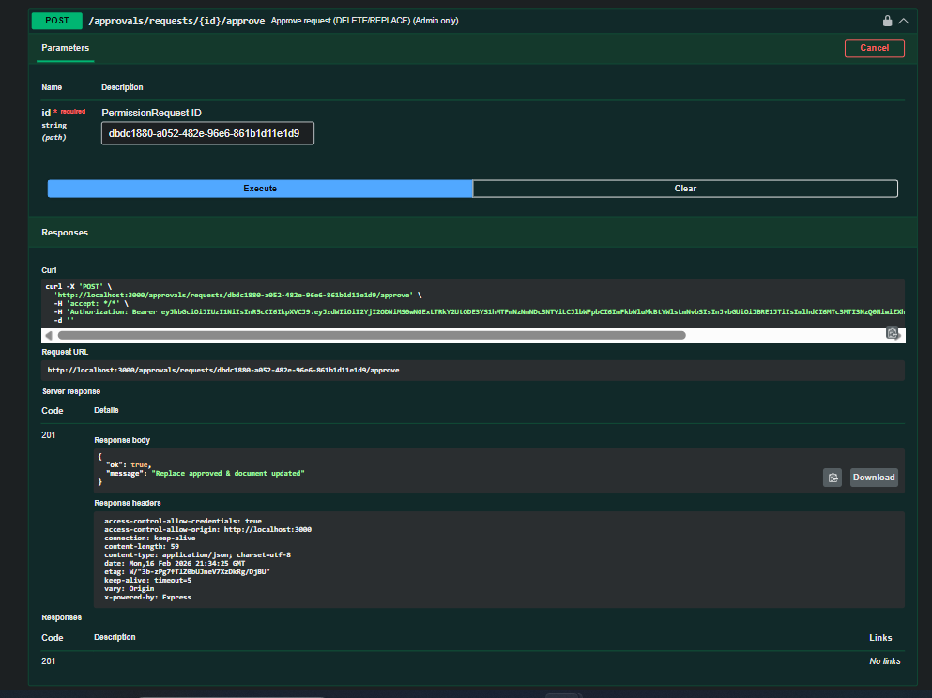
Figure 4 — ADMIN approves the request via /approvals/requests/{id}/approve (HTTP 201).

1.5 Verification after approval (document updated)
Verification points:
• Document status returns to ACTIVE
• Document version increments
• fileUrl changes to the newly uploaded replacement file

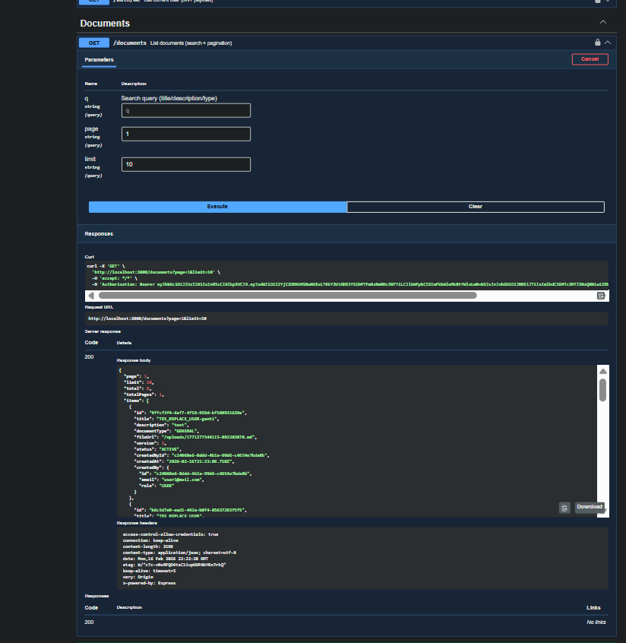
Figure 5 — /documents list shows updated document (ACTIVE) with version increment and updated fileUrl.

2. Notification Verification (USER)
Scenario: after an ADMIN approves/rejects a permission request, a notification is created and can be retrieved by the corresponding USER.

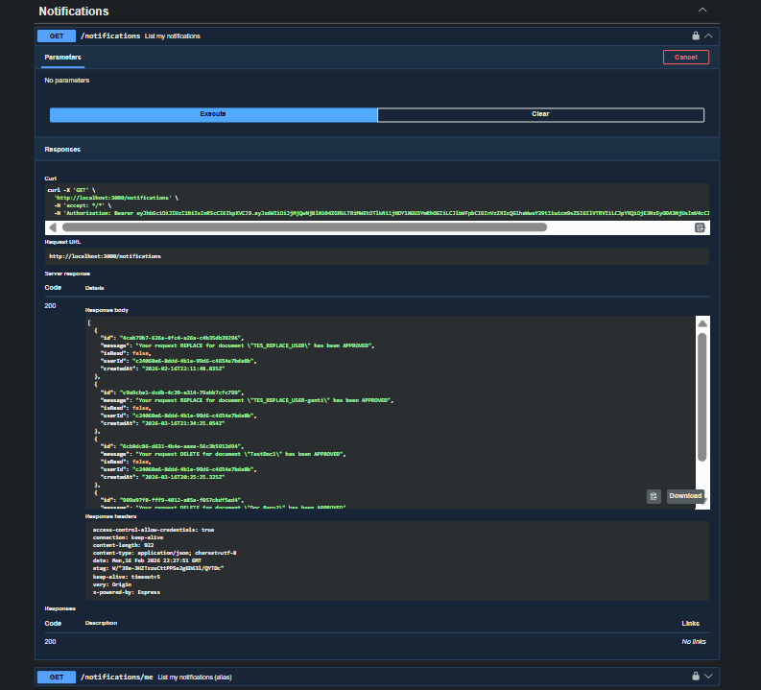
Figure 6 — USER calls /notifications and receives approval notifications (REPLACE and DELETE).

3. DELETE Workflow Evidence
Scenario: an ADMIN approves a DELETE permission request. The system deletes the document safely and notifies the user. The document should no longer be retrievable after deletion.

3.1 ADMIN approves DELETE request

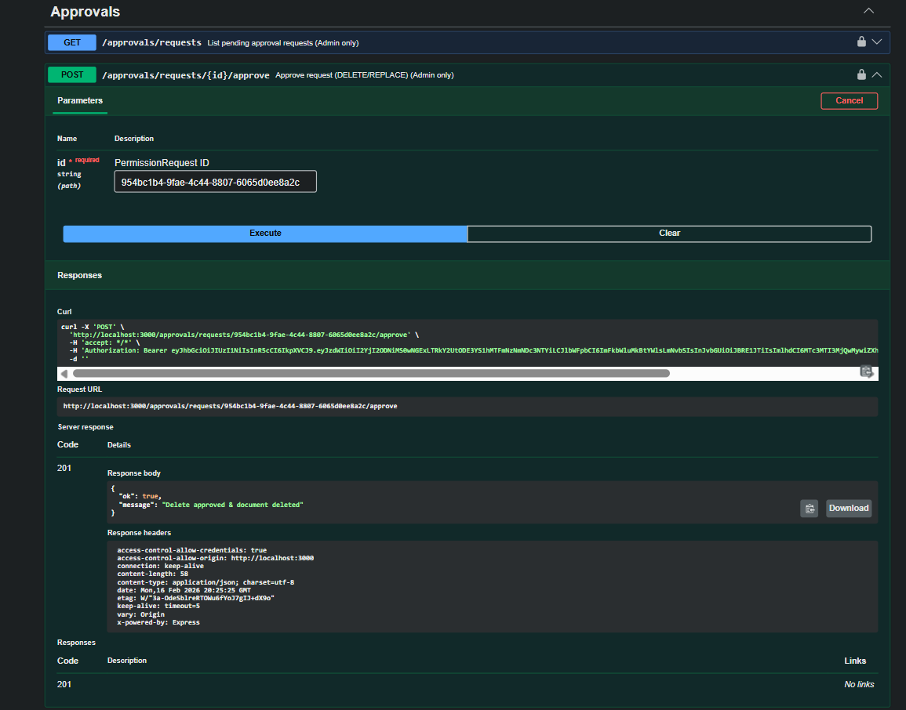
Figure 7 — ADMIN approves DELETE via /approvals/requests/{id}/approve (HTTP 201), document deleted.

3.2 Verification after deletion (document not found)

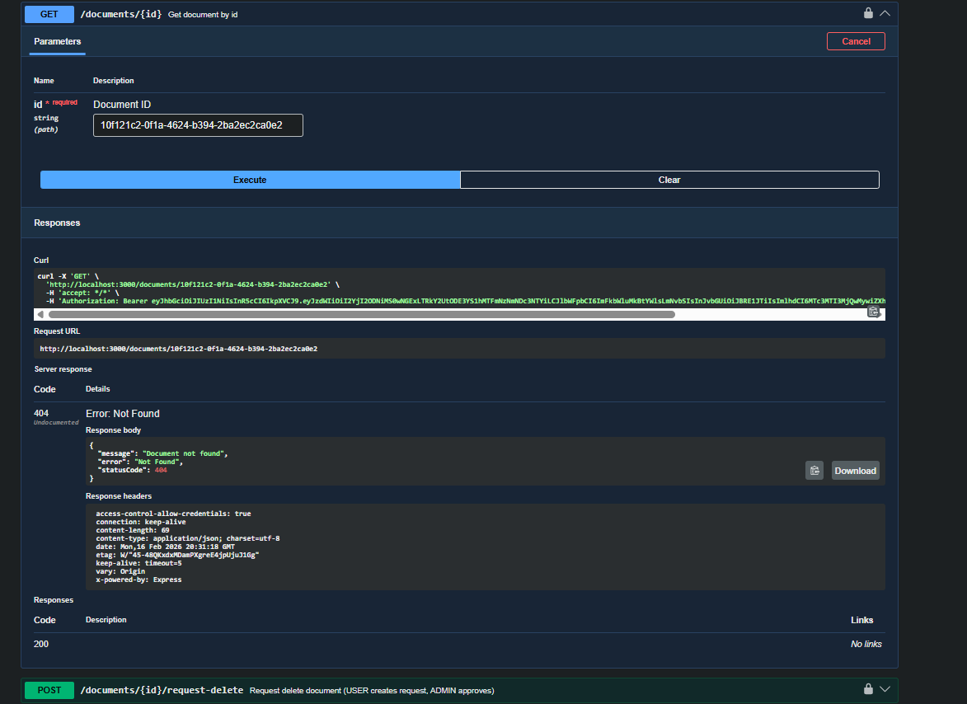
Figure 8 — Subsequent GET document by id returns 404 (Document not found), confirming deletion.

Appendix — RBAC / Security Checks (USER blocked)
To validate role-based access control, USER accounts must not be able to access ADMIN-only endpoints.

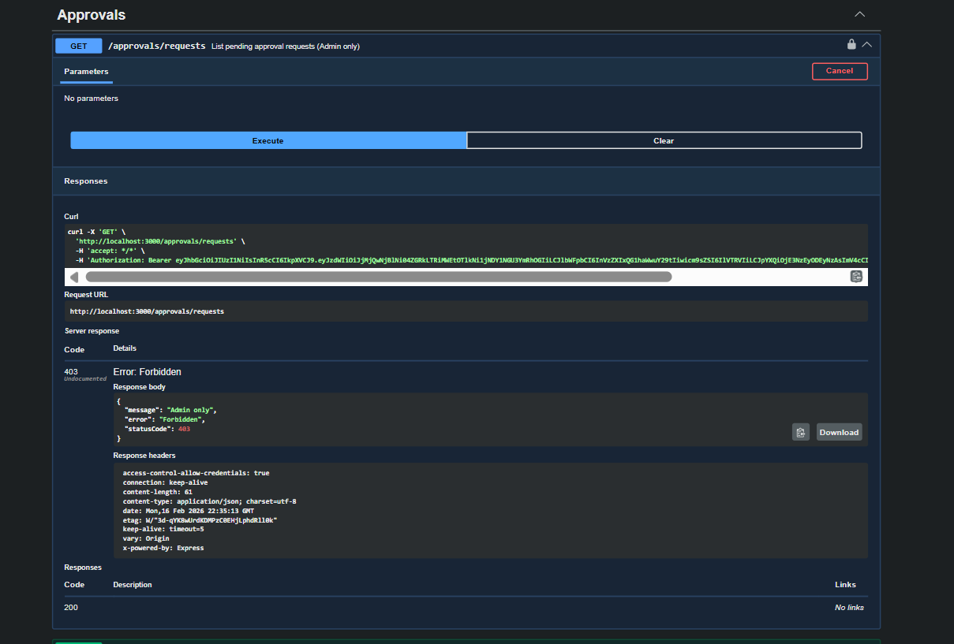
Figure A1 — USER calls /approvals/requests and gets 403 Forbidden (Admin only).

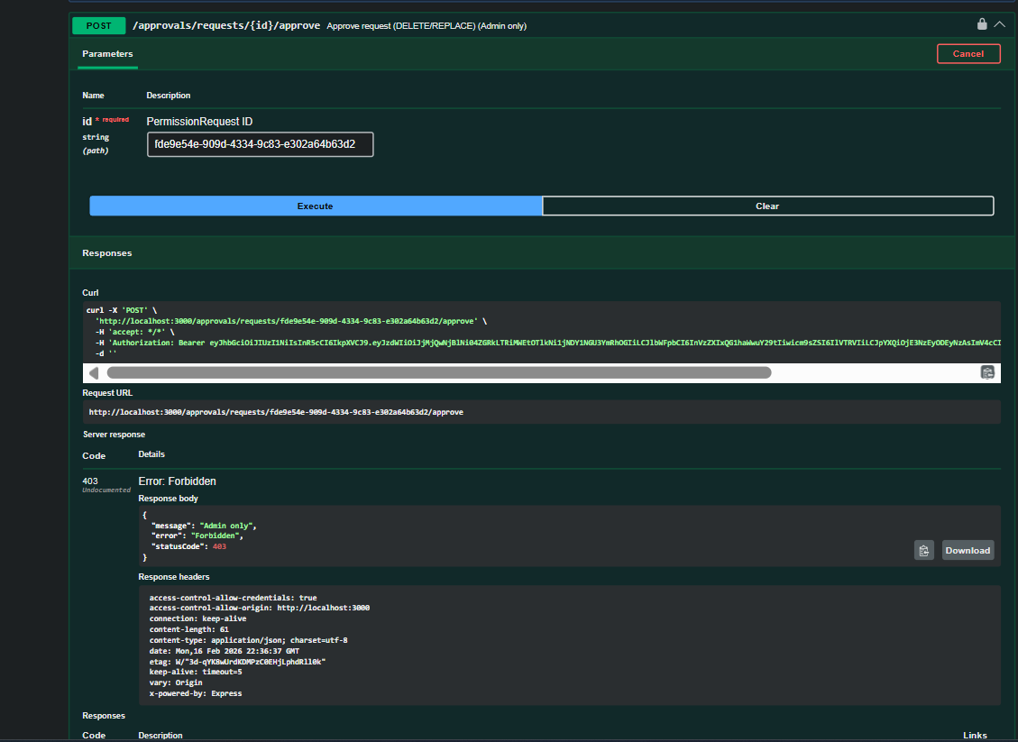
Figure A2 — USER calls /approvals/requests/{id}/approve and gets 403 Forbidden (Admin only).

