Stambuk : 13020230049
Nama : Ichwal
Kelas : A2
Asisten 1 : Adam Adnan

Judul Project : Personal Finance Tracker
Activity Diagram
- Login
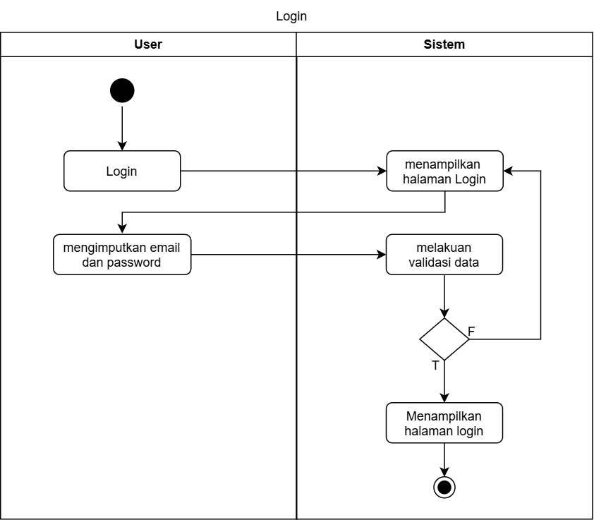
- Registrasi
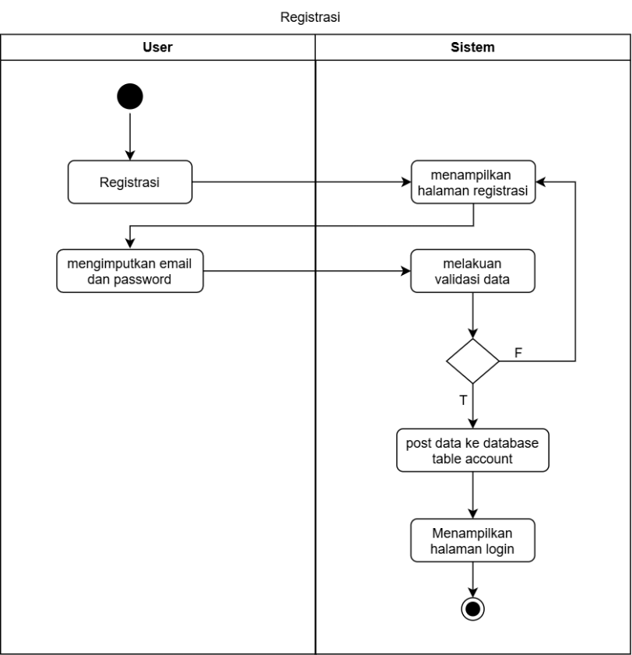
- Dashboard
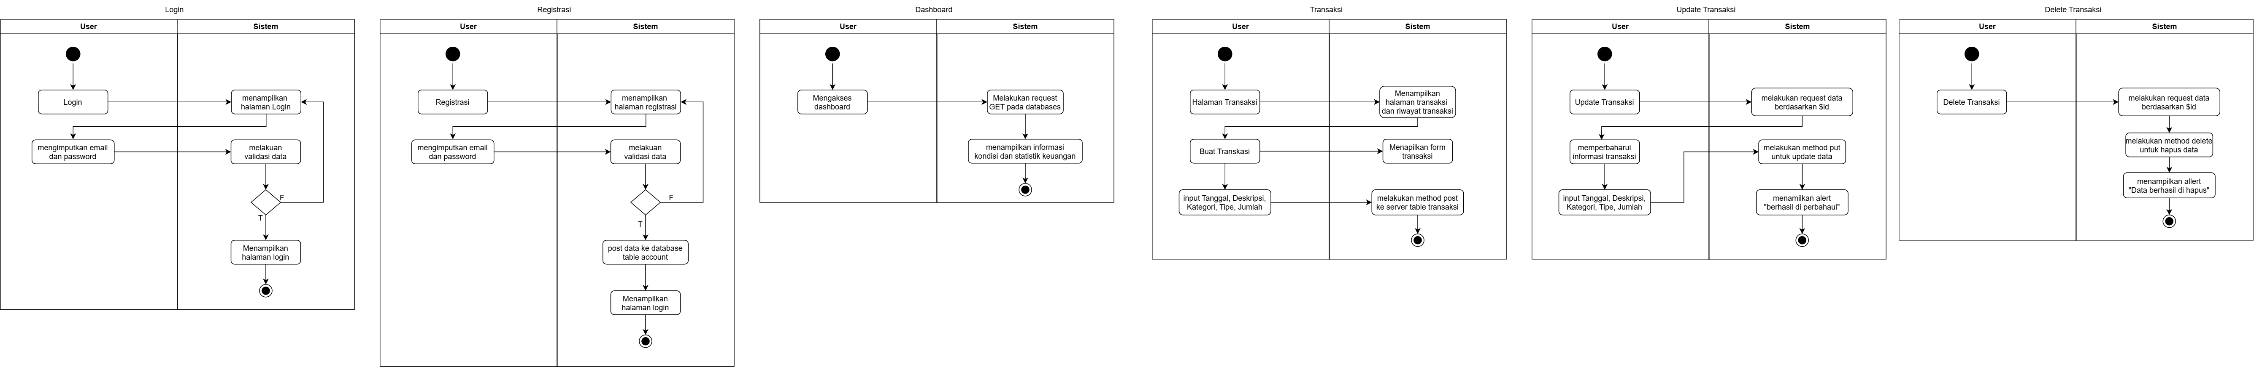
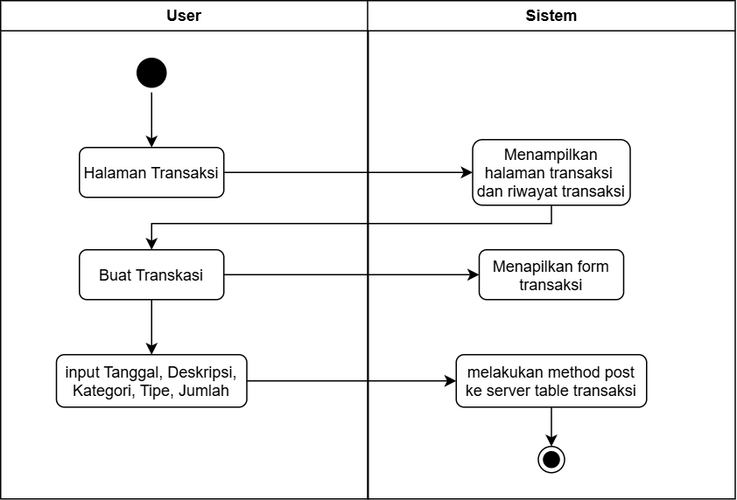
- Create Transaksi

- Update Transaksi
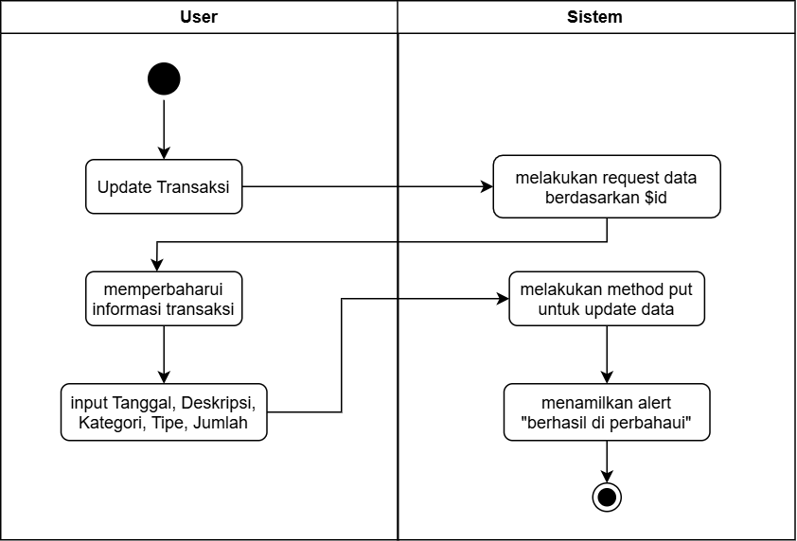
- Delete Transaksi
