  - Jelaskan table apa yang terdistribusi dari Routing OSPF ke RIP dan sebaliknya?
Jawaban :
Tabel yang terdistribusi dari OSPF ke RIP adalah rute-rute yang berasal dari tabel routing OSPF (Routing Information Base OSPF) yang dimasukkan ke dalam domain RIP melalui proses redistribusi, sehingga router-router yang menggunakan RIP dapat mengetahui rute dari OSPF. Sebaliknya, saat redistribusi dilakukan dari RIP ke OSPF, rute-rute dari tabel routing RIP (berbasis jarak-hop) dimasukkan ke dalam domain OSPF sebagai rute eksternal (biasanya bertipe E1 atau E2), sehingga router OSPF dapat mengenali dan memproses rute-rute yang awalnya berasal dari protokol RIP.

  - Lakukan subnetting dari IP 172.20.0.1/16 dan implementasikan hasil subnetting ke rancangan topologi jaringan mengunakan 8 router dan gunakan Routing Protocol OSPF, RIP serta Static untuk menghubungkan semua network!
Jawaban:
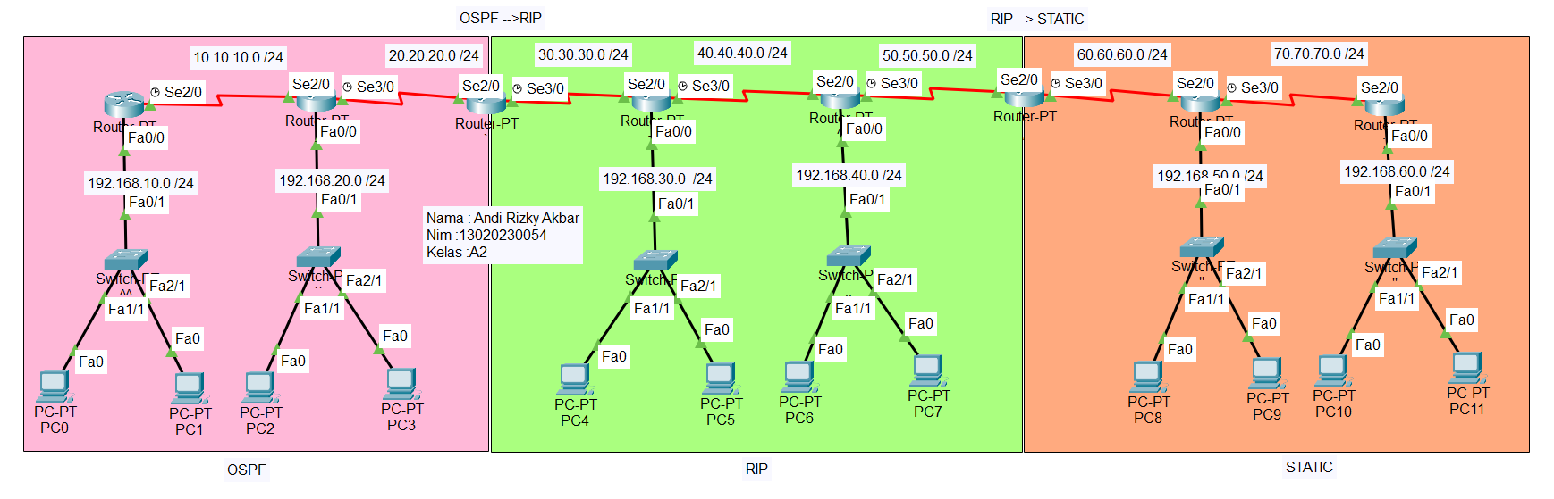
- Ganti Hostname setiap router dan switch
Perintah :
Router>enable
Router#configure terminal
Router(config)#hostname No va-1
Ichwal -1(config)#
Router>enable
Router#configure terminal
Router(config)#hostname Ichwal-2
Ichwal-2(config)#
Router>enable
Router#configure terminal
Router(config)#hostname Ichwal-3
Ichwal-3(config)#
Router>enable
Router#configure terminal
Router(config)#hostname Ichwal-4
Ichwal-4(config)#
Router>enable
Router#configure terminal
Router(config)#hostname Ichwal-5
Ichwal-5(config)#
Router>enable
Router#configure terminal
Router(config)#hostname Ichwal-6
Ichwal-6(config)#
Router>enable
Router#configure terminal
Router(config)#hostname Ichwal-7
Ichwal-7(config)#
Router>enable
Router#configure terminal
Router(config)#hostname Ichwal-8
Ichwal-8(config)#
Switch>
Switch>enable
Switch#configure terminal
Switch(config)#hostname nv1
nv1(config)#
Switch>enable
Switch#configure terminal
Switch(config)#hostname nv2
nv2(config)#
Switch>enable
Switch#configure terminal
Switch(config)#hostname nv3
nv3(config)#
Switch>enable
Switch#conf t
Switch(config)#hostname nv4
nv4(config)#
Switch>enable
Switch#configure terminal
Switch(config)#hostname nv5
nv5(config)#
Switch>enable
Switch#configure terminal
Switch(config)#hostname nv6
nv6(config)#

- Ip Address dan aktifkan Interface
Perintah:
Ichwal-1(config)#interface serial2/0
Ichwal-1 (config-if)#ip address 10.10.10.1 255.255.255.0
Ichwal-1 (config-if)#no shutdown
Ichwal-1 (config-if)#interface fa0/0
Ichwal-1 (config-if)#ip address 192.168.10.1 255.255.255.0
Ichwal-1 (config-if)#no shutdown
Ichwal-1 (config-if)#

Ichwal-2(config)#interface se2/0
Ichwal-2(config-if)#ip address 10.10.10.2 255.255.255.0
Ichwal-2(config-if)#no shutdown
nisa2(config-if)#
Ichwal-2(config-if)#interface se3/0
Ichwal-2(config-if)#ip address 20.20.20.1 255.255.255.0
Ichwal-a2(config-if)#no shutdown
Ichwal-2(config-if)#interface fa0/0
Ichwal-2(config-if)#ip address 192.168.20.1 255.255.255.0
Ichwal-2(config-if)#no shutdown
Ichwal-2(config-if)#
Ichwal-3(config)#interface se2/0
Ichwal-3(config-if)#ip address 20.20.20.2 255.255.255.0
Ichwal-3(config-if)#no shutdown
Ichwal-3(config-if)#
Ichwal-3(config-if)#interface se3/0
Ichwal-3(config-if)#ip address 30.30.30.1 255.255.255.0
Ichwal-3(config-if)#no shutdown

Ichwal-4(config)#interface se2/0
Ichwal-4(config-if)#ip address 30.30.30.2 255.255.255.0
Ichwal-4(config-if)#no shutdown
Ichwal-4(config-if)#
Ichwal-4(config-if)#interface se3/0
Ichwal-4(config-if)#ip address 40.40.40.1 255.255.255.0
Ichwal-4(config-if)#no shutdown
Ichwal-4(config-if)#interface fa0/0
Ichwal-4(config-if)#ip address 192.168.30.1 255.255.255.0
Ichwal-4(config-if)#no shutdown
Ichwal-5(config)#interface se2/0
Ichwal-5(config-if)#ip address 40.40.40.2 255.255.255.0
Ichwal-5(config-if)#no shutdown
Ichwal-5(config-if)#
Ichwal-5(config-if)#interface se3/0
Ichwal-5(config-if)#ip address 50.50.50.1 255.255.255.0
Ichwal-5(config-if)#no shutdown
Ichwal-5(config-if)#interface fa0/0
Ichwal-5(config-if)#ip address 192.168.40.1 255.255.255.0
Ichwal-5(config-if)#no shutdown
Ichwal-5(config-if)#

Ichwal-6(config)#interface se2/0
Ichwal-6(config-if)#ip address 50.50.50.2 255.255.255.0
Ichwal-6(config-if)#no shutdown
Ichwal-6(config-if)#
Ichwal-6(config-if)#interface se3/0
Ichwal-6(config-if)#ip address 60.60.60.1 255.255.255.0
Ichwal-6(config-if)#no shutdown

Ichwal-7(config)#interface se2/0
Ichwal-7(config-if)#ip address 60.60.60.2 255.255.255.0
Ichwal-7(config-if)#no shutdown
Ichwal-7(config-if)#
Ichwal-7(config-if)#interface se3/0
Ichwal-7(config-if)#ip address 70.70.70.1 255.255.255.0
Ichwal-7(config-if)#no shutdown
Ichwal-7(config-if)#interface fa0/0
Ichwal-nisa7(config-if)#no shutdown
Ichwal-7(config-if)#

Ichwal-8(config)#interface se2/0
Ichwal-8(config-if)#ip address 70.70.70.2 255.255.255.0
Ichwal-8(config-if)#no shutdown

Ichwal-8(config-if)#
Ichwal-8(config-if)#interface fa0/0
Ichwal-8(config-if)#ip address 192.168.60.1 255.255.255.0
Ichwal-8(config-if)#no shutdown
Ichwal-8(config-if)#
- Routing OSPF
Perintah:
Ichwal-1(config)#router ospf 1
Ichwal-1(config-router)#network 192.158.10.0 0.0.0.255 area 0
Ichwal-1(config-router)#network 10.10.10.0 0.0.0.255 area 0

Ichwal-2(config)#router ospf 1
Ichwal-2(config-router)#network 192.168.20.0 0.0.0.255 area 0
Ichwal-2(config-router)#network 20.20.20.0 0.0.0.255 area 0
Ichwal-2(config-router)#network 10.10.10.0 0.0.0.255 area 0
Ichwal-2(config-router)#

Ichwal-3(config)#router ospf 1
Ichwal-3(config-router)#network 30.30.30.0 0.0.0.255 area 0
Ichwal-3(config-router)#network 20.20.20.0 0.0.0.255 area 0
Ichwal-3(config-router)#

Output (DO Show Ip Route) :
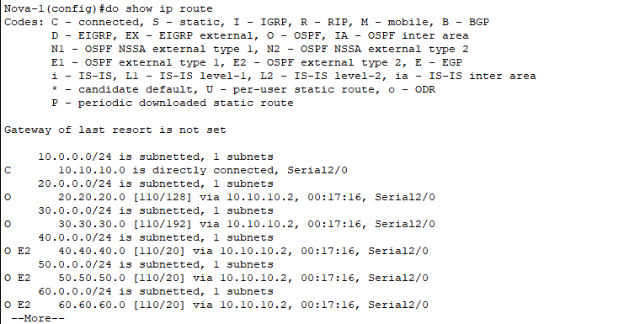
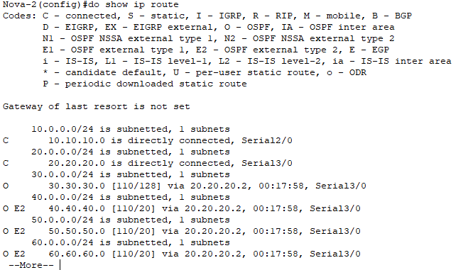
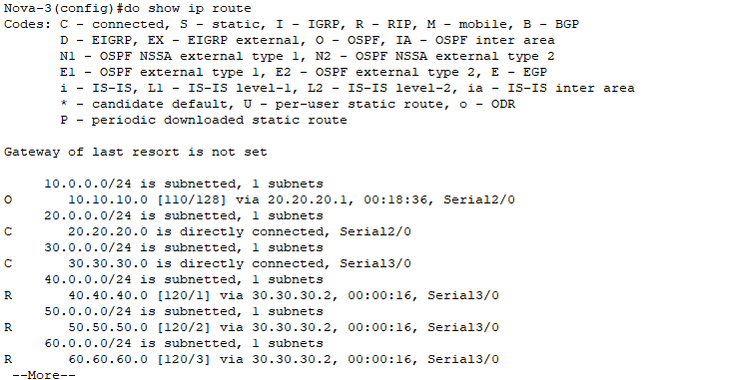
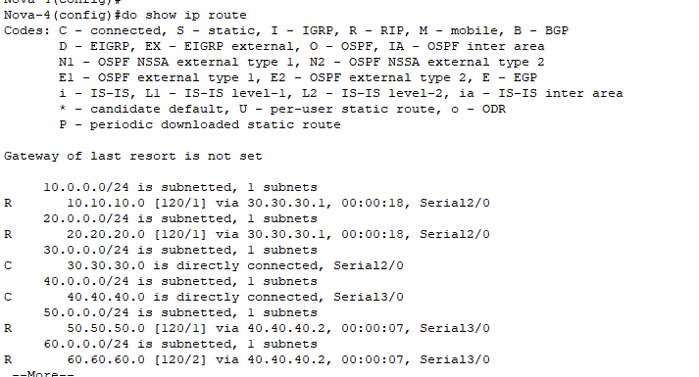
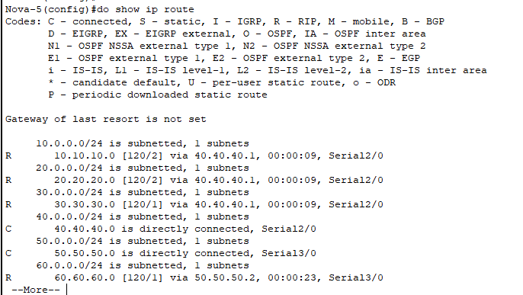
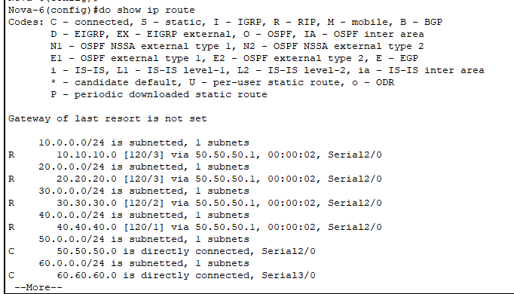
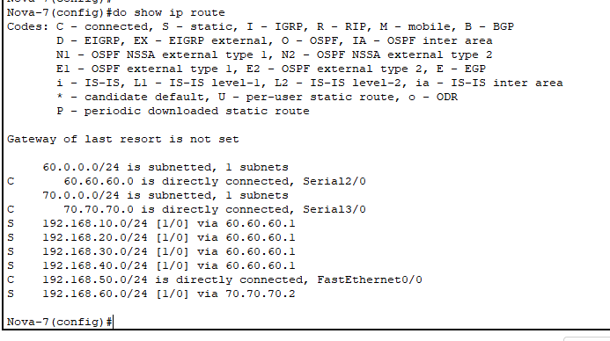
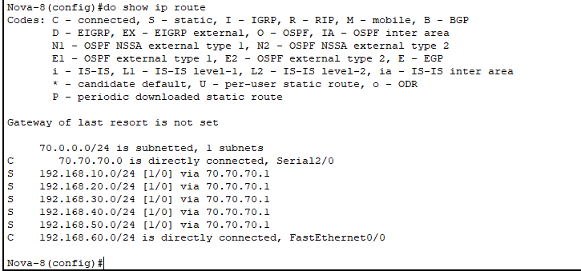

- Routing RIP
Perintah :
Ichwal-3(config)#router rip
Ichwal-3(config-router)#version 2
Ichwal-3(config-router)#no auto-summary
Ichwal-3(config-router)#network 30.30.30.0
Ichwal-3(config-router)#network 20.20.20.0
Ichwal-3(config-router)#
Ichwal-4(config)#router rip
Ichwal-4(config-router)#version 2
Ichwal-4(config-router)#no auto-summary
Ichwal-4(config-router)#network 192.168.30.0
Ichwal-4(config-router)#network 40.40.40.0
Ichwal-4(config-router)#network 30.30.30.0
Ichwal-4(config-router)#
Ichwal-5(config)#router rip
Ichwal-5(config-router)#version 2
Ichwal-5(config-router)#no auto-summary
Ichwal-5(config-router)#network 192.168.40.0
Ichwal-5(config-router)#network 50.50.50.0
Ichwal-5(config-router)#network 40.40.40.0
Ichwal-5(config-router)#
Ichwal-6(config)#router rip
Ichwal-6(config-router)#version 2
Ichwal-6(config-router)#no auto-summary
Ichwal-6(config-router)#network 60.60.60.0
Ichwal-6(config-router)#network 50.50.50.0
Ichwal-6(config-router)#

- Routing Static
Perintah:
Ichwal-7(config)#ip route 192.168.60.0 255.255.255.0 70.70.70.2
Ichwal-7(config)#ip route 192.168.40.0 255.255.255.0 60.60.60.1
Ichwal-7(config)#ip route 192.168.30.0 255.255.255.0 60.60.60.1
Ichwal-7(config)#ip route 192.168.20.0 255.255.255.0 60.60.60.1
Ichwal-7(config)#ip route 192.168.10.0 255.255.255.0 60.60.60.1
Ichwal-8(config)#ip route 192.168.50.0 255.255.255.0 70.70.70.1
Ichwal-8(config)#ip route 192.168.40.0 255.255.255.0 70.70.70.1
Ichwal-8(config)#ip route 192.168.30.0 255.255.255.0 70.70.70.1
Ichwal-8(config)#ip route 192.168.20.0 255.255.255.0 70.70.70.1
Ichwal-8(config)#ip route 192.168.10.0 255.255.255.0 70.70.70.1

- Redistribute Routing
Perintah:
Ichwal-3(config)#router rip
Ichwal-3(config-router)#redistribute ospf 1 metric 1
Ichwal-3(config-router)#ex
Ichwal-3(config)#router ospf 1
Ichwal-3(config-router)#redistribute rip subnets

Ichwal-6(config)#router rip
Ichwal-6(config-router)#redistribute static

- Tes kirim Messege
OSPF ke RIP :
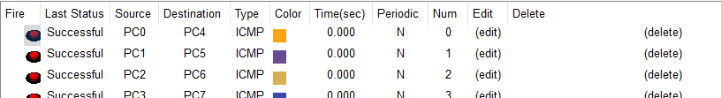
OSPF ke Static
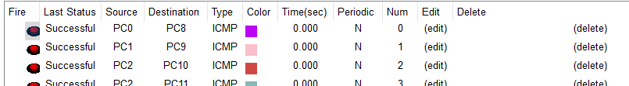
RIP ke OSPF
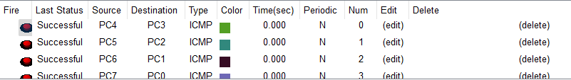
RIP ke Static
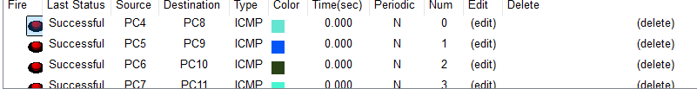
Static ke OSPF
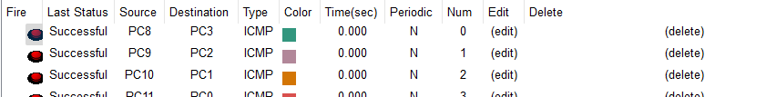
Static ke RIP
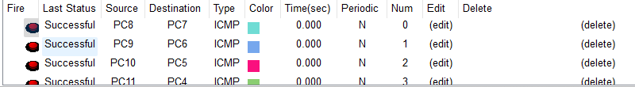

- Tes ping IP
