Iteration 1 Deliverable 5

Domain Model
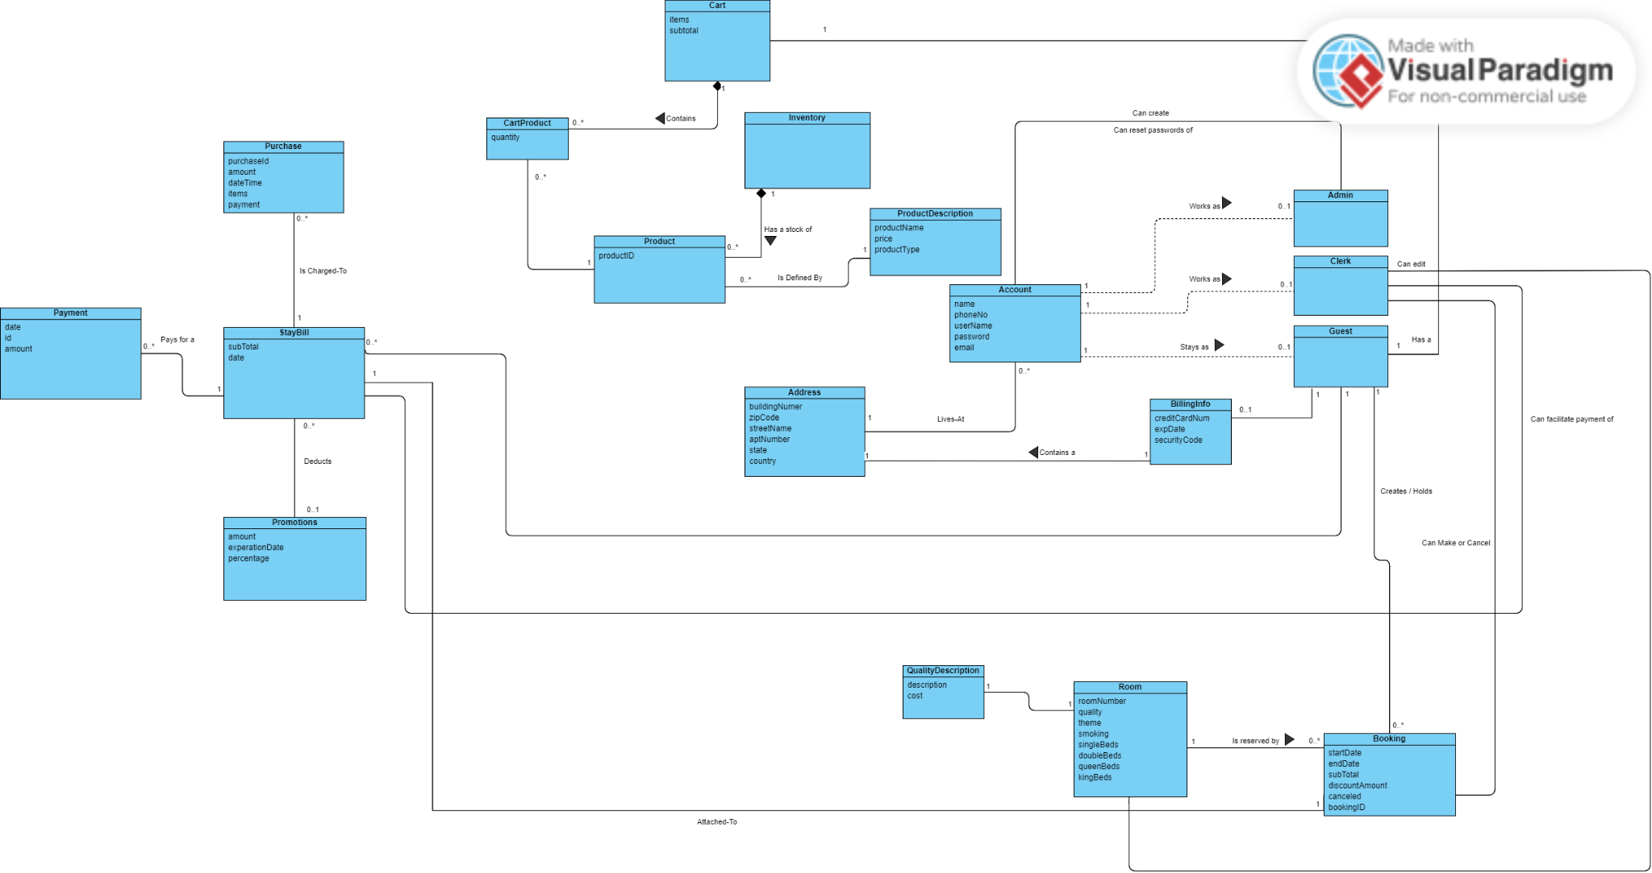

Use Case Diagram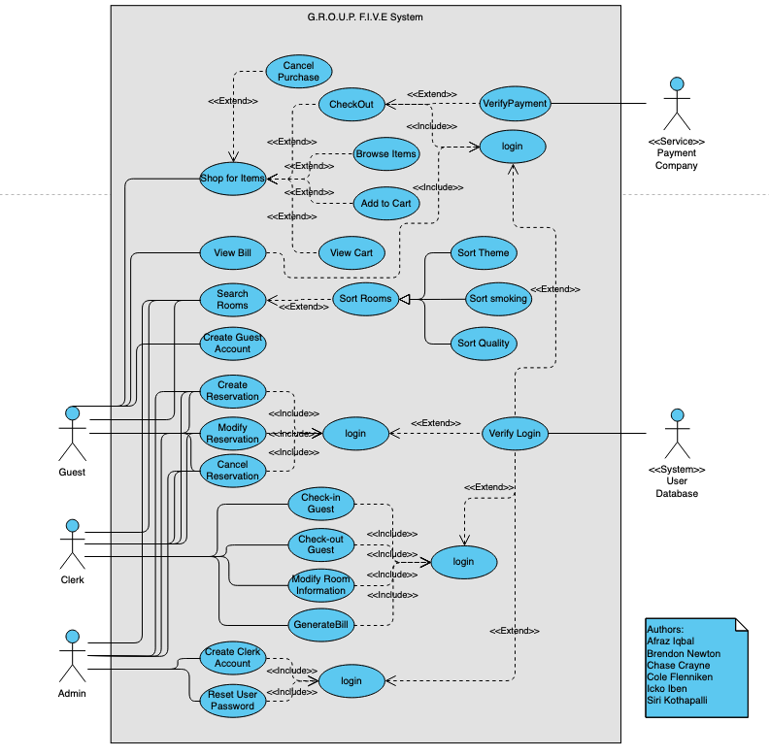

Fully Dressed Use Cases:
Author: Cole

Id: UC-View-Bill
Scope: Hotel Reservation System
Level: User Goal
Stakeholders:
- Customer: Wants to know how much they owe
- Clerk: Wants to be able to present a bill on request
- *Admin: Person responsible for resetting user password
Precondition:
- Guest has valid login credentials
Postcondition:
- Guest can see their bill
Main Success Scenario:
- Customer wants to view the bill for their stay
- Customer logs into their account
- Customer clicks the “view bill” button
- The bill will be displayed to the customer
Alternate Paths:
- Anytime the system does not respond
  - Guest contacts admin
- (login)
  - User is unable to login
    - Guest contacts an admin
    - Admin resets user’s password
- (view bill)
  - View Bill button is unresponsive
    - Guest contacts a clerk
    - Clerk will manually generate the bill & send to guest
    - Clerk will report the bug to an admin
- (display bill)
  - Bill has not been generated
    - Guest will contact a clerk
    - Clerk will manually generate bill & send to guest
  - Stay is being billed to a corporate account
    - No bill will be generated
    - A message will state that the bill is being covered by the user’s company

Author: Cole

Id: UC Cancel Reservation (Guest)
Scope: Hotel Reservation System
Level: User Goal
Stakeholders:
- Customer: Person interested in hotel rooms and services
- Clerk: Person responsible for executing hotel operations
Precondition:
- Guest has a booked room
Postcondition:
- Guest is released from their booking
- Room is freed for new reservations
Main Success Scenario:
- Guest logs in to their account
- Guest navigates to the booking they want to cancel
- Guest clicks cancel
- Guest clicks confirm on the pop-up message confirming their cancelation
- If the cancelation is made over 2 days after the booking, a late fee is charged to the card on their account
- The guests is released from their booking
- A confirmation of cancelation is sent to the guest
Alternate Paths:
- Any time system is down
If the guest is unable to access the system to cancel, they can contact a clerk who can cancel the reservation on their behalf
- (login)
  - If a guest cannot log in, they can contact an admin who can reset their password
- (find booking)
  - If a guest can not find their booking, they can contact a clerk to cancel the booking for them
- (confirmation)
  - If the guest does not confirm the cancelation then, the booking is not canceled
  - If the guest will incur a late fee, a different message will pop up notifying the guest of the charge
Customer (Changed these above to line up with examples from slides. Opinions?
- Person that is canceling their reservation

Author: Cole

Id: UC Admin Reset Guest Password
Scope: Hotel Reservation System
Level: User Goal
Stakeholders:
- Customer: Person interested in hotel rooms and services
- Admin: Person responsible for managing account issues (eg password resets)
Precondition:
- Guest has a valid account created and has notified an admin to change their password
- Admin is logged into their account
Postcondition:
- Guest password is changed
Main Success Scenario:
- The admin navigates to the reset account page
- The admin validates that the person asking for a password reset is the guest who owns the account with the security questions assigned to the account
- The admin asks the user what they want their new password to be
- The admin changes the account password
- The admin Emails the accounts specified email the new password information
Alternate Paths:
- Any time system is down
The admin must wait to help the guest until the system is back to being operational
2.a If the username the guest provided does not exist, the admin must ask the guest again
3.a If the admin cannot validate the person asking for a reset is the guest then, they will instead send an email to the accounts email instead to determine legitimacy
4.a If the admin is no longer on the phone with the guest, they will use an auto-generated password
4.b If the guests new password does not comply with password rules, the admin will ask the guest for a different new password
5.a If the admin is unable to change the password, they will alert the guest
6.a If the email cannot be received, the guest is alerted over the phone if not at the resort or is alerted in person if at the resort

Author: Afraz

Id: UC Shop For Item and Merge Bill
Scope: Hotel Shop and Payment
Level: User Goal
Stakeholders:
- Customer: Person interested in store services / purchasing items
- Admin: Person responsible for managing account issues (eg password resets)
- Clerk: Person responsible for purchase if system is not operating
Precondition:
- Customer must have an active stay (open bill) at the hotel
Postcondition:
- Customer’s transaction is added to their bill
Main Success Scenario:
- Customer wants to purchase any amount of items from the shop.
- Customer logs into their account.
- Customer enter the shop.
- Customer chooses items they wish to purchase within the shop.
- Items are placed into cart.
- Customer clicks their cart.
- The system shows the customer’s carted items and a combined item cost.
- Customer enters the payment page.
- The system shows the customer’s total payments.
- Item(s) are purchased with the option to merge their shop bill with their stay bill.
- System merges the two bills and returns a confirmation with the total current bill.
Alternate Paths:
a Any time system is down
  - If the guest is unable to access the system, they will contact the admin.
  - The guest will communicate what items they wish to purchase and that they wish to merge their shop bill with their stay bill.
  - The admin will communicate this information to the clerk.
  - The clerk will make the purchase on their behalf and merge the bills.
2.a. Anytime the system does not respond
1.Guest will contact an admin
2.Admin will help the guest restart their application
3.a If the user is unable to log into their account
1.Guest will contact an admin
2.Admin will reset the users password
4.a If the shop is not responsive.
1.Guest will contact a clerk.
2.Guest will explain the items they are purchasing and that they choose to merge bills.
3.The clerk will read, review and purchase items for the Guest and merge their bills manually.
5.a If the merge bill option is not responsive.
1.Guest will contact a clerk.
2.Guest will explain the items they are purchasing and that they choose to merge bills.
3.The clerk will read, review and purchase items for the Guest and merge their bills manually.
6.a If the cart is empty and the user tries to click the payment screen
1. System will display an error message indicating that the cart is empty.
7.a If the user tries to merge bill when they do not have an existing hotel bill
1. System will display an error message indicating they do not have an existing bill.

Author: Afraz

Id: UC Guest Creates Account
Scope: Hotel Accounts
Level: User Goal
Stakeholders:
- Customer: Person interested in hotel rooms and services
Precondition:
- An account does not exist under the same username
Postcondition:
- Customer's account is created.
Main Success Scenario:
- Customer wants to create an account.
- Customer enters website.
- Customer selects option to create an account.
- Customer chooses a unique username.
- Customer creates a strong password(Variety of uppercase and lowercase letters, as well)
- Customer’s account is created.
- System returns a confirmation message.

Alternate Paths:
a.* Anytime the website does not respond
1.Customer will contact an admin
2.Admin will help the guest restart their application
2.a If the user cannot create an account due to technical issues.
1.Customer will contact an admin.
2.Admin will attempt to restart the application.
3.If successful, Customer will attempt to create the account again.
2.b If the user cannot create an account due to technical issue.
1.If Admin cannot restart the Customer's application, they will take the Customer's desired username and password under the given constraints.
2.Admin will create the account for the Customer.
3.a If the user does not understand the password requirements.
1.Customer will contact an admin.
2.Admin will explain the password requirements and give additional information on what is a strong password.
4.a If the inputted username exists.
1. Prompt the user that this username exists and they must enter a new one.

Author: Afraz

Id: UC Guest Cancels Purchase and Clears Cart
Scope: Hotel Shop and Payment
Level: User Goal
Stakeholders:
- Customer: Person interested in store services / purchasing items
- Admin: Person responsible for managing account issues (eg password resets)
Precondition:
- Customer must have items in their cart,
Postcondition:
- Transaction is canceled and the Customer’s cart is cleared.
Main Success Scenario:
- Customer clicks their cart after placing the items they wish to purchase.
- The system shows the customer’s carted items and a combined item cost.
- Customer enters the payment page.
- The system presents the payment options.
- The customer decides they do not want to make the purchase.
- The customer returns to the cart.
- The system shows the customer’s carted items.
- The customer goes through each of their items and removes the items.
- The customer’s cart is cleared.
Alternate Paths:
a. Any time system is down
- If the guest is unable to access the system, the guest will contact an admin.
- The admin will explain that since their purchase had not been completed there is no worry about canceling the purchase, and that their cart can be cleared once the system has returned.
- The admin will give the guest an estimate of when the system will become functional again.
2.a.* Anytime the system does not respond
1.Guest will contact an admin
2.Admin will help the guest restart their application
3.a If the user is unable to log into their account
1.Guest will contact an admin
2.Admin will reset the users password
4.a If the shop is not responsive.
1.Guest will contact an admin.
2. Admin will help the guest restart their application

5.a If the remove item button is not responsive.
1.Guest will contact an admin.
2.Admin will help the guest restart their application

Author: Brendon

Id: UC Admin Create Clerk Account
Scope: Hotel Accounts
Level: User Goal
Stakeholders:
- Customer: Person interested in hotel rooms and services
- Admin: Person responsible for managing accounts
Precondition:
- Clerk does not have an account
Postcondition:
- Clerk account is created
Main Success Scenario:
An admin needs to create a clerk account
Admin logs in to their account
Admin accesses clerk page
Admin selects add new clerk account
Admin provides email to be associated with account
System creates account
System confirms account was created
Alternate Paths:
a.* anytime the system does not respond
Admin will contact technical support
Admin will resume manual operation until system is back online
2.a If the Admin is unable to log into their account
Admin will contact technical support and reset username/password
3.a Clerk page is unresponsive
Restart application
If still unresponsive, see a*
4.a New account cannot be created
Restart application
If still unable, see a*
5.a Email is not valid
Admin will enter a valid email
6.a System cannot create account
Restart application
If still unable, see a*

Author: Brendon

Id: UC Clerk Sets Up Account
Scope: Hotel Account System
Level: User Goal
Stakeholders:
- Clerk: Person responsible for executing hotel/shop operations.
- Admin: Person responsible for managing account issues (eg password resets)
Precondition:
- Clerk has received a link to setup their account
- Clerk needs to set up account
Postcondition:
- Clerk’s account is created
Main Success Scenario:
- Clerk needs to set up their account
- Clerk clicks account activation link
- Clerk is brought to activation page
- Clerk enters their information
- Clerk a username and password
- Clerk clicks create account
- System creates account
- System confirms account was created
Alternate Paths:
a.* anytime the system does not respond
Clerk will restart application
If restarting doesn’t work, Clerk will contact Admin
Admin will assist Clerk in restarting the application
2a. Link doesn’t work
Clerk will contact Admin for a new link
3a. Page does not respond
See a*
4a. Information is invalid
Clerk will enter valid information
6a. Username is taken
Clerk will choose a different username
7a. System is unable to create the account
See a*

Author: Brendon

Id: UC Clerk Modifies Account
Scope: Hotel Account System
Level: User Goal
Stakeholders:
- Clerk: Person responsible for executing hotel/shop operations.
- Admin: Person responsible for managing account issues (eg password resets)
Precondition:
- Clerk already has an account
- Clerk has set up their account
Postcondition:
- Account info is changed and saved
Main Success Scenario:
- Clerk wants to modify their account info
- Clerk logs into their account
- Clerk accesses account info page
- Clerk selects modify account info
- Clerk modifies the desired fields
- Clerk clicks apply changes
- The system saves the information and displays a confirmation message
- The new information now on the screen is the account info
Alternate Paths:
a*. System does not respond
- Clerk will restart application
- Clerk will contact Admin if still unresponsive
2a. Access is denied
- Clerk will try again with the correct username and password
- If still unable, Clerk will contact Admin to reset their account info
6a. System denies changes because input is invalid
- Clerk will re-enter the invalid fields and submit again
6b. New username is taken
- Clerk will select a different username and submit again
8a. Changes are not applied
- Clerk will restart application
- If changes are still not applied, Clerk will check internet if connection is stable
- If connection is not the issue, Clerk will contact Admin for assistance

Author: Icko

Id: UC Modify Room Info
Scope: Hotel Reservation System
Level: User Goal
Stakeholders:
- Customer: Person interested in accurate hotel information for purchase decisions
- Clerk: Person responsible for operations like keeping hotel information up to date
- *Admin: Wants room information updated correctly and quickly
Precondition:
- Clerk has an account made and has the ability to sign in
Postcondition:
- Room information has been modified
Main Success Scenario:
- Clerk needs to modify room information
- Clerk logs into their account
- Clerk searches for the specific room which they need to modify
- Clerk clicks “edit room info” button
- Clerk edits all relevant fields
- Clerk clicks “save” which saves their changes
- System displays confirmation
Alternate Paths:
a. Anytime the system does not respond
Clerk will restart the application
If restarting does not work, Clerk will contact Admin
2.a Clerk does not have an account
Clerk will contact Admin
Admin will create account
Admin will provide Clerk with account credentials
2.b Clerk has forgotten username
Clerk will contact Admin for username
2.c Clerk has forgotten password
Clerk will contact Admin to reset password
2.d Clerk has entered incorrect log-in information
Clerk will re-enter correct log-in information
3.a System is unable to find room
Clerk will contact Admin
4.a “edit room” button does not work
Clerk will contact Admin
5.a Clerk is unable to modify fields
Clerk will contact Admin
6.a Clerk is unable to save changes
Clerk will contact Admin
6.b Clerk does not want to save changes
Clerk will hit “cancel”
7.a If information is not saved
System will display an error message instead

Author: Icko

Id: UC Modify Reservation
Scope: Hotel Reservation System
Level: User Goal
Stakeholders:
- Customer: Person interested in hotel reservation services
- Clerk: Person responsible for managing hotel operations (like reservations)
Precondition:
- Guest has a reservation
Postcondition:
- Guest’s reservation details are updated
Main Success Scenario:
- A customer needs to modify their reservation
- Customer logs into their account
- Customer clicks “modify reservation” button
- Customer selects an available smoking room
- Customer modifies reservation to new room
- Confirmation is sent to guest
Alternate Paths:
a.* anytime the system does not respond
Guest will contact an admin
Admin will help the guest restart their application
2.a If the user is unable to log into their account
Guest will contact an admin
Admin will reset the users password
3.a If the guest tries to modify a reservation within 24 hours of check in
The reservation will not be able to be changed
Guest will contact a clerk
Clerk will modify reservation if rooms are available
3.b If the “modify reservation” button is unresponsive
Guest will contact a clerk
Clerk will modify reservation
Clerk will contact an admin about the bug
4.a If the room selected will be occupied during the reservation time
The room will not be shown as available for a room change with the given reservation.
6.a If modification cannot be saved for whatever reason
An email will not be sent to user
An error message will be displayed on screen

Author: Icko

Id: UC Clerk Checks-in Guest
Scope: Hotel Reservation System
Level: User Goal
Stakeholders:
- Guest: Person interested in hotel reservation services
- Clerk: Person responsible for managing hotel operations (like reservations)
Precondition:
- Guest has a reservation
- Guest is present
- Guest has all documentation needed
Postcondition:
- Guest is checked in
- Room status is updated
Main Success Scenario:
- A guest with a reservation has arrived on-site
- Guest will approach clerk and provide reservation name and date
- Clerk will log-in to system
- Clerk will ask guest for any form of valid identification and confirm identity
- Clerk will find reservation in system and check guest in
- Confirmation will be sent to the guest
Alternate Paths:
a.* anytime the system does not respond
Clerk will contact an admin
Admin will help the clerk resolve issues and/or restart their application
1.a Guest does not have reservation
If rooms are available, Clerk can search rooms and find availability
1.b Guest has arrived before check-in time
Guest will be asked to leave and return once it is after check-in time
3.a Clerk cannot log into system
Clerk will contact admin
4.a Guest does not have valid identification
Guest will be denied entry
5.a Cannot find reservation
Clerk will contact admin
5.b Error when checking in guest
Clerk will contact admin

6.a Confirmation not sent to guest
Clerk will resend confirmation
6.b Guest continues to not receive confirmation
Clerk will contact admin

Author: Chase

Id: UC Clerk Generate Bill
Scope: Hotel Reservation & Shop System
Level: User Goal
Stakeholders:
- Customer: Person interested in hotel rooms and services
- Admin: Person responsible for managing account issues (eg password resets)
Precondition:
- A room exists with an active booking
Postcondition:
- A cumulative bill is generated for that booking’s transactions
Main Success Scenario:
- Clerk needs to generate a bill for an actively-staying customer
- Clerk logs into system
- System presents Clerk with their dashboard
- Clerk navigates to the relevant room
- System responds with room info
- Clerk clicks “generate bill for current stay”
- A list of transactions is presented and accumulated for the customer
Alternate Paths:
a.* anytime the system does not respond
- System will indicate a failure to retrieve results from the backend
- Clerk will contact an admin
- Admin will help the clerk restart their application or troubleshoot system.
2.a If the Clerk is unable to log into their account
- Clerk will contact an admin
- Admin will reset the users password
6.a If there are outstanding payments.
- The system will make an obvious indication to the clerk that there are outstanding bills
- The system will provide an interface to allow the user to pay at the clerk’s desk.
6.b If there is no active stay in that room
- The system will grey out the generate bill button and inform the user there is no active stay.

Author: Chase

Id: UC Guest Book Room
Scope: Hotel Reservation System
Level: User Goal
Stakeholders:
- Customer: Person interested in hotel rooms and services
- Clerk: Person responsible for hotel operations, like room booking if the system malfunctions
Precondition:
- None (guest will be prompted to login or create an account)
Postcondition:
- A new booking has been created
Main Success Scenario:
- Guest needs to make a reservation
- Guest logs into the system
- Guest searches for rooms that meet their criteria
- System responds with suitable rooms
- Guest picks a room and requests to book it
- System prompts for relevant user details
- Guest fills out their personal details and advances the booking
- System responds with payment portal link
- Guest executes payment to confirm the booking.
- System responds with acknowledgement of payment
Alternate Paths:
a.* anytime the system does not respond
- System will indicate a failure to retrieve results from the backend
- Admin will help the clerk restart their application or troubleshoot system.
2.a A guest needs to make a reservation but is unable to log into the system
- Guest will call the hotel and contact a clerk
- Clerk will direct guest to an admin to attempt to reset their password
- Guest will then login to the system and complete the booking.
2.b A guest needs to make a reservation but cannot create an account or reset their password
- Guest will call the hotel and contact a clerk
- Clerk will manually create a reservation for the guest
- Clerk will note the guest’s details in the reservation and specify for payment to be collected on arrival
- Clerk will apply guest’s email to the booking
- Guest will be sent confirmation details for the booking via email.
8.b Payment portal is down
- System notifies user of server-side issue with payment services
- System tells user to try again shortly.
10.b The payment fails
- System notifies user of failed payment
- System re-prompts user for payment

Author: Chase

Id: UC Clerk Checkout Guest
Scope: Hotel Reservation System
Level: User Goal
Stakeholders:
- Customer: Person interested in hotel rooms and services
- Clerk: Person responsible for hotel operations, like room booking if the system malfunctions
Precondition:
- Guest has an active reservation
- Guest has previously checked in
Postcondition:
- Guest’s booking is ended
- Guest’s booking’s end time is saved
- Room is marked as available
Main Success Scenario:
- Guest wants to checkout
- Guest approaches clerk and provides reservation details
- Clerk logs into system
- Clerk will verify the identity of the guest
- Clerk finds the guest's reservation
- Clerk checks the guest out
- System responds with confirmation of the checkout
Alternate Paths:
a.* anytime the system does not respond
- System will indicate a failure to retrieve results from the backend
- Admin will help the clerk restart their application or troubleshoot system.
7.a System fails to process the checkout
- Clerk is notified of the error
- Clerk can check the guest out and manually mark the room as available if necessary
- Clerk will contact admin for further support

Author: Siri

Id: UC Shop for Items
Scope: Hotel Shop System
Level: User Goal
Stakeholders:
- Customer: Person interested in hotel rooms and services
- Clerk: Person responsible for hotel operations, like room booking if the system malfunctions
- *Admin: person responsible for troubleshooting
Precondition:
- Guest has an account
Postcondition:
- Guest is able to make a purchase
Main Success Scenario:
- Guest wants to shop for items.
- Guest logs into system.
- Guest accesses store page.
- Guest adds desired items to cart.
- Guest selects check out.
- Guest views items in cart at check out.
- Guest pays with a credit card.
- System records purchase details and charges guest.
- Guest receives a confirmation message and email.
Alternate Paths:
- *
  - anytime the system does not respond
    - Guest will contact admin
    - Admin will help guest restart their application
    - If issues persist, Admin will contact technical support
- (login)
  - Guest is unable to log into their account
    - Guest will contact admin
    - Admin will reset the user’s password
- (view shop)
  - Store page doesn’t open
    - Guest will restart application
    - If still unable, see a*
- (add to cart)
  - Unable to add to cart
    - Guest will restart application
    - If still unable, see *a
- (check out page)
  - Check out does not open
    - Guest will restart application
    - If still unable, see *a
- (view cart)
  - Guest waits to purchase items and exits shop
    - System provides the user a message that their cart will be discarded at the time that their stay concludes
- (payment)
  - Payment fails
    - System shows payment failure message to guest
    - Guest is prompted to enter credit card information, or discard cart
    - If payment is not successful, see 6.
  - Guest does not pay immediately
    - Guest chooses to add to their tab
    - Guest will pay along with the final bill
    - System records shopping cart details and updates guest balance

Author: Siri

Id: UC Admin Creates Guest Reservation
Scope: Hotel Reservation System
Level: User Goal
Stakeholders:
- Admin: Person who wants to create a reservation and is responsible for troubleshooting
- Guest: Person who wants a reservation
Precondition:
- Guest does not already have a reservation and has an account
Postcondition:
- Admin is able to create and book a reservation for guest
Main Success Scenario:

Guest wants an admin to create a reservation

Admin logs into their account.

Admin searches for the room wanted by the guest.

Admin selects room and selects the desired dates.

System verifies that the room is available for the selected dates

Admin selects guest’s email to assign to the reservation

System reserves the room
Alternate Paths:
- *
  - anytime the system does not respond
    - Admin will restart their application.
    - If issues persist, Admin will contact technical support
- (login)
  - Admin is unable to log into their account
    - Admin will contact technical support and reset username/password
- (view room)
  - Rooms do not display
    - Admin will restart application
    - If still unable, see *a
- (select room)
  - Admin is unable to select room
    - Admin will restart application
    - If still unable, see *a
- (room availability)
  - Room is unavailable for selected dates and guest has other availability
    - Guest provides alternative dates
    - Admin books with new dates
  - Room is unavailable for selected dates and guest needs those dates
    - Guest selects another room
    - Admin books with new room
- (assign reservation to guest)
  - Guest does not have an account
    - Guest creates an account
    - Admin assigns email used for account to reservation
  - Email given by guest is not valid
    - Ask Guest for valid email address associated with an account
- (reservation)
  - Reservation fails
    - Admin will restart application
    - If still unable, see *a

Author: Siri

Id: UC Clerk Check Room Status
Scope: Hotel Reservation System
Level: User Goal
Stakeholders:
- Clerk: Person who wants to check reservation status
- Guest: Person who wants to book a reservation
Precondition:
- Clerk has an account and can sign in
Postcondition:
- Clerk views reservation status
Main Success Scenario:
- Clerk wants to check the reservation status of a room.
- Clerk logs into their account.
- Clerk selects the room and desired dates to check.
- System verifies if a room is booked.
- System returns if the room is booked.
Alternate Paths:
- *
  - anytime the system does not respond
    - Clerk will restart their application.
    - If issues persist, Clerk will contact Admin
- (login)
  - Clerk is unable to log into their account
    - Clerk will contact Admin to reset their account info
- (select room)
  - Clerk is unable to select room
    - Clerk will restart application
    - If still unable, see *a
- (room availability)
  - The room selected for the current date has been checked into.
    - System returns that the room is both booked and currently occupied.
  - The room selected for the current date is booked and has not been checked into.
    - System returns that the room is booked but not occupied.
- (availability status)
  - System does not return the availability status
    - Clerk will restart application
    - If still unable, see *a

System Sequence Diagrams:
UC Guest cancel booking - Cole
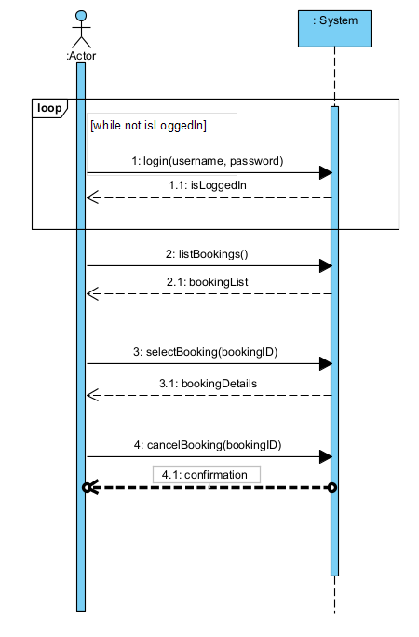
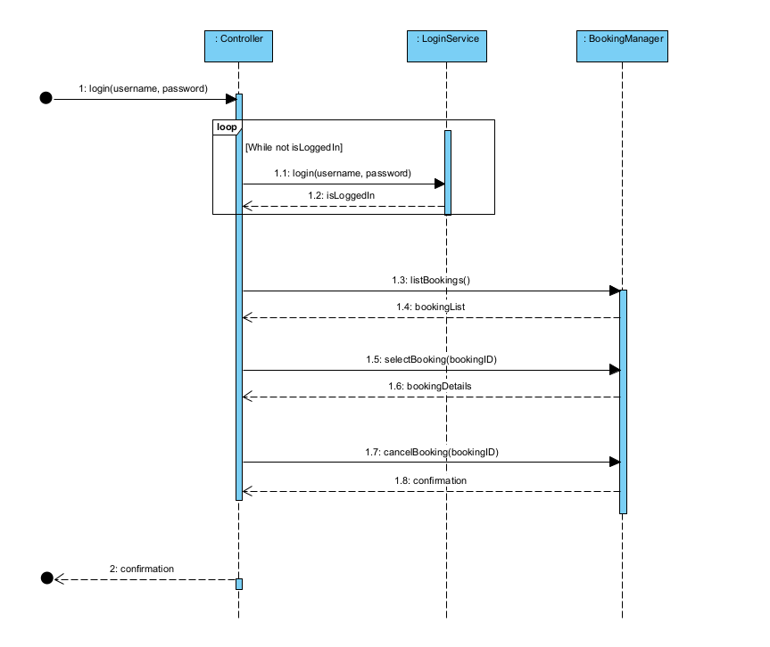
UC Guest View Bill - Cole

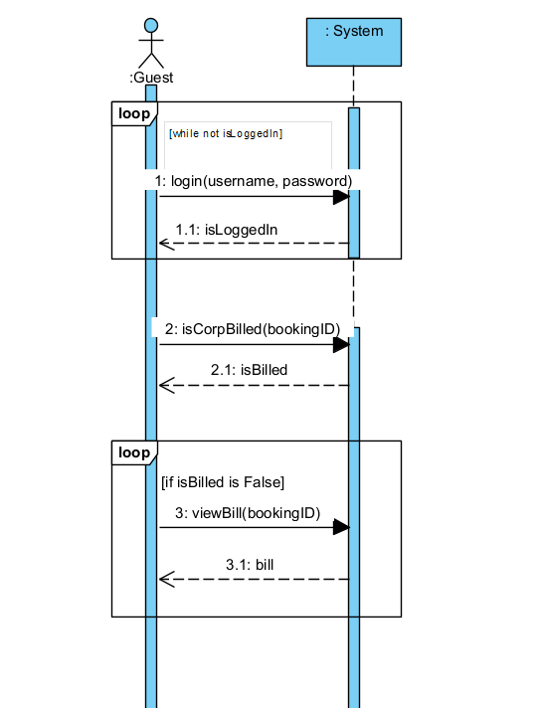
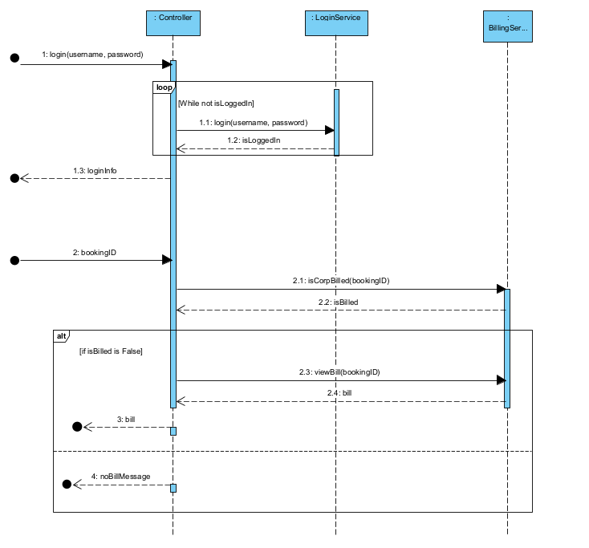

UC Admin Reset Guest Password - Cole

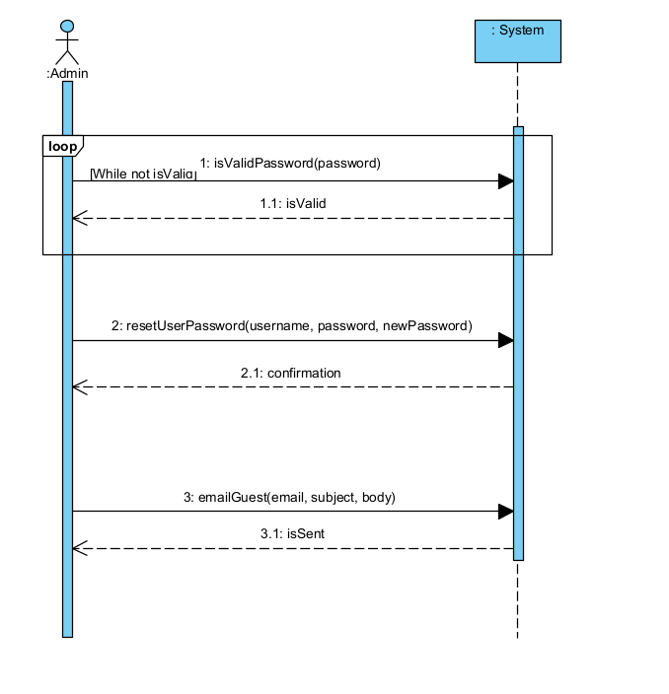
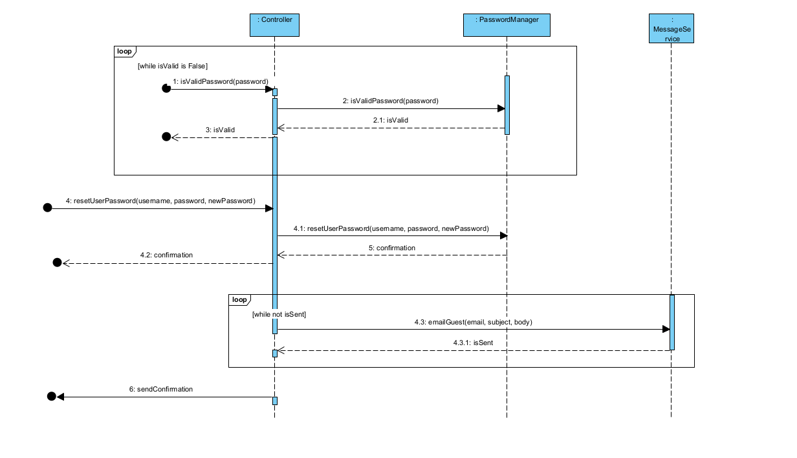
UC Shop Purchase and Merge Bill- Afraz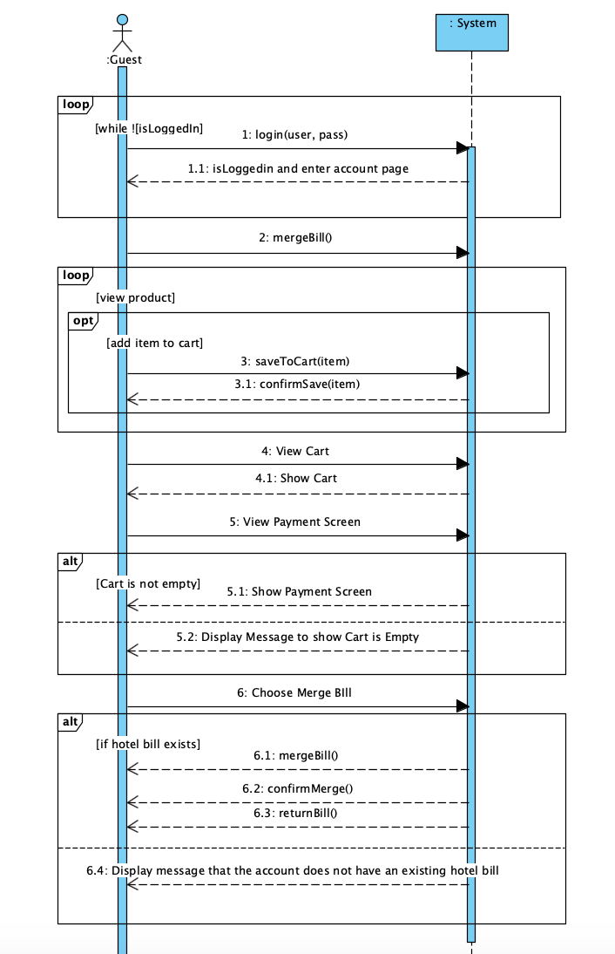

UC Customer Creates An Account- Afraz
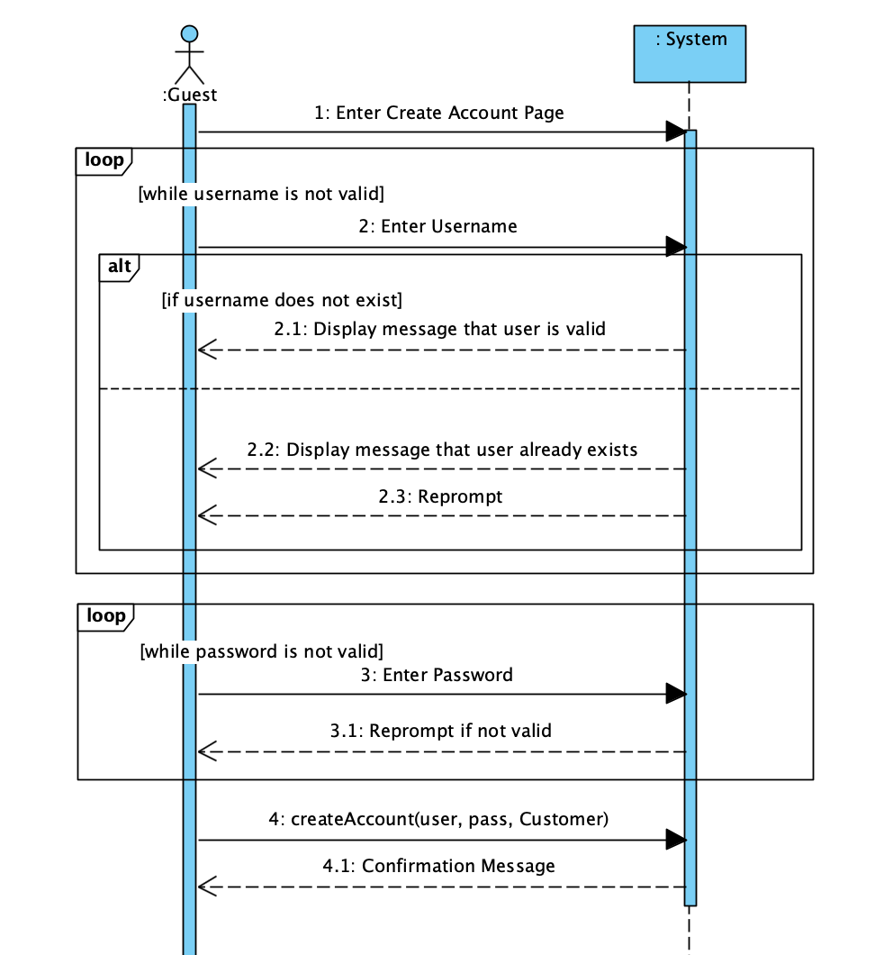
UC Customer Cancels Purchase and Removes Items from Cart- Afraz
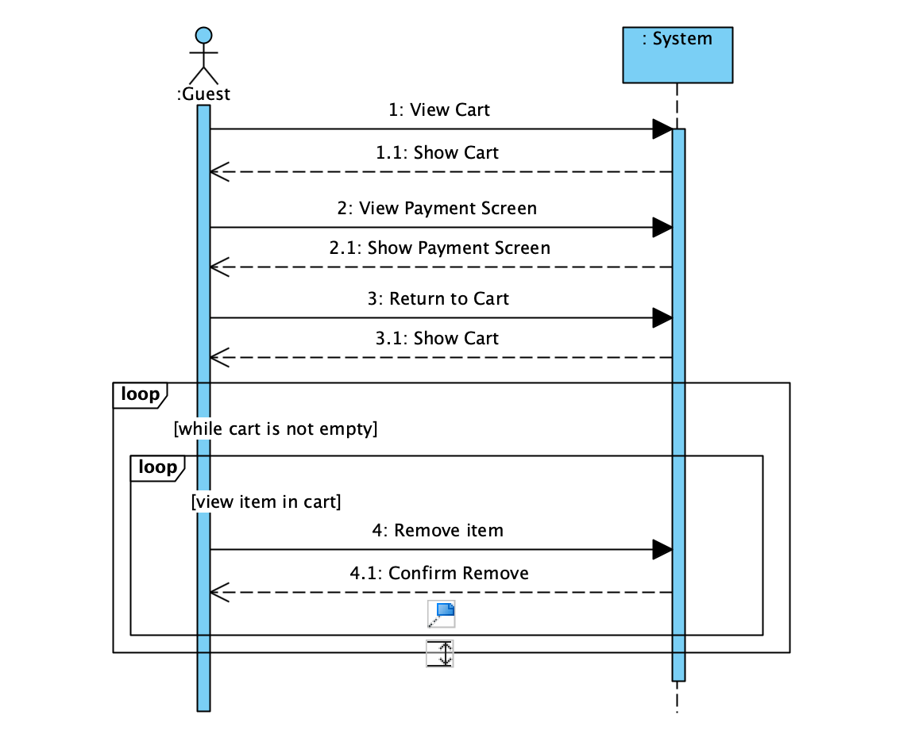

UC Admin makes Clerk account - Brendon
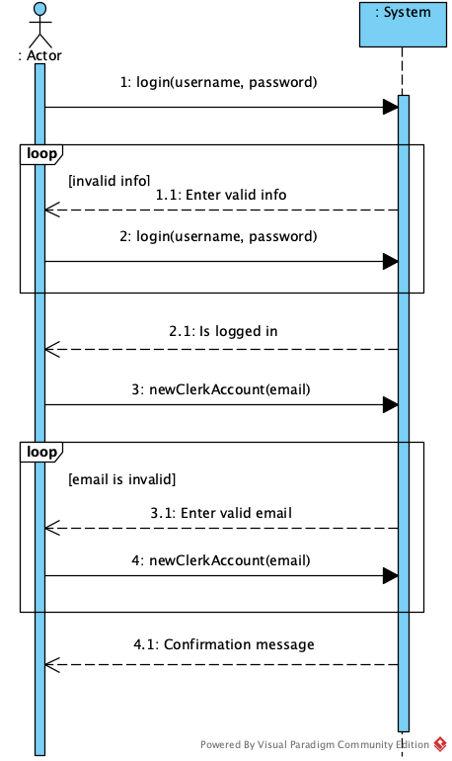

UC Clerk sets up account - Brendon
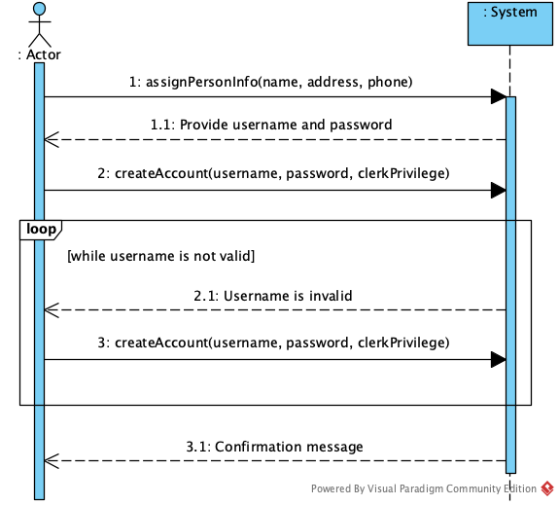

UC Clerk modifies account - Brendon
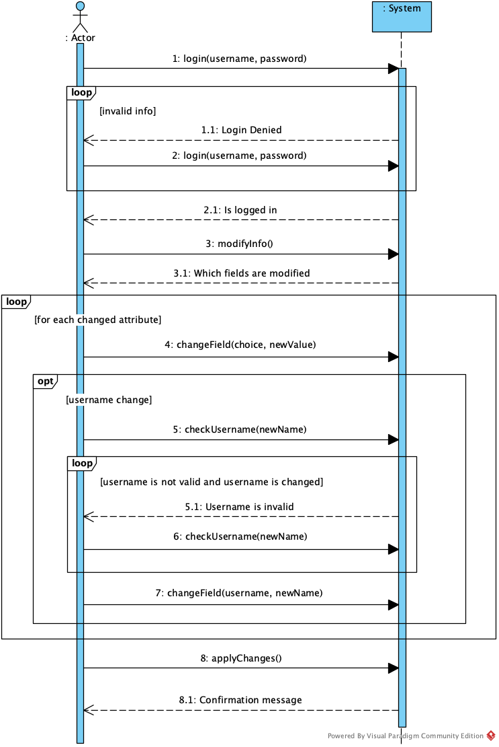

SSD Modify Reservation - Icko
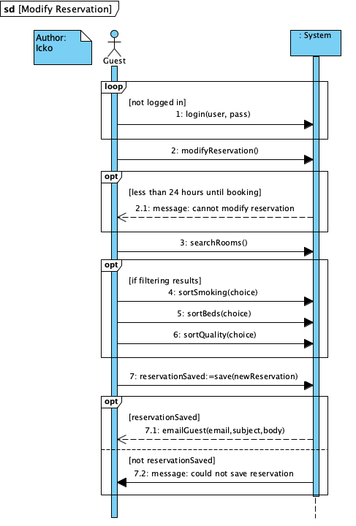

SSD Modify Room Information - Icko
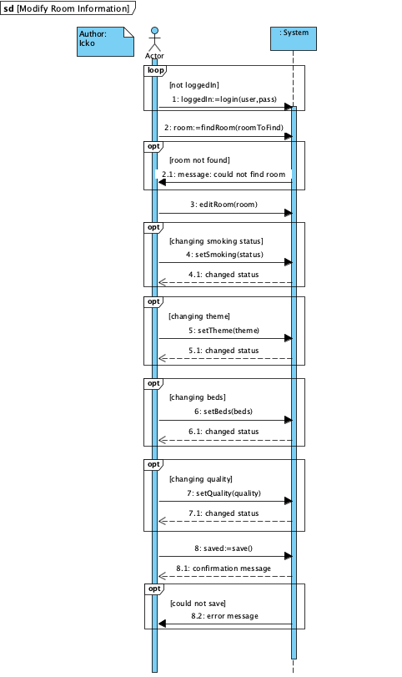

SSD - Clerk Checks in Guest - Icko
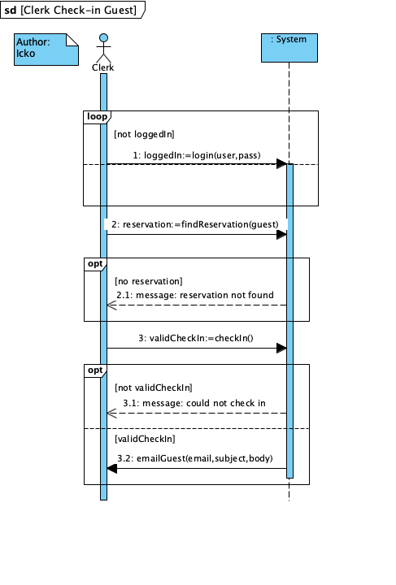
UC Guest books a hotel room - Chase
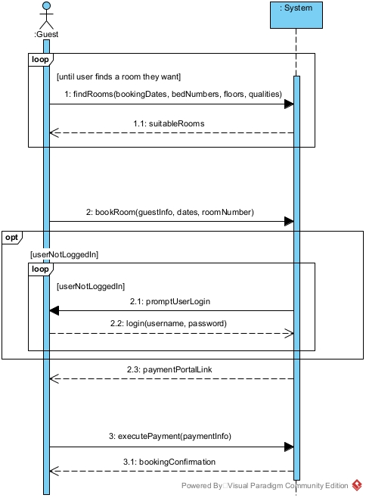

UC Clerk generates a bill - Chase
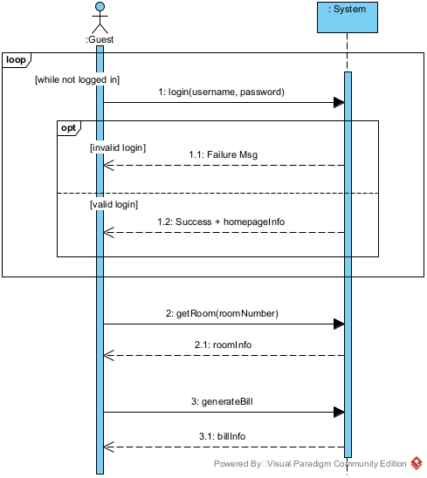

UC Clerk Checkout Guest - Chase
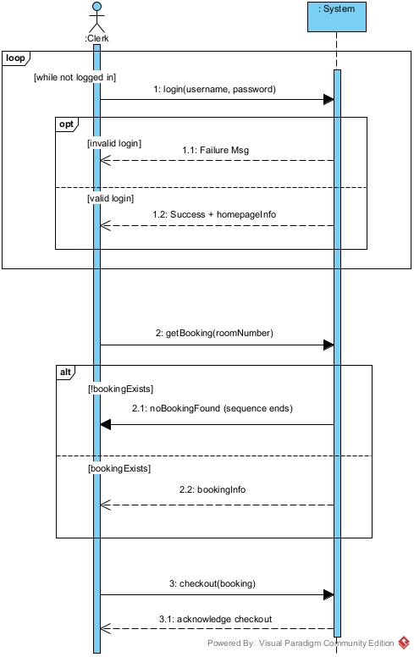

UC Shop for items - Siri
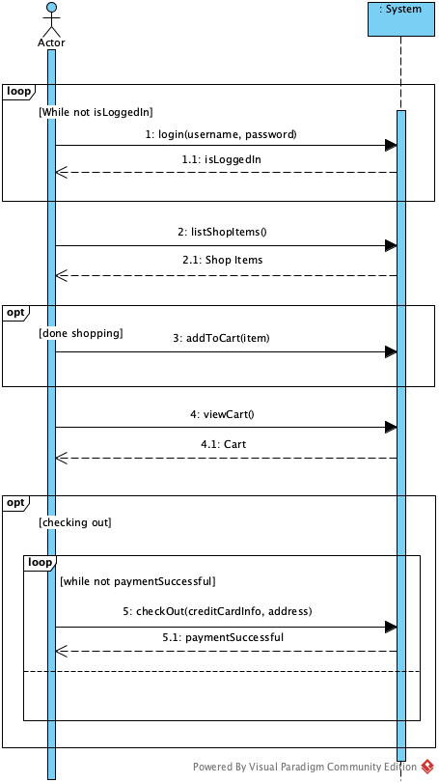

UC Admin creates guest reservation - Siri
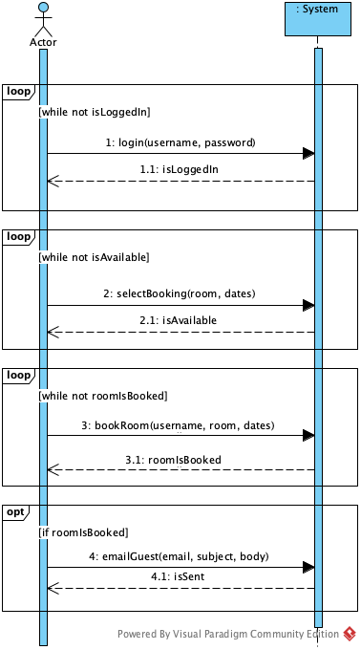
UC Clerk check room status - Siri
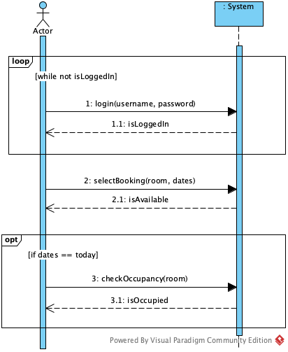
Operation Contracts:

Author: Brendon
Operation CO1: createAccount(username : String, password : String, privilegeLevel : Privilege)
Cross References: Use Case: Clerk sets up account, Customer creates an Account
Pre-Conditions: An account with the same username has not been created
Post-Conditions:
- A new Account instance acct was created
- acct.username was set to username
- acct.password was set to password
- acct.privilege was set to privilegeLevel
- acct was associated to the Person

Author: Brendon
Operation CO2: assignInfo(name : String, address : Address, phone : String)
Cross References: Use Case: Clerk sets up account
Pre-Conditions: None
Post-Conditions:
- A new Person instance person was created
- person.name was set to name
- person.address was set to address
- person.phone was set to phone

Author: Brendon
Operation CO3: createClerkAccount(email : String)
Cross References: Use Case: Admin creates clerk account
Pre-Conditions: None
Post-Conditions:
- None

Author: Cole
Operation CO4: login(username: String, password: String)
Cross References: Use Cases: Guest View Bill, Shop Purchase, Merge Bill, Admin Creates reservation, Room Status
Pre-Conditions: The guest can communicate with the system
Post Conditions:
- The user is validated to access the system

Author: Cole
Operation CO5: viewBill(bookingID)/returnBill(bookingId)
Cross-Reference: Use Cases: Guest View Bill, Shop Purchase and Merge Bill
Pre-Conditions:
- User is logged in
- User has a valid bookingID
Post-Conditions:
- Bill is updated (attribute modification)

Author: Cole
Operation CO6: listBookings
Cross References: Use Cases: Guest Cancel Booking
Pre-condition: guest is logged in
Post condition:
- None

Author: Cole
Operation CO7: selectBooking(bokingID)
Cross References: Use Cases: Guest Cancel Booking
Pre-Condition: guest is logged in and has their valid bookings
Post-Conditions:
- None

Author: Cole
Operation CO8: cancelBooking(bookingID)
Cross References: Use Cases: Guest Cancel Booking
Pre-condition: user is logged in and has a valid booking
Post-Condition:
- Booking association with an account is removed (association removed)
- A user’s stayBill is updated (attribute modification)

Author: Afraz
Operation CO9: saveToCart(item : shopItem)
Cross References: Use Case: Shop Purchase and Merge Bill
Pre-condition: User chooses item to save to their cart.
Post-Condition: Item is associated with Cart.

Author: Afraz
Operation CO10: mergeBill(purchaseTotal : Double)
Cross References: Use Case: Shop Purchase and Merge Bill
Pre-condition:
-Hotel stay bill exists
-User has made a purchase and chose the merge bill option.
Post-Condition: The purchase bill and stay bill are merged.

Author: Afraz
Operation CO11: confirmMerge()
Cross References: Use Case: Shop Purchase and Merge Bill
Pre-condition:
-mergeBill function has passed and a User’s bill has successfully merged.
Post-Condition: None

Author: Chase
Operation CO12: findRooms(bookingDates: BookingDate, bedNumbers: BedNumbers, floors: Integer[])
Cross References: Use Case: Guest is trying to book a room
Pre-Conditions:
- None. (Can start from anonymous, un-logged-in user)
Post-Conditions:
- None. (We only read state and communicate it.)

Author: Chase
Operation CO13: bookRoom(guestInfo, dates, roomNumber)
Cross References: Use Case: Guest is trying to book a room, Admin Creates Guest Reservation
Pre-Conditions:
- None. (Can start from anonymous, un-logged-in user)
Post-Conditions:
- A temporary transaction is created with the relevant information

Author: Chase

Author: Chase
Operation CO14: executePayment(paymentInfo)
Cross References: Use Case: Guest is trying to book a room
Pre-Conditions:
- The specified transaction to pay for exists
Post-Conditions:
- A new Payment object is created
- The specified transaction is marked as paid
- The specified transaction is linked to the Payment

Author: Icko
Operation CO17: editRoomInfo()
Cross References: Use Cases: Modify Room Information
Pre-condition: The room to edit exists and a clerk is logged in
Post-condition:
- State is changes so that the Clerk can make modifications to a room

Author: Icko
Operation CO18: modifyReservation()
Cross References: Use Cases: Modify Reservation
Pre-condition: The guest has already logged in and has selected a reservation to modify
Post-condition:
- State is changed so that Guest is able to make changes to their reservation

Author: Chase
Operation CO19: getRoom(roomNumber)
Cross References: Use Case: Clerk is trying to generate a bill
Pre-Conditions:
- The specified room number exists
Post-Conditions:
- None (State is only read and communicated)

Author: Chase
Operation CO20: generateBill(roomNumber)
Cross References: Use Case: Clerk is trying to generate a bill
Pre-Conditions:
- The specified room exists
- The specified room has an active booking.
Post-Conditions:
- None (State is only read and communicated)

Author: Cole
Operation CO21: emailGuest(email, subject, body)
Cross References: Use Cases: Admin Reset Guest Password, Admin Creates Guest Reservation
Pre-condition: Admin is logged in
Post-Condition:
- None (State is only read and communicated to an email)

Author: Cole
Operation CO22: resetUserPassword(username, password, newPassword)
Cross References: Use Cases: Admin Reset Guest Password
Pre-condition: Admin is logged in
Post-Condition:
- Password of a user is modified

Author: Cole
Operation CO23: isValidPassword(password)
Cross References: Use Cases: Admin Reset Guest Password
Pre-condition: Admin is logged in
Post-Condition:
- None (Password parameter is only read and determined valid or not)
Author: Siri
Operation CO24: listShopItems()
Cross References: Use Case: Shop for items
Preconditions:
- Guest is logged in
Postconditions:
- All shop items are displayed to user

Author: Siri
Operation CO25: addToCart(item)
Cross References: Use Case: Shop for items
Preconditions:
- Guest is logged in
- Guest selected item to be added to cart
Postconditions:
- Selected item is added to cart

Author: Siri
Operation CO26: viewCart()
Cross References: Use Case: Shop for items
Preconditions:
- Guest is logged in
Postconditions:
- All items in cart (if any) are displayed to user with total balance

Author: Siri
Operation CO27: checkOut(creditCardInfo, address)
Cross References: Use Case: Shop for items
Preconditions:
- Guest is logged in
- Balance is > 0
Postconditions:
- If credit card info is processed & balance is paid, system returns successful
- else , system returns unsuccessful

Author: Siri
Operation CO28: selectBooking(room, dates)
Cross References: Use Case: Admin Creates Guest Reservation, Clerk Check Room Status
Preconditions:
- User is logged in
- Room exists
Postconditions:
- Returns if room is available in given dates

Author: Siri
Operation CO29: bookRoom(username, room, dates)
Cross References: Use Case: Admin Creates Guest Reservation
Preconditions:
- Admin is logged in
- Room is available for given dates
- Guest to assign room to has an account (username)
Postconditions:
- If room is successfully booked for given dates, system returns true
- Else if unable to book, system returns false

Author: Siri
Operation CO30: checkOccupancy(room)
Cross References: Use Case: Clerk Check Room Status
Preconditions:
- Clerk is logged in
- Room exists
Postconditions:
- Return occupancy status

Author: Icko
Operation CO31: findRoom(room)
Cross References: Use Case: Modify Room Information
Preconditions:
- Room exists
Postconditions:
- Return the room information if the room is found

Author: Icko
Operation CO32: setSmoking(status)
Cross References: Use Case: Modify Room Information
Preconditions:
- Room exists
- Room can be modified
Postconditions:
- Changes smoking status of the room

Author: Icko
Operation CO33: setBeds(beds)
Cross References: Use Case: Modify Room Information
Preconditions:
- Room exists
- Room can be modified
Postconditions:
- Changes the beds in the room

Author: Icko
Operation CO34: setQuality(quality)
Cross References: Use Case: Modify Room Information
Preconditions:
- Room exists
- Room can be modified
Postconditions:
- Changes the quality level of the room

Author: Icko
Operation CO35: save()
Cross References: UC Modify Room Information, UC Modify Reservation
Preconditions:
- Current operation is saveable
Postconditions:
- Any changes made in the current buffer are saved to the database

Author: Chase
Operation CO36: checkout(booking)
Cross References: Use Case: Clerk is checkout out a user
Pre-Conditions:
- The booking to checkout exists and is active/has been checked in
Post-Conditions:
- Booking is marked as checked out (with checkout date)
- Room is marked as available

Author: Cole
Operation CO37: isCorpBilled(bookingID)
Cross References: Use Case: Guest View Bill
Pre-Conditions:
- The booking to checkout exists
Post-Conditions:
- None

Wireframes:

Landing Screen - Cole
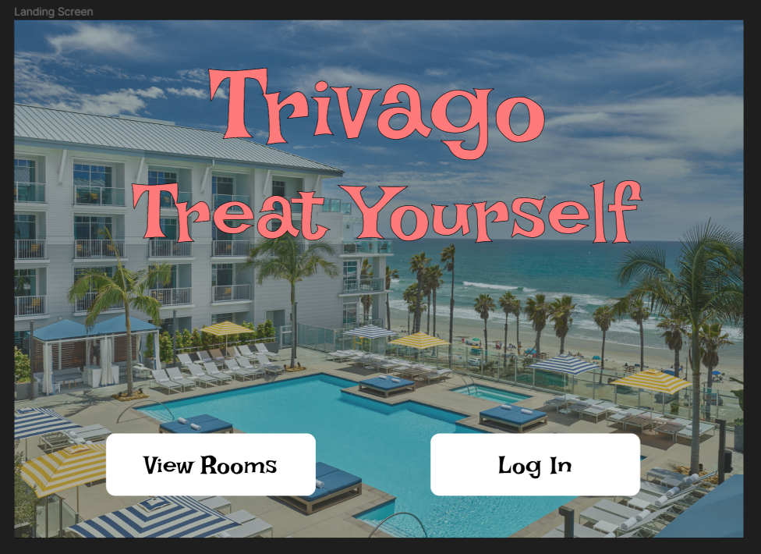

Login Screen - Cole
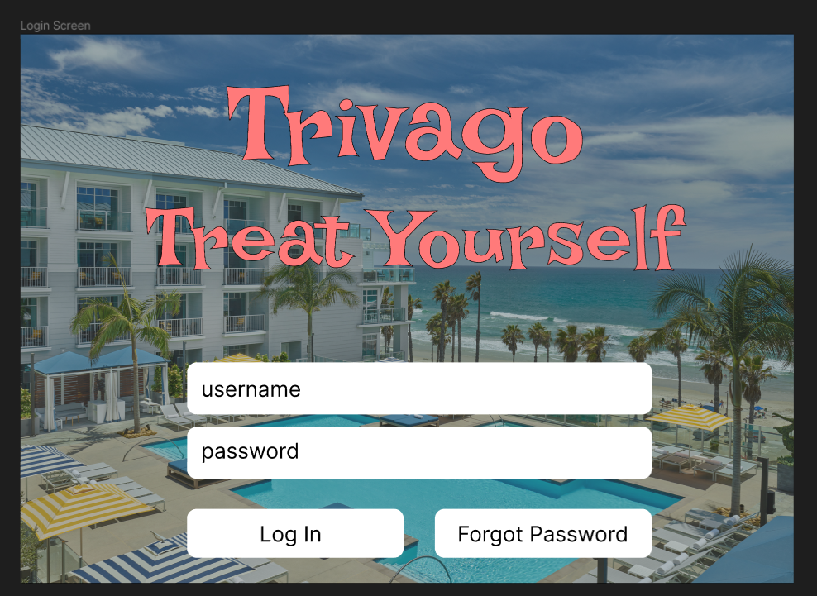

Failed Log in screen - Cole
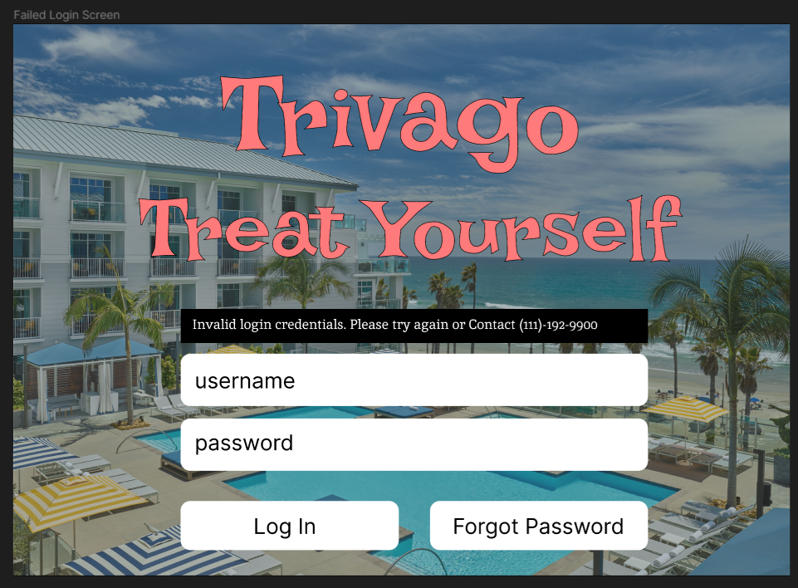

Admin Homepage: Cole
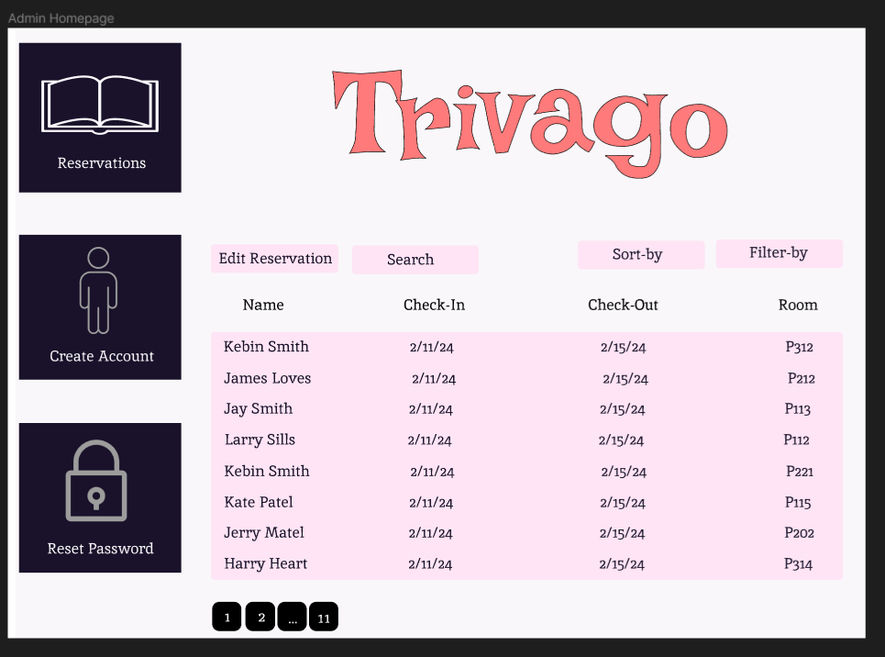

Clerk Room-List Page: Brendon
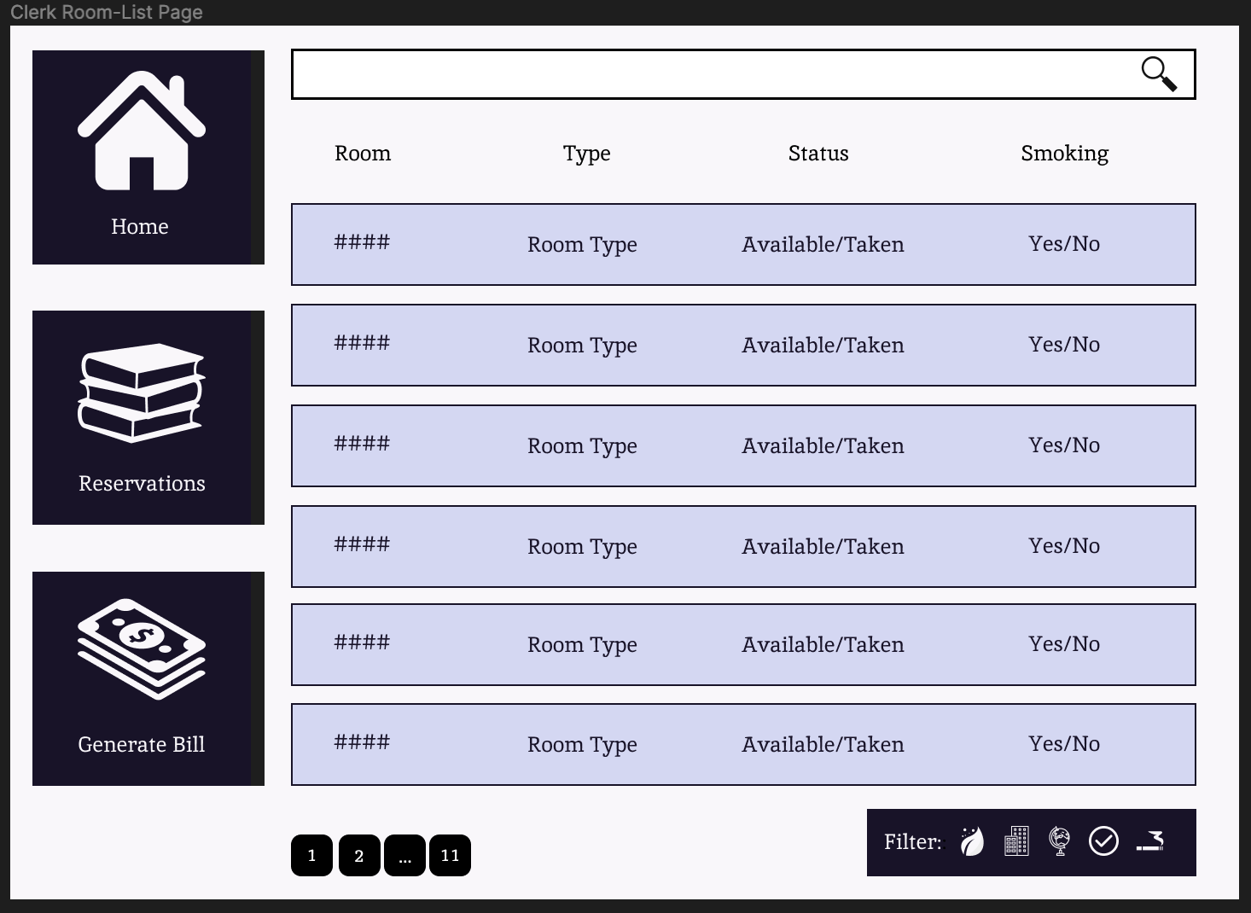

Clerk Room-Status Page: Brendon
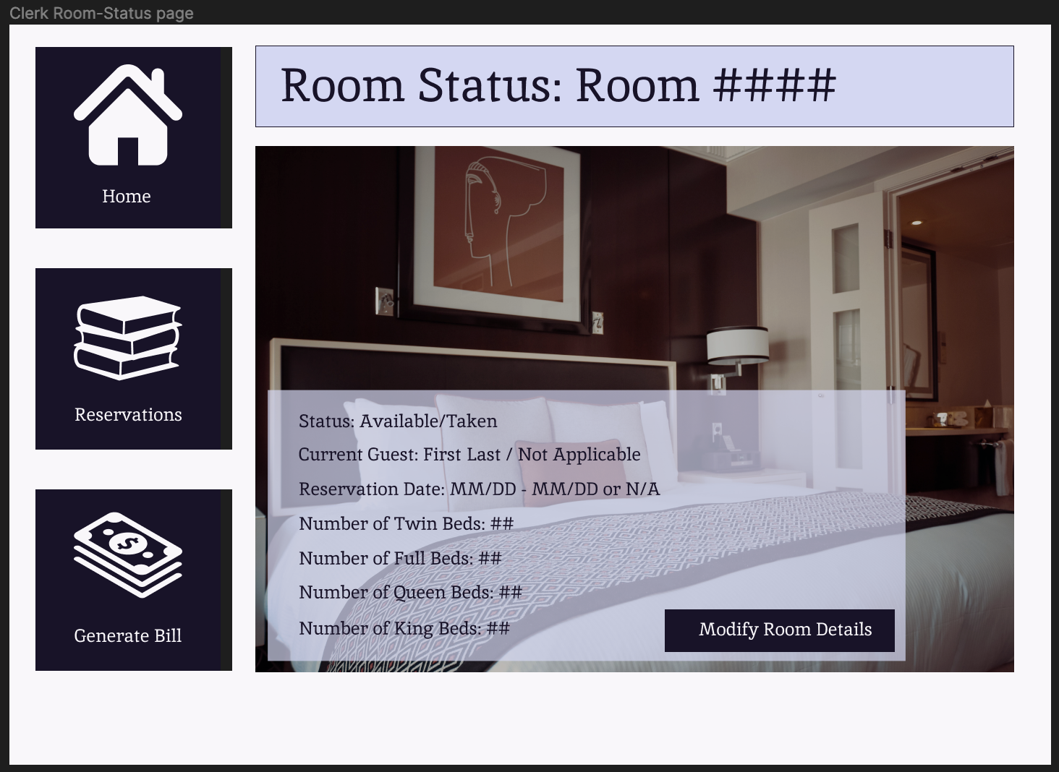

Clerk Modify Account Page: Brendon
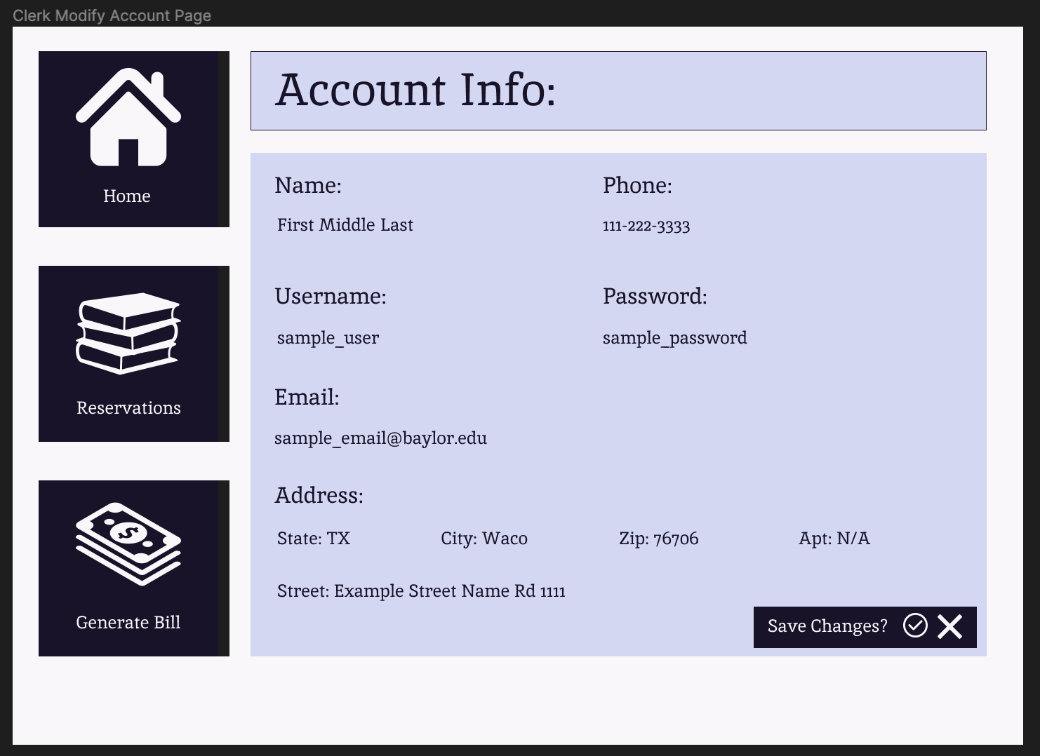

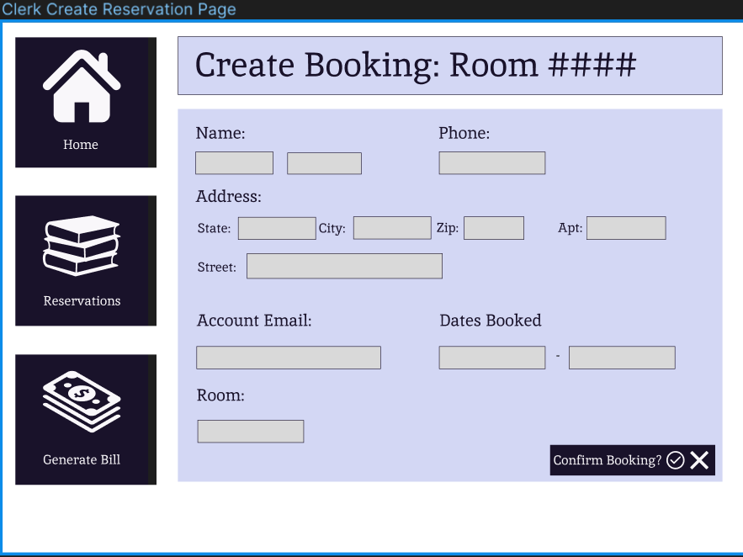
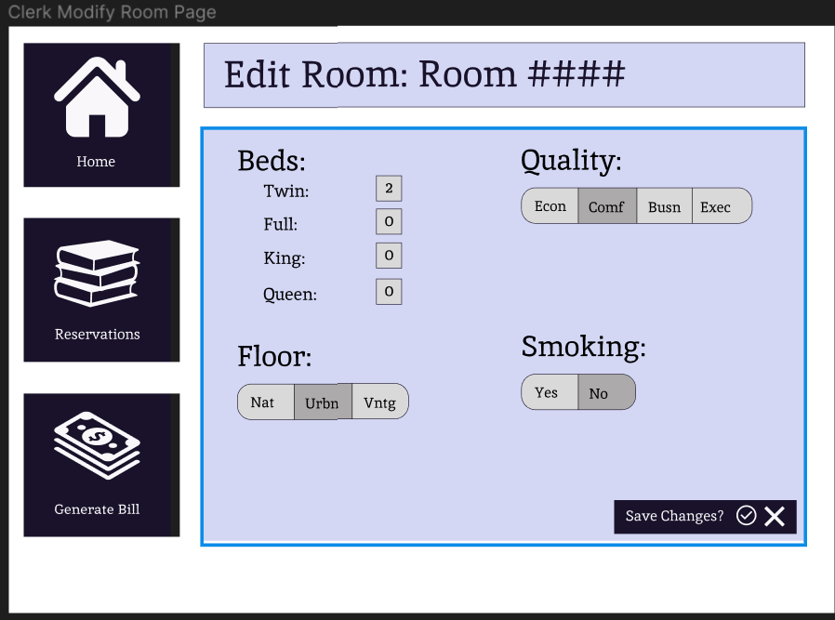
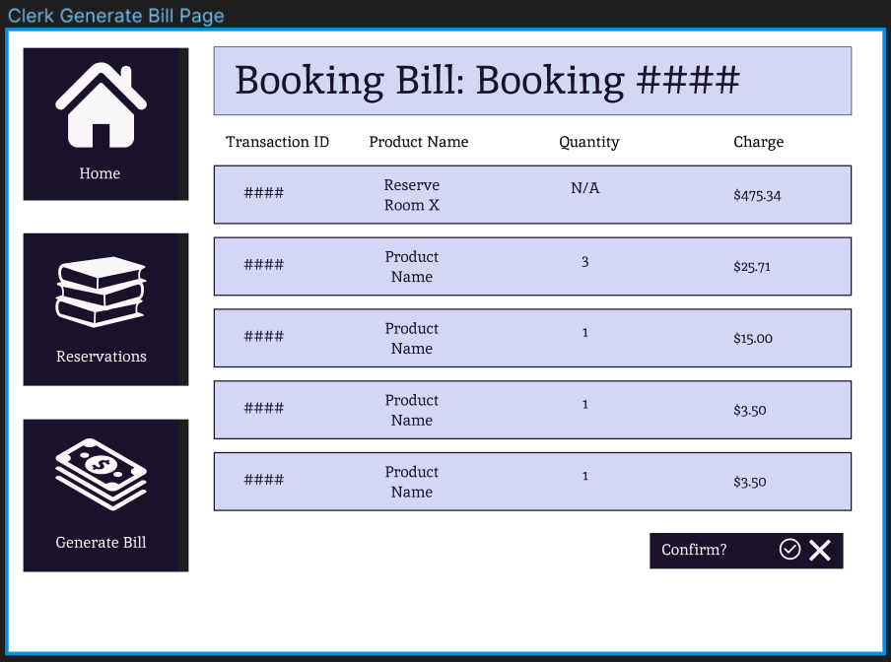
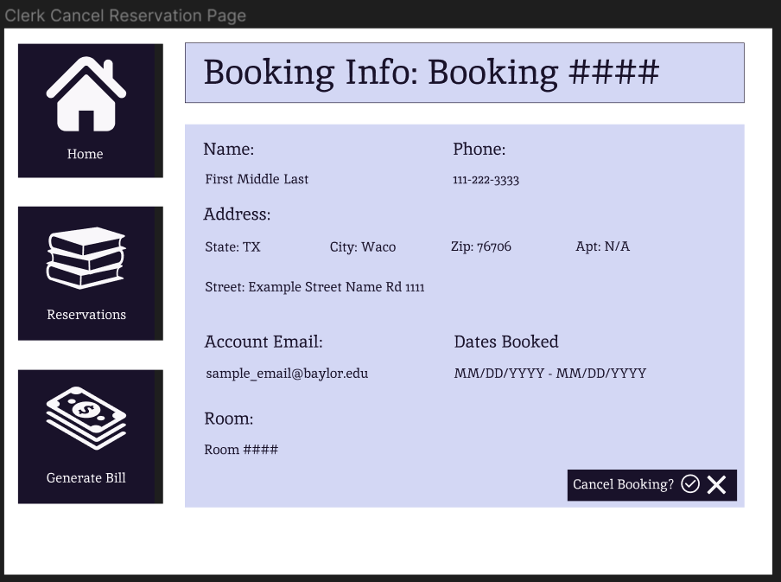

Modify Room Information: Icko
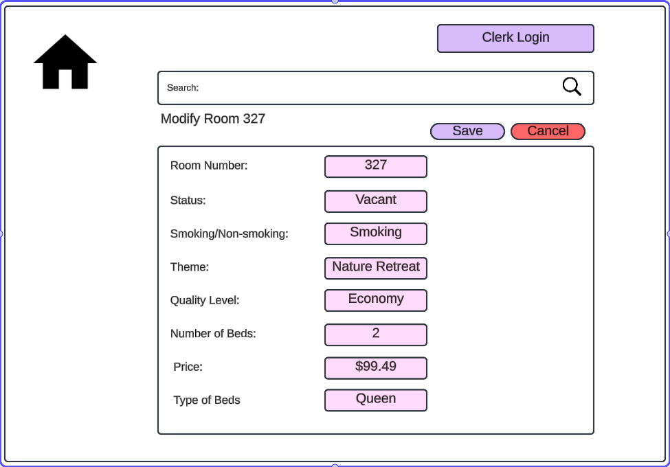
Main Shop Page - Icko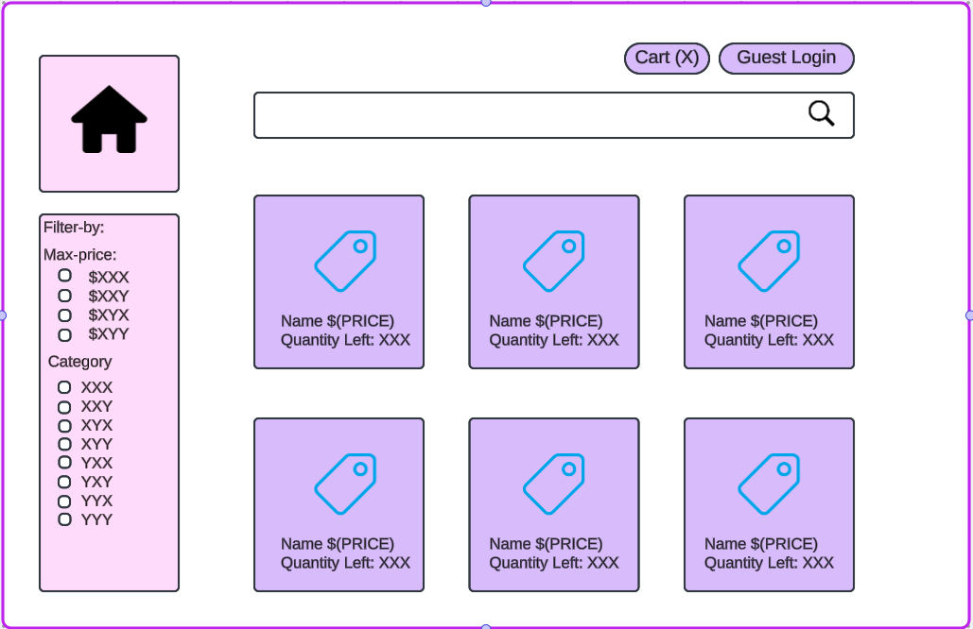

Admin Create Account Page- Afraz
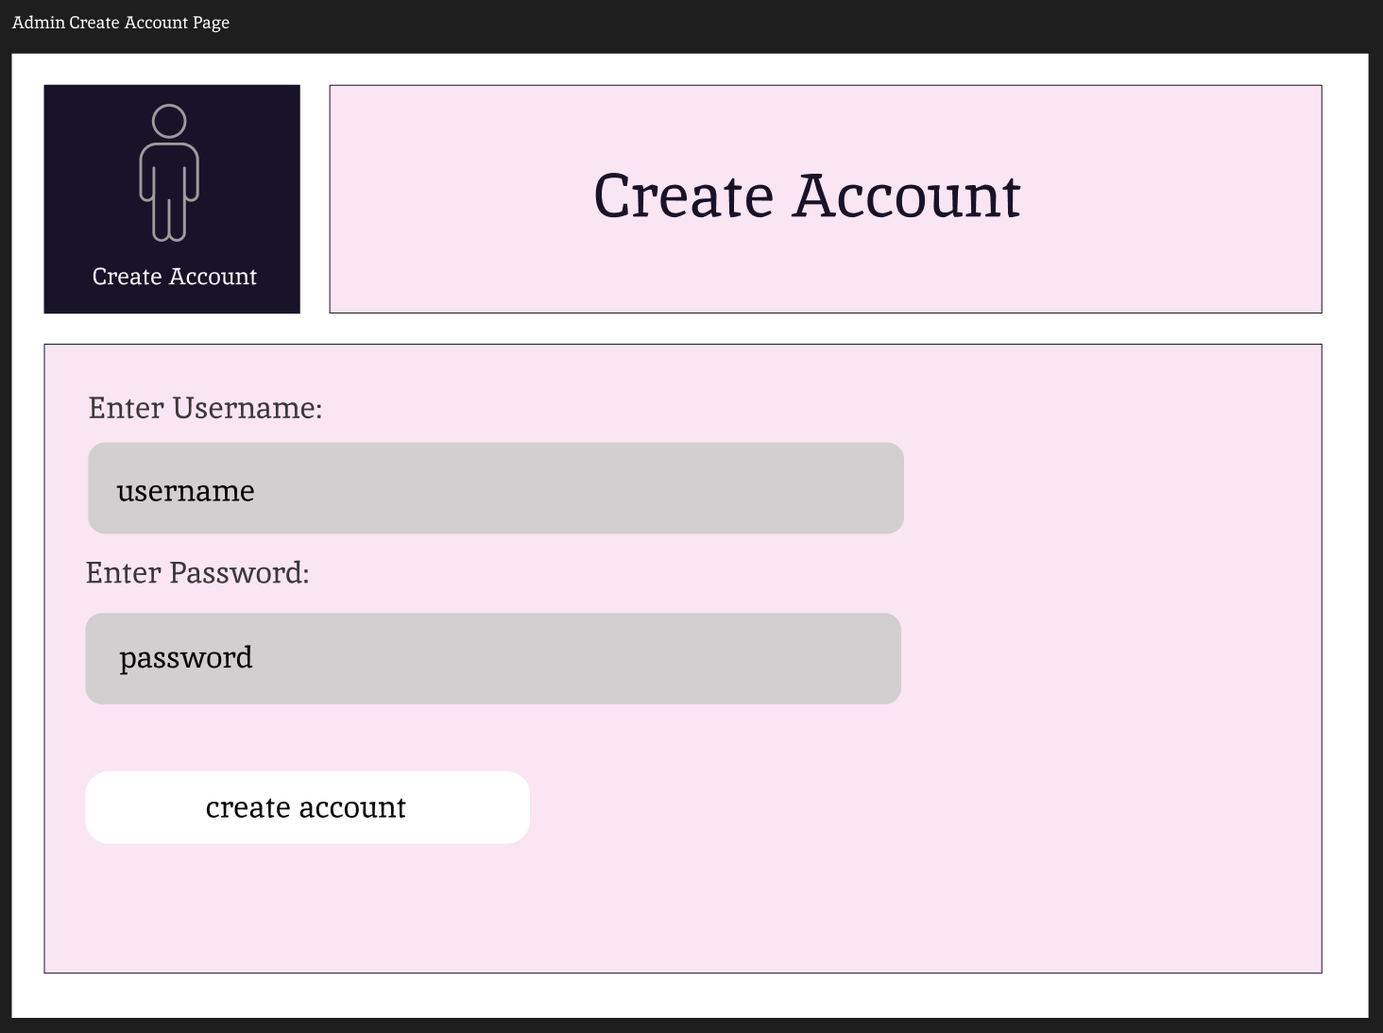
Admin Modify Account Page-Afraz

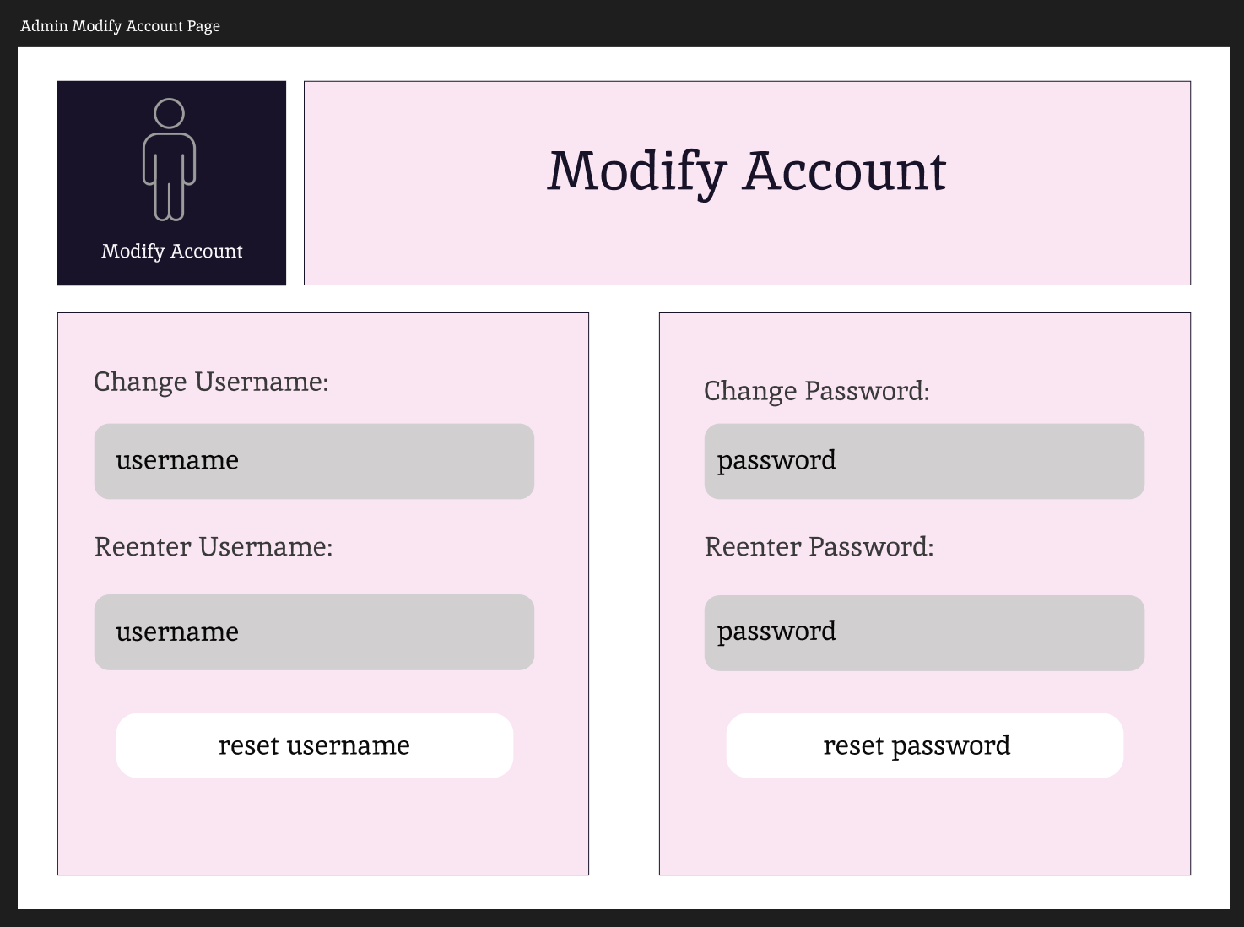

Clerk Home Page-Afraz

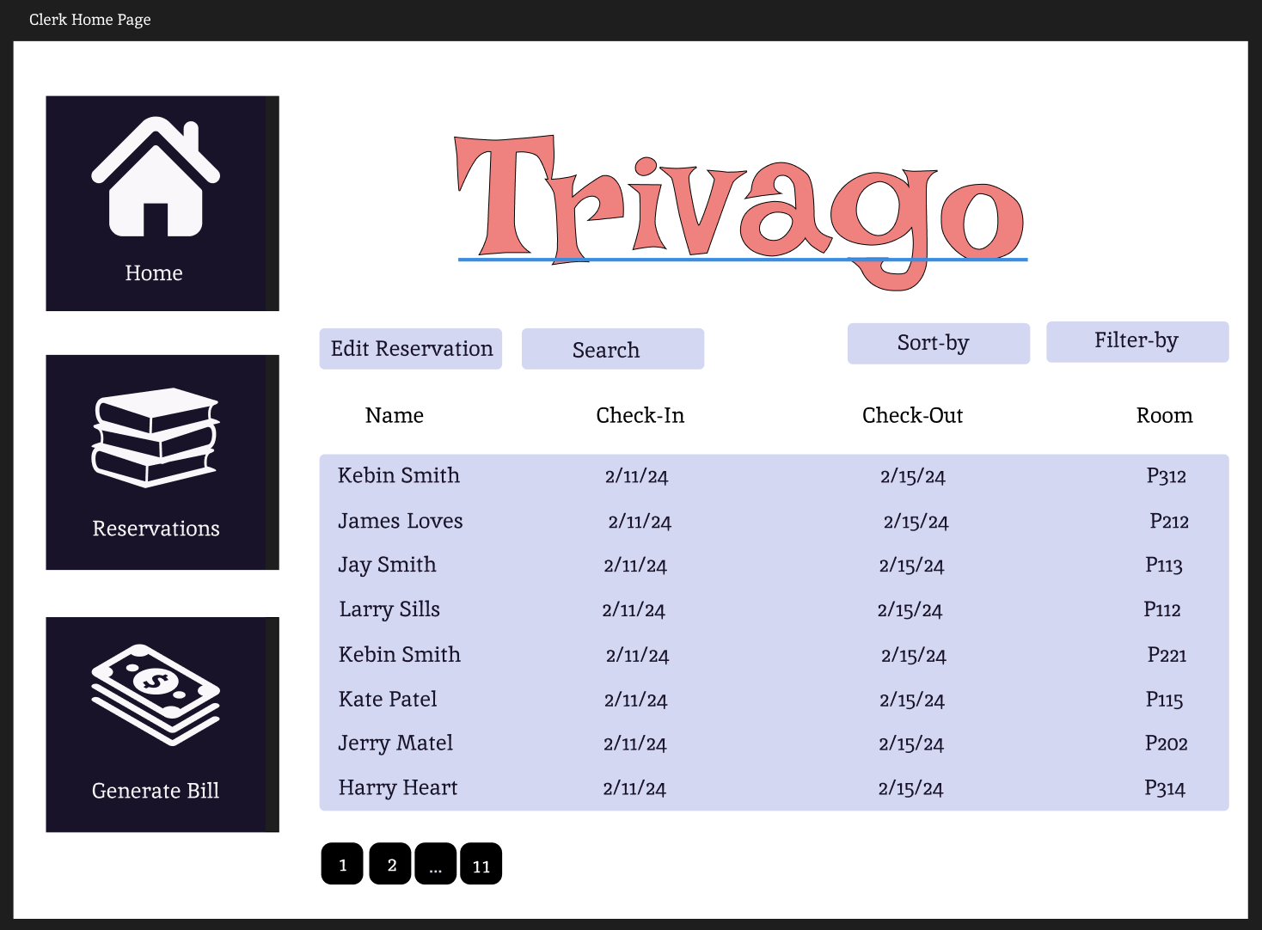

Clerk Process Booking Page-Afraz

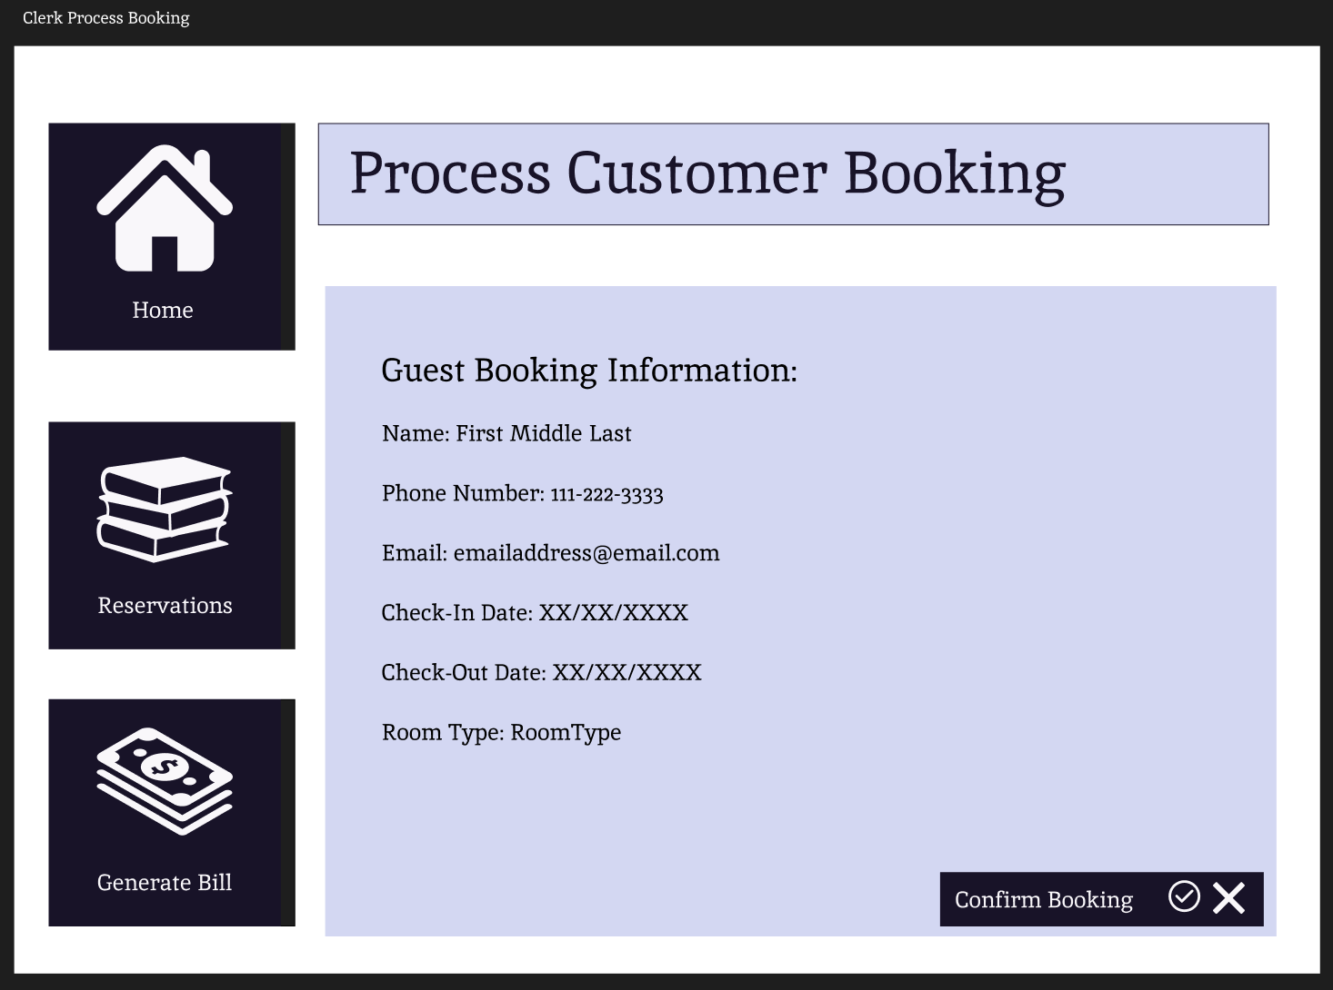
Guest Shopping Cart Page-Afraz

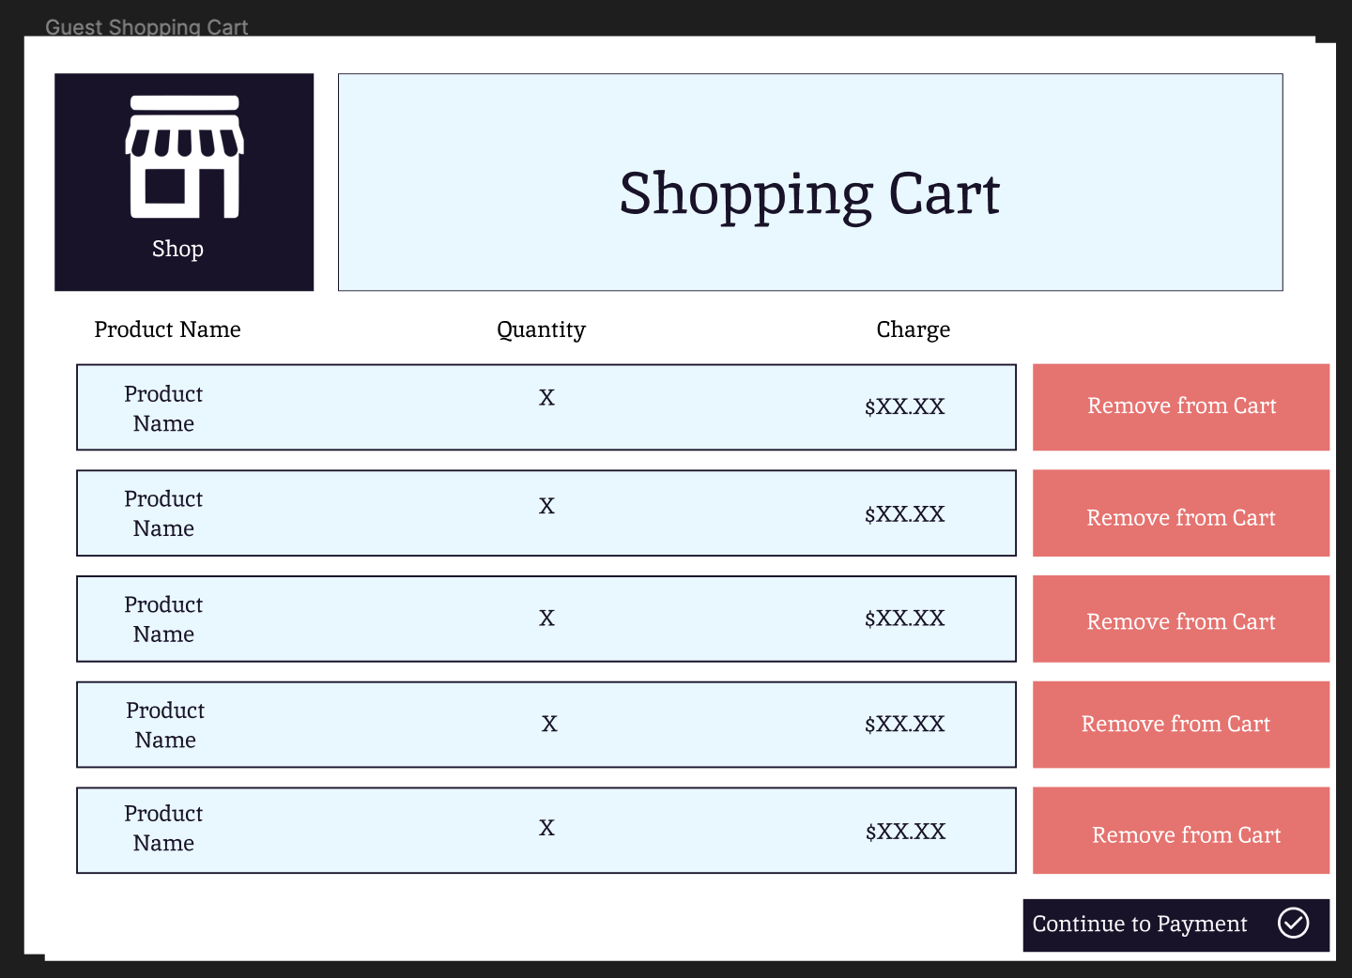

Guest Homepage - Siri
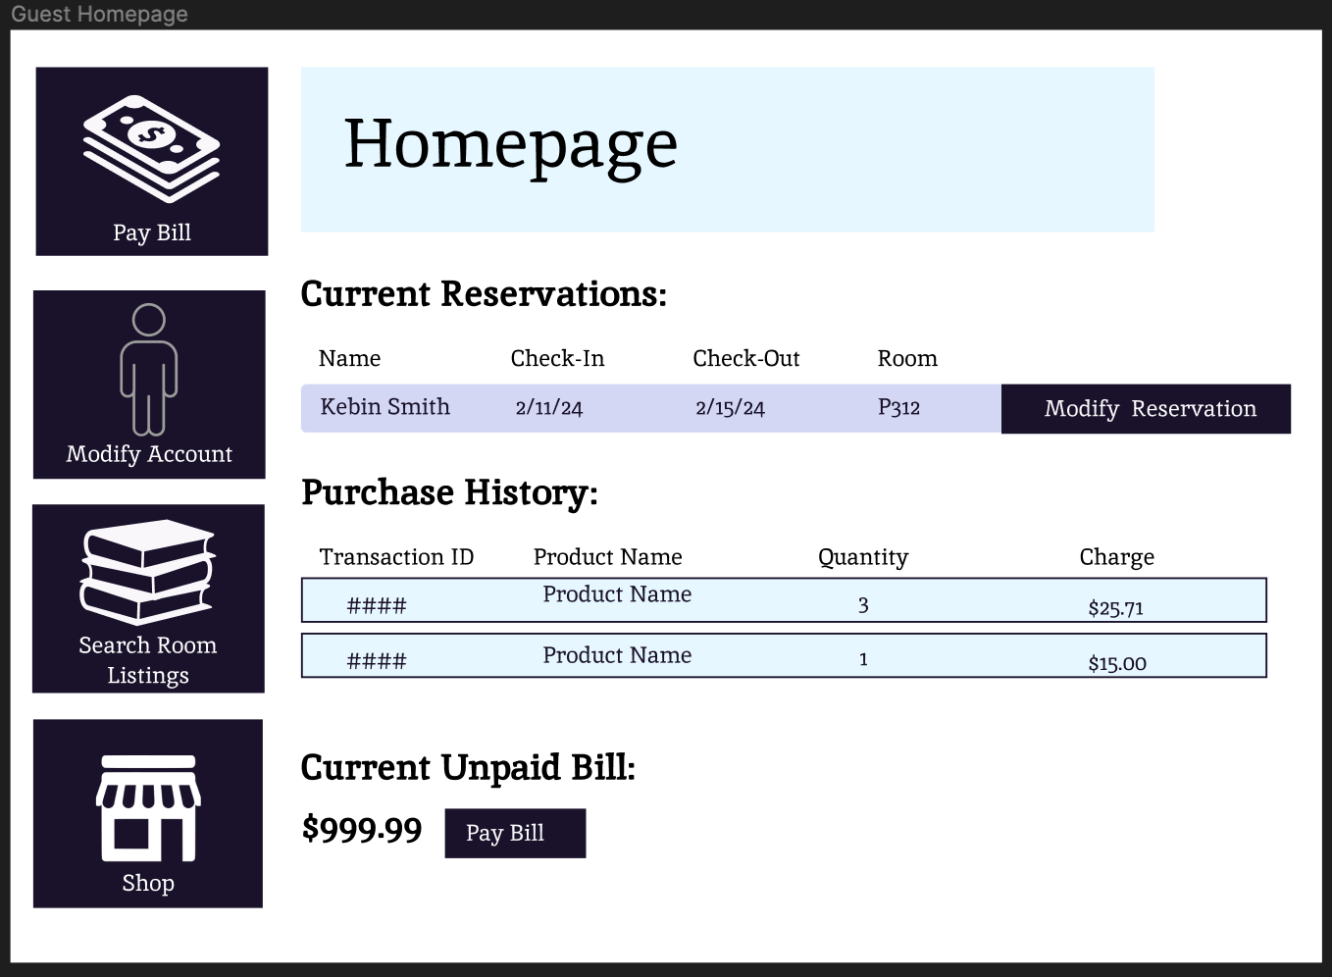

Guest Modify Account page - Siri
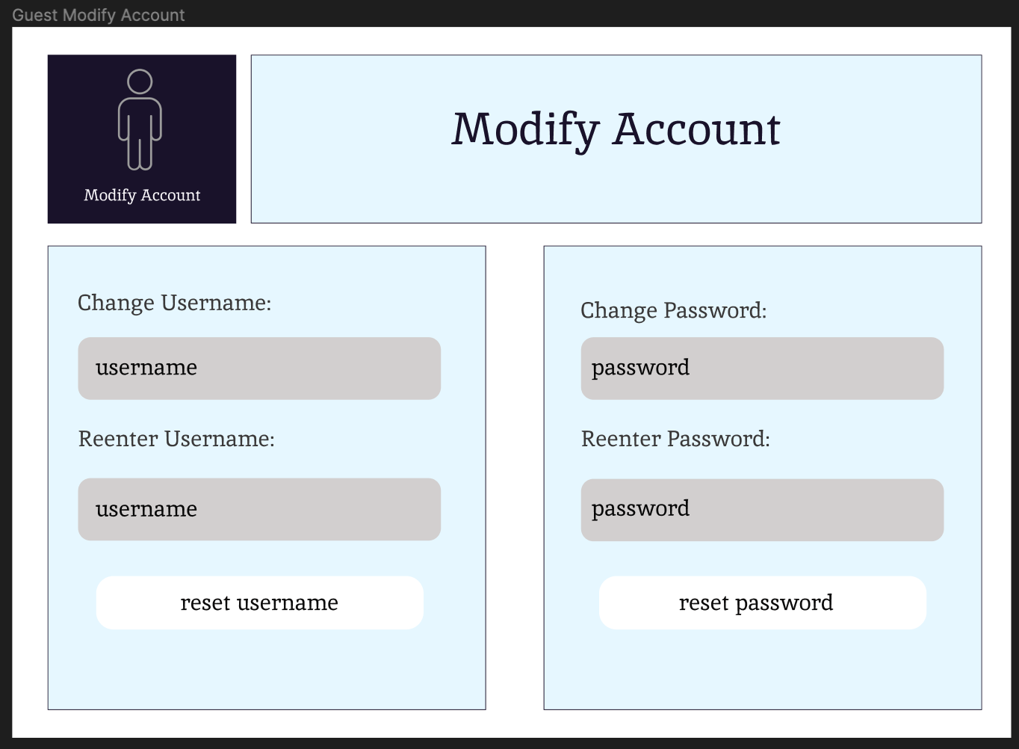

Guest Pay Bill Page - Siri
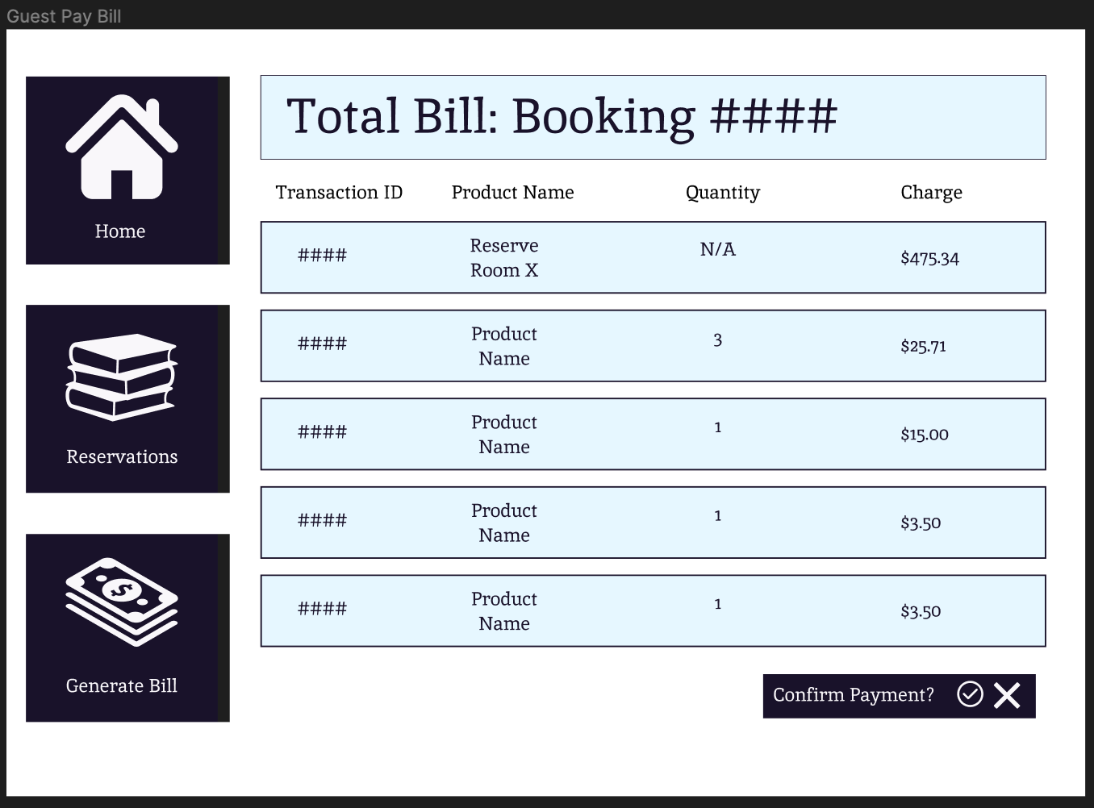

Guest Modify Reservation Page - Siri
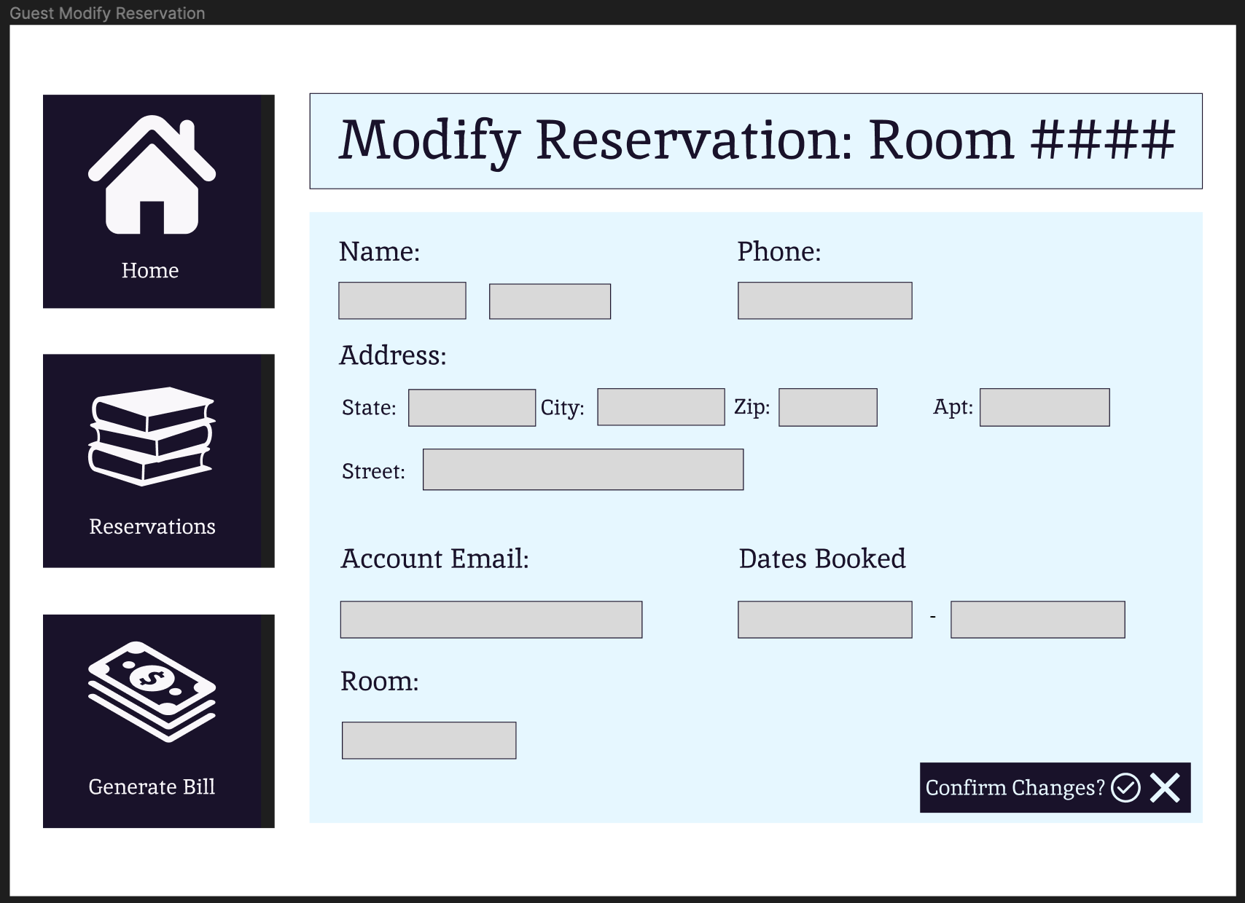

Vision Document

The Mojotel Dojotel Holicasa Inn

Vision (Small Project)

Version <0.2>

Revision History
Date | Version | Description | Author
1/26/2024 | 0.1 | Initial Revision | Chase Crayne
2/2 | 0.2 | Content addition | Cole Flenniken

Table of Contents
1. Introduction 3
1.1 References 3
2. Positioning 3
2.1 Problem Statement 3
2.2 Product Position Statement 3
3. Stakeholder and User Descriptions 3
3.1 Stakeholder Summary 3
3.2 User Summary 3
3.3 User Environment 3
3.4 Summary of Key Stakeholder or User Needs 3
3.5 Alternatives and Competition 3
4. Product Overview 3
4.1 Product Perspective 3
4.2 Assumptions and Dependencies 3
5. Product Features 3
6. Other Product Requirements 3

Vision (Small Project)

Introduction
The purpose of this document is to summarize the high-level needs and features of the G.R.O.U.P. F.I.V.E. HoteleCommerce system. The primary focus is the capabilities required by the stakeholders and target-users, and detailing why the needs exist. Details on how the HoteleCommerce system fulfills these needs are described in the use-cases and supplementary specifications.

References
- Cloudbeds (https://www.cloudbeds.com/)
- Little Hotelier (https://www.littlehotelier.com)
- RoomRaccoon (https://roomraccoon.com)
- Group Project - Overview (Canvas), Professor Quevedo Caballero

Positioning

Problem Statement
The problem of | TRIVAGO
affects | the Mojotel Dojotel Holicasa Inn Project Owners
the impact of which is | the successful operation of the Holicasa Inn and consequent production of revenue.
a successful solution would be | beneficial in terms of cost, efficiency, and guest experience.

Product Position Statement
For | TRIVAGO
Who | needs a venue management solution
The HoteleCommerce Suite | is a webapp software suite
That | unifies the use and management of both Hotel and Shop operations
Unlike | competitor software that doesn’t manage shop operations
Our product | seamlessly connects the shopping and hotel management experiences

Stakeholder and User Descriptions

Stakeholder Summary

Name | Description | Responsibilities
Prof. Caballero  (“Hotel Owner”) | Recipient of the end product. | Will evaluate the final product for efficiency of operation and satisfaction of requirements.
GROUPFIVE Development Team | This group executes the entire plan, design, development, and implementation of the software system. | Plan, manage, and allocate personnel and resources to development tasks.  Coordinate with  Specify domain, non-functional, and functional requirements.  Create design for overall system architecture to guide implementation.  Implement the design for use by end-users.
Project Manager | Primary lead in direction of the project. | Coordinates activities and meetings.  Liasion to the Professor.  Allocating responsibilities to group members.
Requirements Engineer | Primary lead in defining use cases and product requirements. | Define and narrow product use cases.  Define and refine product requirements.  Ensure design and development meets product requirements
Design Engineer | Leads effort in overall system design | Lead system architecture direction.  Work with requirements engineer to ensure system architecture works to satisfying system requirements.
Q.A. Engineer | Guides efforts in product stability | Oversee testcase design  Validate product requirements, design, and implementation
Project Librarian | Tracks all important data related to the project. | Create, store, and distribute product documents as necessary  Track product Intellectual Property & ensure secure access.

User Summary

Name | Description | Responsibilities | Stakeholder
Guest | The guest is the user of the system who is staying or planning to stay at the hotel | - shop for items  - create guest account  - view bill  - modify booking details  - search for rooms  - make a reservation  - cancel reservation | Self
Clerk | The clerk is the user who helps manage the guest’s stay and help with any issues the guests may have | - generate billing information  - view room status  - make a reservation  - cancel a reservation prior to reservation start date  - modify a reservation  - modify room information  - process check-in/check-out | Hotel Owner
Admin | The admin is the user who is in charge of maintaining the functionality of the system | - address system issues and bugs  - create clerk accounts  - modify existing account information | Hotel Owner

User Environment

The system will be used by guests, clerks, and admins who will all be given differing levels of access to the system.
Guests may:
- Shop for items (5+ minutes)
- create an account (3 minutes)
- Log in (1 minute)
- View their bill (1 minute)
- Modify booking details (5 minutes)
- Search for rooms (5-20 minutes)
- Create a Reservation (10-15 minutes)
- Modify a Reservation (5-10 minutes)
- Cancel a Reservation (3 minutes)
Clerks may:
- Generate a bill
- Modify a profile (5-10 minutes)
- Modify room info (5-10 minutes)
- View room status (1 minute)
- Process check in/out (2 minutes)
- Log in to their account (1 minutes)
- Create a Reservation (10-15 minutes)
- Modify a Reservation (5-10 minutes)
- Cancel a Reservation (3 minutes)
Admins may:
- Log in (1 minute)
- Reset user password (3 minutes)
- Create clerk account (5 minutes)
- Create a Reservation (10-15 minutes)
- Modify a Reservation (5-10 minutes)
- Cancel a Reservation (3 minutes)
The system will be a digitization of the current process. The system needs to integrate with a payment service so that guests can pay their bills. A guest must be able to get help with any issues from a clerk or admin depending on the problem. A clerk must be able to get help from an admin for any issues.

The working environment of the target user is largely in an online, web-based application.

Summary of Key Stakeholder or User Needs

Need | Priority | Concerns | Current Solution | Proposed Solutions
Tracking Reservations | High | Gets complicated having to track all reservations manually | The system currently being used |  | A new system could track reservation info for the user that can be easily found
Making A Reservation | High | Guest has to either call or speak to clerk, which can only be done while a clerk is present | The system currently being used |  | A new system could allow the guest to make a reservation online without the help of a clerk
Canceling A Reservation | High | Guest has to either call or speak to clerk, which can only be done while a clerk is present | The system currently being used |  | A new system could allow the guests to cancel their reservation without the help of the clerk as long as it’s more than 48 hours before their reservation
Getting Customer Bill | Medium | Bill has to be calculated manually, which introduces human error | The system currently being used |  | A new system could calculate and output the bill for the clerk
Finding Available Rooms | High | Guests must rely on the clerk to find available rooms | The system currently being used |  | A new system could present a list of available rooms which can be sorted by preference
Modifying Room information | Medium | Requires removing the room, and adding it back with the modifications | The system currently being used |  | A new system could allow rooms to be added or deleted through the system, and their information could be changed by the clerk/admin
Guests Shopping | Medium | Guests have to come to the front desk and speak to the clerk | The system currently being used for the other hotels |  | A new system could provide an online shopping experience with room delivery to simulate room service
Processing Check-In/Check-Out | Low | Guests have to stop on the way to their room to check in with the clerk | The system currently being used for the other hotels |  | A new system could allow guests to check in when they get there without having to speak to a clerk so they can just go straight to their room

Alternatives and Competition

- A range of hotel management applications exist that accomplish a similar function to our system. For examples include: Cloudbeds, Little Hotelier, and RoomRaccoon. The issue is that these are general solutions that do not offer the customization that our client wants. One huge issue is that our hotel also has a shop that needs to integrate into the system in order to provide a seamless experience for our users. This is not possible with existing out of the box solutions.

- Another alternative is to do nothing. This requires no investment nor training for employees which is a huge upside. The tradeoff is a lack of efficiency and more error prone reservations. Over time, the system’s increase in efficiency and lower number of errors will more than make up for the initial cost and training of the employees.

Product Overview

Product Perspective
The service is provided through a backend webserver, which users interact with through web-browsers.
This product interacts with a third-party payment service to process user payment.

Assumptions and Dependencies
As the application is a web-service for a U.S based hotel, it is assumed that:
- User assumptions
  - Users are capable of reading and typing the english language
  - Or alternatively, capable of using screen-readers, dictation software, or other accessibility devices to interface with the webpage.
  - Users have means to access the internet via a relatively modern Desktop Browser. (Mobile and/or legacy browser support not guaranteed)
  - Users can utilize one of the payment methods provided by our service partner to render payment.
- Application assumptions
  - The application will be supported by a server running a common Linux Distribution.
  - The application’s hardware will have configurable networking to facilitate the webserver and other communications.

Product Features
Feature | User | Priority | Stability | Benefit | Effort | Risk
Buy items | Guest | Medium | Medium | High | High | Low
Browse items | Guest | Medium | Medium | High | High | Low
Add items to Cart | Guest | Medium | Medium | High | High | Low
View items in cart | Guest | Medium | Medium | High | High | Low
Delete items in cart | Guest | Medium | Medium | High | High | High
Search for rooms | Guest, Clerk, Admin | High | Medium | Medium | Low | Low
Filter rooms by smoking/non-smoking | Guest, Clerk, Admin | Low | Medium | Low | Low | low
Filter by theme | Guest, Clerk, Admin | Low | Medium | Medium | Low | low
Filter by quality level | Guest, Clerk, Admin | Low | Medium | Medium | Low | low
Filter rooms by availability | Guest, Clerk, Admin | Low | Medium | Medium | Medium | low
Generate bill | Clerk | High | High | High | Low | High
Modify profile | Clerk | Medium | High | High | Medium | low
Modify room info | Clerk | Medium | High | High | Medium | low
View room status | Clerk | Medium | Medium | Medium | Low | Medium
Process check in/out | Clerk | High | High | High | Medium | Medium
Log in | Guest, Clerk, Admin | High | High | Medium | Medium | low
Reset user password | Admin | Medium | High | Low | Low | Medium
Create a clerk account | Admin | High | High | High | Low | Medium
Create reservation | Guest, Admin, Clerk | High | High | High | Medium | High
Modify reservation | Guest, Admin, Clerk | Medium | Medium | High | Medium | High
Cancel reservation | Guest, Admin, Clerk | Medium | Medium | High | Low | High
Restock items | Clerk | Medium | Medium | High | Medium | Medium
View bill | Guest | High | High | High | Low | High
Modify booking details | Guest | Medium | Medium | Medium | Low | Medium
Create guest account | Guest | High | High | Low | Medium | Low

Other Product Requirements
- The system’s server needs to be able to handle all requests from users.
- The system should respond to the user with sub 0.5 second delays in order to not frustrate the user.
- The user needs a valid internet connection to communicate with the server(s) that the system runs on.
- Any payment and personal information sent to and from the system must be encoded as to prevent data vulnerabilities.
- The system should maintain 99.9% uptime in order to minimize lost business by guests who cannot access the system.
- The system needs a back-up server that automatically engages if the main server goes offline
- The system, for the guest, should be simple to accommodate guests with low technological literacy.

Trello History
