Linear Algebra with Application to CME200/ME300A
Engineering Computations M. Gerritsen
Autumn 2013

CME200 MIDTERM EXAMINATION, 2013

75 minutes, CLOSED BOOK

Write your answers on these sheets. Always show and explain your work to receive full credit for each problem. Problems indicate with * are harder.

1. (40 points total, 10 points each)
We are given the LU decomposition of a matrix A:

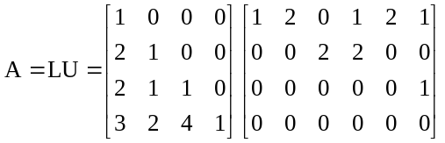.

a) What is the rank of A? Explain
b) Find a basis for the null space of A. Show your work.

c) Find a basis for the column space of A. Show your work.
d) For 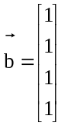 do solution(s) to 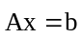exist? Clearly motivate your answer. Note that it is not necessary to compute the solution(s).

2. (30 points total, 10 points each)
TRUE/FALSE
Indicate whether the following statements are TRUE or FALSE and motivate your answers clearly.
a) If the vectors x₁, x₂, …., x_{m} span a subspace S the dimension of S is m.
*b) If for the m x n matrix A, always has at least one solution for every , then the only solution to 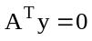 is 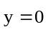.
*c) If A is an m x n matrix and B is an n x m matrix, and n < m, then the matrix AB is singular.

3. (30 points total)
a) (i) (10 points) Using Gram-Schmidt orthogonalization, create an orthonormal basis for R² from the basis vectors
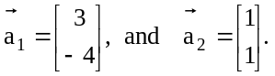
(ii) (10 points) Find the QR decomposition of the matrix
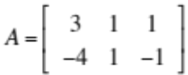

b) (10 points) The system 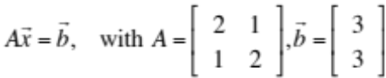 has the solution 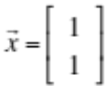. If we perturb the first element of b by 0.001, what is the maximum perturbation we can expect in the solution x?

