Statistical Analysis of California Public-Sector Procurement Trends
for ICM Solutions Workforce Planning
Luis Muniz
Master's in Artificial Intelligence Capstone
Capstone Project 2: Conduct a Statistical Analysis Using Python
July 25, 2026

Overview
This project analyzes five complete California fiscal years of public-sector procurement records to identify patterns relevant to ICM Solutions staffing and business-development planning. The analysis integrates closed bids from California Cal eProcure, the County of El Dorado PlanetBids portal, and the City of Sacramento PlanetBids portal, then separately applies the same screening rules to a current/open-bid snapshot. The central statistical question is whether the broad mix of ICM-relevant staffing demand differs by fiscal quarter.
The work is positioned as a procurement-intelligence component of ICM Solutions broader AI-enabled public-sector consulting intelligence and assurance concept. It does not train a machine-learning model. Instead, it uses reproducible data ingestion, descriptive statistics, visual models, a chi-square hypothesis test, and effect-size interpretation to convert public bid data into a cautious workforce-planning signal.

Dataset Description
The historical analytical dataset contains 29,646 procurement records with due dates from July 1, 2021 through June 30, 2026. It includes 28,107 California state records, 1,227 City of Sacramento records, and 312 El Dorado County records. The original source schemas were harmonized into common fields for source portal, jurisdiction, agency, solicitation ID, title, due date, status, fiscal year, and fiscal quarter. Derived fields include a composite record key, normalized status, title-based ICM relevance, detailed service category, and broad staffing-demand family.
The data were downloaded from the California Cal eProcure public portal, the County of El Dorado PlanetBids public portal, and the City of Sacramento PlanetBids public portal. The Cal eProcure exports use an .xls filename but contain an HTML table, so the notebook loads them with pandas.read_html(). PlanetBids records are loaded from UTF-8 CSV exports. All raw files are preserved in the submission, and the notebook writes a standardized CSV and data dictionary for reproducibility.
Table 1
Historical Dataset Composition and ICM-Relevant Screening Results
Jurisdiction level | Historical bids | ICM-relevant bids | Relevant rate
State | 28,107 | 160 | 0.57%
City | 1,227 | 9 | 0.73%
County | 312 | 7 | 2.24%
Note. Rates are title-based screening rates, not win rates, award rates, or estimates of contract value.

Methods

Initial Data Analysis and Reproducibility
The workflow separated initial data screening from the confirmatory hypothesis test. Lusa et al. (2024) describe systematic initial data analysis as a foundation for transparent, reproducible inference, including examination of missingness, distributions, and the implications of data properties for the analysis plan. Although the present records are procurement events over time rather than repeated participant measurements, that workflow principle is applicable: source structure, date coverage, missing analytical fields, and potential duplicate identifiers were evaluated before testing the research question. Baillie et al. (2022) similarly recommend an initial data analysis plan linked to the research objective and emphasize reproducible code, visualization, missing-data review, and reporting of consequences.
The five-year window was pre-specified to match five complete California fiscal years. Records outside the period and one local record without a usable due date were excluded from temporal analysis. A SHA-256-based composite fingerprint was created from portal, agency, bid ID, normalized title, and due date. No duplicate composite records remained. Thirteen source-agency-bid-ID groups repeated, but these were retained because the associated titles or dates differed and could represent amendments, reissues, or distinct postings rather than exact duplicates.

ICM-Relevance and Staffing-Family Classification
The portals did not share a complete commodity-code or scope-of-work field. A deterministic title-based ruleset was therefore used to identify explicit service terms aligned with ICM Solutions capabilities. The detailed categories were Software Development and Systems Integration; Data, Analytics and Artificial Intelligence; IT Consulting and Staff Augmentation; Cloud, Infrastructure and Cybersecurity; Organizational Change, Training and Process; and Project Management, Independent Verification and Validation, and Quality. Exclusions removed common false matches involving physical construction, guard services, unrelated laboratory or fire-system testing, roadway equipment, herbicide application, and product-only renewals.
The detailed categories were consolidated into two staffing-demand families for statistical testing. Technology Delivery contains software and systems integration, data and analytics, and cloud and cybersecurity. Advisory, Assurance and Change contains IT consulting, project management and IV&V, and organizational change and training. Each record retains the exact matched term or exclusion reason. A stratified classification-audit sample is included for human review. This procedure is a screening mechanism and does not establish that ICM is eligible for, qualified for, or capable of delivering the complete scope of any bid.

Descriptive Statistics and Visual Models
Frequency counts and proportions summarized categorical variables. Monthly counts and three-month rolling averages represented timing. Wilson 95% confidence intervals were calculated for jurisdiction-level screening rates because the city and county sources were much smaller than the state source. Four visual models were created: monthly relevant-bid volume, relevant rate by jurisdiction, staffing-family composition by fiscal quarter, and detailed service-category counts. The models were compared based on the business question each supports and the information each hides.

Hypothesis Test
The null hypothesis stated that staffing-demand family and fiscal quarter are independent among ICM-relevant historical bids. The alternative stated that the distribution of staffing-demand family differs across quarters. A Pearson chi-square test of independence was selected because both variables are categorical and the analysis compares observed contingency-table counts with counts expected under independence (McHugh, 2013). The significance level was set at .05. Expected cell frequencies were inspected, and Cramer’s V was reported to distinguish statistical significance from the strength of association.

Results

Descriptive Findings
The deterministic screening rules identified 176 ICM-relevant records, or 0.59% of the historical dataset. Technology Delivery represented 133 records (75.6%), while Advisory, Assurance and Change represented 43 records (24.4%). The annual relevant counts were 37, 36, 28, 34, and 41 across FY 2021-22 through FY 2025-26, respectively. The observed range does not show a monotonic growth pattern, although FY 2025-26 had the largest count and rate within the five-year period.
Table 2
Detailed ICM Service-Category Distribution
Service category | Bid count | Share of relevant bids
Software Development & Systems Integration | 79 | 44.9%
Data, Analytics & AI | 38 | 21.6%
IT Consulting & Staff Augmentation | 20 | 11.4%
Cloud, Infrastructure & Cybersecurity | 16 | 9.1%
Organizational Change, Training & Process | 14 | 8.0%
Project Management, IV&V & Quality | 9 | 5.1%
Note. Categories are mutually exclusive deterministic title classifications.
Figure 1
Monthly ICM-Relevant California Public-Sector Bids
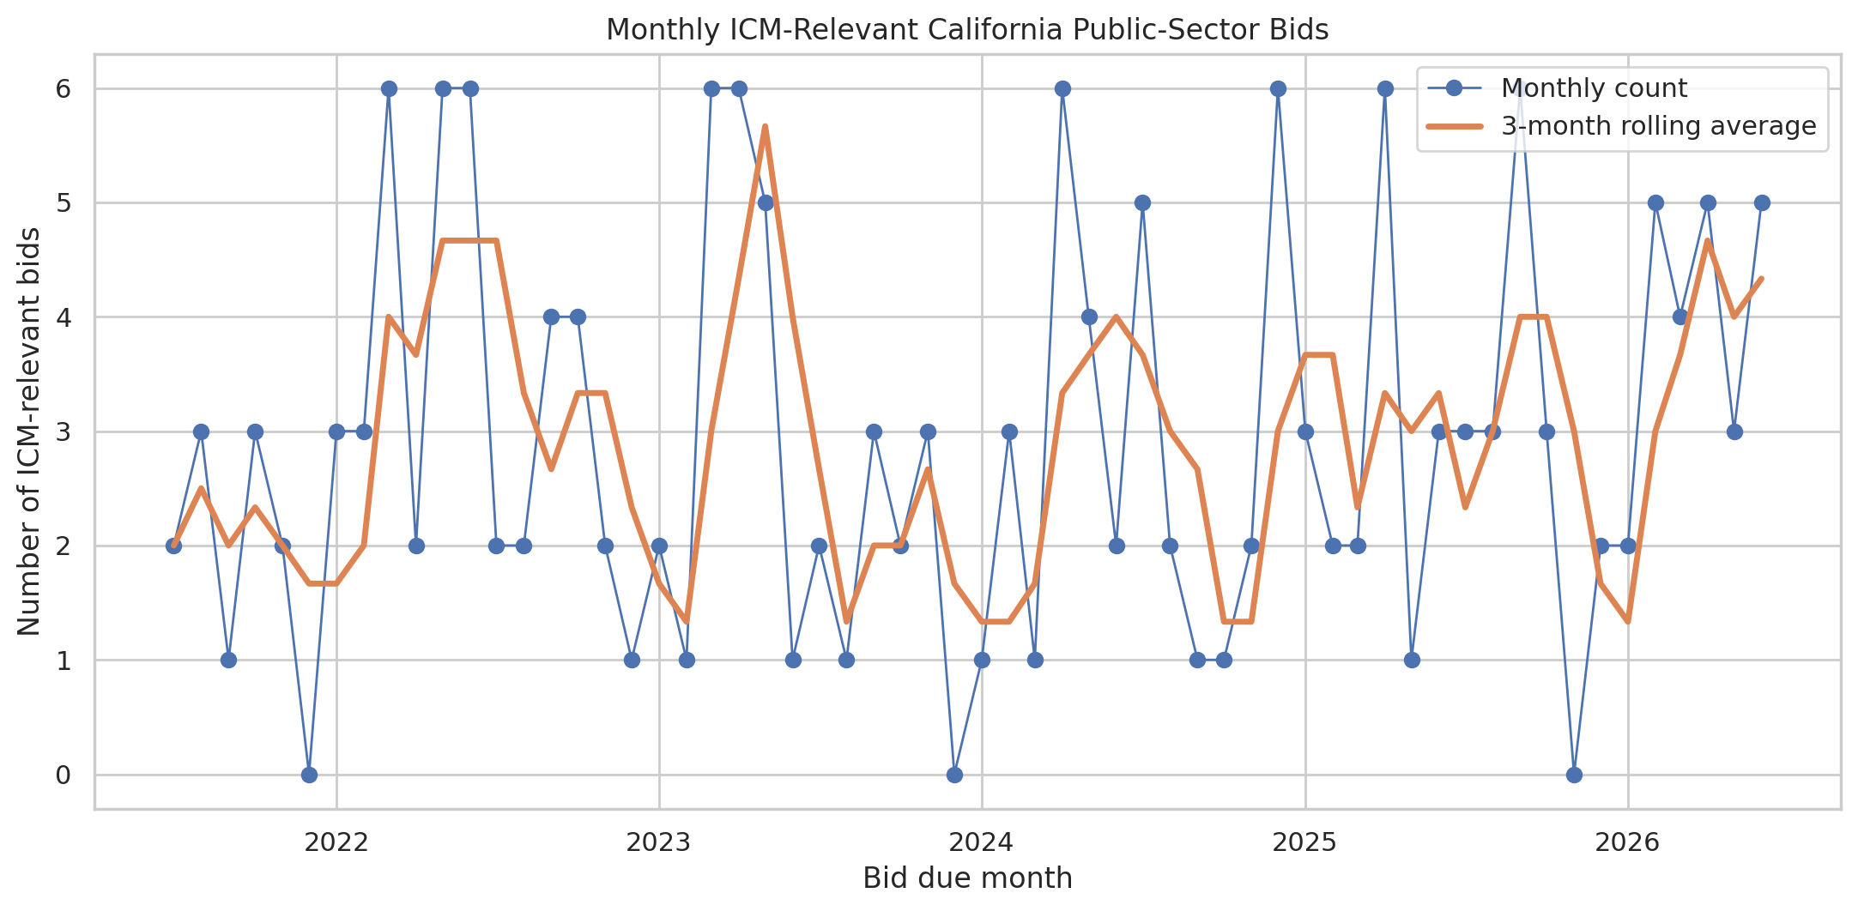
Note. The rolling average smooths monthly variation. Counts combine the three sources and therefore remain influenced by the much larger state source.
The monthly series contained occasional peaks of six relevant records and two months with no relevant records. The three-month rolling average generally remained between approximately one and five relevant bids per month. This suggests an ongoing but uneven opportunity flow rather than a single dependable annual surge.
Figure 2
ICM-Relevant Bid Rate by Jurisdiction
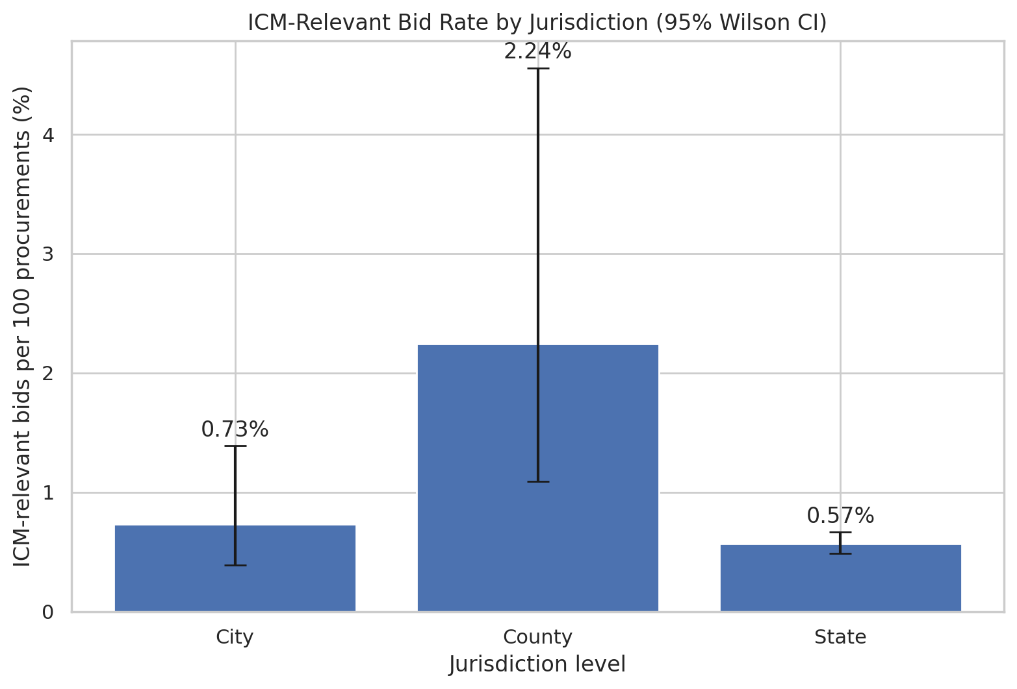
Note. Error bars are Wilson 95% confidence intervals. The county estimate is based on seven relevant records and therefore has substantial uncertainty.
The title-based relevant rate was 0.57% for the state source, 0.73% for the City of Sacramento, and 2.24% for El Dorado County. The county point estimate is higher, but its wide confidence interval reflects the small denominator of 312 records. Portal coverage, procurement mix, and title conventions also differ, so the result should not be treated as evidence that county opportunities are inherently more attractive.
Figure 3
Staffing-Demand Family Composition by California Fiscal Quarter
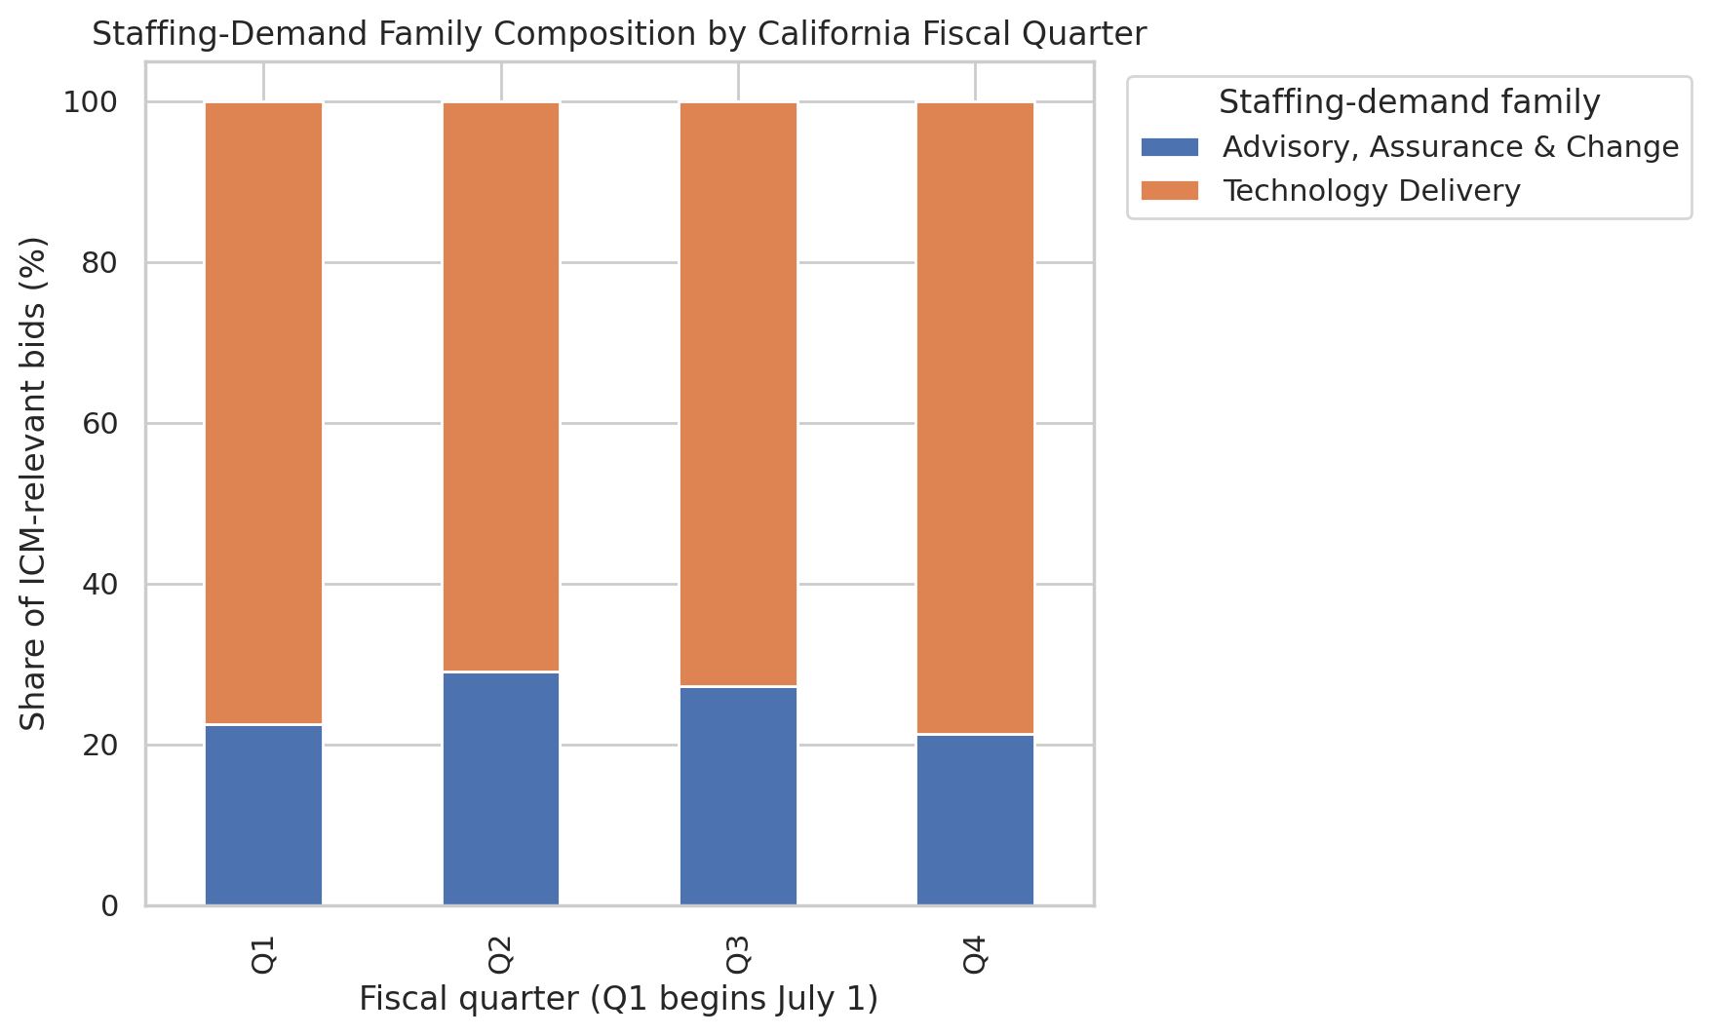
Note. Q1 is July-September. Percentages are calculated within ICM-relevant records for each fiscal quarter.

Figure 4
ICM-Relevant Historical Bids by Service Category
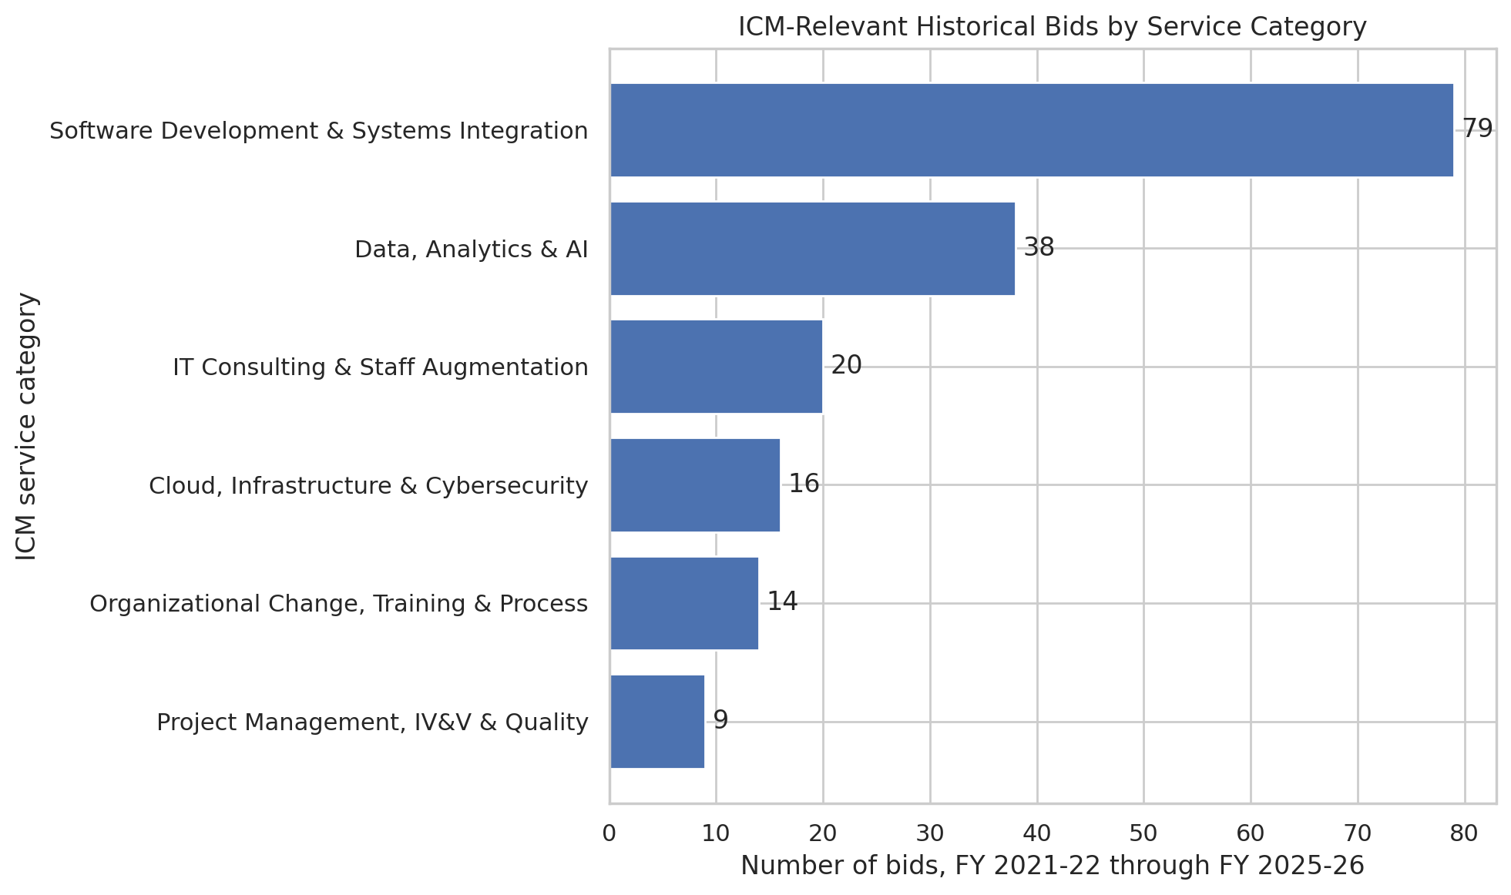
Note. Software Development and Systems Integration was the largest detailed category, followed by Data, Analytics and AI.

Comparison of Visual Models
Figure 1 is most useful for operational timing because it reveals monthly bursts and quieter periods, but it does not adjust for total procurement volume or source imbalance. Figure 2 places sources on a common rate scale and shows uncertainty, but it does not explain the service capabilities behind each rate. Figure 3 most directly supports the formal hypothesis because it compares staffing-family composition by quarter; however, its 100% scale hides absolute counts. Figure 4 is the clearest model for capability planning because it ranks the recurring detailed categories, but it does not show timing. Therefore, Figure 3 is the best visual model for the hypothesis test, while Figures 1 and 4 together are the best pair for ICM staffing decisions.

Hypothesis-Test Results
Table 3
Observed Staffing-Family Counts by Fiscal Quarter
Fiscal quarter | Advisory, assurance & change | Technology delivery | Total
Q1 | 9 | 31 | 40
Q2 | 9 | 22 | 31
Q3 | 12 | 32 | 44
Q4 | 13 | 48 | 61
Note. Pearson chi-square = 0.950, df = 3, p = 0.813, Cramer's V = 0.073. Minimum expected count = 7.57.
The expected-frequency assumption was satisfied because the smallest expected cell count was 7.57. The test produced chi-square(3) = 0.950, p = 0.813. Because the p-value exceeded .05, the null hypothesis was not rejected. Cramer's V was 0.073, indicating a weak observed association. The sample therefore does not provide evidence that the broad staffing-family mix systematically changes by fiscal quarter.
This non-significant result is substantively useful. It suggests that ICM should not plan major quarter-specific shifts between technology-delivery and advisory capabilities based only on these five years of bid titles. The result does not establish that every quarter is identical, and it does not rule out seasonality within a more specific service category. It indicates that the two broad families remain comparatively stable at the quarterly level in this dataset.

Current Opportunity Application
The separate current snapshot contained 306 open records, of which 5 matched the high-precision rules. These records included Microsoft 365 cloud development and support, online IT training, Genesys application support, CALNET managed cybersecurity, and Homeless Data Integration System maintenance and operations. This list is an operational review queue rather than part of the historical statistical test. ICM personnel must review the complete scope, eligibility rules, procurement vehicle, staffing levels, deadlines, and conflict considerations before deciding whether to pursue an opportunity.

Interpretation for a Non-Technical Audience
The analysis found that most ICM-aligned opportunities in the five-year sample involved building, integrating, supporting, or improving technology. Software development and systems integration was the largest category, and data, analytics, and artificial intelligence was the second largest. Together with cloud and cybersecurity, these Technology Delivery activities represented about three quarters of all relevant records. This supports maintaining or developing access to software, integration, data, and cloud/security talent rather than relying primarily on general project-management capacity.
The data did not show a reliable quarterly shift between Technology Delivery work and advisory, assurance, and change work. In practical terms, ICM should not assume that one fiscal quarter will consistently require software and data staff while another will consistently require project managers, IV&V personnel, or change-management specialists. A steadier core capability, supplemented by contractor relationships and current-bid monitoring, is better supported by the evidence than a large seasonal staffing cycle.
El Dorado County had a higher percentage of titles that matched ICM services than the other sources, but the county dataset was small and its estimate was uncertain. The result is best treated as a reason to continue monitoring local opportunities, not as proof that county work will generate more revenue or awards. Bid frequency alone does not reveal contract size, start date, win probability, or staffing effort.

Limitations and Potential Bias
The most important limitation is title-only classification. Titles can omit essential scope details, and generic words such as system, application, testing, security, and project management can describe either technology consulting or unrelated physical services. The analysis used conservative rules and explicit exclusions, but false positives and false negatives remain possible. The current and historical files also do not contain a common commodity code, full scope, estimated contract value, award amount, labor estimate, or incumbent information.
The source sizes and portal practices differ substantially. Cal eProcure contributes approximately 95% of the historical records, while the local portals contribute much smaller samples. Portal retention periods, naming conventions, cancellation handling, and use of amendments may vary. The lower City of Sacramento count in FY 2025-26 may reflect real procurement volume, incomplete portal coverage, or changes in posting practice; the dataset cannot distinguish among these explanations.
The chi-square test treats records as independent. Although exact composite duplicates were absent, repeated bid IDs and related solicitations may represent reissues or linked procurement events, which can weaken the independence assumption. The statistical test is also conditional on the deterministic classification framework. Different but reasonable service-category definitions could change the counts and the result. For this reason, the rules, matched terms, processed data, and audit sample are included in the submission.
A potential interpretation bias is equating solicitation frequency with addressable staffing demand. A single large modernization may require more labor than dozens of small bids, while many postings may be outside ICM eligibility or procurement vehicles. The analysis should not be used to infer agency preferences, automatically submit bids, or bypass human review. Ethical use requires transparent screening, validation against full solicitations, protection of contact information, and human accountability for pursuit and staffing decisions.

Next Steps
The most valuable next enhancement is to obtain commodity codes, full solicitation descriptions, estimated values, and award data where available. Those fields would support a better measure of addressable demand than title counts. ICM could also maintain the current-bid snapshot on a scheduled basis, add a human-reviewed training set for classification validation, and compare title-based results with commodity-code and scope-based classifications. Staffing decisions should combine this evidence with ICM pipeline probability, contract vehicles, current utilization, subcontractor availability, and expected start dates.

References
Baillie, M., le Cessie, S., Schmidt, C. O., Lusa, L., & Huebner, M. (2022). Ten simple rules for initial data analysis. PLOS Computational Biology, 18(2), e1009819. https://doi.org/10.1371/journal.pcbi.1009819
California Department of General Services. (n.d.). Cal eProcure. Retrieved July 25, 2026, from https://caleprocure.ca.gov/
City of Sacramento. (n.d.). Bid opportunities [PlanetBids vendor portal]. Retrieved July 25, 2026, from https://vendors.planetbids.com/portal/15300/bo/bo-search
County of El Dorado. (n.d.). Bid opportunities [PlanetBids vendor portal]. Retrieved July 25, 2026, from https://vendors.planetbids.com/portal/48157/bo/bo-search
Lusa, L., Proust-Lima, C., Schmidt, C. O., Lee, K. J., le Cessie, S., Baillie, M., Lawrence, F., & Huebner, M. (2024). Initial data analysis for longitudinal studies to build a solid foundation for reproducible analysis. PLOS ONE, 19(5), e0295726. https://doi.org/10.1371/journal.pone.0295726
McHugh, M. L. (2013). The chi-square test of independence. Biochemia Medica, 23(2), 143-149. https://doi.org/10.11613/BM.2013.018

