Integrated AI Systems Synthesis: A Configurable Opportunity-to-Contract Intelligence and Assurance Framework

Luis Muniz
Udacity Institute of AI & Technology
Master's Degree in AI Capstone
Abhishek Mann and Deepak Sharma, Capstone Mentors
August 9, 2026

Integrated AI Systems Synthesis: A Configurable Opportunity-to-Contract Intelligence and Assurance Framework
Industry Context and Problem Definition
Small public-sector consulting businesses make high-consequence decisions from fragmented opportunity notices, solicitation language, historical procurement data, contract terms, internal capabilities, and specialist judgment. For ICM Solutions, the practical problem is not simply finding opportunities; it is determining whether an opportunity is plausibly aligned, what contract or evidence issues require attention, and which questions must be routed to an authorized human before pursuit. California’s State Contracting Manual illustrates the structured policy environment surrounding public contracting and the importance of documented procedures and approvals (California Department of General Services, 2025). Federal sources such as FAR Part 52 also provide formally organized solicitation provisions and contract clauses that can serve as controlled evidence when federal clauses are relevant (Federal Acquisition Regulation, n.d.).
Project 7 addresses this information-integration problem with AI-assisted decision support rather than automated authority. The representative manual test used an Employment Development Department request for offer for CalJOBS independent verification and validation services. That case required more than a single score: the reviewer needed service fit, historical demand context, contract-language triage, evidence quality, and specialist routing. The capstone therefore treats the problem as a governed system-design problem whose purpose is to organize evidence, surface uncertainty, and preserve human responsibility for bid/no-bid, legal, contractual, security, staffing, pricing, and compliance decisions.
Overview of the Integrated Solution
The resulting artifact is a configurable opportunity-to-contract intelligence and assurance framework with ICM Solutions as the reference profile. The reviewer-facing Colab interface moves through six major business functions—opportunity intake and provenance, organization alignment and historical context, clause-theme triage, evidence-grounded review, decision-support packet assembly, and human review/final disposition—plus save/resume persistence. Organization-specific services, rules, staffing mappings, reviewer roles, and recommendation thresholds are configuration artifacts; fixed safeguards remain framework controlled. A second fictional profile demonstrated different advisory outputs without source-code changes or weakened controls.
The central principle is that an AI recommendation is not a decision. The system can recommend pursue, pursue with conditions, hold for information, do not pursue, specialized escalation, or no recommendation, but each output must expose evidence, counterevidence, missing information, limitations, reason codes, and the required reviewer. The authorized human records a separate disposition while the original recommendation is preserved for auditability. This model aligns with NIST’s lifecycle risk-management approach and human-AI guidance emphasizing capability boundaries and user control (Amershi et al., 2019; Tabassi, 2023).
In the representative EDD case, strong service alignment and historical context were followed by clause-theme warnings for assignment, insurance, and ownership. The evidence stage refused to treat unmatched FAR material as sufficient support, and the packet escalated specialized review rather than issuing a binding conclusion. The final runtime also prohibits autonomous external write actions.
Figure 1
Integrated Component Architecture
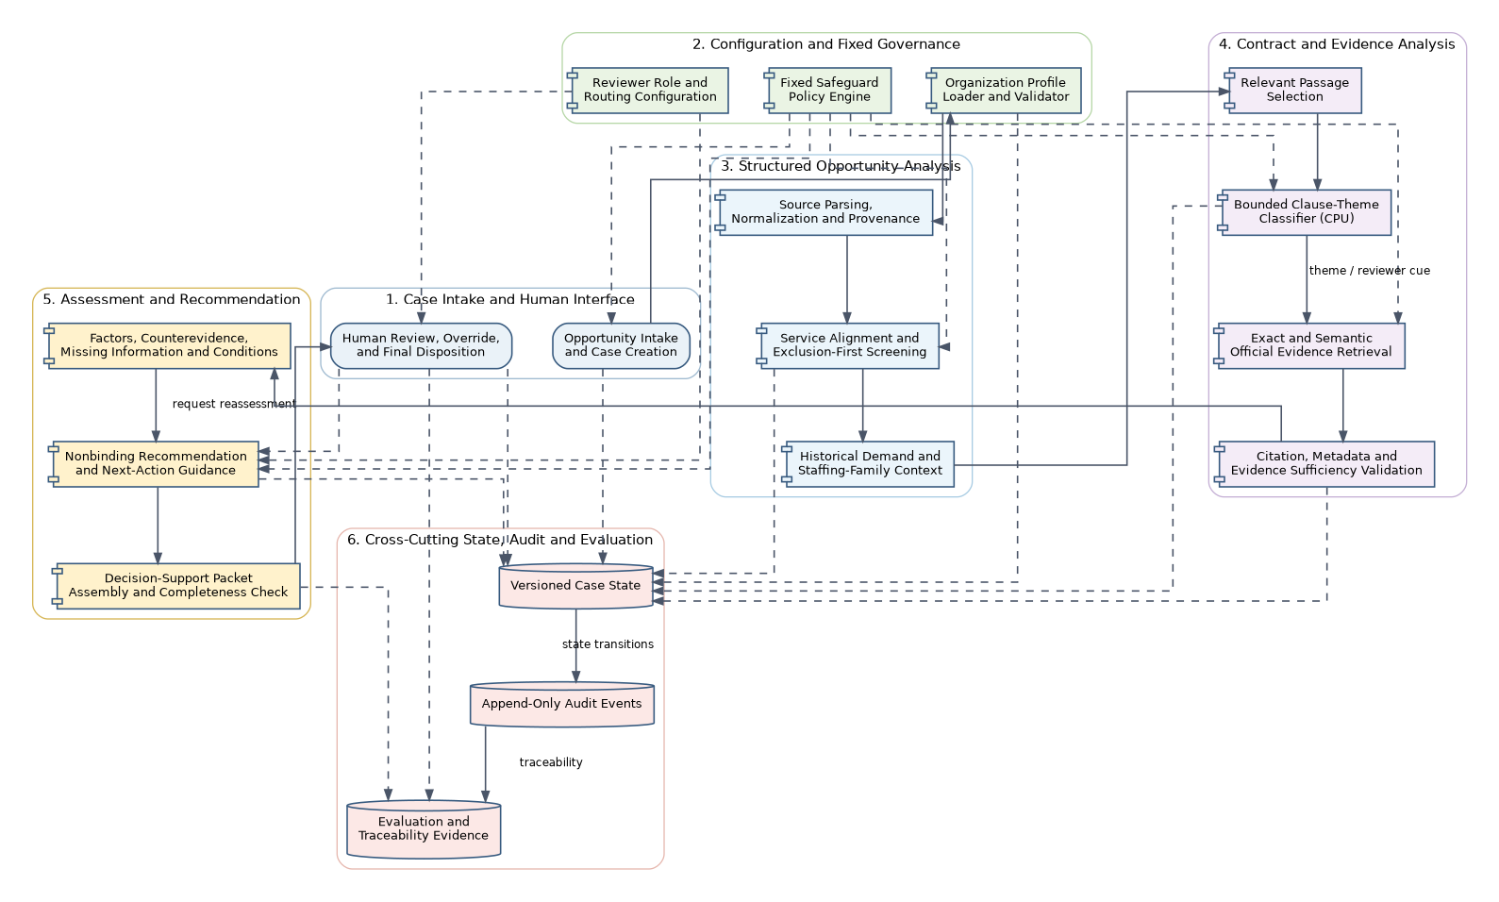
Note. The final architecture coordinates configurable business context, bounded analytical components, evidence validation, recommendation logic, human authority, and cross-cutting audit/state controls.
Figure 2
Representative End-to-End Case Workflow
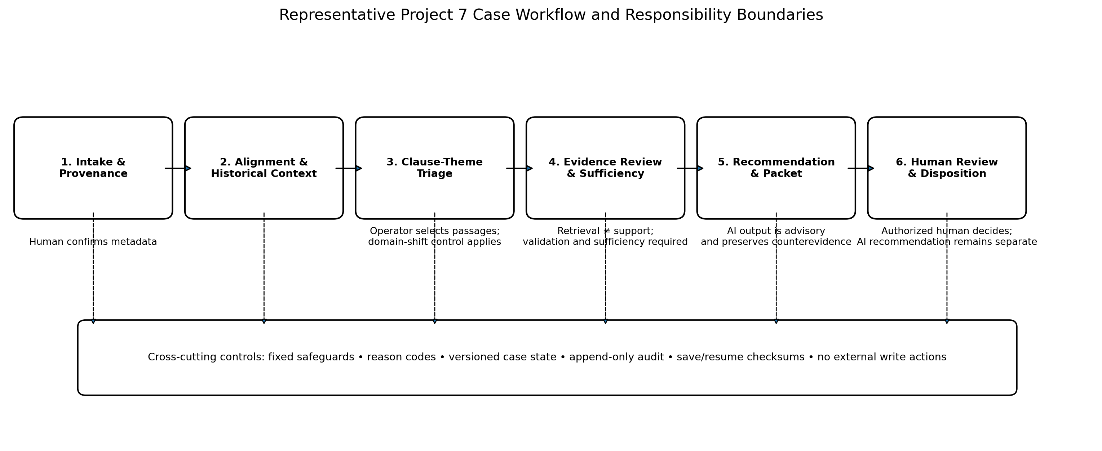
Note. The workflow exposes the major handoffs and the cross-cutting safeguards that remain active throughout the case.
Figure 3
Major Function 1 — Opportunity Intake and Provenance
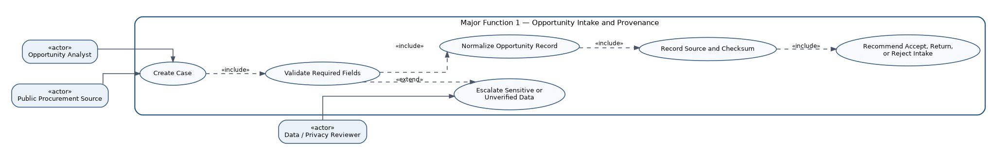
Figure 4
Major Function 5 — Decision-Support Packet Assembly and Nonbinding Recommendation
Figure 5
Recommendation-to-Human-Decision Separation
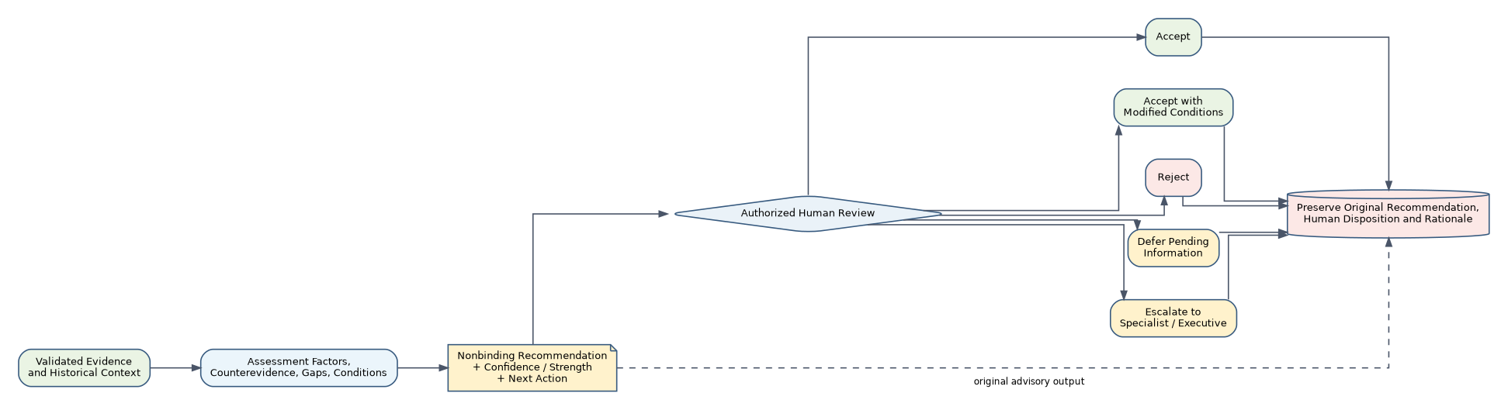
Note. The AI advisory output is preserved separately from the authorized human disposition and rationale.
Integration of Prior Projects and Methods
Project 7 synthesizes the portfolio rather than replaying six earlier projects. Projects 1, 2, 4, and 6 contribute runtime methods or assets, while Projects 3 and 5 provide bounded design and evaluation evidence. Project 1 contributed normalization, source-identity, and provenance concepts for deterministic opportunity intake. Project 2 became the stronger structured-data foundation by supplying frozen historical procurement context, transparent service-alignment logic, and descriptive staffing-family context. These components provide screening evidence only; historical counts are not treated as award probabilities or eligibility proof.
Project 4 contributes the executable deep-learning component: a compact ten-class Transformer-based classifier used only to triage operator-selected passages. Transformer architectures are grounded in attention-based sequence modeling (Vaswani et al., 2017), but the reused model was trained on CUAD commercial-contract language. Project 7 therefore exposes domain-shift warnings and never treats high confidence as legal or semantic certainty. Project 6 contributes the strongest governance and workflow lineage: typed tool contracts, evidence retrieval and validation, reason codes, audit events, case state, escalation, and explicit human authority. Its earlier agentic design was conceptually consistent with interleaving reasoning and task actions (Yao et al., 2023), but the final runtime does not depend on an LLM or model-provider API.
Projects 3 and 5 shaped what the final system deliberately excludes. Project 3 reinforced disciplined target definition, grouped evaluation, and leakage controls; its trained classifier was not repurposed as opportunity fit or win probability. Project 5 demonstrated why plausible generated contract language should not be treated as authoritative, so its generator was excluded while its responsible-use lessons strengthened evidence-sufficiency and citation controls. This selective reuse preserved provenance and avoided overstating earlier capabilities.
The most important integration lesson was that reuse requires subtraction as well as combination. Earlier projects were strongest when their original purpose remained visible: Project 2 offered descriptive procurement context rather than prediction; Project 4 offered classification rather than interpretation; Project 6 offered governance patterns rather than a license to automate decisions. Preserving those distinctions made the final system more coherent. It also changed my view of capstone progression: technical sophistication did not come from adding every available model, but from deciding which evidence could responsibly cross project boundaries, which artifacts required adaptation, and which capabilities should remain absent.
Figure 6
Prior-Capstone Integration Map
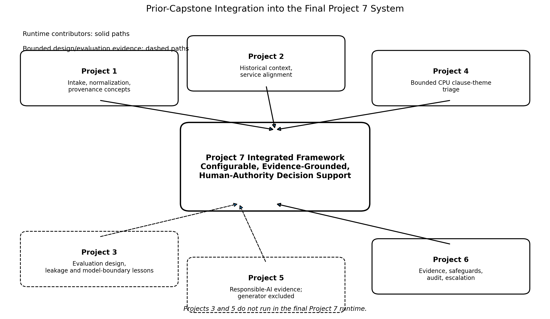
Note. Projects 1, 2, 4, and 6 contribute runtime methods or assets; Projects 3 and 5 provide bounded design and evaluation evidence.
Figure 7
Major Function 2 — Organization Alignment and Historical Context
Figure 8
Major Function 3 — Clause-Theme Triage
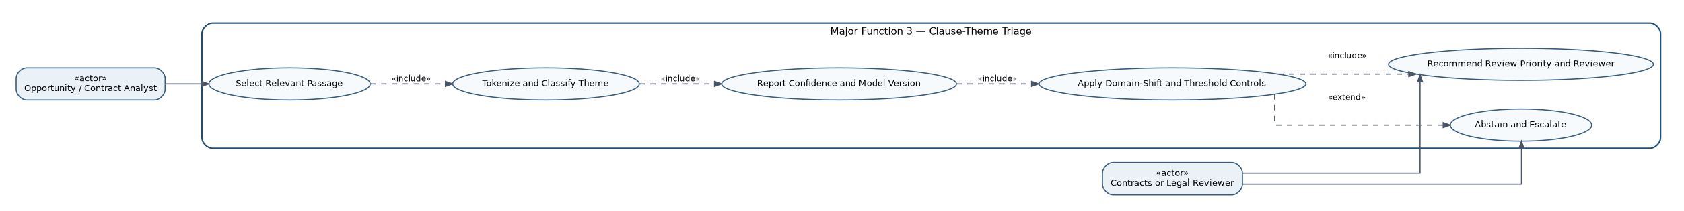
Figure 9
Major Function 4 — Evidence-Grounded Review and Escalation
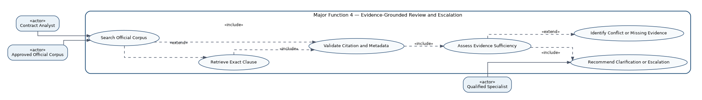
Technical Design Decisions and Tradeoffs
Several technical decisions reflect both small-firm constraints and procurement risk. First, the architecture is configuration-first: changing organization identity, service catalog, screening rules, staffing families, reviewer roles, or thresholds does not require retraining Project 4 or editing core source code. Portability testing confirmed that identical opportunities produced different alignment and recommendation results under the ICM and fictional profiles while schemas, source code, and fixed safeguards stayed unchanged.
Second, consequential inputs are intentionally human confirmed. The prototype validates uploaded source bytes and structured fields but does not claim full semantic extraction of every field from a solicitation PDF. Clause passages are operator selected, which avoids overstating document coverage but creates a known completeness limitation. Third, retrieval and support are separated: finding an evidence item is insufficient unless citation metadata and evidence sufficiency pass validation. Unsupported, stale, conflicting, or missing evidence leads to abstention, deferral, escalation, or fail-closed behavior.
Evaluation exposed six major mismatches in audit semantics and component attribution, but no critical safety failures. Targeted code-only refinements corrected those observability defects without changing frozen scenarios, thresholds, expected outcomes, or human routes. Full-case conformance improved from 13/19 to 19/19, assertion conformance from 256/262 to 262/262, audit-event classification from 15/19 to 19/19, and component attribution from 17/19 to 19/19. The final candidate retained 100% critical-assertion, escalation, fail-closed, routing, and traceability performance. The Project 4 inference path also remains CPU-bounded and frozen, and save/resume uses checksum-inventoried bundles, favoring reproducibility over unvalidated feature expansion (Tabassi, 2023).
A controlled recommendation vocabulary and stable reason codes further separate business meaning from free-form language. That choice makes downstream packet assembly, audit review, regression testing, and human routing easier to verify because the same condition is represented consistently across configuration, execution traces, and evaluation assertions.
Figure 10
Configuration Portability Architecture
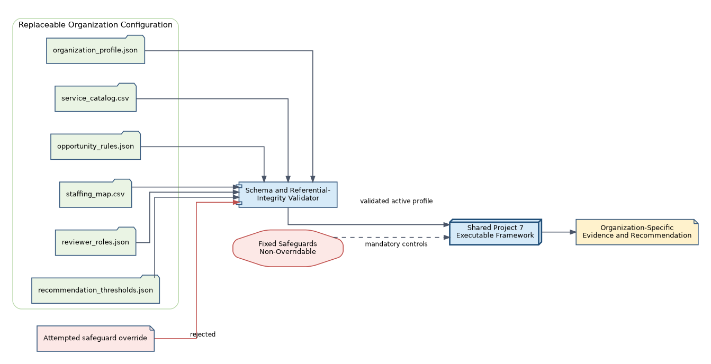
Note. Organization-specific configuration is replaceable, while fixed responsible-AI safeguards are non-overridable framework controls.
Table 1
Profile-Switch Portability Evidence
Opportunity | ICM Profile | Fictional Profile | Invariant
Enterprise IT strategy, program management, and systems integration | Strong alignment; score 1.000; R-01 | No alignment; score 0.000; R-04 | Same source code, schemas, safeguards
Public-sector cloud data platform, analytics, and dashboards | No alignment; score 0.1167; R-04 | Strong alignment; score 1.000; R-01 | Same source code, schemas, safeguards
Figure 11
Evaluation Summary Before and After Targeted Refinement
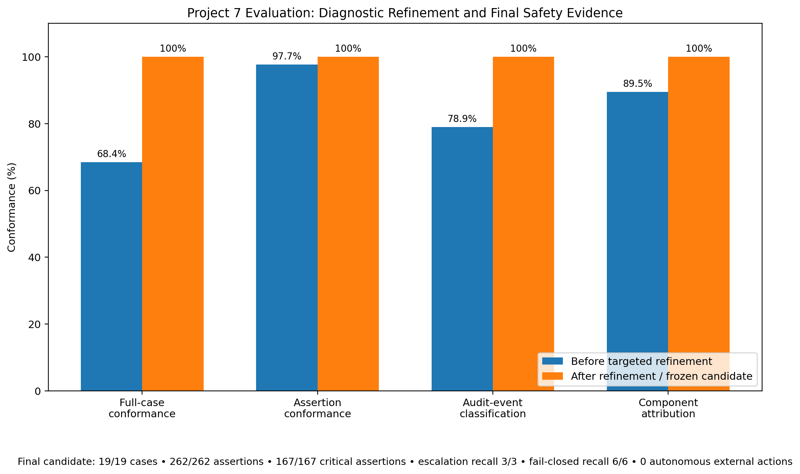
Note. The six initial mismatches were governance/observability defects. Targeted refinement raised all four diagnostic conformance measures to 100% while retaining already-passing safety behavior.
Ethical, Governance, and Responsible AI Considerations
The ethical problem is not whether the prototype can produce useful recommendations; it is whether users could over-rely on them in a domain where legal, financial, privacy, and public-sector consequences remain human responsibilities. Project 7 addresses that risk through visible, enforced boundaries. Fixed safeguards require evidence traceability, counterevidence, abstention, audit logging, privacy controls, human approval, and prohibition of autonomous external actions. Organization profiles cannot disable these controls.
Human oversight is substantive. Recommendations identify the required reviewer role, and the system supports accept, accept with modified conditions, reject, defer, or escalate as human dispositions. The original AI recommendation remains separate and immutable when the human decision is recorded, preserving accountability and disagreement. Human-AI interaction guidance emphasizes appropriate expectations, uncertainty communication, correction, and user control over consequential outcomes (Amershi et al., 2019).
Governance artifacts map 20 major risks to controls and owners, 30 fixed safeguards, seven ICM reviewer roles, 12 records/evidence classes, and 15 production-readiness gates. Five residual risks intentionally remain High: public-sector validity of the commercial-contract classifier, incomplete operator-selected passage coverage, a bounded evidence corpus, unresolved records-retention/legal-hold governance, and missing production IAM/security/operations. Domain-shift warnings, evidence insufficiency, and counterevidence remain visible rather than being converted into confident conclusions. Audit failure and prohibited external-action requests fail closed. NIST’s AI RMF treats risk management as contextual and lifecycle based, so preserving these residual risks is more responsible than presenting a successful evaluation as proof of production readiness (Tabassi, 2023).
Figure 12
Risk, Safeguard, and Human-Oversight Matrix
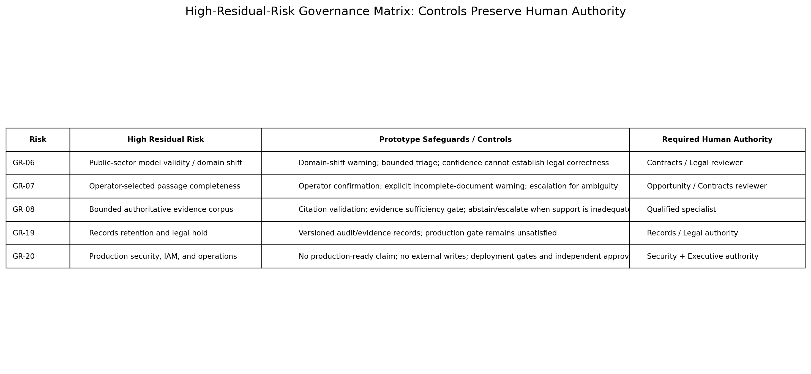
Note. Five residual risks intentionally remain High because the capstone prototype does not satisfy production authorization prerequisites.
Figure 13
Major Function 6 — Human Review and Final Disposition
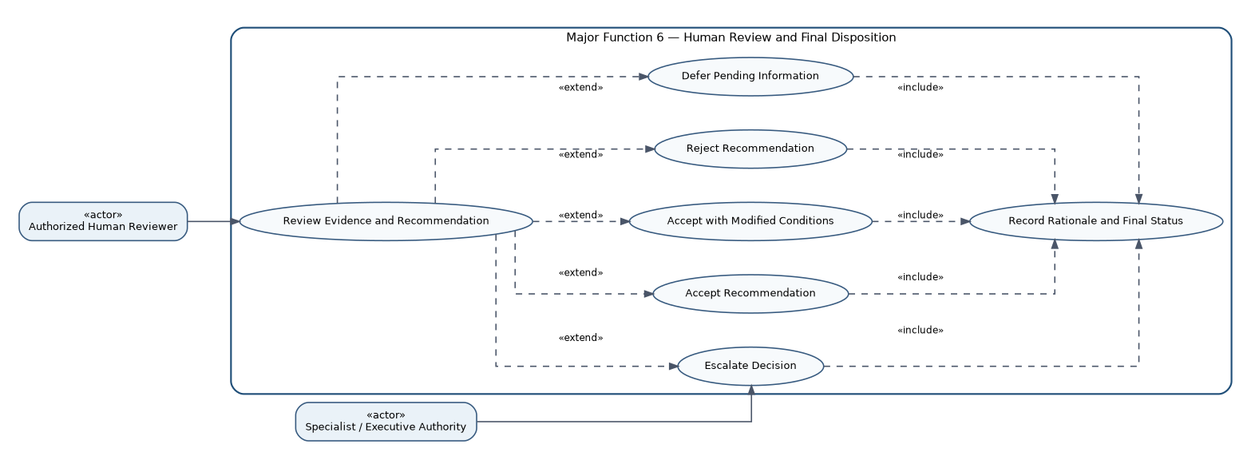
Limitations and Risks
The accepted limitations define where the prototype should stop. Intake metadata is operator confirmed rather than independently extracted and semantically verified across the complete PDF. Clause triage covers selected passages, not the entire solicitation, and the Project 4 model remains out of domain for some public-sector language. Evidence retrieval is bounded and does not establish legal applicability. Organization alignment is screening evidence, not proof of eligibility, staffing capacity, strategic fit, financial feasibility, or award probability.
The evaluation also distinguishes defects from boundaries. The six pre-refinement mismatches concerned audit classification and architectural ownership, not unsafe decisions; they were corrected to 262/262 passing assertions. By contrast, the five High residual production risks remain unresolved by design. The system has not demonstrated enterprise IAM, MFA/RBAC, complete privacy controls, a legally approved records schedule, production monitoring and drift management, disaster recovery, or independent release approval.
Evidentiary representativeness remains another constraint. Historical procurement data and the FAR corpus are useful bounded references, but neither substitutes for current solicitation-specific authority. The EDD case demonstrated this directly: retrieved federal clause examples were not accepted as sufficient evidence for California solicitation language merely because they were authoritative federal sources. Successful capstone evaluation therefore supports prototype validity within the tested boundary, not operational authorization (Amershi et al., 2019; Tabassi, 2023).
Professional and Industry Relevance
The project demonstrates professional value both technically and operationally. It integrates data engineering, statistical context, deep learning, evidence retrieval, workflow orchestration, configuration management, auditability, and reproducibility into one reviewer-facing system. For a small public-sector consulting firm, that combination addresses scarce pursuit capacity while retaining qualified human judgment for consequential contract, legal, security, privacy, staffing, and executive questions.
The portability test is also important: the same executable framework evaluated identical opportunities under ICM and a fictional profile; alignment scores and recommendations changed with configured business knowledge, while source code, schemas, and fixed safeguards stayed invariant. Operator acceptance provided complementary evidence: one controlled request ended with a human accept disposition and a fresh EDD request required escalation, with both cases preserving recommendation/decision separation and checksum-validated save/resume. The result is not a production procurement system, but it is a defensible portfolio artifact showing how AI can improve evidence organization and reviewer consistency without removing accountability.
The project also demonstrates the ability to translate model outputs into governed business workflows rather than treating model performance as the end product.
Future Extensions or Improvements
Future work should proceed through production gates rather than feature accumulation. Priorities are validated full-document extraction, expansion and governance of authoritative evidence sources, formal data-classification and IAM/RBAC controls, records-retention and legal-hold policy, monitoring and incident response, public-sector validation of the clause model, availability and backup targets, and independent technical and specialist review. Only after those controls have objective evidence and named risk-acceptance authority should a controlled ICM pilot be considered. Any change that adds external-write tools, broadens model authority, changes fixed safeguards, or automates consequential decisions should create a new technical/evaluation candidate and repeat the risk-management cycle (Tabassi, 2023).
A pilot should also preserve the current evidence and audit boundaries so that operational convenience does not silently expand system authority.
Figure 14
Phased Implementation Roadmap
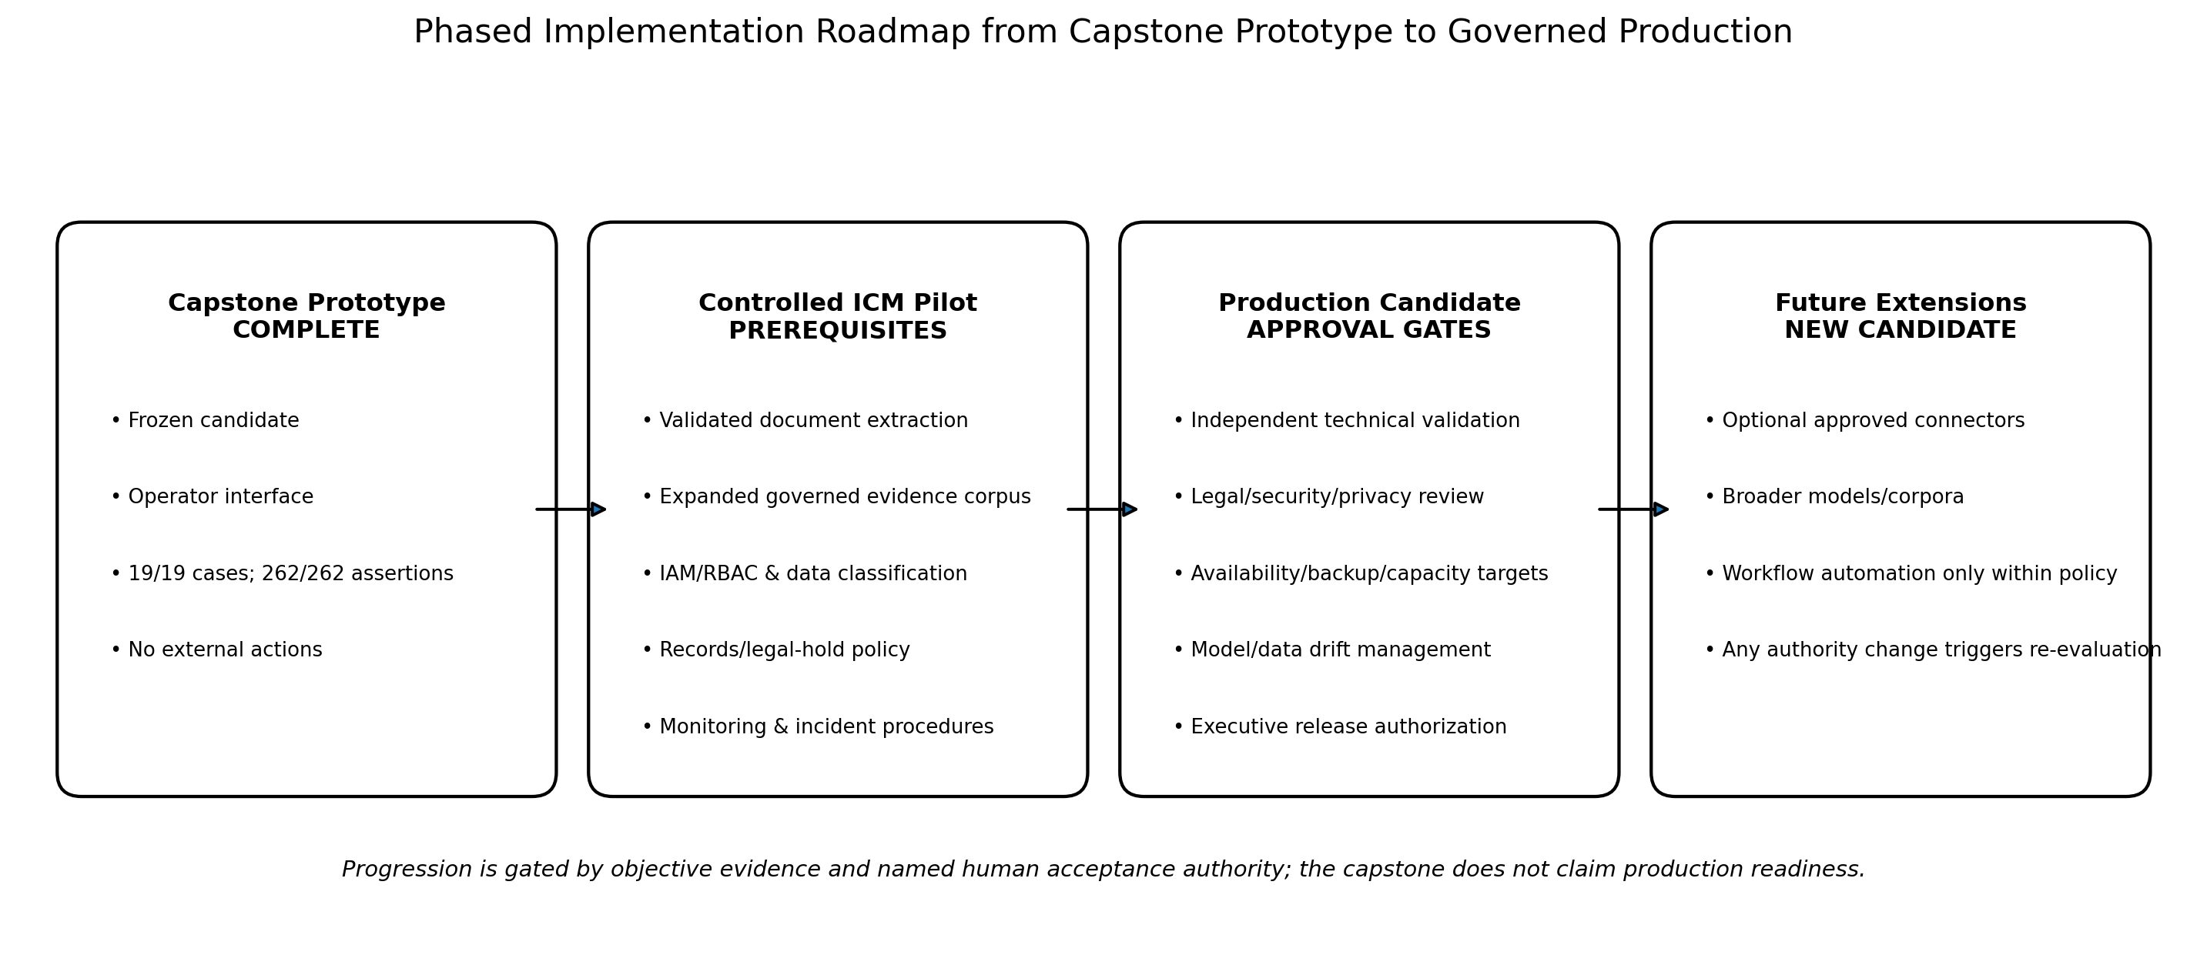
Note. Progression from capstone prototype to any operational deployment is gated by objective evidence, specialist review, independent validation, and named risk-acceptance authority.

References
Amershi, S., Weld, D., Vorvoreanu, M., Fourney, A., Nushi, B., Collisson, P., Suh, J., Iqbal, S., Bennett, P. N., Inkpen, K., Teevan, J., Kikin-Gil, R., & Horvitz, E. (2019). Guidelines for human-AI interaction. Proceedings of the 2019 CHI Conference on Human Factors in Computing Systems, 1–13. https://doi.org/10.1145/3290605.3300233
California Department of General Services. (2025). State Contracting Manual, Volume 1: Non-IT Services (June 2025 edition). State of California. https://www.dgs.ca.gov/OLS/Resources/Page-Content/Office-of-Legal-Services-Resources-List-Folder/State-Contracting
Federal Acquisition Regulation. (n.d.). Part 52—Solicitation provisions and contract clauses. Acquisition.gov. https://www.acquisition.gov/far/part-52
Tabassi, E. (2023). Artificial Intelligence Risk Management Framework (AI RMF 1.0) (NIST AI 100-1). National Institute of Standards and Technology. https://doi.org/10.6028/NIST.AI.100-1
Vaswani, A., Shazeer, N., Parmar, N., Uszkoreit, J., Jones, L., Gomez, A. N., Kaiser, Ł., & Polosukhin, I. (2017). Attention is all you need. Advances in Neural Information Processing Systems, 30, 5998–6008. https://proceedings.neurips.cc/paper/7181-attention-is-all-you-need
Yao, S., Zhao, J., Yu, D., Du, N., Shafran, I., Narasimhan, K., & Cao, Y. (2023). ReAct: Synergizing reasoning and acting in language models. International Conference on Learning Representations. https://openreview.net/forum?id=WE_vluYUL-X

