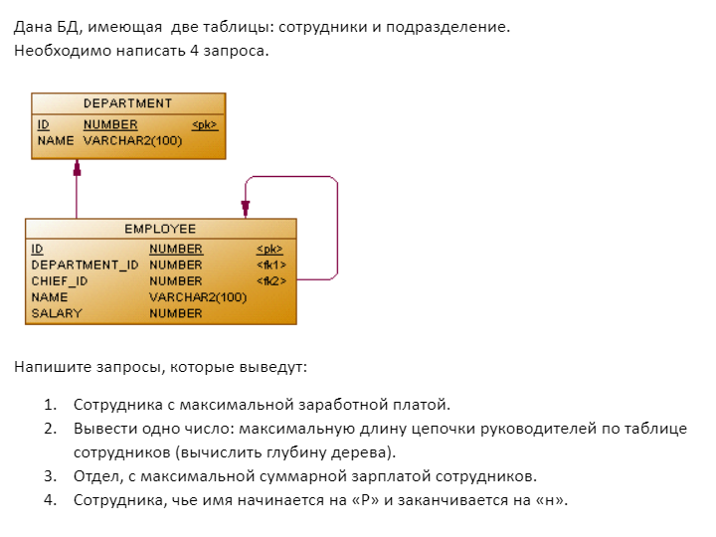

1.

select NAME  
from employee  
where salary = (select max(salary) from employee)

2.

with recursive cte as (  
select 1 as lvl, CHIEF_ID, id  
from employee  
where CHIEF_ID is null  
union all  
select lvl + 1, tab.CHIEF_ID, [tab.ID](https://vk.com/away.php?to=http%3A%2F%2Ftab.ID&cc_key=)  
from employee tab  
join cte  
on tab.CHIEF_ID = [cte.id](https://vk.com/away.php?to=http%3A%2F%2Fcte.Id&cc_key=)  
)  
select MAX(lvl)  
from cte;

3.

with salary_dep as (select DEPARTMENT_ID, sum(SALARY) as salary  
from employee  
group by DEPARTMENT_ID)  
select DEPARTMENT_ID  
from salary_dep  
where salary = (select max(salary) from salary_dep)

4.

select NAME from employee  
where NAME like 'Р%н'