**Cover Page**

Program Solicitation # ARPA-H-SN-24-06

Abstract Title: Miniaturizing X-Ray CT to Improve Access in Underserved Rural Areas

Submitter Organization: University of Texas at Arlington (UTA)

Type of Organization: Hispanic Serving, Educational Institution, Public, Nonprofit

Technical Point of Contact (POC): Andrew Makeev

Jenkins Garrett Professor, Mechanical and Aerospace Engineering, The University of Texas at Arlington

701 S. Nedderman Drive, Arlington, TX 76019

Cell Phone: (404)840-2378

[makeev@uta.edu](mailto:makeev@uta.edu)

Administrative POC: Elizabeth I. Merwin

Dean & Professor

College of Nursing and Health Innovation

Box 19407

411 S. Nedderman Drive, Arlington, TX 76019-0407

Cell Phone: (817)771-5487

[elizabeth.merwin@uta.edu](mailto:elizabeth.merwin@uta.edu)

Total Basis of Estimate: $16M

Place(s) of Performance: Arlington, Texas, USA

South Korea?

Japan?

Other Team Members (subawardees and consultants): Korean Institution? Ahn Bekay?

Samsung Electronics?

Shimadzu Corporation?

Any others?

For all subawardees and consultants

Technical POC Name:

Organization:

Organization Type:

2/27/2024

**CONCEPT SUMMARY**

UTA is proposing a novel concept of Mini X-Ray CT scanning/reconstruction to simplify advanced imaging for use in a mobile care delivery platform. Unlike the traditional CT technology, which is based on generating X-ray projections all around the patient, resulting in the bulky scanners, the proposed concept requires only a limited range of X-Ray projections around a stationary patient in lying down/sitting/standing position during the scan, resulting in a small footprint yet capable of the full-body scanning. The proposed concept of a versatile and reconfigurable mini-CT scanner utilizes modern cone-beam X-Ray source – flat-panel detector technologies and innovative iterative reconstruction software algorithms enabling full 3D CT reconstruction from the limited set of X-Ray projection angles. Generative AI will also be employed in the reconstruction to filter out any remaining artifacts in the simplified scanner configuration. Advanced (pulsed) X-Ray source and (photon-counting) detector technologies may further help increasing fidelity of the CT imaging. The proposed concept addresses the Technical Area 4 (TA4) of the draft ARPA-H PARADIGM Program Solicitation, by “building a miniaturized, ruggedized, self-shielded CT scanner by reimagining both the hardware and software design elements of the device,” as listed in the solicitation. Additionally, input from rural health care leaders and from clinical providers will be obtained and used to influence each phase of the project so that their ideas for this new minimized CT scan can be developed to best meet the needs of rural communities which have different needs and health care infrastructure. Strategies will be identified for integrating such a system into communities’ different types of outpatient settings, considering device design and operational innovations that mitigate traditional barriers to care such as lack of providers, transportation, health insurance and other funding challenges.

**INNOVATION AND IMPACT**

The traditional bulky medical X-Ray CT scanners include a motorized table for a patient, providing linear motion, and a line-beam X-Ray tube – detector system rotating 360° around the patient/table for a CT scan. The traditional CT reconstruction algorithms are also based on generating X-ray projections all around the patient. In a portable/mobile setting, the patient should remain stationary in lying down/sitting/standing position during the scan to save the space. Modern cone-beam X-Ray source – flat-panel detector systems enable advanced tomosynthesis technology for 3D reconstruction based on a limited range of X-Ray projections around a stationary patient, suitable for a full-body scan. The main challenge is that such systems are still using traditional FDK-like reconstruction software algorithms which need the full range X-ray projections all around the patient for accurate 3D reconstruction/images. While working relatively well in-plane, implying a horizontally-placed patient, these methods result in unacceptable distortions/artifacts in the vertical or out-of-plane cross-sections. UTA has recently developed iterative reconstruction algorithms and software to enable a high-fidelity full 3D CT-like reconstruction from the limited set of X-Ray projection angles. In collaboration with Shimadzu, the largest scientific research instrument manufacturer in Japan, UTA achieved an important milestone of industrial CT imaging – breaking through object size limitations of industrial X-ray CT, which makes possible, for example, the much-needed high-resolution nondestructive inspection, or NDI, of large aerospace composite structures[1]. X-ray CT has proven to be the only three-dimensional NDI technique with sufficient resolution and objectivity for automated interpretation of inspection results in a reverse engineering model, or a digital twin, including manufacturing flaws and damage affecting aircraft survivability. However, as we know, the traditional CT methods and equipment, based on generating X-ray projections all around the inspected object, are limiting the methods to high-fidelity inspection of small parts. Simply scaling up traditional X-ray CT systems to fit aircraft structure is not the solution, as this makes it impossible to detect critical flaws or damage in composites. The UTA researchers developed reconstruction algorithms and software tools for expanding X-ray CT to high-resolution NDI of large structures and paired these with new CT scanning hardware developed by Shimadzu. The result was a prototype CT NDI system that can conduct high-resolution three-dimensional NDI not possible with the conventional CT. The prototype inspected large aerospace composite structures with the fidelity required to detect and assess the flaws and damage. The proposed effort is the perfect opportunity to develop miniaturized compact/portable medical X-RAY CT scanners relying on the UTA’s reconstruction software technology. Tractable compact hardware solutions, resembling dental CT configurations, medical tomosynthesis systems[2], and C-Arm and dual-robotic solutions, with the range of motion/X-Ray projection angles optimized for a small footprint, are available, and will be utilized in the CT scanner design. Such hardware paired with a limited <<180° X-Ray projection angle range, next to a wall of the mobile care delivery platform, is also well-suited for a compact self-shielding of the miniaturized CT system. Such system is expected to be rugged enough to sustain the environmental variations of the mobile care platform. As an additional measure to reduce vibrations, the X-Ray source can be designed as a multi-source distributed system eliminating certain motions – reducing the number of degrees of freedom (fewer moving parts).

This project has a tremendous commercialization potential. It not only develops the miniaturized CT technology for use in mobile platforms in rural communities, but also will revolutionize the industry by providing high-fidelity 3D CT capability with minimum/no changes in the design of modern commercially available X-Ray/C-Arm/Tomosynthetic systems. Adapting available hardware solutions can also be the first step in the technology validation and FDA approval process. A Center for Rural Health and Nursing with active partnerships with rural communities throughout Texas will leverage use of their outreach nurse liaisons and recruiters to obtain community input to all phases of the work. A mockup of the mini-CT devise for a mobile care platform will be evaluated for usability and clinician satisfaction in a clinical simulation in our state-of-the-art Smart Hospital, a clinical simulation facility. Following revision of the mockup devise considering provider input, a revised working prototype device will be loaded on our Mobile Simulation Van (available 9/24) and will be evaluated in a rural community.

**PROPOSED WORK**

The first milestone will enable the high-fidelity CT capability in a medical Tomosynthesis system, like one shown in Figure 1, through the UTA’s iterative reconstruction software algorithms enabling full 3D CT reconstruction from the limited set of X-Ray projection angles.

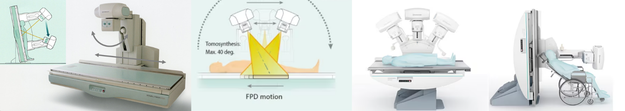

**Figure 1. Shimadzu SONIALVISION Medical Tomosynthesis System**

The next milestone will be the development of the Mini-CT scanner to simplify advanced imaging for use in a mobile care delivery platform. Both single as well as distributed X-Ray source – detector configurations will be considered. Figure 2 shows notional examples of such systems.

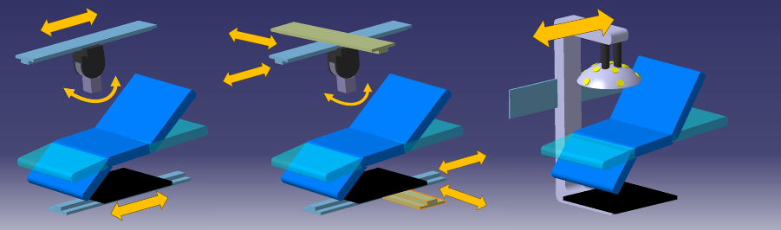

**Figure 2. Various X-Ray Source – Detector Configurations**

UTA will work in partnership with medical imaging industry including Samsung Electronics and Shimadzu. At least two working prototypes of the mini-CT scanner capable of performing diagnostic quality full-body scans and body region scans on human subjects, will be delivered in this effort. An evaluation of different types of outpatient settings present in rural communities in Texas will be completed. The unique needs of different organizational types such as Community Health Centers, Rural Health Clinics, Emergency Hospitals, Health Departments, Critical Access Hospitals, Home Health Services, etc. will be identified using available datasets and provider interviews/surveys. The mockup mini-CTs will be developed first and evaluated through clinical simulation in a Smart Hospital and in the community on a Mobile Simulation Van, followed by the development and evaluation of the working prototypes.

**TEAM ORGANIZATION AND CAPABILITIES**

UTA, the lead institution, is known for unique X-Ray CT imaging capabilities, complemented by data-driven modeling techniques and software tools advancing the state of the art in the digital twin creation, placing UTA as a pioneer in this emerging field. UTA’s Center for Rural Health and Nursing is also world-class. SHIMADZU, a subcontractor, is a world's leading manufacturer of advanced medical X-ray imaging systems with a very strong focus on portable/mobile technology, and more than 100 years' experience as the real 'Professionals of X-ray' technology. Shimadzu is also the world’s leader in medical tomosynthesis. UTA will also subcontract partners from South Korea, including Samsung Electronics, one of the leaders in medical imaging technology[3].

1. Robeson, M. (2023) U.S. Department of Defense Researchers Improve Survivability in the Air and in Space. *Aerospace America*, Year-In-Review, December 2023. <https://aerospaceamerica.aiaa.org/year-in-review/u-s-defense-department-researchers-improve-survivability-in-the-air-and-in-space/>
2. <https://www.shimadzu.com/med/products/index.html> and <https://www.shimadzu.com/med/products/app/m-k25cur0000003yxw.html>
3. <https://healthcare-in-europe.com/en/news/samsung-unveils-new-innovative-mobile-ct-omnitom-at-rsna.html>