Experiment

**Aim**: Design an Automatic Night Lamp.

**Circuit Diagram:**

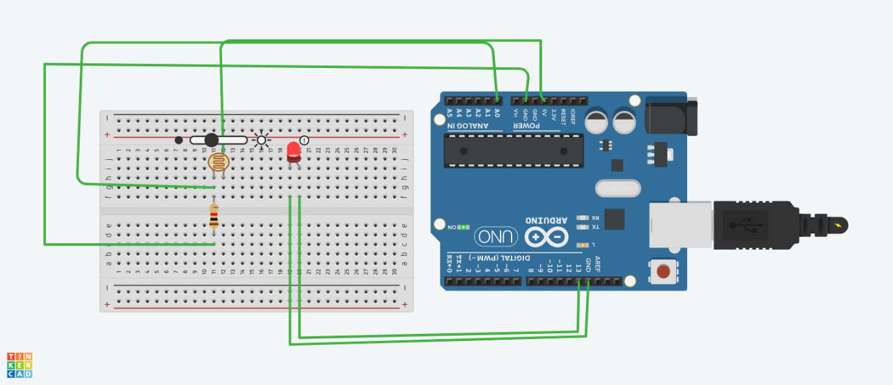

**Theory:**

**CONCEPT USED:**

1. We have used the concept of LDR (light dependent resistor).
2. The LDR is a special type of resistor which allows a lower voltage to pass through it (high resistance) whenever its dark and higher voltages to pass (low resistance) whenever there is a high intensity of light.
3. A photoresistor can be applied in light-sensitive detector circuits, and light -activated and dark -activated switching circuits.

**LEARNING & OBSERVATION:**

1. How to control Arduino and its coding.
2. Controlling of LED through Bluetooth.
3. Relation between software and hardware.
4. Connect Arduino to smartphone Wirelessly.
5. Resistance is inversely proportional to incident light intensity.
6. In dark, resistance become less and LED glows brighter and in light, resistance is more and LED is dimmer.

**PROBLEMS & TROUBLESHOOTING:**

1. To select the right port and type of Arduino.
2. To check the continuity of the circuit.
3. To check the flow of current in the circuit.
4. Errors in writing the code.
5. Check the range of sensor value for darkness correctly.
6. A resistor of proper resistance should be used to avoid fuse.
7. Connection should be tight.
8. LED should be checked earlier to avoid any error.

**PRECAUTIONS:**

1. Handle tools carefully.
2. Do not connect LEDs without a variable resistor.
3. Appropriate Bluetooth module to be used.
4. Correct PORT/ Board should be selected.
5. LDR should be working properly.
6. Resistor should be of suitable value.

**LEARNING OUTCOMES:**

1. How the waves are sent and received by sensor when object is detected.
2. Connect Arduino to phone wirelessly.
3. We have learnt the use and function of LDR which is light sensitive resistance.
4. 0 to 5 volts is indicated by the sensor value from 0 to 1023.
5. How to connect LDR and Arduino using breadboard.