SalesIQ
Intelligent Sales Analytics & Forecasting Platform
Project Report — AI/ML Internship Assignment
A plain-language walkthrough of what was built, why, and how it works.
github.com/icodervivek/SalesIQ

1. The Problem, In Plain Terms
Most businesses have years of sales data sitting in spreadsheets or databases. That data can tell you what already happened — but turning it into a useful answer to “what will we sell next month?” is genuinely hard to do by hand. You'd need to notice seasonal patterns, spot which products are trending up or down, and build some kind of statistical model — none of which a spreadsheet does for you automatically.
SalesIQ solves this by taking raw sales transactions, cleaning them up, and running them through a machine learning pipeline that produces an actual forecast — with a dashboard on top so anyone, not just a data scientist, can use it.

Who is this for?
Person | What they need
Sales / Business Manager | A quick read on performance and what's coming next
Business Analyst | The ability to slice data by product, region, or category
Operations / Inventory Team | Demand forecasts to plan stock and staffing
Technical Team | A pipeline they can run, evaluate, and maintain

2. What SalesIQ Actually Does
Think of SalesIQ as three things stacked on top of each other, each doing one job well:
- A data intake step — someone drops a CSV of sales history into the app. SalesIQ checks it for problems (missing values, bad dates, duplicates) and cleans it up automatically.
- An analytics dashboard — the cleaned data gets summarized into charts: revenue over time, top products, best regions, and so on. This is the part that answers “what already happened?”
- A forecasting engine — three different forecasting models are trained on the historical data, compared side by side, and the best one is used to predict the next 7, 30, or 90 days. This answers “what's likely to happen next?”
All of this is wrapped in a normal web app — no command line or notebook needed to use it day to day.

Feature List
Feature | What it does
Data Upload | Upload a CSV; the app validates required columns are present
Data Cleaning | Fixes/removes bad rows: missing values, duplicates, negative numbers, bad dates
EDA Dashboard | Revenue trend, growth rate, top products, region/category breakdowns
Feature Engineering | Builds the inputs the ML models actually learn from (behind the scenes)
Forecasting | Pick a horizon (7 / 30 / 90 days, or a custom number) and get a forecast
Model Comparison | See all 3 models' accuracy side by side, with the best one highlighted
Prediction Intervals | A shaded “confidence range” around the forecast, not just one number
Product/Region Scoping | Forecast a specific product or region instead of the whole business
Anomaly Detection | Flags days where sales were unusually high or low
CSV Export | Download the forecast to use elsewhere (Excel, another tool, etc.)

3. Tech Stack — and Why Each Piece Was Chosen
Every layer was picked for a specific, practical reason rather than “because it's popular”:
Layer | Technology | Why
Backend API | FastAPI (Python) | Fast to build, auto-generates interactive API docs
ML pipeline | Pandas, scikit-learn, statsmodels, XGBoost | The standard, well-tested tools for this kind of work
Database | SQLite by default, PostgreSQL via Docker | Zero setup for local dev; production-grade option available
Frontend | Next.js + React + TypeScript | A modern, fast, type-safe way to build the dashboard
Charts | Recharts | Clean, composable charts that fit a React app naturally
Styling | Tailwind CSS | Fast to build a consistent, professional-looking UI with
Packaging | Docker + Docker Compose | So anyone can run the whole stack with one command
Testing | Pytest | 22 automated tests covering the pipeline and the API

4. High-Level Design (HLD)
The system is split into three independent layers that only talk to each other through clean interfaces — this means each one can be tested, changed, or even replaced without breaking the others.
- Frontend — the Next.js dashboard. It never touches the database directly; it only calls the backend's REST API, the same way any external client would.
- Backend — a FastAPI application. Its only jobs are: validate incoming requests, call the right piece of ML code, save the result, and send back JSON.
- ML pipeline — plain Python code (no web framework in it at all) that does the actual data cleaning, feature building, model training, and forecasting. Because it doesn't know anything about FastAPI or HTTP, it can be tested on its own or reused from a notebook.
A small database (SQLite for local use, PostgreSQL when running with Docker) stores uploaded datasets, training results, and forecast history so they don't have to be recomputed every time.

In one picture
Browser → Next.js Frontend → REST API (FastAPI) → ML Pipeline (pandas / scikit-learn / statsmodels / XGBoost) → Database
↕
Docker packages all of this together

5. How a Request Actually Flows Through the System
Here's what happens, step by step, from uploading a file to seeing a forecast on screen:
- Upload — a CSV lands on the Upload page and is sent to the backend.
- Validate — the backend checks the required columns exist and reports back what's wrong, if anything (bad dates, missing fields, etc.).
- Clean — rows with unrecoverable problems are dropped; recoverable gaps (like a missing unit price) are filled in sensibly; extreme outliers are dampened rather than deleted.
- Store & report — the cleaned dataset is saved, and a summary of what was found/fixed is shown back to the user immediately.
- Analyze — on the Overview page, the backend aggregates the clean data into KPIs and charts on request.
- Train — the backend builds calendar/lag/rolling features from the daily sales numbers, trains all three forecasting models on data before a cutoff date, and tests them against the days after that cutoff — never letting the models see the future during training.
- Forecast — using the best (or a chosen) model, the backend predicts forward for the requested horizon and returns both a forecast line and an uncertainty range.
- Display — the frontend draws the forecast chart, distinguishing historical data from the predicted future, and offers a CSV download.

6. Dashboard Walkthrough
The screenshots below are from a live run of the app against the bundled sample dataset — not mockups.

6.1 Overview Page — “What already happened”
This is the home page. Four KPI cards up top give the headline numbers — total revenue, units sold, average order value, and how many products are being tracked, along with a week-over-week growth indicator. Below that, a revenue trend chart shows the whole history at a glance, and a “Top Products” list ranks what's selling best.
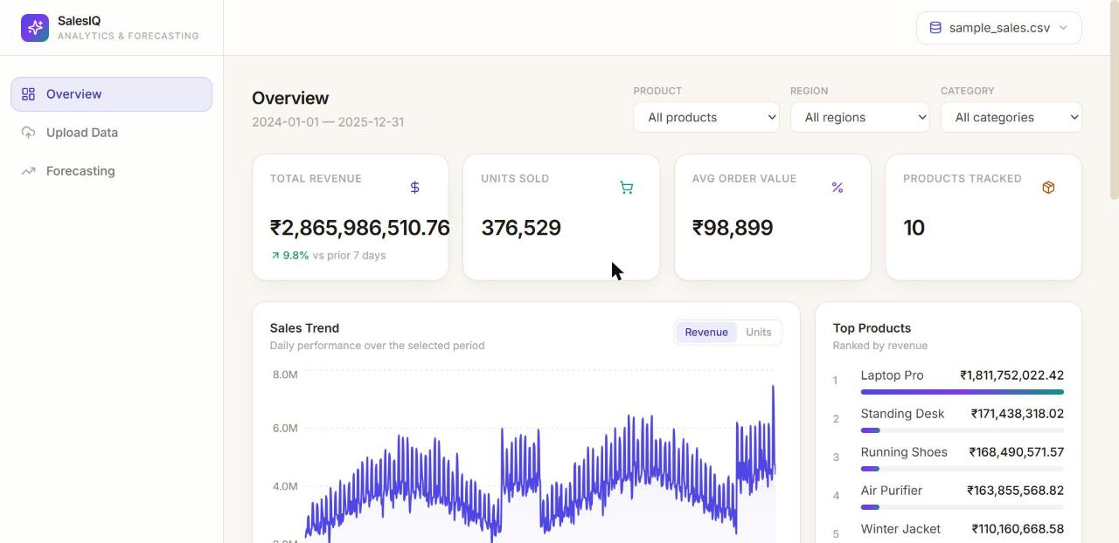
Overview — KPI cards and the revenue trend chart
Scrolling down, two bar charts break revenue down by region and by category, so you can spot which parts of the business are carrying the most weight. Underneath that is a Data Quality panel — this is the app being transparent about what it found and fixed in your uploaded file (missing values, duplicates, and so on), rather than silently changing your data.
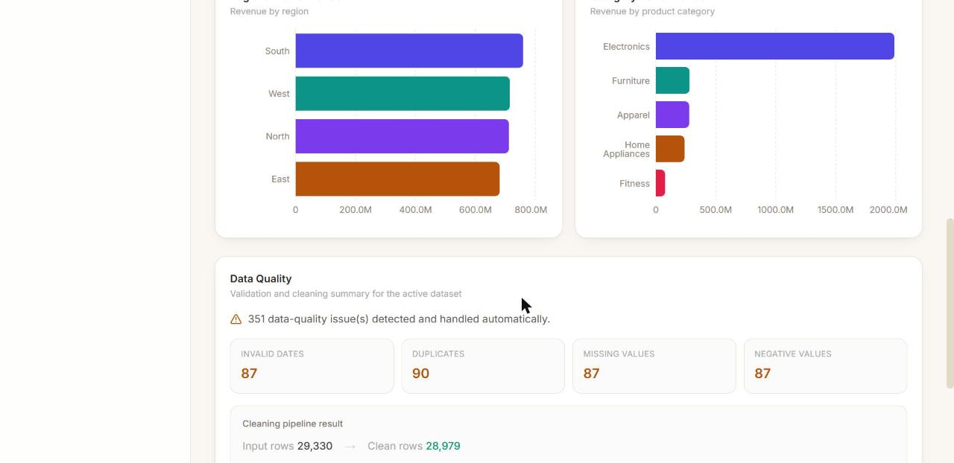
Regional/category performance and the data-quality report

6.2 Upload Page — Getting your data in
A simple drag-and-drop zone accepts a CSV file. Below it, a reference table lists exactly which columns are required, which are recommended, and which are optional, so there's no guessing about the expected format before you upload.
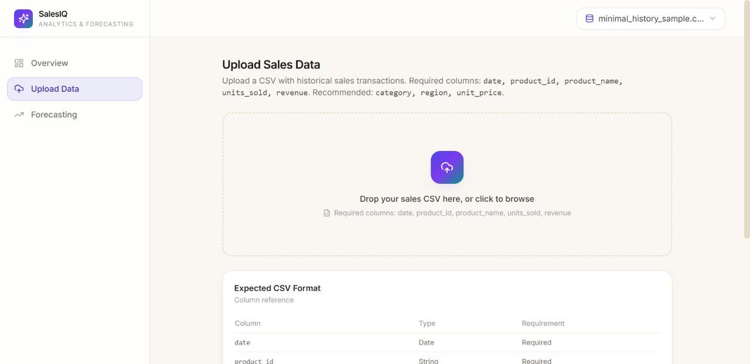
Upload page with the expected CSV column reference

6.3 Forecasting Page — “What's likely to happen next”
This page has three steps. First, choose a scope (all data, or a specific product/region) and click Train Models — this runs the baseline, SARIMA, and XGBoost models and shows a comparison table with accuracy metrics (MAE, RMSE, MAPE, R²), with a trophy marking the best-performing model. A chart underneath shows how that model's predictions lined up against actual historical values it wasn't trained on.
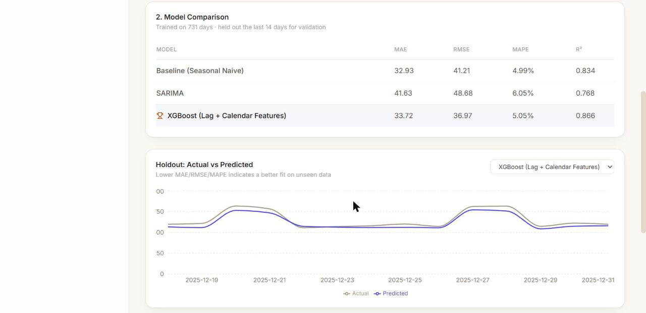
All three models compared on the same holdout data
Second, pick a forecast horizon (7, 30, 90 days, or a custom number) and a model, then click Generate Forecast. The resulting chart clearly separates the solid historical line from the dashed future forecast, with a shaded band showing the range of likely outcomes — and a button to export the numbers as a CSV.
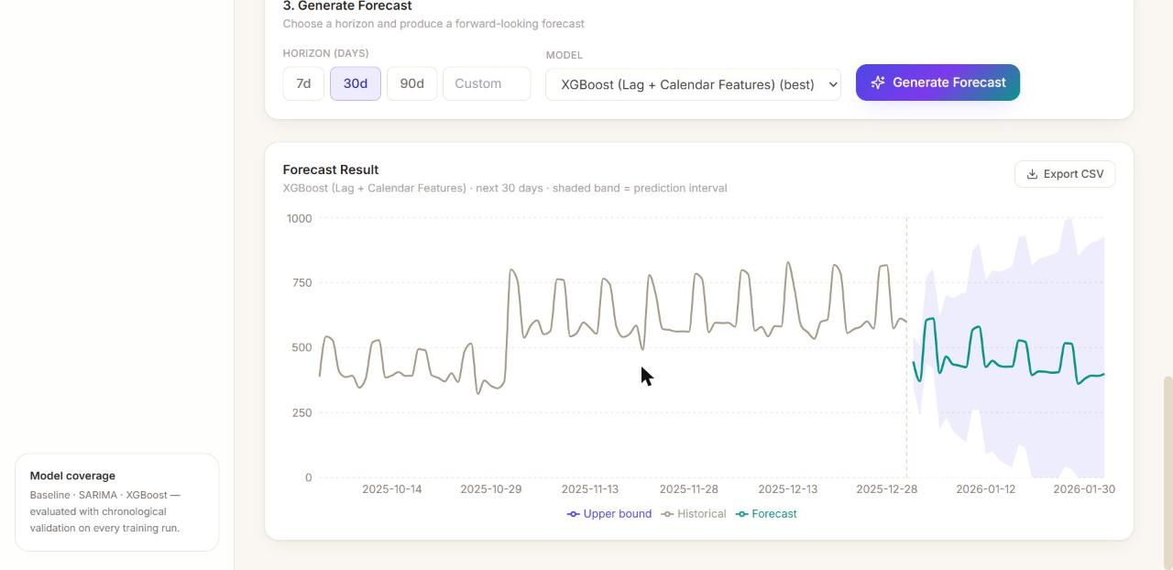
A 30-day forecast with historical data and a prediction interval

7. The Machine Learning, Explained Simply
Three different forecasting approaches are trained and compared every time, rather than committing to just one:

The Baseline — Seasonal Naive
The simplest possible forecast: “assume today looks like the same day last week.” It costs nothing to compute, but it's surprisingly hard to beat when sales have a strong weekly rhythm (which most retail data does). Its whole purpose is to be a fair bar that the smarter models have to clear — if a complex model can't beat this, it isn't actually adding value.

Model 1 — SARIMA
A classical statistics model that explicitly models trend and seasonality (in this case, a 7-day weekly cycle). It's the kind of model a statistician would reach for, and it comes with built-in, mathematically principled confidence intervals.

Model 2 — XGBoost
A machine-learning model that looks at patterns like “what were sales yesterday / last week / last month,” “is today a weekend,” and a few business signals (discounts, marketing spend, and how a product's category is trending), and learns which combinations predict tomorrow's sales best. It's the most flexible of the three and, in testing on the bundled dataset, came out on top.

How they're tested fairly
Every model is trained only on the older portion of the data and tested against the most recent two weeks it never saw during training — never shuffled, so no model ever accidentally “peeks” at the future. That's the same discipline a real production forecasting system needs.

Actual results (not illustrative — this is a real run)
Model | MAE | RMSE | MAPE | R²
Baseline (Seasonal Naive) | 32.93 | 41.21 | 4.99% | 0.834
SARIMA | 41.63 | 48.68 | 6.05% | 0.768
XGBoost (winner) | 33.72 | 36.97 | 5.05% | 0.866

Lower MAE/RMSE/MAPE is better; higher R² is better. XGBoost wins on RMSE, meaning it made fewer big mistakes overall — though the baseline is unusually strong here, which is a genuine and honest finding: this dataset has very regular weekly seasonality, so a sophisticated model only has a modest edge over a simple one. That's a useful, realistic result to report rather than hide.

8. Running It Yourself
Two ways to get it running:
- Option A: Docker (easiest) — run
docker compose up --build
then open http://localhost:3000 for the dashboard.
- Option B: Manual — start the FastAPI backend with
uvicorn app.main:app --reload
and the frontend with npm run dev; full step-by-step instructions are in the repository README.

9. Conclusion
SalesIQ demonstrates the full journey a real sales-forecasting product has to make: getting messy real-world data into a trustworthy state, understanding what it shows, building multiple forecasting models and honestly comparing them, and putting the result in front of a user through an actual working dashboard — not just a notebook full of numbers.
22 automated tests, 6 sample datasets covering both the happy path and edge cases, and a written model evaluation report back up every claim made in this document.
github.com/icodervivek/SalesIQ

