

**ENGLISH EXAMINATION  
SYSTEM**

COMP1108 :Project – for External Programmes

Center: FPT-GREENWICH (HCMC, Vietnam)

Student Name: Nguyen An Cat

**Acknowledgment**

In time when I did the project, Mr … who give me the feedback and recommend me a lot. But I know I’m not good in development, lack of experience , not good in control time for this project. So that why in this time, I met many mistakes and limit functionality, and feedback from tutors make me realize our mistake. And what the right way to continue the project.  
  
During this time, I learn many experience, and understand deeply about my knowledge, and understand deeply about my technology. It increase my knowledge. And after that, I want to say thank one time, Mr ...

**Abstract**

Try to increase performance, and requires all general parts, that need to apply technology, new technologies, and bring information, get requirements from customers and users can do English multichoice by level and age, get the points, and can add questions and answers.  
Try to develop an multichoice, English examination, and we need to have question and answers library.  
  
I hope customer’s English skill for users, based on levels and age of the customers.  
Try to create good performance for our products, make good UX.  
Some level of this is defined : Easy, Medium, Hard...

1. **Introduction**

* **Background information:**  
  English is an international language, so that why, not body the time is not less, and every do not have enough time to study English, we can’t learn by the way communicate with the foreigner, but we can’t study grammar by communicate and listening.
* **Project aim and objective**

Purpose of this project was created to help peoples can study grammar and listening languages  
In this project there are some numbers of problems

* We need time to get some questions and answer.
* We need some tutor has understand deeply about the English skills.
* We need to create some levels about exams or test.
* And the systems can’t calculate the point for total of exams.

The system has some functions recommends for this system.

* Cool templates. Eye-catching interfaces, easy to use, easy to understand.  
  Why we need a goods user interface, because the user when they feels bad UI, they don’t want to come back with this system.
* For details, they can take the exams with some levels, for example : beginner , intermediate. Medium or advances, something like that.
* The systems can’t provide some short-time practices, maybe the maps and the contact from customers and users.

1. **Literature review**

* **Introduction**
* In this system, we have some levels for this English exams: easy, medium, advances, intermedia.
* Because the English is an intermediate language, so people need the system can help them to improve their English skills .
* In Vietnam, when the Kids were young, their parents advices their children communicate with foreigners, and their parent want their child will study English as soon as possible.
* And system has some the notification about the exams and some classes will be begin at the next time for the candidate or the tutor, the student need to study English.
* Vietnam belongs Asian, and with English, it’s necessary, we need to study English at secondary schools. With beginner level, we will study from School, at the English center. We will ensure the users and the tutors will be favorites with this system, make this system to be bigger.
* **Economic situation**
* With above conditions, they will need a system, a place to study English, and one system can help people know and evaluate their knowledge and skills.
* And English Club Website will bring you into the exam and test, the news and the notification from systems.
* And the user will lost too much time to take the exams.
* **Causes and remedies**
* With this system, users can evaluates their knowledges, and they know their skills to improve with the English club class or something like that.
* If they have right strategy to study, they will choose the levels to take the exams.
* They will get the notifications and news from the systems, can register and take the exams.
* **Conclusion**
* Based on the above conditions, which is one a good way to make sure create the systems, and the exams for the users, and the guys want to know the knowledge. And the exams will get from the tutors and the teacher in control panel.

1. **Advertising in internet**With our system, if compare with the other system in Internet. The first time system will be free in Internet. Open for everyone, they just register easily, and login easily too.   
     
   Don’t need to confirm email to verify account. Because it costs a lot of time for candidate.  
   Just focus about the test, and examinations. And customer can see their result to check their knowledge and environment.  
     
   After that, we can provide the information about this club and notification from this club.  
     
   Based on that, we will create the system auto define the level based on age. I will try to develop it with my best.  
     
   But I don’t think it’s effectively with Vietnamese. But I love that ideas. It’s not a bad idea.
2. **System Requirement Specifications  
     
   Scope**

In fact, the WWW has created the new technologies to the billions of people around the world, so that why Internet becomes the new methodologies and functionalities and good platform to marketing online and SEO for English club, tend to get the user register, in order to big system for English Club.

English Club is a test system, an examinations for the users to check their skills and improve their knowledge, and want to share for every one. Users can register account via the web, and they can’t input basic theri information about them. They need to login into the system.  
  
And the web can managed by Admin and teacher / tutors. And everyone can log into the system like students and candidates.

This system is very useful users and for the customers and the people because when someone need to check their knowledge , and the information sharing with the admin will be kept at the system, and all information that will be confirmed by the website administrators , in order to enhance the prestige and credibility of the site for users.

**Objectives**

The system must have the login sessions.The register dialog will be appeared after they invoke the register functionality.

Administrator can manage and by the system, and maintenance of the system.

Admin is the property management and maintenance of the system.

This system allows customers can submit and change your personal information and the administrator can check the user's profile.

**Overall description**

* 1. **The Proposed System**

System help users to test their knowledge, and improve their English skill

Admin: will manage the account information of the registered user and the image, insert the question and answers

User Details: is used to contain user information. The information about your account is user input such as (name, address, date of birth, my, ...)

User: will manage the account information of yourself and do some test exam with many level. Show result of the test exam with true, wrong answer and score of it.

* 1. **Product Functions**

The system has the following functions:

-Nice GUI

-Information and pictures about question, audio

Solid systems:

-Can create the test

-Show question and answer

-Picture of the question and answer

-Menu in the bar

The system helps to save time and effort: users just sit at home and take the exams, then they can know all the information about the candidate and the their private information

Reduce redo: confirmation and agreement soon by developers and the quality system for the parties concerned will decrease go time again

Increase accuracy, ease of use.

* 1. **System Overview**

● Basic server requirement:

A system must be easy to use and be a full main functionality, but not simple and colorful.

● Server recommendation

* • Windows 7,8,10 based operating system.
* • GNU Aspell 0.50 or higher.
* • At least 3Gb Free space in this server
* • A server of web supports java, such as apache tomcat

● Unsupported

Mac IE 5.17 or higher

Opera 2.0

Netscape Navigator 3.0 (unsupported)

● Basic Client Requirement

Microsoft Internet Explorer 9.0 or higher.

Google Chrome 42.0 or higher.

Mozilla Firefox 34.0

● Browser Setting Requirement

Full functionality for JavaScript.

● Database Support

SQL 2.0 or higher .

The database is at least 3GB or more highly.

**Functional And Non Functional Requirement**

Requirement for Function:

- This project includes database, application controls function, and the recovery database information.

The previous operating system saves database to access. it is easy to link. And the flexibility element is essential in the process of development.

* Requirement for Non-Functional:
* • Availability: the system should be the user terminology interface, concepts. This is the experience of the system developers.
* • Efficiency: it is inexpensive but the system still provides the quick and easy access.
* • Durability: it is easy for the system to store data, this satisfy the needs of the user.

**Attributes**

**Level of reliability:**

Website was created with a very simple database to satisfy the needs of dining searching of users. It has overcome all difficulties in the test stage to develop.

**Privacy:**

Website is appraised and checked, no users can pass. And only the users are granted permission could be allowed to use the application.

**Maintenance:**

The database in the system is provided and maintained by the system administrator. If not, the system will not need to maintain.

**Portability:**

The site is a stand-alone application which runs in the system database and not shared.

1. **Assumption And Dependencies**

**Assumption:**System provide the examination with some levels : easy, medium, beginner, intermediate … etc

It’s only system administrator.

Developer will fix the bug code.

The admin’s site need to be simple and easy to understand.

**Dependencies:**

Almost the software and hardware were developed by PHP.  Based on the requirement of the software development users. It will be designed and implement by development, history and proposed of system. Users do not need to have knowledge about the computer , besides the development of understanding deeply provides references materials.

The report was created to make the friendly for users not required to saved them.

1. **Programming method**

The method was used to create the system which was studied from a list of prescribed standards. The results of these studies will be taken and compared with each other to figure out a best programming methods.

The necessary functions of system:

Useful interface.

Connect to the database.

Confirm entry data.

The ability to custom branding.

Running on the Microsoft Windows Operation System 7,8,10.

Create a login system.

**HTML5:**

**What is the HTML5?**

HTML5 (Hypertext Markup Language 5) is a new version of the language 5th World Wide Web - this is as the common language of the Web to allow developers and programmers create Web sites with features superiority over Vietnam. Besides, it is used to develop, structure, design logic application and presentation of content creation for websites. HTML5 is a milestone for the open web platform (Open Web Platform), a complete programming environment to help multi-platform applications which can access the functionality of the device, display video, animation graphic "and many other things related to digital editions, enhanced ability to exploit the network.  The aim of HTML5 is reduce dependence and necessity of the Internet application technology monopoly. However, it takes a lot more years to reach that goal. Previously, language HTML4 not allow embedding or controlling the multimedia content is now the advent of HTML5 was allowed to use the new video and audio elements. It also allows developers not need to install plug-in Adobe Flash Player and enable the simplification of adding a video on web. The usability of HTML5 is placed on top, so user’s syntax is quite comfortable, secure support available; there is a clear distinction between content and presentation and many convenient features other support. For users, the benefits that we will enjoy services, web-based applications will be better because the programmer made a "frame" for the construction to make sure the software. Not to mention many new features which are written in HTML5 will appear in the near future. HTML5 completes configuration which also focus more on increasing processor performance with the hope of closing the gap between the web app and app installed on the device. Many large companies, such as Facebook that had to switch from HTML5 to native applications to access users' mobile devices on Android, iOS is fast and easy. Hopefully we have the new HTML5 application better soon.

To reduce the fragmentation of the browser, while supporting the expansion of tools for creating / consuming content HTML, W3C has begun HTML5 standardization phase, expected to be completed by 2014. On this occasion, the W3C has launched the first configuration panel of HTML5.1 draft, Canvas 2D and Level 2, the first component to the new standards. Organizations will continue to work to bring many new features to the next generation of HTML and HTML5 complement what is lacking in terms of connectivity, interactive images, content transmission, etc.

Nowadays, HTML5 is one of the newest technologies is the major browser vendors like Mozilla, Opera, Microsoft, Apple and Google applications on Web design with the technical features of HTML5 and supports web languages although the characteristics have not been through hard mode.

**CSS3**

**What is CSS3?**

CSS3 (Cascading Style Sheets 3) is an upgrade to the latest standards of CSS, the component makes a comprehensive website with the support available without using additional external components like JavaScript, jQuery, Flash ... new CSS3 many additional new components to help reduce a lot of resources from additional external components into, especially CSS3 is very beneficial to work the most effective website that takes little data downloads page.

**The purpose of CSS3**:

CSS3 helps for the design and build websites or easier. The change of status of a simple site than when you just change in a CSS file that already can make this change on the entire site. CSS3 is the latest generation of CSS supports many new features.

**Advantages and disadvantages of CSS3**

**Advantages of using CSS3**

Increasing strength for HTML

CSS combined with HTML to create a web page with a higher technical level and prettier interface. Also, CSS using will help to arrange elements in HTML, such as: div, header, footer, body ... a more scientific way.

• Supporting search engine

CSS helps you to eliminate redundancy code for these cards which are often used to repeat like the <font>, the <p> or unimportant attributes are generated by the programming tool.

• CSS helps the website has projected absolute synchronization.

Although the website has many pages away, you just have to format a single CSS file. As you need to develop the look of the website you just have to change a single page, the page will automatically change.

• CSS is compatible with most of browsers

This language is supported by most browsers. Websites are displayed in different browsers with fairly consistent content. However in some cases, the web designer needs to determine customers who often use the browser to be adjusted accordingly.

**The disadvantage of using Web design with CSS**

• Learn about what is related to CSS code.

• Regarding design may have to spend a lot of time to learn the algorithms to handle the problem of web browsers.

• On the side of the web design company: be careful, especially with the new web browser version is updated daily.

• For developers: to really keep in mind when viewing the sites because it may be damaged due to this incompatibility.

**PHP**

**Introduction**

PHP ( an acronym for PHP : Hypertext Processor), an open source is used widely with scripting language purpose that is especially suited for web development and can’t be embedded into HTML.

**Learn basic**

Example #1 An introductory example

<!DOCTYPE HTML>

<html>

<head>

<title>Example</title>

</head>

<body>

<?php

echo "Hi, I'm a newbie of PHP!";

?>

</body>

</html>

Instead of many codes to output HTML (as C and Perl), PHP pages contains HTML with scripting language "something" (in this case, the output is "Hi, I'm a newbie of PHP!").

The difference of PHP from something (client-side JavaScript) is the code to run on the server, generate HTML from PHP. The client would receive the results of that script running, however they would not know what the underlying code was. You can even configure your web server to process all your HTML files with PHP, and then there is no way for users to know what you have up your sleeve.

Although PHP's development focused on server-side scripting, you can code not much like more with it.

* + 1. **Advantages and Disadvantages**

**Advantages of PHP**

Some advantages with PHP:

Free of cost.

Capable.

Easy.

Platform Independent.

Supports All Major Database.

Faster Development.

Secure.

Large Communities.

Proven And Trusted.

**Disadvantage of PHP**

Security: Since it’s open source.

Not suitable a large applications.

Weak types.

**JQuery**

In short, jQuery is a method of library-defined javascript which is available for you to write javascript code faster, simpler. In the web page, it will add Ajax to interact. It means that will change the way you write Javascript. In the previous work, it must be written 20 lines code DOM JavaScript, but now it is replaced by only 10 lines of JQuery code.

In addition, it also contains a big library that supports the entire programming languages that developers only need to know about HTML is learnt. JQuery brings benefits of time for the programmers, and help them to spend not too much time on writing code.

**The reason that you choose JQuery**

If you have worked in the JavaScript, jQuery probably is not strangers anymore. jQuery is a JavaScript framework to help us making manipulation on DOM faster than using classical JavaScript. It looks like a library on top of JavaScript written. Besides jQuery framework, it also has others like Prototype, MooTools , etc. Although there are many frameworks, the way to operate and write code is almost similar, excepting that the community supports the using of a certain framework. Currently, jQuery is a powerful tool in your kit JavaScript deployment for developer to uses for applying the application.

For jQuery, you can do more complex operations on HTML content easily or can search plugins for application interaction effects that you want for your website. Moreover, many special features of jQuery are easy to use, scalable, runs on most of browsers, browser DOM javascript to use the net more convenient, events and callback system, writing Ajax application over time and creating effective stunning animation effectively.

**Change the form of the website interface**

JQuery is created for the purpose to fill the empty space for the sites in order to run well on most of the browsers which the user will use. In addition, JQuery also has the ability to changed web page format when applied to any component of the HTML and change the CSS.

**Change the Website content.**

In addition, to change the website, JQuery can alter the content of the site with a little snippets of code such as: adding or removing any content, images or other changes is removing images, reorder the list, etc.

**MySQL**

**Definition**

MySQL is the database administrator's most popular open source world use Web applications for small and medium scale; developers are very popular during application development. Because MySQL database is a high speed, stability and ease of using, portability, and works strongly on many operating systems to provide a large system utility function. With high speed and security, MySQL is well suited for applications that access databases on the internet. Although not a large database, we also have projects on Windows or Linux interface which allow users to manipulate the actions related to the database. MySQL is completely free for you to download MySQL from the homepage. It has multiple versions for different operating systems: Win32 versions for Windows line of operating systems, Linux, Mac OS X, Unix, FreeBSD, NetBSD, Novell NetWare, SGI Irix, Solaris, SunOS, etc.

Purpose

MySQL is used for supporting PHP, Perl, and other programming language; it was made for the storage of information on the web pages written in PHP or Perl, etc.

Storage: store the data on the disk; convert the database to another database. With small scale, we can choose small databases such as Microsoft Excel, Microsoft Access, MySQL, Microsoft Visual Fox Pro, etc. With large scale, we can use large databases like Oracle, SQL Server, etc.

• Access: data accessing depends on the purpose and requirements of the users. There are several methods to access the database between databases together and depend on the purpose and requirements of the users that have the appropriate method.

• Organization: the organization of the database depends on the following factors: model, analyze, design and individual characteristics of each application. To increase access and optimal processing, databases should comply with the standards of the database system.

• Process: depending on the needs and purpose computational database queries, with query statements and operations of the database corresponding to output the results as required. The programming language often used to manipulate, process database: PHP, C ++, Java, Visual Basic, etc.  
Working

Like the database, when working with MySQL database, you need to register the connection, create a database, user management, the right to use; design objects Table of base data and handle data. However, in any database applications too, if they themselves support a graphical user interface, you can use them more convenient to use Command line. Because, whether you control MySQL under any form, goals manage and manipulate databases.

1. **Project management**

* **What’s Scrum ?**

Scrum is a part of Agile Methodology, and it’s a development framework, Scrum will provide the objection and the way to create the project correctly. If we use Scrum, the customers and Scrum master will follow project’s step easily.

And Scrum will be applied in many projects and majors: education, network, business and Scrum bring benefits when applied

* **Scrum’s Feature**

**Perspective for the Organizations:**  The first customer was important, and they also know about the Scrum’s benefits, and the cost for the business is less. Therefore, the repeated product providing is referred to as the golden-egg, and Scrum will improve the performance , and improves organizations.

**About the Management System:**  Scrum helps the management team to improve the performance and the whole of the organization operations as the English club. People will understand if the group action to contribute a good, professional, competitive , self control and management environment.

**Product Management:**  Scrum is a modern methodology. It would have more advantages after products was modified, this means it bring more revenue, more clients are attractive and will bring convenience to fit with customer requirement. In the future, Scrum help you to develop this system.

Scrum ensures to enhance the quality, efficiency and has any more benefits for this Scrum

* **Scrum Implementation**

I will apply Scrum to this project, but I just have one person do project.

Location: In this school and my home.

In daily meeting, I need to answer three questions :

What you did yesterday ? I need to code something and make plans for tomorrow, or something like that.

What you did today ?

Today I will code GUI, something reaches features. And I make plans and I have some features need to plans.

What the problem I meet ?

Yesterday I can’t do anything because I can’t keep or can’t operate with the bug. Or exception can’t be fixed.

1. **Data Flow Diagram**

* **The main components Context Diagram**

DgcIFie.png

This is a main flow of our system, the first users will request into server, it’ will process and connect into our database, and respond to external.  
 You can check workflow when you run my system in your server.

* **Context Diagram**

dcx.pngSome actions from users and customers, and request management will be manage by Routing class, User Management will Manage by Controller and View, and user can do the test by Test Management.  
 Do the test by level, based on your English’s knowledge and learn English grammars and vocabulary.

* **Login - Log out**

log in.png User will input username and password, system will encrypt data. After that, user will login into system.  
 And user can see their information, and logout system.

* **System information management**

how to show.png

With the system information system, user will input data, and system will validate data, by click the button, and after execute, system will show result for users, and show data for users.

1. **Use Case Diagram**

* **User Use case:**

admin-user.png

Use case description:

|  |  |  |
| --- | --- | --- |
| Name of usecase | Admin can add user | |
| Required | Usecase | |
| Description: | Administrator can add user by input field like, username, password, email, full name, and choose correct role. | |
| Basic courses of events: | Click into the Create User Button | Data will be validated |
| Assumption: | None. |  |
| Precondition: | Admin will navigate the menu, and click into the manage users link. After that, click into create button. | |
| Scope: | Administrator can add the new user. | |
| Author: | Nguyen An Cat | |

|  |  |  |
| --- | --- | --- |
| Use case name: | Admin can edit user | |
| Required | Usecase | |
| Summary: | Administrator can add user by input field like, username, password, email, full name, and choose correct role. | |
| Basic courses of events: | Click into the Update Button | Data will be validated |
| Assumption: | None. |  |
| Precondition: | Admin will navigate the menu, and click into the manage users link. After that, click into update button. | |
| Scope: | Administrator updates user, and edit information. | |
| Author: | Nguyen An Cat | |

|  |  |  |
| --- | --- | --- |
| Use case name: | Admin can delete user | |
| Required | Filled | |
| Summary: | Administrator can choose the correct user, and delete the user. | |
| Basic courses of events: | Click into the delete button | Data will be validated. |
| Assumption: | None. |  |
| Precondition: | Click button delete by ID | |
| Scope: | Administrator delete user, and popup will be confirmed delete popup. | |
| Author: | Nguyen An Cat | |

|  |  |  |
| --- | --- | --- |
| Use case name: | Admin can view list of users | |
| Required | Filled |  |
| Summary: | Admin can view a list of user, show some information of list users. | |
| Basic courses of events: | The page was loaded and list users will be displayed. | Data will be validated. |
| Assumption: | None. |  |
| Precondition: | Click into the manage users, and we will see the list of users | |
| Scope: | Administrator can see the list of user, and see some information about the user’s information | |
| Author: | Nguyen An Cat | |

* **Role Use Case**

admin-role.png

Use case description:

|  |  |  |
| --- | --- | --- |
| Name of usecase | Admin can add role | |
| Required | Usecase | |
| Description: | Administrator can add role by input field like role name, description ... | |
| Basic courses of events: | Click into the Create role Button | Data will be validated |
| Assumption: | None. |  |
| Precondition: | Admin will navigate the menu, and click into the manage roles link. After that, click into create button. | |
| Scope: | Administrator can add the new role. | |
| Author: | Nguyen An Cat | |

|  |  |  |
| --- | --- | --- |
| Use case name: | Admin can edit role | |
| Required | Usecase | |
| Summary: | Administrator can add role by input field like role name, description ... | |
| Basic courses of events: | Click into the Update Button | Data will be validated |
| Assumption: | None. |  |
| Precondition: | Admin will navigate the menu, and click into the manage roles link. After that, click into update button. | |
| Scope: | Administrator updates role, and edit information. | |
| Author: | Nguyen An Cat | |

|  |  |  |
| --- | --- | --- |
| Use case name: | Admin can delete role | |
| Required | Filled | |
| Summary: | Administrator can choose the correct role, and delete the role. | |
| Basic courses of events: | Click into the delete button | Data will be validated. |
| Assumption: | None. |  |
| Precondition: | Click button delete by ID | |
| Scope: | Administrator delete role, and popup will be confirmed delete popup. | |
| Author: | Nguyen An Cat | |

|  |  |  |
| --- | --- | --- |
| Use case name: | Admin can view list of roles | |
| Required | Filled |  |
| Summary: | Admin can view a list of role, show some information of list roles. | |
| Basic courses of events: | The page was loaded and list roles will be displayed. | Data will be validated. |
| Assumption: | None. |  |
| Precondition: | Click into the manage roles, and we will see the list of roles | |
| Scope: | Administrator can see the list of role, and see some information about the role’s information | |
| Author: | Nguyen An Cat | |

* **Level Use Case**

admin-level.png

Use case description:

|  |  |  |
| --- | --- | --- |
| Name of usecase | Admin can add level | |
| Required | Usecase | |
| Description: | Administrator can add level by input field like level name, description ... | |
| Basic courses of events: | Click into the Create level Button | Data will be validated |
| Assumption: | None. |  |
| Precondition: | Admin will navigate the menu, and click into the manage levels link. After that, click into create button. | |
| Scope: | Administrator can add the new level. | |
| Author: | Nguyen An Cat | |

|  |  |  |
| --- | --- | --- |
| Use case name: | Admin can edit level | |
| Required | Usecase | |
| Summary: | Administrator can add level by input field like level name, description ... | |
| Basic courses of events: | Click into the Update Button | Data will be validated |
| Assumption: | None. |  |
| Precondition: | Admin will navigate the menu, and click into the manage levels link. After that, click into update button. | |
| Scope: | Administrator updates level, and edit information. | |
| Author: | Nguyen An Cat | |

|  |  |  |
| --- | --- | --- |
| Use case name: | Admin can delete level | |
| Required | Filled | |
| Summary: | Administrator can choose the correct level, and delete the level. | |
| Basic courses of events: | Click into the delete button | Data will be validated. |
| Assumption: | None. |  |
| Precondition: | Click button delete by ID | |
| Scope: | Administrator delete level, and popup will be confirmed delete popup. | |
| Author: | Nguyen An Cat | |

|  |  |  |
| --- | --- | --- |
| Use case name: | Admin can view list of levels | |
| Required | Filled |  |
| Summary: | Admin can view a list of level, show some information of list levels. | |
| Basic courses of events: | The page was loaded and list levels will be displayed. | Data will be validated. |
| Assumption: | None. |  |
| Precondition: | Click into the manage levels, and we will see the list of levels | |
| Scope: | Administrator can see the list of level, and see some information about the level’s information | |
| Author: | Nguyen An Cat | |

admin-news.png

Use case description:

|  |  |  |
| --- | --- | --- |
| Name of usecase | Admin can add news | |
| Required | Usecase | |
| Description: | Administrator can add news by input field like news name, description ... | |
| Basic courses of events: | Click into the Create news Button | Data will be validated |
| Assumption: | None. |  |
| Precondition: | Admin will navigate the menu, and click into the manage news link. After that, click into create button. | |
| Scope: | Administrator can add the new news. | |
| Author: | Nguyen An Cat | |

|  |  |  |
| --- | --- | --- |
| Use case name: | Admin can edit news | |
| Required | Usecase | |
| Summary: | Administrator can add news by input field like news name, description ... | |
| Basic courses of events: | Click into the Update Button | Data will be validated |
| Assumption: | None. |  |
| Precondition: | Admin will navigate the menu, and click into the manage news link. After that, click into update button. | |
| Scope: | Administrator updates news, and edit information. | |
| Author: | Nguyen An Cat | |

|  |  |  |
| --- | --- | --- |
| Use case name: | Admin can delete news | |
| Required | Filled | |
| Summary: | Administrator can choose the correct news, and delete the news. | |
| Basic courses of events: | Click into the delete button | Data will be validated. |
| Assumption: | None. |  |
| Precondition: | Click button delete by ID | |
| Scope: | Administrator delete news, and popup will be confirmed delete popup. | |
| Author: | Nguyen An Cat | |

|  |  |  |
| --- | --- | --- |
| Use case name: | Admin can view list of news | |
| Required | Filled |  |
| Summary: | Admin can view a list of news, show some information of list news. | |
| Basic courses of events: | The page was loaded and list news will be displayed. | Data will be validated. |
| Assumption: | None. |  |
| Precondition: | Click into the manage news, and we will see the list of news | |
| Scope: | Administrator can see the list of news, and see some information about the news’s information | |
| Author: | Nguyen An Cat | |

admin-notification.png

Use case description:

|  |  |  |
| --- | --- | --- |
| Name of usecase | Admin can add level | |
| Required | Usecase | |
| Description: | Administrator can add level by input field like level name, description ... | |
| Basic courses of events: | Click into the Create level Button | Data will be validated |
| Assumption: | None. |  |
| Precondition: | Admin will navigate the menu, and click into the manage levels link. After that, click into create button. | |
| Scope: | Administrator can add the new level. | |
| Author: | Nguyen An Cat | |

|  |  |  |
| --- | --- | --- |
| Use case name: | Admin can edit level | |
| Required | Usecase | |
| Summary: | Administrator can add level by input field like level name, description ... | |
| Basic courses of events: | Click into the Update Button | Data will be validated |
| Assumption: | None. |  |
| Precondition: | Admin will navigate the menu, and click into the manage levels link. After that, click into update button. | |
| Scope: | Administrator updates level, and edit information. | |
| Author: | Nguyen An Cat | |

|  |  |  |
| --- | --- | --- |
| Use case name: | Admin can delete level | |
| Required | Filled | |
| Summary: | Administrator can choose the correct level, and delete the level. | |
| Basic courses of events: | Click into the delete button | Data will be validated. |
| Assumption: | None. |  |
| Precondition: | Click button delete by ID | |
| Scope: | Administrator delete level, and popup will be confirmed delete popup. | |
| Author: | Nguyen An Cat | |

|  |  |  |
| --- | --- | --- |
| Use case name: | Admin can view list of levels | |
| Required | Filled |  |
| Summary: | Admin can view a list of level, show some information of list levels. | |
| Basic courses of events: | The page was loaded and list levels will be displayed. | Data will be validated. |
| Assumption: | None. |  |
| Precondition: | Click into the manage levels, and we will see the list of levels | |
| Scope: | Administrator can see the list of level, and see some information about the level’s information | |
| Author: | Nguyen An Cat | |

admin-question.png

Use case description:

|  |  |  |
| --- | --- | --- |
| Name of usecase | Admin can add question | |
| Required | Usecase | |
| Description: | Administrator can add question by input field like question name, description ... | |
| Basic courses of events: | Click into the Create question Button | Data will be validated |
| Assumption: | None. |  |
| Precondition: | Admin will navigate the menu, and click into the manage question link. After that, click into create button. | |
| Scope: | Administrator can add the new question. | |
| Author: | Nguyen An Cat | |

|  |  |  |
| --- | --- | --- |
| Use case name: | Admin can edit question | |
| Required | Usecase | |
| Summary: | Administrator can add question by input field like question name, description ... | |
| Basic courses of events: | Click into the Update Button | Data will be validated |
| Assumption: | None. |  |
| Precondition: | Admin will navigate the menu, and click into the manage question link. After that, click into update button. | |
| Scope: | Administrator updates question, and edit information. | |
| Author: | Nguyen An Cat | |

|  |  |  |
| --- | --- | --- |
| Use case name: | Admin can delete question | |
| Required | Filled | |
| Summary: | Administrator can choose the correct question, and delete the question. | |
| Basic courses of events: | Click into the delete button | Data will be validated. |
| Assumption: | None. |  |
| Precondition: | Click button delete by ID | |
| Scope: | Administrator delete question, and popup will be confirmed delete popup. | |
| Author: | Nguyen An Cat | |

|  |  |  |
| --- | --- | --- |
| Use case name: | Admin can view list of question | |
| Required | Filled |  |
| Summary: | Admin can view a list of question, show some information of list question. | |
| Basic courses of events: | The page was loaded and list question will be displayed. | Data will be validated. |
| Assumption: | None. |  |
| Precondition: | Click into the manage question, and we will see the list of question | |
| Scope: | Administrator can see the list of question, and see some information about the question’s information | |
| Author: | Nguyen An Cat | |

admin-answer.png

Use case description:

|  |  |  |
| --- | --- | --- |
| Name of usecase | Admin can add answer | |
| Required | Usecase | |
| Description: | Administrator can add answer by input field like answer name, description ... | |
| Basic courses of events: | Click into the Create answer Button | Data will be validated |
| Assumption: | None. |  |
| Precondition: | Admin will navigate the menu, and click into the manage answer link. After that, click into create button. | |
| Scope: | Administrator can add the new answer. | |
| Author: | Nguyen An Cat | |

|  |  |  |
| --- | --- | --- |
| Use case name: | Admin can edit answer | |
| Required | Usecase | |
| Summary: | Administrator can add answer by input field like answer name, description ... | |
| Basic courses of events: | Click into the Update Button | Data will be validated |
| Assumption: | None. |  |
| Precondition: | Admin will navigate the menu, and click into the manage answer link. After that, click into update button. | |
| Scope: | Administrator updates answer, and edit information. | |
| Author: | Nguyen An Cat | |

|  |  |  |
| --- | --- | --- |
| Use case name: | Admin can delete answer | |
| Required | Filled | |
| Summary: | Administrator can choose the correct answer, and delete the answer. | |
| Basic courses of events: | Click into the delete button | Data will be validated. |
| Assumption: | None. |  |
| Precondition: | Click button delete by ID | |
| Scope: | Administrator delete answer, and popup will be confirmed delete popup. | |
| Author: | Nguyen An Cat | |

|  |  |  |
| --- | --- | --- |
| Use case name: | Admin can view list of answer | |
| Required | Filled |  |
| Summary: | Admin can view a list of answer, show some information of list answer. | |
| Basic courses of events: | The page was loaded and list answer will be displayed. | Data will be validated. |
| Assumption: | None. |  |
| Precondition: | Click into the manage answer, and we will see the list of answer | |
| Scope: | Administrator can see the list of answer, and see some information about the answer’s information | |
| Author: | Nguyen An Cat | |

teacher-news.png

Use case description:

|  |  |  |
| --- | --- | --- |
| Name of usecase | Teacher can add news | |
| Required | Usecase | |
| Description: | Teacher can add news by input field like news name, description ... | |
| Basic courses of events: | Click into the Create news Button | Data will be validated |
| Assumption: | None. |  |
| Precondition: | Teacher will navigate the menu, and click into the manage news link. After that, click into create button. | |
| Scope: | Teacher can add the new news. | |
| Author: | Nguyen An Cat | |

|  |  |  |
| --- | --- | --- |
| Use case name: | Teacher can edit news | |
| Required | Usecase | |
| Summary: | Teacher can add news by input field like news name, description ... | |
| Basic courses of events: | Click into the Update Button | Data will be validated |
| Assumption: | None. |  |
| Precondition: | Teacher will navigate the menu, and click into the manage news link. After that, click into update button. | |
| Scope: | Teacher updates news, and edit information. | |
| Author: | Nguyen An Cat | |

|  |  |  |
| --- | --- | --- |
| Use case name: | Teacher can delete news | |
| Required | Filled | |
| Summary: | Teacher can choose the correct news, and delete the news. | |
| Basic courses of events: | Click into the delete button | Data will be validated. |
| Assumption: | None. |  |
| Precondition: | Click button delete by ID | |
| Scope: | Teacher delete news, and popup will be confirmed delete popup. | |
| Author: | Nguyen An Cat | |

|  |  |  |
| --- | --- | --- |
| Use case name: | Teacher can view list of news | |
| Required | Filled |  |
| Summary: | Teacher can view a list of news, show some information of list news. | |
| Basic courses of events: | The page was loaded and list news will be displayed. | Data will be validated. |
| Assumption: | None. |  |
| Precondition: | Click into the manage news, and we will see the list of news | |
| Scope: | Teacher can see the list of news, and see some information about the news’s information | |
| Author: | Nguyen An Cat | |

teacher-notication.png

Use case description:

|  |  |  |
| --- | --- | --- |
| Name of usecase | Teacher can add notification | |
| Required | Usecase | |
| Description: | Teacher can add notification by input field like notification name, description ... | |
| Basic courses of events: | Click into the Create notification Button | Data will be validated |
| Assumption: | None. |  |
| Precondition: | Teacher will navigate the menu, and click into the manage notification link. After that, click into create button. | |
| Scope: | Teacher can add the new notification. | |
| Author: | Nguyen An Cat | |

|  |  |  |
| --- | --- | --- |
| Use case name: | Teacher can edit notification | |
| Required | Usecase | |
| Summary: | Teacher can add notification by input field like notification name, description ... | |
| Basic courses of events: | Click into the Update Button | Data will be validated |
| Assumption: | None. |  |
| Precondition: | Teacher will navigate the menu, and click into the manage notification link. After that, click into update button. | |
| Scope: | Teacher updates notification, and edit information. | |
| Author: | Nguyen An Cat | |

|  |  |  |
| --- | --- | --- |
| Use case name: | Teacher can delete notification | |
| Required | Filled | |
| Summary: | Teacher can choose the correct notification, and delete the notification. | |
| Basic courses of events: | Click into the delete button | Data will be validated. |
| Assumption: | None. |  |
| Precondition: | Click button delete by ID | |
| Scope: | Teacher delete notification, and popup will be confirmed delete popup. | |
| Author: | Nguyen An Cat | |

|  |  |  |
| --- | --- | --- |
| Use case name: | Teacher can view list of notification | |
| Required | Filled |  |
| Summary: | Teacher can view a list of notification, show some information of list notification. | |
| Basic courses of events: | The page was loaded and list notification will be displayed. | Data will be validated. |
| Assumption: | None. |  |
| Precondition: | Click into the manage notification, and we will see the list of notification | |
| Scope: | Teacher can see the list of notification, and see some information about the notification’s information | |
| Author: | Nguyen An Cat | |

teacher-questions.png

Use case description:

|  |  |  |
| --- | --- | --- |
| Name of usecase | Teacher can add question | |
| Required | Usecase | |
| Description: | Teacher can add question by input field like question name, description ... | |
| Basic courses of events: | Click into the Create question Button | Data will be validated |
| Assumption: | None. |  |
| Precondition: | Teacher will navigate the menu, and click into the manage question link. After that, click into create button. | |
| Scope: | Teacher can add the new question. | |
| Author: | Nguyen An Cat | |

|  |  |  |
| --- | --- | --- |
| Use case name: | Teacher can edit question | |
| Required | Usecase | |
| Summary: | Teacher can add question by input field like question name, description ... | |
| Basic courses of events: | Click into the Update Button | Data will be validated |
| Assumption: | None. |  |
| Precondition: | Teacher will navigate the menu, and click into the manage question link. After that, click into update button. | |
| Scope: | Teacher updates question, and edit information. | |
| Author: | Nguyen An Cat | |

|  |  |  |
| --- | --- | --- |
| Use case name: | Teacher can delete question | |
| Required | Filled | |
| Summary: | Teacher can choose the correct question, and delete the question. | |
| Basic courses of events: | Click into the delete button | Data will be validated. |
| Assumption: | None. |  |
| Precondition: | Click button delete by ID | |
| Scope: | Teacher delete question, and popup will be confirmed delete popup. | |
| Author: | Nguyen An Cat | |

|  |  |  |
| --- | --- | --- |
| Use case name: | Teacher can view list of question | |
| Required | Filled |  |
| Summary: | Teacher can view a list of question, show some information of list question. | |
| Basic courses of events: | The page was loaded and list question will be displayed. | Data will be validated. |
| Assumption: | None. |  |
| Precondition: | Click into the manage question, and we will see the list of question | |
| Scope: | Teacher can see the list of question, and see some information about the question’s information | |
| Author: | Nguyen An Cat | |

techer-answer.png

Use case description:

|  |  |  |
| --- | --- | --- |
| Name of usecase | Teacher can add answer | |
| Required | Usecase | |
| Description: | Teacher can add answer by input field like answer name, description ... | |
| Basic courses of events: | Click into the Create answer Button | Data will be validated |
| Assumption: | None. |  |
| Precondition: | Teacher will navigate the menu, and click into the manage answer link. After that, click into create button. | |
| Scope: | Teacher can add the new answer. | |
| Author: | Nguyen An Cat | |

|  |  |  |
| --- | --- | --- |
| Use case name: | Teacher can edit answer | |
| Required | Usecase | |
| Summary: | Teacher can add answer by input field like answer name, description ... | |
| Basic courses of events: | Click into the Update Button | Data will be validated |
| Assumption: | None. |  |
| Precondition: | Teacher will navigate the menu, and click into the manage answer link. After that, click into update button. | |
| Scope: | Teacher updates answer, and edit information. | |
| Author: | Nguyen An Cat | |

|  |  |  |
| --- | --- | --- |
| Use case name: | Teacher can delete answer | |
| Required | Filled | |
| Summary: | Teacher can choose the correct answer, and delete the answer. | |
| Basic courses of events: | Click into the delete button | Data will be validated. |
| Assumption: | None. |  |
| Precondition: | Click button delete by ID | |
| Scope: | Teacher delete answer, and popup will be confirmed delete popup. | |
| Author: | Nguyen An Cat | |

|  |  |  |
| --- | --- | --- |
| Use case name: | Teacher can view list of answer | |
| Required | Filled |  |
| Summary: | Teacher can view a list of answer, show some information of list answer. | |
| Basic courses of events: | The page was loaded and list answer will be displayed. | Data will be validated. |
| Assumption: | None. |  |
| Precondition: | Click into the manage answer, and we will see the list of answer | |
| Scope: | Teacher can see the list of answer, and see some information about the answer’s information | |
| Author: | Nguyen An Cat | |

User (2).png

|  |  |  |
| --- | --- | --- |
| Name of usecase | User take exem | |
| Required | Usecase | |
| Description: | User can take the exam, and they can improve their English skill, and get the point after test. | |
| Basic courses of events: | Click into the Examination Button |  |
| Assumption: | None. |  |
| Precondition: | User can navigate the examination in button, display screen choose level and take the exam. | |
| Scope: | User can take the exam. | |
| Author: | Nguyen An Cat | |

|  |  |  |
| --- | --- | --- |
| Name of usecase | User read the news | |
| Required | Usecase | |
| Description: | User can read the news, and see something news from webmaster. | |
| Basic courses of events: | Click into the News button | Validate data |
| Assumption: | None. |  |
| Precondition: | User can navigate the news in button, display news from English club. | |
| Scope: | User read somethings from English club. | |
| Author: | Nguyen An Cat | |

|  |  |  |
| --- | --- | --- |
| Name of usecase | User read the notification | |
| Required | Usecase | |
| Description: | User can read the notification, and see something notification from webmaster. | |
| Basic courses of events: | Click into the Notification button |  |
| Assumption: | None. |  |
| Precondition: | User can navigate the notification in button, display notification from English club. | |
| Scope: | User read some notifications from English club. | |
| Author: | Nguyen An Cat | |

|  |  |  |
| --- | --- | --- |
| Name of usecase | User can contact with webmaster | |
| Required | Usecase | |
| Description: | If user miss something, they can contact with the webmaster through contact us form | |
| Basic courses of events: | Click into the Notification button |  |
| Assumption: | None. |  |
| Precondition: | User can navigate the contact us in button, display contact us from English club. | |
| Scope: | User read sent contact us to webmaster. | |
| Author: | Nguyen An Cat | |

1. **Database**

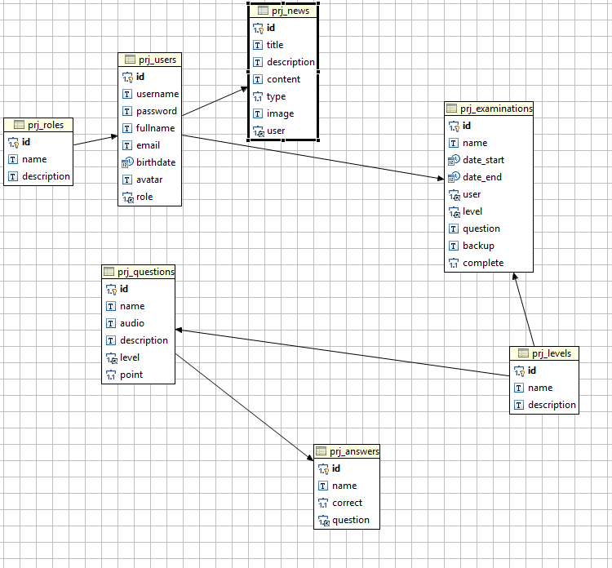

1. **Entity Relationship Diagram**

Table Users:

users (1).png

Table roles:

roles.png

Table news  
  
news.png

Table levels

level (1).png

Table Question

q.png

Table Answer

a.png

Table Examination:  
  
exams.png

1. **Entity Details**

Table Users

|  |  |  |  |  |
| --- | --- | --- | --- | --- |
| **Table: Users** | | | | |
| **Field Name** | **Data Type** | **Null** | **Key** | **Description** |
| id | Int | No | PK | Stores id of the table role |
| username | varchar(255) | No |  | Stores username of the table role |
| password | varchar(255) | No |  | Stores password of the table role |
| fullname | varchar(1000) | No |  | Stores full name of the table users |
| emal | varchar(1000) | No |  | Store email of the table email |
| birthdate | Date time | No |  | Store Birthdate of the users |
| avatar | varchar(1000) |  |  | Store link of avatar |

Table Roles

|  |  |  |  |  |
| --- | --- | --- | --- | --- |
| **Table: Role** | | | | |
| **Field Name** | **Data Type** | **Null** | **Key** | **Description** |
| id | Int | No | PK | Stores id of the table role |
| Name | Varchar(80) | No |  | Stores name of the table role |
| Description | Varchar(100) | No |  | Stores description of the table role |

Table Levels

|  |  |  |  |  |
| --- | --- | --- | --- | --- |
| **Table: Levels** | | | | |
| **Field Name** | **Data Type** | **Null** | **Key** | **Description** |
| id | Int | No | PK | Stores id of the table role |
| Name | Varchar(80) | No |  | Stores name of the table role |
| Description | Varchar(100) | No |  | Stores description of the table role |

Table News

|  |  |  |  |  |
| --- | --- | --- | --- | --- |
| **Table: News** | | | | |
| **Field Name** | **Data Type** | **Null** | **Key** | **Description** |
| id | Int | No | PK | Stores id of the table role |
| title | Varchar(80) | No |  | Title of the news |
| description | Varchar(1000) | No |  | Description of the news |
| content | Varchar(2000) | No |  | Content of the news |
| type | INT |  |  | Type of the news |
| image | varchar(2000) |  |  | Image of the news |
| user |  |  | FK |  |

Table Answers

|  |  |  |  |  |
| --- | --- | --- | --- | --- |
| **Table: Answer** | | | | |
| **Field Name** | **Data Type** | **Null** | **Key** | **Description** |
| id | Int | No | PK | Stores id of the table **Answer** |
| name | Varchar(80) | No |  | Stores name of the table **Answer** |
| correct | INT | No |  | Stores description of the table **Answer** |
| question | INT | No | FK |  |

Table Questions

|  |  |  |  |  |
| --- | --- | --- | --- | --- |
| **Table: Question** | | | | |
| **Field Name** | **Data Type** | **Null** | **Key** | **Description** |
| id | Int | No | PK | Stores id of the table question |
| Name | Varchar(80) | No |  | Stores name of the table question |
| Description | Varchar(100) | No |  | Stores description of the table question |
| audio | varchar(1000) | No |  | Audio of the question |
| level | INT |  | FK | Level of the question |
| point | INT |  |  | Point of the question |

Table Examinations

|  |  |  |  |  |
| --- | --- | --- | --- | --- |
| **Table: Examinations** | | | | |
| **Field Name** | **Data Type** | **Null** | **Key** | **Description** |
| id | Int | No | PK | Stores id of the table examinations |
| name | Varchar(80) | No |  | Stores name of the table examinations |
| date_start | datetime | No |  | Stores date start of the table examinations |
| date_end | datetime | No |  | Stores date end of the table examinations |
| user | INT | No | FK | Store the user of table |
| level | INT | No | FK | Store the level of table |
| question | INT | No | FK | Store the question of table |
| backup | Varchar(2000) | No |  | Backup the question and answer |
| complete | INT |  |  | Complete or not |

**PERSONAL EVALUATION:**

After completion of the project last year and put my final step to this report, I feel a sense of accomplishment. I feel better equipped and ready for life after graduation, although part of me told me that I just experienced the hype of accomplishing a task. I have benefited a lot from the whole experience and learned a lot about IT projects. Most importantly, I've understood as well as achieve the learning experience of using a method in the structure of an IT project. Completion of this project has helped me to appreciate the importance of the framework of IT projects despite the use of a person does not necessarily ensure a successful project. This project has supported my personal development and have given me the advanced knowledge of the issues subject I did not achieve otherwise.

To begin, the time keeping my skills have improved immensely as a result of this project. In the first few weeks of embarking on this project, I could not turn up for appointments with the supervisor of my project without giving any prior notification form. Not that I was indisposed or have other commitments to attend to; I just do not feel like facing up. My attitude left a lot to be desired as I did not seem to have a care in the world at that time. I still do not understand the reason behind my attitude. It could be that I've been struggling to adapt to college life after coming straight from the second year course at FPT University or I have been chuffed with the novelty of writing a final year project ; or even a combination of both. Even when I started to turn up for appointments I just turn up late. As time progressed I gradually came to terms with the task in front of me, and develop a change in attitude.

I started attending appointments and in my time as well. Attend appointments with the supervisor of my project made me realize the importance of it. It was during these meetings that I received instructions on my project without that I had strayed into a tangent. I would not have a clue about what I was doing or about how I'm going to go about it. I also began to attend lectures on time which is a significant improvement compared to my participation in the previous year. In my program on the foundation degree course I turned up late for the lectures. There has been a significant improvement in my overall attitude toward keeping time since starting this project and time keeping my skills have improved. Write this project has been a formula for improving my own. I was able to successfully manage a project from start to finish. I learned about the role of the framework of the implementation of IT projects. I understand that the use of a framework does not necessarily guarantee a successful project as a number of factors also need to be exploited, those factors including technical project management effectiveness. project management skills of mine had been up to scratch as I had limited time and resources to work with. I encountered a few bumps and failures but I was able to reorganize and keep abreast of my project plan. Some errors have been existent in my approach and I was able to do some different things. However, I was able to learn from my mistakes, modify and make a decision if I happen to be faced with a similar situation or similar circumstances. For example: I will make my time box more flexible concerning deliverables end by reducing the number of deliverables in each box while. I also want to start my requirements specification earlier than I had realized. This will give me more time to reconsider my request to allow a full repeat of my project to build up the required development time.

CONCLUSION :

Which is one great experience for me to study and work on the project on this. I have projects through various stages of development of the project and have give me insight into the world of real software engineers .The joy of work and the thrill join khi solve problems different and challenges me one feels about development industry.

After do this project I have more knowledge about php, server , ……..

**APPENDICES**

1. **Interface Design**

Login Page:

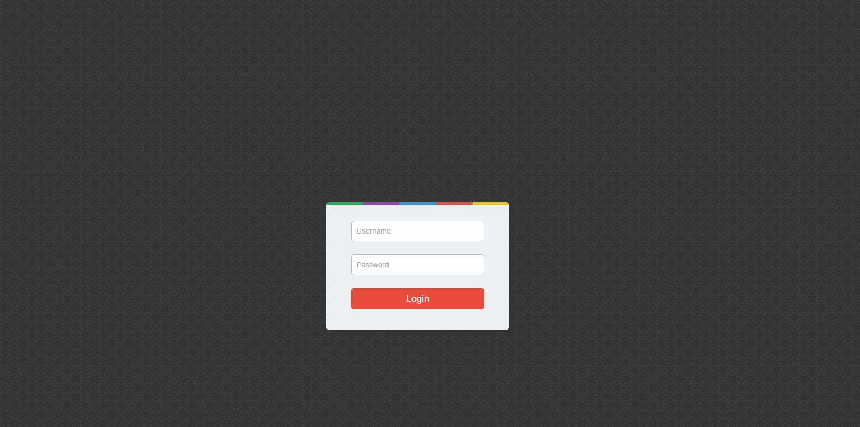

User management

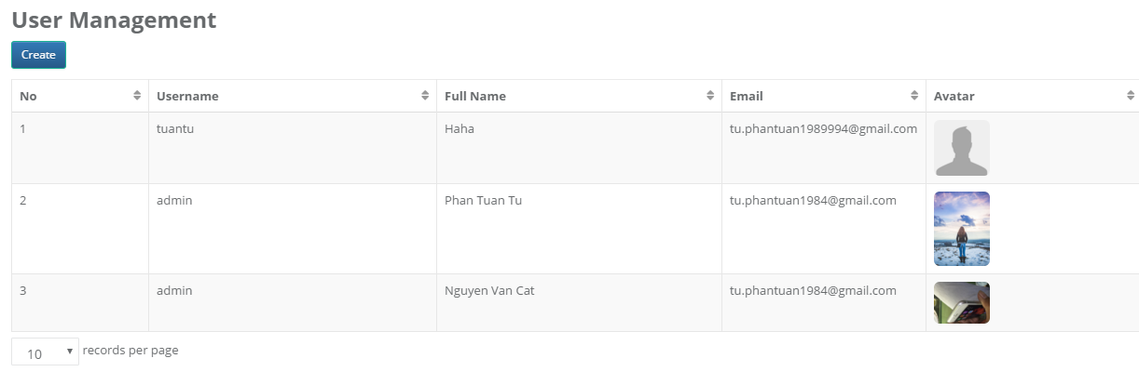

Create or update

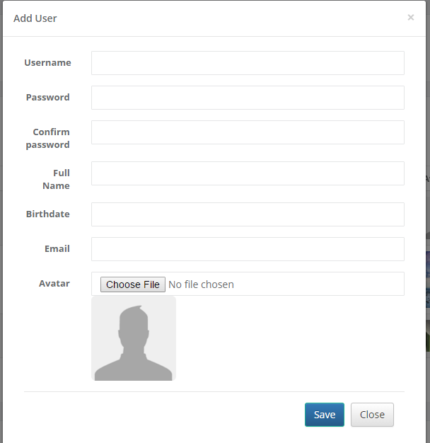

Role Manage

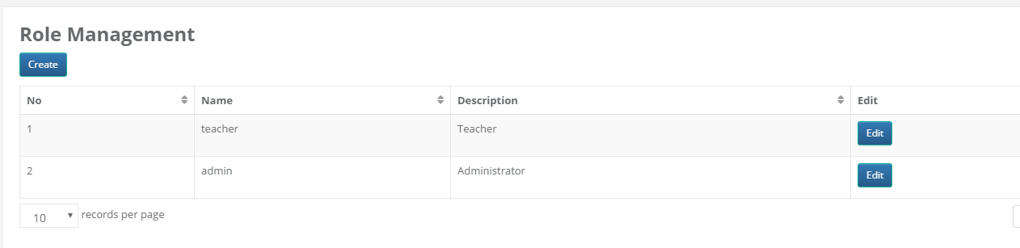

Add/ Save Role

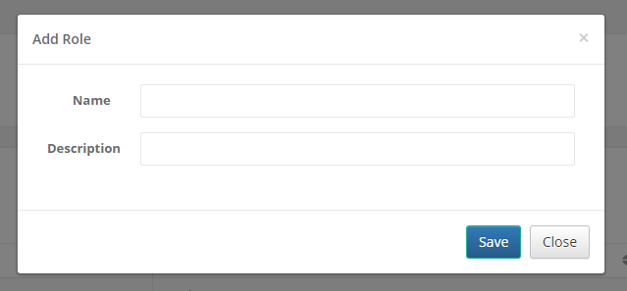

Level Management

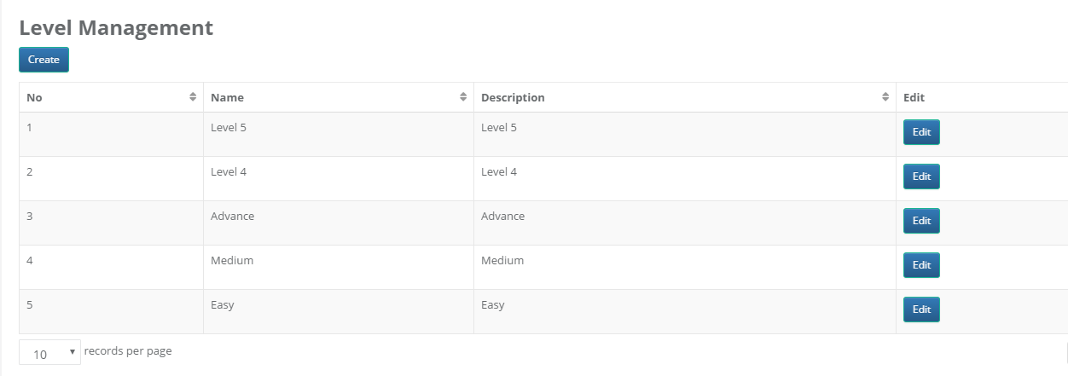

Add/ save level

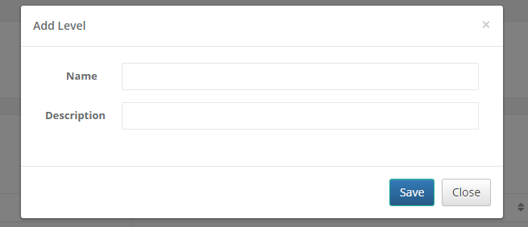

Question and answer Management

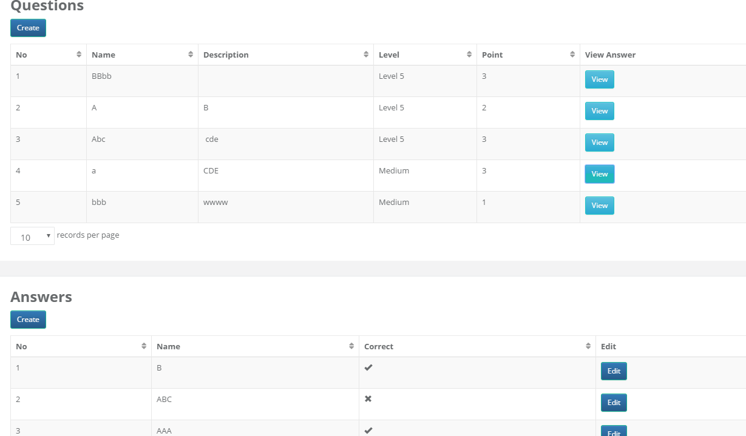

Add remove answer

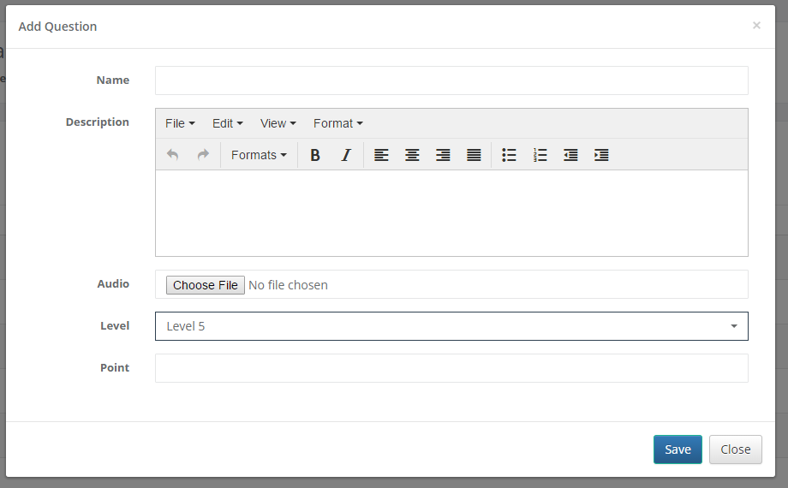

Add remove Answer

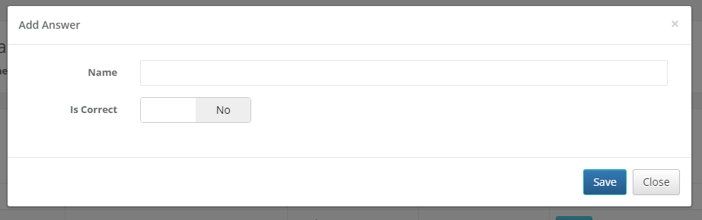

And Test UI

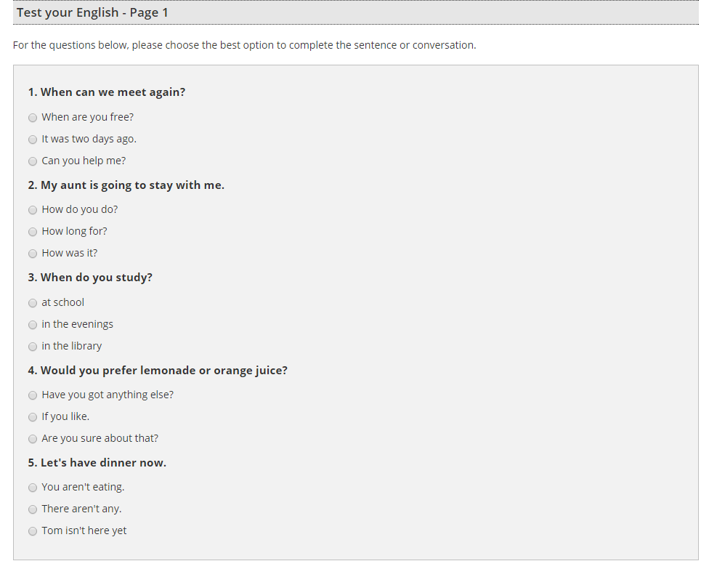

Thank for read this document !!!

**LINK DOWNLOAD:**

[**https://drive.google.com/file/d/0B-Jy2yK3QPOzTWRndjc2VEhpTkU/view?usp=sharing**](https://drive.google.com/file/d/0B-Jy2yK3QPOzTWRndjc2VEhpTkU/view?usp=sharing)