**LINCOLN CONFIGURATION**

**LMS FORMS**

# **DOCUMENT CONTROL**

|  |  |  |  |  |
| --- | --- | --- | --- | --- |
| **Date**  **(dd/mm/yyyy)** | **Updated by**  **(author name)** | **Changes made**  **(section numbers and description)** | **Version** | **Status of document** |
| 11/11/2016 | Uyen Ho | Initial document | 0.1 |  |

**TABLE OF CONTENTS**

DOCUMENT CONTROL

Overview

Creating the forms configuration

2.1. Create forms configuration page

2.2. Create form definition container page

2.3. Create form definition page detail

2.4 Create dropdown configuration page

2.4.1. Create dropdown container page

2.4.2, Create dropdown data page

2.4.3. Config dropdown component link to dropdown data page

2.4.4, Overview configuration data in definition form page

Create Form Page

## Overview

* Document guide how to config data for LMS Foms on Lincoln project

View page

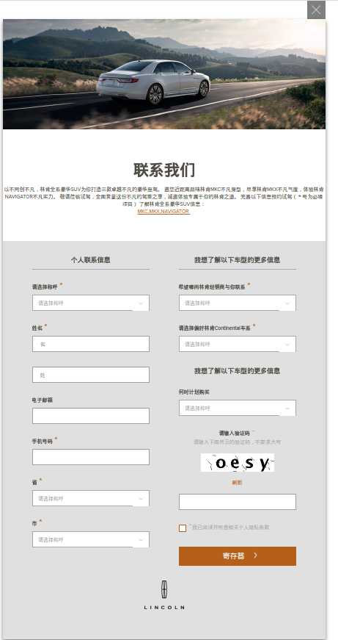

## Creating the forms configuration

### 2.1. Create forms configuration page

* This page allows author config data for LSM forms includes: SL captcha, Field name, manual, dynamic data for dropdown on forms, …..
* The path for this page is here:

**/content/lincoln/{market}/{language_market}/configuration**

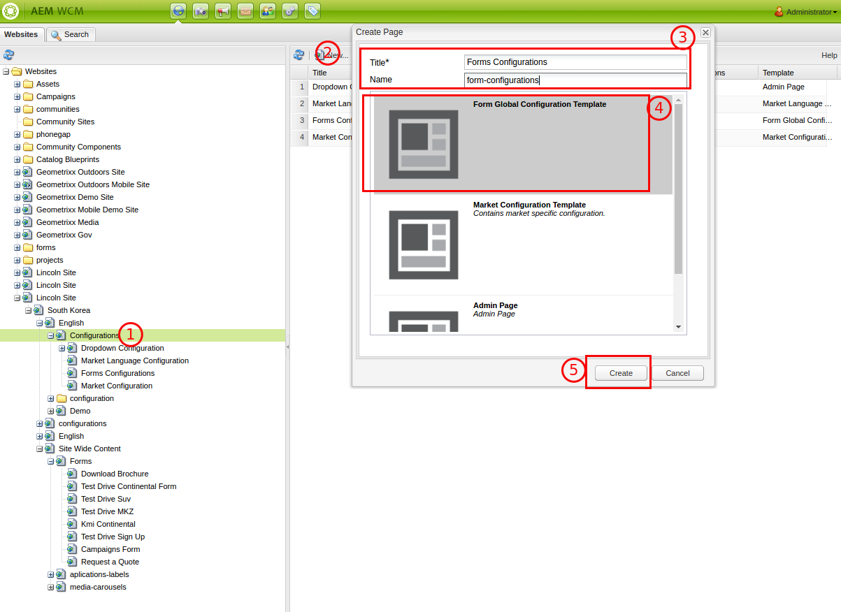

Click to open this page for config data

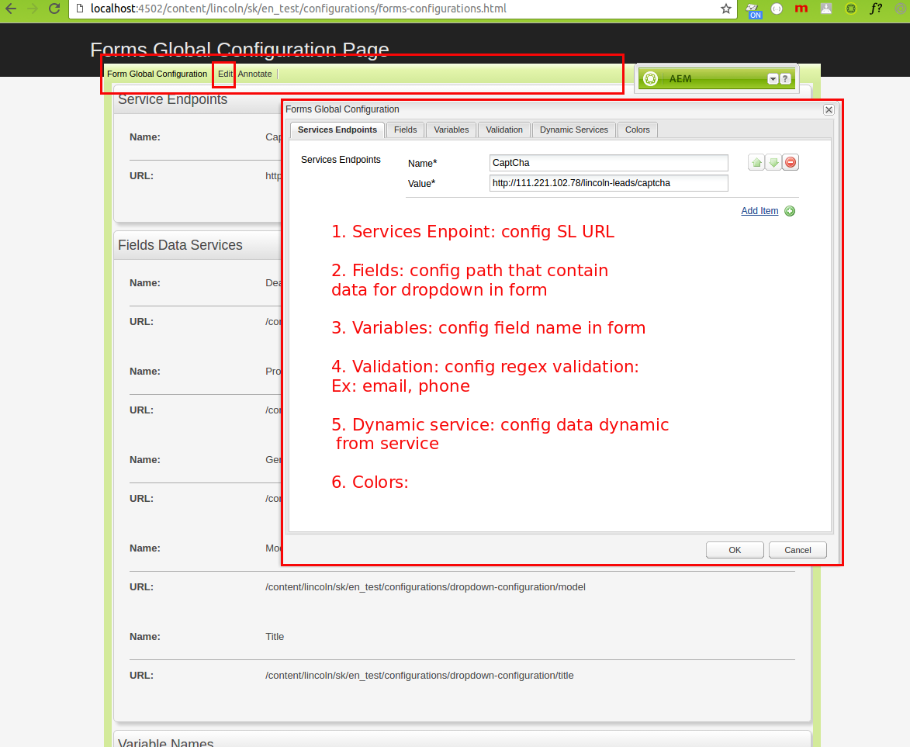

### 2.2. Create form definition container page

* This page allows author create the forms definition page detail to config content for LSM forms
* The path for this page is under the page **site-wide-content** with format

**/content/lincoln/{market}/{language_marker}/site-wide-content**

*Ex:* /content/lincoln/sk/en_sk/site-wide-content

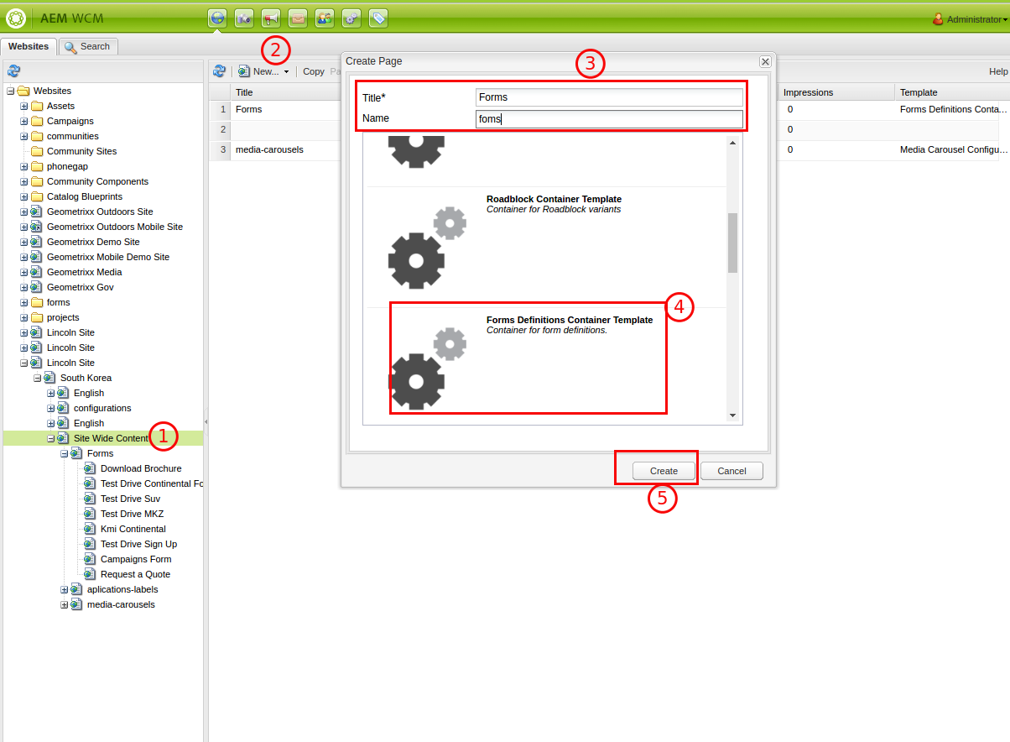

### 2.3. Create form definition page detail

* This page allow config content detail for form
* This page will config under the path:

**/content/lincoln/{market}/{language_marker}/site-wide-content/{page form container}**

*Ex:* /content/lincoln/sk/site-wide-content/forms, forms is form container page as mentioned above

* Click to open this page as view below:

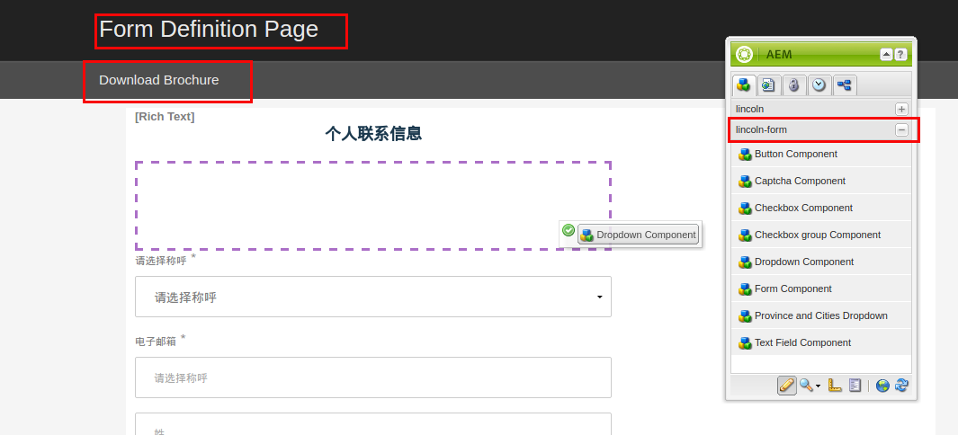

### 2.4 Create dropdown configuration page

* Dropdown configuration page allow author create page data for dropdown in forms

#### 2.4.1. Create dropdown container page

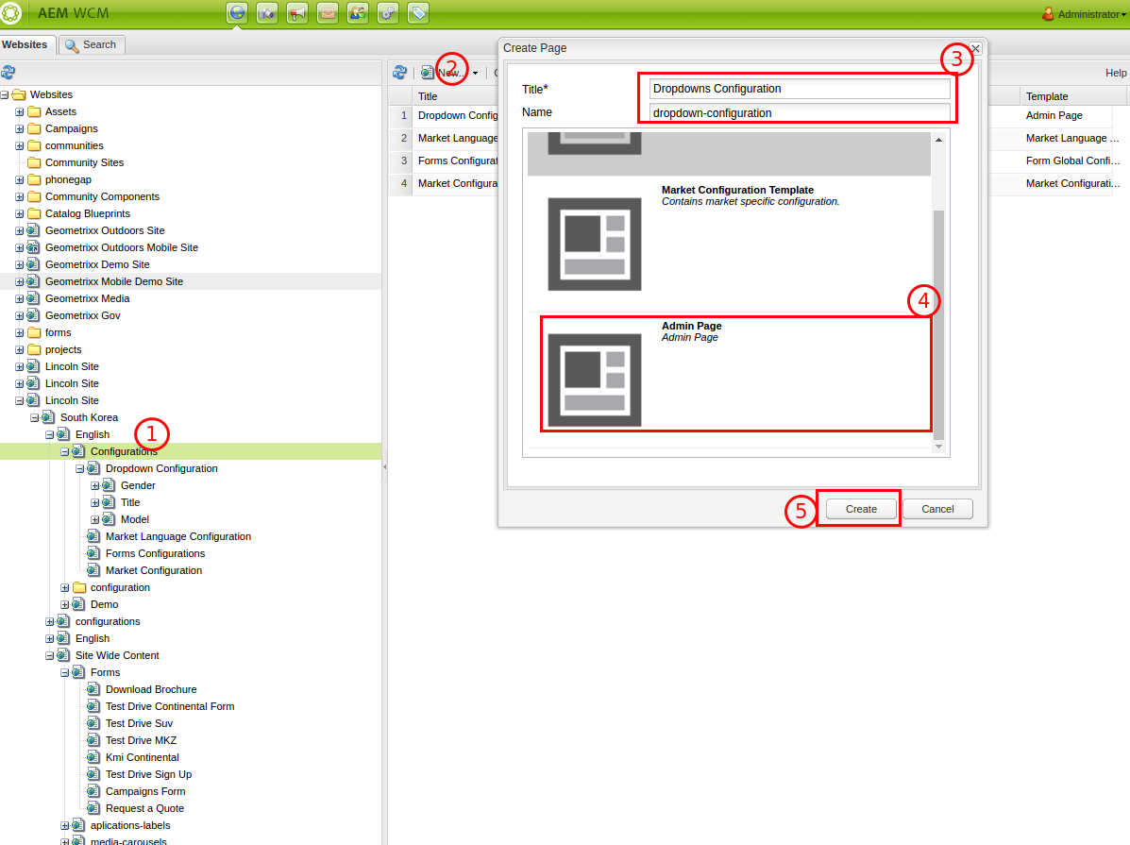

#### 2.4.2, Create dropdown data page

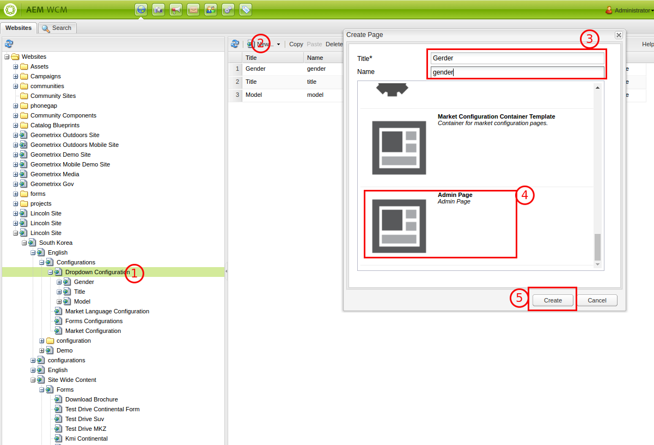

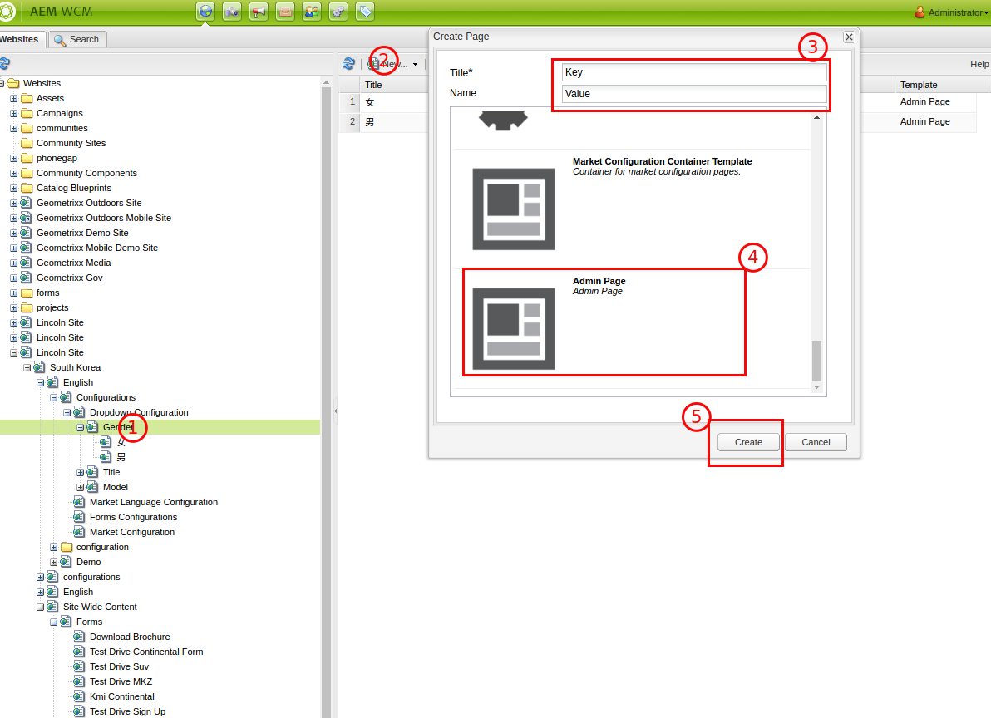

#### 2.4.3. Config dropdown component link to dropdown data page

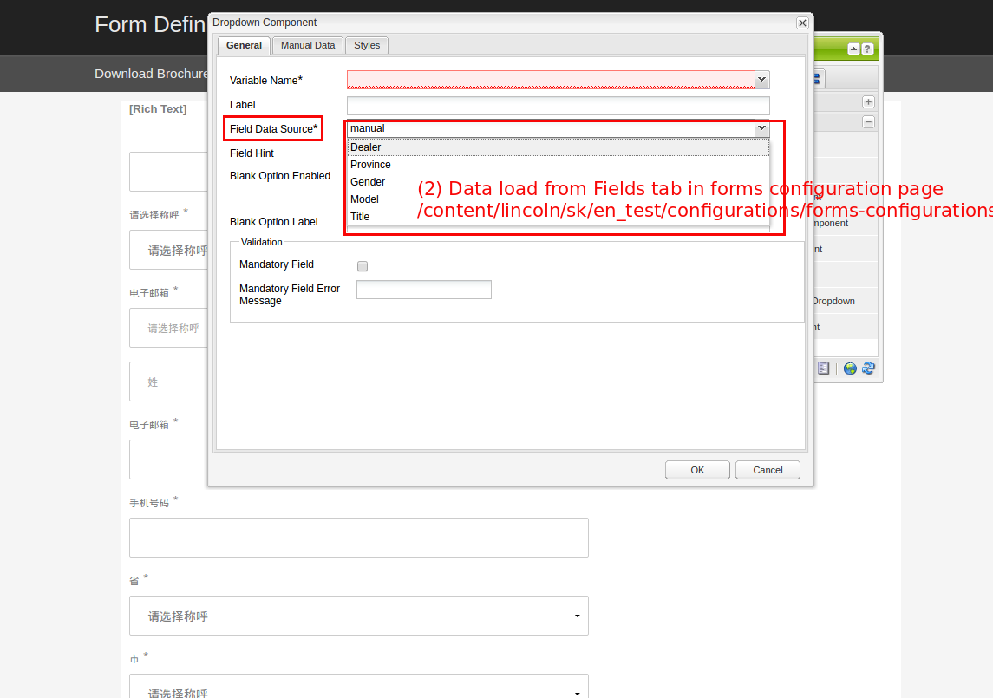

#### 2.4.4, Overview configuration data in definition form page

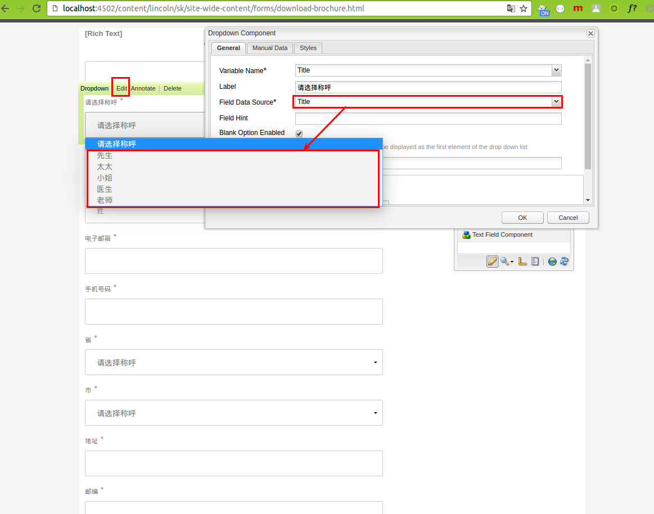

(1) : Variable Name: config field name for field in fom

(2): Form definition page Field: config to definition form page that mentioned at here 2.3. Create form definition page detail

(3): Hidden Field: allow author config input data hidden in form

*Ex:* CanpaindId, Market key….

## Create Form Page

* Create a any page in Lincoln project with Blank Page Template
* Drap and Drop Form component in this page

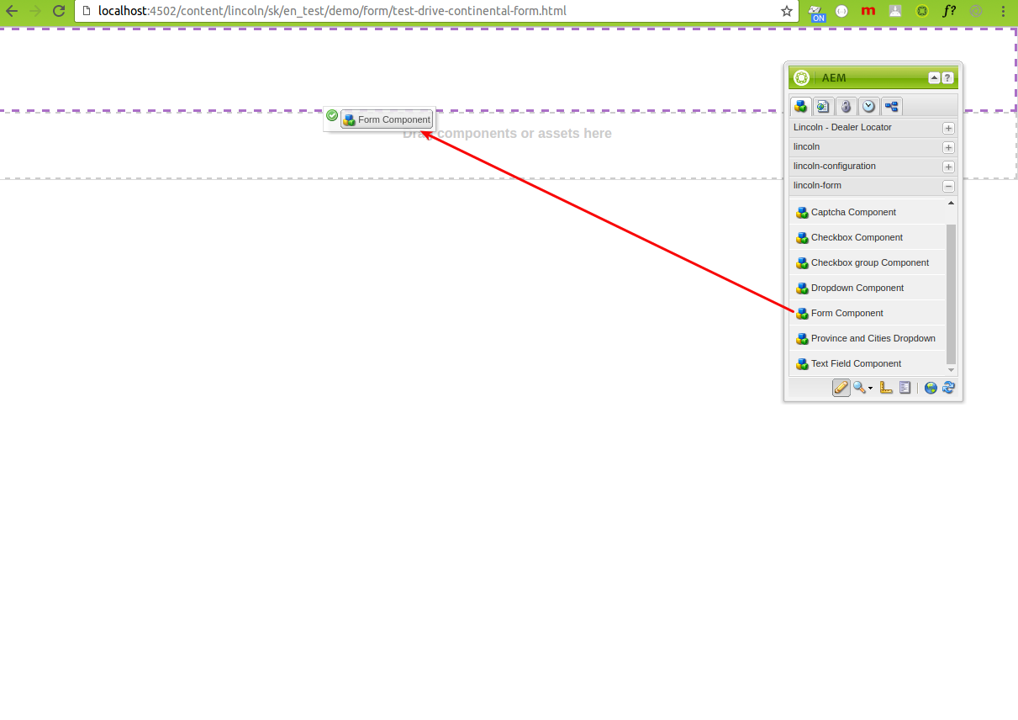

* Hover in form component to show edit button
* Click edit button to open dialog to update data for form component

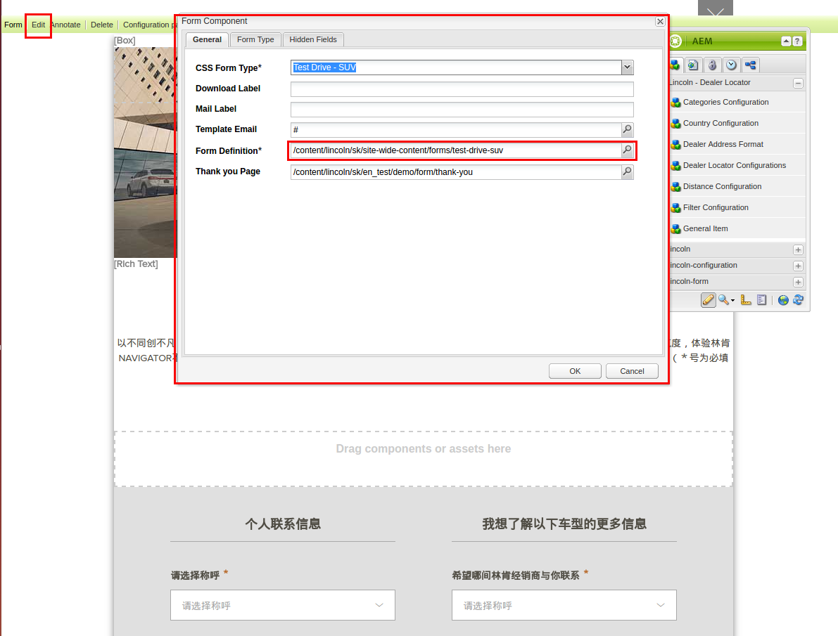

* View form page complete

